E
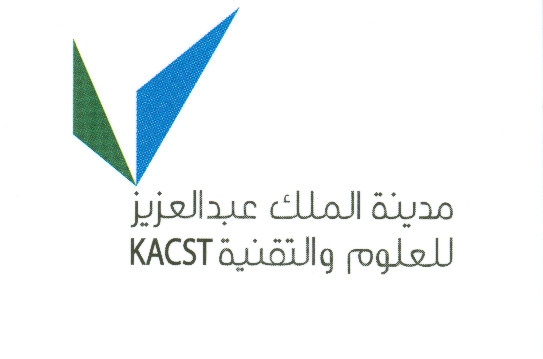
King AbdulAziz city of science
and technology

training of trainers program
WIPO/SMEs/RYD/11/INF/1 prov.
OriGINAL: English
DATE: DECEMBER 10, 2010
WIPO TRAINING OF TRAINERS PROGRAM ON EFFECTIVE INTELLECTUAL PROPERTY ASSET MANAGEMENT BY SMALL AND MEDIUM-SIZED ENTERPRISES
Organized by
the World Intellectual Property Organization (WIPO)
and
the King Abdulaziz City for Science and Technology (KACST)
Riyadh, Kingdom of Saudi Arabia, January 29 to February 2, 2011
PROVISIONAL PROGRAM
prepared by the international bureau of WIPO

Saturday, January 29, 2011

8.30 – 8.45 | Opening Ceremony  Representative of WIPO: Mr. Guriqbal Singh Jaiya, Director, Small and Medium-Sized Enterprises Division, WIPO, Geneva, Switzerland  Representative of King Abdulaziz City for Science and Technology
8.45 – 10.00 | Introduction to the World Intellectual Property Organization (WIPO) and its Small and Medium-sized Enterprises (SMEs) Division; Overview of Intellectual Property (IP) and the Role of Effective IP Asset Management in Enhancing the Competitiveness of SMEs
 | Speaker: Mr. Guriqbal Singh Jaiya, Director, Small and Medium-Sized Enterprises Division, WIPO, Geneva, Switzerland
 | Resources: Module One of IP PANORAMA
Third WIPO-INSME International Training Program: Financing Your Business with Intellectual Property

An Introduction to the World Intellectual Property Organization
The World Intellectual Property Organization and its Program for SMEs

Intellectual Property Management for Enhancing the Competitiveness of SMEs and Other Creative Communities
Creative Communities

IP PANORAMA TM
10.00 – 10.15 | Tea/Coffee Break
10.15 – 11.30 | “Making a Mark” – The Role of Trademarks in Branding
 | Speaker: Ms. Najmia Rahimi, Senior Program Officer, SMEs Division, WIPO, Geneva, Switzerland
 | Resources: Module Two of IP PANORAMA
“Making a Mark – An Introduction to Trademarks for Small and Medium-Sized Enterprises”
The Role of Trademarks in Marketing
Trademark Usage: Getting the Basics Right
The Synergy of Trademarks and Marketing
So What are the Do's & Don’ts for Choosing a Brand?
Independent Existence or Coexistence of Identical or Similar Trademarks
11.30 – 12.30 | Lunch Break
12.30 – 13.45 | “Looking Good” – The Role of Design in Branding
 | Speaker: Ms. Larysa Kushner, Consultant, Minsk, Belarus
 | Resources: Module Two of IP PANORAMA
“Looking Good – An Introduction to Industrial Designs for Small and Medium-Sized Enterprises
The Power of Design for Marketing Success
13.45 – 15.00 | “Inventing the Future” – The Role of Utility Models and Patents in Leveraging Technical Innovation in the Marketplace
 | Speaker: Ms. Rachna Singh Puri, CEO, Xellect IP Solutions, Bangalore, India
 | Resources: Module Three of IP PANORAMA
“Inventing the Future – An Introduction to Patents for Small and Medium-Sized Enterprises”
Quality Patents: Claiming What Counts
Managing Patent Costs: An Overview

Sunday January 30, 2011

8.30 – 9.45 | “In Confidence” – Putting in Place a Trade Secret Protection Program in an SME
 | Speaker: Ms. Najmia Rahimi
 | Resources: Module Four of IP PANORAMA
“In Confidence” (Draft WIPO publication)
Trade Secrets are Gold Nuggets : Protect Them
Trade Secrets: Policy Framework and Best Practices
Disclosing Confidential Information
What an Employee Needs to Know About Trade Secrets

9.45 – 10.00 | Tea/Coffee Break
10.00 – 11.30 | “Creative Expression” - Benefiting From Your Copyright and Using the Copyright Works of Others in Your Business
 | Speaker: Ms. Larysa Kushner
 | Resources: Module Five of IP PANORAMA
“Creative Expression – An Introduction to Copyright for Small and Medium-Sized Enterprises”
Copyright Protection: Reaping the Benefits of Literary or Artistic Creation
Intellectual Property in the Fashion Industry
Using Photographs of Copyrighted Works and Trademarks
Legal Pitfalls of Taking and Using Photographs of Copyright Material, Trademarks and People
What to do if you are Accused of Copyright Infringement
11.30 – 12.30 | Lunch Break
12.30 – 13.45 | Collective Marketing: Adding Value With Geographical Indications, Certification Marks and Collective Marks
 | Speaker: Ms. Rachna Singh Puri
The Value of Collective and Certification Marks for Small Players
Using Collective Marks for the Protection of Traditional Products
Role of Intellectual Property in Enhancing the Competitiveness of the Tourism Industry

13.45 – 15.00 | IP Law and Administration in Saudi Arabia
 | Speaker: Local speaker from Saudi Arabia
Monday, January 31, 2011

8.30 – 9.45 | Intellectual Property in the Digital Economy
 | Speaker: Ms. Larysa Kushner
 | Resources: Module Eight of IP PANORAMA
Business Success, Copyright and the Digital Environment
Intellectual Property and E-Commerce: How to Take Care of Your Business Website

9.45 – 10.00 | Tea/Coffee Break
10.00 – 11.30 | Managing Intellectual Property Assets in International Business
 | Speaker: Ms. Najmia Rahimi
 | Resources: Module Nine of IP PANORAMA
SMEs or Micromultinationals? Leveraging the Madrid System for International Branding
The Outsourcing Offshore Conundrum: An Intellectual Property Perspective
International Trade in Technology – Licensing of Know-How and Trade Secrets
International Trade in Technology – Licensing of Know-How and Trade Secrets

11.30 – 12.30 | Lunch Break
12.30 – 13.45 | Shaping Business Strategy Through Competitive Intelligence – Strategic Use of Intellectual Property Information
 | Speaker: Ms. Rachna Singh Puri
 | Resources: Module Six of IP PANORAMA
Connecting Strategy and Competitive Intelligence: Refocusing Intelligence to Produce Critical Strategy Inputs

Intellectual Property Rights Information Serving Innovation

Patents in Technical Standards

Prior Art Searches: A Must for Innovative SMEs

Going Beyond the Prior Art Search
13.45 – 16.30 | Exploiting Intellectual Property Assets; Overview of Licensing, Franchising and Merchandising
 | Speaker: Mr. Guriqbal Singh Jaiya
 | Resources: Modules Seven and Twelve of IP PANORAMA
Exchanging Value - Negotiating Technology Licensing Agreements - A Training Manual
Successful Technology Licensing
Franchising & Licensing - What are they? and how can you benefit from them?
IP Licensing: Reaping the Benefits
Starting a New Company: Consider Franchising as an Option
Savvy Marketing: Merchandising of Intellectual Property Rights
Role of the Intellectual Property System in Developing and Marketing of New Products
Tuesday, February 1, 2011

8.30 – 9.45 | IP and Finance: Accounting and Valuation of IP Assets and IP-based Financing
 | Speaker: Mr. Guriqbal Singh Jaiya
 | Resources: Module Eleven of IP PANORAMA
IP Financing: the Ten Commandments
Managing Patent Costs: An Overview
IP Reporting
90.45 – 10.00 | Tea/Coffee Break
10.00 – 11.30 | Enforcing Intellectual Property Rights in Saudi Arabia
 | Speaker: Local Speaker from Saudi Arabia
11.30 – 12.30 | Lunch Break
12.30 – 13.45 | Role of IP Management in Effective Government-University/Research Institutes-Industry Relations
 | Speaker: Mr. Guriqbal Singh Jaiya
 | Local Speaker from Saudi Arabia
Resource: IP Ownership: Avoiding Disputes
Technology Transfer, Intellectual property and Effective University-Industry Partnerships: The Experience of China, India, Japan, Philippines, the Republic of Korea, Singapore and Thailand

13.45 – 15.00 | IP Asset Management: IP Audit and IP Due Diligence
 | Speaker: Ms. Rachna Singh Puri
 | Resources: Module Ten of IP PANORAMA
IP Audit: “A How To” Guide
IP Due Diligence Readiness
Wednesday, February 2, 2011

8.30 – 9.45 | Case Studies or Group Exercise: Effective Use of Intellectual Property Assets by SMEs in their Business Strategies
Speaker: Local expert(s) from Saudi Arabia
Ms. Rachna Singh Puri
Ms. Larysa Kushner
 | Resources: Module Ten of IP PANORAMA
9.45 – 10.00 | Tea/Coffee Break
10.00 – 11.30 | Current and Proposed IP Information, Teaching/Training, Advice and Consulting Services for SMEs in Saudi Arabia
 | Speaker: Local Speakers from Saudi Arabia
11.30 – 12.30 | Lunch Break
12.30– 13.45 | Round Table Discussion: Creating a Tool Box of Support Services: Basic IP Services to be Provided by SME Support Institutions in Saudi Arabia
 | Moderator: Mr. Guriqbal Singh Jaiya
 | Discussants: Representative(s) of SME Support Institution in Saudi Arabia, Ms. Rachna Singh Puri, Ms. Larysa Kushner, and Ms. Rahimi
13.45 – 15.00 | Written Test (open book) for Evaluation of Participants
15.00– 15.30 | Feedback from participants, summing up and closing ceremony

[End of document]

