E
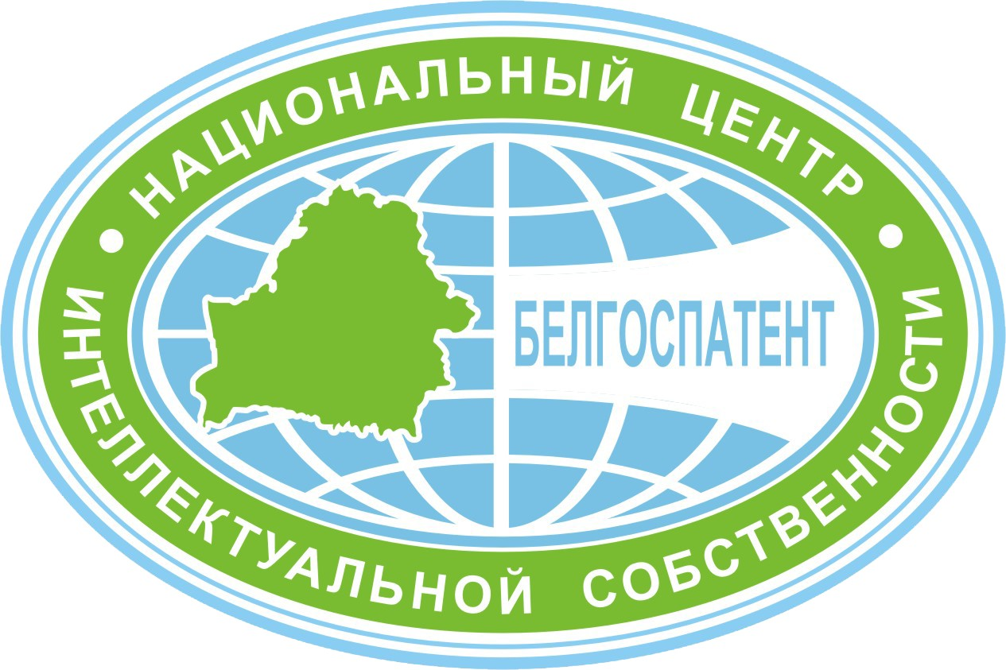 | 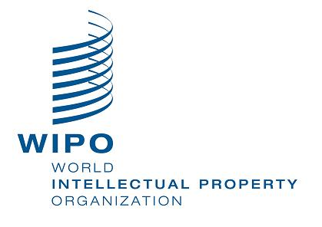
NATIONAL CENTER OF INTELLECTUAL
PROPERTY OF BELARUS
(NCIP)
NATIONAL SEMINAR

WIPO/SMEs/MSK/14/INF/1prov
ORIGINAL: english
DATE: february 2014

Intellectual Property for Small and Medium-Sized Enterprises (SMEs)

organized by
the World Intellectual Property Organization (WIPO)

and

the National Center of Intellectual Property of Belarus (NCIP)

Minsk, March 11 and 12, 2014

PROVISIONAL PROGRAM

prepared by the International Bureau of WIPO

Tuesday, March 11, 2014

9.00 – 9.30 Registration

9.30 – 9.45 Opening Ceremony

Welcome addresses by:

Mr. Piotr Broukin, Director General, NCIP

Mr. Anil Sinha, Head, Small and Medium-sized Enterprises Section, WIPO, Geneva
9.45 – 10.15 Topic 1 Development of the National IP Systems in Countries in Transition: Role of WIPO

Speaker: Mr. Evgeniy Sesitsky, Consultant, Department for
Transition and Developed Countries (TDC),
WIPO, Geneva

10.15 – 10.45 Topic 2 WIPO’s Activities for SMEs Support in the Field of IP. IP PANORAMA

Speaker: Mr. Anil Sinha

10.45 – 11.15 Topic 3 Recommendations on Strengthening the Role of Innovative
Small and Medium-sized Enterprises (SMEs) in CIS
Countries: WIPO Tool

Speaker: Mr. Evgeniy Sesitsky

11.15 – 11.30 Coffee Break

11.30 – 12.15 Topic 4 National IP Strategies as a Basis for the Innovation Model Economy

Speaker: Mr. Ron Marchant, International IP Expert, Torfaen,
United Kingdom

12.15 – 13.00 Topic 5 National IP Strategy and the Enhancement of SMEs Capacities on IP Management

Speaker: Mrs. Iryna Rudakova, Head, Division of Registers
and Industrial Property Economics, NCIP

13.00 – 14.30 Lunch Break

14.30 – 15.10 Topic 6 The Role of Effective IP Asset Management in Enhancing the Competitiveness of SMEs in the Domestic and International Markets

Speaker: Mr. Anil Sinha

15.10 – 15.40 Topic 7 State Policy on the Development of Small and Medium-sized Business in Belarus

Speaker: Mr. Konstantin Krukov, Head, Business
Environment Department, Entrepreneurship Board,
Ministry of Economy of the Republic of Belarus

15.40 – 16.15 Topic 8 Managing IP Assets in International Business with a Focus
on Transfer of Technology

Speaker: Mr. Ron Marchant

16.15 – 16.30 Coffee Break

16.30 – 17.15 Topic 9 Inventing the Future – The Role of Utility Models and Patents in Leveraging Technical Innovation in the Marketplace

Speaker: Mr. Ron Marchant

17.15 – 17.30 Evaluation and closing of the first day of the seminar

Wednesday, March 12, 2014

09.30 – 10.15 Topic 10 Looking Good – The Role of Design in Branding

Speaker: Mr. Pierre El Khoury, Professor,
University La Sagesse, Beirut

10.15 – 11.00 Topic 11 Making a Mark – The Role of Trademarks in Branding

Speaker: Mr. Anil Sinha

11.00 – 11.15 Coffee Break

11.15 – 12.00 Topic 12 Collective Marketing: Adding Value through Geographical Indications, Certification Marks and Collective Marks

Speaker: Mr. Anil Sinha

12.00 – 13.00 Topic 13 Creative Expression - How to Use Your Own Copyright and Copyrightable Works of Others

Speaker: Mr. Pierre El Khoury

13.00 – 14.30 Lunch Break

14.30 – 15.00 Topic 14 Shaping Business Strategy through Competitive Intelligence (including Practical Exercises)

Speaker: Mr. Pierre El Khoury, Professor,
University La Sagesse, Beirut

15.00 – 15.45 Topic 15 Company’s Strategy on IP Management:
National Experience

Speaker 1: Mr. Vladimir Karyagin, Chairman, Minsk Capital Association of Entrepreneurs and Employers

Speaker 2: The representatives of local SMEs (tbc.)

Speaker 3: The representatives of local SMEs (tbc.)

15.45 – 16.00 Coffee Break

16.00 – 16.30 Topic 16 Conducting an IP Audit and Managing IP Assets

Speaker: Mr. Pierre El Khoury

16.30 – 17.00 Topic 17 IP and Finance: Accounting and Valuation of IP Assets and
IP-based Financing

Speaker: Mr. Anil Sinha

17.00 – 17.30 Evaluation and closing of the seminar

[End of document]

