E
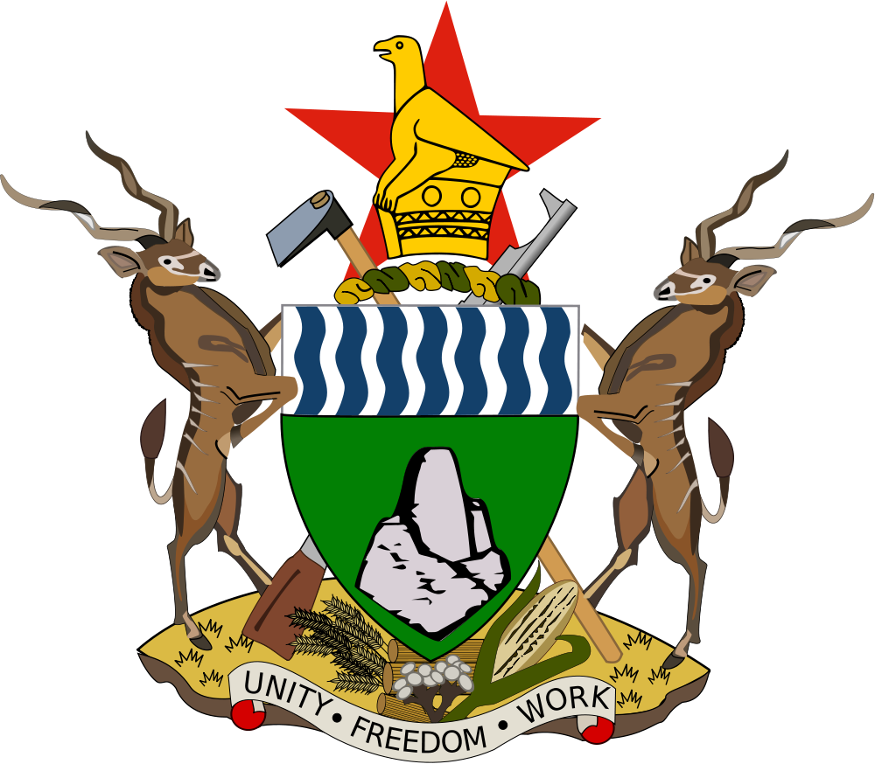  Ministry of Justice, Legal  and Parliamentary Affairs | 
training of trainers program
WIPO/SMEs/HRE/INF/1 PROV.
ORIGINAL: English
DATE: nOVEMBER 25, 2015

WIPO Basic Training of Trainers Program on
Effective Intellectual Property Asset Management by
Small and Medium-sized Enterprises (SMEs)

organized by
the World Intellectual Property Organization (WIPO)
and
the Department of Deeds, Companies and
Intellectual Property, Zimbabwe

Harare, December 14 to 17, 2015

PROVISIONAL PROGRAM

prepared by the International Bureau of WIPO

Monday, December 14, 2015

9.00 – 9.30 | Opening Ceremony  Welcome addresses by
 | The representative of the Office of the Registrar for the Deeds, Companies and Intellectual Property Department, Harare
 | The representative of the World Intellectual Property Organization (WIPO), Geneva
 | The representative of the Government of Zimbabwe, Harare
9.30 – 10.30 Topic 1: | Overview of Intellectual Property (IP) and the Role of Effective IP Asset Management in Enhancing the Competitiveness of Small and Medium-sized Enterprises (SMEs)
 | Speaker: Mr. Christopher Kalanje, Senior Program Officer, Small and Medium-sized Enterprises (SMEs) Section, SMEs and Entrepreneurship Support Division, Department for Transition and Developed Countries (TDC), WIPO
 | Resources: Module One of IP PANORAMA
10.30 – 10.45 | Tea/Coffee Break
10.45 – 11.30 Topic 2: | Overview of Intellectual Property Legislation in Zimbabwe
 | Speaker: Mr. Willie Mushayi, Deputy registrar, Ministry of Justice, Legal and Parliamentary Affairs, Department of Deeds, Companies and Intellectual Property (Local Speaker)
11.30 – 12.30 Topic 3: | The role of Trademarks in Branding
12.30 – 14.00 | Speaker: Mr. Vladimir Yossifov  Resources: Module Two of IP PANORAMA  “Making a Mark” – An Introduction to Trademarks for Small and Medium-sized Enterprises  Looking Good” – An Introduction to Industrial Designs for Small and Medium-sized Enterprises  Lunch Break
14.00 – 15.00 Topic 4: | Putting in Place a Trade Secret Protection Program
 | Speaker: Christopher Kalanje
 | Resources: Module Four IP PANORAMA
15.00 – 15.30 | Tea/Coffee Break
15.30 – 16.30 Topic 5: | Benefiting from your Copyright and Using the Copyright Works of Others in your Business
Speaker: Ms. Maureen Fondo, Copyright Officer (ARIPO)

Resources: Module Five of IP PANORAMA
“Creative Expression” – An Introduction to Copyright for Small and Medium-sized Enterprises

Tuesday, December 15, 2015

9.00 – 9.45 Topic 6: | Intellectual Property in the Digital Economy
Speaker: Mr. Vladimir Yossifov,

Resources: Module Eight of IP PANORAMA

9.45 – 10.15 | Tea/Coffee Break
10.15 – 11.30 Topic 7: | Overview of the Main Initiatives and Program to Support the SMEs Sector in Zimbabwe
 | Speaker: Mr. David Nyakonda, Director Business Development, Ministry of Small and Medium Enterprises and Cooperative Development
11.30 – 12.30 Topic 8: | The Role of Industrial Designs in Branding
 | Speaker: Mr. McLean Sibanda, Partner, Sibanda & Zantwijk Attorneys, Gauteng, South Africa
12.30 – 14.00 | Lunch Break

14.00 – 15.00 Topic 9: | The Role of Utility Models and Patents in Leveraging  Technical Innovation in Marketplace
 | Speaker: Mr. McLean Sibanda
Resources: Module Three of IP PANORAMA

“Inventing the Future” – An Introduction to Patents for Small and Medium-sized Enterprises
15.00 – 15.30 | Tea/Coffee Break
15.30 – 16.30 Topic 10: | Collective Marketing: Adding Value with Geographical Indications, Certification Marks and Collective Marks
 | Speaker: Mr. Christopher Kalanje
 | Resources: Module Nine of IP PANORAMA

Wednesday, December 16, 2015

9.00 – 10.00 Topic 11: | Shaping Business Strategy through Competitive  Intelligence – Strategic Use of Intellectual Property  Information – Practical Exercise
 | Speaker: Mr. Vladimir Yossifov
 | Resources: Module Six of IP PANORAMA
10.00 – 10.30 | Tea/Coffee Break
10.30 – 11.30 Topic 12: | Exploiting Intellectual Property Assets; Licensing, Franchising and Merchandising
 | Speaker: Mr. McLean Sibanda
 | Resources: Modules Seven and Twelve of IP PANORAMA
11.30 – 12.30 Topic 13: | Intellectual Property Issues in International Business
 | Speaker: Mr. Christopher Kalanje
 | Resources: Module Nine of IP PANORAMA
12.30 – 14.00 | Lunch Break
14.00 – 15.00 Topic 14: | IP Asset Management: IP Audit and IP Due Diligence
 | Speaker: Mr. Vladimir Yossifov
15.00 – 15.30 | Tea/Coffee Break

15.30 – 16.30 Topic 15: | Accounting and Valuation of IP Assets: IP-based Financing
 | Speaker: Mr. Christopher Kalanje

Thursday, December 17, 2015

9.00 – 10.30 Topic 16: | Case Studies: Effective Use of IP Assets by SMEs in their Business Strategies
Speakers: Mr. McLean Sibanda
Ms. Brenda Matanga, Legal Practitioner, Conveyancer
Patent and Trademark Agent
10.30 – 11.00 | Tea/Coffee Break
11.00 – 12.00 Topic 17 | The Interface between Universities, Public Research Institutions and SMEs
 | Speakers: Mr Africa Makasi, Lecturer and Business Consultant (PhD)
12:00 – 13.30 | Lunch break
13.30 – 14.45 | Round Table Discussion: Creating a Tool Box of Support Services: Basic IP Services to be Provided by SME Support Institutions in Zimbabwe
 | Moderator: Representative of the Office of the Registrar for the Deeds, Companies and Intellectual Property Department, Zimbabwe
 | Discussants: Mr. Christopher Kalanje
 | International and Local Speakers and Participants
14.45 – 15.15 | Tea/Coffee Break

15.15 – 16.15 | Written Test (open book) for Evaluation of Participants
16.15 – 16.30 | Summing up and Closing Ceremony

[End of document]

