E
WIPO-PPO-KIPO/IP/WAW/09/INF/1 Prov.
ORIGINAL: English
DATE: April 2009
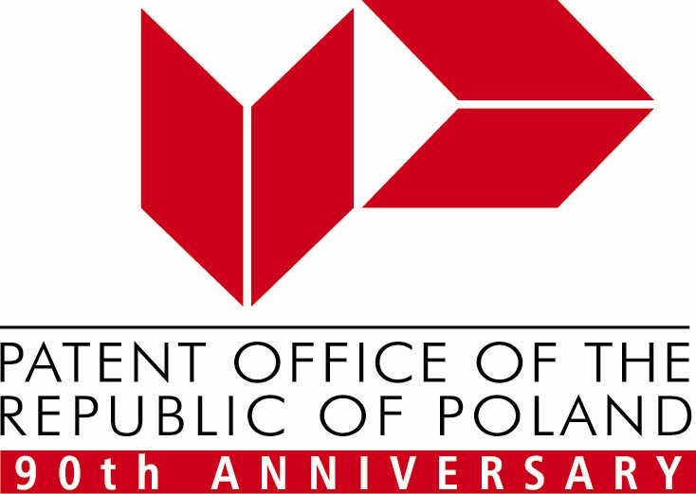 |  | 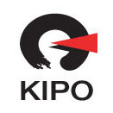 | 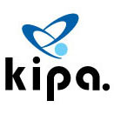
PATENT OFFICE OF THE  REPUBLIC OF POLAND | WORLD INTELLECTUAL  PROPERTY ORGANIZATION | KOREAN INTELLECTUAL PROPERTY OFFICE | KOREA INVENTION  PROMOTION ASSOCIATION
wipo-PPO-KIPO Eastern european REGIONAL forum
On Using THE Intellectual property (IP) PANORAMA
for Building THE Capacity of SMALL AND MEDIUM-SIZED ENTERPRISES (SMES) for Strategic INTELLECTUAL PROPERTY Management
organized by
the World Intellectual Property Organization (WIPO)
in cooperation with
the Patent Office of the Republic of Poland (PPO),
the Korean Intellectual Property Office (KIPO)
and
the Korea Invention Promotion Association (KIPA)
Warsaw, April 2 and 3, 2009
PROVISIONAL PROGRAM
prepared by the International Bureau of WIPO

Thursday, April 2, 2009

9.00 – 9.30 OPENING CEREMONY

Welcome addresses by:

Mrs. Alicja Adamczak, President, Patent Office of the Republic of Poland (PPO), Warsaw

Mr. Park Hyoung-Ho, Director, Intellectual Property (IP) Management Support Division, Korean Intellectual Property Office (KIPO), Daejeon, Republic of Korea

Mr. Guriqbal Singh Jaiya, Director, Small and Medium-Sized Enterprises (SMEs) Division, World Intellectual Property Organization (WIPO), Geneva

9.30 – 10.10 Topic 1: IP Awareness and Capacity of Polish Entrepreneurs and SMEs and Capacity Building Activities of the PPO and the Polish Agency for Enterprise Development (PAED)

Speaker: Mr. Radosław Runowski, Director, Industrial Property Unit, Polish Agency for Enterprise Development (PARP), Warsaw

10.10 – 10.40 Topic 2: Korean National Experience on Building IP Awareness and Capacity of SMEs

Speaker: Mr. Park Hyoung-Ho

10.40 – 11.00 Coffee Break

11.00 – 11.30 Topic 3: Benchmarking National and Regional Support Services for SMEs in the Field of Intellectual and Industrial Property; Study Report Prepared by the Austrian Institute for SMEs Research

Speaker: Mr. Alfred Radauer, Austrian Institute for SMEs Research, Vienna

11.30 – 12.00 Topic 4: KIPO Innovation for Customer Satisfaction Utilizing Information Technology

Speaker: Mr. Lee Byung-Yep, Director, Technical Cooperation Team, KIPO

12.00 – 12.30 Topic 5: French National Experience on Building IP Awareness and Capacity of SMEs

Speaker: Ms. Hélene Salaville, National Institute of Industrial Property (INPI), Paris

12.30 – 13.00 Topic 6: WIPO’s Experience on Capacity-Building on IP for SMEs and IP PANORAMA as an Effective Capacity-Building Tool

Speakers: Mr. Guriqbal Singh Jaiya
Mr. Yoon Won-Kil, Counsellor, SMEs Division, WIPO

13.00 – 14.00 Lunch Break

14.00 – 14.40 Topic 7: IP and performance: an empirical analysis of the UK's SMEs

Speaker: Mr. Christian Rodrigo Helmers, Researcher, University of Oxford, United Kingdom

14.40 – 15.00 Coffee Break

15.00 – 16.00 Topic 8: IP Awareness and Capacity Building Programs of Public Institutions in Korea

Speakers: Ms. Han Mi-Young, President, Korea Women Inventors Association (KWIA), Seoul
Ms. Hwang Hye-Jin, Consultant, IP e-HRD Team, Korea Invention Promotion Association (KIPA), Seoul

16.00 – 17.15 Country Presentations

Speakers: The representatives of the invited countries

17.15 – 17.45 Group Discussion (all speakers and participants)

17.45 CLOSING CEREMONY

Friday, April 3, 2009

The IP PANORAMA Exhibition in the foyer of the Warsaw Stock Exchange

[End of document]

