E
WIPO-INSME/SMEs/GE/06/1 Prov.
ORIGINAL: English
DATE: July 7, 2006
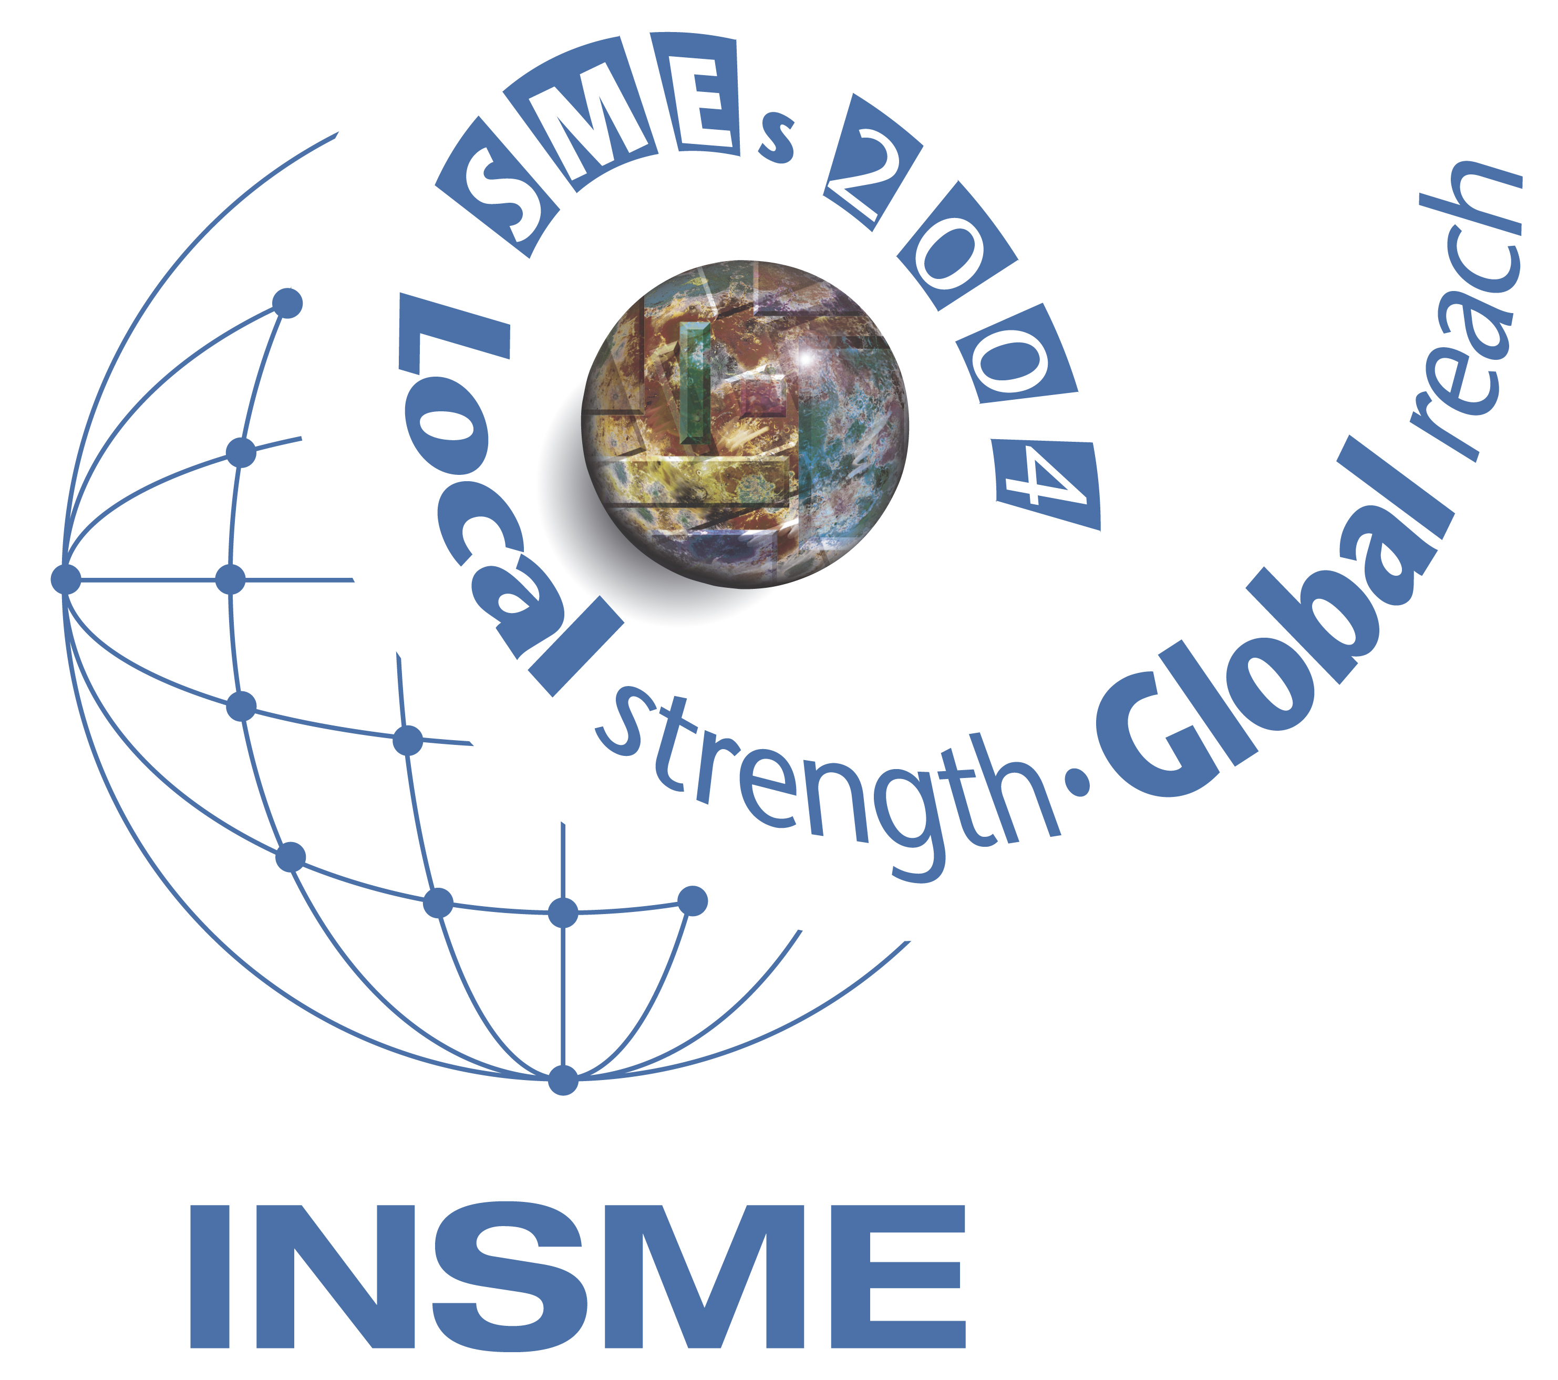 | 
INTERNATIONAL NETWORK  FOR SMALL AND MEDIUM-SIZED ENTERPRISES | WORLD INTELLECTUAL  PROPERTY ORGANIZATION
WIPO-INSME INTERNATIONAL TRAINING PROGRAM
ON the role of INTELLECTUAL PROPERTY in raising finance BY small and medium-sized enterprises
jointly organized by
the World Intellectual Property Organization (WIPO)
and
the International Network for Small and Medium-Sized Enterprises (INSME)
Geneva, July 11 and 12, 2006
PROVISIONAL PROGRAM
prepared by the Secretariat

Tuesday, July 11, 2006

9.00 – 9.30 Registration

9.30 – 10.00 Opening Ceremony

Welcome addresses by:

Mr. Guriqbal Singh Jaiya, Director, Small and Medium-Sized (SMEs) Enterprises Division, World Intellectual Property Organization (WIPO), Geneva

Ms. Simona Marzetti, Secretary General, the International Network for Small and Medium-Sized Enterprises (INSME) Association, Rome

10.00 – 11.00 Theme 1 The Importance of Intellectual Property (IP) for Enhancing the Competitiveness of Small and Medium-Sized Enterprises (SMEs)

Speaker: Mr. Guriqbal Singh Jaiya

11.00 – 11.30 Coffee Break

11.30 – 12.30 Theme 2 Making Intangibles a Valuable Tangible Asset; Generating Value by Relying on Intellectual Capital

Speaker: Mr. John D. Swaim, Consultant, Geneva

12.30 – 14.00 Lunch

14.00 – 15.30 Theme 3 Strategic Use of Intellectual Capital: IP Audit for Leveraging IP Assets in Business Strategy

Speaker: Mr. Jeremy Lack, Attorney-at-law, Geneva

15.30 – 16.00 Coffee Break

16.00 – 17.30 Theme 4 Measuring the Value of Intangibles: IP Valuation

Speaker: Mr. John D. Swaim

Case Study: Mr. Mauro De Bona, Campus srl, Innova Group, Rome

17.30 – 18.30 Theme 5 Using IP as a Tool for Accessing Finance and Harvesting Returns From IP Assets

Speaker: Mr. Jeremy Lack

Wednesday, July 12, 2006

9.30 – 10.30 Theme 6 Sources of Finance for Innovative SMEs

Speaker: Mr. Christian Saublens, Managing Director, European Network of Business Angels (EBAN), Brussels

10.30 – 11.00 Coffee Break

11.00 – 12.30 Theme 7 Accessing Public Sector Funds for Innovation and R&D

Speakers: Mr. Antoine Rety, Officer, Institut National de Propriété Industrielle, Lyon

Mr. Andrew Beale, Director, IP Wales, Swansea

12.30 – 14.00 Lunch

14.00 – 15.00 Theme 8 A Venture Capitalist’s View of IP Assets

Speaker: Mr. Luigi Amati, CEO, Meta Group, Terni

Case Study: Mr. Vittorio Palmieri, Partner, Nabla Technologies, Geneva

15.00 – 16.00 Theme 9 Role of Business Angels in Supporting Your Innovation Plans

Speaker: Mr. Paolo Anselmo, President of the Italian Network of Business Angels (IBAN) and Member of the Executive Committee of the European Network of Business Angels (EBAN), Aosta

Case Study: Mr. Christophe Beaud, President, Association of Swiss Business Angels Networks (ASBAN), Zurich

Mr. Andreas Schweitzer, Swiss Business Angel and Entrepreuner, Ocean AG, Geneva

16.00 – 16.30 Coffee Break

16.30 – 17.30 Theme 10 Financial and Other Assistance by Multinationals to SMEs and Spin-offs

Speaker: Mr. Wilfried Grommen, General manager Business Strategy, Microsoft Europe, EMEA, Brussels

17.30 – 18.00 Round–table

18.00 CLOSING CEREMONY

[End of document]

