E
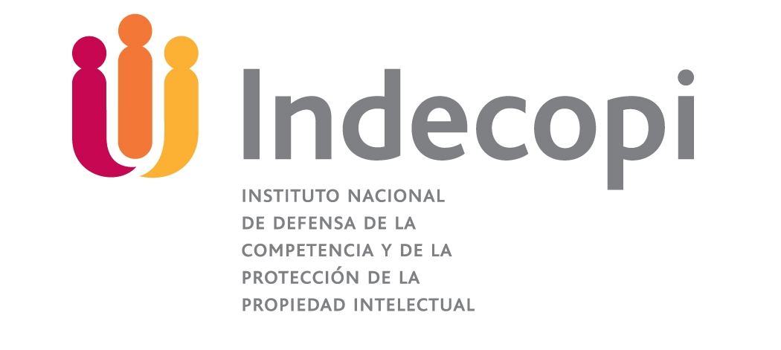 | 
the national institute for the defense OF competition and the protection of intellectual property | MINISTRY OF FOREIGN AFFAIRS

SymPOSIuM
WIPO/GEO/LIM/11/INF/1 Rev.
OriGINAL: ENGLISH
DATE: May 7, 2011
Worldwide Symposium on Geographical Indications
organized by
the World Intellectual Property Organization (WIPO),
the National Institute for the Defense of Competition and the Protection of Intellectual Property (INDECOPI) of Peru
and
the Ministry of Foreign Affairs of Peru
Lima, June 22 – 24, 2011
REVISED GENERAL INFORMATION
Document prepared by the International Bureau of WIPO
- ORGANIZATION OF THE SYMPOSIUM

Organizers

The Worldwide Symposium on Geographical Indications is being organized jointly by the World Intellectual Property Organization (WIPO), the National Institute for the Defense of Competition and the Protection of Intellectual Property of Peru (INDECOPI) and the Ministry of Foreign Affairs of Peru.

Venue and Dates

The Symposium will be held in Lima, on Wednesday, June 22 and Thursday, June 23, 2011, at the following address:

Swissôtel Lima
Via Central 150
Centro Empresarial Real
San Isidro
Lima 27
Telephone: (+51-1) 421-4400
Facsimile: (+51-1) 611-4401
E-mail: lima@swissotel.com
Website: www.swissotel.com/lima

A technical excursion to a geographical indication production site will take place on Friday, June 24, 2011 (see paragraph below).

Objectives

The International Symposium on Geographical Indications is organized every other year by WIPO in cooperation with an interested Member State. It brings together representatives of Member States’ administrations, producers of GI products and specialists in the field of geographical indications. The Symposium is a forum for an exchange of ideas and views on various issues relating to the use and protection of geographical indications. The Symposium will offer insights into the technicalities of the subject and it is expected that it will contribute to the ongoing debates on geographical indications at the national and international levels.

Registration

Registration for the Symposium should be made by means of the Registration Form annexed to this document, to be returned to WIPO by facsimile or by e mail, by June 10, 2011.

On-site registration will take place on Wednesday, June 22, 2011, from 8 a.m. to 9.15 a.m. at the Registration Counter, located next to the conference room on the first floor at the Swissôtel Lima. During the Symposium, participants are required to visibly wear their event badges while inside the conference venue.

Working Languages and Documentation

The working languages of the Symposium will be English, French and Spanish with simultaneous interpretation.

All documents will be published on the WIPO website at the following address:
http://www.wipo.int/meetings/en/details.jsp?meeting_id=22582.

Excursion

An excursion to a Pisco Bodega requiring one-hour drive will take place on Friday, June 24, 2011. Although the timing of the Symposium does not coincide with the grape-picking and processing periods for making Pisco, participants will have an explanation on the production method of that typical Peruvian liquor (which benefits from a protected appellation of origin, also registered under the Lisbon Agreement), and taste different piscos. This visit will be combined with a tour to the pre-Inca ruins of Pachacamac, located between Lima and the bodega.

Coaches will depart from the Swissôtel Lima to the Bodega at 8.30 a.m. The visit will be followed by a lunch in the Bodega.

The return to Lima is expected at approximately 6.30 p.m.

Participants in the excursion are advised to wear warm casual clothing and comfortable shoes.

Participants who wish to take part in the excursion are kindly requested to fill in the relevant part of the registration form attached to this document and return it by June 10, 2011.

II. INFORMATION CONCERNING IMMIGRATION FORMALITIES

Entry Visa

Most nationalities do not need a visa to enter Peru. Foreign participants who do need a Peruvian entry visa should contact the Embassy or Consulate of Peru in their respective countries. They must be in possession of a valid entry visa before commencing their travel.

Detailed information on the procedure and the required documents to apply for a visa are available on the official site of the Ministry of Foreign Affairs:
http://www.rree.gob.pe/portal/mre.nsf/Interior?OpenAgent&6CC6E835AECBFE8105256BAB00788288|1 (only in Spanish) and http://www.learn4good.com/travel/peru_visa.htm (in English). A list of countries whose nationals need or do not need entry visas as well as a list of Peruvian embassies and consulates and their addresses are also available on the same site.

In case any participant or speaker has difficulties in obtaining a Peruvian entry visa, he or she may request assistance from the following person at the Ministry of Foreign Affairs of Peru:

Mr. Jimmy Ulloa
E-mail: julloa@rree.gob.pe

III. INFORMATION CONCERNING HOTELS

Hotel Accommodation

Participants should make their room reservation directly at the hotel of their choice. All bills are to be settled directly with the hotel. The following hotels are recommended:

1. Swissôtel Lima (venue of the Symposium)

Via Central 150
Centro Empresarial Real
San Isidro
Lima 27
Telephone: (+51-1) 421-4400
Facsimile: (+51-1) 611-4401
E-mail: lima@swissotel.com
Website: www.swissotel.com/lima

100 rooms have been reserved at the following preferential rates if booking is made before May 20, 2011. Prices include breakfast.

Premier room single or double: USD 195 + 10% (negotiated rate)
Suite Business advantage single or double: USD 195 + 10% (negotiated rate)
Suite executive single or double USD 250 + 10% (negotiated rate)

To book a room at the Swissôtel Lima, please fill in the reservation form annexed to this information note, and send it directly to the hotel, to the following contact person:

Miss Elizabeth Fonseca
E-mail: elizabeth.fonseca@swisslim.com.pe

Other hotels:

- Delfines Hotel y Casino

Los Eucaliptos 555
San Isidro
Telephone: (+51-1) 215-7000
Website: www.losdelfineshotel.com

Contact person:
Mrs. Nathalie Loayza
E-mail: nloayza@losdelfineshotel.com.pe

*Single: USD 155 + 10% (negotiated rate)

- Novotel Lima

Av. Víctor Andrés Belaúnde 198
San Isidro
Telephone: (+51-1) 441-4171
Website: www.novotel.com

Contact person:
Mr. Ian Galindo
E-mail: Ian.GALINDO@accor.com

*Single: USD 150 + 10% (negotiated rate)

- Sonesta Hotel El Olivar

Pancho Fierro 194
San Isidro
Telephone: (+51-1) 712-6043
Website: www.sonesta.com

Contact Person:
Mr. Jorge Carrera
E-mail: jcarrera@sonestaperu.com

*Single: USD 165 + 10% (negotiated rate)

Transport from other hotels to the venue of the event will not be provided.
IV. MISCELLANEOUS INFORMATION

Safety and Security

Lima is a big city of almost 10 million inhabitants. It is recommended that event participants be aware of the following safety and security-related information:

- participants should maintain security awareness at all times while they are in Lima.

- it is recommended to avoid the use of informal taxi services at all times. In Lima there are only two taxi companies that fulfill the UN Security Management System standards: MITSU Taxi Remise and CMV Taxi Remise, which should be used for transfers to/from the airport. A taxi service can be contracted prior to travel or at a counter outside customs at the Jorge Chavez International Airport. The Swissôtel can arrange for transfer from the airport to the hotel with MITSU Taxi Remise at the cost of USD 45. To that end, contact Mr. Luis Casas at the following email address: luis.casas@swisslim.com.pe or by phone: (+51-1) 421-9888; and

- due to the high reporting incidence of frauds in connection with Automated Teller Machines (ATM) transactions, especially at night, it is highly recommended to use only ATMs located inside banks or at selected hotels.

Climate

The weather in June in Lima is generally warm, with the temperature ranging between 16 and 20 degrees Celsius.

Local time

The local time for Lima is Peru Standard Time, which is GMT (UTC) minus six hours.

Currency

Peru’s local currency is the Nuevo Sol (S/.). The exchange rate is approximately USD1 = 2,81800 PEN (Peru Nuevos Soles) (subject to change).

Electricity

The electric power provided in Lima is 220 V, 60Hz.

V. CONTACT DETAILS

For further assistance and inquiries from WIPO, the following persons may be contacted:

Mrs. Aurélie Lugrin
Telephone: + 41 22 338 9440
Facsimile: + 41 22 338 8745
E-mail: aurelie.lugrin@wipo.int

Mrs. Margarita Marcel de Griffiths
Telephone: + 41 22 338 7363
Facsimile: + 41 22 338 8745
E-mail: margarita.marceldegriffiths@wipo.int

For further assistance and inquiries from INDECOPI, the following persons may be contacted:

Ms. Lily Escobar
Telephone: (+51-1) 224-7800 ext. 1337
Facsimile: (+51-1) 224-0348
E-mail: lescobar@indecopi.gob.pe

Ms. Melina Glave
Telephone: (+51-1) 224-7800 ext. 1393
Facsimile: (+51-1) 224-0348
E-mail: mglave@indecopi.gob.pe

[Annex follows]
the national institute for the defense OF competition and the protection of intellectual property | MINISTRY OF FOREIGN AFFAIRS

REGISTRATION FORM

WORLDWIDE SYMPOSIUM ON GEOGRAPHICAL INDICATIONS

Lima, June 22 to 24, 2011

TO BE RETURNED TO:

WIPO

FACSIMILE: +41 22 338 8745
E-MAIL: aurelie.lugrin@wipo.int AND margarita.marceldegriffiths@wipo.int

Mr./Ms.:

First Name:

Family Name:

Country - Organization:

Address:

City: State:

Country:

Telephone: Fax:

E–mail:

EXCURSION ON JUNE 24, 2011

I will participate

Name of the accompanying person (if relevant):

I will not participate

[End of Annex and of document]
Swissôtel Lima, Peru
OMPI

From June 21st to June 25th 2011
(To be sent directly to Miss Elizabeth Fonseca by Mail)
elizabeth.fonseca@swisslim.com.pe

I prefer the following accommodations:

- Standard Room USD195.00 + 10% Of services per room, per night
- Swiss Executive Room USD250.00 + 10% Of services per room, per night

(Please fill the Reservation Form by Computer)

Guest Name & last name_________________________________________________

Check in Date: ________________ Arrival Time: ______

Check out Date: Departure Time: ______

Number of persons staying in the room: ____________

Number of Nights: ______________

**1 Room with king size bed: ________ **2 Rooms with 2 full size beds: ________

**Smoking Room: _____ **Non Smoking Room: _____

Credit Card Type and Number for Guarantee: __________________________

Expiration Date:

Name (like in the credit card):

Passport Number: __________________ Date of Birth: __/__/____

Address: __________________________________

Phone Number (indicate the Country and City code): ______________________

Mail: _________________________________

Special Requirements: ____________________________

Signature:

Name and mail of the person requesting the reservation: ___________________________________________

**Upon Availability

*It is mandatory, in order to send the confirmation number, to have the credit card information.

The relevant information for the hotel is:
Swissotel Lima Hotel
Via Central N°150, Centro Empresarial Real
San Isidro, Lima Perú
Telephone: (+511) 611-4415
Website: www.swissotel.com

