WIPO |  | E  SCT/S2/INF/2  ORIGINAL: English  DATE: March 29, 2002
WORLD INTELLECTUAL PROPERTY ORGANIZATION
GENEVA

standing committee on the law of trademarks, industrial designs and geographical indications
Second Special Session
on the Report of the Second WIPO Internet Domain Name Process

Geneva, May 21 to 24, 2002

CYBERSQUATTING:
THE OECD'S EXPERIENCE AND THE PROBLEMS IT ILLUSTRATES WITH
REGISTRAR PRACTICES AND THE “WHOIS” SYSTEM

Report prepared by
the Organisation for Economic Cooperation and Development (OECD)
and submitted by the Secretariat

1. On March 4, 2002, the Organisation for Economic Cooperation and Development (OECD) provided the Secretariat with a Report entitled “Cybersquatting: The OECD's Experience and the Problems it Illustrates with Registrar Practices and the ‘Whois’ System,” which details that Organisation’s experience with regard to the abusive registration, as a domain name, of the French acronym of the Organisation. As the members of the Standing Committee on the Law of Trademarks, Industrial Designs and Geographical Indications (SCT) had requested, at the first Special Session of the SCT, further evidence of the extent of the problem of the abusive registration, as domain names, of the names and acronyms of intergovernmental organizations, the Report provided by the OECD is submitted by the Secretariat for the information of the second Special Session of the SCT.

2. The OECD Report is reproduced in Annex I.
[Annex I follows]
SCT/S2/INF/2

ANNEX I

This report summarises the problem recently met by the OECD with regard to the cybersquatting of the ocde.org domain name, and identifies the general policy issues arising from this experience.

For further information, please contact: David H. Small, Director of Legal Affairs OECD
Tel (33-1) 45 24 80 75; Fax (33-1) 45 24 80 53; e-mail: david.small@oecd.org

1. From December 17, 2001 to February 11, 2002, the Organisation’s French acronym domain name, ocde.org was in the hands of a very active cybersquatter. For one month, the name pointed to a pornography service and an offer to sell the domain name. From January 17, the name got only an error response. On February 11, the Organisation received the name back, free, from the cybersquatter, without resort to the ICANN Uniform Dispute Resolution Procedure (UDRP) or the courts.

2. This paper describes the Organisation’s experience – which illustrates many problems with Registrar practice and the “whois” public information system as it operates today. It also sets out some thoughts on the public policy agenda concerning this area.

The domain name “ocde.org” and how it was lost

3. The Organisation had “owned” the domain names oecd.org and ocde.org for six years – and had progressively built up the web-site to which they pointed. By the end of 2001, the site had over 20 000 visits per day. While most visitors accessed the site through the English acronym, the traffic through the French acronym was significant and growing, ocde.org was increasingly found as a link on French language sites and had just been selected by a French Internet review as one of the top five resources for the business community.

4. In Fall 2001, OECD’s registration renewal check was cashed by its registrar, Verisign / Network Solutions. OECD, however, had not written the Verisign notice number on the check and Verisign, which claims to have sent us an e-mail about it, let the registration lapse. On December 17, we learned that “ocde.org” was pointing to a pornographic site and an offer to sell the domain name.

What OECD was able to learn about its situation quickly

5. WHOIS ocde.org (Appendix I) told us that the name had been registered on December 10; the registrant was “Domain for Sale”; 7 Vardanants Street, # 32, Yerevan, Armenia, with an e-mail address of admin@elazy.com; and that its administrative and technical contact was Philip O’Neal, American Institute of Architects (AIA) with an address, phone and fax in Washington, D.C. Mr. O’Neal was away until January 3, at which time we spoke to him and learned that he was an official of the AIA, itself a recent victim of Domain for Sale. OECD was the fifth victim to call in recent weeks about a cybersquatted domain name for which Domain for Sale had falsely listed him as contact.

6. The Organisation found that it was part of a rapidly growing list of victims of this extortion scheme, as disparate as Hewlett Packard, ESPN, a small town in Idaho; a former San Francisco Forty-Niner quarterback; an Australian football club; children’s web-sites in the US and in Italy; a chemistry professionals’ discussion site, etc. We learned that one victim which needed its domain name back quickly paid USD 3 000 to Domain for Sale; another victim got its domain name back in about two and a half months through an uncontested UDRP proceeding in the NAF. We also learned that the cybersquatter restricted contacts to e-mail addresses and anonymous automated phone answering services (US phone numbers), arranged payments though an e-escrow service; used a variety of borrowed famous names in communications (Allen Ginsberg, Charles Bukowski, William Burroughs, etc.); and, according to press articles from Armenia, was not to be found there.

OECD’s contacts with its Registrar

7. Beginning December 17, OECD tried to get Verisign / Network Solutions to address the problem of recovering the domain name. They handled OECD’s inquiries defensively, responding only about the check. Later, OECD learned from ICANN Registrar Liaison that registrars sometimes co-operate with each other in returning domain names de-registered through mistake. When we called Verisign about this possibility, we were informed that they had asked the new registrar, Namescout Corp. (Canada) to return it at the outset, but Namescout had declined.

OECD’s contacts with Domain for Sale’s registrar

8. Once it learned of the fraudulent information in the “WHOIS ocde.org”, the Organisation telephoned Namescout, naively expecting co-operation in the prompt return of the name. This began what turned out to be an extensive and frustrating correspondence, by phone and e-mail, seeking to recover ocde.org without the delay, risk and expense of filing a UDRP or court action.

9. We were told that Namescout could legally do nothing to help us absent a court order or UDRP award, unless the name had been stolen from OECD, e.g., by a hacker who had taken it from our account. We found this to be untrue under the plain language of its standard Terms of Service agreement.
10. OECD went back to Namescout and pressed the wilfully false information and the clearly improper purpose as grounds for deleting the Domain for Sale registration. (A compendium of the correspondence is available from the Secretariat). Namescout, however, acted as if it were faced with an innocent contact information error. It sent an e-mail to Domain for Sale, advising it of the receipt of a complaint about its information and giving it fifteen days to correct or confirm.

11. When OECD questioned Namescout’s decision to give the cybersquatter an opportunity to retain the registration by modifying its filing Namescout (through legal counsel) asserted that there was “insufficient evidence to establish…improper purpose” and that it was required to give the fifteen day opportunity to correct. OECD took issue with this, offered to have Mr. O’Neal communicate with them directly, and appealed in vain to Namescout’s interest in a healthy Internet.
12. In a follow-up phone conversation, Namescout counsel declined to look at the web-site, the clear evidence of improper purpose, arguing that registrars can’t be held responsible for web-site content – therefore Namescout couldn’t properly look at it! Namescout also insisted, despite the plain language of the contract, that submission of Mr. O’Neal and AIA as administrative and technical contact was not a material breach unless the Registrant failed to correct it! Later, more senior Namescout counsel appeared to recognise that “wilful” submission of false information was perhaps a different matter, but asserted that there was no “clear evidence” that the supply of false information was wilful! (see paragraph 16, below).

13. Namescout’s counsel agreed to consider de-registration if Mr. O’Neal sent in a statement that the registration was false. He promptly did so. However, that same day, the account holder removed the references to Mr. O’Neal and substituted the following information for its administrative and technical contact: Name : “Domain for Sale”; Organisation – “Domain for Sale”, Position – “President”. (The “corrected” WHOIS ocde.org is set out in Appendix II of this Note.) Namescout asserted that this “correction” put registrant in compliance. Counsel offered to send a further request to verify, which would commence a further fifteen day period. OECD questioned the purpose of a new fifteen day period since listing Mr. O’Neal was an independent material breach. Moreover, the revised information, on its face, was not “complete and accurate”: it alleged that Domain for Sale was the President of Domain for Sale and it did not meet the requirement of naming a person as contact for a company [as set out in Article 3.7.1.1. of the ICANN Registrar Accreditation Agreement].

14. Namescout subsequently offered to de-register Domain for Sale for listing a phone number the OECD had shown to be false, provided OECD would indemnify Namescout for i) any breach of contract claim, ii) its legal expenses in responding to OECD’s complaint; and iii) two years potential loss of registration business from Domain for Sale which, it said, then had 113 registrations in its Namescout account! OECD declined the last two conditions. This quickly became moot when “Allen Ginsberg” at “NicGod Productions” said he was correcting the number and Namescout said that there was thus no material breach.

15. At this stage, in a strong letter, OECD pointed out, inter alia, that Namescout should have simply required the registrant to supply reasonably satisfactory evidence that its information was complete and accurate, e.g., evidence of its formation as a legal person and a lease or utility bill showing its presence at the address claimed in Armenia.

16. On January 16, more senior counsel asserted that Namescout could not accede to OECD’s requests because of its contractual obligations to ICANN and to Registrants and “its responsibilities as a registrar of high repute in protecting the integrity of the domain name system.” He maintained that Namescout had met its obligation, under clause 3.7.8. of the ICANN Registrar Accreditation Agreement, to take reasonable steps to investigate. He asserted that his client had no clear evidence that the owner of the domain name ocde.org wilfully provided inaccurate information and argued that the fact that the owner provided updated information demonstrated that any inaccuracies were not wilful within the meaning of clause 3.7.7.2 of the ICANN Agreement. He also asserted that the fact Namescout could get responses to e-mails proved that the Domain for Sale registration information was adequate. Counsel claimed that Verisign would have responded to our complaint in the same manner as Namescout.

17. OECD then submitted affidavits from the Armenian Ministries of Justice and Interior that there was no legal entity registered in Armenia under the name “Domain for Sale”, there was no legal entity registered at the address 7 Vardanants Street, #32, Yerevan, Armenia; and the address belonged to an Armenian couple and their 6 year old daughter. We also referred Namescout to a number of UDRP cases showing that the pornographic cybersquatting of ocde.org was part a pattern of conduct considered improper. Namescout counsel argued that the Armenian couple might be carrying on business under the name Domain for Sale and superficially dismissed the UDRP cases. Namescout did offer to make a “further inquiry of the owner to…confirm that its name and address as specified in the domain name registration ocde.org is complete and accurate.” OECD, however, submitted further information from Yerevan that no one was doing business at the address given and pointed out that it would have been irrelevant if someone were doing so, because the alleged contract was with “Domain for Sale” not a natural person doing business under that name. Their contract partner appeared to be fictitious.

18. OECD received no response to this and, on January 21, sent another strongly worded letter calling for action by Namescout and suggesting we jointly consult ICANN Registry Liaison or General Counsel on the legality of returning the name to OECD in these circumstances.
Namescout again did not reply. OECD sent a reminder on January 25 and received a brief message again insisting that the name could not be returned to OECD and again urging OECD to file in UDRP. OECD declined the advice. At this point, OECD had decided to examine suing Namescout for damages and, consequently, to pursue recovery of the ocde.org domain name by an in rem action under the United States’ Anti-Cybersquatting Protection Act (ACPA), rather than under UDRP rules which require waiver of all claims against the Registrar.

19 On February 6, OECD received advice from US and Canadian counsel that an action for damages against Namescout, while novel, would have a reasonable chance of success in either jurisdiction, given its egregious conduct and the clarity of the record.

20. OECD received two other interesting e-mails on February 6. First, Namescout informed us that, on January 18, following our second communication from Yerevan, it had asked Domain for Sale to confirm the accuracy of its name and address, had received no reply in the fifteen day period, and had sent ten day notice of material breach. At the end of that period, subject to the response, Namescout was inclined to de-register Domain for Sale and would be prepared to register the name to OECD if we would execute its Terms of Service Agreement and pay its standard registration fee.

21. Second, OECD received a message from “NicGod” asking if it could be helpful. The ensuing e-mail exchange led to an offer from “NicGod” to transfer ocde.org to OECD. OECD accepted, opened a free corporate account on the Namescout web-site and sent “NicGod” the registration template information. “NicGod” initiated the automated transfer of ocde.org to OECD’s account and we confirmed acceptance on February 11. No registration fee was involved. The WHOIS ocde.org was promptly modified. (Appendix III).

The Policy Problem

22. To those in the OECD Secretariat involved in the effort to recover the ocde.org domain name, the experience proved that something is quite wrong in the current system and the public interest is not being well protected by it.

23. Under this system, all losses fall on the victim, including the entire cost of the UDRP proceedings and any losses incurred until the name can be recovered.

24. There seems to be no risk to the cybersquatter in continuing to operate this scheme, no incentive to stop. If one victim doesn’t take the bait, the cybersquatter can simply stop actively supporting the name, ignore the UDRP proceeding and move on to the next victim for a very low filing fee. It takes a fairly low percentage of sales to cover costs. While the Registrant is theoretically responsible for its actions, the Registrar, by sponsoring registrations it knows or should know are sham, allows cybersquatters to operate anonymously and protects them from civil and criminal process.

25. The record in this case demonstrates that the Registrar’s interest is to keep the cybersquatters as client for the volume of registration fees they generate and to avoid helping the victim – which might lead the client to switch to a more protective registrar. The system provides no incentive for the Registrar to exercise any degree of diligence or to help reduce the victim’s period of losses or recovery costs, even when its contract gives it every ability to do so. Victims filing in UDRP

waive claims against the Registrar and Registry for that privilege, even if their conduct is reckless or in bad faith.

26. Note also that a victim may not always be able to get a name back under the UDRP or ACPA, for example if it doesn’t have a legally recognised “mark” in that name.

27. It would seem from this experience that improvements need to be made and could be made within the current self-regulatory ICANN system. Some improvements in registration information and verification are already under discussion. ICANN is currently floating some ideas about the registration and whois system – which need to be assessed. Other specific improvements might be suggested by the experience described above and similar experiences of others. ICANN might, for example, issue some interpretations, clarifications, or modifications of the existing contractual scheme. It might develop elements of a consensus Code of Conduct for Registrar response to reasonable complaints.

28. OECD is providing this report to WIPO, for its work on names of international organisations. However, the problems it illustrates go beyond protecting international organisation names and intellectual property interests more generally. They are part of a broader set of concerns with the “Whois” database registration procedures and maintenance expressed by government agencies dealing with such matters as taxation, law enforcement, consumer protection, as well as Internet security and the day to day co-ordination of Internet infrastructure.

APPENDIX I

The Data in Network Solutions' WHOIS database is provided by Network Solutions for information purposes, and to assist persons in obtaining information about or related to a domain name registration record. Network Solutions does not guarantee its accuracy. By submitting a WHOIS query, you agree that you will use this Data only for lawful purposes and that, under no circumstances will you use this Data to:(1) allow, enable, or otherwise support the transmission of mass unsolicited, commercial advertising or solicitations via e-mail (spam); or (2) enable high volume, automated, electronic processes that apply to Network Solutions (or its systems). Network Solutions reserves the right to modify these terms at any time. By submitting this query, you agree to abide by this policy.

Domain ocde.org
Date Registered: 12/10/2001
Date Modified: 12/11/2001
Expiry Date: 12/10/2002
DNS1: ns1.o0o.net
DNS2: ns2.o0o.net

Registrant

Name: Domain ForSale
Organization: DomainForSale
Job Title: <b><a href="http://domains.nicgod.com"> Domain For Sale </A></b>
Postal Address: 7 Vardanants St., # 32
Yerevan
--
AM
375010

Administrative Contact

Name: Domain ForSale
Organization: The American Institute of Architects
Job Title: O'Neal, Philip
Postal Address: 1735 New York Avenue, NW
Washington, DC (US)
20006

Phone: 202-626-7485
Fax: 202-626-7485
Email: poneal@AIA.ORG

Technical Contact

Name: Domain ForSale
Organization: The American Institute of Architects
Job Title: O'Neal, Philip
Postal Address: 1735 New York Avenue, NW
Washington
DC
US
20006

Phone: 202-626-7485
Fax: 202-626-7485
Email: poneal@AIA.ORG

Register your domain now at www.namescout.com

The previous information has been obtained either directly from the
registrant or a registrar of the domain name other than Network Solutions.
Network Solutions, therefore, does not guarantee its accuracy or
completeness.

[Appendix II, follows]

APPENDIX II

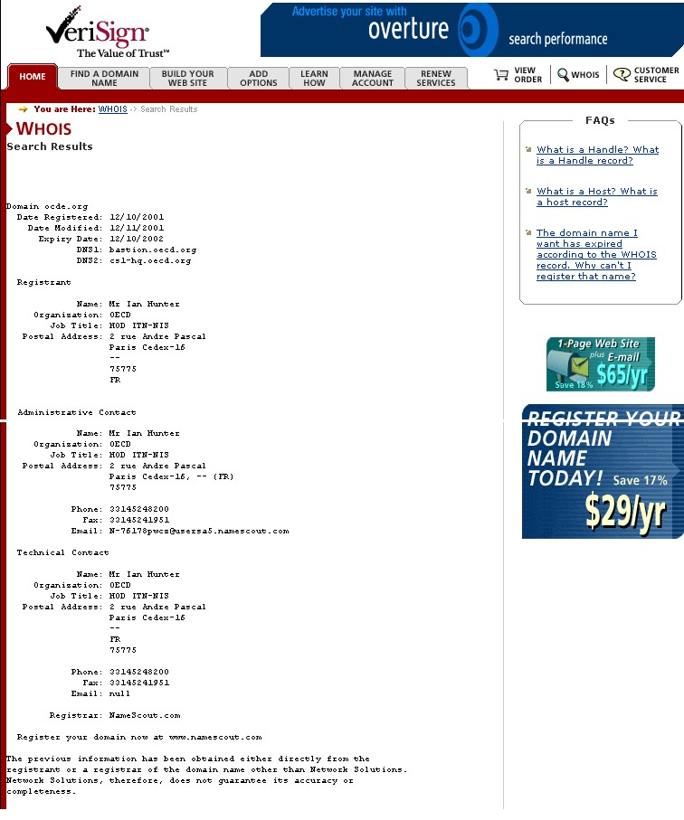

[Appendix III, follows]

APPENDIX III

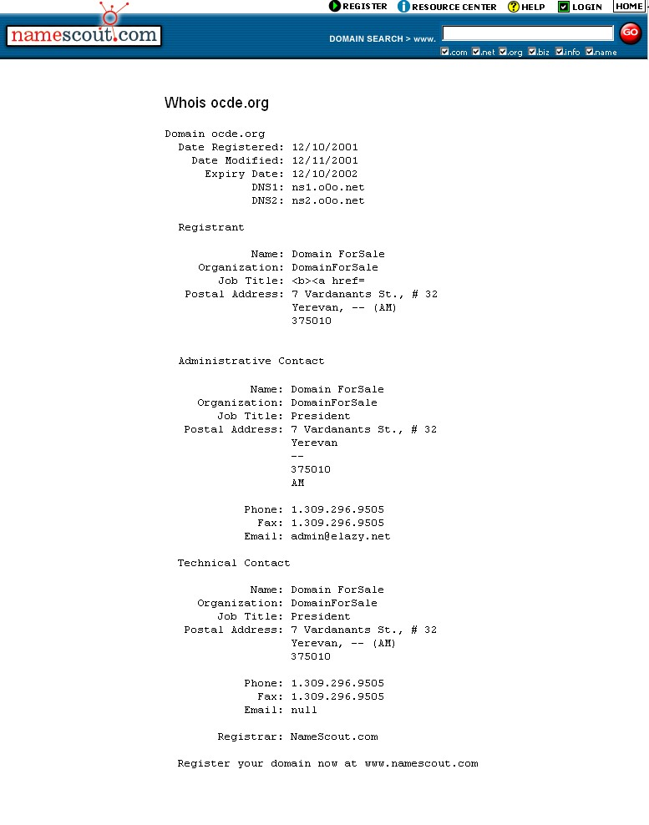
[End of Annexes and of document]

The following provisions of the Namescout Terms of Service agreement appear to allow de-registration: Section 7: "any failure by a Registrant to provide complete and accurate registration information or update it, or to respond within 15 days to the Registrar’s request to update or confirm the accuracy of the information is a material breach of the agreement; Section 21: Registrar may revoke the agreement and delete a registration if, within ten days of notice of material breach the Registrant fails to provide evidence which is reasonably satisfactory to the Registrar that Registrant has not breached its obligations; Section 25: Registrar may delete the domain name if the information that registrant provides or subsequently modifies contains false or misleading information; Section 25: Registrar may terminate its services, including registration services, immediately and without notice, in the event that Registrant uses such services for any improper purpose, as determined in Registrar’s sole discretion; Section 26(1): Registrar, in its sole discretion, reserves the right to delete a domain name within the first thirty (30) calendar days from receipt of payment for such services;”
Clause 3.7.8 provides, in part: “Registrar shall, upon notification by any person of an inaccuracy in the contact information associated with a Registered Name sponsored by Registrar, take reasonable steps to investigate that claimed inaccuracy. In the event Registrar learns of inaccurate contact information associated with a Registered Name it sponsors, it shall take reasonable steps to correct that inaccuracy.”
The US Anti-Cybersquatting Protection Act (ACPA), provides some protection to domain name authorities, but not the same extent as UDRP. Section 1125d)(2)(D)(ii)provides: “The domain name registrar or registry or other domain name authority shall not be liable for injunctive or monetary relief under this paragraph except in the case of bad faith or reckless disregard...."

