WIPO |  | E  SCT/S2/7  ORIGINAL: English  DATE: May 21, 2002
WORLD INTELLECTUAL PROPERTY ORGANIZATION
GENEVA

standing committee on the law of trademarks, industrial designs and geographical indications
Second Special Session
on the Report of the Second WIPO Internet Domain Name Process

Geneva, May 21 to 24, 2002
THE PROTECTION OF COUNTRY NAMES IN THE DOMAIN NAME SYSTEM
Comments submitted by the Government of Mauritius

1. Further to document SCT/S2/3 entitled “The Protection of Country Names in the Domain Name System,” the Secretariat received a submission from the Government of Mauritius on the topic concerned.

2. The submission of the Government of Mauritius is reproduced in the Annex.

3. The SCT is invited to note the contents of the Annex.

[Annex follows]
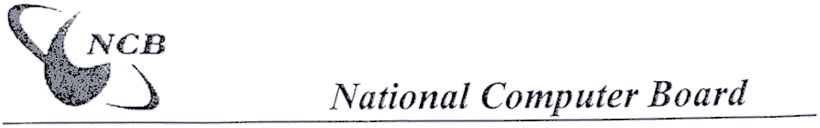

QUESTIONNAIRE ON THE PROTECTION OF COUNTRY NAMES IN THE

DOMAIN NAME SYSTEM

(i) How should the name of a country be identified (for example by reference to the UN Terminology Bulletin, ISO Standard 3166, or by some other method) and should both the long and short names of countries be protected?

The ISO Standard 3166 can be adopted for identification of country names in the domain name system since it is an international standard. Both long and short names of countries should be protected.

(ii) In what languages should country names be protected?

Country names should be protected in English, French and Spanish as these are the most widely used languages worldwide and on the Internet. In addition, the country name in its native language must also be protected.

(iii) To what domains should any protection be extended (for example, to all, both existing and future gTLDs, also ccTLDs, etc)?

Country names should be protected in both existing and future gTLDs and also in ccTLDs.

(iv) How should any alleged acquired rights be treated?

Only the government of the country in question has genuine alleged acquired rights to a domain name bearing its own name (whether in short or long format). A mechanism. should apply so that organisations that have registered domain names bearing country names be able to hand over these domain names back to the appropriate governments.

(v) What mechanism should be used to implement protection (for example, the UDRP or some other mechanism)?

Another mechanism other than the UDRP should apply for protection of country domain names because the UDRP does not provide any such protection for country names unless it can be shown that the country name is a trademark of the organisation that wants to claim the ownership of the domain name. The government of a country has an acquired (sovereign) right to its country domain name; the question of proof of trademark as is required in the UDRP is irrelevant in this context.

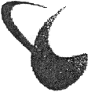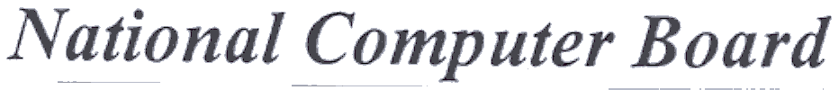

(vi) Should any protection extend to the exact country name only, or also to misleading variations?

The protection should cover the exact country name only,

(vii) Should protection be absolute or should it be dependent upon a showing of bad faith?

The protection needs to be absolute as the interpretation of the bad faith clause is very subjective.

[End of Annex and of document]

