SCIT/SDWG/1/6

Annexe I, page 5

APPENDICE 1

World Wide Web (WWW) pages found using information provided by

WIPO Standard ST.14, Paragraph 13, Example 6



SCIT/SDWG/1/6

Annexe I, page 6

Appendice 1, page 2

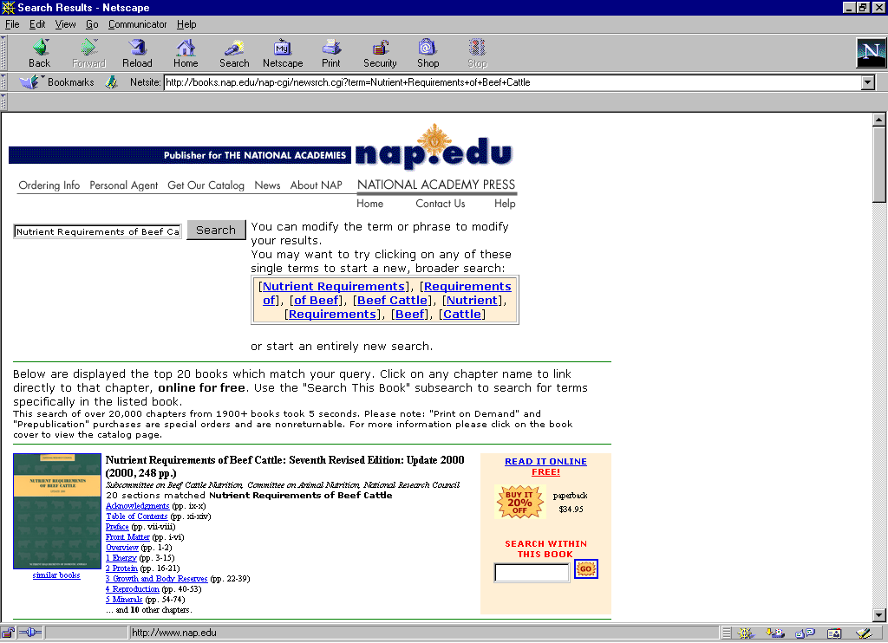

SCIT/SDWG/1/6

Annexe I, page 7

Appendice 1, page 3

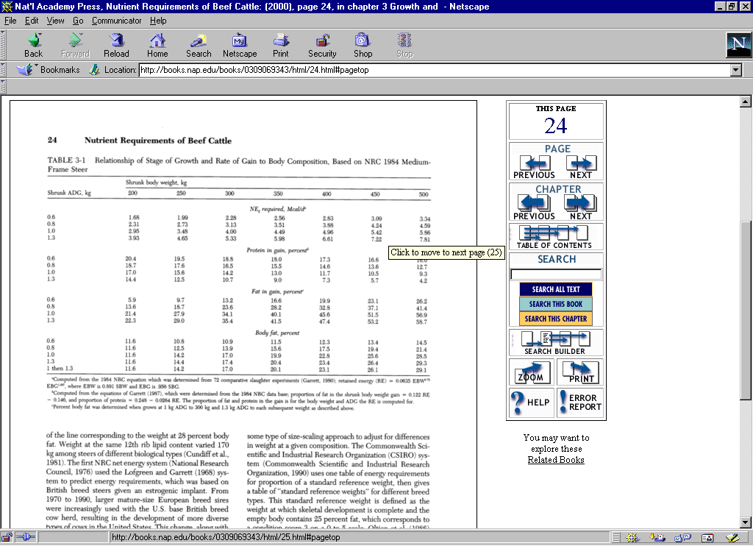

[L’appendice 2 suit]

SCIT/SDWG/1/6

Annexe I, page 8

APPENDICE 2

Cited reference found using information provided by
WIPO Standard ST.14, Paragraph 13, Example 6

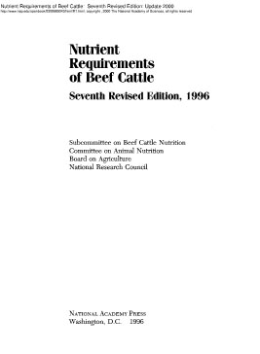

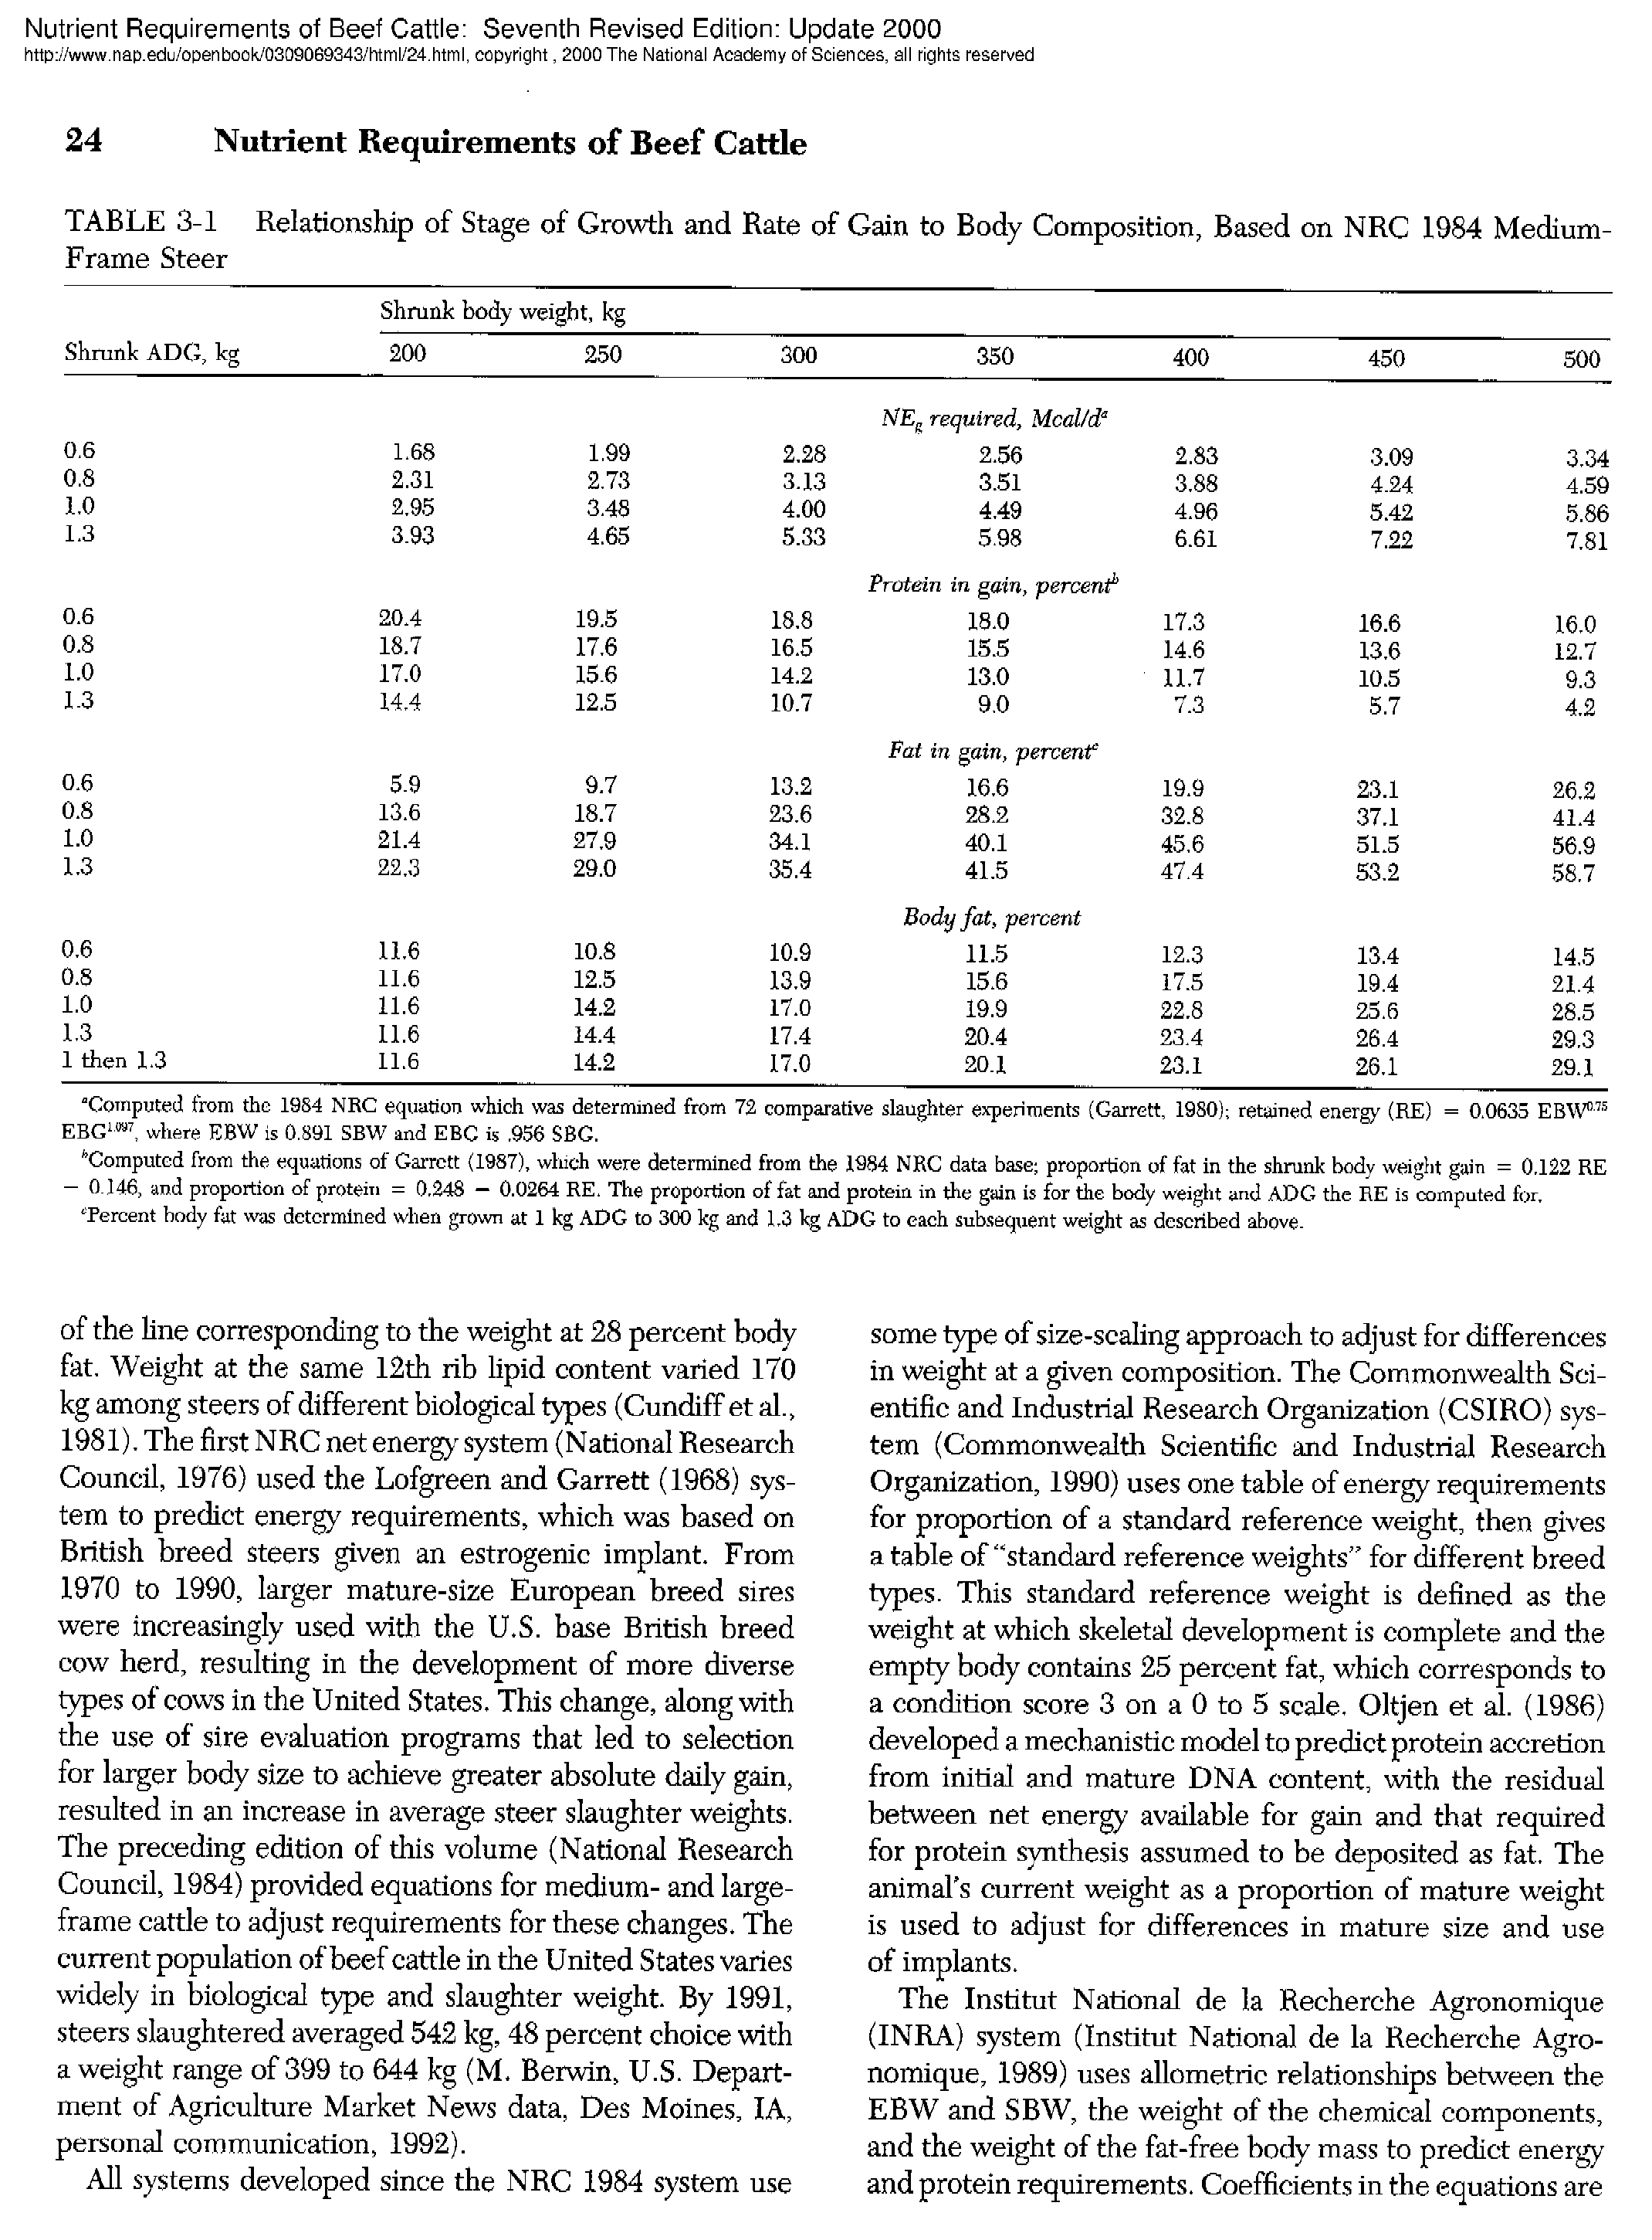

[L’annexe II suit]

