STANDARD ST.22

RECOMMENDATION FOR THE AUTHORING OF PATENT APPLICATIONS FOR THE PURPOSE
OF FACILITATING OPTICAL CHARACTER RECOGNITION (OCR)
Revision proposed by the ST.22 Task Force

INTRODUCTION
1 This recommendation applies to patent applications submitted on paper or submitted electronically (e-filed) but having the text body of the application submitted in image form (e.g., PDF or TIFF images).
2 This Recommendation has been established so as to assist in the preparation of a patent application in a typewritten form suitable for the subsequent production of an electronic digitized record of the contents of the patent application by the use of Optical Character Recognition (OCR) equipment.
3 This Recommendation has been established based upon the experiences of various offices in the use of OCR equipment. It has been drawn up with the objective of achieving the lowest possible error rate in the step of automatic reading of the text of patent applications whilst, at the same time, still permitting efficient personal reading of the document.
4 The primary aim of producing a digitized record of a patent application is to permit the easy publication of that application in a composed format using computer typesetting techniques and to thus enhance the presentation and value of patent documents to the advantage of all users. A further aim is to create a machine-readable database of the full text of a published document so that advantage can be taken at a later date of the possibilities offered by full text computer search.

DEFINITION
5 For the purposes of this Recommendation, the expression “patent application” means applications for patents for invention, inventor’s certificates, utility certificates, utility models, patents or certificates of addition, inventor’s certificates of addition and utility certificates of addition.
6 A mathematical or chemical formula is said to be “complex” if it cannot be displayed as a linear sequence of characters, each character having an optional subscript or superscript attribute. A formula is notably complex if it contains nested subscript/superscripts or if it contains the sum, integral or product mathematical symbols.

CREATION OF THE ORIGINAL
7 A patent application will often be prepared using word processing equipment. Experience has shown that the most efficient format of type that is to be used which would enable OCR equipment to be reliable is that defined in the International Standard Organization (ISO) Standard 1073/II, the so-called OCR-B format.

Paper support if filed on paper
8 To facilitate scanning, the paper support of the typed application should have the following characteristics:
(a) the paper should be strong, white and substantially free of wood cellulose;
(b) the paper weight should lie between 70 and 120 gms/m²;
(c) the paper size should preferably be A4, viz. 210 mm x 297 mm or 8 1/2 by 11 inches (which is the de-facto North-American standard);
(d) sheets should be free of creases, holes and should not be rolled;
(e) the paper should not be absorbent in order to avoid migration of the ink (for example, when using an ink jet printer).

PAGE LAYOUT RECOMMENDATIONS
9 The characters should be solid black on a white background.
10 A minimum margin of 2 cm should be present at the top, bottom and sides of each sheet, and one of 2.5 cm on the left side of each sheet. Any applicant’s or representative’s references should appear in the margin at the top. Please refer to Appendix 1.
11 Line numbering should be avoided. If required, line numbers should be typed using Arabic characters in the left hand margin area, at least 1 cm outside of the box as shown in Appendix 1. The font size of the line numbers should at least be 12 points.
12 Page numbering should be given by simply using Arabic characters without other delimiting characters. Page numbers should preferably be centered at the top or bottom of the sheet in the margin, as shown in Appendix 1.
13 The description, the claims and the abstract should be typed starting each on a new page. Moreover, the first word printed on the first page of each of the three aforementioned parts of the application should specify the corresponding part (in the language of the application); claims paragraphs should be numbered sequentially. The preferred format for the numbering of the claims is to use decimal numbers followed by a point and a tabulation.
14 Pages should be constituted of single column paragraphs (text paragraphs or paragraphs containing an embedded image).
15 Pages containing paragraphs must have a portrait orientation.
16 Landscape orientation should be avoided. It is acceptable only for pages containing embedded drawings or tables that would not fit in a portrait orientation.
17 Any page contains only one direction of text.
18 Landscape pages should be turned 90 degrees counterclockwise for integration within the set of portrait pages.
19 The use of footnotes, footers, margin texts and headers must be avoided (except page numbering).

PARAGRAPH LAYOUT RECOMMENDATIONS
20 A line of text should not contain tables, complex chemical or mathematical formulae.
21 Images and drawings should at maximum be included in the “Drawings” section of the patent application. If embedded images are required to assist the presentation and improve the understanding of the “description” and “claims” sections of the patent application, they should be easily separable from pure text paragraphs. It is advised that such items be separated from the text line above and below them by blank margins with a minimum height of 1 cm that run the entire width of the page; all text at the same horizontal location as a detected embedded image is likely not to be recognized as text and to be considered as part of the image.
22 Tables should be easily separable from pure text paragraphs. It is advised that tables be separated from the text line above and below them by blank margins with a minimum height of 1 cm that run the entire width of the page; paragraphs of texts must not be horizontally adjacent to tables.
23 Handwritten text paragraphs or annotations must be avoided. If required, they would be considered as embedded drawings and should follow the recommendation given in paragraph 21.
24 Typing should be done at one and a half line spacing.
25 Paragraphs should be separated by spacing that is at least twice as big as the intra-paragraph line spacing.
26 All characters within a paragraph line should have their baselines carefully aligned.
27 Justified text paragraphs must be avoided. If applied, the spacing between words should be at least as big as with unjustified text. Justified text may prevent the OCR systems to correctly identify the word boundaries in a paragraph.
28 Word splitting by the use of hyphens should be avoided (for example, at the end of lines or table cells).

TABLE RECOMMENDATIONS
29 Only white background should be used.
30 Tables must have borders. The borders should be thicker than 1.5 points and be only solid lines.

FONT RECOMMENDATIONS
31 The minimal recommended font size is 12 points, 14 points being preferred. As a general rule, all characters of a paragraph should have the same font size.
32 Text paragraphs containing subscripts and superscripts should use a font size of at least 12 points and recommended 14 points (the bigger, the better). It should be ensured that the bounding box of subscript or superscript characters intersects sufficiently with the bounding box of the normal characters on the same line (this prevents the OCR procedures to put the subscripts/superscripts on different lines).
33 The recommended fonts are the following in order:
(a) Monospaced family: OCR-B, Courier New
(b) Serif family: ITC Officina Serif, Times New Roman
(c) Sans Serif family: Verdana, ITC Officina Sans, Arial
However, the Arial and Times New Roman fonts are not recommended for applications containing chemical and/or mathematical formulae, as well as acronyms mixing letters and digits. For Chinese characters, the Song font is recommended.
34 The characters of the fonts have to be well shaped, with no shadows. The spaces between characters should be large enough (narrow spacing should be avoided).
35 Unusual characters should be avoided at maximum. If necessary, they belong preferably to the standard Greek alphabet and to the symbol font (by order of preference). Characters that cannot be found in the UNICODE range must not be used; those characters are recognized as embedded images by OCR engines and therefore make the recognized text difficult to read. Each office shall define and publish the character set it enforces for the preparation of the applications.
36 Narrow and cursive fonts should not be used.
37 Text should not be underlined. If required, it should be assured that the underline does not intersect with the underlined characters’ bounding boxes.
38 Bold and italic styles should be avoided as much as possible.

RECOMMENDATIONS FOR NON-LATIN LANGUAGES
39 Within sections/pages of patent applications, the mixing of Latin and non-Latin languages is problematic for the OCR procedures and should be avoided.

CORRECTIONS
40 Corrections of the text of an application should be done by reprinting the whole page. Proof correction marks, as, for example, specified in the International Standard ISO 5776, are not accepted. Correction means such as white correcting fluid, self adhesive strips of paper, erasure or strikethrough are not accepted. Replacement pages shall not be sent by fax to the office using the 200 dpi resolution; pages should be sent physically or as an email attachment.

RECOMMENDATIONS FOR OFFICES
41 Patent offices should avoid altering the received pages before submitting them to scanning and OCR operations. For example, some current practices include stamping operations that may superimpose characters on pages, making text submitted by the applicant unreadable by OCR procedures. If stamps/changes have to be applied on the original pages, the office should take measures to ensure that the changes only occur in the margins of the documents, as defined in Appendix 1.

IMPLEMENTATION
42 It is recommended that offices intending to start accepting or requesting the filing of patent applications typed in OCR format should publish full guidance in their Official Gazettes at regular intervals and on their websites, defining therein the exact character type or types permitted, and specifying the exact paper size allowable.
Examples
43 Examples of good and bad practices regarding OCR are reproduced in Appendix 2 to this Recommendation. The examples show what should and what should not be done, along with a short explanation.
[Appendices follow]

APPENDIX 1

Original Size = A4

[Appendix 2 follows]

APPENDIX 2

Examples of good and bad practices
This Appendix contains good and bad examples of patent document pages with respect to the accuracy obtained when performing OCR operations on them.

Examples of good practices

1. A good description page
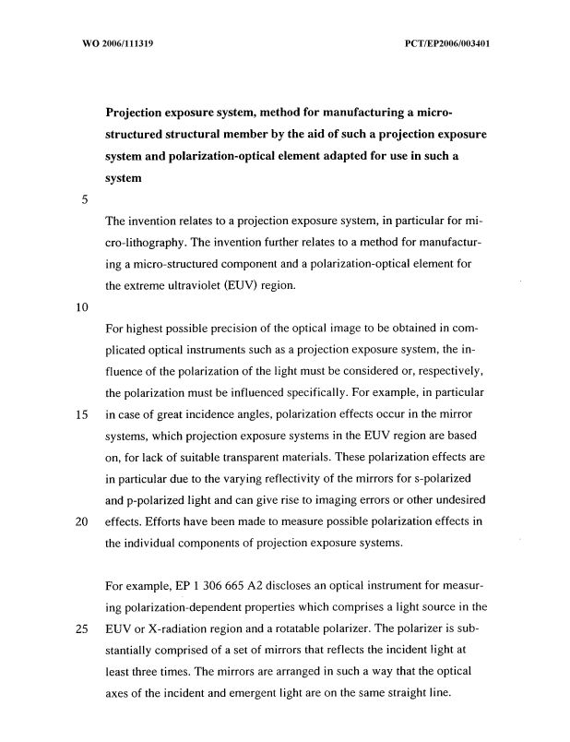

2. A good claims page
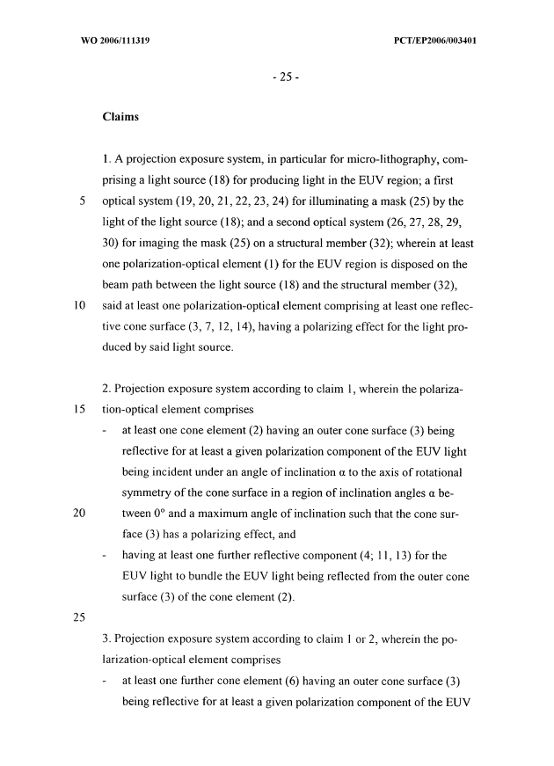

All recommendations are met: margins, a standard font (Times New Roman), a good font size, line numbers big enough and separated from the text, no justification, limited use of bold, no italics, no underlined text....

3. A good complex description page
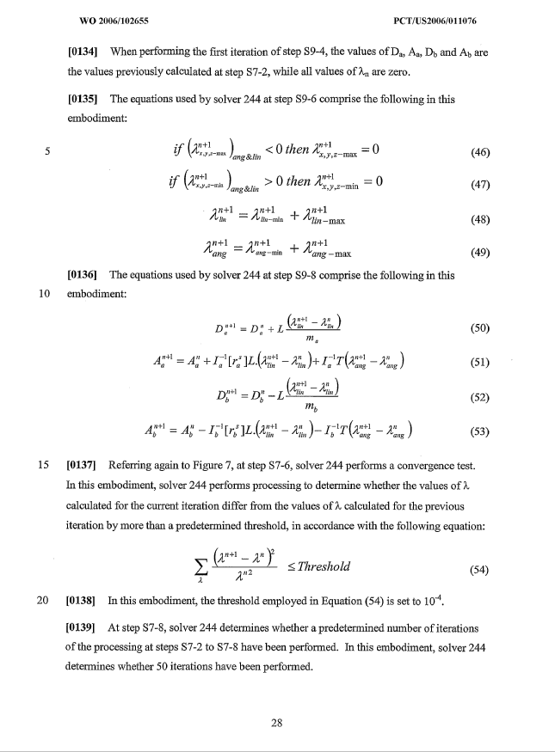

The text paragraphs do not contain unusual mathematical characters. The mathematical formulae are correctly embedded allowing for an easy segmentation of the embedded images by the OCR engines. A possible result of the segmentation is shown in blue.

Examples of bad practices

1. A poor quality page with many defects
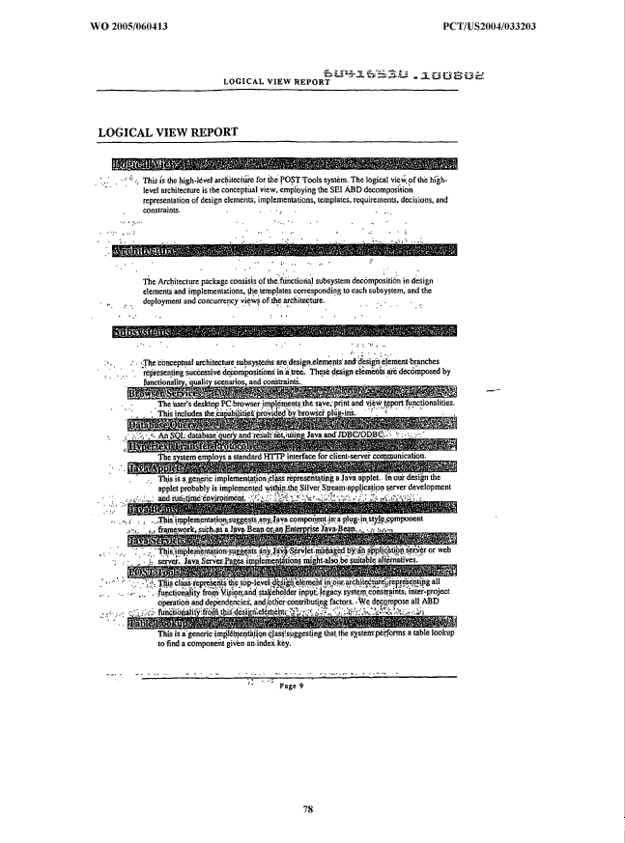
Paragraph 9 is not respected (the page was probably submitted by fax at 200 dpi to the office –please note the “noise”– and some text appears on heavy gray backgrounds). Paragraphs 10 and 41 are not respected; a reference number (604115530.100802) is stamped within the body of the page (it should be in the margins). The page numbering is incorrect (should be 9, not “page 9” see paragraph 12). Last but not least, the font size is too small (paragraph 31). Such pages should ideally not be accepted by offices and replacement pages requested (this page is impossible to OCR correctly).

2. A page with a non-white background
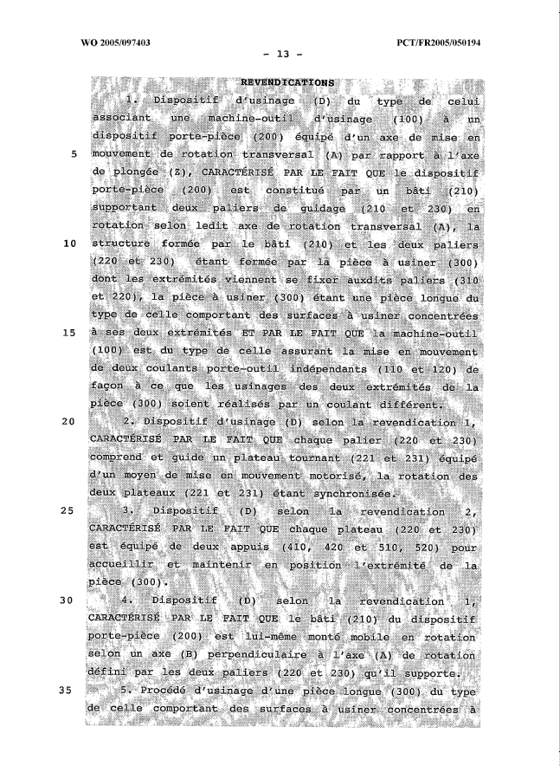

Paragraph 9 is not respected. The page needs to be filtered to attempt to remove the noisy background before submitting it to an OCR operation. If OCRed as is, the obtained text is unreadable.

3. A page with faint characters
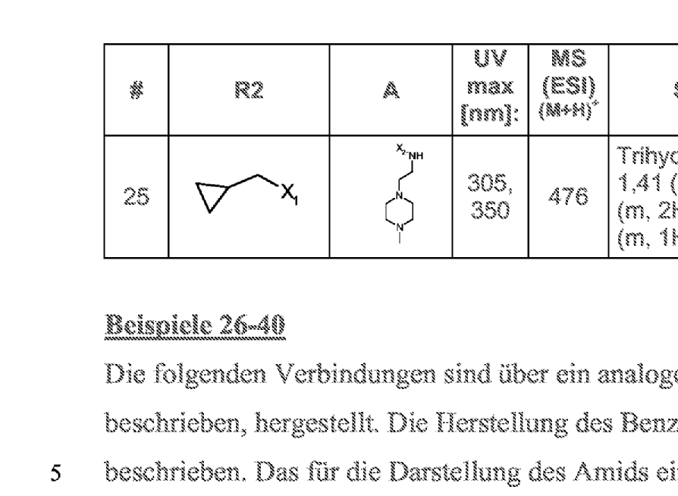

A small area of the page is zoomed to show the characters; the color of the original text is probably gray, resulting after the scanning in 300dpi black and white in characters which are not solid. As a result, the accuracy of the OCRed text is poor (Paragraph 9 is not respected).

4. A page with handwritten text
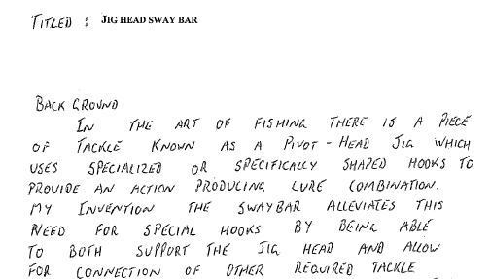

As to be expected, the text obtained by OCRing this page is unreadable. Offices should request typewritten text to ensure minimum publication quality.

5. A page with a non recommended layout and other defects
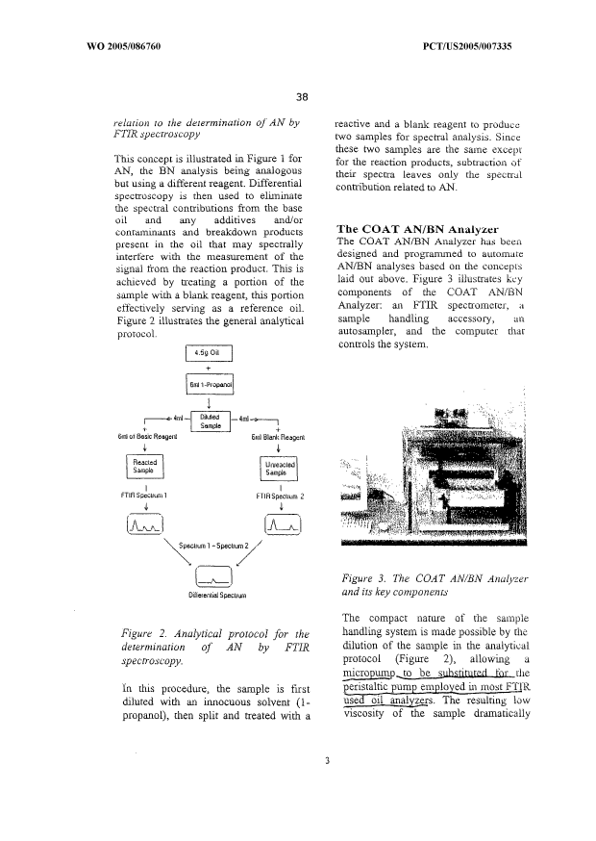

This page does not respect paragraph 14 (single column formatting), uses italic and bold fonts (against paragraph 38), has manual corrections performed after printing (against paragraph 40). The left-right justification of the paragraph is also not recommended (paragraph 27), although in this case, this would not have negative effects on the OCR since the words are still sufficiently separated by white spaces. Paragraph 24 is also not respected (one and a half line spacing).

6. A page with line numbers that are too small
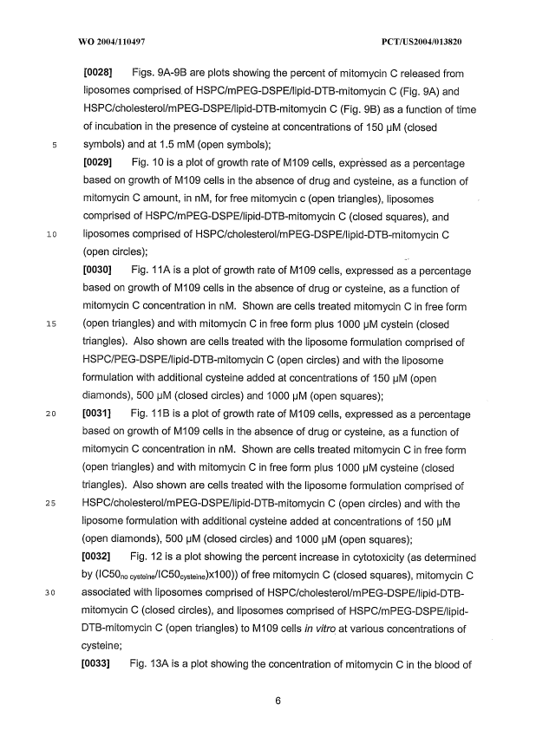

Line numbers cause problems to the OCR engines for several reasons (paragraph 11):
- They may not be aligned with the lines they correspond to, leading to baseline detection defaults.
- They could be too small, leading to recognition errors that would prevent the XML extraction procedures to remove them correctly from the text body of the page.
- They could be misplaced within the body text area of the page, or in the margins but too close to the body text area and as a result will appear inside the text stream exported by the OCR operations.
In this example, they are too small.
Subscript characters are also too small in this example (paragraph 32).

7. A page containing several directions of text
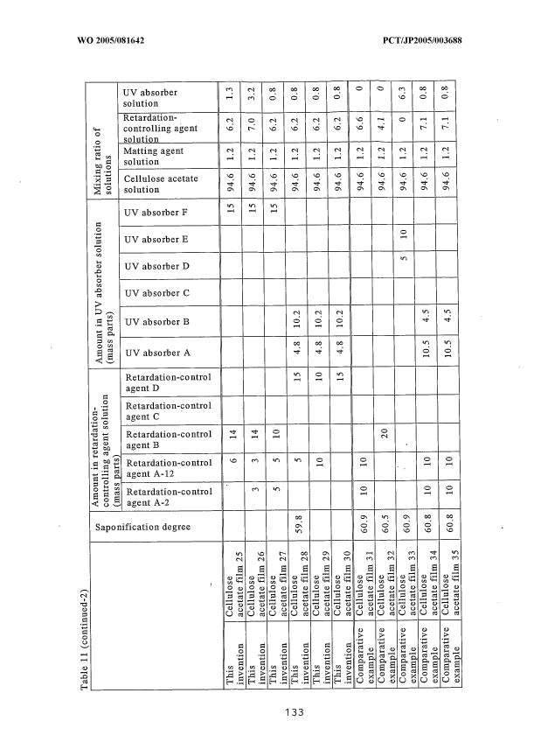

This example does not respect paragraph 17.
One of the limitation of the best OCR engines available today is that they can read only one direction of text in one page (a preprocess of the page is to detect the main text orientation of the page). As a result, all the words that are not in the main text direction are ignored. It is of course acceptable to have in a page a landscape table or even a main landscape text with portrait annotations in the margins (page number, application number and so on).

8. A page with mixed embedded mathematical formulae and text
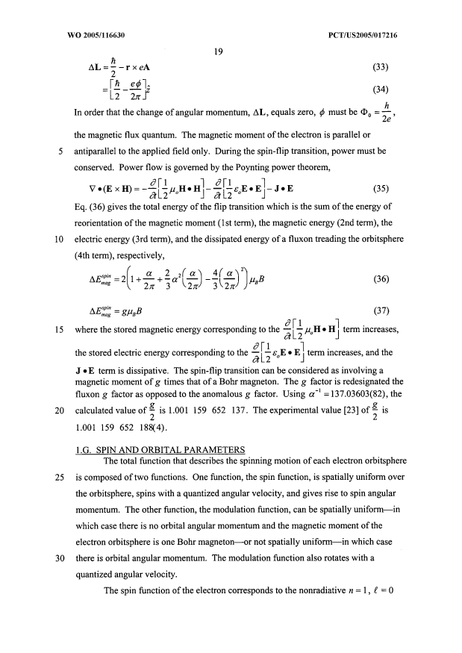

This example does not respect paragraphs 20 and 22. The OCR engine is not able to separate correctly the text and the formulae (see the result of a manual segmentation of the formulae in red; the embedded formulae even intersect).
As a general comment, in this example, the text and the formulae are too dense for good recognition; paragraphs 24 and 25 are also not respected.
This example also uses unusual characters; Greek symbols can be used even if they increase the recognition difficulty of the page (see paragraph 35). However, it is highly unrecommended to combine italics, bold or underlined fonts with unusual characters (paragraph 38).

9. A page with mixed embedded chemical formulae and text
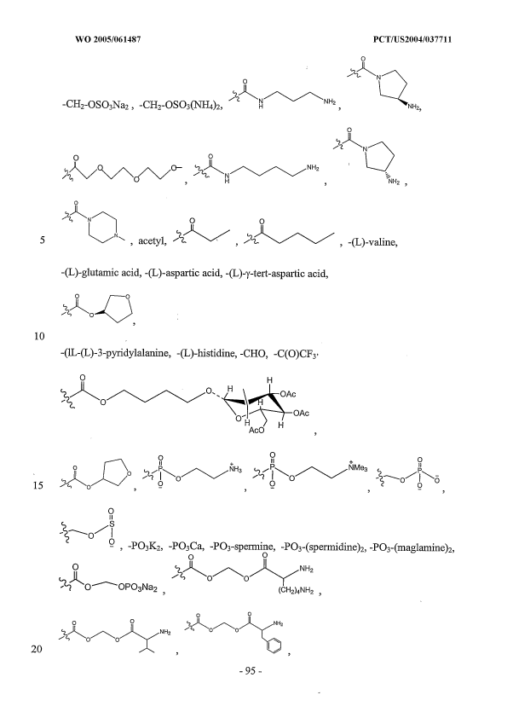

This example does not respect paragraphs 20 and 21. You can find in red one expected result of the drawings segmentation (done manually). This segmentation cannot be performed correctly by an OCR engine since the formulae are too close to the surrounding text.

10. A page with subscript characters that are too small
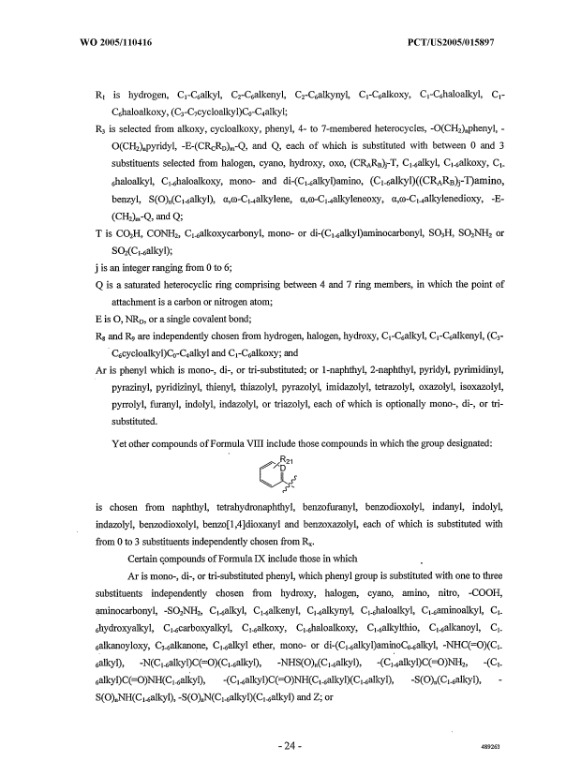

This is a typical example where the subscripts characters are too small to allow for accurate recognition. This phenomenon is particularly recurrent for patents in the chemistry field.

11. A page with badly formatted tables
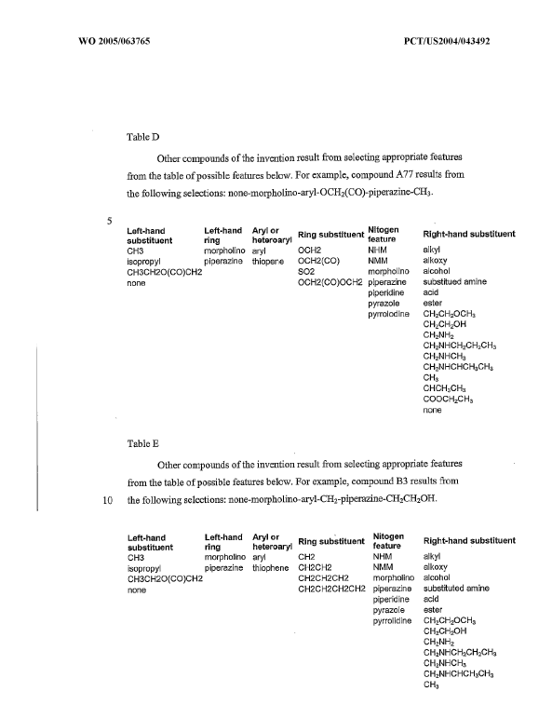
In this example, the table boundaries are missing (against paragraph 30). As a result, the OCR engine will try to recognize contents of the tables as paragraph text. This leads to several other problems:
- The font size of the characters in the tables is too small (paragraphs 31 and 32).
- The baselines of the column headings are mixed (paragraph 26). As a result, the engine will wrongly detect subscripts or superscripts.
- The text stream obtained will not take into account the columns:
Left-hand Left-Hand Aryl or Nitogen
Substituent ring heteroaryl ^{Ring substituent} feature ^{Right-hand substituent}
CH3…

12. A justified page
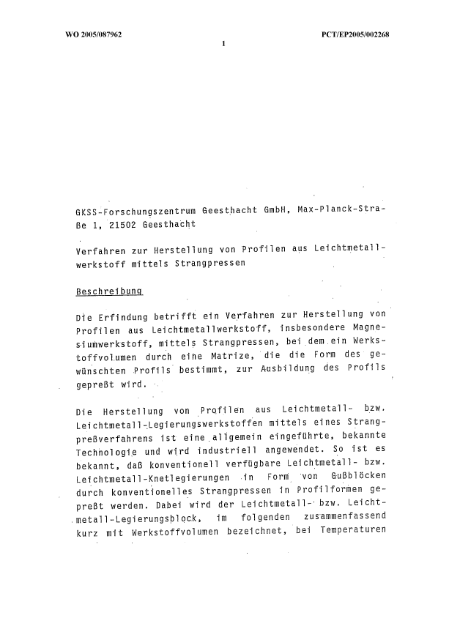
In this example, left and right justifications are applied to the paragraphs. If this makes the text look better, it sometimes makes OCR operations difficult when the separations between the words become too small (paragraph 27). This example also does not respect paragraph 28 that states that word splitting at the end of the lines should be avoided as much as possible (the OCR engine sometimes has difficulties distinguishing hard and soft hyphens, resulting in words containing undesired hyphens in the output).

13. A table with bad boundaries
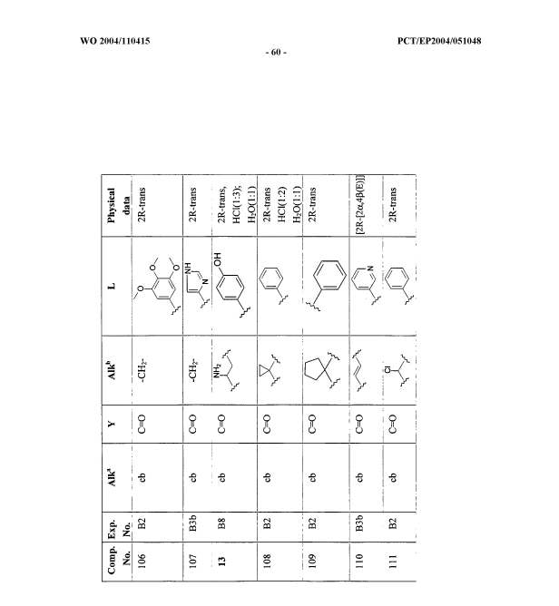

In this example, the boundaries of the table in the received original before scanning are of bad quality. After scanning, the OCR procedure is unable to detect correctly the table and a manual operation is required to segment the page. If such a page is not checked by an operator for quality, the text output will contain many undesired “junk” characters that will make the indexation of the document by search engines less effective.

14. Bad subscript and superscript characters
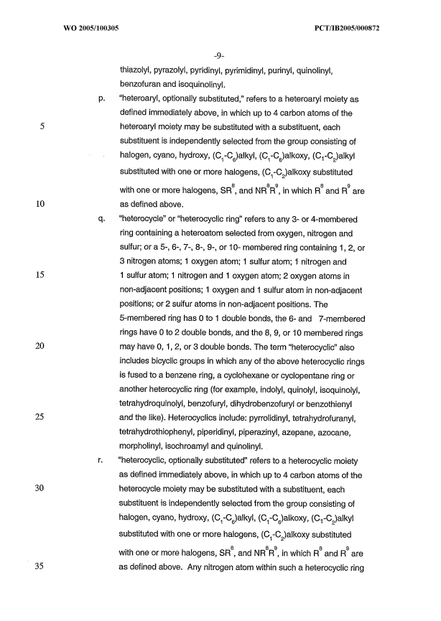
This example exhibits the following problems (paragraph 32):
- subscript and superscript characters too small;
- subscript characters located too low with respect to the baseline;
- superscript characters located too high with respect to the baseline.

As a result, lines 33 and 34 of the text are recognized as follows by the OCR procedure:
“Substituted with one or more halogens, (C -C )alkoxy substituted
1 2
8 8 9 8 9
with one or more halogens, SR , and NR R , in which R and R are”

15. An example with unusual characters

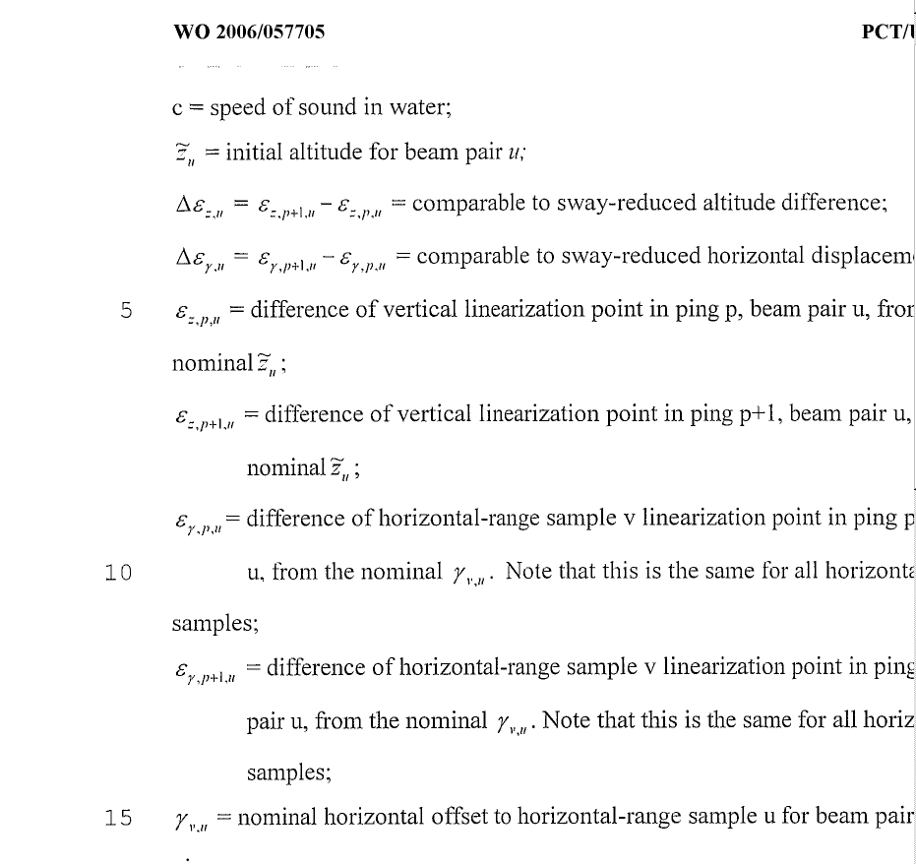

This sample exhibits the following problems:
- Unusual characters: Greek italic, and even characters with a tilda on top.
- The subscripts here again are too small.

With most OCR engines, all unusual characters will not be recognized correctly.

16. An example with narrow fonts and narrow spacing
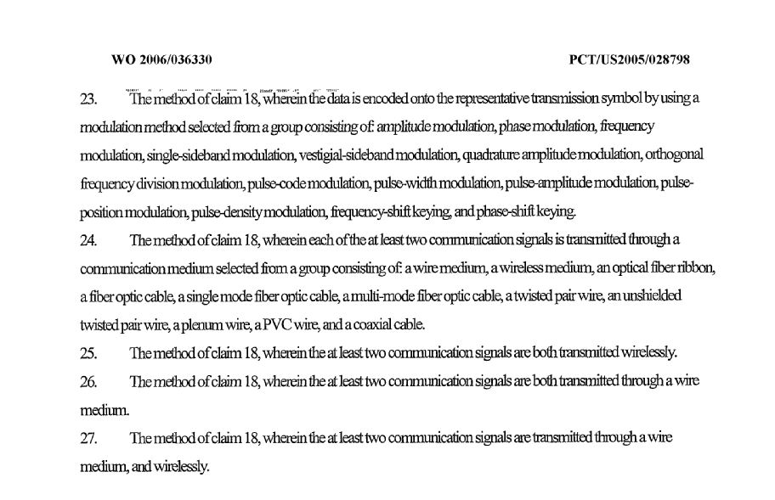

This example does not respect paragraphs 34 and 36. As a result, the OCR engine cannot distinguish correctly word boundaries and the result of the OCR is totally unusable.

17. Bad stamp by receiving office before scanning
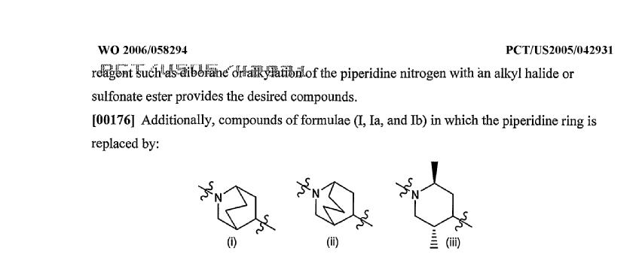

This example does not respect paragraph 41. As a result, the first six words of the text of the page cannot be read by the OCR procedure. Moreover, the stamp introduces extra invalid characters that will pollute the indexation engines if the page is not quality checked by an operator.

18. Another page with mathematical formulae badly laid out
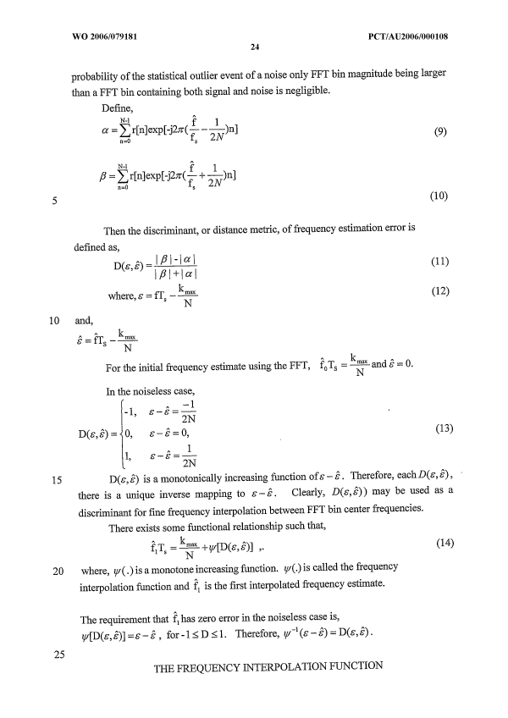
As this page does not respect many recommendations, the result of the OCR is not usable:
- Embedded mathematical formulae not separated from text paragraphs (paragraph 22)
- Unusual characters in text paragraphs (paragraph 35)
- Italic style combined with Greek characters (paragraph 38)
The recommended way to lay out this page is to use extra spaces to separate embedded formulae from the paragraphs. Greek letters should not be italicized in formulae and paragraphs. Hats (^) shall be avoided to denote variables in text paragraphs when possible; superscripts may be used instead: “epsilon hat” could be represented ε^ or ε^{hat}.

19. A page with unrecommended italic and underlined characters
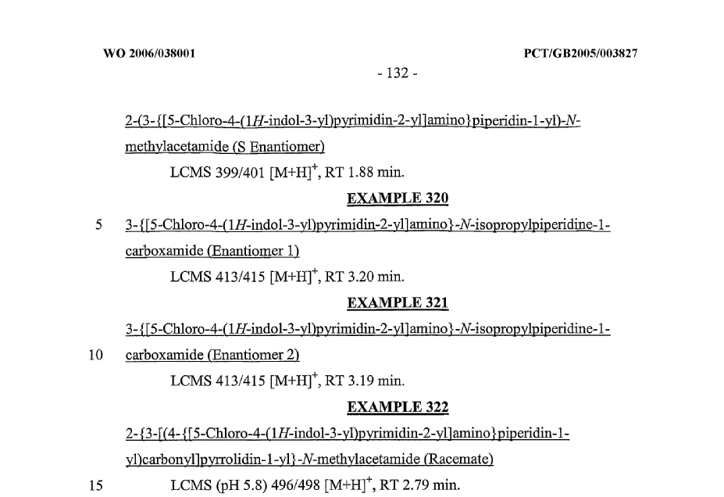

This is a recurrent example of page with OCR problems encountered in the PCT publication. This page does not respect the following rules:
- Paragraph 37: text should not be underlined. Underlining is especially unrecommended for chemical formulae (dictionaries cannot help in these cases). Notably, this causes problems with all characters that intersect with the underline: ] ) y p … are not recognized correctly.

- Paragraph 38: italic style is not recommended. It is specially unrecommended to change the font style within a word (OCR engines assume often that all characters of a word share the same style). As a result, all the “1H” and “-N-” are badly recognized.

20. A page completely unreadable
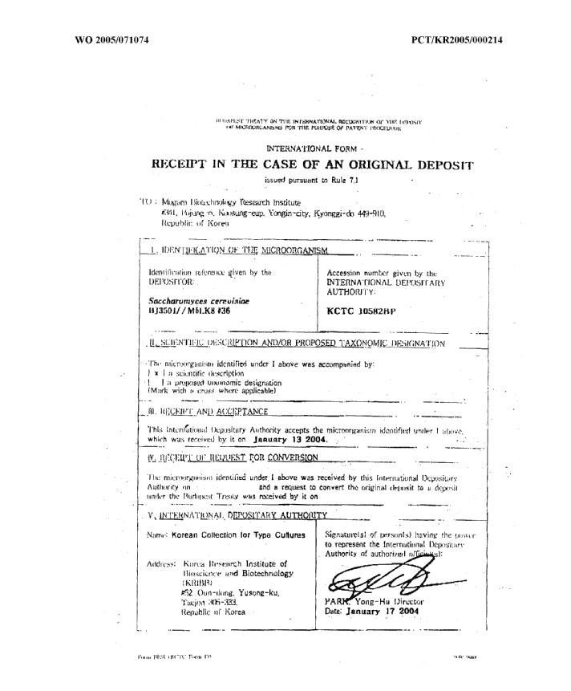

This page should not be accepted by offices; it has been sent by fax at 200 dpi and is not readable. In order to deal with these cases, operators should declare the whole content of the page as an image as no text is extractable.
[End of Appendix 2 and of document]

