WIPO |  | E  SCIT/SDWG/4/10  ORIGINAL: English  DATE: November 25, 2003
WORLD INTELLECTUAL PROPERTY ORGANIZATION
GENEVA

standing committee on information technologies
standards and documentation working group
Fourth Session
Geneva, January 26 to 30, 2004
HARMONIZATION AND IDENTIFICATION OF THE PARTS
OF PATENT SPECIFICATIONS
Document prepared by the Secretariat

1 In its letter of August 20, 2003, the Patent Documentation Group (PDG) drew the attention of the International Bureau (IB) to a problem users of patent information are faced with, namely the difficulties in referring to citations and in locating specific parts of a patent document (e.g., when a patent document is available in electronic media, the identification of specific parts of the description text may become difficult if the document layout depends on the software settings of the users). This problem is related to the diverse forms of media on which patent documents are now made available.

2 The letter of the PDG is reproduced in the Annex to this document.

3 As a first step, the PDG proposes to carry out a survey in order to clarify the different practices by industrial property offices regarding the form of addressing the difficulties referred to in paragraph 1, above.

4 The Standards and Documentation Working Group is invited:

(a) to consider the letter of the PDG reproduced in the Annex to this document; and,

(b) if found appropriate, to establish a task in order to carry out the survey referred to in paragraph 3, above.

[Annex follows]

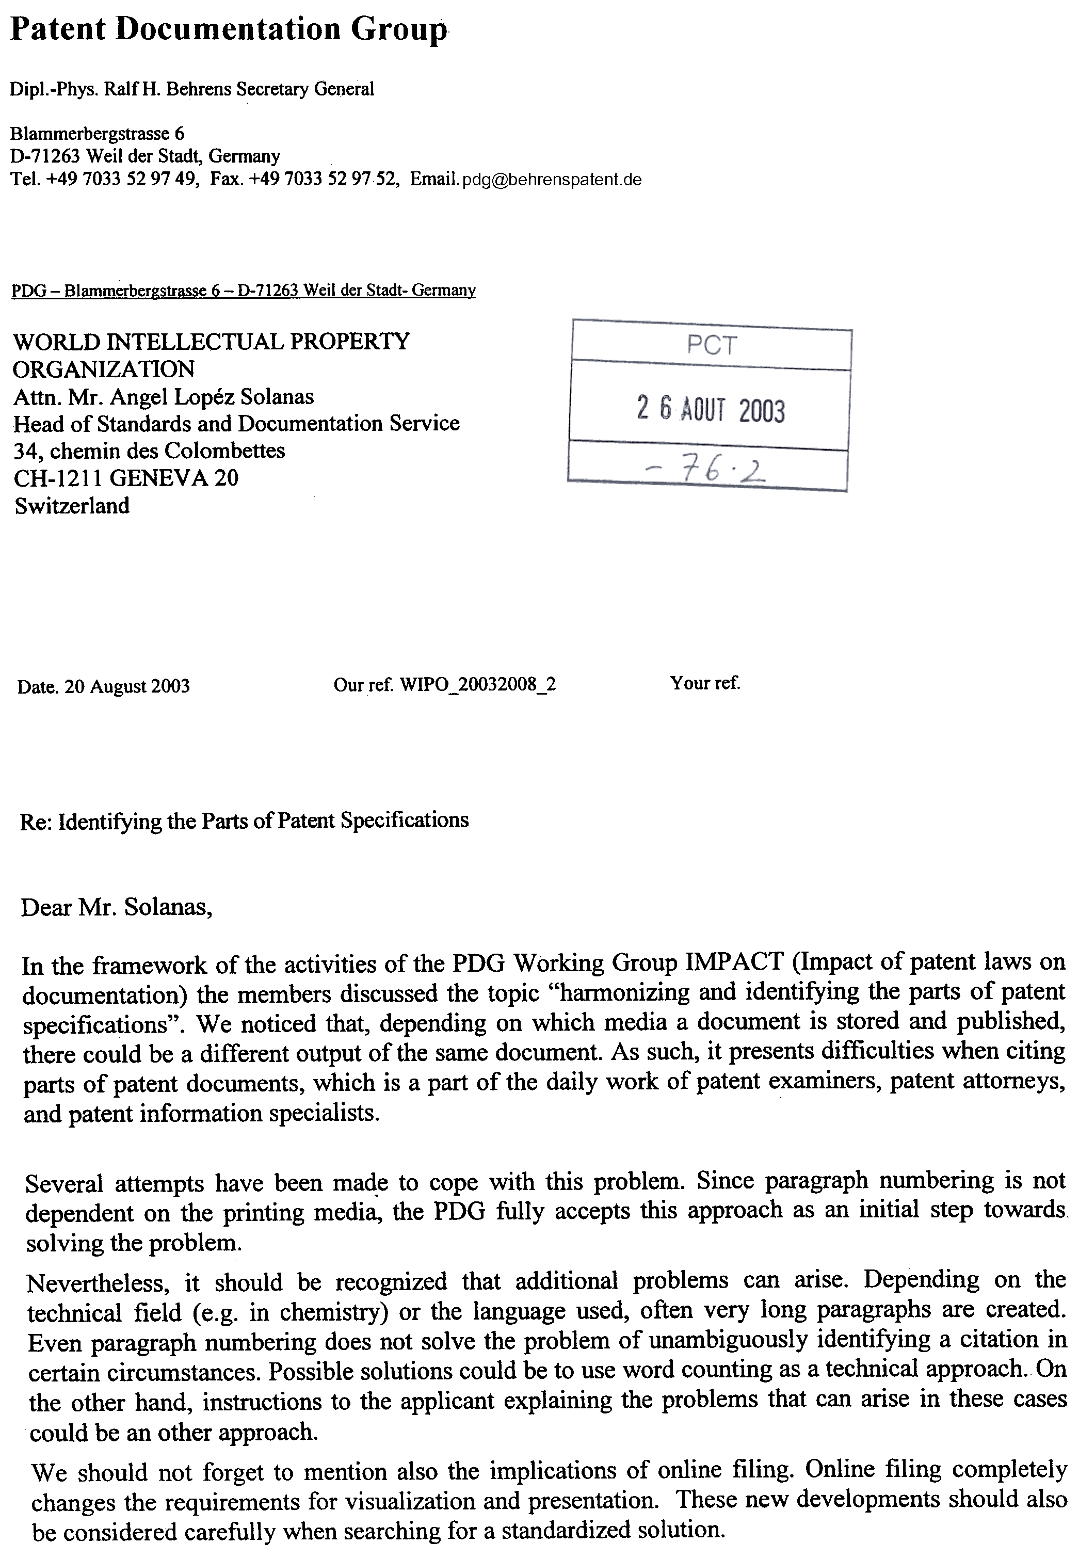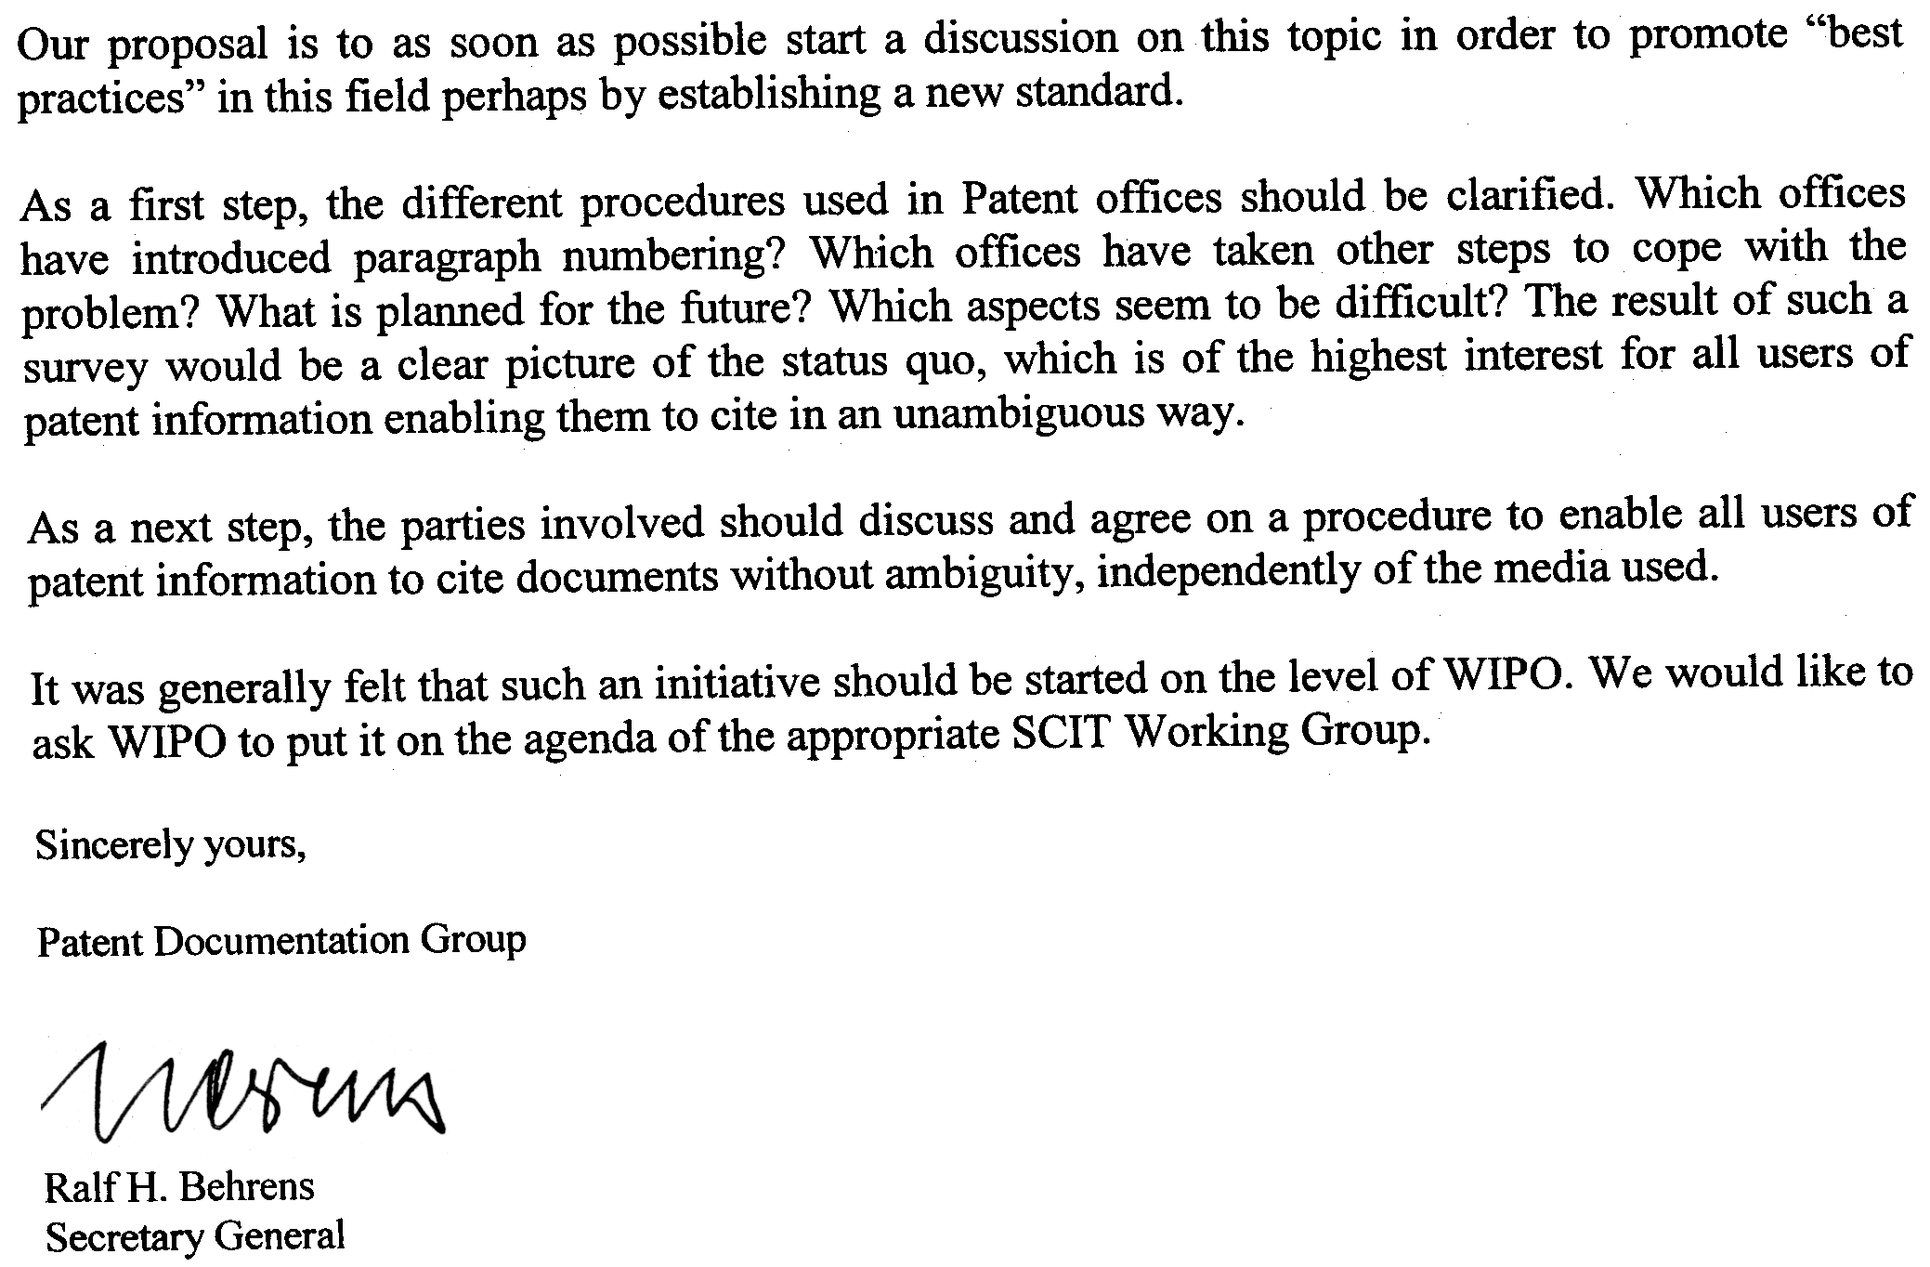

[End of Annex and of document]

