

C. SCIT 2541  03 | July 31, 2001

Re: Formats of figurative elements of marks (SCIT Task No. 20)
_____________________________________________________

Madam,
Sir,

During its first session, in May 2001, the Standards and Documentation Working Group (SDWG) considered background and scope of Task No. 20 “Prepare a recommendation on how figurative elements of marks should be captured in electronic form and how they should be displayed on visual display units.” The SDWG agreed on certain steps to be taken before a decision could be made as to the continuation of the task (see Annex III, page 13 of document SCIT/SDWG/1/9 Prov.).

As a follow-up to the decision by the SDWG, the Secretariat has prepared, in cooperation with the United States Patent and Trademark Office and the Office for Harmonization in the Internal Market, a Questionnaire to collect information from industrial property offices on formats currently in use for figurative elements of marks. The Questionnaire is enclosed as an Annex to this Circular.

The Secretariat would appreciate your kind cooperation in providing, before October 30, 2001, the information requested in the said Questionnaire. Your reply should be sent, preferably via e-mail, to scit.mail@wipo.int or fax to (41.22) 734 63 92. Please refer to the SCIT circular number in your reply.
Sincerely yours,
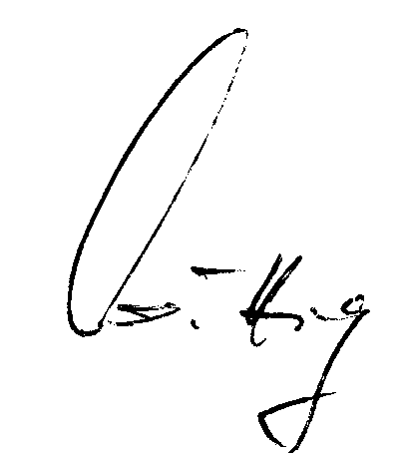
Klaus-Peter Wittig
Deputy Director
Standards and Documentation Service

QUESTIONNAIRE CONCERNING FORMATS CURRENTLY IN USE BY INDUSTRIAL PROPERTY OFFICES FOR FIGURATIVE ELEMENTS OF MARKS

INTRODUCTION

- This questionnaire aims at collecting information from Industrial Property Offices (IPOs) on formats currently in use for figurative elements of marks. The next steps would be to analyze the different standards/techniques applied by the IPOs of the various Member States and by regional organizations and to determine the feasibility of establishing a WIPO recommendation on how figurative elements of marks should be captured in electronic form.

- The proposal to develop a WIPO recommendation on the above-mentioned subject matter was made in view of the fact that, with the entry into force of the Madrid Protocol and the ensuring internationalization of trademark data exchange, standards are needed to guarantee the exchange of highly standardized data in impeccable quality.
(See Task No. 20 of the SCIT Task List and document SCIT/SDWG/1/2).

Question 1: Does your Office process electronically the figurative elements of marks?

Yes …….

No …….

Question 2: Does your Office have a legal basis for the electronic processing (including electronic storage and/or exchange) of figurative elements of marks?
(If “Yes,” please specify the national law, regional regulation, etc.)

Yes …….

No …….

Question 3: Which format is your Office currently using for the capturing, presentation and exchange of figurative elements of marks?
- For scanning :
Please indicate: image format (TIFF, JPG, GIF, PNG, CCITT…Please specify the version, e.g., TIFF Group 4), image resolution (in dots per inch), image color management techniques (i.e., description of techniques applied to ensure reliable color reproduction).

(i) Bilevel or grayscale:: …….….

(ii) Colour: ………..

- For publishing :
Please indicate: image format (TIFF, JPG, GIF, PNG, CCITT…Please specify the version, e.g., TIFF Group 4), image resolution (in dots per inch), image color management techniques (i.e., description of techniques applied to ensure reliable color reproduction).

(i) Bilevel or grayscale:: …….….

(ii) Colour: ………..

- For displaying :
Please indicate: image format (TIFF, JPG, GIF, PNG, CCITT…Please specify the version, e.g., TIFF Group 4), image resolution (in dots per inch), image color management techniques (i.e., description of techniques applied to ensure reliable color reproduction).

(i) Bilevel or grayscale:: …….….

(ii) Colour: ………..

- For other purpose (please specify) : …….….
Please indicate: image format (TIFF, JPG, GIF, PNG, CCITT…Please specify the version, e.g., TIFF Group 4), image resolution (in dots per inch), image color management techniques (i.e., description of techniques applied to ensure reliable color reproduction).

(i) Bilevel or grayscale:: …….….

(ii) Colour: ………..

Question 4: Indicate how the images of figurative elements of marks are displayed.
(e.g., expandable thumbnails, thumbnails only, full screen image).

(a) Expandable thumbnails …………

(b) Thumbnails only …………

(c) Full screen image …………

(d) Other (please specify):

Question 5: Who carries out the electronic capture?

- Applicant

- Your Office (if so, what are the dimensions in which the images of figurative elements of marks have to be submitted?)

- Other (please specify):

Question 6: How is your Office ensuring the quality of mark images taking into account the various quality levels ?

Question 7: How many mark images are stored with the above-indicated format(s) in your Office’s computer system(s)?
(Please specify breakdown by format.)

Question 8: Which option does your Office prefer for the elaboration of a WIPO recommendation on the electronic processing of figurative elements of marks:

(a) the determination and application of a new format?

Yes ……..

No ……..

(b) the use of freely available non-proprietary standards?

Yes ……..

No ……...

(c) the use of a proprietary de-facto standard (i.e., TIFF)?

Yes ………

No ………

Further comments/remarks:

Please provide contact details:

Name:

Office/Organization:

E-mail:

Fax No.:

[End of Annex II and of document]

