E
PCT/WG/9/24
ORIGINAL: English
DATE: May 3, 2016

Patent Cooperation Treaty (PCT)
Working Group

Ninth Session
Geneva, May 17 to 20, 2016

National Phase Entry Using ePCT

Document prepared by the International Bureau

Summary
- Designated Offices and interested user groups are invited to review a “proof of concept” system for preparing national phase entries which will shortly be deployed to the ePCT Demo environment, with a view to making necessary improvements and beginning a pilot for applicants wishing to enter the national phase in interested Offices.

Background
- At the seventh and eighth sessions of the PCT Working Group, the International Bureau set out a concept for using ePCT to trigger national phase entry (documents PCT/WG/7/12 and PCT/WG/8/19). The aim was to provide “a secure, interactive platform to assist cooperation between an instructing agent and a local agent prior to national phase entry, allowing both parties to be confident that the key information was in a mutually satisfactory form before the national phase processing began. This arrangement could also be used to add any documents which needed to accompany the national phase entry request, such as translations and powers of attorney.”
- A variety of concerns were expressed, falling into the following categories:
  - Every national system has specific requirements. It is not merely a legal requirement that applicants must normally be represented by a qualified person resident in the relevant country or region, but important for the interests of the applicant that the national phase entry is prepared by such a person in order that differences in national law and practice do not cause problems later on which may be expensive or even impossible to solve.
  - The system needs to ensure that submission of documents and information for national phase entry can be seen by both Office and applicant to have properly occurred within the relevant time limit as measured at the relevant designated Office. Ideally, the submission should immediately return some form of filing receipt, preferably including a national application number.
  - The system should ideally include an integrated payment system, but at least needs to be clear about the time limits for making payments and how the payments can be reliably matched to the national phase entry information.
  - The system needs to have reliable information on the requirements of each designated Office, enforcing appropriate validations where necessary and practical (such as “is a translation required in these circumstances; if so, is such a document attached?”) though clearly substantive issues cannot generally be automatically checked and will require the effective involvement of the national agent.
  - The information and documents must be provided in a format which is recognized and easy to use for the designated Office concerned.
  - A machine interface would be at least highly desirable to ensure that the system could be used effectively by large firms who need to populate or verify fields based on the contents of their local systems.
- Nevertheless, several delegations expressed an interest in addressing these issues and proceeding towards a pilot.

Purpose of Proposal
- The International Bureau has prepared a “proof of concept” of a system to help applicants prepare and submit to a designated Office the documents and information required to begin national phase processing, as well as other documents and information commonly submitted at the same time, drawing on the data already in the system from the international phase and requesting a minimum number of additional documents and data items, as appropriate.
- The system does not currently permit the direct and simultaneous payment of national fees. This issue would need to be addressed before a full scale implementation would be practical, but the International Bureau proposes that a pilot should be run with a limited group of designated Offices whose procedures and national laws allow any risks to be effectively mitigated.
- As indicated in previous sessions, the International Bureau does not see the purpose of this proposal as reducing the professional role of the national agent in respect of national phase entry. The system seeks to eliminate the unnecessary formalities of transcribing existing information to and from national forms, with its inherent risk of introducing errors. However, on a substantive level, it focuses on assisting communication and collaboration between an instructing (international) agent and a national agent. By having a secure common platform where both partners are able to see the full international phase file as well as the draft documents and information proposed for use in entry to any particular national phase before they are submitted, the risks of misunderstandings are reduced.

Overview of Demonstration System
- The International Bureau has created a demonstration system, which offers applicants the opportunity to create draft national phase entries for a range of Offices. In a working system, these would be the Offices which had notified the International Bureau that they were willing to accept national phase entries using this arrangement; the cases in the demonstration system are taken as examples covering different languages and time limits for national phase entry. Screenshots below are taken from the test system in English. Some minor changes will be made before the demonstration system is released to the public, by when the interface will be available in all 10 languages of publication.
- For each of the relevant designated Offices, a table shows the normal deadline for national phase entry (for most Offices, either 30 or 31 months from the priority date), some basic information about any draft national phase entry submission which might have been prepared or submitted, links to the PCT Applicant’s Guide (Annex) National Chapter for that Office and links to create a draft national phase entry submission, or else to edit, preview, submit or delete a draft which has been previously created.
Table of Sample Offices With Two Draft National Phase Entry Submissions Created
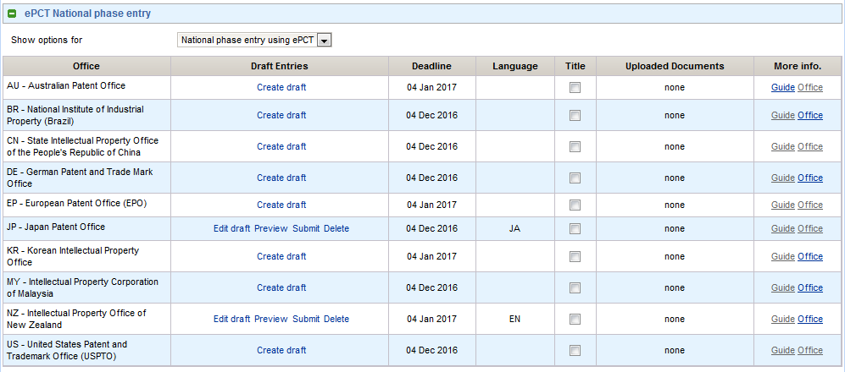

- When creating a draft national phase entry submission, the system invites entry of the following information:
  - the language in which the national phase processing will occur (preselected if there is only one possible option or if the language of international publication is one of the options);
  - the type of protection which is sought (such as patent or utility model);
  - the title of the invention for the purpose of the international phase (prefilled with the international phase title if available in the relevant language);
  - the name of the agent or agents for the national phase;
  - whether the national phase processing is to begin at the normal time (expiry of the normal deadline for national phase entry) or immediately on receipt of the national phase entry submission;
  - the basis of the national phase entry (the international application as filed or as amended under Articles 19 or 34, or an amendment specifically for the purposes of the national phase (Articles 28 and 41));
  - a signature of the applicant or agent.
Partial Views of Data Entry Screen in English
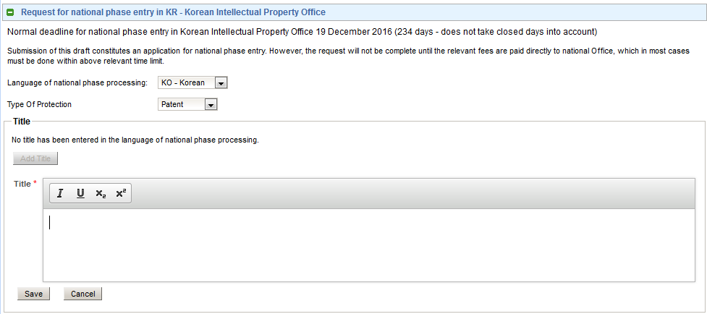

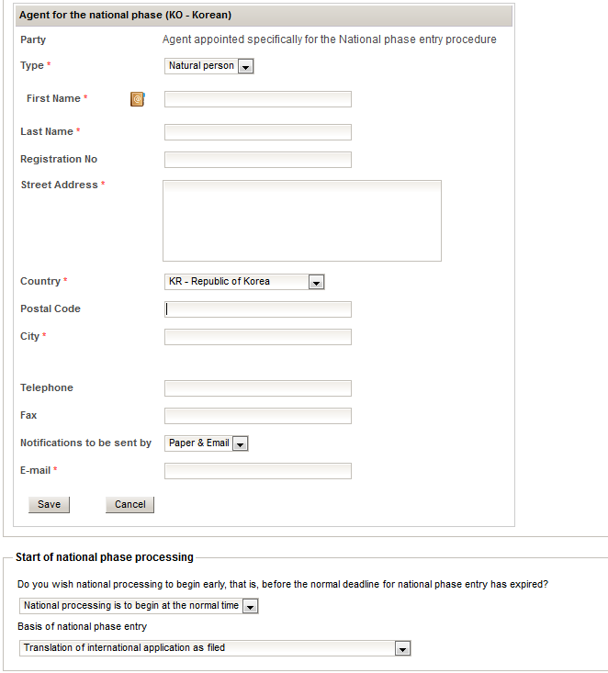

- The system also optionally allows attachment of a number of types of document, including amendments, declarations under Rule 51bis.1(a) (where relevant declarations were not provided within the international phase), powers of attorney and translations.
- The data and documents entered into a draft can be viewed by any person who, via his WIPO account, has access rights to the international application. They can be edited by those with eEditor or eOwner rights. The interface is available in any of the languages of publication. Thus, the system allows secure collaboration between agents in different countries, who can see exactly what is intended to be submitted without the need for any special common software.
- On submission to the designated Office, the system prepares a package of documents and data, currently consisting of a ZIP file containing:
  - an XML representation of the information required for national phase entry, whether entered in the above screens specifically for the purpose (such as type of protection sought or name and address of the national phase agent) or extracted from the international phase data (such as priority claims and lists of names and addresses of applicants);
  - a page-based view of the national phase entry information as a PDF file; and
  - any documents uploaded, as PDF files.
- In a working system, the documents and data would be transmitted to the designated Office and, preferably, a receipt returned for the applicant. This aspect of the system remains to be discussed with Offices interested in beginning a pilot.

Limitations of The Demonstration System
- The demonstration system has a number of known limitations, mainly due to the reference data for national phase information not yet being complete at the International Bureau. Users evaluating the system should be aware of these facts and make comments based on the system as if the limitation had been resolved.
- Some of these limitations will be removed over the course of the next few months, as more data becomes available. All are easy to address for a live pilot or a working system, provided that the Offices which are interested in joining such a system can agree a minimum set of variations which must be allowed for and carefully review the reference data for their Office before the system is opened up for use.
- At the time of writing, some of the main limitations which will be noticed by users are as follows:
  - The reference data for permitted languages of national phase processing is not yet available in an appropriate form. Consequently, the demonstration system uses the list of languages which the relevant Offices accept in their role as receiving Office (so, for example, the Japan Patent Office appears to allow national phase entry in English as well as Japanese).
  - Some of the functionality assumes that the language of filing of the international application is the same as the language of international search and international publication. This is true in a large majority of cases, but other variations will need to be allowed for in a final working system.
  - The reference data for “type of protection” at each Office is not yet available, so all Offices are shown as offering the choice of “patent” or “utility model”. Furthermore, the system only handles one type of national phase entry per designated Office, whereas in some Offices it is permitted to proceed as, for example, both a patent application and a utility model application.
  - There is no validation on the country of residence for the agent appointed for the national phase – this will require Offices to be able to specify the relevant countries either by specific lists (in the case of a national Office, usually only the country itself or else that country and a neighboring country with a special agreement) or by reference to membership of a group (such as member of the European Union or of the African Intellectual Property Organization).
  - Documents can only be uploaded in PDF format – a working service will permit additional types (most notably XML application bodies, including the possibility of uploading a Word file and having that converted automatically to Annex F-compliant XML).
  - The page-based view of the national phase entry information is currently rendered in English, irrespective of the language of national phase entry. A final version will support at least the languages of international publication and may have an option to support other national languages if the equivalent text is provided and tested by the Offices concerned.
  - “Submission” of the national phase entry documents and information does not currently send the data anywhere. It merely prepares a package which can be downloaded from the applicant’s ePCT account. Offices evaluating the system would need to prepare national phase entries in an applicant-style account, retrieve the package and consider how they would wish to receive it in an operational system.
  - Documents in the package are not properly coded according to the PCT “minspec” definitions which are used to identify document types in packages currently transmitted between the International Bureau and national Offices. This is largely because the system allows the attachment of a number of document types which are not used in the international phase and consequently do not yet have official codes.

Next Steps
- The International Bureau proposes that interested Offices and user groups try out the system in the Demo environment. The Demo system can be used by any user with an ePCT account which works in the live ePCT system, except that accounts which have been configured for use with ePCT Office services cannot use the applicant environment; such users will need to create a new account. New accounts can be set up as a self-service operation, except that users who do not already have a compatible digital certificate will need to request one. Instructions for this are available within the system and certificates are usually available within one working day.
- Comments should then be made to pct.bdd@wipo.int on what changes would be required, in addition to those referred to in paragraph 17, above, in order to make the system effective. Some of the issues which would need to be addressed include:
  - Does the interface allow for entry of all the necessary information? Are there any types of information missing which is normally provided at the same time as furnishing the documents and paying the fees referred to in Articles 22(1) and 39(1)? Does any other information need to be translated into the language of national processing? For example, the system requests the name and address of the national phase agent(s) in the language of national processing, but will presently only deliver the names and addresses of applicants in non-Latin characters if the language of national processing is the same as the language in which the request form (PCT/RO/101) was filed. However, the applicant should only be required to enter additional data, including translations, if it is actually needed for processing in the national phase.
  - Are there any fields which can have better Office-specific content validation? For example, if Offices supply the relevant information, it should be possible to check that agent registration numbers match the expected national format or to allow different lengths and character types for agents’ reference numbers.
  - How should the system deal with national phase entry documents and information submitted after the normal deadline? At present, the system only provides a warning that the deadline has been missed, noting that in some Offices a late request can be accepted, either on payment of a fee or on demonstration that the failure to meet the time limit was either unintentional or despite due care.
  - How would interested Offices wish to receive the notifications? Options which could be implemented immediately include delivery by PCT-EDI (a batch delivery which would normally run daily) or by notification that the package was available for viewing and download from the browser-based ePCT system. Other options which could be considered include “pushing” the package to a server at the designated Office either by a web service or by a service similar to the current PCT e-filing protocol, returning a receipt generated directly by the Office concerned.
  - If the request is not pushed immediately to the designated Office in a way which returns a national application number, would it be acceptable for the International Bureau to provide a provisional application number from a range reserved for the purpose?
  - Until centralized payment services can be offered, what arrangements need to be made for payments and to what extent do different national Offices have flexibility on payments being received after the deadline for national phase entry?
  - Is there any need for adjusting the ePCT access control arrangements to allow this system to be effectively extended to national phase users, noting that it would be impractical for an eOwner in the office which originally filed the international application to directly administer rights for multiple users in the office of an agent for a national phase entry?
- Of particular legal importance are the questions of recognition of the date on which the package was created and the date on which any required payment is made. Before the service could be opened up for a designated Office, the International Bureau would need certain assurances and information:
  - The date of creation of the package (according to the time zone of the designated Office) must be recognized as the date on which it was received by that Office, even if it is only imported into the Office’s local systems on a later date. In most cases, this should not be a fundamental issue since the package would in fact be available to the Office on a secure server to which they have immediate access. This is similar to the situation in paper processing where a letter has been received by the Office. As long as the date of receipt can be verified, it does not matter when it is opened and the Office becomes actively aware of its contents.
  - If a system for centralized payment is established, it must be clear that the date of receipt of payment by the International Bureau on behalf of the designated Office is recognized as the date of payment by the designated Office.
  - If payments need to be made directly to the designated Office, separately from the submission of forms and documents, it needs to be clear how payments can be made, how the payments can be reliably associated with the request for national phase entry and whether it is essential that the payment is made before the expiry of the time limit for national phase entry or whether there is any “grace period” permitted to complete the payment.
- Assuming that sufficient Offices indicate their willingness to begin a pilot following this consultation, the International Bureau would make any necessary changes to the system, deploy it to the live environment, seek confirmation from the participating Offices that all the necessary reference data is correct and set those Offices as available for use of the system from an agreed date.
- The access management and sharing features embedded in ePCT will also be used to offer collaboration, work and document distribution and activity monitoring features between agents and potentially other third parties, even in cases where the final results cannot be submitted directly to the designated Office. Where useful, import and export features would also be made available, making it possible to combine ePCT national phase entry functions and data with local systems
- Furthermore, as noted in paragraph 17 of document PCT/WG/9/17, the International Bureau is developing web services for use by applicants as well as Offices. If there is demand, the International Bureau can provide web services either to allow applicants’ automated systems to create and at least partially pre-fill draft national phase entries, or else to retrieve drafts for use in the manner referred to in paragraph 22, above (as well as for the retrieval of bibliographic data more generally).
- The Working Group is invited to comment on the system as described in paragraphs 8 to 17 and the proposed next steps set out in paragraphs 18 to 23, above.

[End of document]

