E
PCT/WG/9/23
ORIGINAL: English
DATE: April 13, 2016

Patent Cooperation Treaty (PCT)
Working Group

Ninth Session
Geneva, May 17 to 20, 2016

STATUS REPORT ON eSearchCopy Pilot at the European Patent Office

Document submitted by the European Patent Office

Summary
- On July 1, 2015, the European Patent Office (EPO) and the International Bureau launched a pilot program on the electronic transmittal of search copies via the International Bureau (called “PCT Paperless” at the EPO). The aim of this pilot is to assess the feasibility of a new electronic transmittal process where the EPO acts as International Searching Authority, with a view to stopping the current paper flow with receiving Offices meeting the necessary requirements.
- The present document summarizes the background and the state of play of the pilot program.

Background
- At present, for each international application, receiving Offices (ROs) transmit a record copy to the International Bureau (IB) in accordance with Rule 22 and a separate search copy to the International Searching Authority (ISA) in accordance with Rule 23. In 2013, they sent around 95 per cent of the record copies of international applications for which the EPO was selected as ISA to the IB in electronic form. Around 77 per cent of the search copies received that year by the EPO, in its capacity as ISA (ISA/EP), were likewise transmitted in electronic form (RO/EP, RO/GB, RO/IB, RO/US). The rest of the search copies received by the ISA/EP were sent via surface mail (paper or CDs), even where the international application had originally been filed with the receiving Office in electronic form, which was the case for around 38 per cent of those search copies. Moreover, the percentage of international applications filed with receiving Offices in electronic form has been increasing in recent years (see paragraph 20).
- In Circular C. PCT 1332, dated February 17, 2012, the International Bureau set out a proposal for implementation of a mechanism whereby the IB could electronically transmit search copies to the ISA on behalf of the receiving Office. Following that proposal, a preliminary pilot on the transmittal of search copies to the ISA/EP via the IB was launched with the receiving Offices of Italy, Norway and Israel. That pilot ran from October 2013 to April 2014. During that preliminary pilot, an initial investigation for an electronic exchange was conducted and the normal paper flow was maintained for the purpose of processing the applications. The preliminary pilot delivered positive results, but it also showed that there were issues to be addressed. As a result, it was decided to launch a more comprehensive pilot to test the system before entering production.
- A further step towards electronic transmittal of search copies from the receiving Office to the ISA via the IB was taken with the eSearchCopy service forming part of WIPO’s ePCT system (version 2.10 deployed on February 11, 2014).

state of play
- In view of the above and desiring to implement a flawless and cost-efficient mechanism for transmitting search copies from receiving Offices, which so far send paper copies to the ISA/EP via the IB, the EPO and the International Bureau launched a pilot program, based on the eSearchCopy service, on the electronic transmittal of search copies via the IB (called “PCT Paperless” at the EPO) on July 1, 2015.
- For search copies to be transmitted electronically via the IB, the receiving Office must send the record copy package (an electronic bundle of documents including the record copy and a number of accompanying items) to the IB by electronic transfer (PCT-EDI or ePCT) and inform the IB that the search fee has been paid by the applicant. The latter is important in order to ensure that search fees relating to search copies received by the ISA/EP have been paid.
- After having checked that the ISA/EP is competent to carry out the international search and upon receipt of the above information from the receiving Office that the search fee has been paid by the applicant, the IB will promptly make the prepared search copy package (a copy of the electronic record copy package received from the receiving Office) available to the ISA/EP on behalf of the receiving Office, using PCT-EDI and/or PatNet. The prepared search copies will be in the WIPO MINSPEC data exchange format and will be transmitted, if possible, in daily batches.
- Subsequent documents which were not included in the record copy package, but were received by the receiving Office at a later point in time, will also be forwarded by the receiving Office to the IB via PCT-EDI or ePCT and thereafter by the IB to the ISA/EP using PCT-EDI and/or PatNet as described above. The objective is to stop the current paper flow completely.
- The pilot program has a specific timeline (see Annex). It started with a preparatory phase, now being followed by an operational phase. The preparatory phase encompassed all the technical work required to set up and test the electronic mechanism for receiving search copies and the drawing up of the necessary documentation, including specification of the requirements to be met by receiving Offices.
- The operational phase is dedicated to use of the new electronic transmittal process in practice. Since the aim of the pilot program is to assess the feasibility of this process where the EPO acts as ISA, it has been launched with only a limited number of receiving Offices of different sizes and in different geographical locations.
- The RO/IB is in a different situation from the other receiving Offices participating in this pilot, as it was already transmitting search copies to the ISA/EP electronically by means of a different technical solution. As a consequence there was no need to assess the electronic flow against the paper flow. Therefore, the RO/IB was able to switch over to the new electronic transmittal process as soon as it had been successfully tested and could enter the production phase on February 1, 2016.
- For each of the other receiving Offices, the operational phase is divided in two phases: an evaluation phase and a production phase. During the evaluation phase, search copies are to be transmitted to ISA/EP electronically via the IB and on paper by the receiving Office in parallel, so that the two processes can be compared in terms of timeliness, data quality, traceability, completeness and consistency of the received documents and in terms of whether there is any problem-solving mechanism.
- The move from the evaluation phase to the production phase is subject to a positive assessment of the above metrics by the EPO and IB. In practice, their assessment will be positive only if the receiving Office meets a set of specified requirements.
- During the evaluation phase, the EPO will regularly report to the IB on the above metrics with respect to all participating receiving Offices. If the evaluation is positive, the EPO and IB will agree on a date for entry into production for each receiving Office, which will be informed accordingly. It will then enter the production phase and stop sending search copies on paper to the ISA/EP.
- For practical reasons, a phased rollout of this new electronic transmittal process has been chosen. More specifically, it started with the RO/IB and is now being continued with the other receiving Offices, divided into two groups: RO/IT, RO/IL and RO/NO (group 1), followed by RO/ES, RO/FI and RO/JP (group 2).
- For group 1, the evaluation phase started on February 29, 2016. In practice, this means that for international applications with an international filing date on or after February 29, 2016, the IB, using the documents electronically received from the receiving Office (record copy package and subsequently filed documents), will electronically transmit the search copies and subsequently filed documents to the ISA/EP on behalf of the receiving Office. For group 1, the evaluation phase is expected to last until at least May 30, 2016. For group 2, the evaluation phase started on April 4, 2016 and is expected last until at least June 20, 2016. Any receiving Office which successfully completes the evaluation phase will thereafter enter into the production phase.
- At the end of this pilot program, the EPO and IB will agree on the requirements for launching the implementation of the new service by switching to electronic transmittal via the IB as the standard transmittal process for those offices which do not yet use an electronic transfer to the EPO. The EPO and IB will also agree on a methodology for extending this transmittal process to other receiving Offices wishing to use it and on the requirements to be met by them.

Main benefits

Further improvement of EPO’s timeliness as an ISA
- In 2015, 89.8 per cent of the international search reports drawn up by the EPO were published with the international application 18 months after filing (A1 publication) and 67.4 per cent were established within the time limit under Rule 42.1 (three months from the receipt of the search copy by the ISA, or nine months from the priority date, whichever expires later). These figures could be further improved by introducing the electronic transmittal of search copies via the IB. This new workflow will avoid postal delays so that search copies are received more quickly. This will have the result that international search reports can be established earlier and published in good time by the IB. This will be beneficial to both applicants and third parties.

Improvement of the service offered to receiving Offices
- Many receiving Offices have expressed an interest in switching over to electronic transmittal of search copies. In 2015, 93.6 per cent of international applications were filed in electronic form. This is the result of a significant growth over the last five years (78.3 per cent in 2010). In the vast majority of cases, receiving Offices currently have to print electronically received documents in order to send the search copies via surface mail to the ISA/EP. The new electronic transmittal process will enable the EPO to meet their demand for a more-efficient transmittal process, since the receiving Offices will make significant savings on printing and mailing costs.

Streamlining of the transmittal process
- Switching over to electronic transmittal of search copies would also streamline the transmittal process as there would eventually be one main processing flow with the ISA/EP based on electronic transmittal using a common electronic platform, instead of having as many flows as receiving Offices.
- In view of the above, the EPO intends to offer this new service to any interested receiving Office after completion of the pilot program which is expected by the end of the year.

- The Working Group is invited to take note of the contents of the present document.

[Annex follows]

PCT PAPERLESS TIMELINE
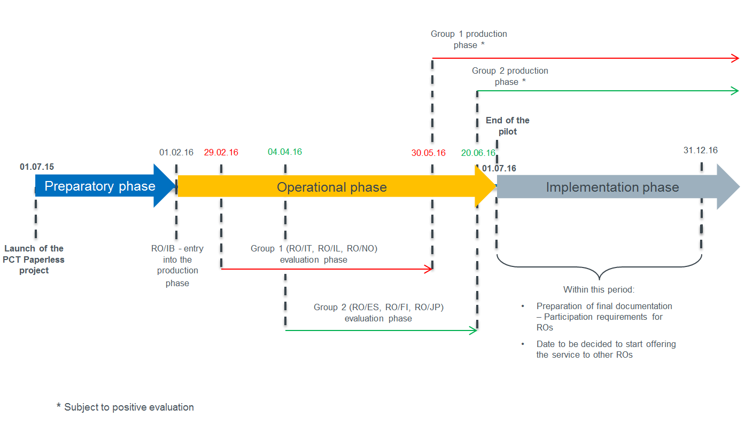

[End of Annex and of document]

