WIPO |  | E  PCT/WG/2/7  ORIGINAL: English  DATE: April 3, 2009
WORLD INTELLECTUAL PROPERTY ORGANIZATION
GENEVA
international patent cooperation union
(pct union)
patent cooperation treaty (PCT)
WORKING GROUP
Second Session
Geneva, May 4 to 8, 2009
Presentation of revisions to international applications
Document prepared by the International Bureau

SUMMARY

At present, Offices can identify replacement sheets by the stamps which appear at the bottom of the page. As international applications are more commonly amended, corrected, rectified or incorporation of missing parts confirmed by replacing paragraphs, individual figures, etc., it may become difficult to identify which parts of the international application were present at the time of filing and which have been replaced for various reasons.

The Working Group is invited to comment on the extent to which it is important that a reader (including an examiner in a designated or elected Office, but also other interested parties) is able to identify that changes have been made and where those changes lie. The comments provided by the Working Group are intended to assist the drafting of a more detailed consultation circular in the second half of 2009, covering a variety of issues related to XML processing of international applications, including revision by paragraph, instead of by sheet.

Background

This document is identical in substance to document PCT/MIA/16/13, which was discussed by the Meeting of International Authorities at its 16th session, held in Seoul from March 16 to 18, 2009, save that the questions have been opened to more clearly seek information on the needs of users other than Offices which act as International Authorities. The Meeting’s discussions are outlined in paragraphs 94 to 97 of the report of that session (PCT/MIA/16/15), as follows:

“94. Discussions were based on document PCT/MIA/16/13.

“95. The Secretariat recalled that an increasing proportion of international applications were being filed in XML format. Certain Offices wished, to the greatest extent possible, that international phase processing be carried out directly in XML format (such as submitting replacement paragraphs) and, as designated Offices, to receive the results in XML format. If this was to be done effectively, it was essential that the communications meet the information and processing needs of designated Offices. One major issue might be that the XML standards in application-body.dtd at present did not specifically allow for any information to be included to distinguish between original and new or revised paragraphs, figures, etc.

“96. Authorities were not yet in a position to state firm positions on the issues set out in the paper. Initial views included the following:

(a) It was essential that an examiner viewing the application (either as XML or as a rendered view based on the XML) be able to identify individual paragraphs and drawings which had been changed in any way since the international filing date.

(b) It was desirable that this information should be clear when viewing the paragraph itself, but it might be acceptable as an alternative to provide a list of changes at the start or end of the specification, so long as this was in a clear format and was clearly distinguished from the application body.

(c) It was at least desirable, and possibly essential, to include information concerning the date and nature of the change, in addition to the simple fact that a change had occurred. This information should preferably be provided in a clear, consistent and language-independent manner.

(d) It was not clear whether there would be technical or legal issues if text indicating showing the details of a change were added to the text of a paragraph itself, as distinct from being included as an attribute of the paragraph or as a separate list.

(e) If information on changes were included as a separate file, concerns over this information being separated from the application body might be overcome be providing the various files as a package.

(f) There might be significant resource issues in allowing for national phase receipt of such XML information, quite apart from systems for creating the new application bodies in the international phase. Discussion of the business requirements should not be restricted to consideration of specific solutions set out in the discussion paper.

“97. The Meeting agreed that the Secretariat should send a consultation circular to designated Offices and International Authorities outlining the above and related issues in order to ensure that the business requirements for presenting XML application bodies, and views rendered from such application bodies, be properly identified.”

At present, paper sheets which are received at the receiving Office later than the time when a purported international application is initially filed are stamped with the date of receipt in the top right hand corner (Section 308bis of the PCT Administrative Instructions) and an indication of the nature of the change in the bottom margin, for example “INCORPORATED BY REFERENCE (RULE 20.6)” (Section 309) or “SUBSTITUTE SHEET (RULE 26)” (Section 305). Similar provisions also apply to replacement or additional sheets which are received by the International Searching Authority, International Bureau and International Preliminary Examining Authority. Consequently, when these are viewed at any later stage in the process, an examiner can easily see whether a sheet was part of the international application as originally filed, or has been added at a later stage so that it may be necessary to determine whether the changes introduced subject matter going beyond what was disclosed in the international application as originally filed.

These arrangements are also directly applicable to electronic processing to the extent that this is done on the basis of page-images (PDF documents or scanned images of paper pages).

However, the current standards for application bodies in XML format (and indeed other parts of the international application and its associated file, such as the request form) do not make any provision for storing information relating to changes which have been made to the document. If a paragraph or drawing is replaced in such a document and a new image of the application generated for reading, there will be no indication that the text and drawings are anything other than what was originally filed unless this information is kept associated with the new document in a related file, or else additional text is added which is not strictly part of the international application.

For the purposes of international publication of XML international applications which need to be corrected or rectified, or published with Article 19 amendments, an interim solution has been adopted comprising two elements:

an index portion appears at the top of the full text version of the international application listing the paragraph, claim and drawing numbers in each section of the application: where one of these is not original, a rule number indicating the type of change appears next to the particular number, as shown below (the examples are all from international applications published in Japanese since at present only Japanese applications using this arrangement have been published).

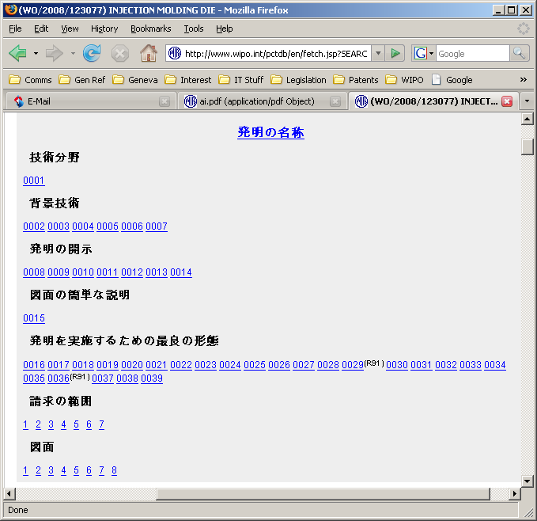

Index section of an international application published in Japanese where paragraphs 29 and 36 have been rectified under Rule 91.

additional text is pasted into the paragraphs which have been changed, or else into a figure title field for figures, as shown below.

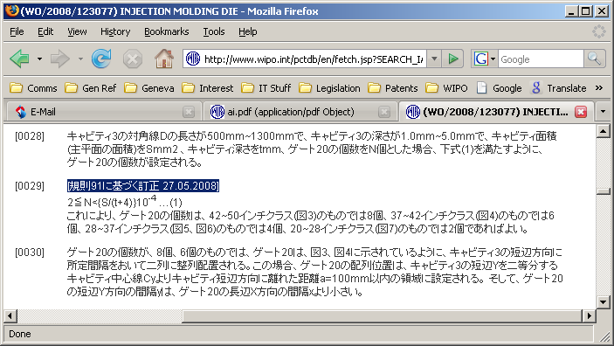

Paragraph which was rectified under Rule 91 on May 25, 2008, between two original paragraphs; the text indicating that the paragraph is rectified is shown highlighted.

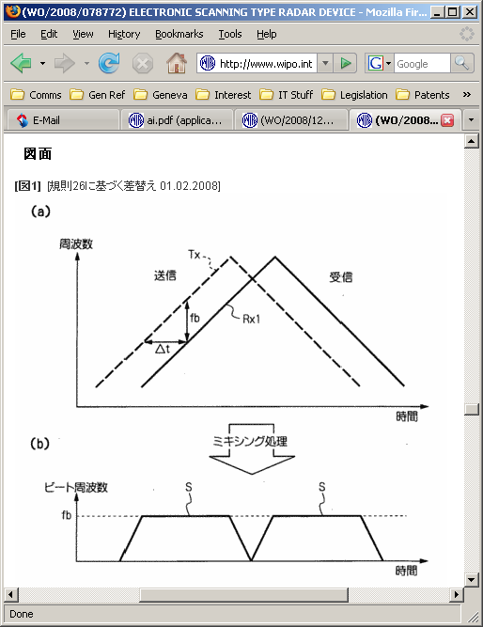

Drawing which was corrected under Rule 26 on February 1, 2008

This approach has been useful in permitting corrections to be made by paragraph or by drawing without a need for major new system or legal developments, but it clearly has a number of limitations, including the following:

the index section does not form an integral part of the XML version of the application and consequently the information could easily be lost when being transferred between systems;

the text indicating that a paragraph has been changed is included within the text of the international application even though it is not actually a part of the description; consequently, it will usually need to be removed again in the national phase before the application is granted; and

the indication is not clearly separated from the body text or description and is language-specific: an examiner quickly looking over the text could easily overlook it, especially if he is not a native speaker of the particular language.

In the context of the desire of certain applicants and Offices to move quickly towards full text electronic processing of international applications, there have been a number of proposals to formalize the system of replacement of parts of the international application by paragraph or by drawing, rather than by sheet. In designing the appropriate technical arrangements for receiving paragraphs and drawings and incorporating them into the
international application (and describing these arrangements in the context of the legal framework), it is important to understand the needs of end users of the system so as to ensure that the process can deliver a product which is as effective as possible.

Identifying Changed Paragraphs, Drawings, Etc.

Bearing in mind that, in general, no single Office (including the International Bureau) holds a complete file covering every action which has occurred to an international application, it has always been assumed that it was important that sheets which were not present on the international filing date should be clearly stamped so that examiners in the International Searching Authority, International Preliminary Examining Authority and designated and elected Offices can see that these sheets are not original and the type of changes which have been made. They can then decide whether it is necessary to obtain a copy of the record copy (which contains a copy of the sheets as originally filed, as well as of sheets correcting formal defects which are deemed to be part of the international application as filed and used for the international publication) to check whether there is any added subject matter.

In the context of developing an effective system where some international applications in future will not have original and substitute sheets as such, but rather will have completely new rendered views based on XML application bodies containing modified paragraphs and references to modified drawing files, it is necessary to ask:

is it essential for an examiner or other person reading a modified application body, whether using either an XML application body directly or a rendered view based on such an application body, to be able to determine whether any parts of that application have been changed since the international filing date without reference to any external source of information?

if so, is it necessary to identify the specific paragraphs or drawings which have been changed?

if so, is it necessary for the indication to be visible at each affected paragraph or drawing, or can this information be contained in a list at the start or end of the document?

if the indication needs to be visible at each affected paragraph or drawing, are there significant technical or legal problems in having text which does not form part of the international application included within the paragraph or the drawing reference text?

is it sufficient to know that text or a drawing is not original, or is it also important to include information concerning the date and nature of any change?

are there any other important issues which should be taken into account in preparing XML or rendering easily read application bodies from XML?

The Working Group is invited to comment on the issues raised in paragraph 11.

[End of document]

