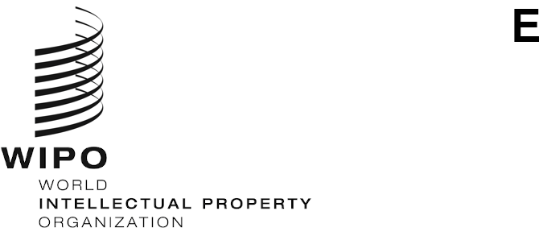
PCT/WG/13/11
ORIGINAL: English
DATE: September 10, 2020

Patent Cooperation Treaty (PCT) Working Group

Thirteenth Session
Geneva, October 5 to 8, 2020

Survey on the Use of e-Learning Resources for the Training of Substantive Patent Examiners
Document prepared by the International Bureau

Background
- The Working Group, at its twelfth session in June 2019, discussed a document that evaluated the responses to a survey regarding the training of substantive patent examiners carried out in 2018 (document PCT/WG/12/6). At the three previous sessions, the Working Group had also discussed surveys covering substantive examiner training, initially for training activities that took place between 2013 and 2015 (document PCT/WG/9/18), subsequently for 2016 (document PCT/WG/10/7), and then for 2017 (document PCT/WG/11/16).
- Discussions of the survey at the twelfth session of the Working Group are summarized in paragraphs 81 to 84 of the Summary by the Chair of the session (document PCT/WG/12/24); paragraphs 166 to 173 of the Report of the session (document PCT/WG/12/25) provide details of these discussions. The Working Group agreed on the following actions, as set out in paragraph 173 of the Report:
“173. The Working Group:
  - noted the contents of document PCT/WG/12/6;
  - approved the proposal that the International Bureau should carry out a one-time survey on policies of IP Offices with regard to e-learning resources, as set out in paragraph 23 of document PCT/WG/12/6; and
  - approved the proposal that the International Bureau should conduct future surveys on patent examiner training biennially, with the next survey taking place in 2021 to report on activities in 2019 and 2020, as set out in paragraph 28 of document PCT/WG/12/6.”

Survey on e-Learning Resources
- The International Bureau issued Circular C. PCT 1588, dated February 27, 2020, to request information regarding the use of e-learning resources for the training of substantive patent examiners. This Circular requested replies by March 16, 2020 in order to prepare a working document for this session of the Working Group, which had been due to take place from May 26 to 29, 2020. The International Bureau received 19 responses to the Circular, although few of these were from IP Offices in developing and least developed countries.
- In recent months, IP Offices have made more e-learning resources available that were not part of the questionnaire sent with the Circular C. PCT 1588. Moreover, in light of their experience of the COVID-19 pandemic, Offices may be reviewing their policies with regard to e-learning.
- In view of the above developments, the International Bureau proposes to repeat the survey in a revised version and to report to the fourteenth session of the Working Group in 2021. This will allow Offices to provide information on any changes to how they use e-learning resources for training substantive patent examiners from their experiences of the COVID-19 pandemic. A revised survey will also provide the opportunity for more Offices to respond to the survey.

Survey on Patent Examiner Training
- As stated in paragraph 173(c) of the Report of the twelfth session of the Working Group (reproduced in paragraph 2, above), the Working Group approved the International Bureau to conduct future surveys on patent examiner training biennially, with the next survey in 2021 for IP Offices to report on activities that have taken place in 2019 and 2020. If the International Bureau repeats the survey on e-learning resources in a revised version and reports on the findings to the Working Group in 2021, to avoid overlap between the two surveys, it is proposed to defer the general survey on patent examiner training until 2022. This survey would therefore cover the activities in substantive patent examiner training in 2019, 2020 and 2021 and could allow Offices to report on experiences from the COVID-19 pandemic and any resulting changes to the delivery of substantive patent examiner training.
- The Working Group is invited to:
    - note the contents of this document; and
    - to comment on the proposals set out in paragraphs 5 and 6 of this document.

[End of document]

