WIPO |  | PCT/MIA/VI/14  ORIGINAL: English  DATE: February 11, 1997
WORLD INTELLECTUAL PROPERTY ORGANIZATION
GENEVA
International patent cooperation union
(PCT union)
Meeting of international authorities
under the PCT
Sixth Session
Canberra, February 17 to 21, 1997
REstrictions of international search for reasons of Economy
Proposal by the European Patent Office

The Annex to this document contains proposals by the European Patent Office concerning possible restrictions of international search for reasons of economy where international applications claim extremely broad, vague or imprecisely formulated claims, submitted for consideration at the sixth session of the Meeting of International Authorities under the PCT.

[Annex follows]

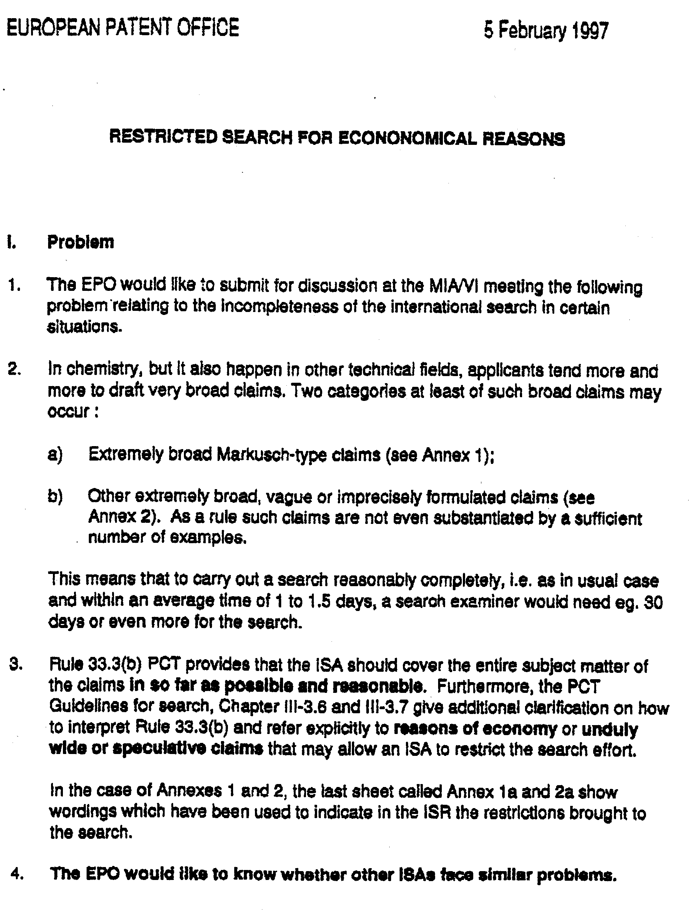
…/…

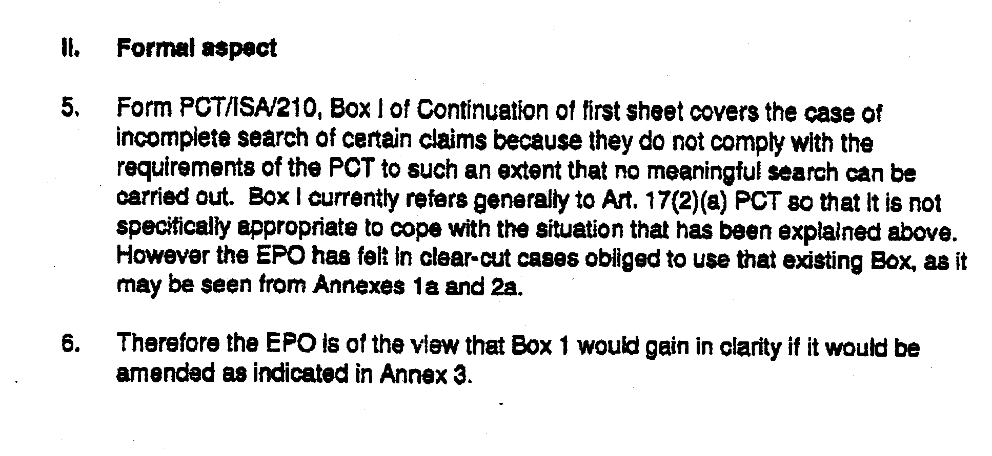

________________________

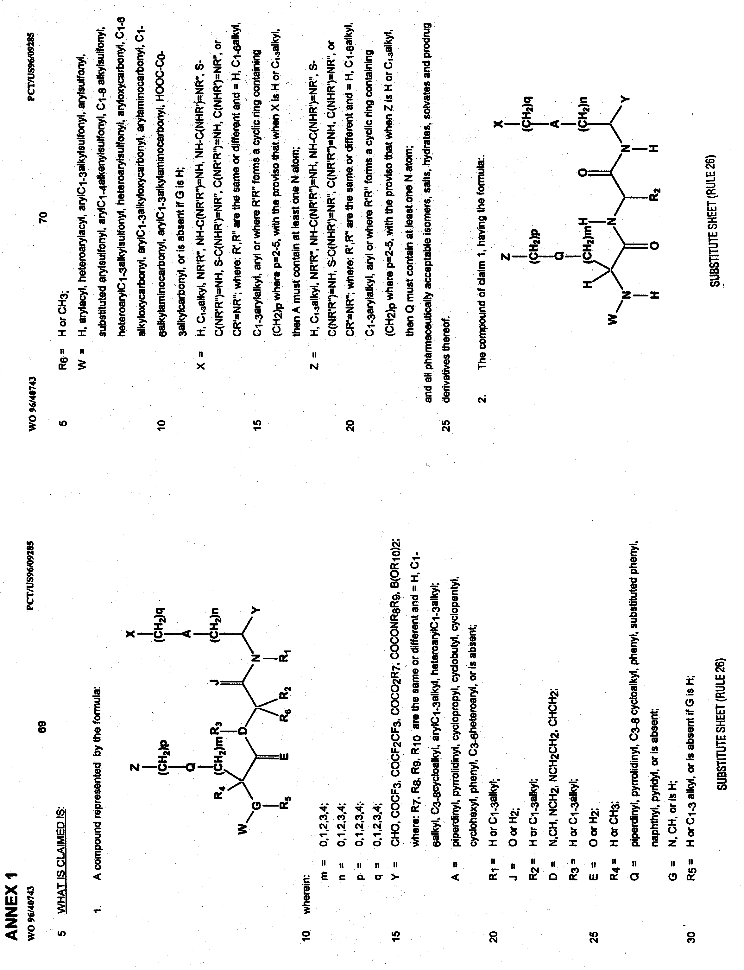

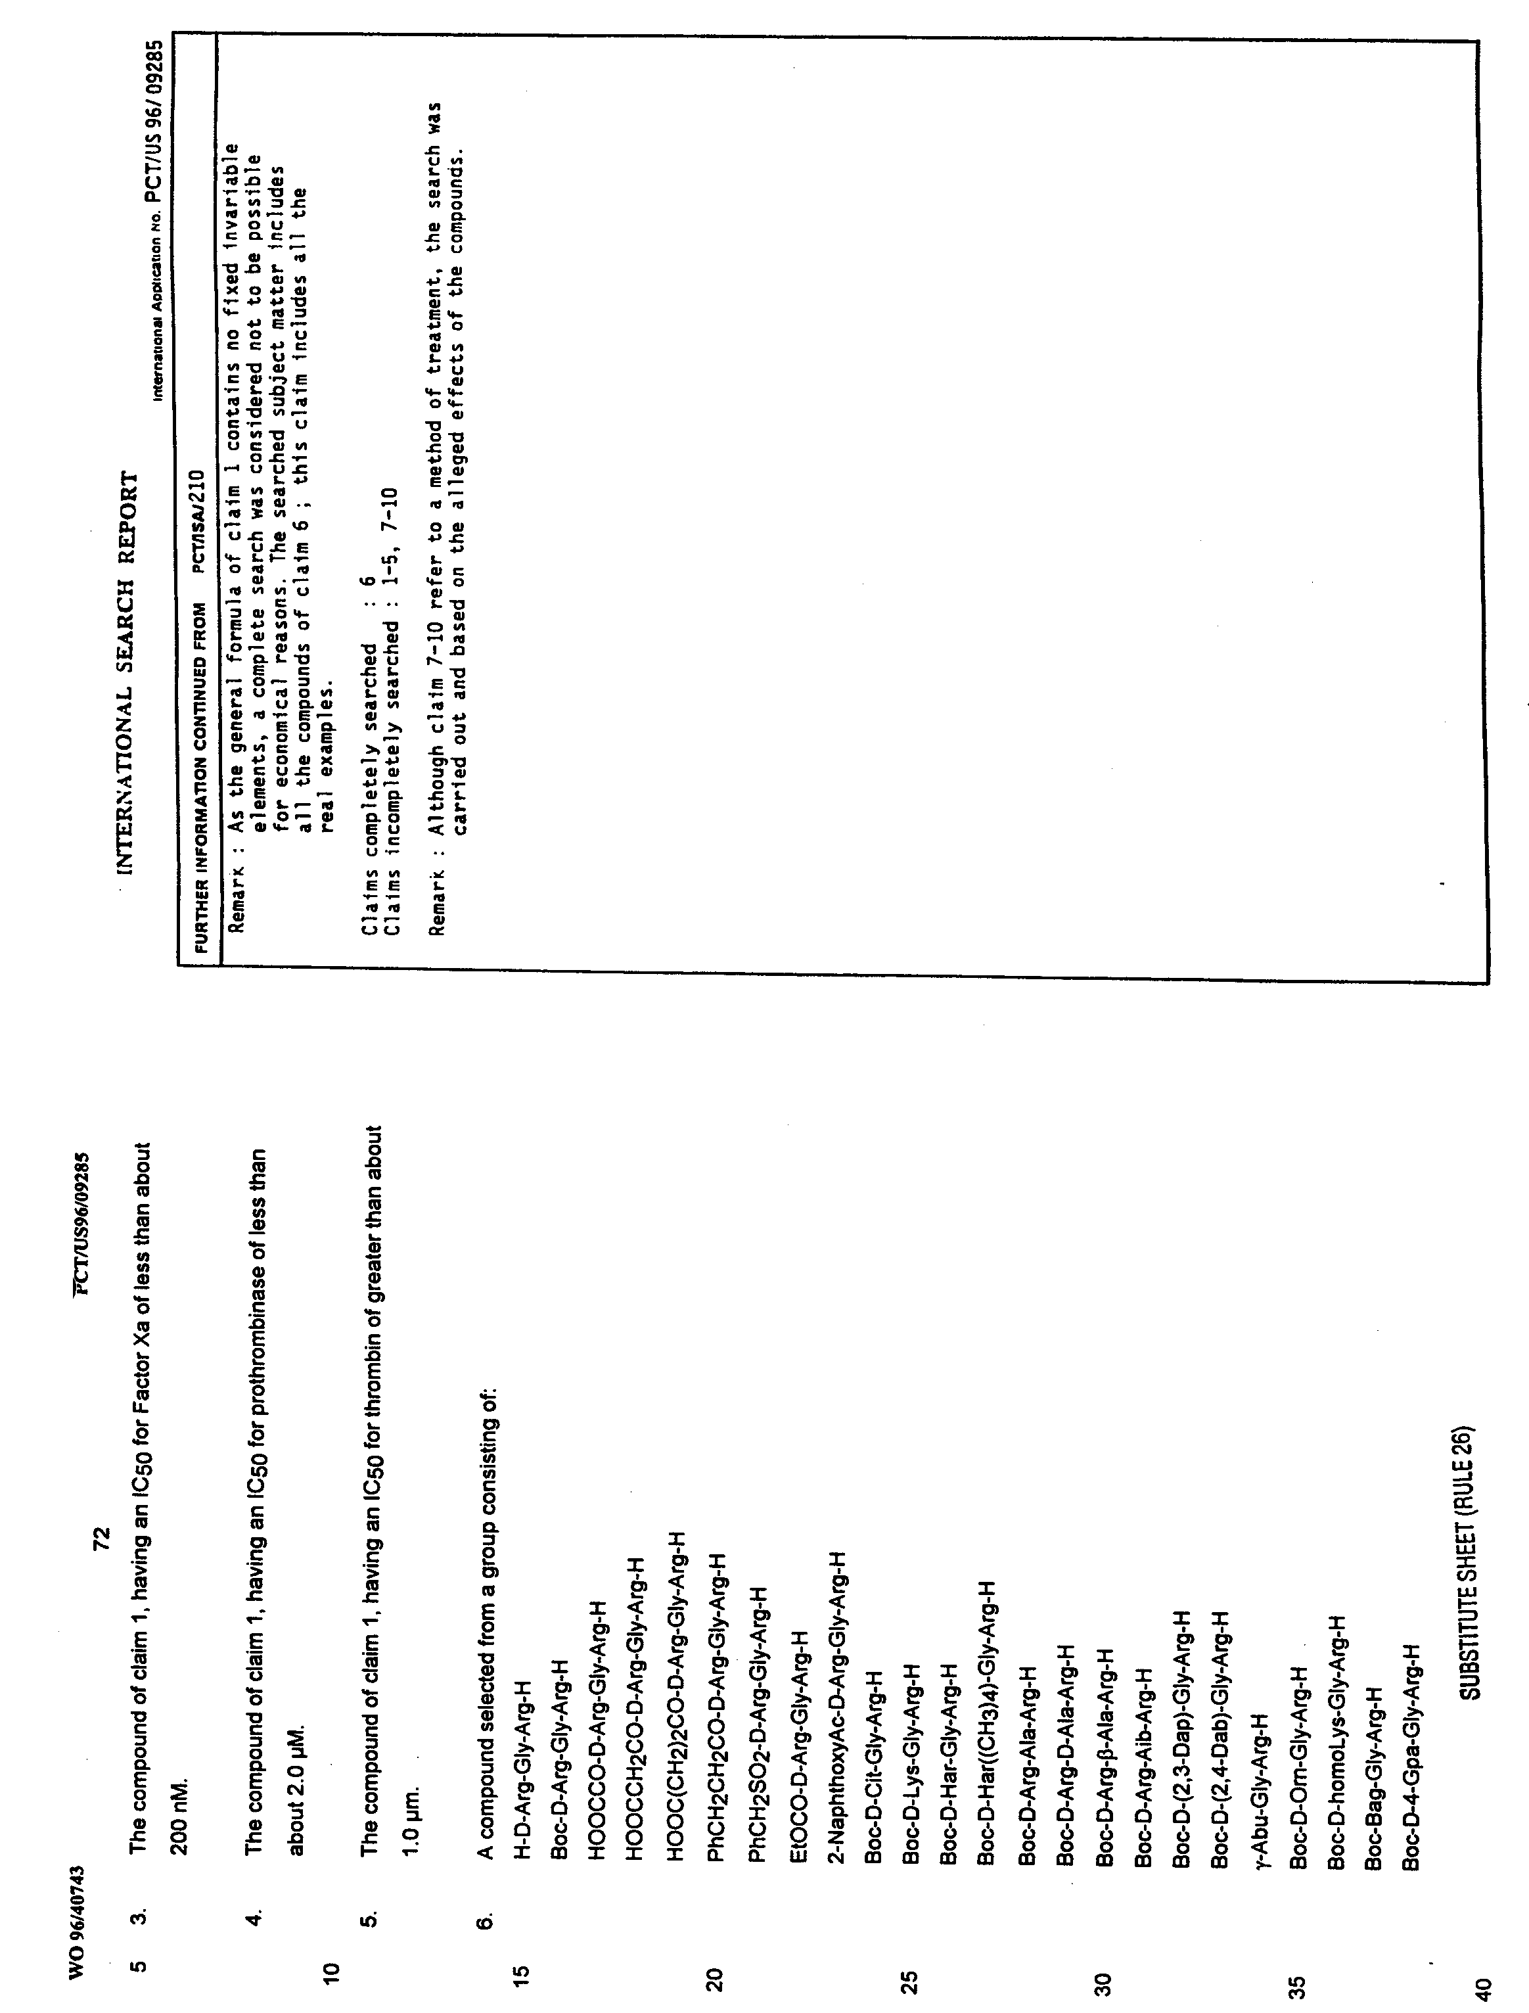

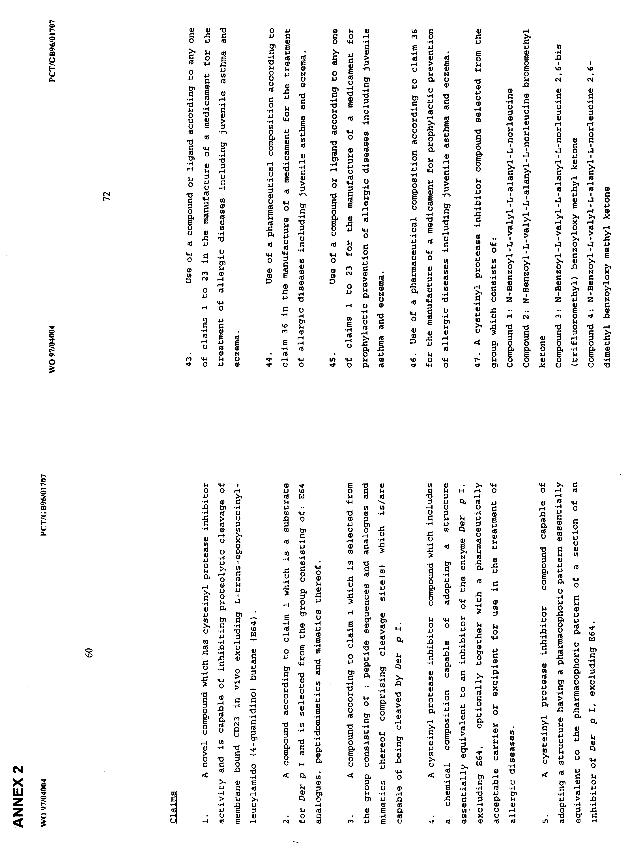

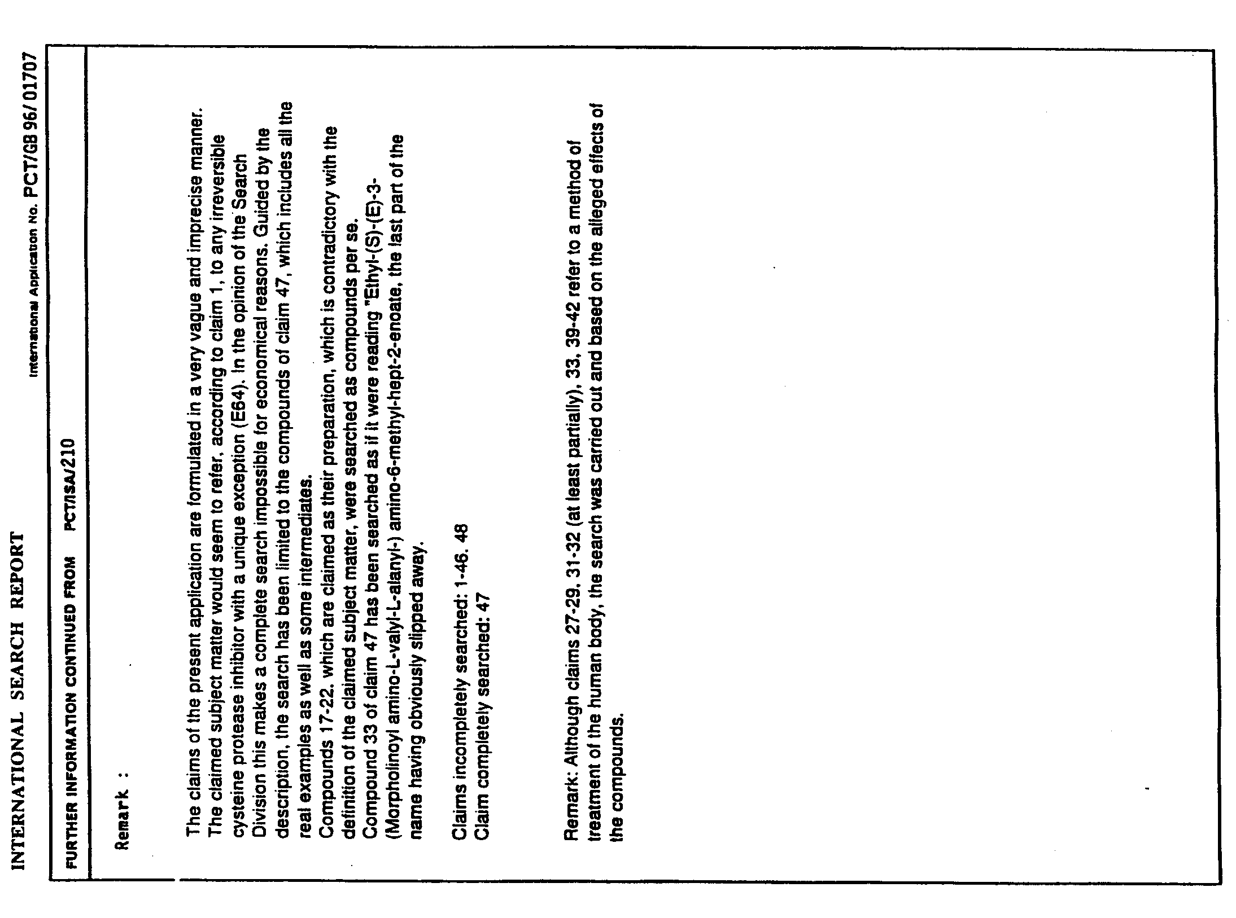

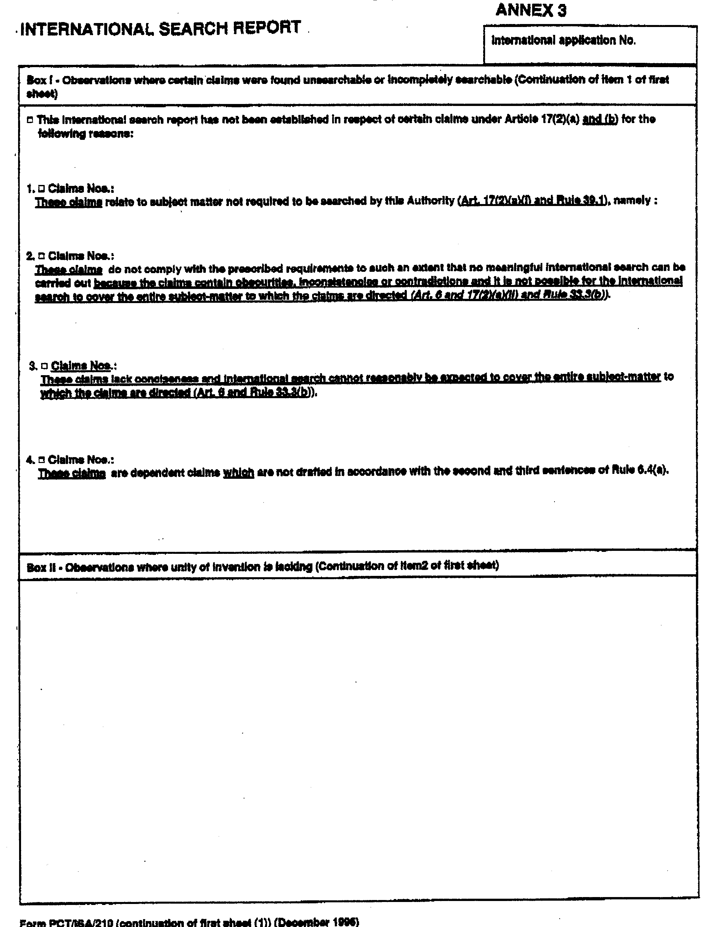

[End of Annex and of document]

