WIPO |  | PCT/MIA/VI/11  ORIGINAL: English  DATE: February 6, 1997
WORLD INTELLECTUAL PROPERTY ORGANIZATION
GENEVA
International patent cooperation union
(PCT union)
Meeting of international authorities
under the PCT
Sixth Session
Canberra, February 17 to 21, 1997
Proposed amendment of pct Rule 13bis
“microbiological inventions”
Proposal by the European Patent Office

The Annex to this document contains a proposal by the European Patent Office for amendment of PCT Rule 13bis to reflect recent amendments of Rule 28 of the Implementing Regulations to the Convention on the Grant of European Patents (EPC) relating to the deposit of “biological material” for the purposes of the European patent grant procedure, including provisions relating to the deposit of biological material by a person other than the applicant.

[Annex follows]
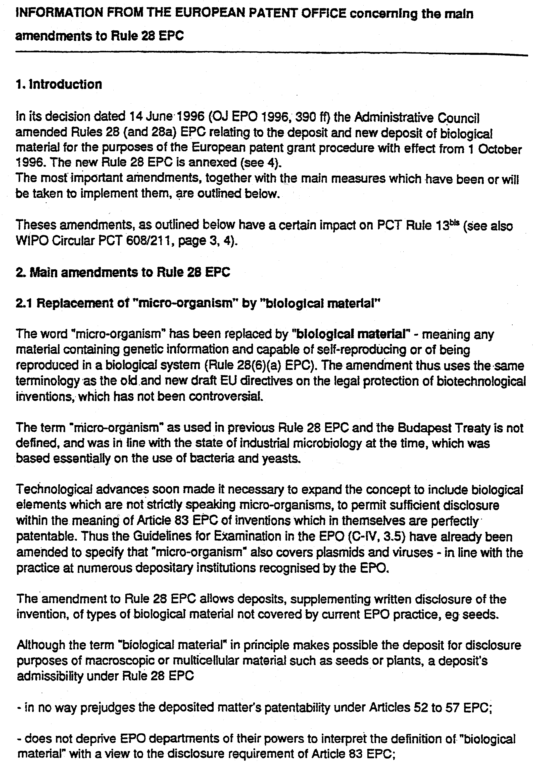

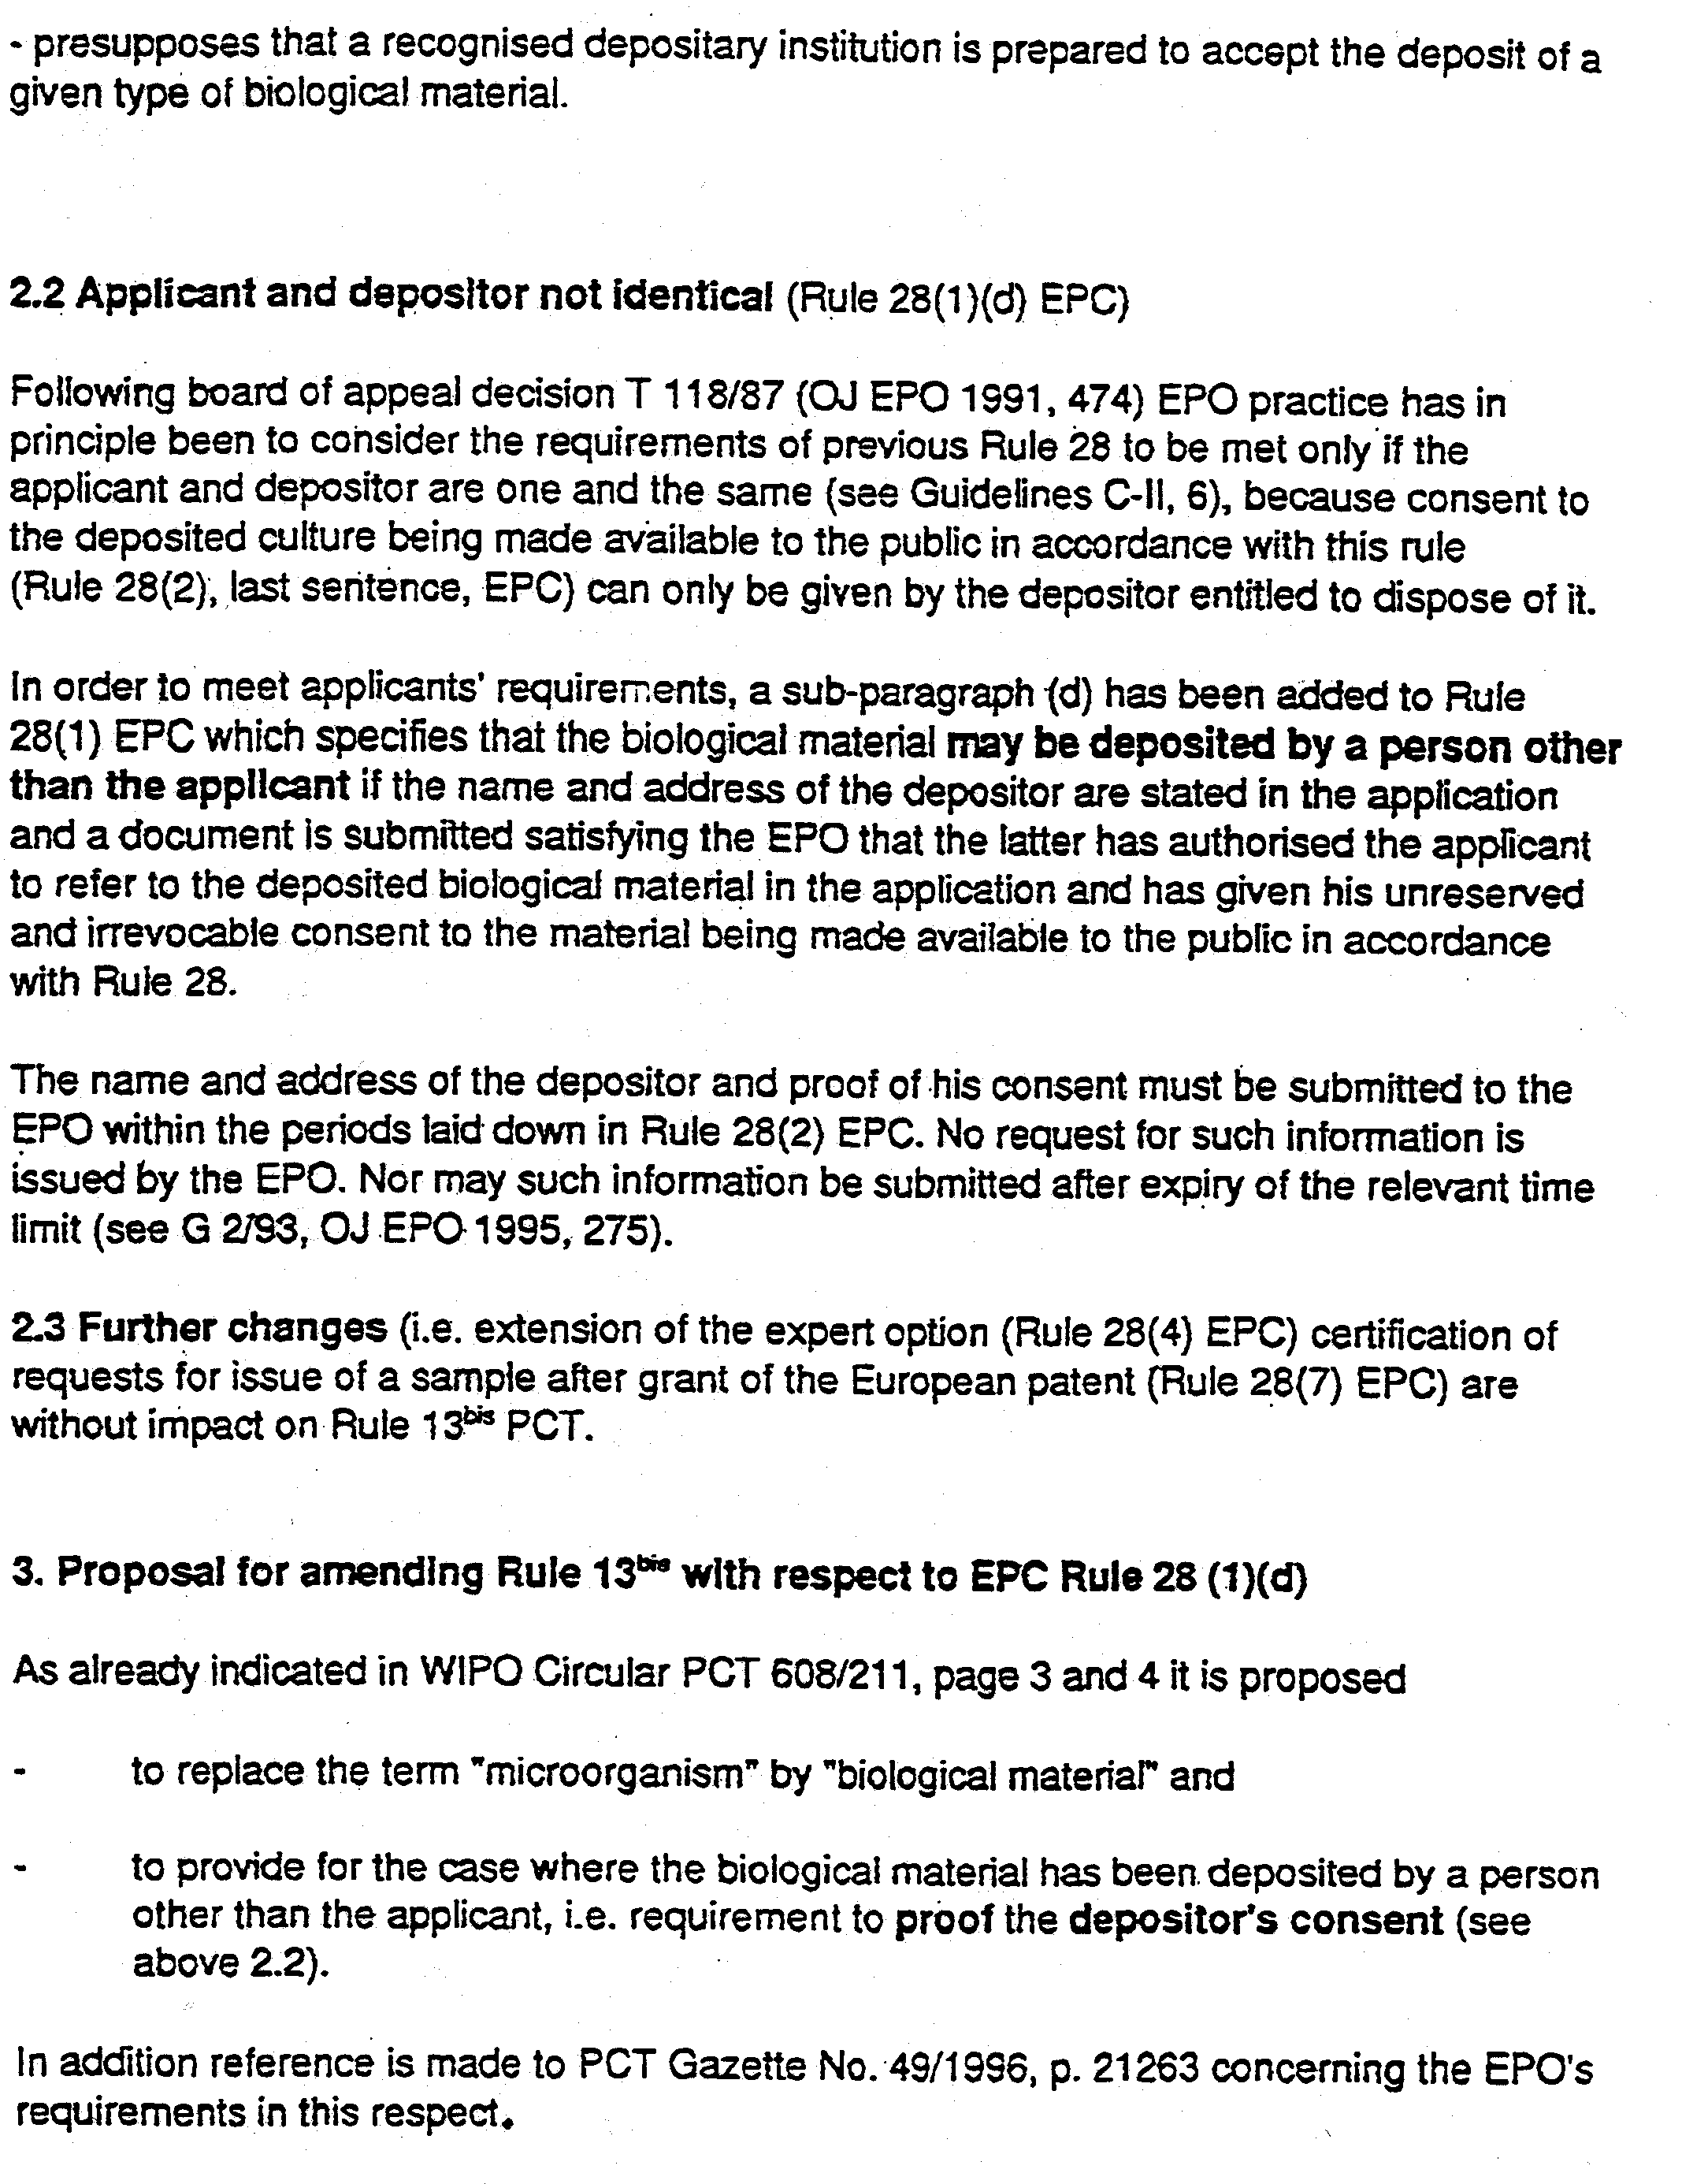

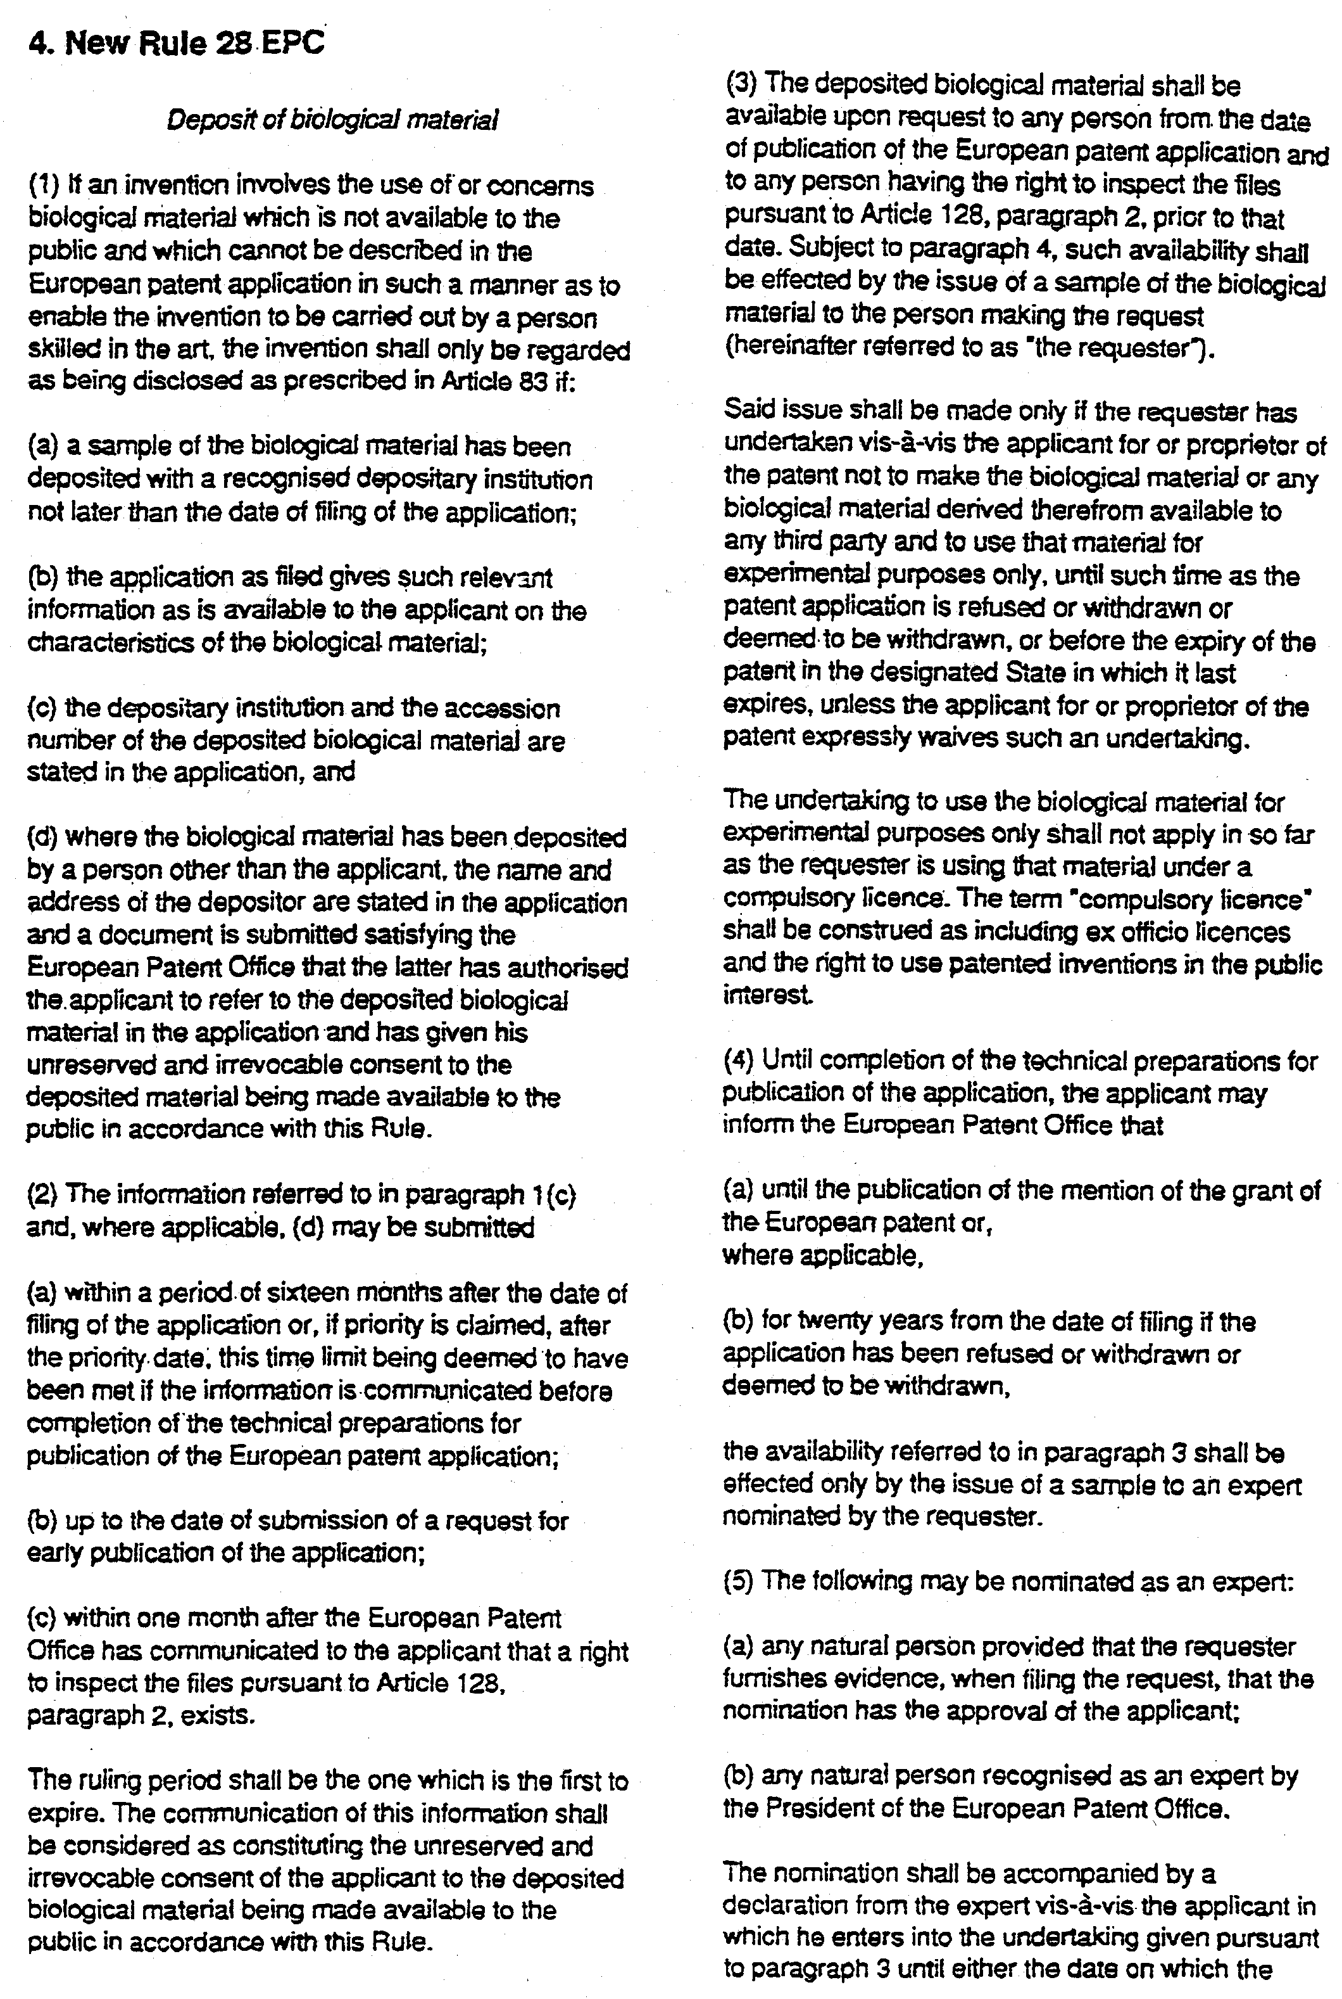

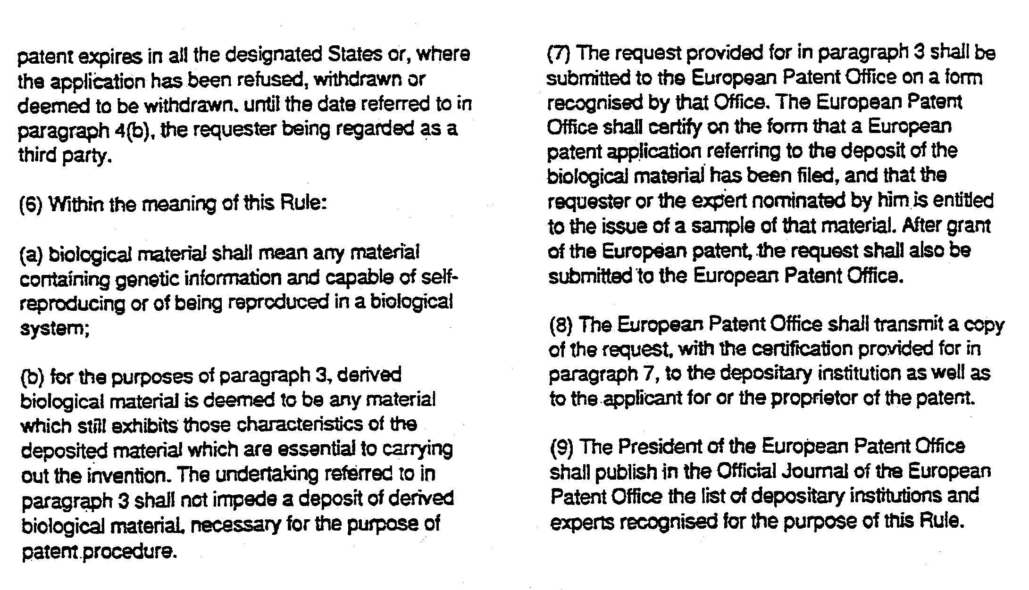

[End of Annex and of document]

