WIPO |  | PCT/MIA/IV/3  ORIGINAL: English  DATE: May 5, 1994
WORLD INTELLECTUAL PROPERTY ORGANIZATION
GENEVA
International patent cooperation union
(PCT union)
Meeting of international authorities
under the PCT
Fourth Session
Geneva, June 27 to July 1, 1994
PROPOSALS FOR SAMPLE FILLED-IN FORMS TO BE ANNEXED TO THE
PCT PRELIMINARY EXAMINATION GUIDELINES
Document prepared by the International Bureau
1 The Annex to this document contains proposals provided by the European Patent Office for sample filled-in forms to be annexed to the PCT Preliminary Examination Guidelines (document PCT/GL/3). These filled-in forms are an “Invitation to restrict or pay additional fees” in a case of lack of unity of invention, a subsequent “Written opinion” and finally an “International preliminary examination report,” all for the same theoretical case.

2. It is proposed that these filled-in forms be approved by the International Preliminary Examining Authorities at the fourth session of the Meeting of International Authorities under the PCT. They are submitted herewith for information and comment.

[Annex follows]

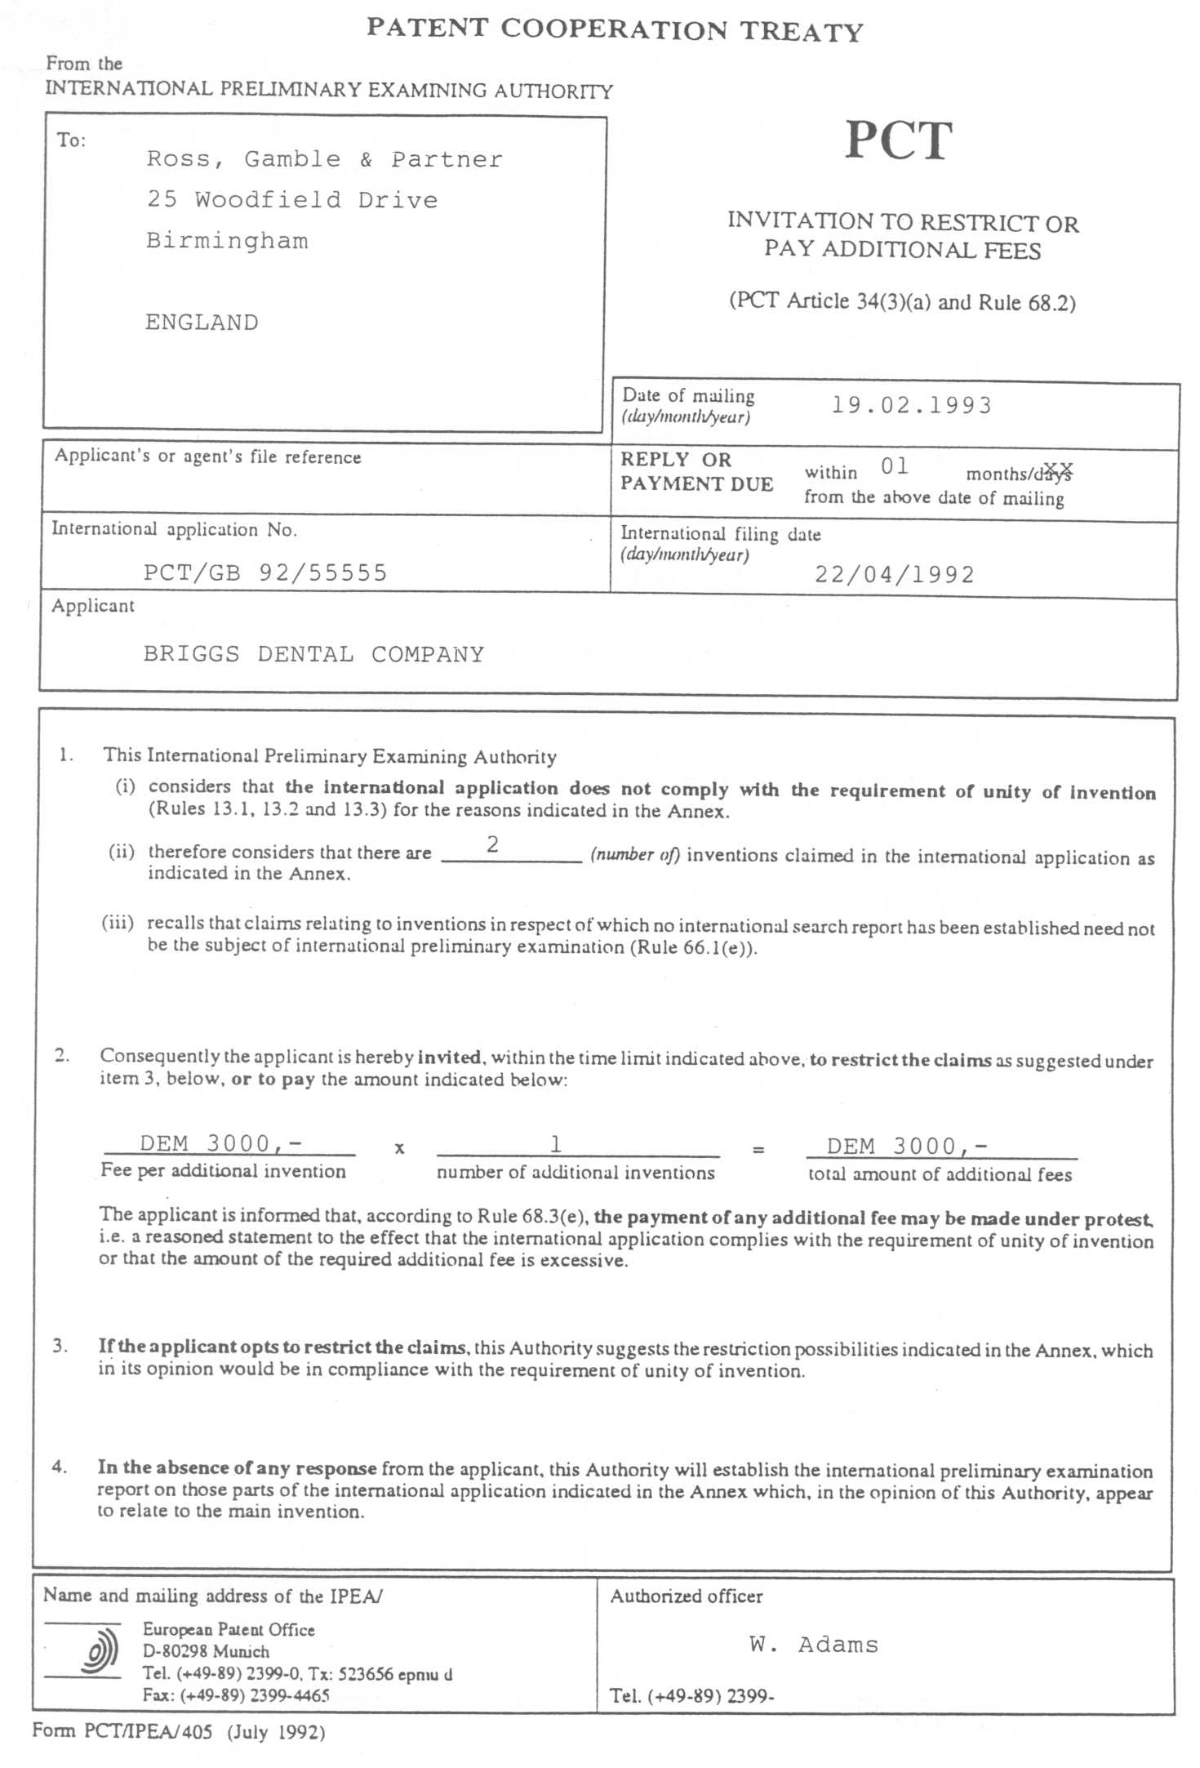

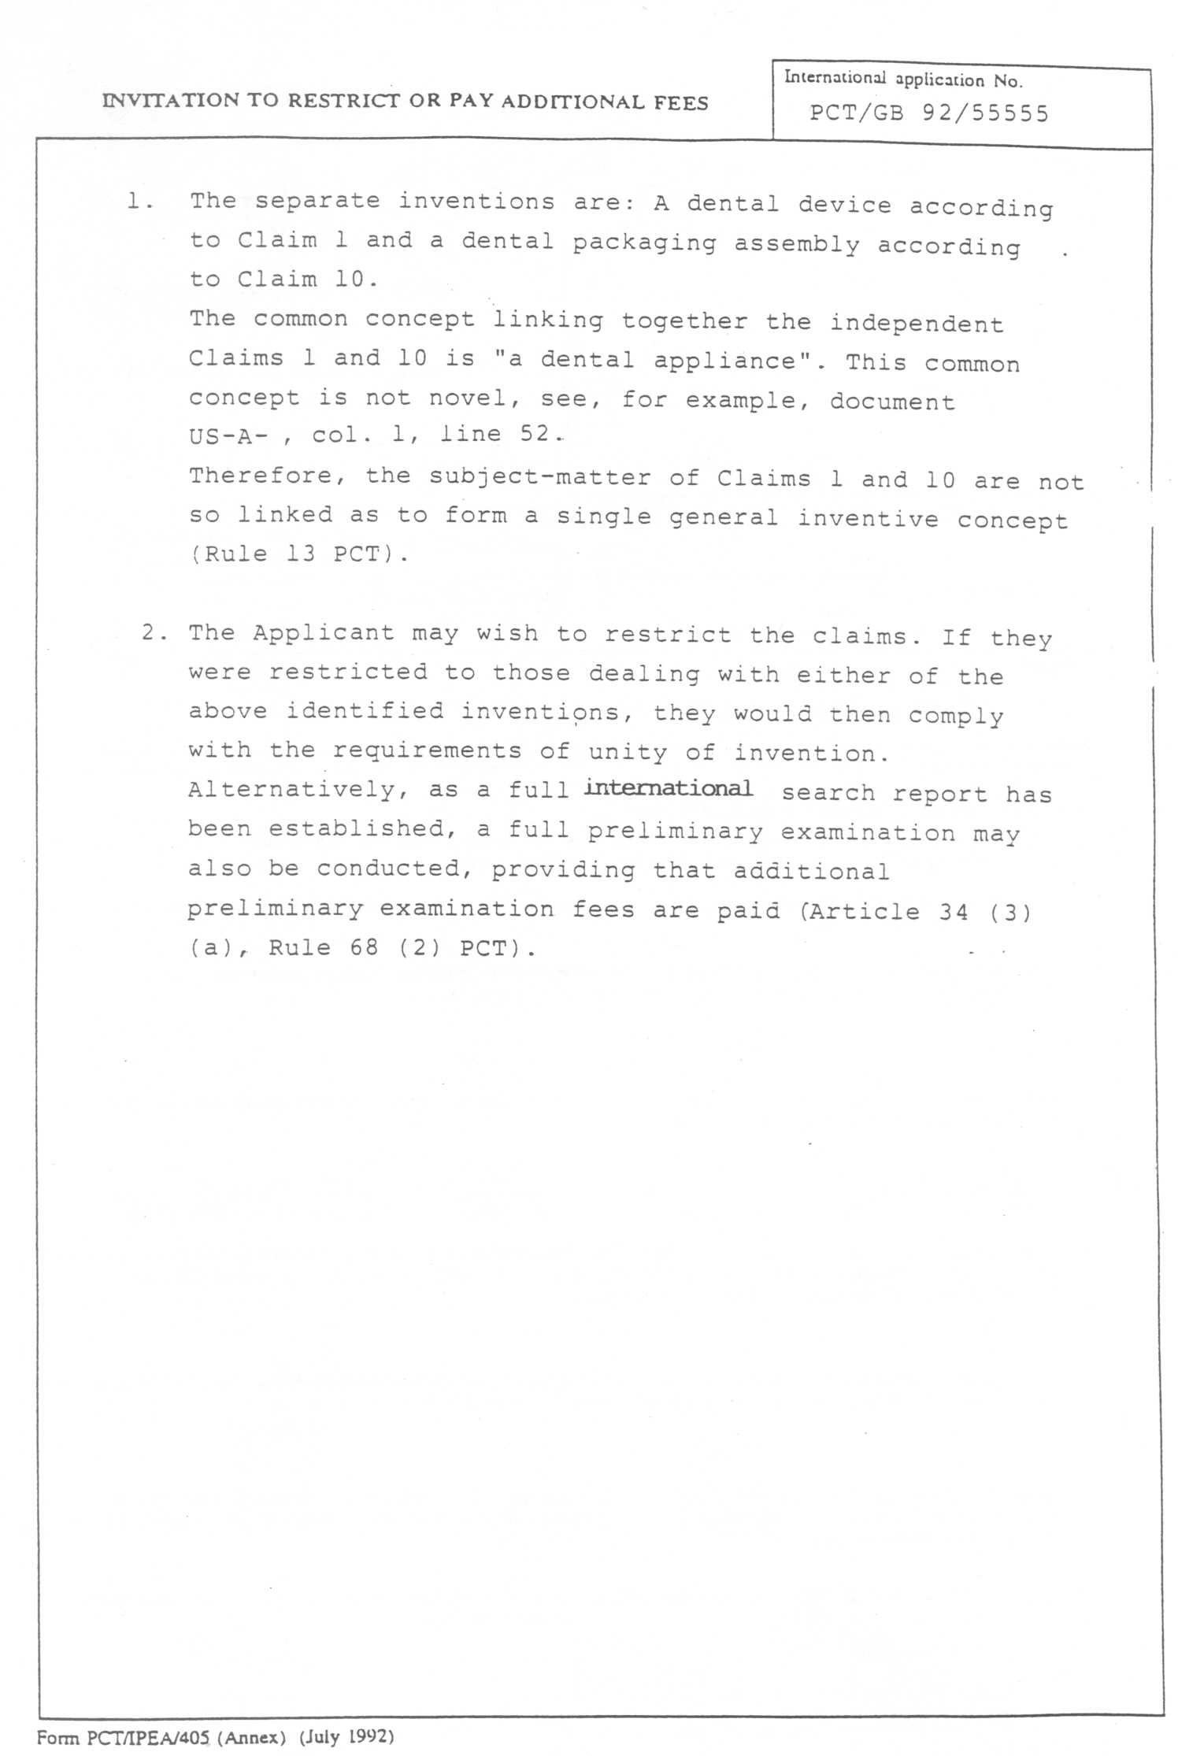

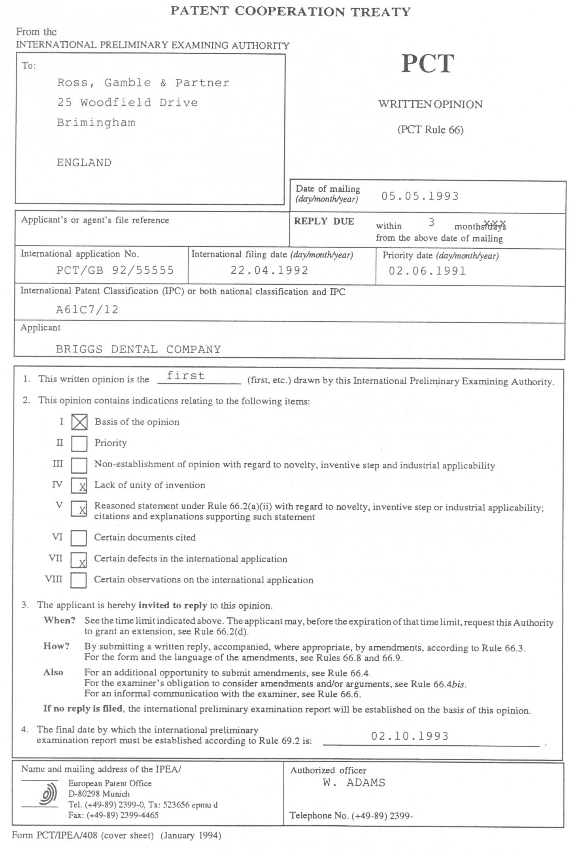

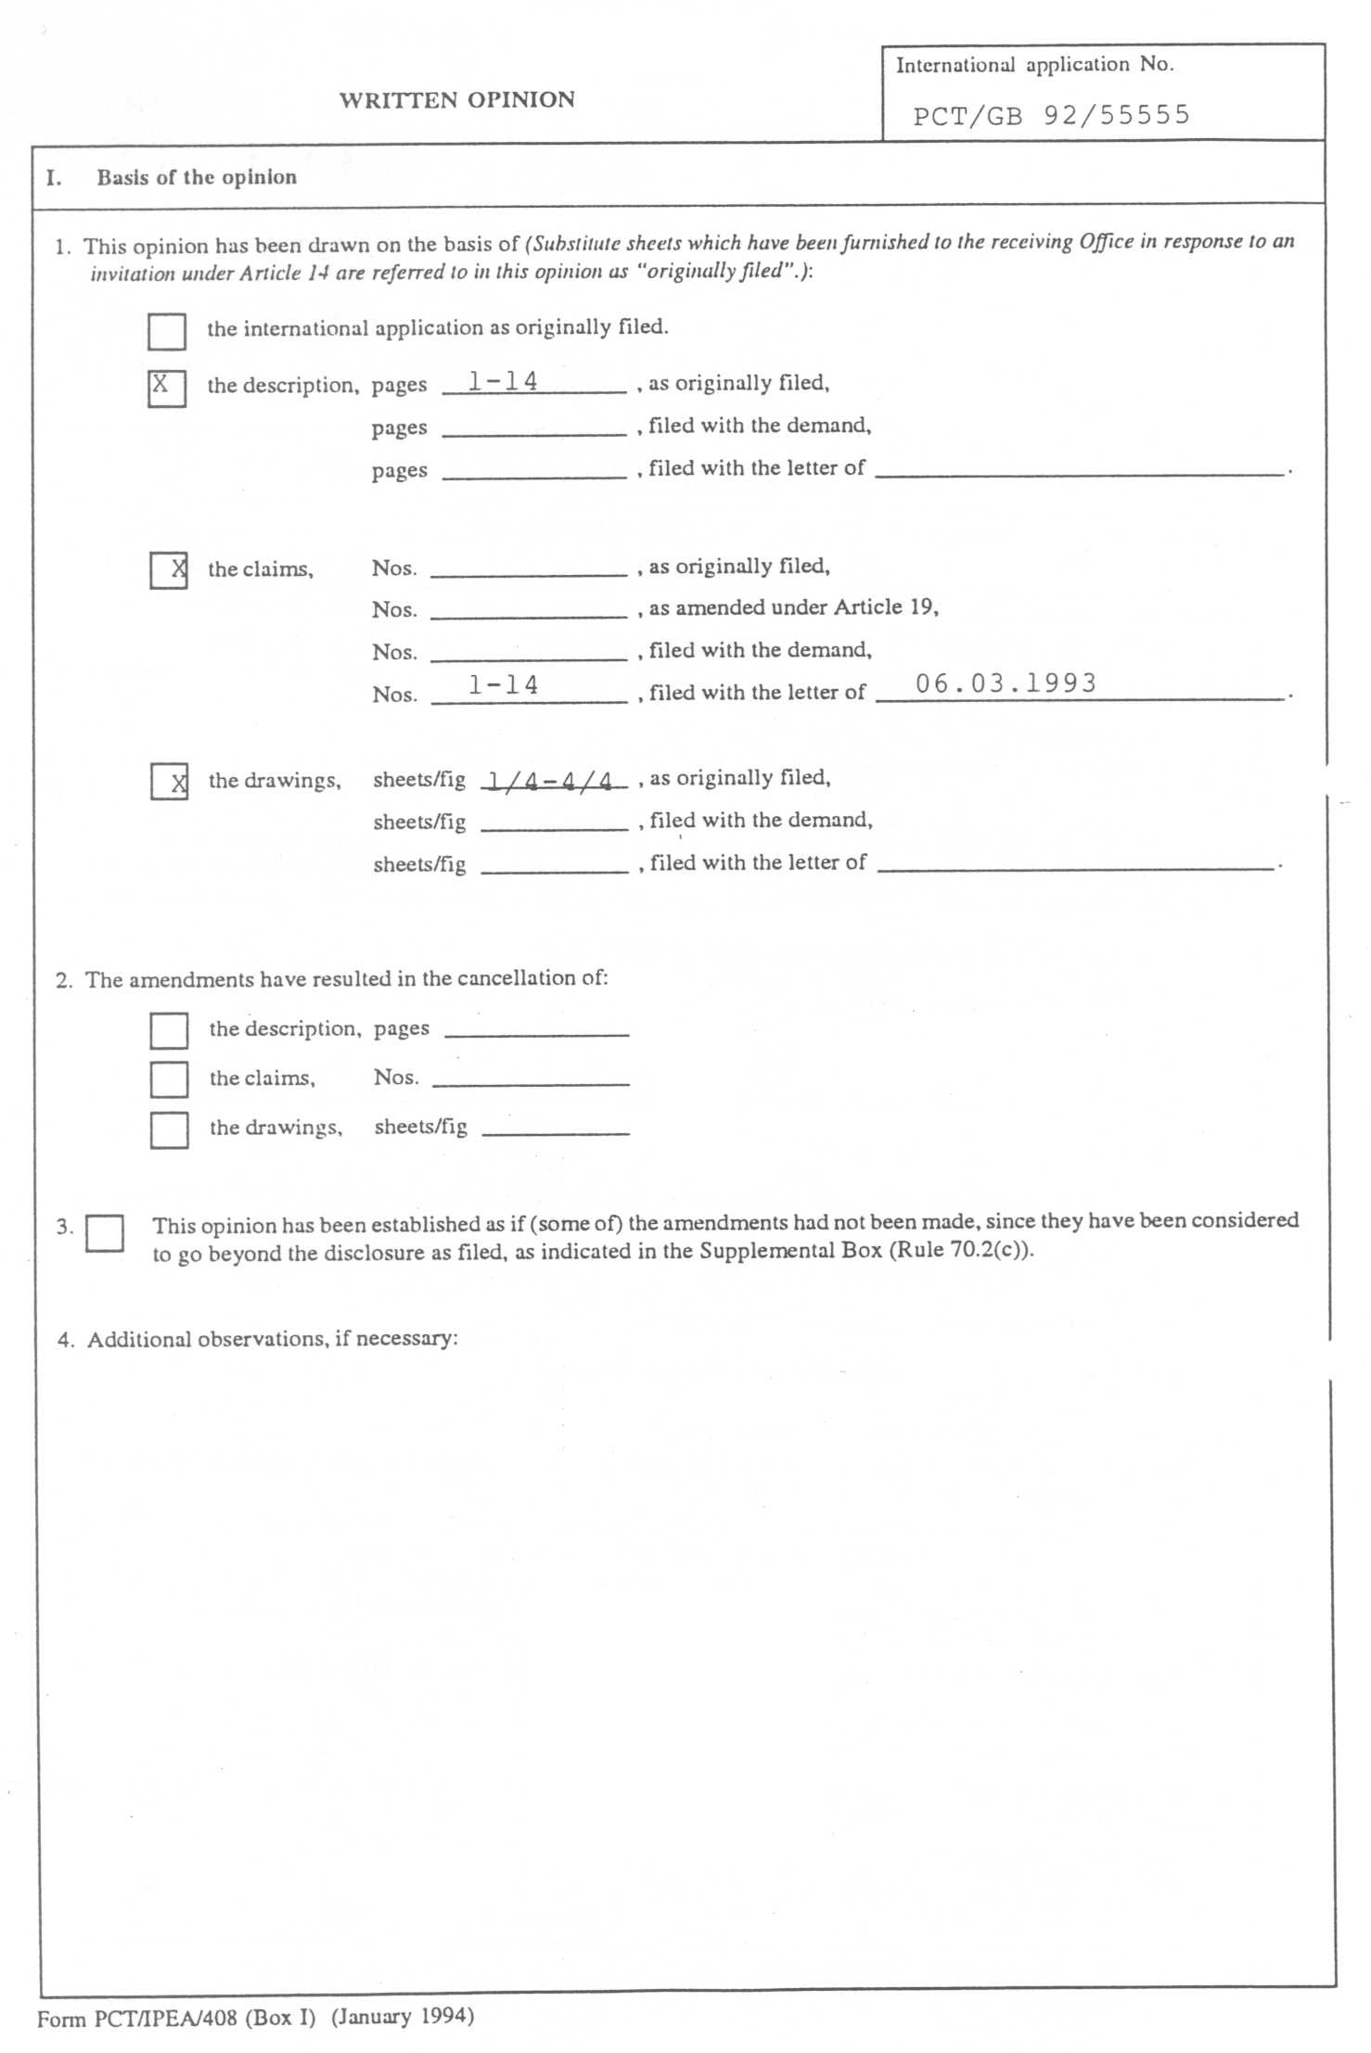

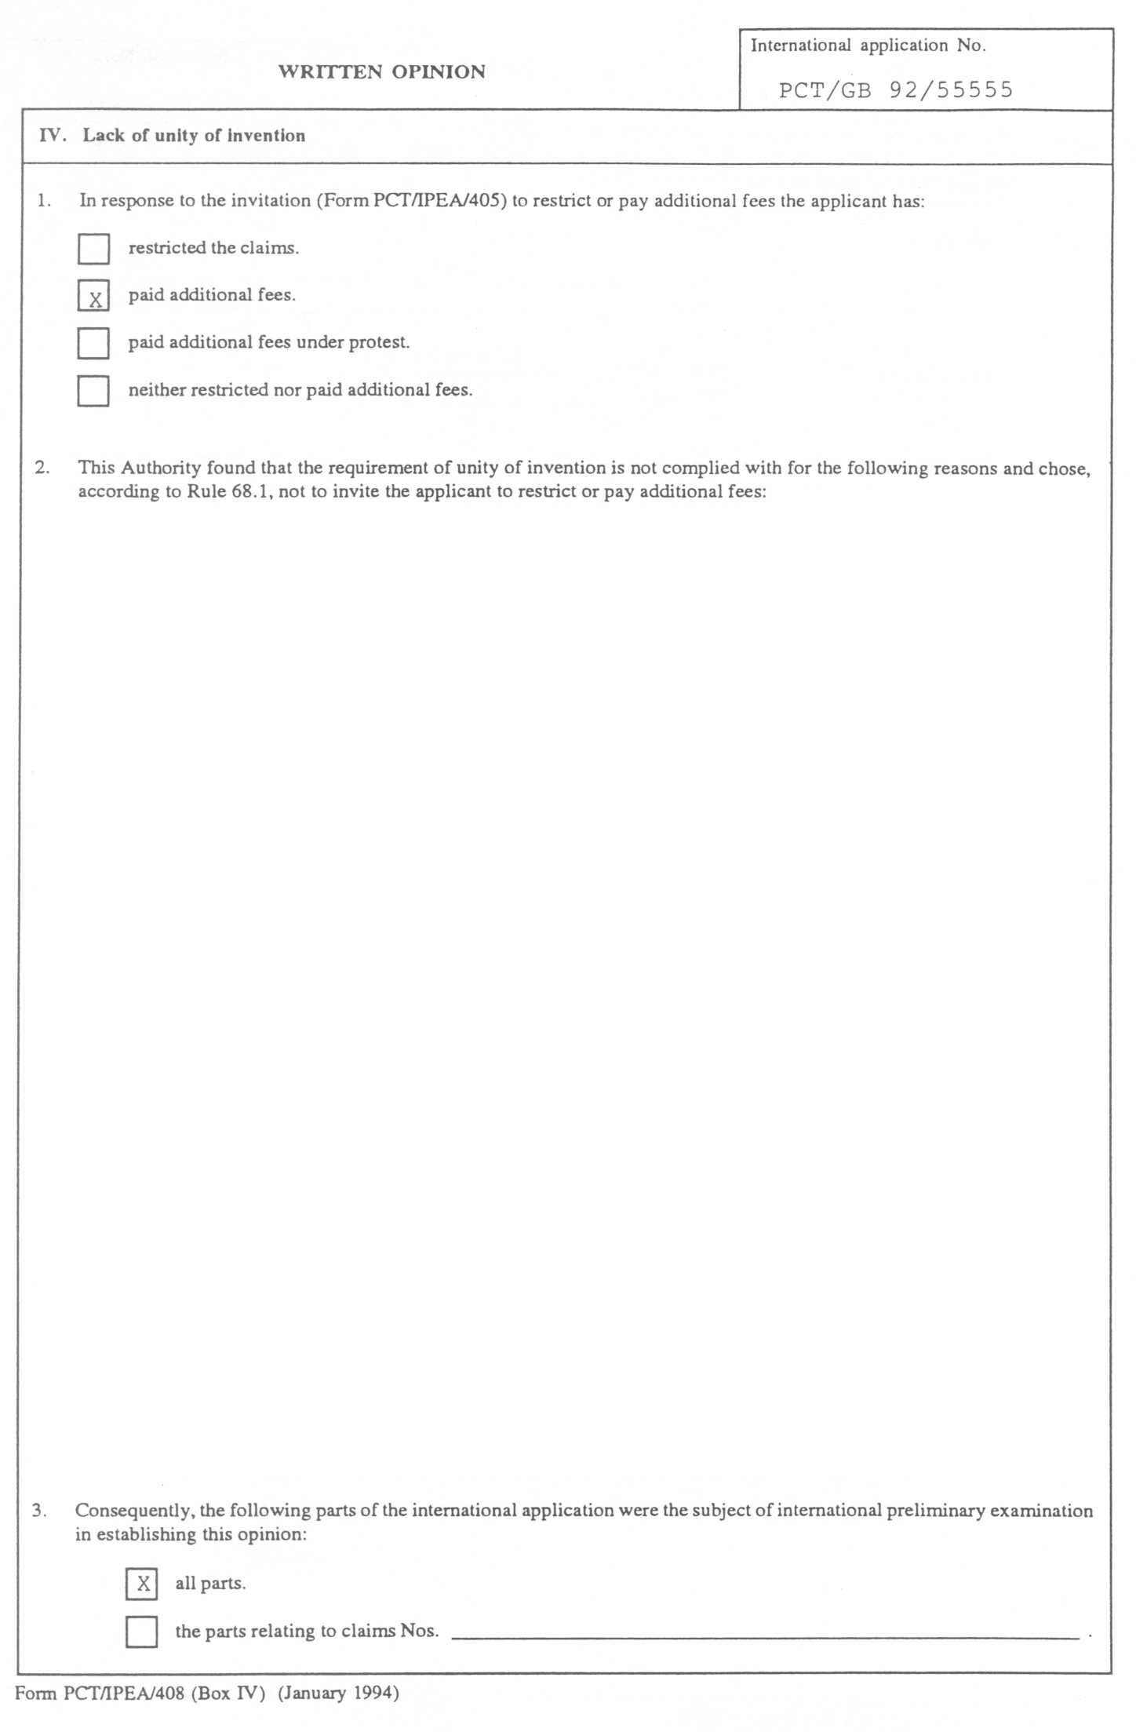

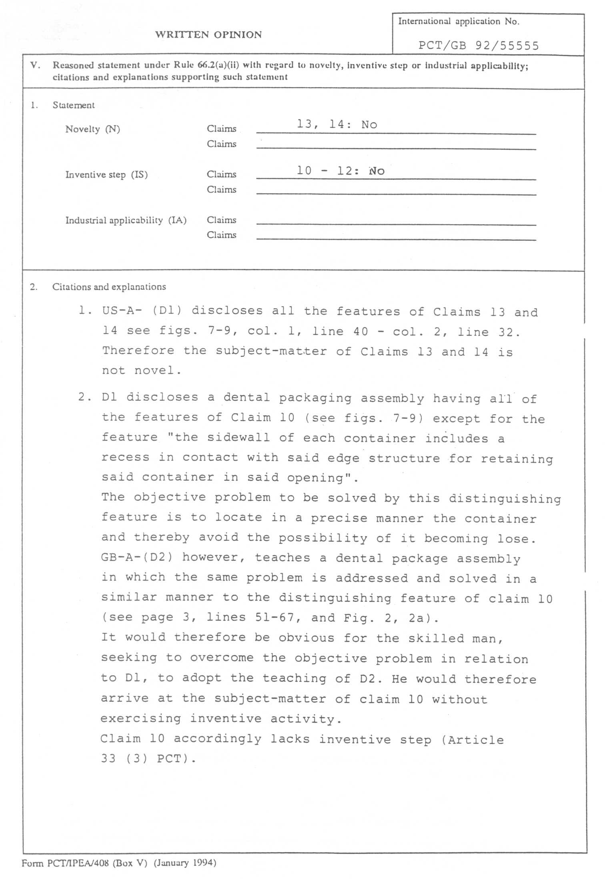

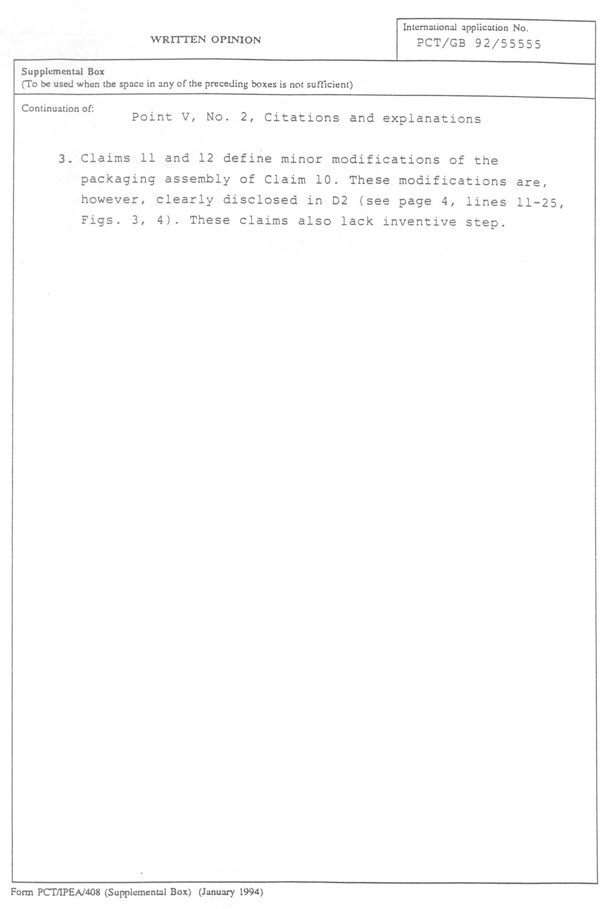

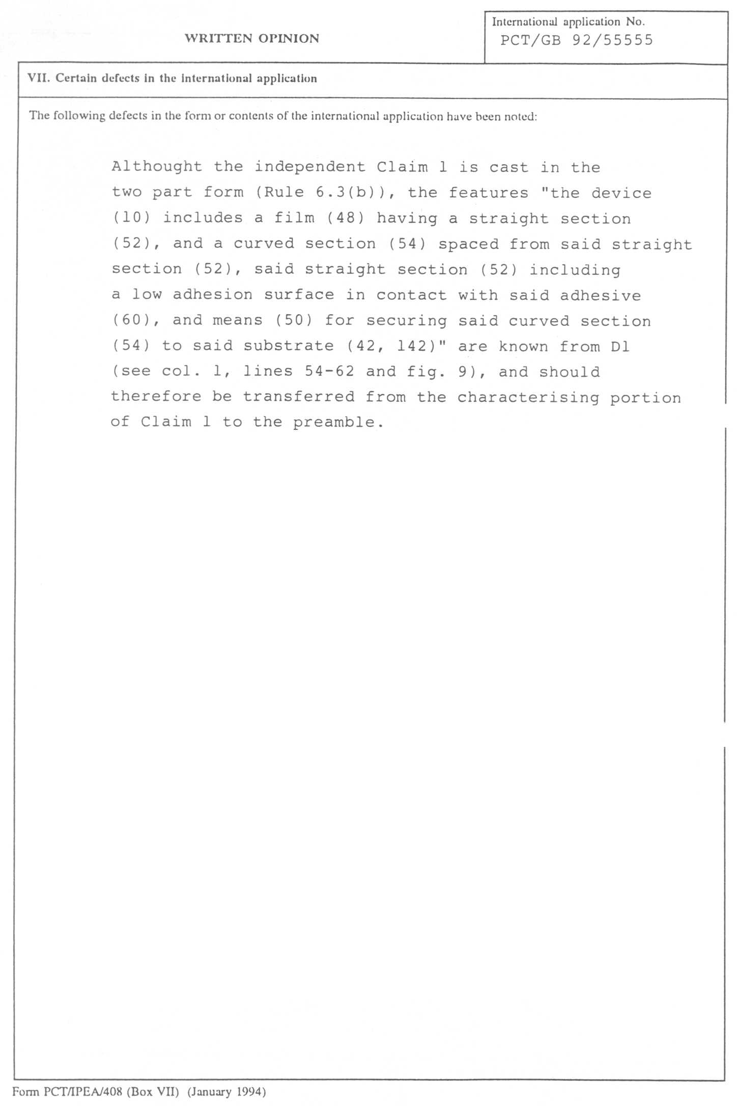

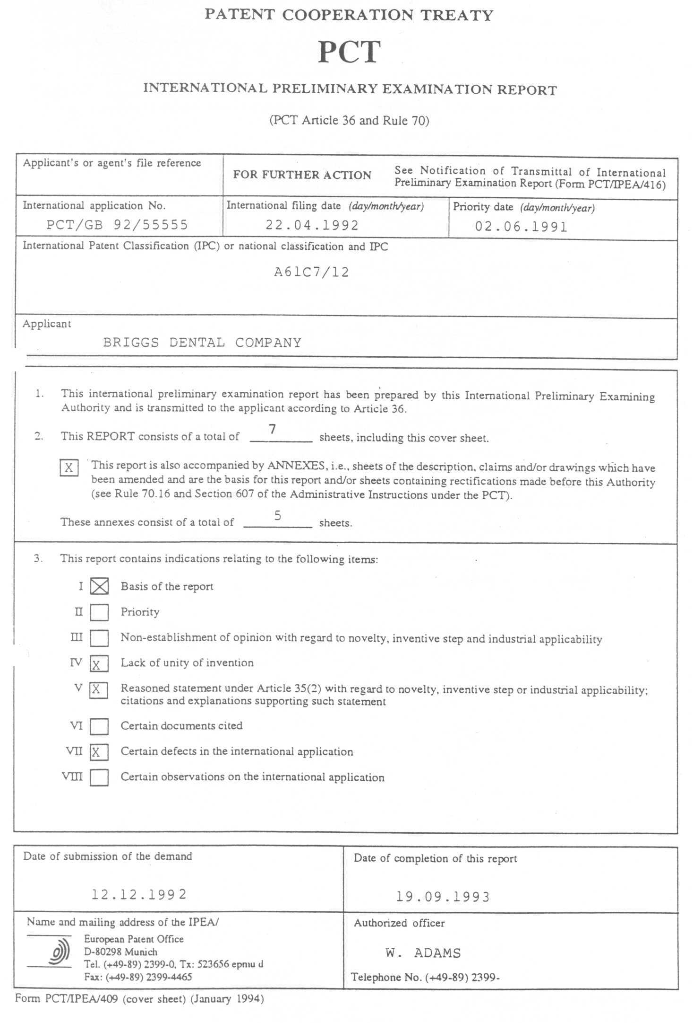

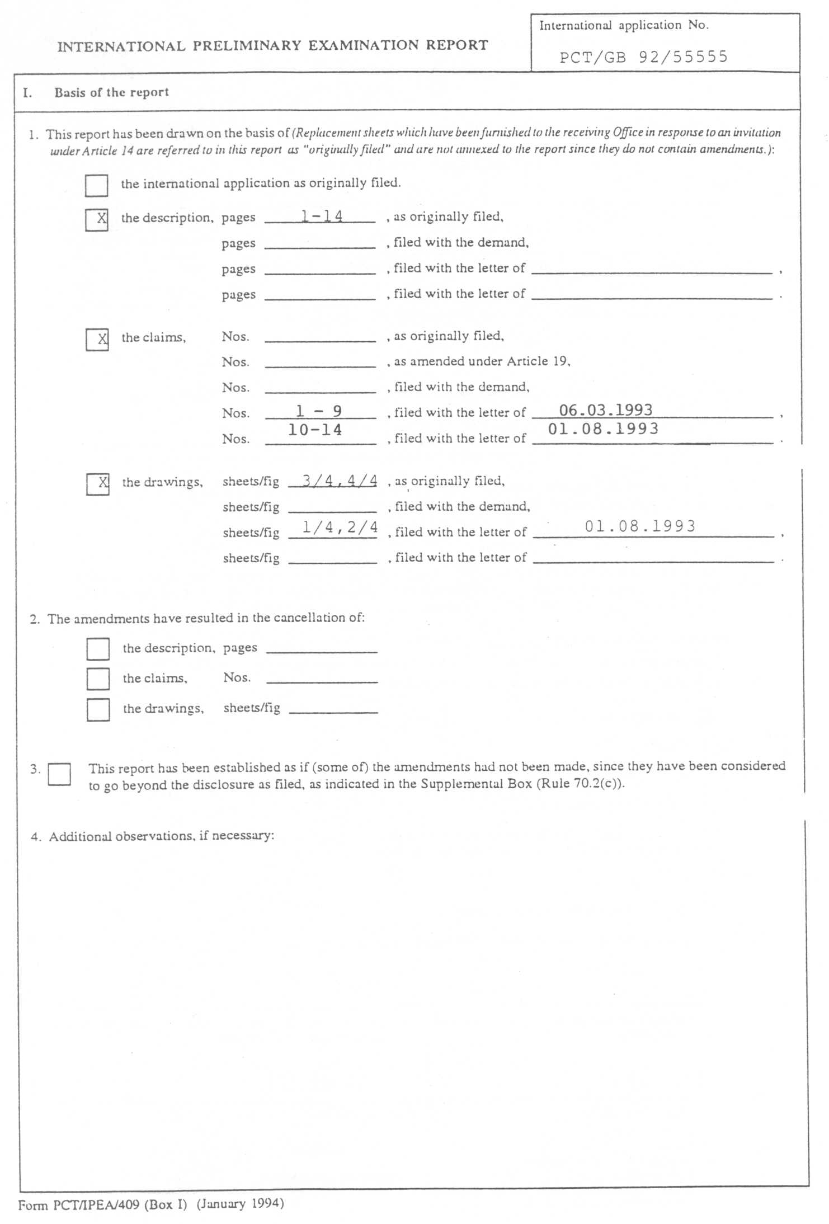

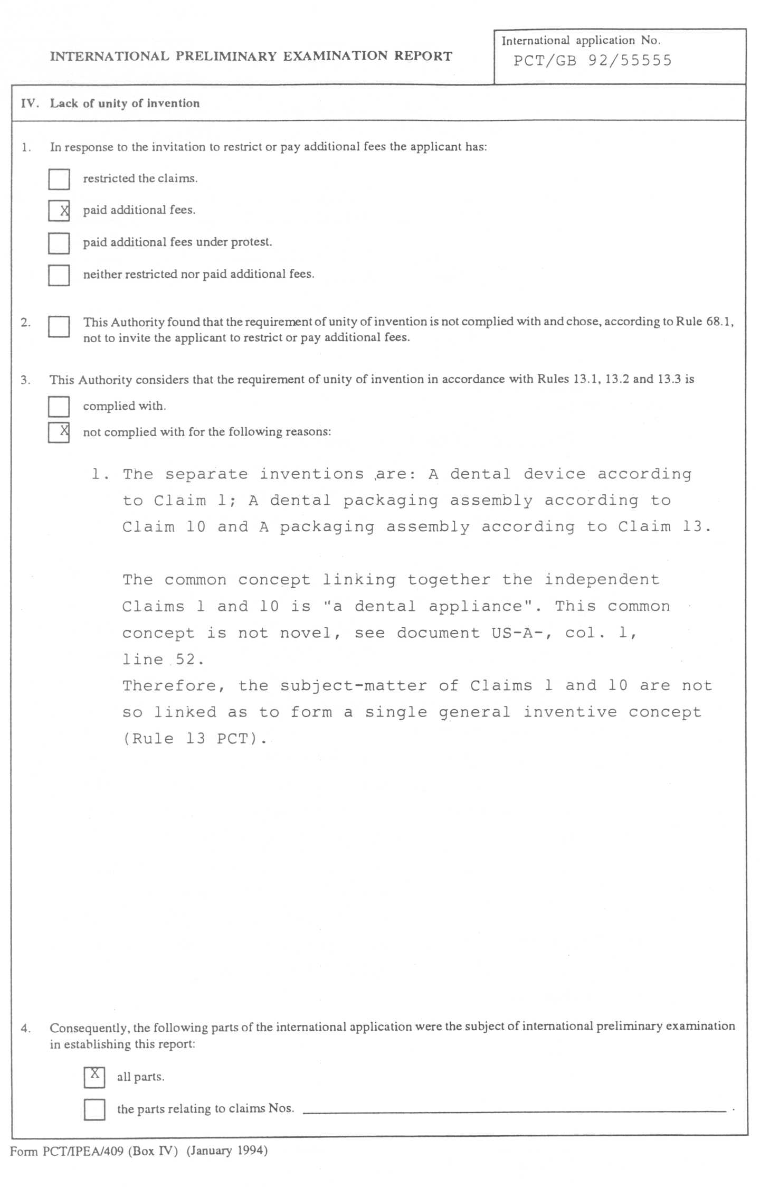

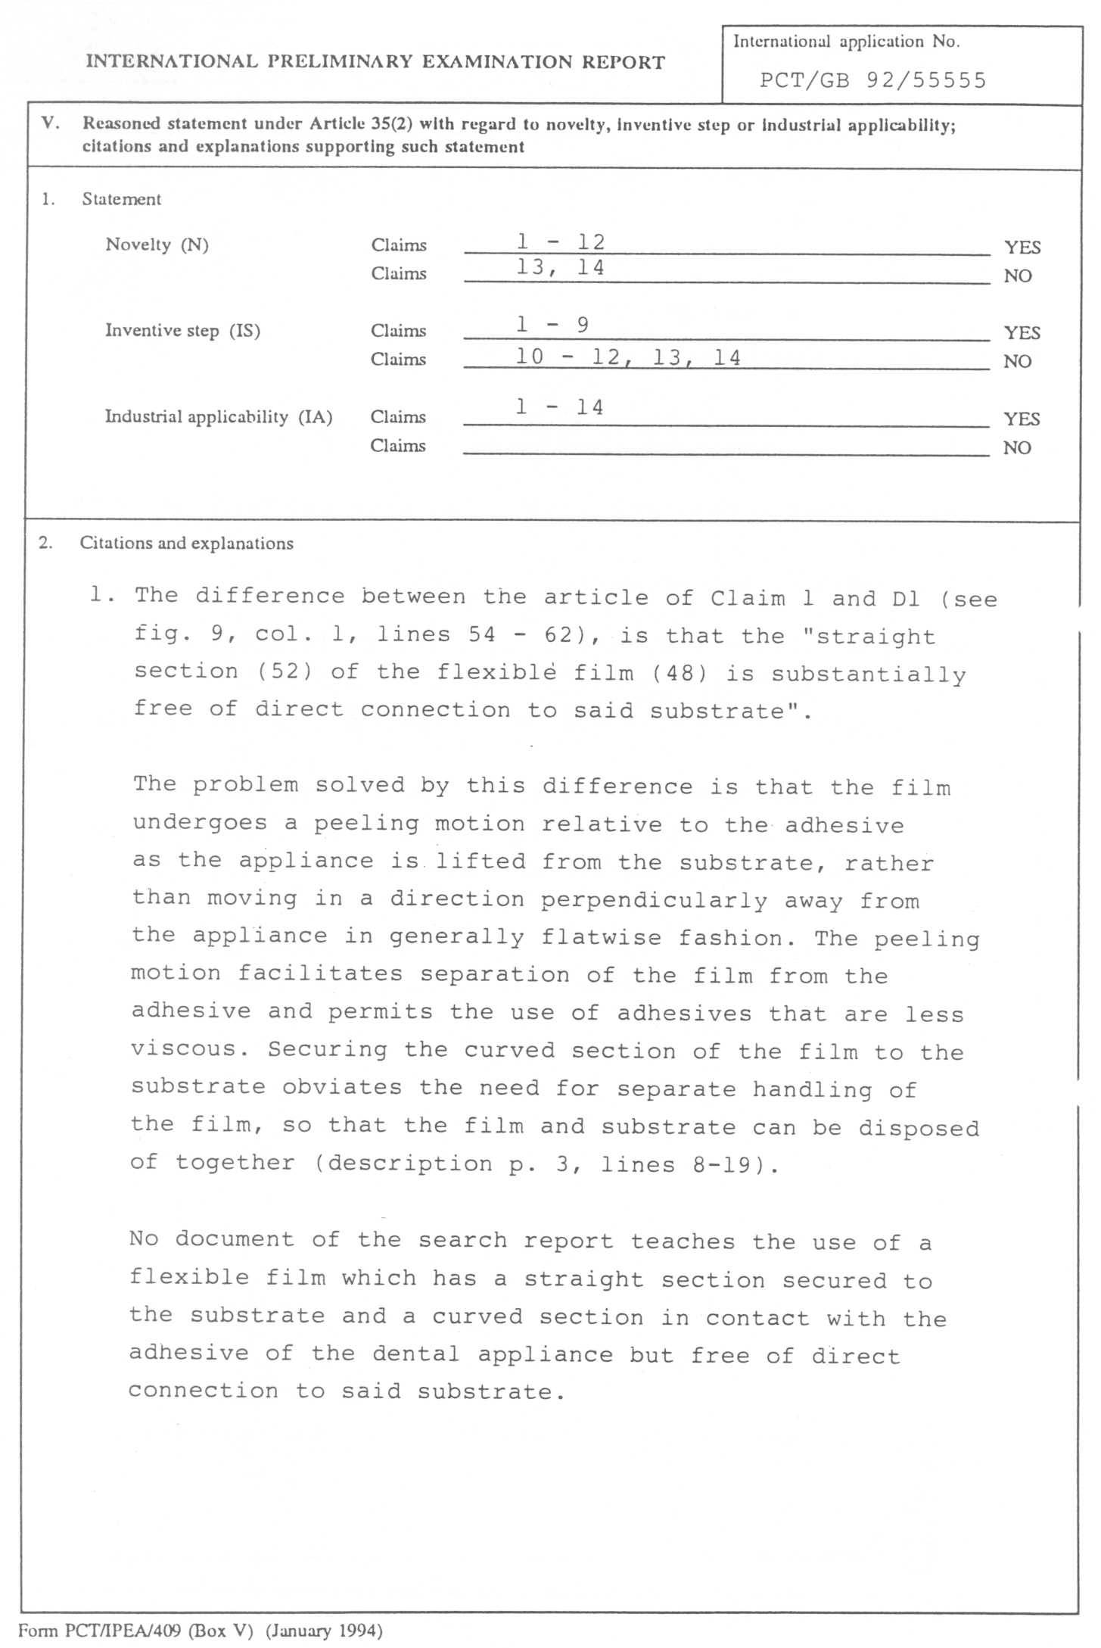

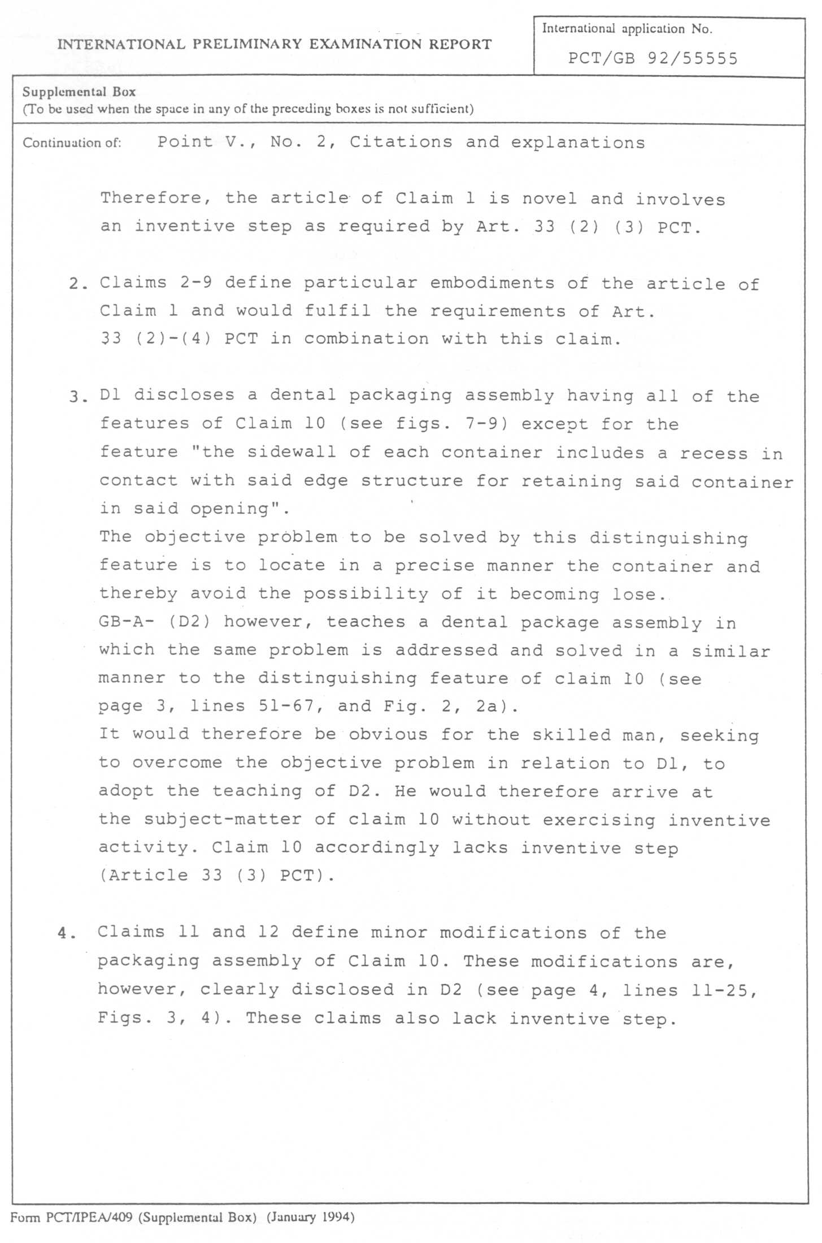

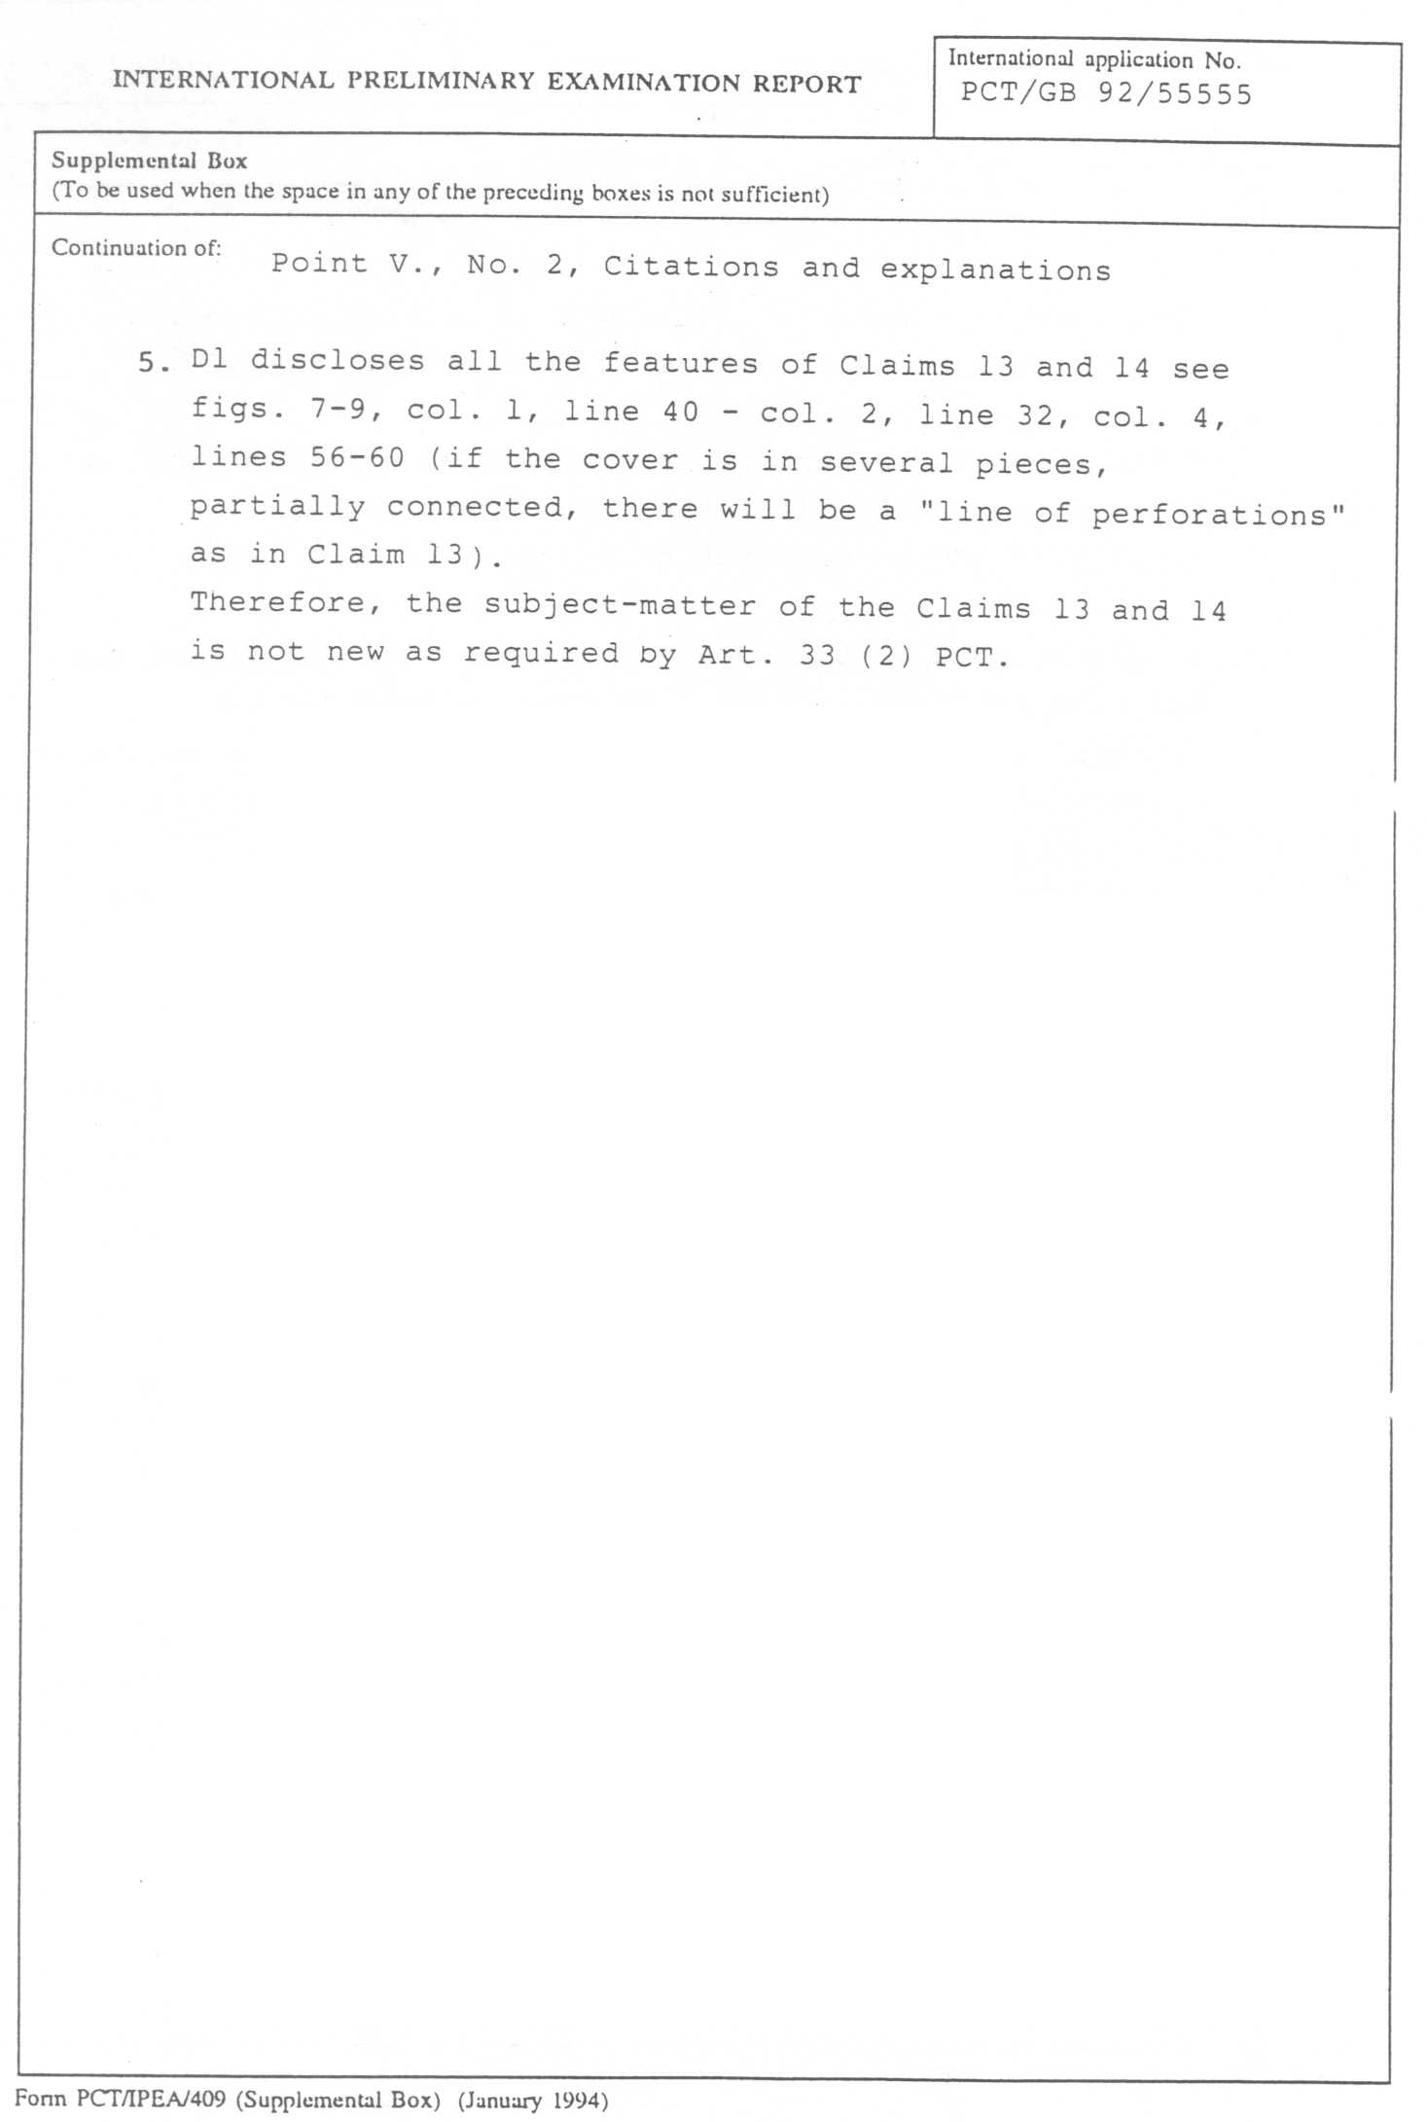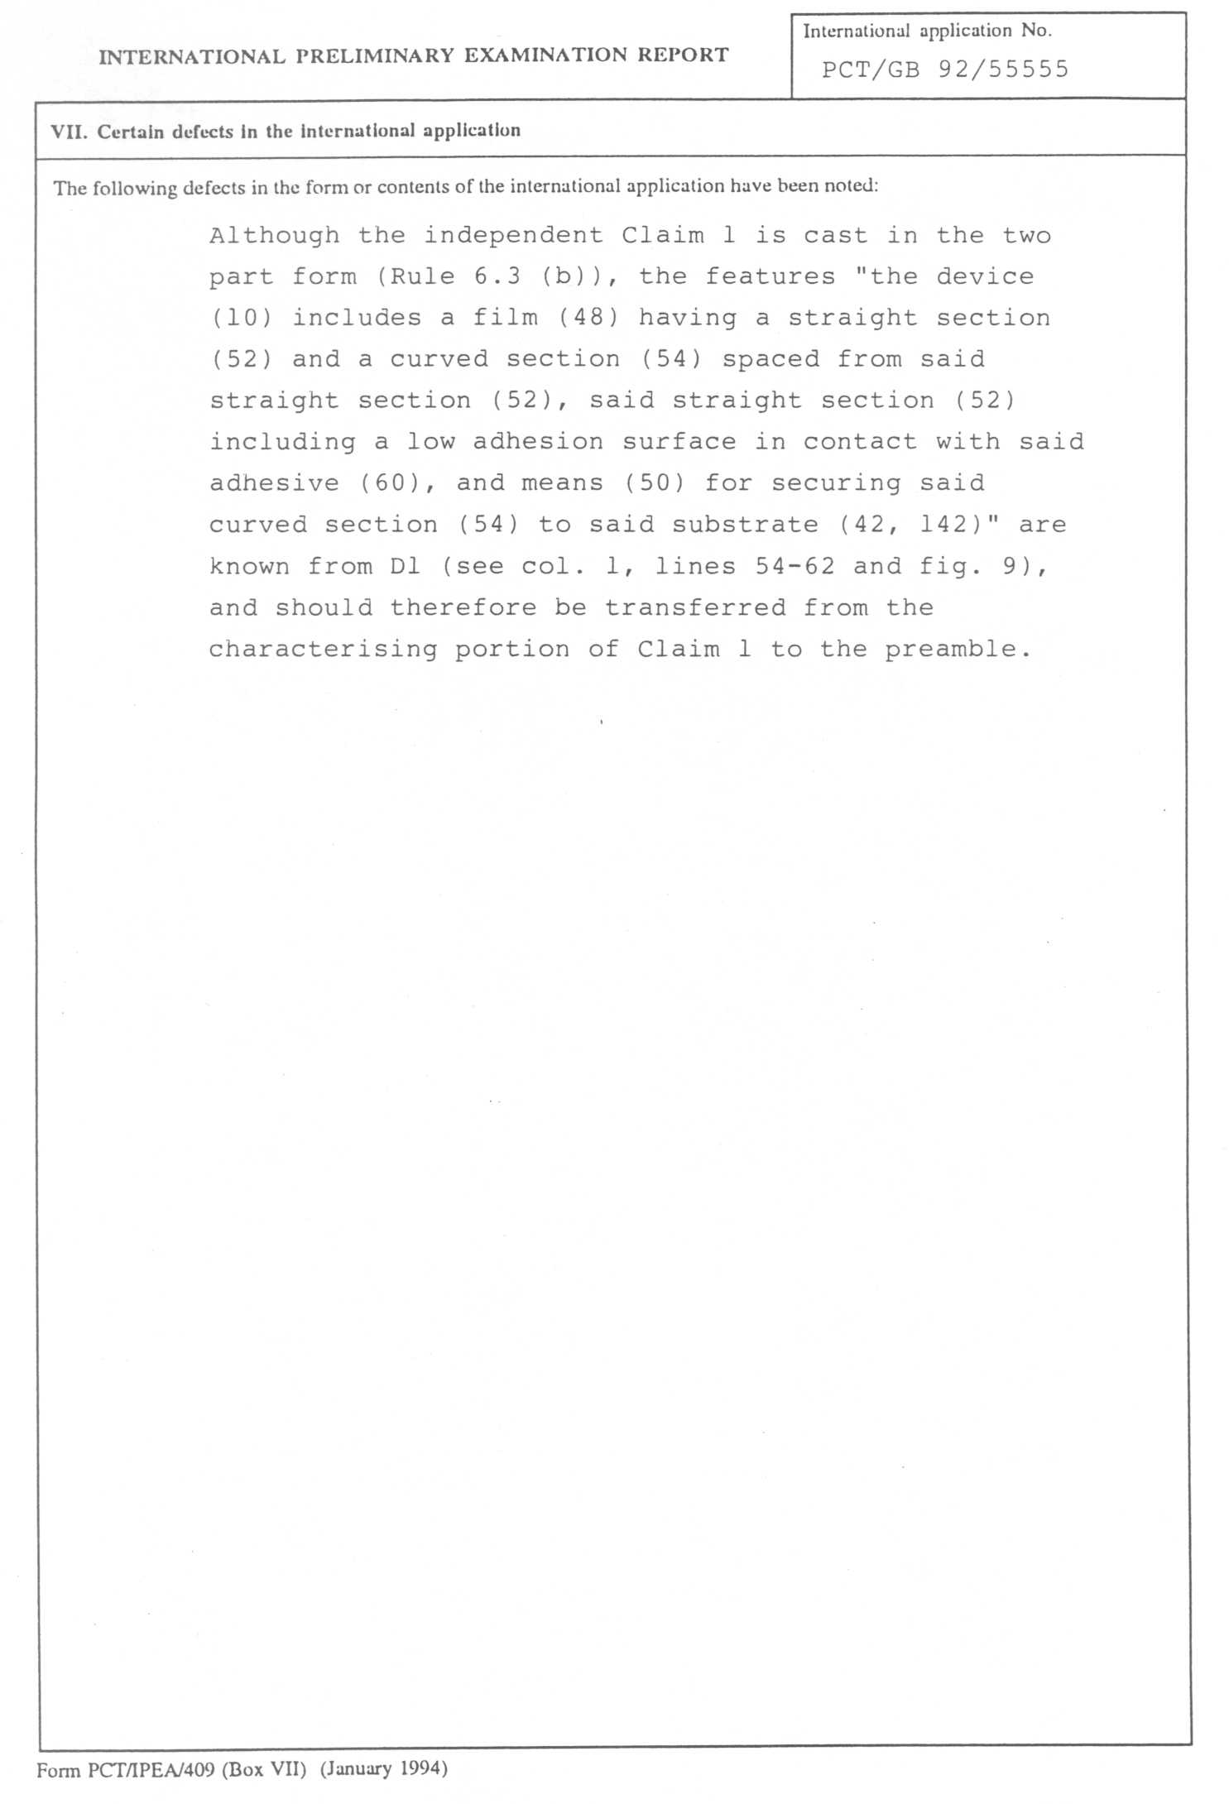

[End of Annex and of document]

