WIPO |  | PCT/MIA/IV/2  ORIGINAL: English  DATE: March 17, 1994
WORLD INTELLECTUAL PROPERTY ORGANIZATION
GENEVA
International patent cooperation union
(PCT union)
Meeting of international authorities
under the PCT
Fourth Session
Geneva, June 27 to July 1, 1994
COmments ON AND PROPOSALS FOR MODIFICATION OF THE
PCT PRELIMINARY EXAMINATION GUIDELINES
RECEIVED FROM INTERNATIONAL AUTHORITIES
Document prepared by the International Bureau
1 The Annex to this document contains comments on and proposals for modification of the PCT Preliminary Examination Guidelines (document PCT/GL/3) provided by the United States Patent and Trademark Office.
2. These comments and proposals, which will serve as a topic for discussion at the fourth session of the Meeting of International Authorities under the PCT, are hereby provided to all International Authorities for information and comment.
[Annex follows]

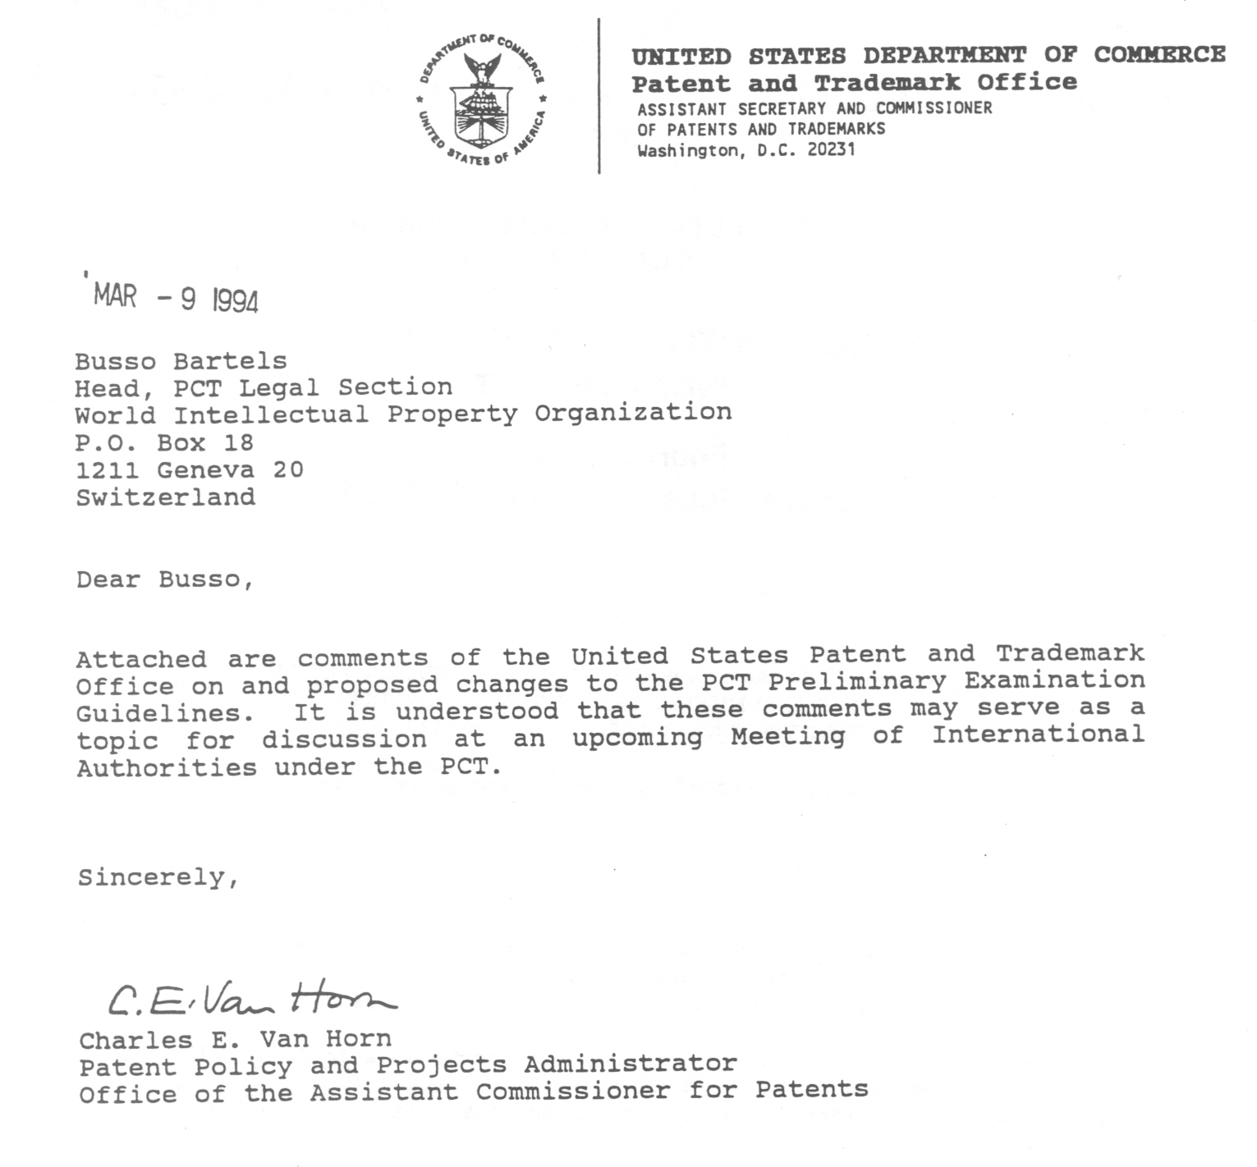
IPEA GUIDELINES

The IPEA Guidelines should allow some variation in practice, and
make clear when IPEAs are taking a different approach. As many of
the differences between IPEAs are no doubt based on differences in
substantive law, consistency in practice is dependent on
consistency in substantive law principles. Although the proposals
made below would be consistent with U.S. law and practice, we have
no intent of asking other authorities to change their practice to
be consistent with our law. Likewise, however, we do not intend to
have our examiners operating under different standards of examining
practice for PCT and national applications. Unless the Guidelines
are amended to reflect differences among the IPEAs, the national
offices are not likely to fully appreciate the content of the
preliminary examination report.

CHAPTER I

PARAGRAPH 3.3 – The PCT should not impose rigid procedures which
require examiners to adopt practices substantially different from
their national practice. Therefore, provisions should be made for
some flexibility in the Guidelines. Accordingly, paragraph 3.3 of
Chapter I should be modified as follows (note that additions are
underlined and deletions are indicated in brackets) :

  - The Guidelines are intended to cover typical
occurrences. They should therefore be considered only as
general directives; examiners will have to go beyond the
instructions in exceptional cases. Nevertheless,
applicants can expect the International Preliminary
Examining Authorities to act, as a general rule, in
accordance with the Guidelines until such time as they
are revised. It should be noted also that the Guidelines
do not have the binding authority of a legal text, and as
such, these Guidelines are merely advisory to the
International Preliminary Examining Authorities. For the
ultimate authority on questions concerning international
preliminary examination, it is necessary to refer to the
PCT itself interpreted, where necessary, by reference to
the Minutes of the Washington Diplomatic Conference.

CHAPTER II

PARAGRAPH 2.2 – In U.S. practice, the abstract has legal effect
and can be used to justify adding subject matter found in the
abstract to the description. Specifically, U.S. law considers the
abstract to be a part of the specification of an application which
can be relied upon to provide an acceptable disclosure of the
claimed invention. In re Armbruster, 185 USPQ 152 (CCPA 1975).
Accordingly, the last sentence should be rewritten as follows:

  - Rule 8 delineates the requirements for the abstract
1
and it is for the International Searching Authority (Rule
38.2) to establish its final form (see Chapter XI,
paragraphs 1 to 5 of the PCT Search Guidelines). The
examiner will not be concerned with seeking any amendment
of the abstract. He should, however, note that the
abstract [has no legal effect on the international
application containing it; for instance, it] cannot be
used to interpret the scope of protection [or to justify
the addition of new subject matter].

PARAGRAPH 4.4 – The U.S. takes a relatively strict position as
to what constitutes new matter. The provisions of this paragraph
which instruct the examiner to invite amendments containing
additional descriptions of the prior art may involve the
solicitation of new matter under U.S. law.

An applicant for a U.S. patent need only provide a disclosure which
enables one skilled in the art to make and use the invention.
There is no requirement that applicant describe the background of
the invention – the state of the prior art at the time the
invention was made.

An applicant may not introduce new matter into an application after
the filing date. New matter is generally considered to be
information that is not explicitly, implicitly, or inherently
disclosed in the application as filed. Generally, the prohibition
against adding new matter does not depend on whether the
information was known at the time the application was filed. It
has been held that the specification need not include that which is
known and available to the public at the time the invention was
made. In fact, "a patent need not teach, and preferably omits,
what is well known in the art." Hybritech. Inc. v. Monoclonal
Antibodies, Inc., 231 USPQ 81 (Fed. Cir. 1986).

The introduction of background information to an application is
generally not permitted. For example, in General Railway Signal
Co. v. Thullen, 32 App. D.C. 575, a general reference to
transformers in the original application was not considered to have
been a sufficient disclosure to justify entry of an amendment to
specific transformers. However, in In re Chaplin, 77 USPQ 601
(CCPA 1948), an applicant was permitted to amend his specification
to cite expired patents to illustrate mechanisms for driving
various parts of a machine that were referred to in the original
specification as being well known in the art. The court in Chaplin
relied on the Supreme Court decision in The Webster Loom Co. v.
Higgins, 105 U.S. 580 (1882) which stated "That which is common and
well known is as if it were written out in the patent and
delineated in the drawings."

Accordingly, such amendments require careful scrutiny and should
not be solicited. Such amendments may be added during the national
phase if the national law so permits.

2
Rewrite paragraph 4.4 as follows:

4.4 Background art. The description should also mention
any background art of which the applicant is aware, and
which can be regarded as useful for understanding the
invention and its relationship to the prior art;
identification of documents reflecting such art,
especially patent specifications, should preferably be
included. This applies in particular to the background
art corresponding to the first or "prior art" portion of
the independent claim or claims (see Chapter III,
paragraph 2.2). The insertion into the statement of prior
art of references to documents identified subsequently,
for example by the search report, [should be invited] may
be permitted, [where necessary, to put the invention into
proper perspective,] provided that the amendment would
not go beyond the disclosure in the international
application as filed. For instance, while the originally
filed description of prior art may give the impression
that the inventor has developed the invention from a
certain point, the cited documents may show that certain
stages in, or aspects of, this alleged development were
already known. [In such a case, the examiner should
invite the inclusion of a reference to these documents
and a brief summary of the relevant contents. The
subsequent inclusion of such a summary in the description
does not contravene Article 34(2)(b). The latter merely
lays down that, if the application is amended, for
example by limiting it in the light of additional
information on background art, its subject matter must
not extend beyond the content of the application as
filed. But the subject matter of the application within
the meaning of Article 34(2)(b) is to be understood–
starting off from the prior art-as comprising those
features which, in the framework of the disclosure
required by Article 5, relate to the invention (see
Chapter VI, paragraph 7.8). References to the prior art
introduced after filing must be purely factual. Any
alleged advantages of the invention must be adjusted if
necessary in the light of the prior art.] New statements
of advantage are permissible provided that they do not
introduce into the description matter which could not
have been deduced from the application as originally
filed (see Chapter VI, paragraph 7.9).

CHAPTER III

PARAGRAPH 3.7a – U.S. law and PCT Rule 6.4(b) provide that a
dependent claim must include all of the limitations found in the
claim from which it depends. U.S. practice does not permit a
claim in dependent form which does not include all of the
limitations of its parent claim. In addition, paragraph 3.7a
3
indicates that if a product is unobvious, a process which results
in or uses that product is also unobvious. This interpretation is
not consistent with current U.S. law. We propose that the first
two sentences of paragraph 3.7a be retained and the remainder be
eliminated.

3.7a A claim may also contain a reference to another
claim even if it is not a dependent claim as defined in
Rule 6.4. One example of this is a claim referring to a
claim of a different category (e.g., "Apparatus for
carrying out the process of Claim 1 …", or "Process for
the manufacture of the product of Claim 1 ...").
Similarly, in a situation like the plug and socket
example in paragraph 3.3 of this Chapter, a claim to the
one part referring to the other cooperating part (e.g.,
"plug for cooperation with the socket of Claim 1 ...") is
not a dependent claim. [References from one claim to
another may also occur where alternative features which
may be substituted for one another are claimed in
separate claims. Thus, there may be a first independent
Claim 1 for a machine including, inter alia, a feature X
followed by further claims for alternatives such as "A
machine according to Claim 1 modified in that feature X
is replaced by feature Y." In all these examples, the
examiner should carefully consider the extent to which
the claim containing the reference necessarily involves
the features of the claim referred to and the extent to
which it does not. In the case of a claim for a process
which results in the product, of a product claim, or a
claim for the use of that product, if the product claim
does not give rise to objections on novelty or inventive
step grounds, then no separate examination for the
obviousness of the process or use claim is necessary (see
Chapter IV, paragraph 8.5). In all other instances, the
fact that the claim referred to contains novel and
inventive matter does not necessarily imply that the same
is also true of the independent claim containing the
reference.]

PARAGRAPH 4.8 – The first example in this paragraph is
inconsistent with U.S. practice in that a fish-hook may, in certain
devices, such as miniature or toy cranes, be suitable for or
capable of functioning as a hook for a crane. Therefore, we
propose to modify this paragraph as follows:

4.8 If a claim commences with such words as "Apparatus
for carrying out the process, etc., ..." this must be
construed as meaning merely apparatus suitable for
carrying out the process. Apparatus which otherwise
possesses all of the features specified in the claim, but
which would be unsuitable for the stated purpose or which
would require modifications to enable it to be so used,
4
should not normally be considered as coining within the
scope of the claim. Similar considerations apply to a
claim for a product for a particular use. [For example/
if a claim refers to "a hook for a crane," this implies,
e.g., particular dimensions and strength in the hook.
Therefore, a fish-hook could never come within the
claim.] For example , if a claim refers to a "mold for
molten steel," this implies certain limitations for the
mold. Therefore, a plastic ice cube tray with a melting
point much lower than that of steel would not come within
the claim. Similarly, a claim to a substance or
composition for a particular use should be construed as
meaning a substance or composition which is in fact
suitable for the stated use; a known product which is per
se the same as the substance or composition defined in
the claim, but which is in a form which would render it
unsuitable for the stated use, would not deprive the
claim of novelty.

PARAGRAPH 4.9 – U.S. law does not permit claims drawn to a "use
of" a substance. Such "use of" claims have been held to be
improper process claims in that they fail to recite any process
steps, and were accordingly found to be indefinite. Ex parte
Erlich, 3 USPQ2d 1011 (BPAI 1986). Other cases have held that "use
of claims" do not constitute a process and therefore do not qualify
as statutory subject matter under 35 U. S. C. 101. Ex parte Dunki,
153 USPQ 678 (Bd. App. 1967), Clinical Products. Ltd. v. Brenner,
255 F.Supp. 131, 149 USPQ 475 (D.D.C. 1966). Accordingly,
paragraph 4.9 of Chapter III should be deleted in its entirety.

CHAPTER IV

PARAGRAPH 5.2 – Under U.S. law, non-patent literature having a
publication date after the relevant date of an application may
still constitute prior art or be relevant to the claimed invention
in certain circumstances. For example, a document published after
the filing date of an application may be used to establish that
undue experimentation would be required to make or use the
invention, that a recitation absent from the claims is critical,
that the invention is inoperative, that a claim is indefinite or
that characteristics of a prior art product were known. See In re
Hogan, 194 USPQ 527 (CCPA 1977). Accordingly, provision should be
made to cite such documents. An appropriate amendment to PCT Rule
64 may be in order. Also, under U.S. law, a written work must be
accessible to the public to qualify as prior art. For example, a
printed work must be cataloged and not merely placed on the shelf
of some library. In addition, there is no need to again cite
documents listed in the search report. Therefore, the phrase ",
but are mentioned in the preliminary examination report" should be
deleted as indicated below.

5.2 A written disclosure, i.e., a document, should be
5
regarded as made available to the public if, at the
relevant date (as to "relevant date," see paragraph 5.4
of this Chapter), it was [possible for members of the
public to gain knowledge of the content of the document]
accessible to the public and there was no bar of
confidentiality restricting the use or dissemination of
such knowledge. As a general rule, no non-patent
document will be cited in the international search report
if the date of publication or public availability of the
document concerned is clearly the same as, or later than,
the filing date of the international application.
However, patent documents published on or after the
filing date of the searched application will be cited in
the search report if the filing or priority date of such
published application is earlier than the filing date of
the searched application. Such published patent
documents, although cited in the search report, are not
considered as prior art for the purposes of Article 33(2
and (3) [, but are mentioned in the preliminary
examination report]. The international search report may
have cited a document where there is difficulty in
establishing whether the date of publication or public
availability of the document is or is not the same as, or
later than, the filing date of the international
application. The International Searching Authority will
have tried to remove any doubt that may exist.
Additional documents providing evidence in the case of
doubt may have been cited. Any indication in a document
of the date of its publication should be accepted as
correct by the examiner unless proof to the contrary has
been offered, e.g., by the International Searching
Authority, showing earlier publication, or by the
applicant, showing later publication. Also, if there is
any ambiguity as to the precise date of publication of a
document, the International Searching Authority may have
established a publication date, e.g., the date of receipt
in a library to which the public has access. If the
applicant presents sound reasons for doubting that the
document forms part of the prior art in relation to his
international application and any further investigation
does not produce evidence sufficient to remove that
doubt, the examiner should not pursue the matter further.

PARAGRAPHS 5.3 & 5.4 – Move "64.1(b)" in the margin from
paragraph 5.3 to 5.4, since paragraph 5.4 deals with the relevant
date.

PARAGRAPH 8.7 - U.S. law provides that the number of documents
which are combined is not relevant to a finding of obviousness.
Therefore, the 4th line from the end of page 3 9 should be deleted.
In addition, the phrase "it would be natural" is unclear; the
phrase ––there is reasonable basis–– is more appropriate.

6
8.7 In considering whether there is inventive step as
distinct from novelty (see section 7 of this Chapter), it
is permissible to combine the disclosure of two or more
documents or parts of documents, different parts of the
same document or other pieces of prior art, but only
where such combination would be obvious to the person
skilled in the art. In determining whether it would be
obvious to combine two or more distinct documents, the
examiner should have regard to the following:

(i) whether the nature and content of the
documents are such as to make it likely or unlikely that
the person skilled in the art, when concerned with the
problem solved by the claimed invention, would combine
them;

(ii) whether the documents come from similar,
neighboring or remote technical fields. [ ;

(iii) the number of documents which need to be
combined.]

The combining of two or more parts of the same document
would be obvious if [it would be natural] there is
reasonable basis for the person skilled in the art to
associate these parts with one another. It would
normally be obvious to combine with other prior art
documents a well-known text book or standard dictionary;
this is only a special case of the general proposition
that it is obvious to combine the teaching of one or more
documents with the common general knowledge in the art.
It would, generally speaking, also be obvious to combine
two documents, one of which contains a clear and
unmistakable reference to the other.

CHAPTER V

PARAGRAPH 1.5 – U.S. law does not permit two different priority
dates for a single claim. Specifically, to be entitled to foreign
priority under U.S. law (35 U.S.C. 119), the priority application
must provide a sufficient written description of the entire subject
matter of the claim in question. In re Gosteli, 10 USPQ2d 1614
(Fed. Cir. 1989) . In addition, a mere reference in one application
to a second application may not be sufficient to establish that the
subject matter of the first application may form a combination with
the subject matter of the second application. Accordingly, the
following changes should be made.

1.5 An international application may claim rights of
priority based on more than one earlier application
("multiple priorities"), even if they originate in
different countries. The earliest application must have
7
been filed not more than 12 months before the date of
filing of the international application. An element of
an international application will be accorded the
priority date of the earliest priority application which
discloses it. If, for instance, the international
application describes and claims two embodiments (A and
B) of an invention, A being disclosed in a French
application and B in a German application, both filed
within the preceding 12 months, the priority dates of the
French and German applications may be claimed for the
appropriate parts of the international application;
embodiment A will have the French priority date and
embodiment B will have the German priority date. [If
embodiments A and B are claimed as alternatives in one
claim, these alternatives will likewise have different
priority dates.] If[, on the other hand,] an
international application is based on one earlier
application disclosing a feature C and a second earlier
application disclosing a feature D, neither disclosing
the combination of C and D, a claim to that combination
will be entitled only to the date of filing of the
international application itself. In other words, it is
not [normally] permitted to make a mosaic of the priority
documents. An exception might arise where one priority
document contains a reference to the other and explicitly
states that features from the two documents can be
combined in a particular manner.

CHAPTER VI

PARAGRAPH 4.12 – A letter must be filed with each amendment which
draws attention to the differences between the replaced sheets and
the replacement sheets. Accordingly, the following changes should
be made in the first sentence of this paragraph.

4.12 When amendments to the description, claims or
drawing are made under Rule 66.8, [they may be
accompanied by an explanation] they must be accompanied
by a letter which draws attention to the differences
between the replaced sheets and the replacement sheets.
These amendments may have been submitted to avoid
possible objections of lack of novelty or lack of
inventive step in view of the citations listed in the
international search report: to meet any objections noted
by the International Searching Authority under Article
17(2)(a)(ii) (i.e., that all or at least some claims do
not permit a meaningful search) or under Rule 13 (i.e.,
that there is a lack of unity of invention); or to meet
objections that may be raised for some other reason,
e.g., to remedy some obscurity which the applicant
himself has noted in the original documents.

8
PARAGRAPH 8.16 – This paragraph indicates that the IPER must be
signed. This is inconsistent with Rule 70.14, which indicates that
the IPER "shall indicate the name of the officer responsible for
the report."

In the next to last line of this paragraph, change "be signed by"
to – –indicate– –.

8.16 When completing the certification of the report,
the examiner must indicate the date on which the demand
for international preliminary examination was submitted
and the date on which the report was completed and the
name and address of the International Preliminary
Examining Authority. These last-mentioned items may
either be completed when including the other data or when
completing the certification. Every international
preliminary examination report must [be signed by]
indicate the name of an authorized officer of the
International Preliminary Examining Authority responsible
for that report.

CHAPTER VII

PARAGRAPH 15.1 – In line 6, "sends" should be changed to – –may
send– –. This change gives flexibility to the IPEA & may decrease
the amount of paper generated.

15.1 If the International Preliminary Examining
Authority finds one or more defects referred to in Rule
60.1(a) and (b), it invites the applicant to correct the
defects within one month from the date of the invitation
(Form PCT/IPEA/404). The International Preliminary
Examining Authority notifies the International Bureau by
sending it a copy of the invitation. Where the defect
consists of the lack of the signature and Rule 53.8(b)
does not apply (see paragraph 11 of this Chapter), the
International Preliminary Examining Authority [sends] may
send to the applicant, together with the invitation to
correct, a copy of the last sheet of the demand which the
applicant returns after affixing thereto the prescribed
signature.

9

[End of Annex and of document]

