WIPO |  | PCT/MIA/III/4  ORIGINAL: English  DATE: June 8, 1993
WORLD INTELLECTUAL PROPERTY ORGANIZATION
GENEVA
International patent cooperation union
(PCT union)
Meeting of international authorities
under the PCT
Third Session
Geneva, June 21 to 25, 1993
DRAFT OF PROPOSED MODIFIED FORMS FOR USE BY
THE INTERNATIONAL PRELIMINARY EXAMINING AUTHORITIES
Document prepared by the International Bureau
1 The Annex to this document contains draft modified Forms for use by the
International Preliminary Examining Authorities. It also contains, for easy
reference, a list of those Forms.

2. The proposals take into account comments received from International
Preliminary Examining Authorities, based on their experience with the Forms
since July 1, 1992 (see document PCT/MIA/III/2), as well as the results of a
study undertaken by the International Bureau.

3. The proposed modifications of Forms PCT/IPEA/410 and 411 are based on
comments received from the United States Patent and Trademark Office (USPTO).
The proposed modifications of Forms PCT/IPEA/408, 409 and 428 are based on the
comments received from the USPTO and the Swedish Patent Office and on the
results of the study undertaken by the International Bureau.

4. The major proposed modifications relate to the written opinion (Form
PCT/IPEA/408) and the international preliminary examination report (Form
PCT/IPEA/409). They are outlined in the following paragraphs. Reference is
also made to the proposed modifications outlined in the comments and
observations of the International Preliminary Examining Authorities contained
in document PCT/MIA/III/2.

5. On the first sheet of Form PCT/IPEA/409, in connection with the basis of
the report, it is proposed to modify item 2 to make it clear that the sheets
of the description, claims and/or drawings annexed to the report may contain
claims amended under Article 19 (i.e. amendments made before international
preliminary examination started).

6. It is also proposed to modify Box I, Basis of the report, of Form
PCT/IPEA/409, by adding,

(i) under item 1, a reminder for the benefit of examiners in the
International Preliminary Examining Authority and in the elected Offices as
well as of applicants that “replacement sheets” furnished in response to an
invitation under Article 14 must be referred to as “originally filed” and not
as “amended”, and that, as a consequence, these sheets are not to be annexed
to the report; and

(ii) under item 2, a separate check box for each element of the
international application which has been cancelled as a result of amendments.

7. In connection with the indications on lack of unity (Box IV), it is
proposed to provide check-boxes for all possible situations which may occur
depending on whether or not the International Preliminary Examining Authority
invited the applicant to restrict the claims or pay additional fees, whether
or not the applicant responded, either by restricting claims, or by paying
additional fees and if so, whether the payment was made under protest. It is
further proposed to provide for an indication of the reasons for the finding
of lack of unity, not only where Rule 68.1 applies (i.e., where the
International Preliminary Examining Authority chose not to invite the
applicant to restrict the claims or pay additional fees) but in all cases.
This is essential for the elected Offices and will make the report more useful
and self-sufficient for the reader.

8. As far as the layout and presentation of the report are concerned, the
following modifications are proposed in order to allow each International
Preliminary Examining Authority to more easily produce computer-generated
filled-in reports:

(i) simplification of the identification of the sheets of the report by
way of the Box number rather than a sheet number, the “first sheet” becoming
the “transmittal sheet”;

(ii) more uniform presentation with each Box starting on a new sheet (in
the present form, Boxes I and II are still on the same sheet);

(iii) possibility to adjust the size of any Box in each case and avoid
the need to refer to a supplemental sheet, since any “Box” could be several
sheets long if necessary and its contents would appear directly under the
relevant heading.

9. When considering the proposed modifications and the streamlining of the
production of reports by the International Preliminary Examining Authority,
due regard should be given to the needs of the International Bureau in the
preparation of translations into English of reports established in languages
other than English as well as to the question of use of reports by elected
Offices, especially by elected Offices whose official language(s) is(are) not
English. If, on the one hand, it may be desirable for International
Preliminary Examining Authorities to streamline the production of reports, the
use of such reports should, on the other hand, not be hampered by such
streamlining. The reports should be user-friendly for elected Offices.

10. The observations made in paragraphs 6 to 8 in relation to the report
(Form PCT/IPEA/409) apply equally to the written opinion (Form PCT/IPEA/408) .

11. Each proposed modification is identified by a heavy line in the margin of
the Form concerned.

12. It is noted that a draft modified Demand Form (PCT/IPEA/401) is contained
in document PCT/MIA/III/5.

13. The modifications are submitted to the International Preliminary
Examining Authorities for their observations and for the purpose of the
consultations required under PCT Rule 89.2(b).

[Annex follows]

This Annex contains the following draft modified Forms:

Form No. Title of Form

PCT/IPEA/408 Written Opinion

PCT/IPEA/409 International Preliminary Examination Report

PCT/IPEA/410 Request for the Production of Proof of Right to Practice

PCT/IPEA/411 Invitation to Request Rectification

PCT/IPEA/428 Note on Informal Communication with the Applicant

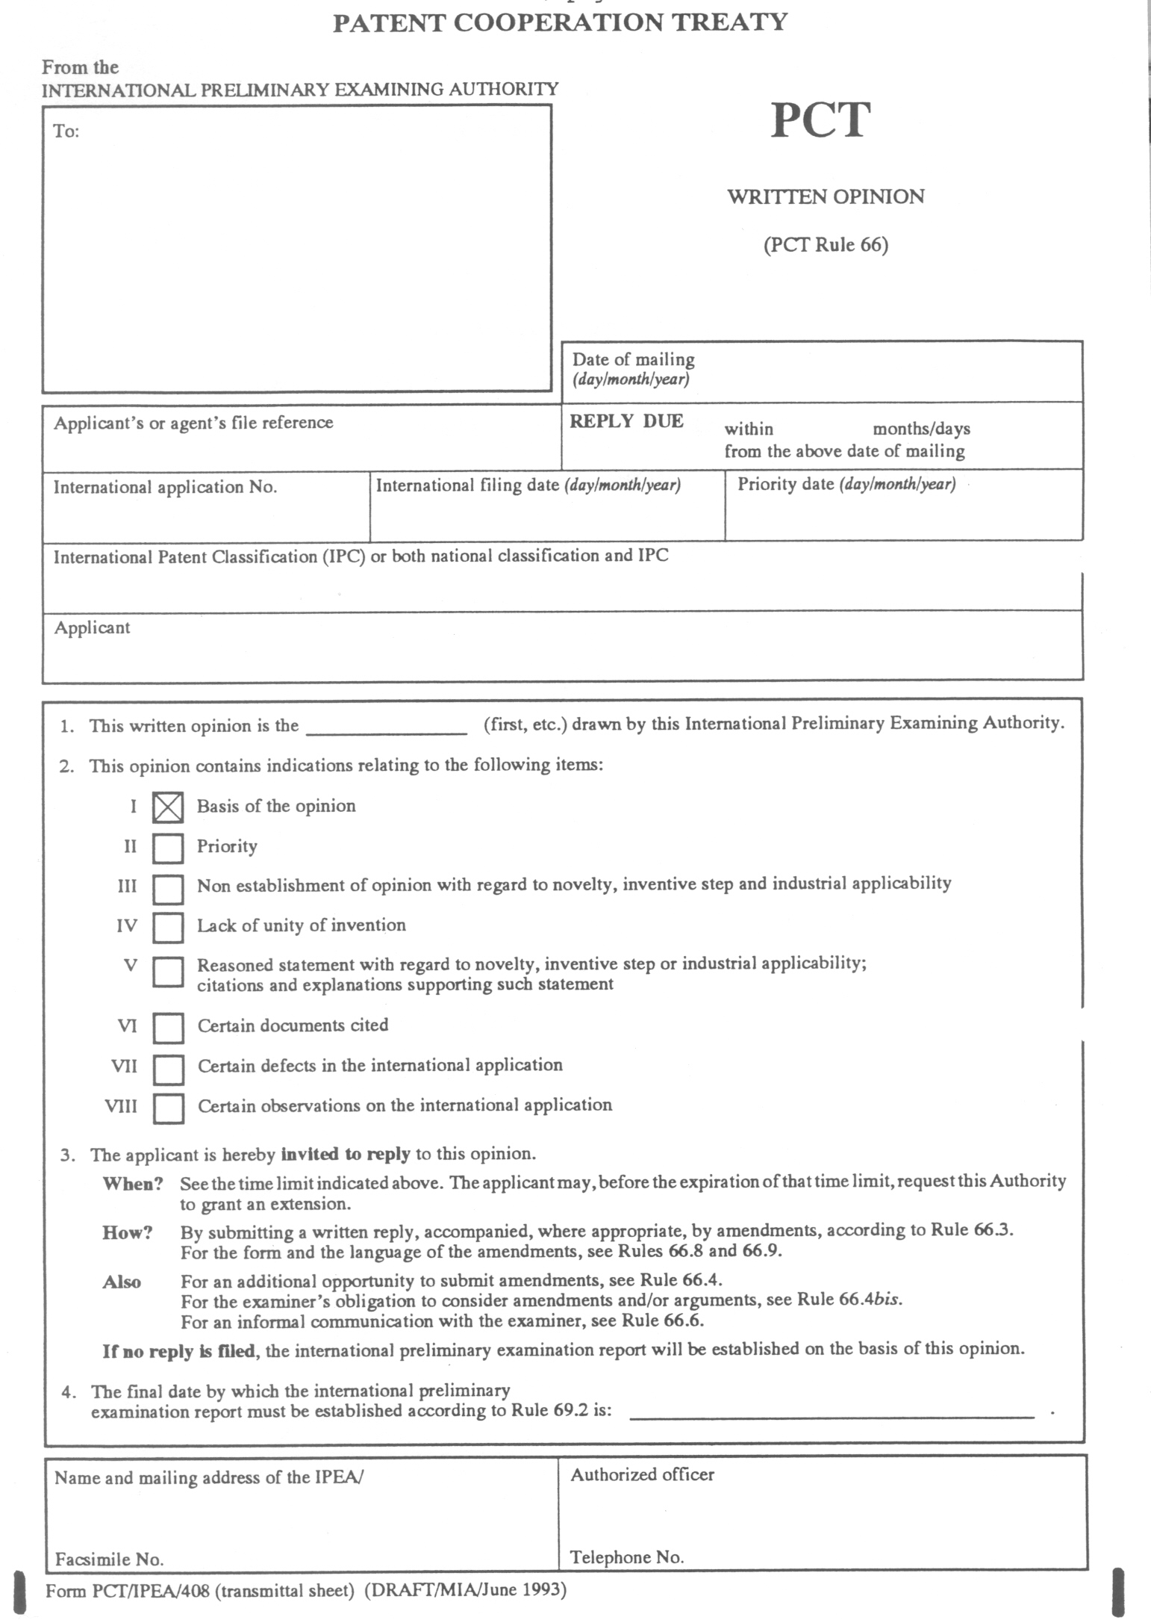

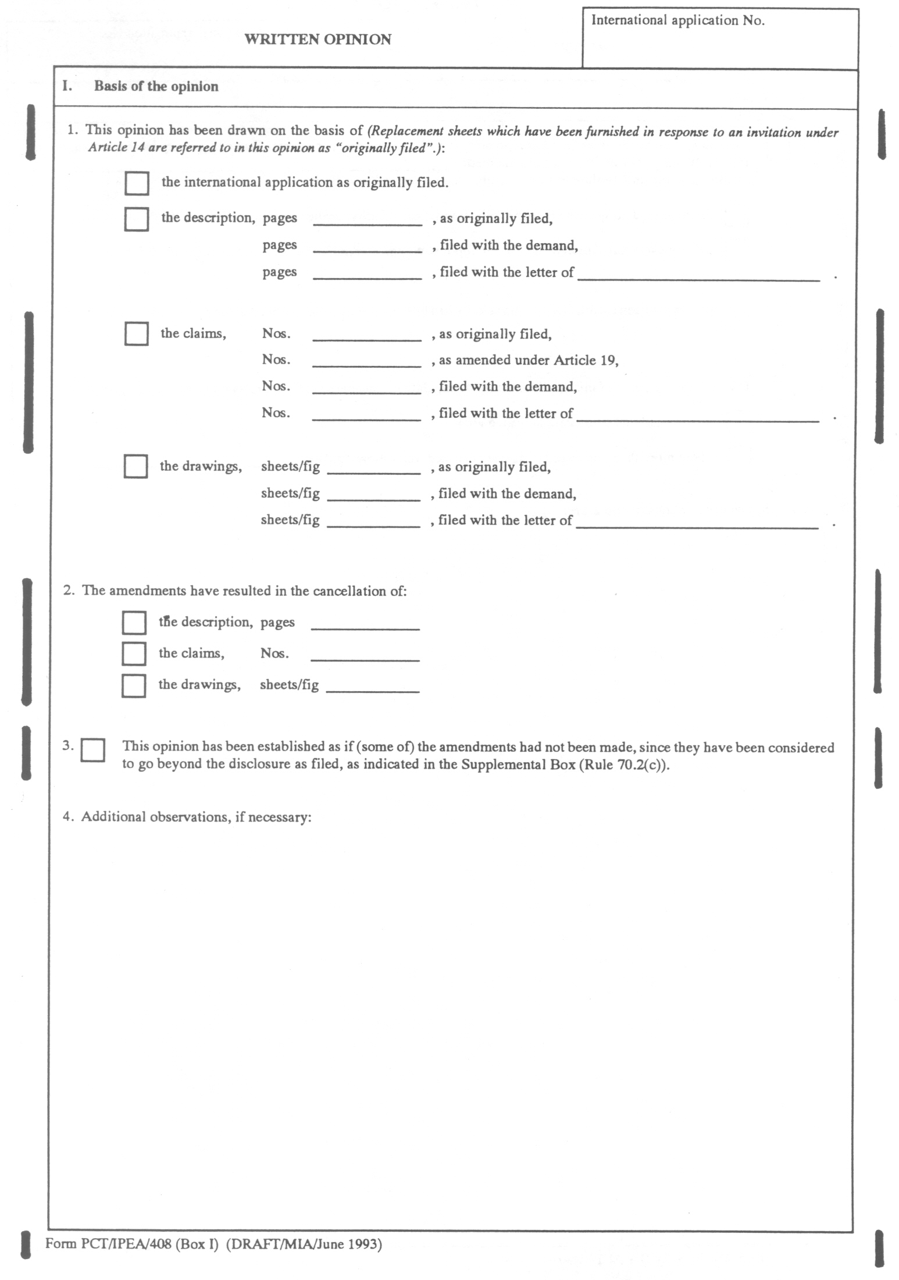

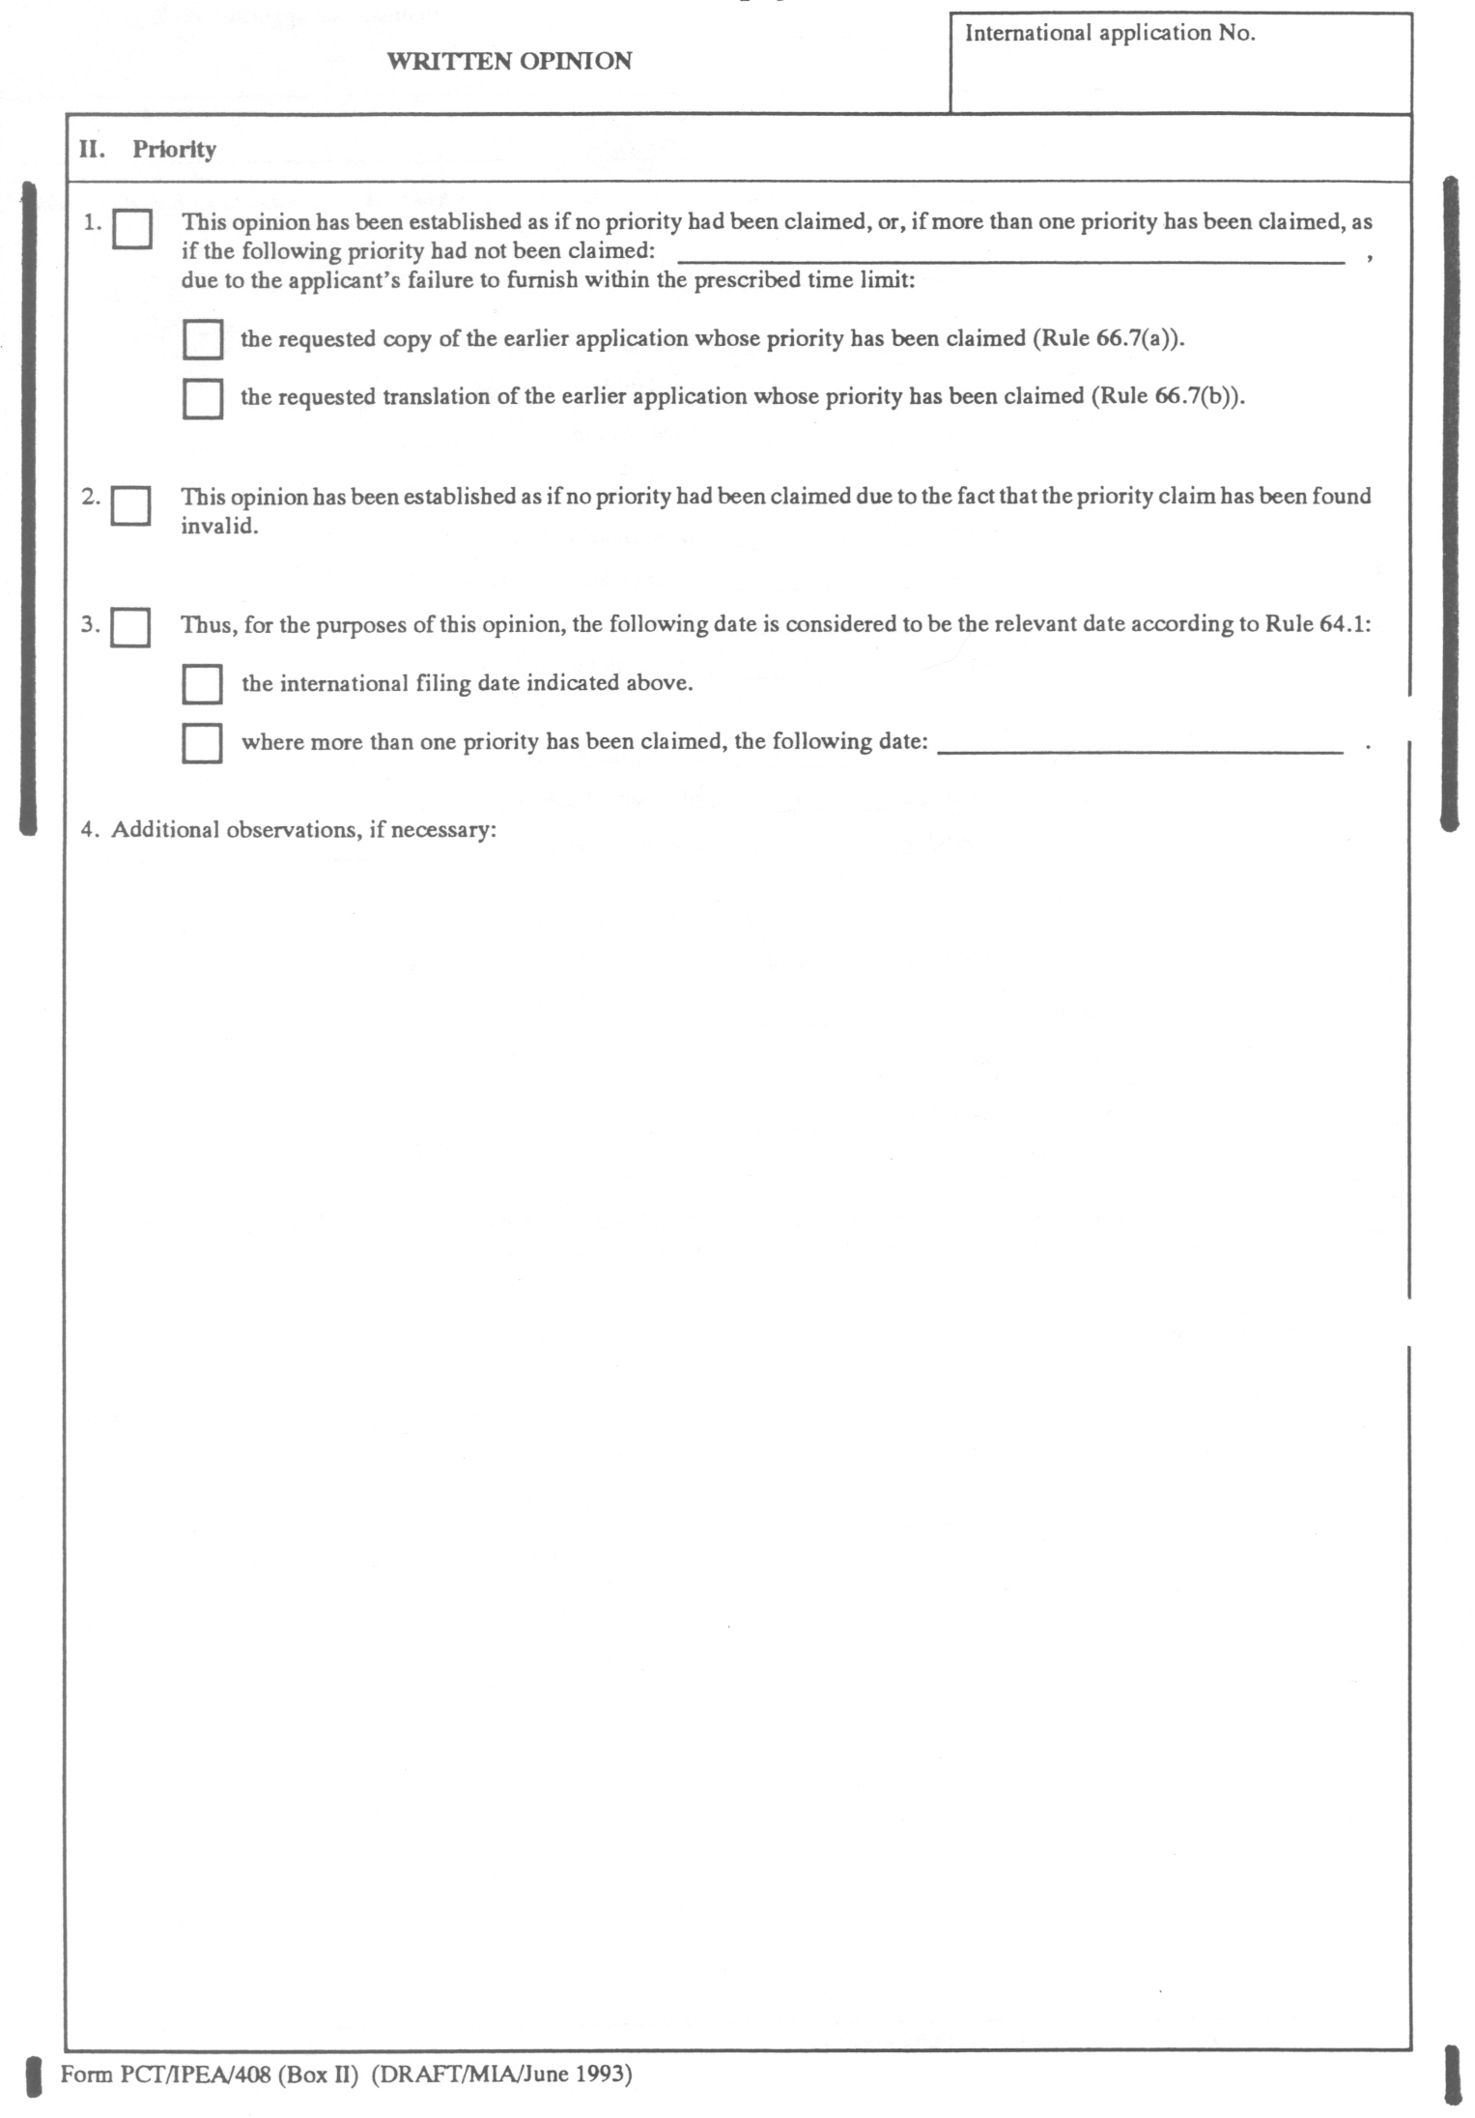

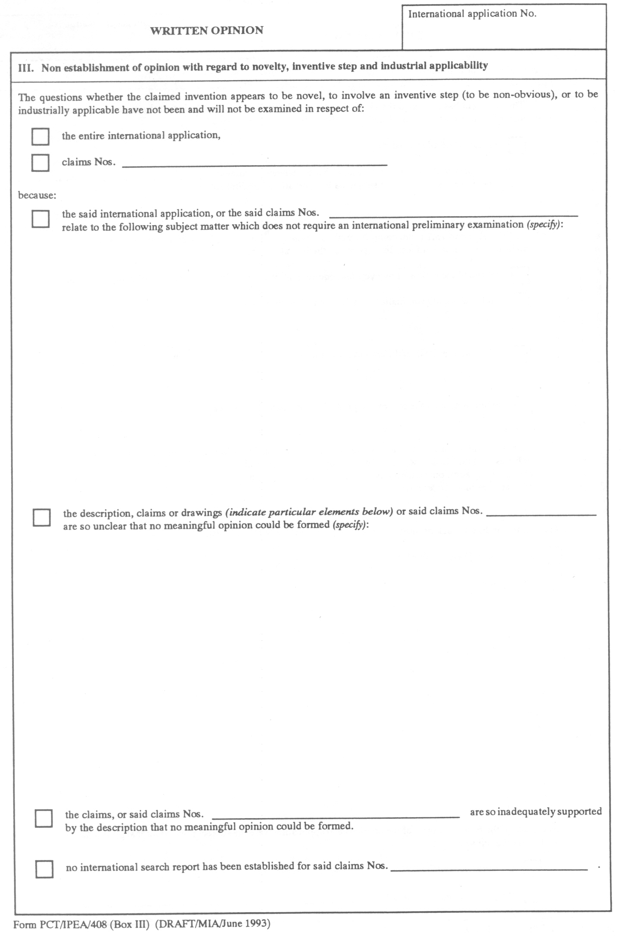

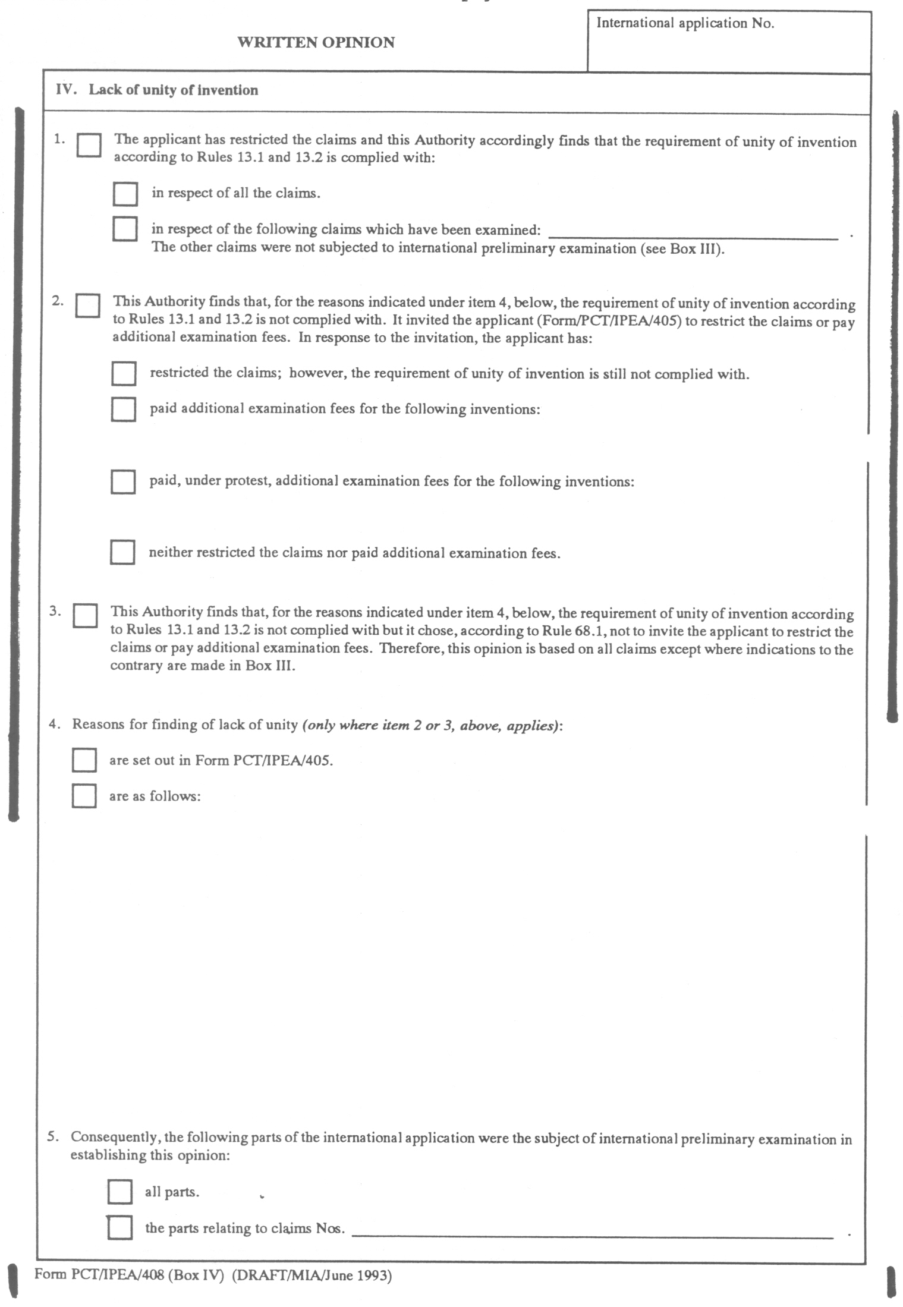

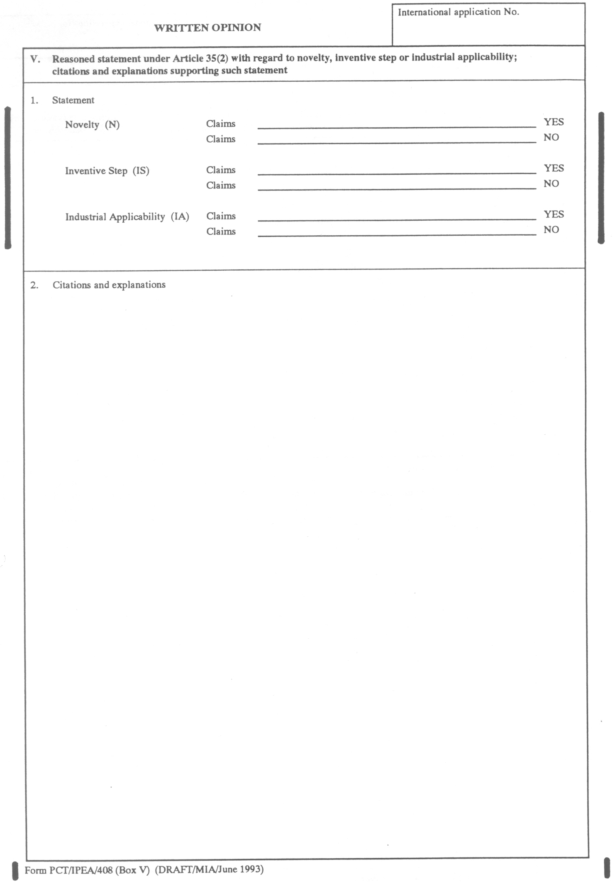

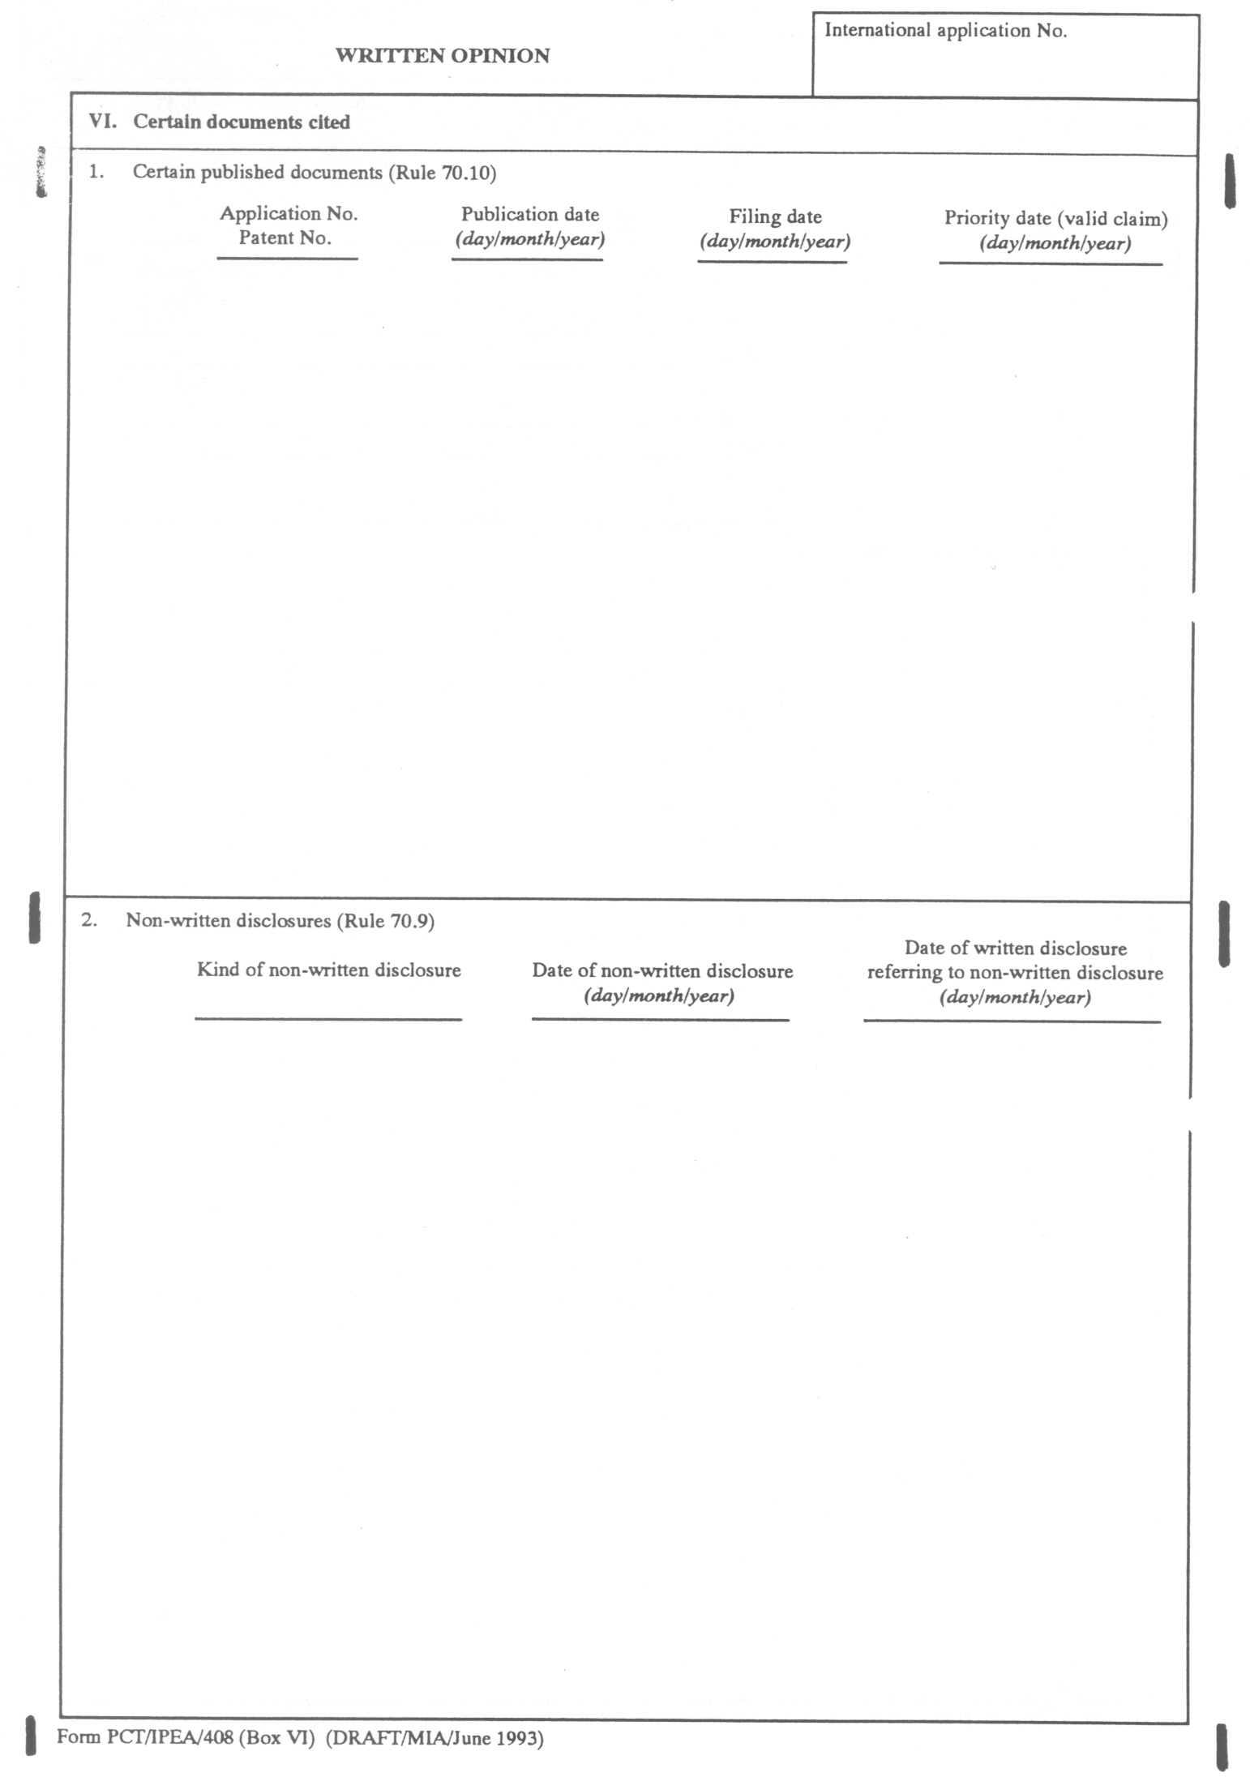

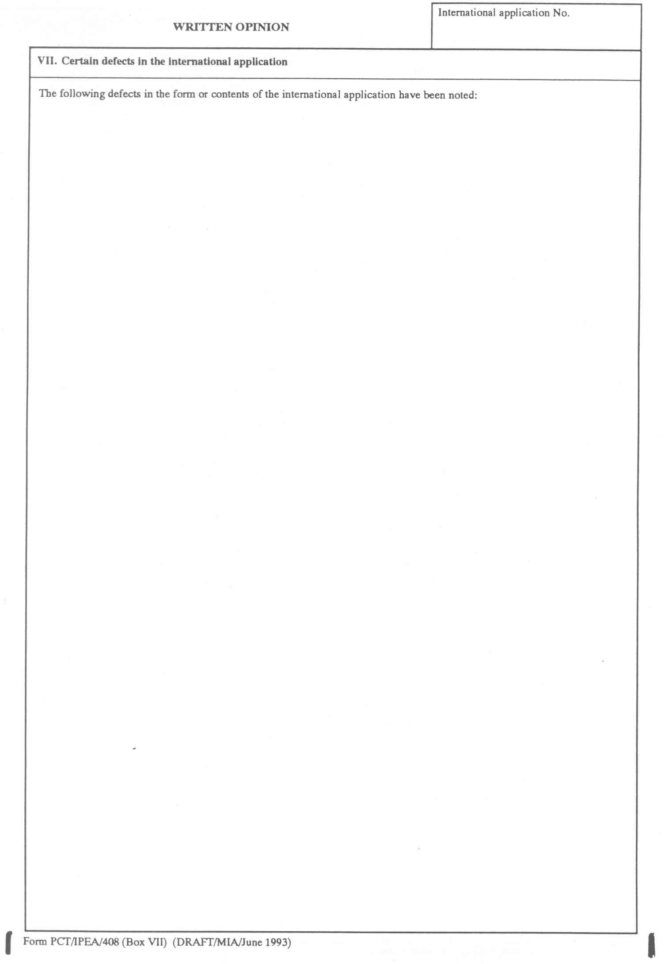

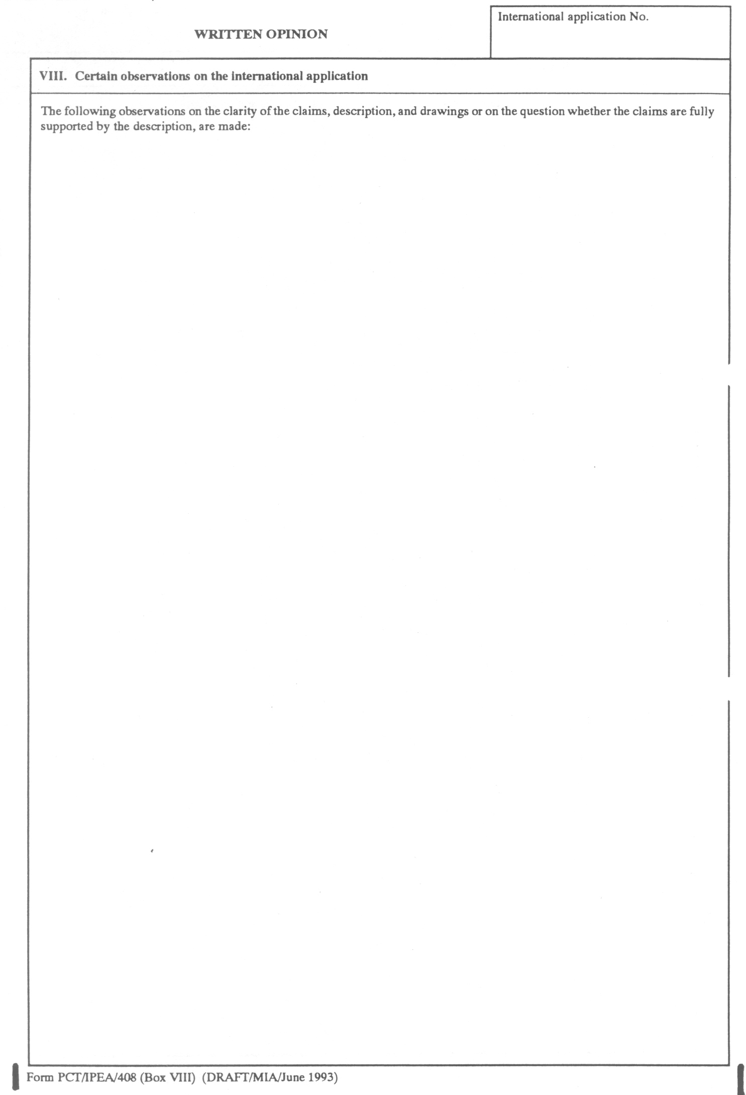

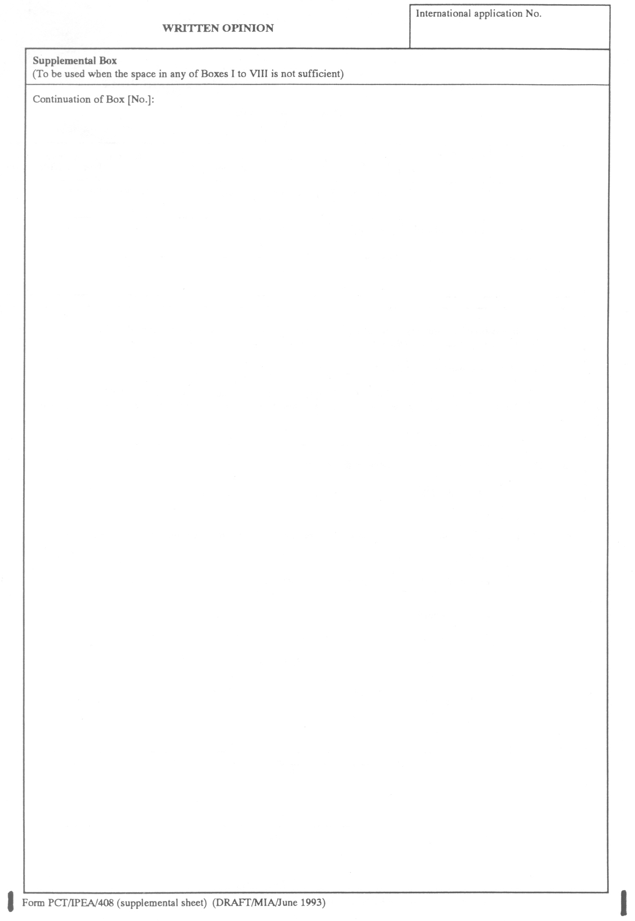

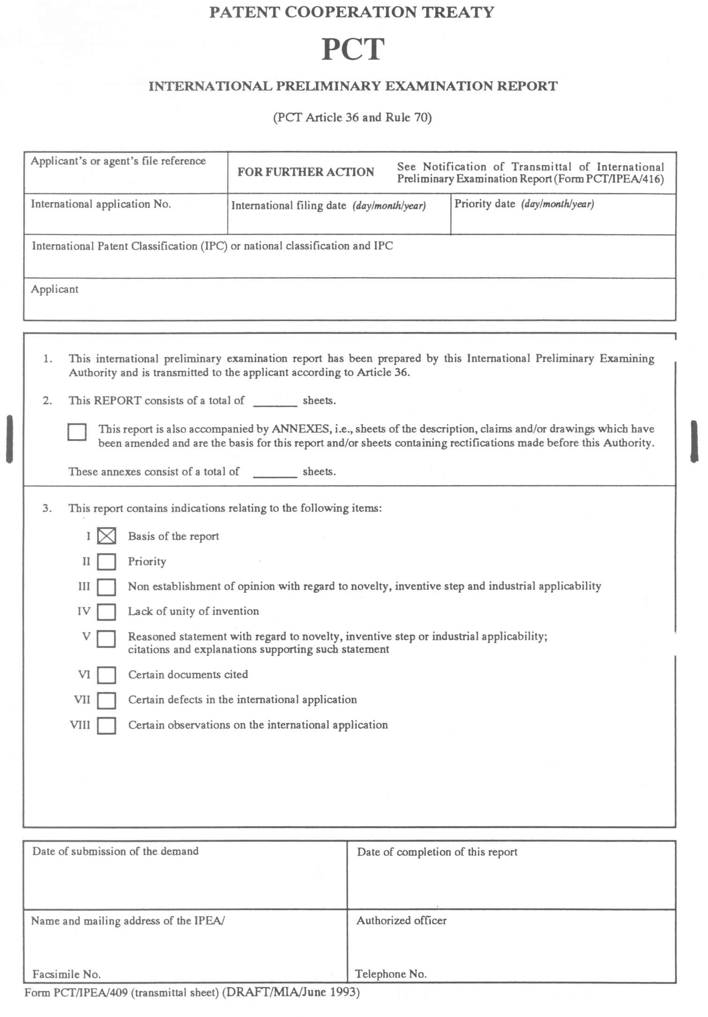

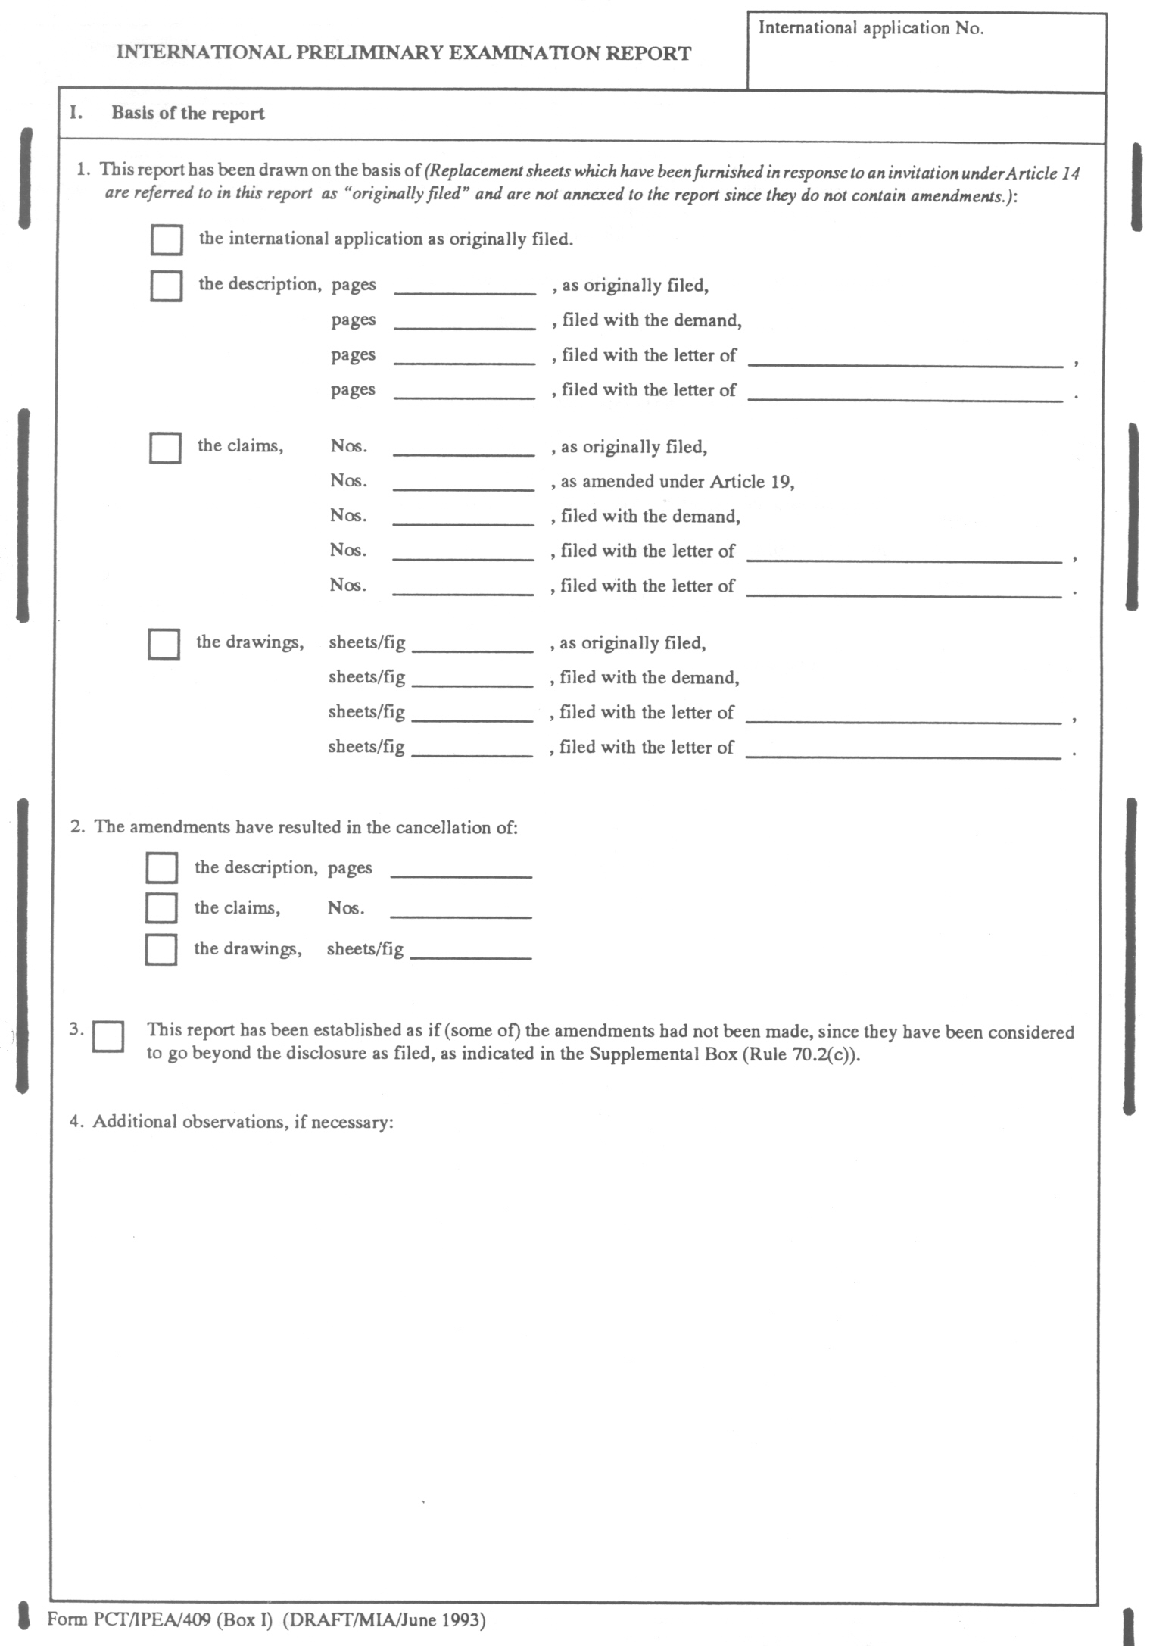

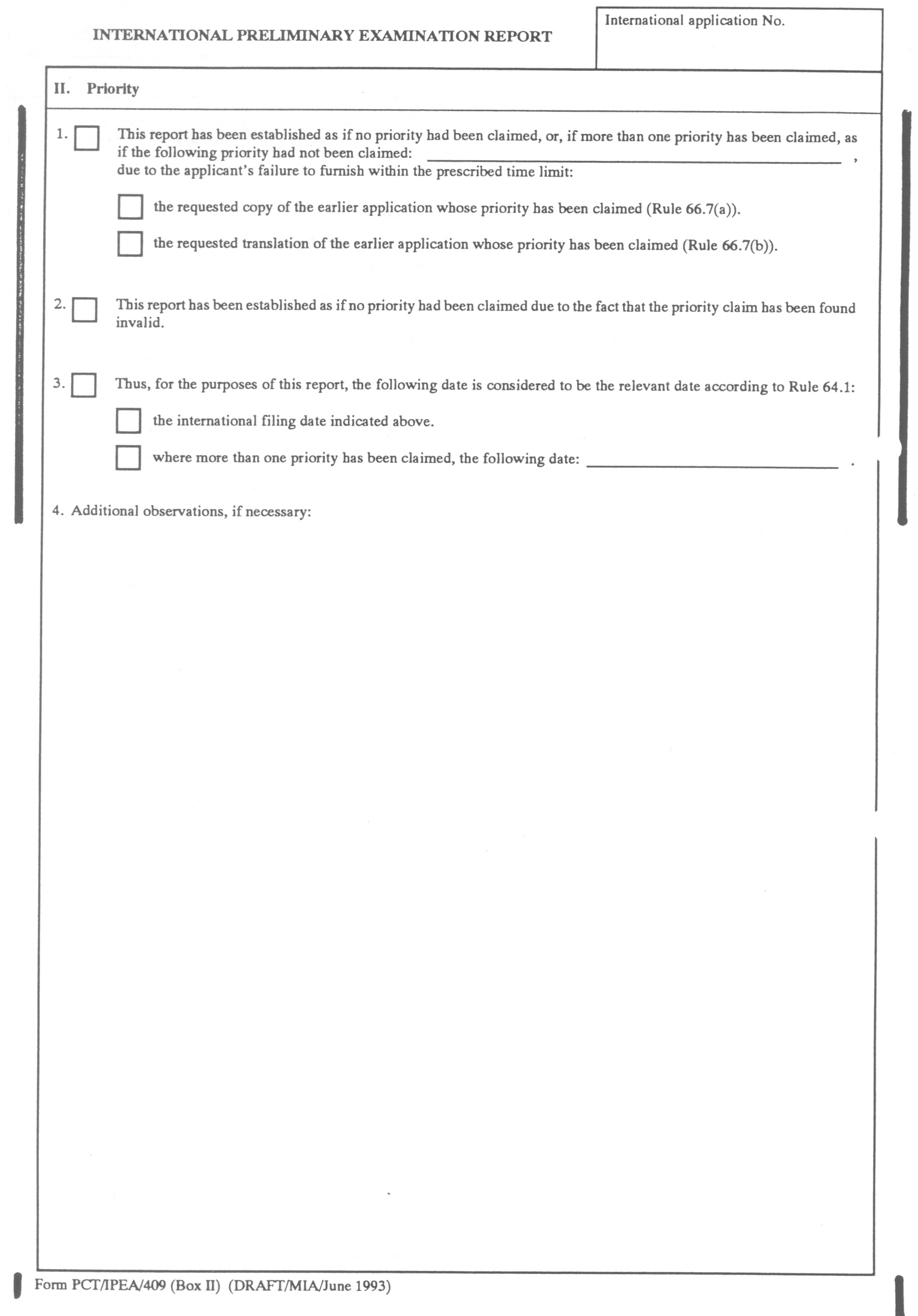

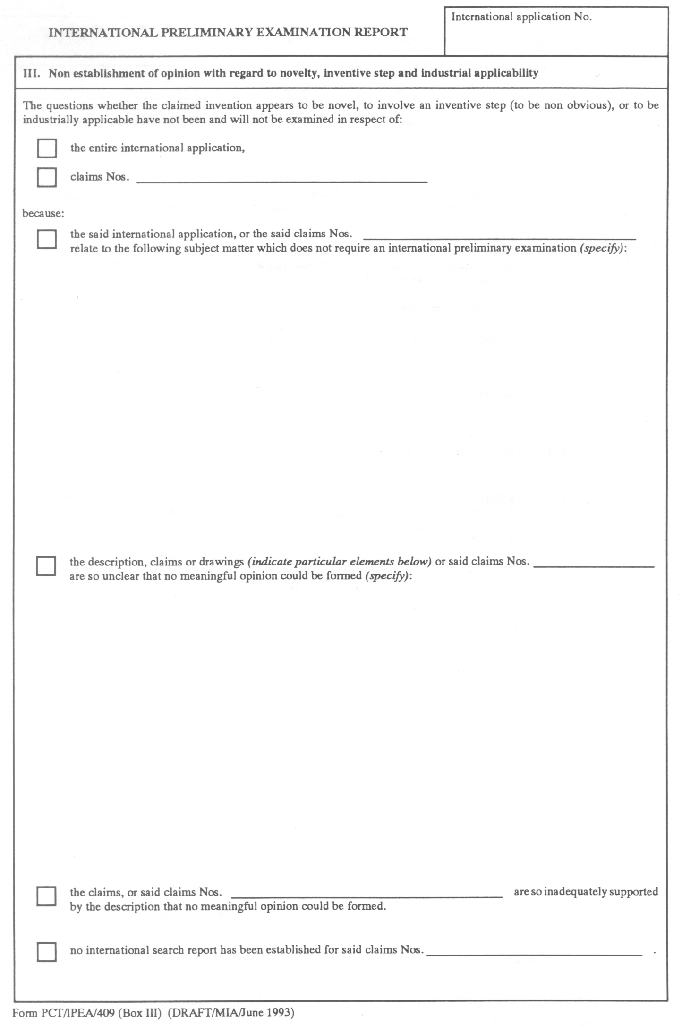

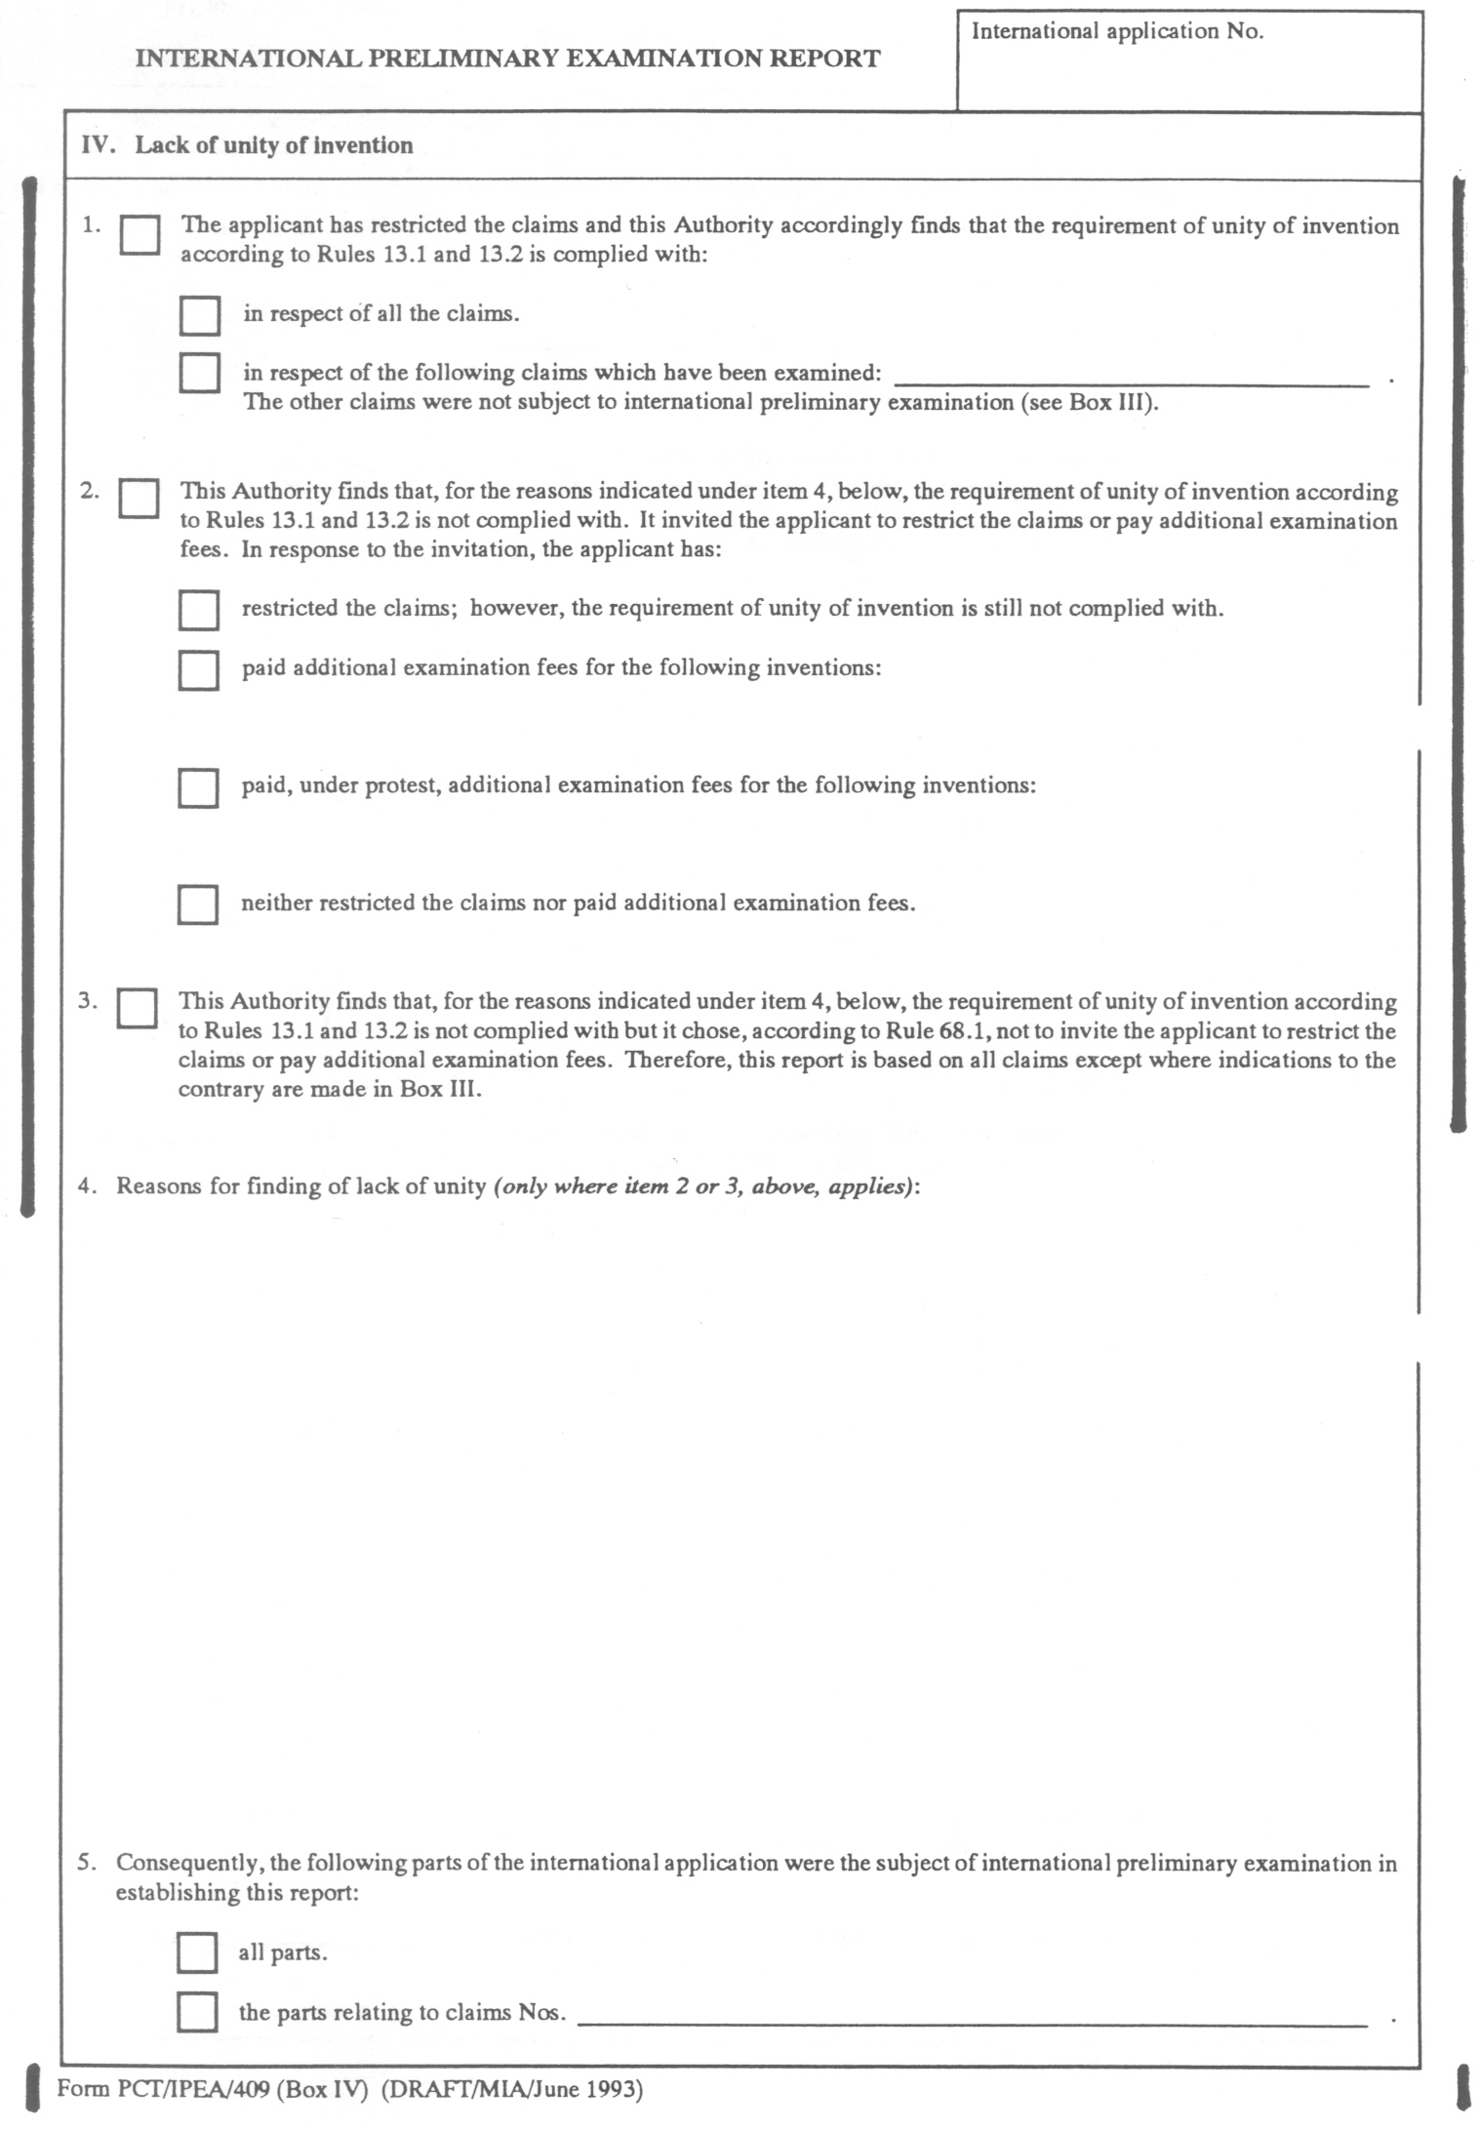

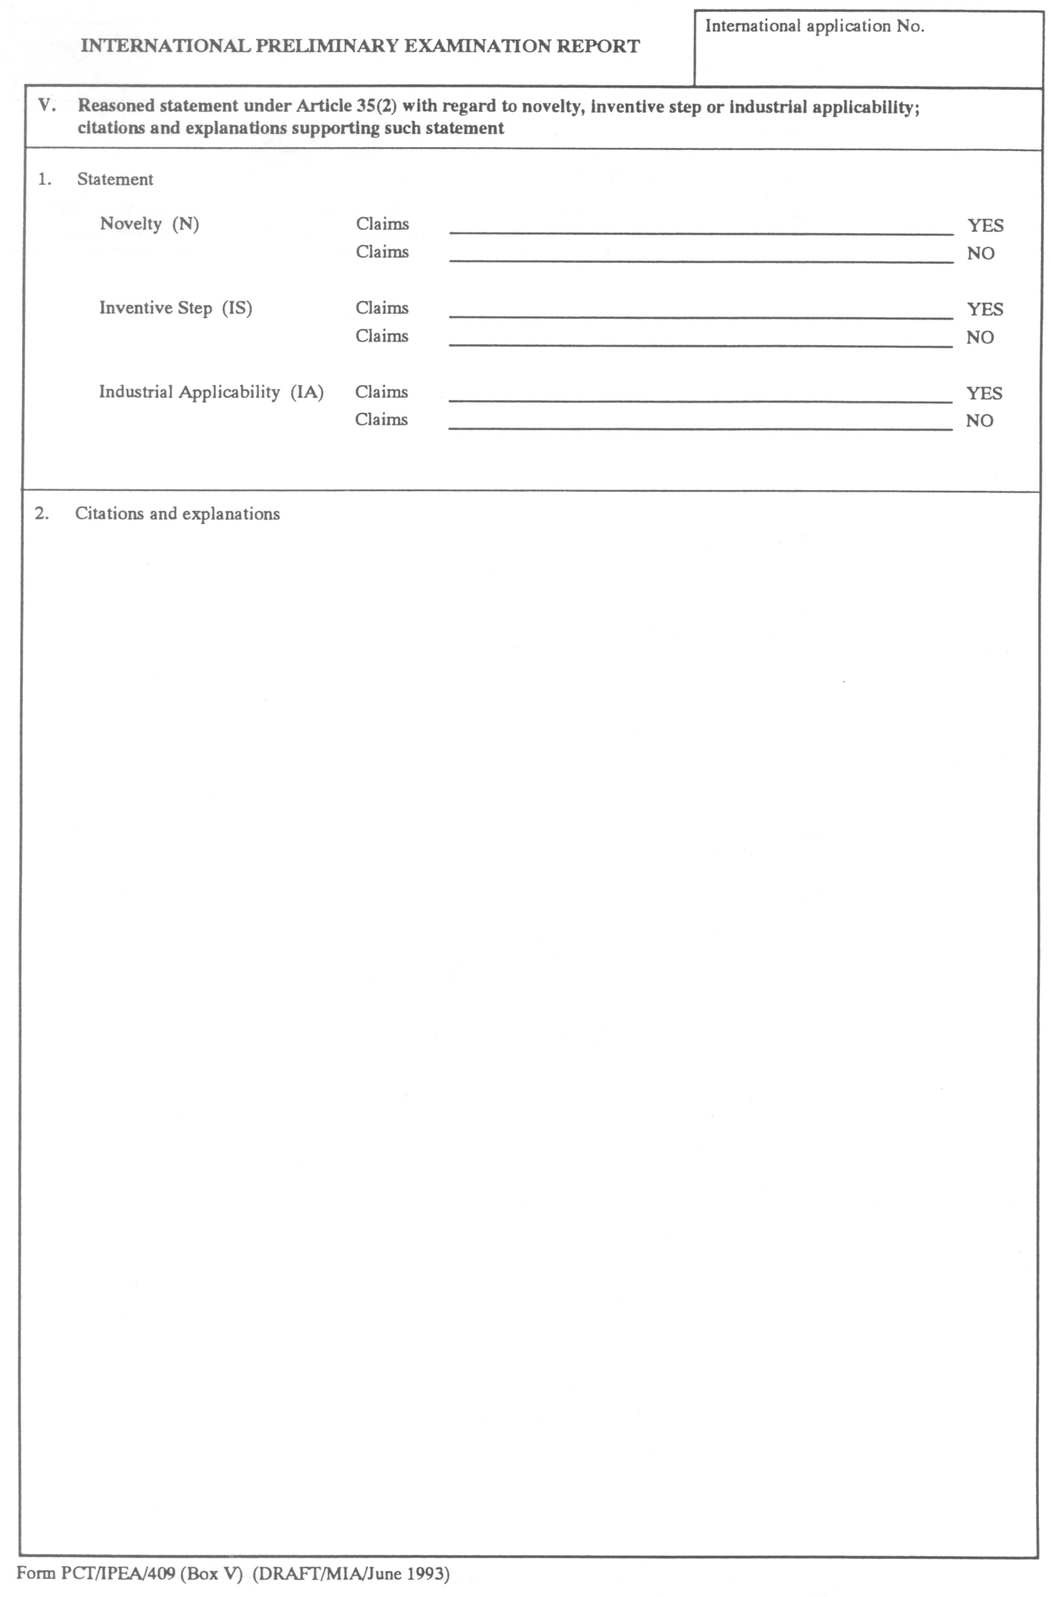

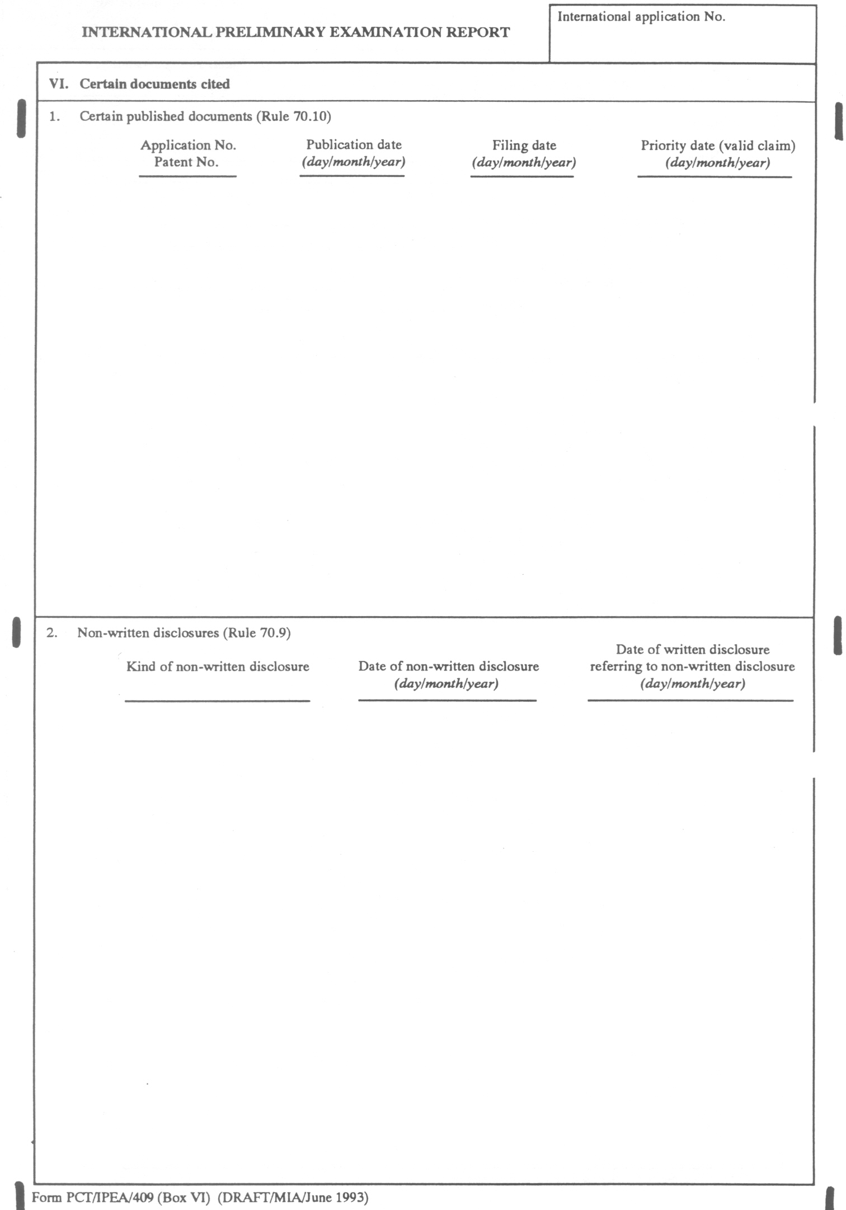

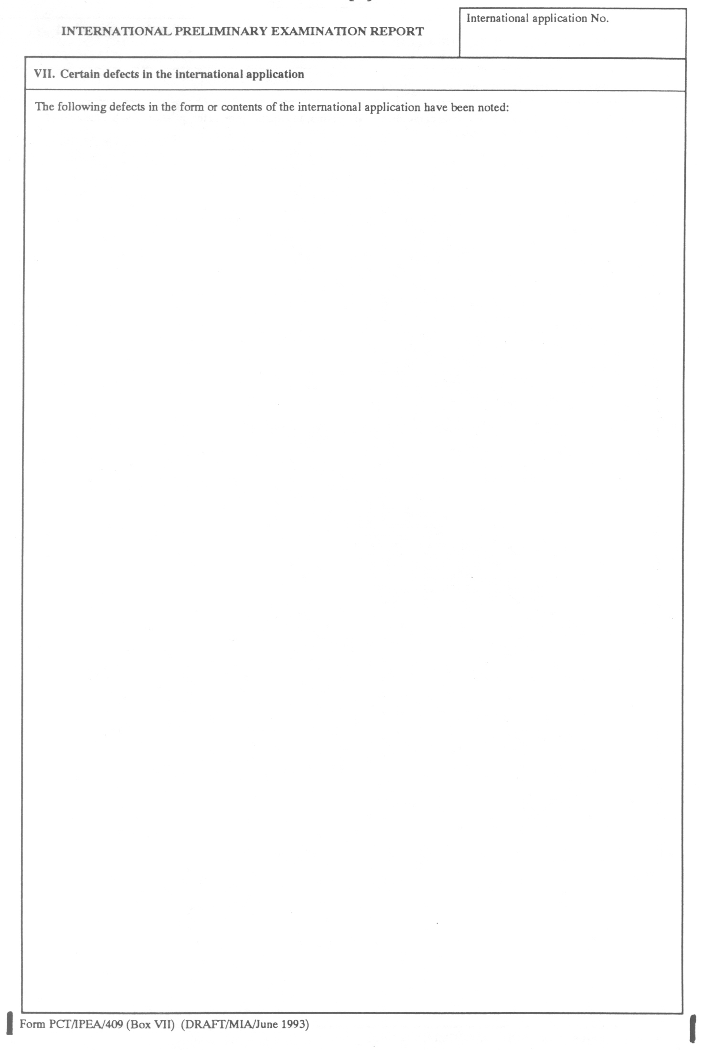

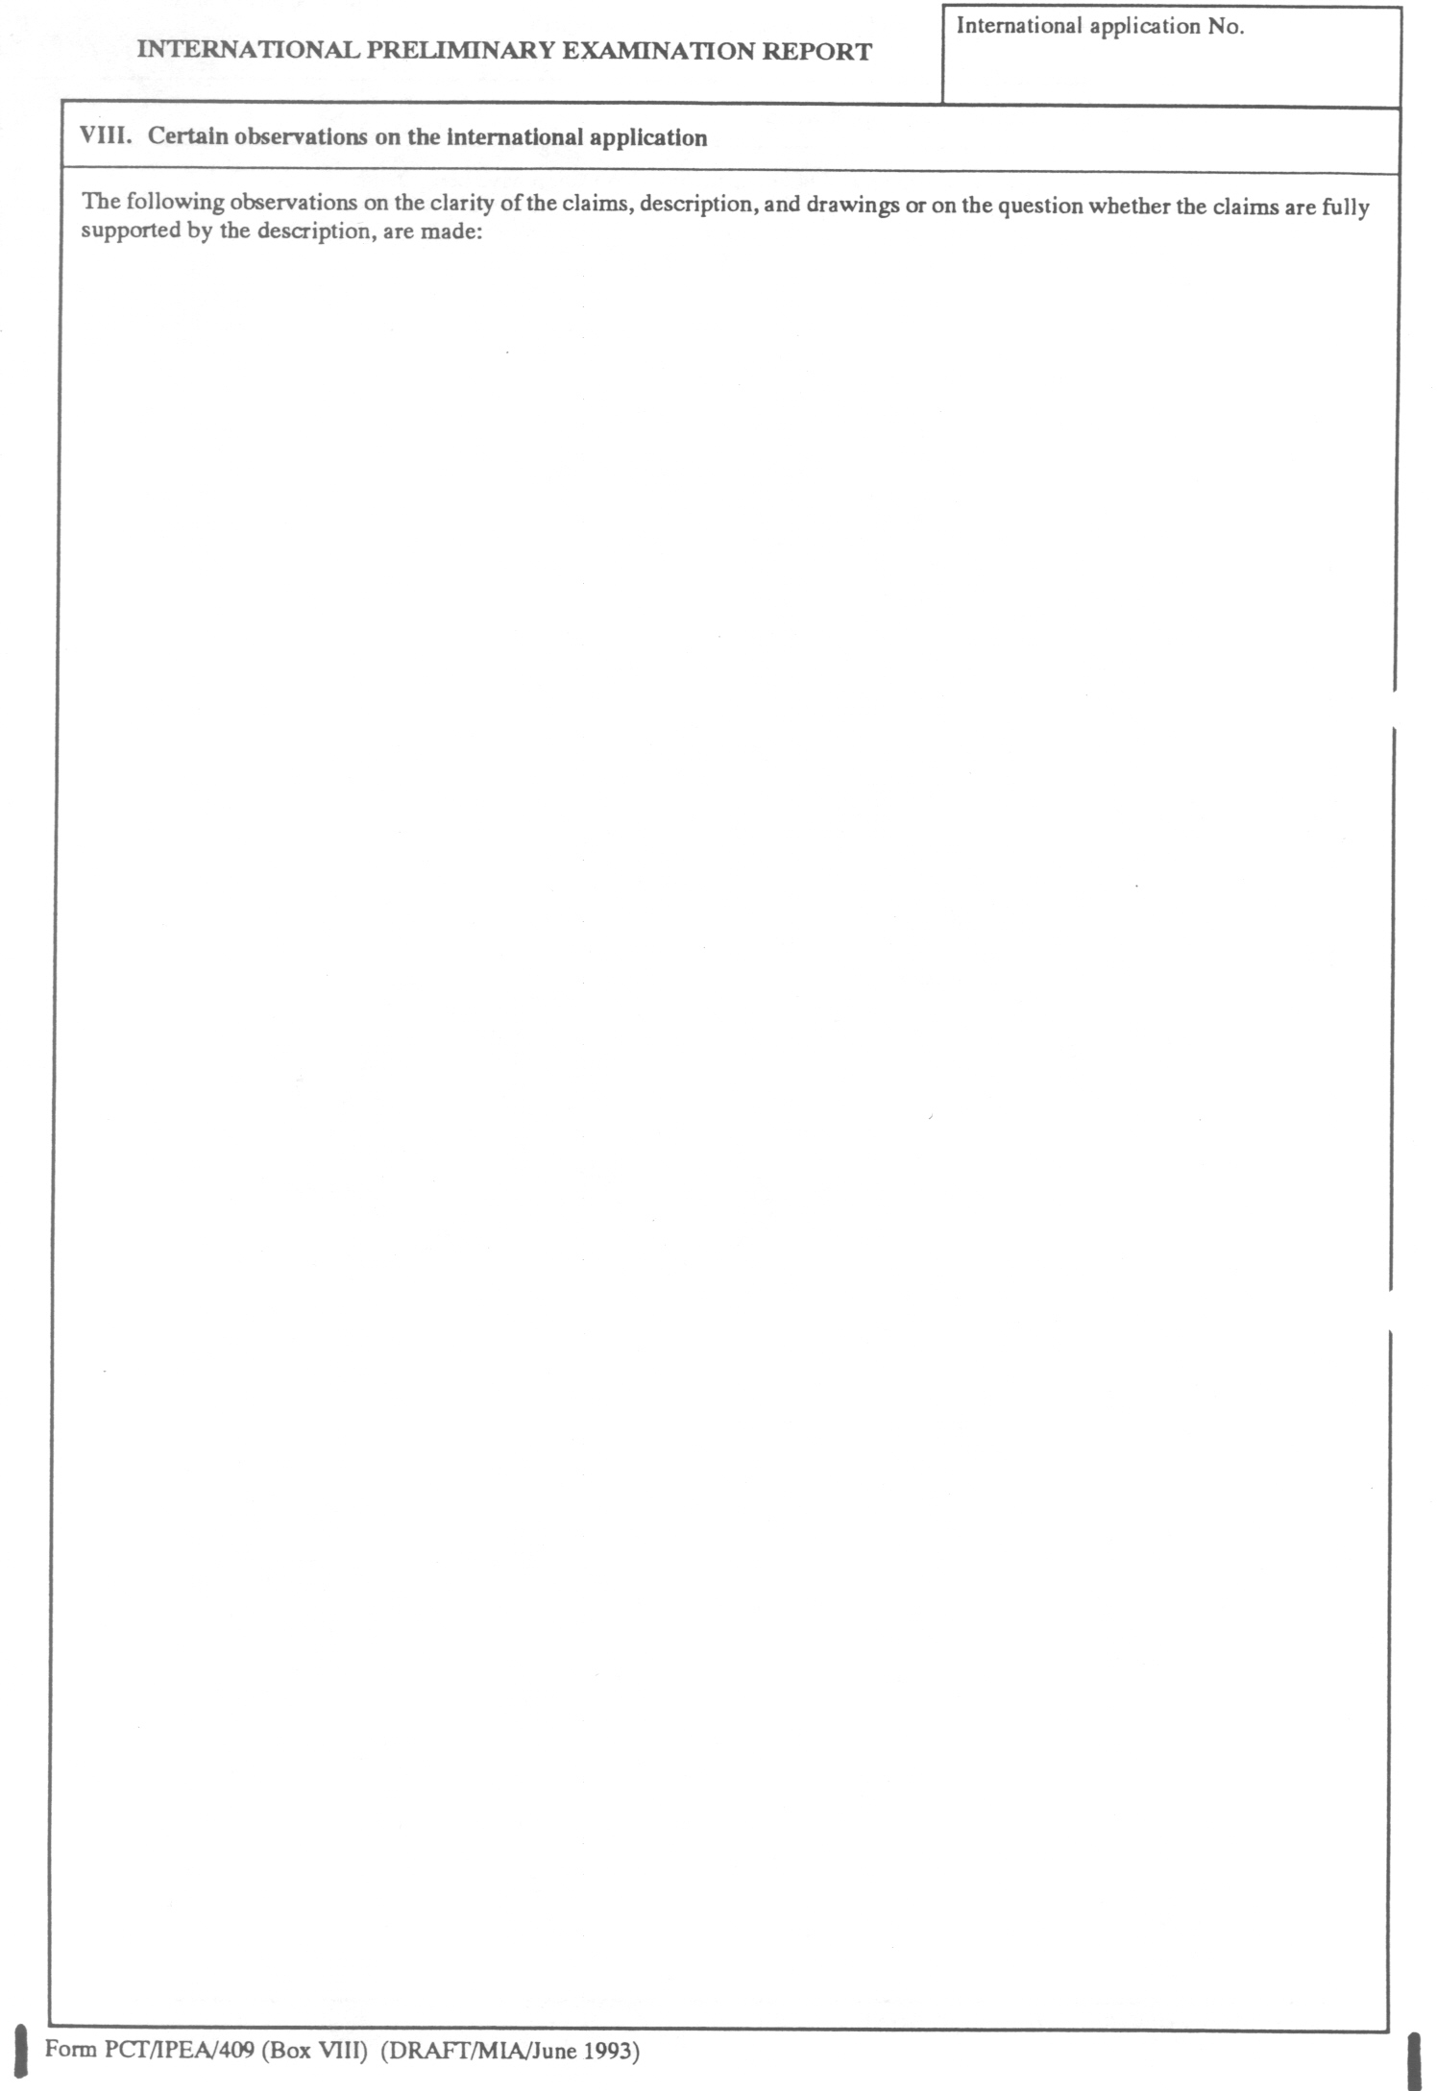

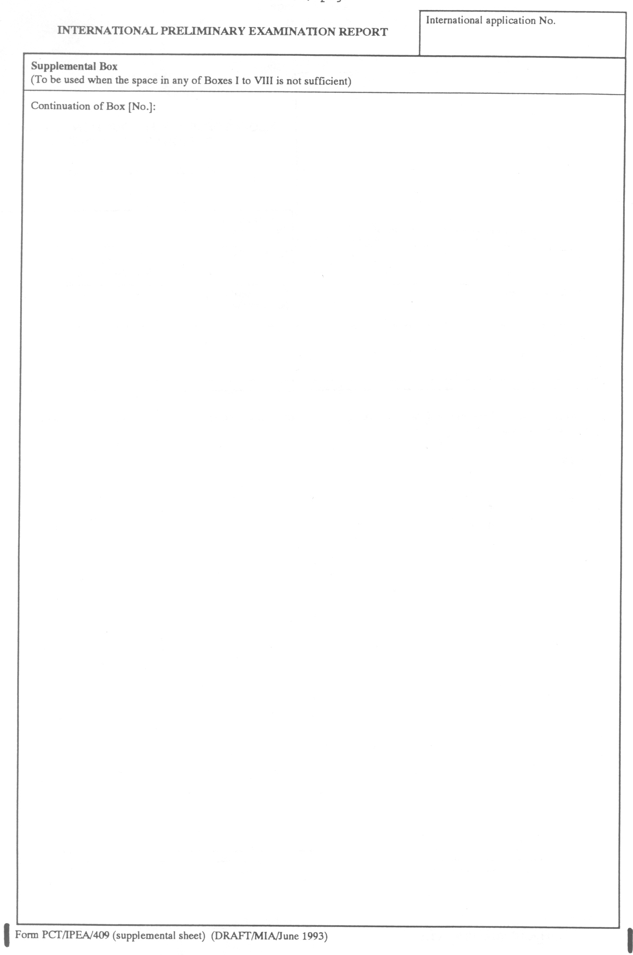

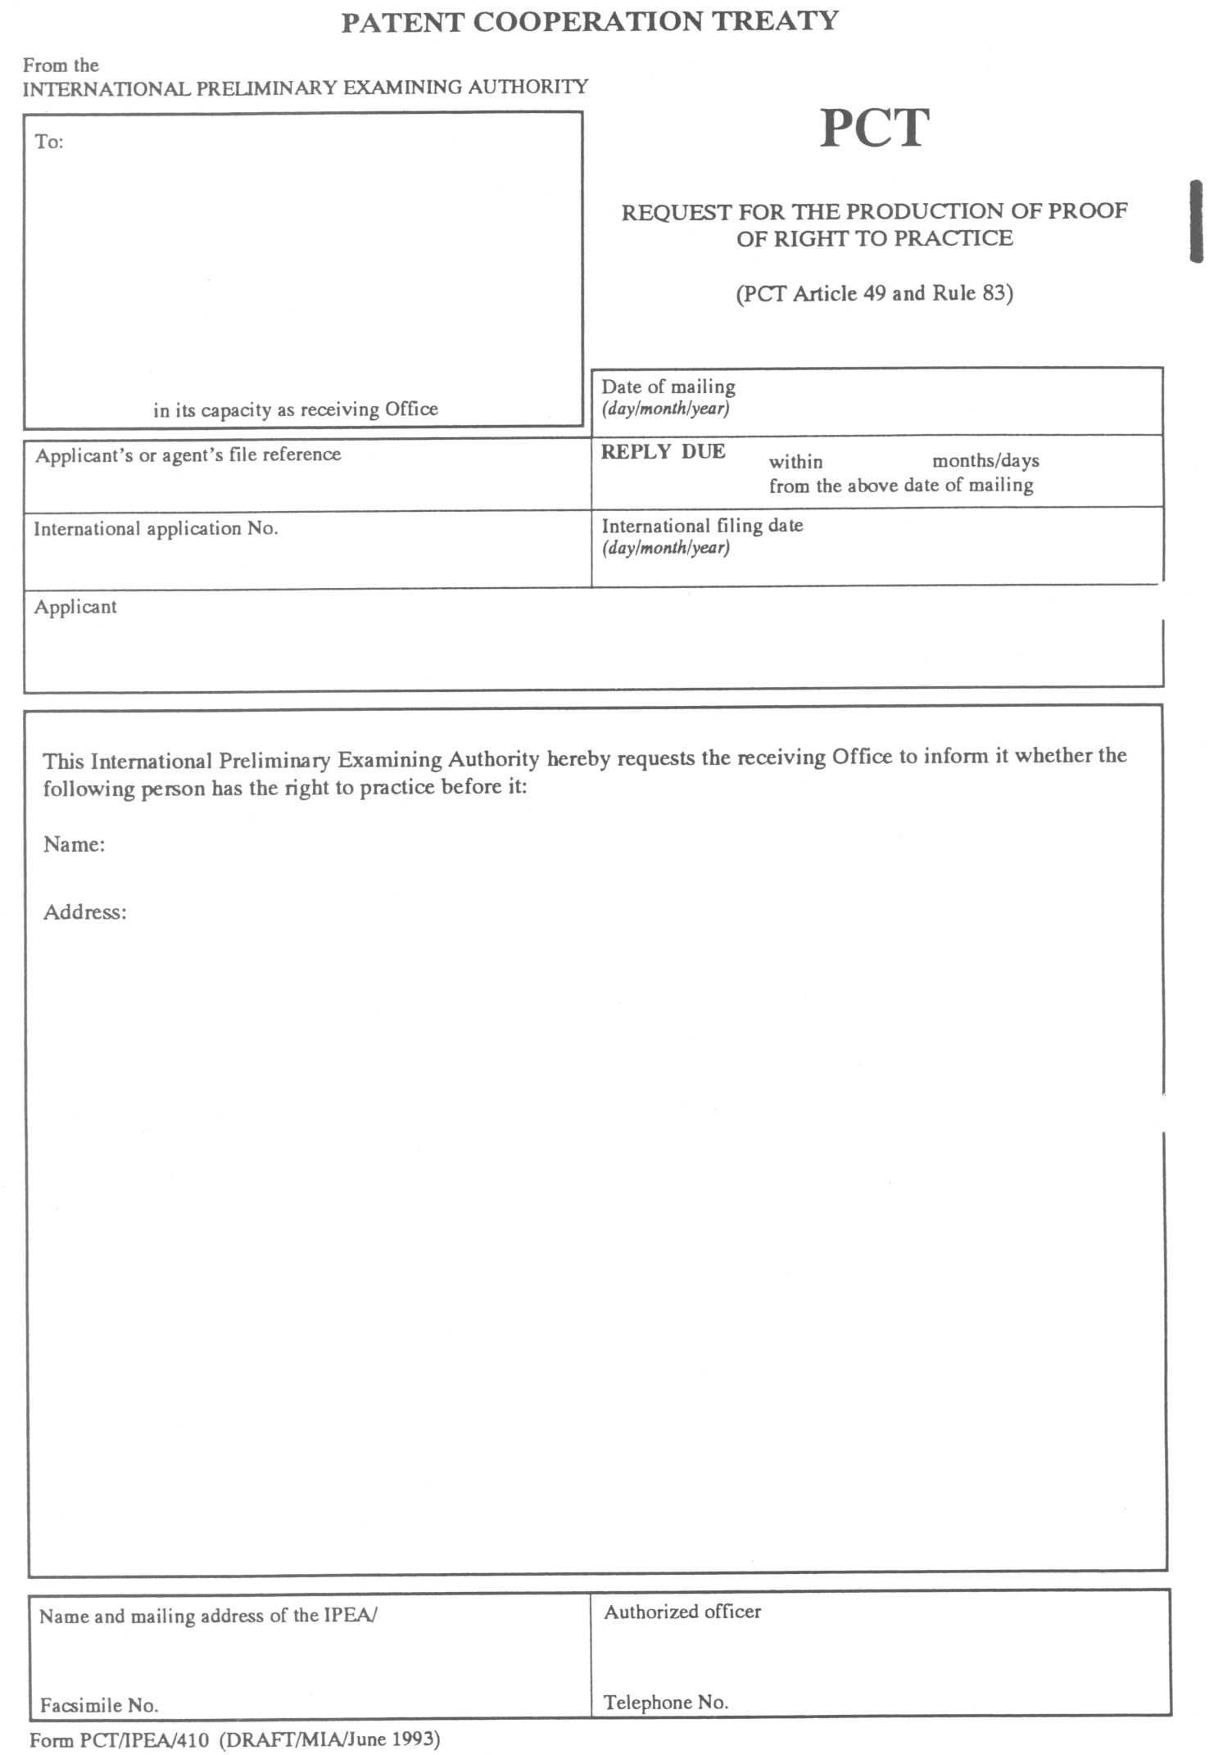

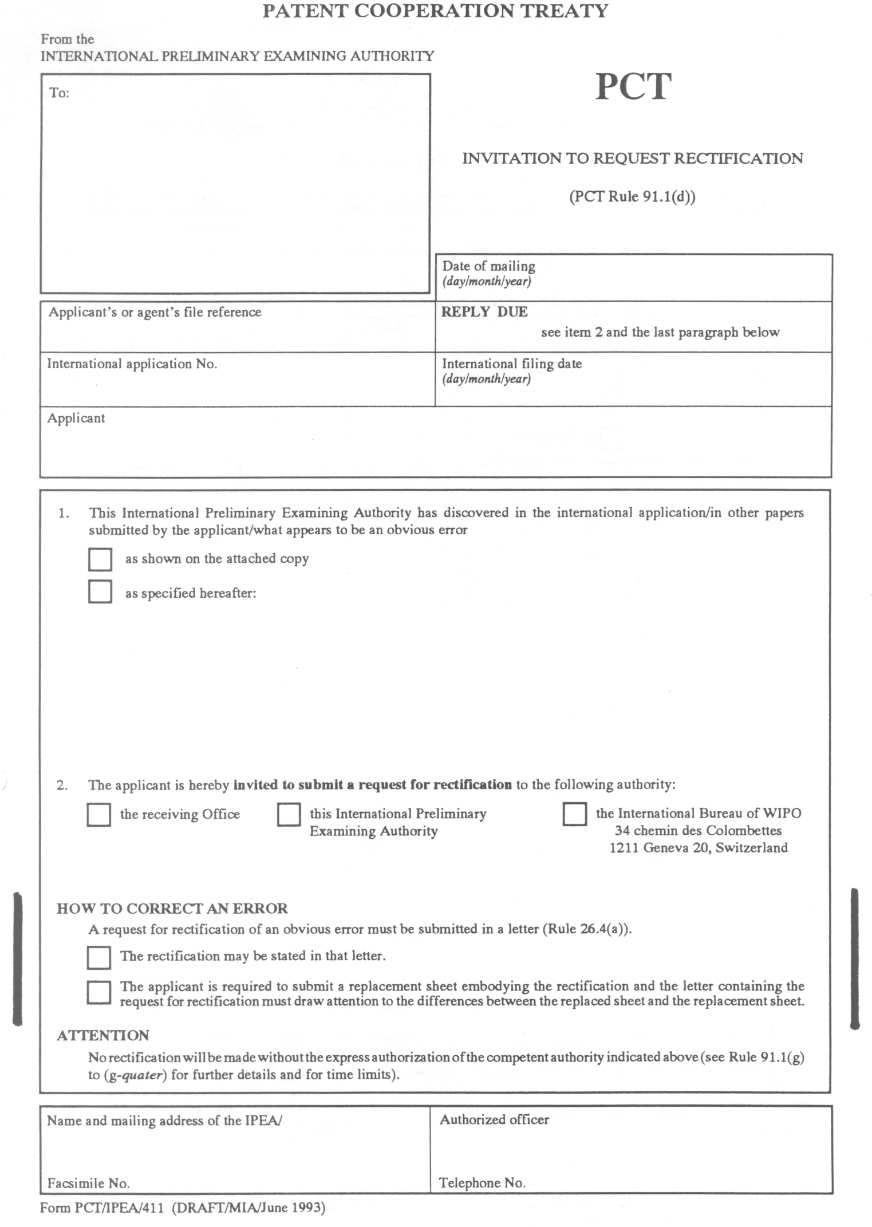

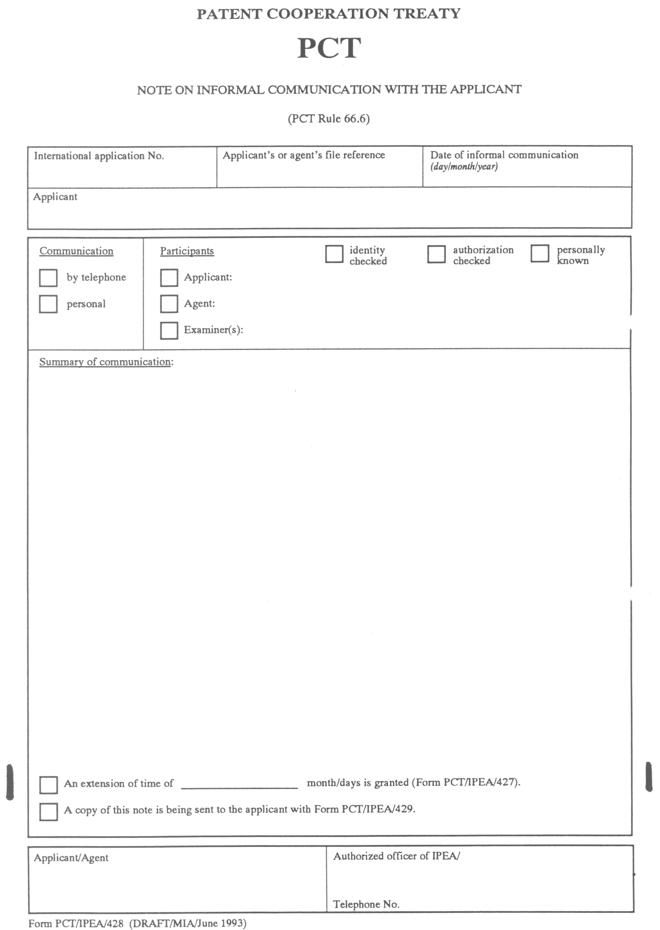

[End of annex and of document]

