WIPO |  | PCT/MIA/II/8  ORIGINAL: English  DATE: February 21, 1992
WORLD INTELLECTUAL PROPERTY ORGANIZATION
GENEVA
International patent cooperation union
(PCT union)
Meeting of international authorities
under the PCT
Second Session
Geneva, March 9 to 13, 1992
DRAFT OF PROPOSED MODIFIED FORMS FOR USE BY
THE INTERNATIONAL PRELIMINARY EXAMINING AUTHORITIES
prepared by the International Bureau
The annex to this document contains the draft of the modified Forms for use by the International Preliminary Examining Authorities. It also contains, for easy reference, a list of those Forms.

The draft of the modified Forms PCT/IPEA/408 and 409 is contained in document PCT/MIA/II/7.

The modifications take into account the amendments to the PCT Regulations and are submitted to the International Preliminary Examining Authorities for their observations and for the purpose of the consultations required under Rule 89.2(b).

[Annex follows]

LIST OF MODIFIED PCT/IPEA FORMS AS FROM JULY 1992

Form identification number | Title of Form | Provision pursuant to which Form is issued
PCT/IPEA/402 | NOTIFICATION OF RECEIPT OF DEMAND | Rule 61.1(b), first sentence and Administrative Instructions, Section 601
PCT/IPEA/403 | NOTIFICATION CONCERNING PAYMENT OF THE PRELIMINARY EXAMINATION AND HANDLING FEES | Rules 57 and 58
PCT/IPEA/404 | INVITATION TO CORRECT DEFECTS IN DEMAND | Rule 60.1
PCT/IPEA/405 | INVITATION TO RESTRICT OR PAY ADDITIONAL FEES | Article 34(3)(a) and Rule 68.2
PCT/IPEA/406 | [DELETED]
PCT/IPEA/407 | NOTIFICATION THAT DEMAND CONSIDERED AS NOT HAVING BEEN SUBMITTED | Rule 61.1(b), second sentence
PCT/IPEA/410 | REQUEST FOR THE PRODUCTION OF PROOF | Article 49 and Rule 83
PCT/IPEA/411 | INVITATION TO REQUEST RECTIFICATION | Rule 91.l(d)
PCT/IPEA/412 | NOTIFICATION OF DECISION CONCERNING REQUEST FOR RECTIFICATION | Rule 91.1(f)
PCT/IPEA/413 | NOTIFICATION OF TRANSMITTAL OF REQUESTED COPIES OF DOCUMENTS IN FILE | Rule 94.1
PCT/IPEA/414 | INVITATION TO FURNISH TRANSLATION OF PRIORITY DOCUMENT | Rule 66.7(b)
PCT/IPEA/415 | NOTIFICATION CONCERNING DOCUMENTS TRANSMITTED | Rules 61.1(a), 71.1 and 71.2(c)
PCT/IPEA/416 | NOTIFICATION OF TRANSMITTAL OF INTERNATIONAL PRELIMINARY EXAMINATION REPORT | Rule 71.1
PCT/IPEA/417 | NOTIFICATION OF TRANSMITTAL OF REQUESTED COPIES OF CITED DOCUMENTS | Article 36(4)
PCT/IPEA/418 | [DELETED]
PCT/IPEA/419 | [DELETED]
PCT/IPEA/420 | NOTIFICATION OF DECISION ON PROTEST | Rule 68.3(c) and Administrative Instructions, Section 603
PCT/IPEA/421 | INVITATION TO PAY FOR REQUESTED COPIES OF CITED DOCUMENTS | Rule 71.2(b)
PCT/IPEA/422 | INVITATION TO PAY FOR REQUESTED COPIES OF DOCUMENTS IN THE FILE | Rule 94.1
PCT/IPEA/423 | INVITATION TO CORRECT DEFECTS IN CORRESPONDENCE SUBMITTED BY THE APPLICANT | Rules 92. l(b) and 92.4(g)(ii)
PCT/IPEA/424 | COMMUNICATION IN CASES FOR WHICH NO OTHER FORM IS APPLICABLE
PCT/IPEA/425 | NOTIFICATION OF CANCELLATION OF CERTAIN ELECTIONS | Administrative Instructions, Section 606
PCT/IPEA/426 | [DELETED]
PCT/IPEA/427 | COMMUNICATION REGARDING EXTENSION OF TIME LIMIT | Rules 60.1(a) and 66.2(d)
PCT/IPEA/428 | NOTE ON INFORMAL COMMUNICATION WITH THE APPLICANT | Rule 66.6
PCT/IPEA/429 | NOTIFICATION CONCERNING INFORMAL COMMUNICATION WITH THE APPLICANT | Rule 66.6
PCT/IPEA/430 | REQUEST FOR INTERNATIONAL SEARCHING AUTHORITY TO FURNISH COPY OF SEQUENCE LISTING TO INTERNATIONAL PRELIMINARY EXAMINING AUTHORITY | Rule 13ter.l(e)
PCT/IPEA/431 | INVITATION TO SUBMIT AMENDMENTS | Rule 60.1(g)
PCT/IPEA/432 | COMMUNICATION REGARDING AMENDMENTS NOT TAKEN INTO ACCOUNT | Rule 66.4bis
PCT/IPEA/433 | NOTIFICATION REGARDING ATTEMPTED TRANSMITTAL OF DOCUMENTS VIA TELEGRAPH, TELEPRINTER, FACSIMILE MACHINE, ETC. | Rule 92.4(c)
PCT/IPEA/434 | INVITATION TO FURNISH ORIGINAL OF DOCUMENT TRANSMITTED BY TELEGRAPH, TELEPRINTER, FACSIMILE MACHINE, ETC. | Rule 92.4(d), (e) and (f)
PCT/IPEA/435 | NOTIFICATION REGARDING RECEIPT OF DOCUMENTS VIA TELEGRAPH, TELEPRINTER, FACSIMILE MACHINE, ETC. | Rule 92.4(h)
PCT/IPEA/436 | NOTIFICATION CONCERNING THE COMPETENT INTERNATIONAL PRELIMINARY EXAMINING AUTHORITY | Rule 59
PCT/IPEA/437 | INVITATION TO PAY PROTEST FEE | Rule 68.3(e)
PCT/IPEA/438 | NOTIFICATION CONCERNING PAPER BEING DISREGARDED OR DOCUMENT CONSIDERED AS NOT HAVING BEEN SUBMITTED | Rules 92. l(b), last sentence, and 92.4(g)(ii)
PCT/IPEA/439 | NOTIFICATION THAT CERTAIN ELECTIONS CONSIDERED NOT TO HAVE BEEN MADE | Rule 60. l(d)

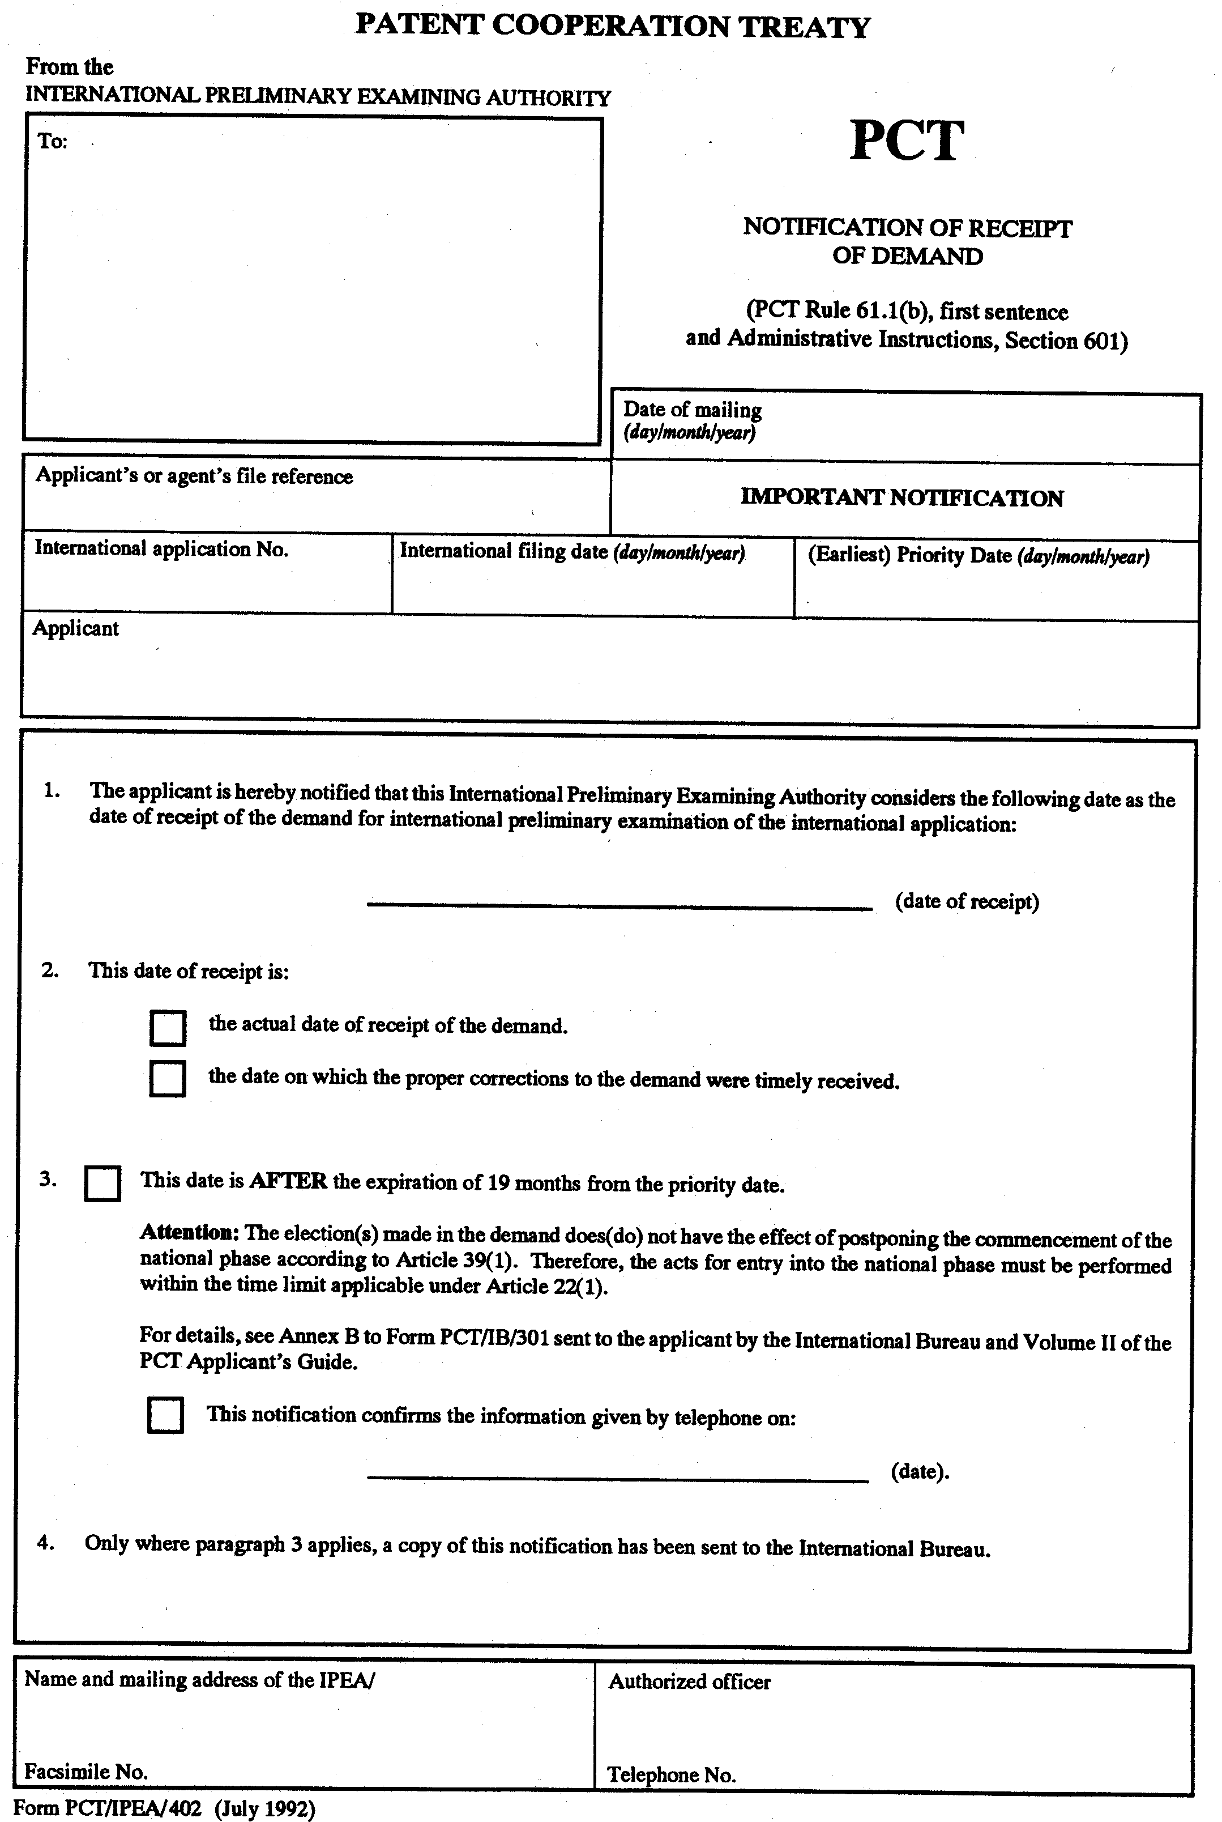

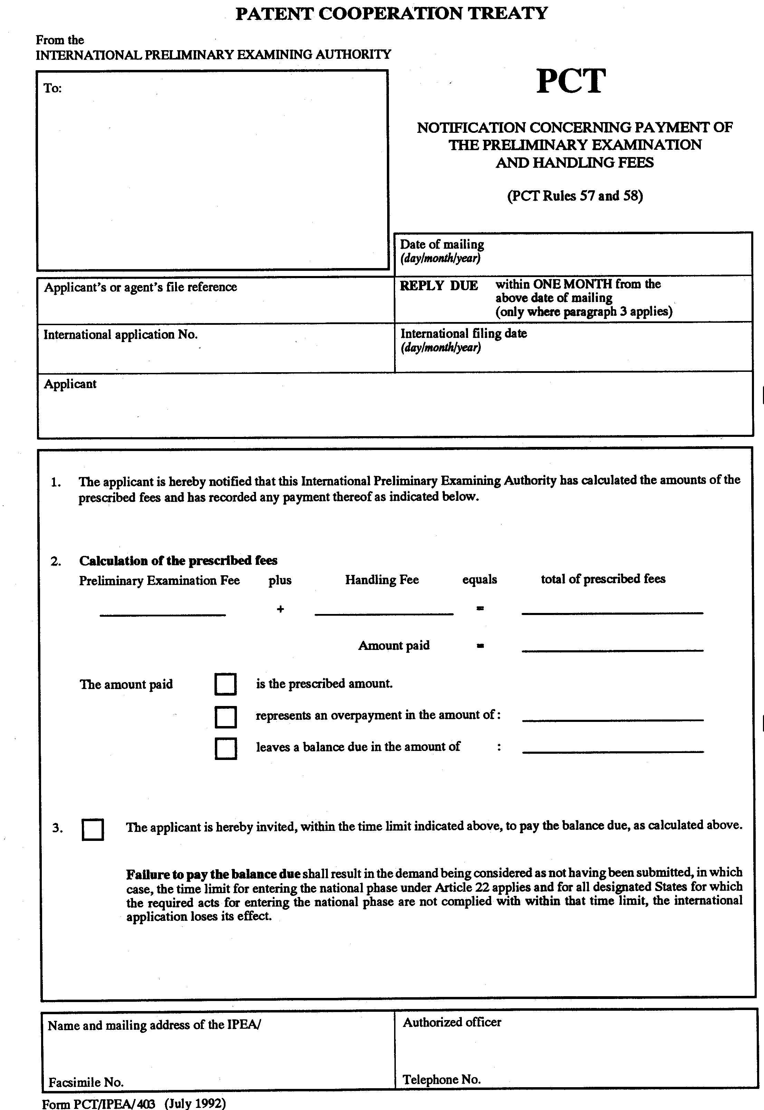

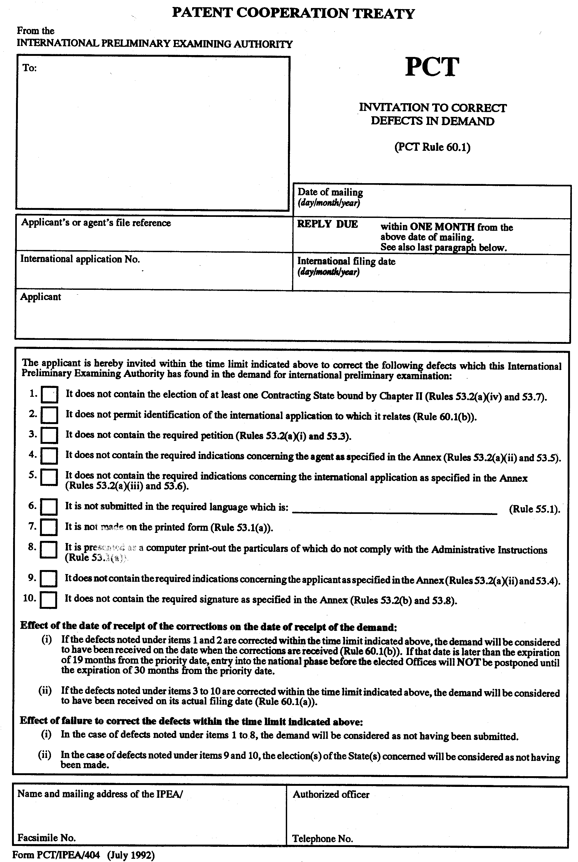

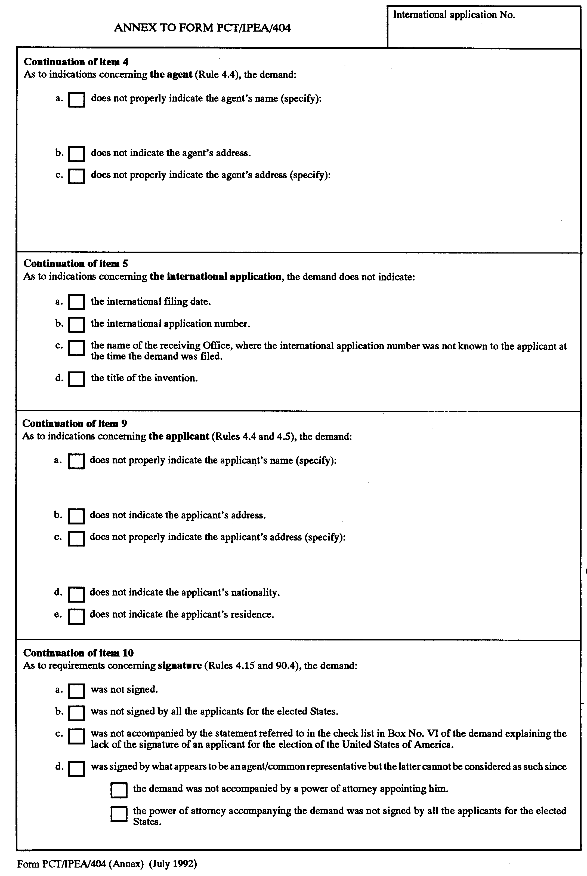

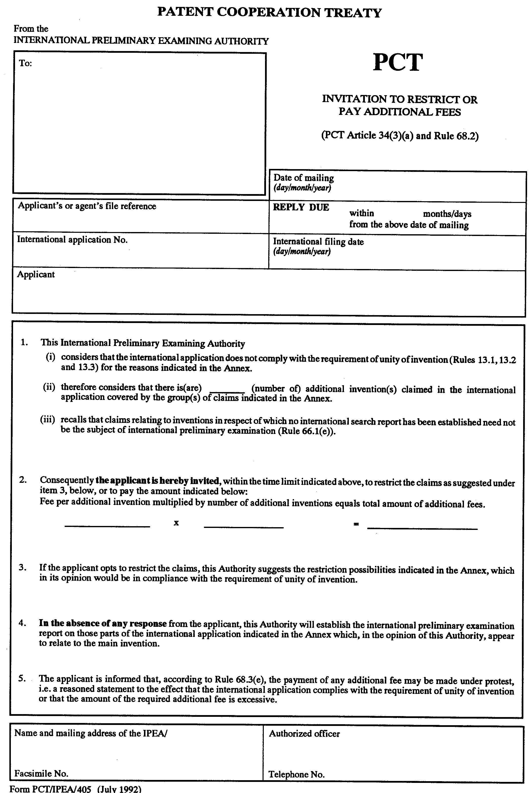

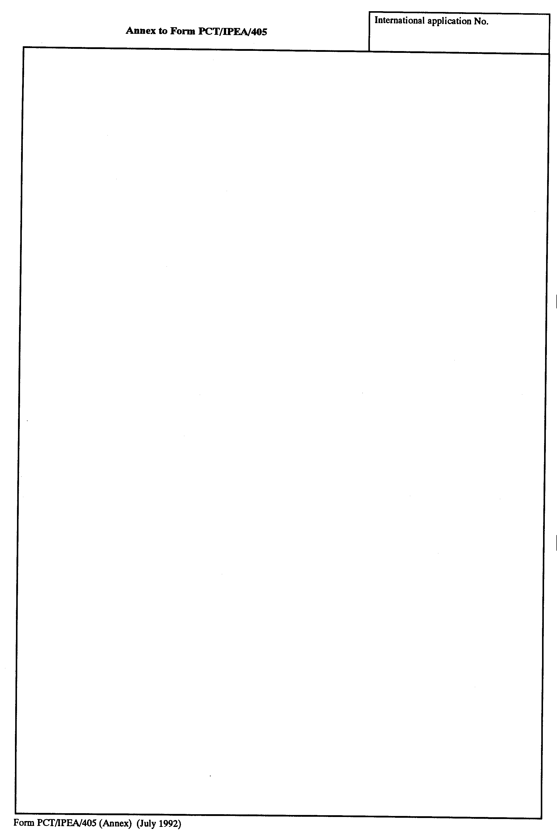

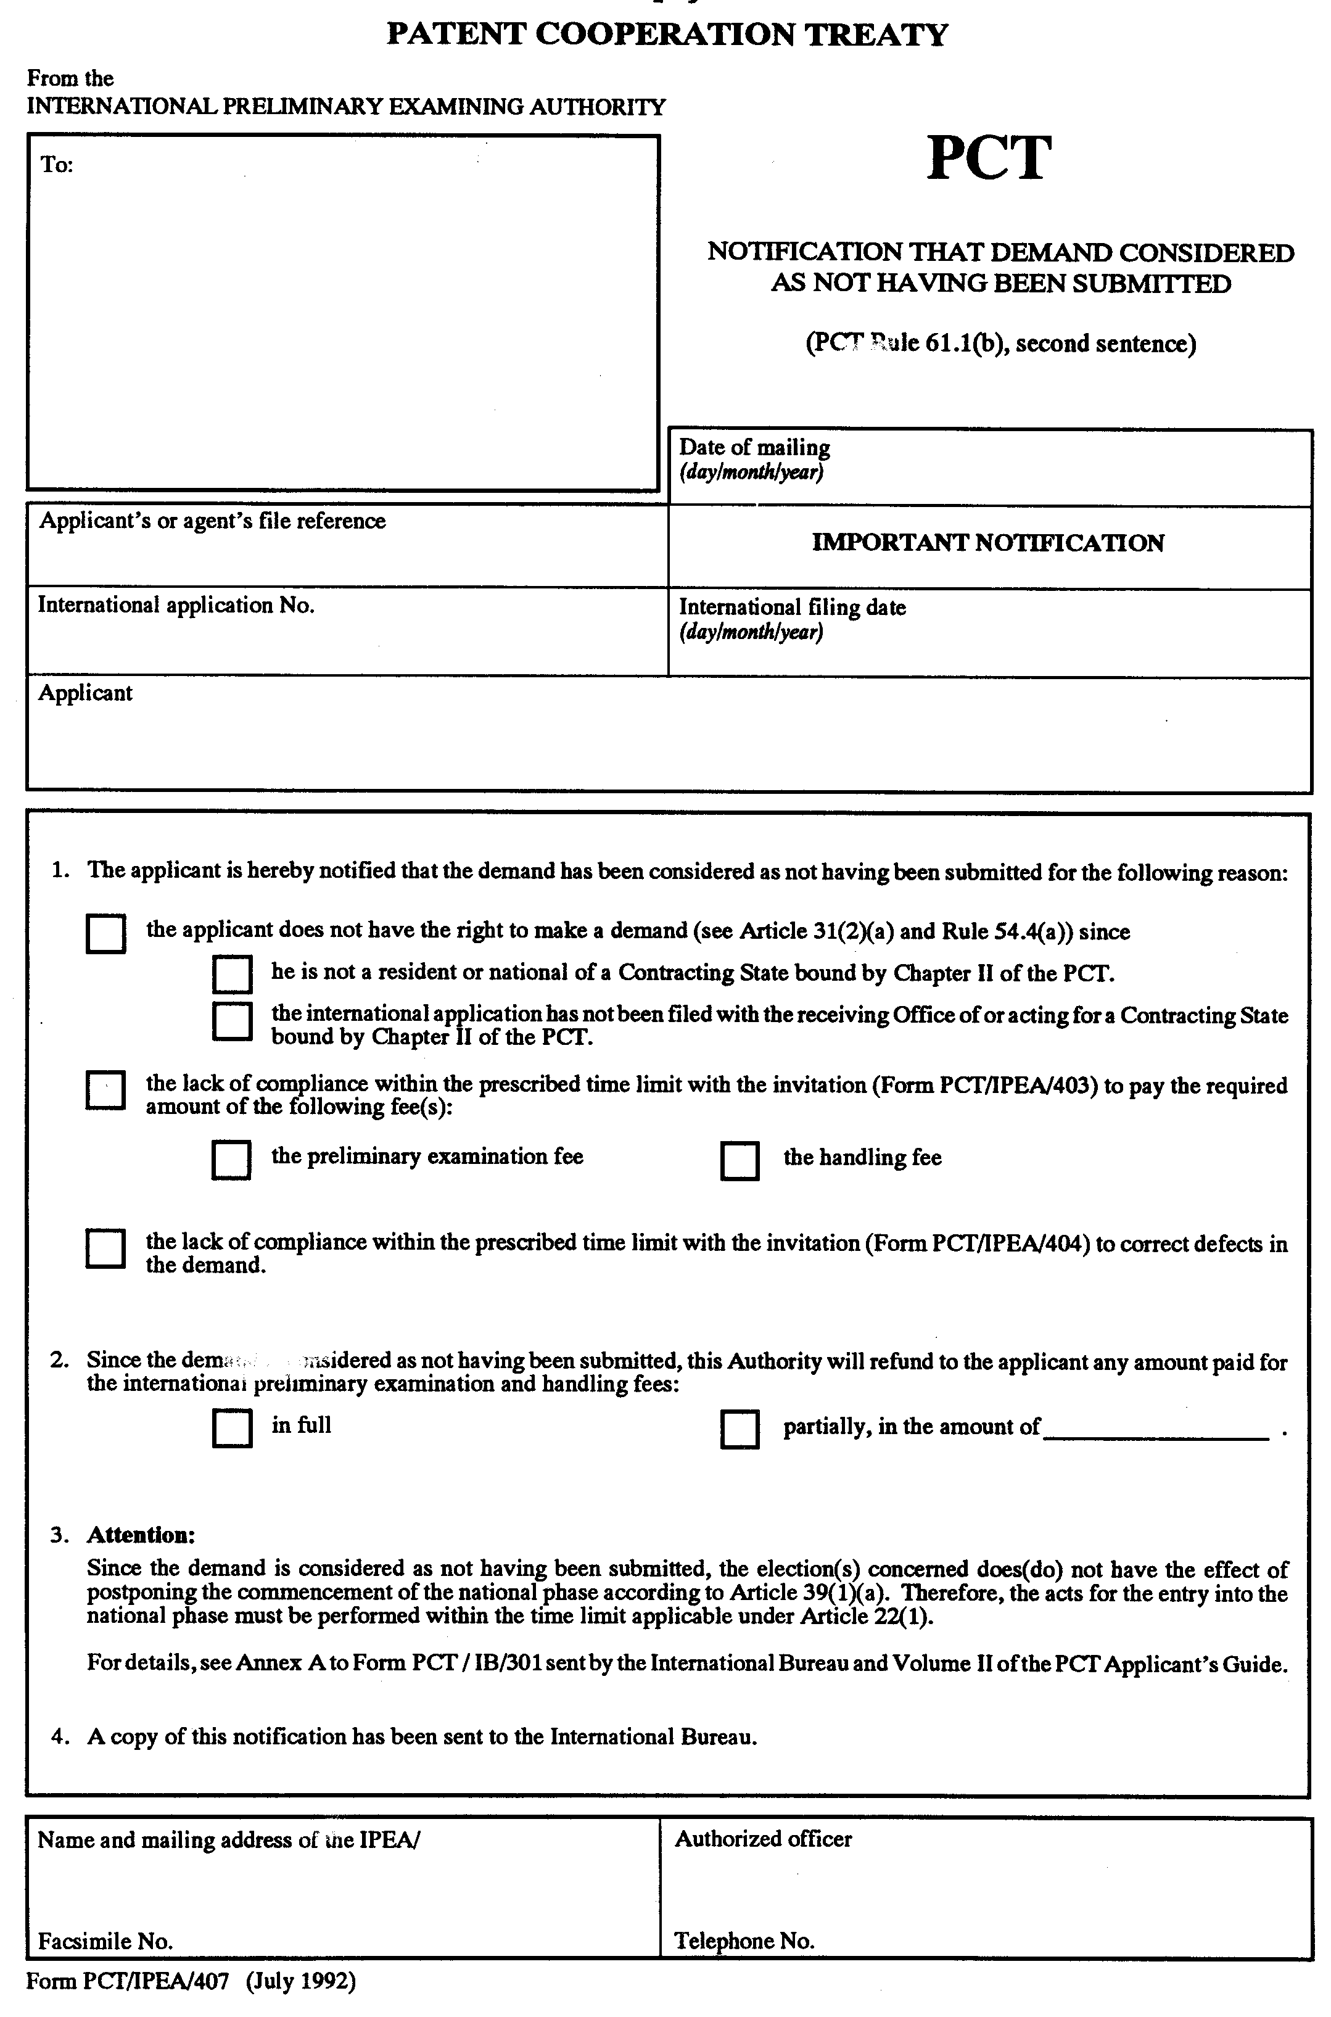

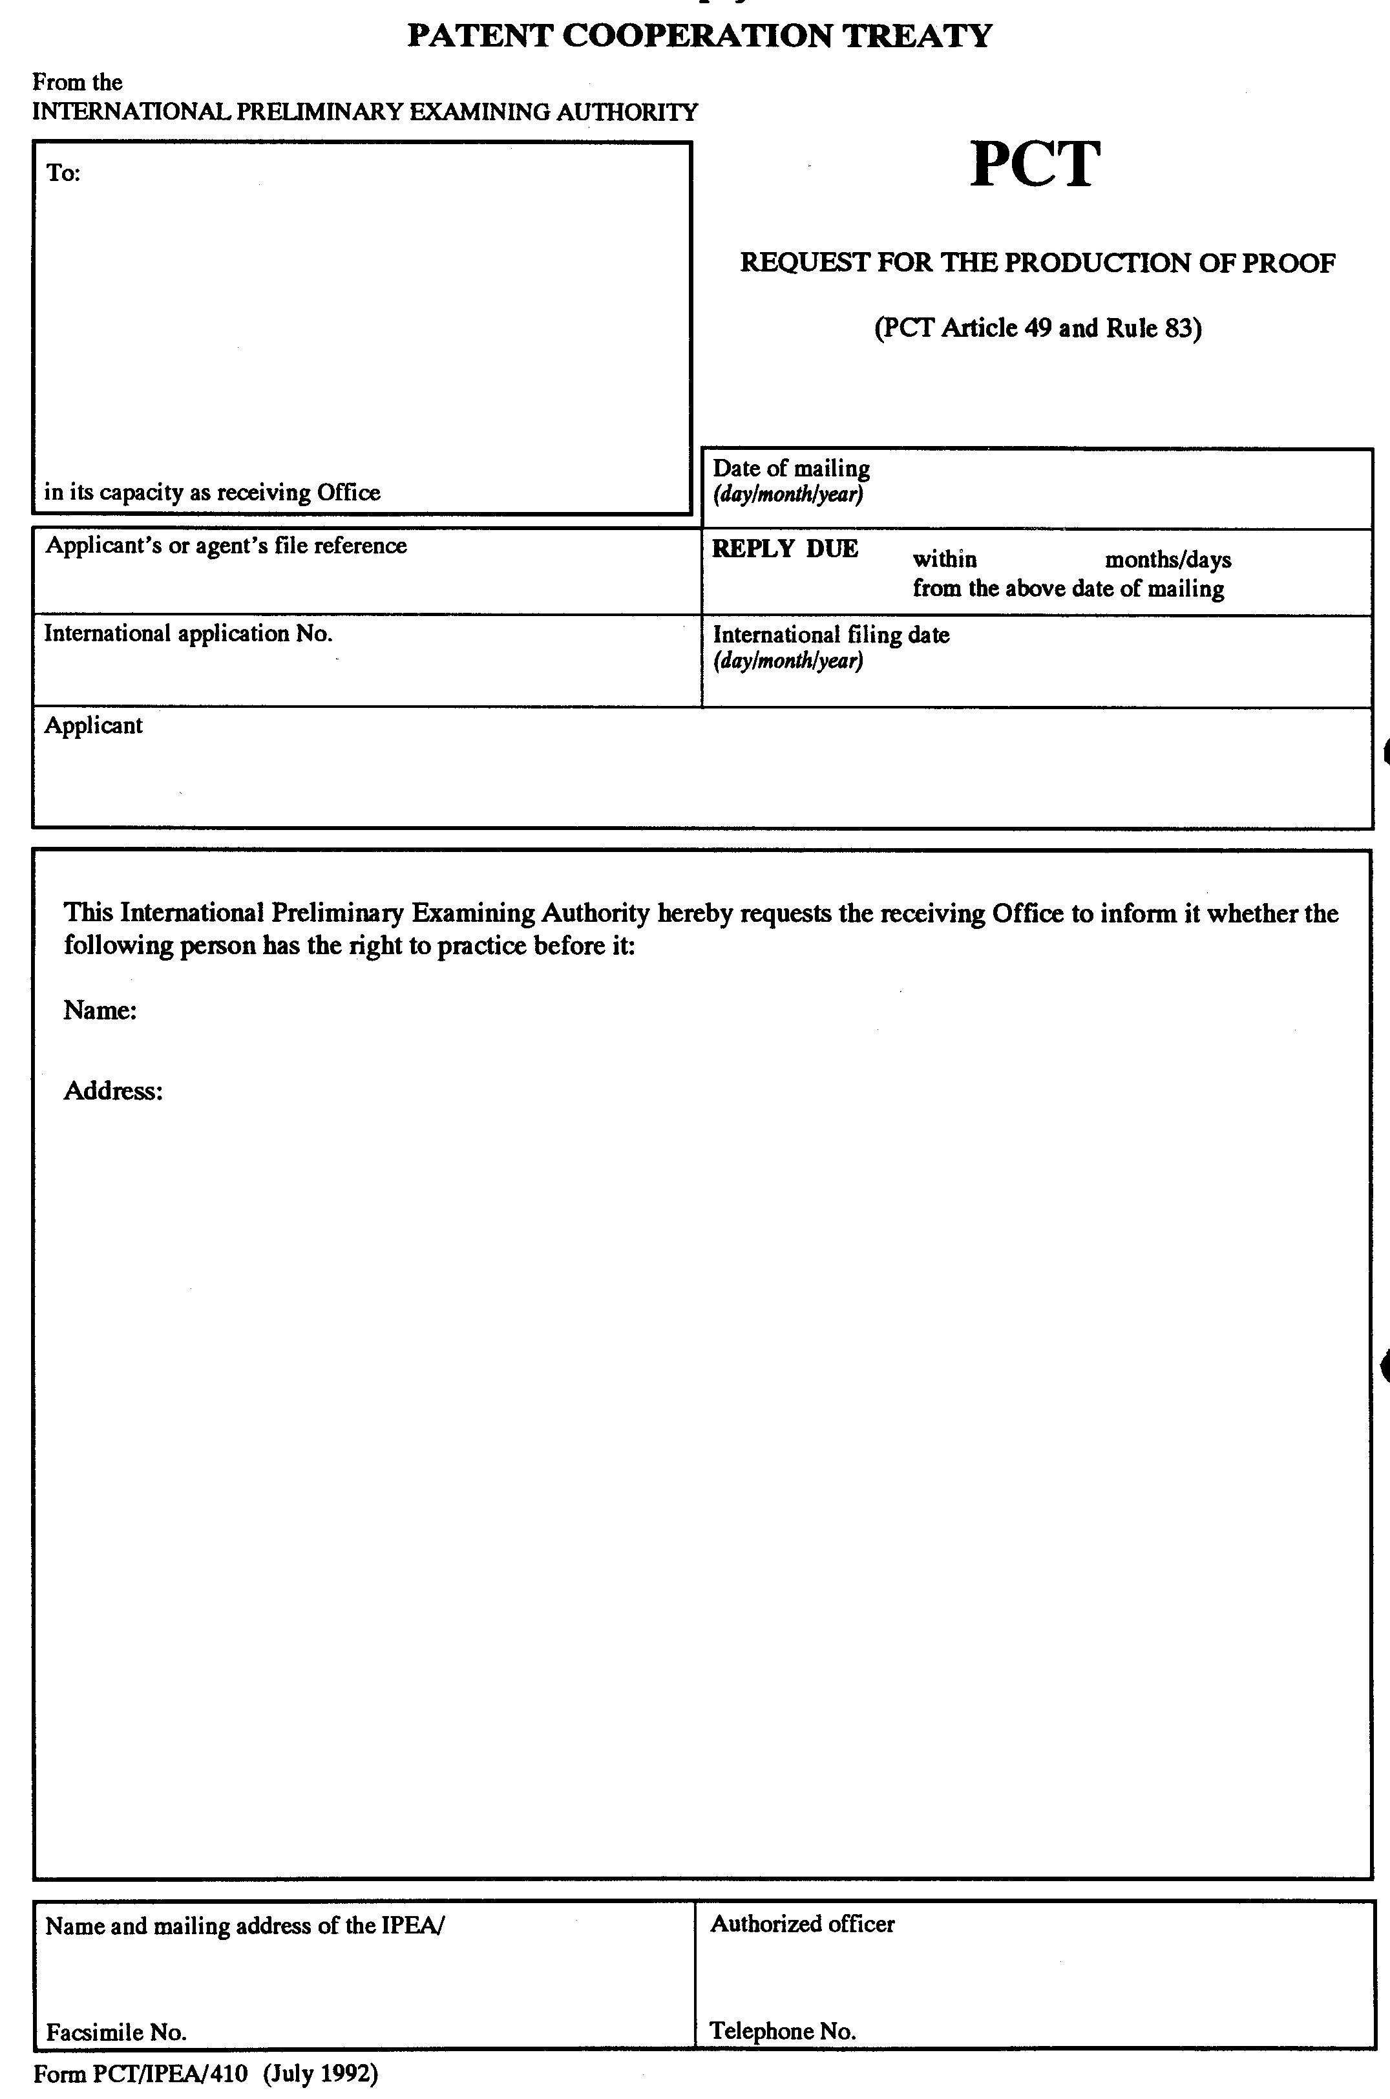

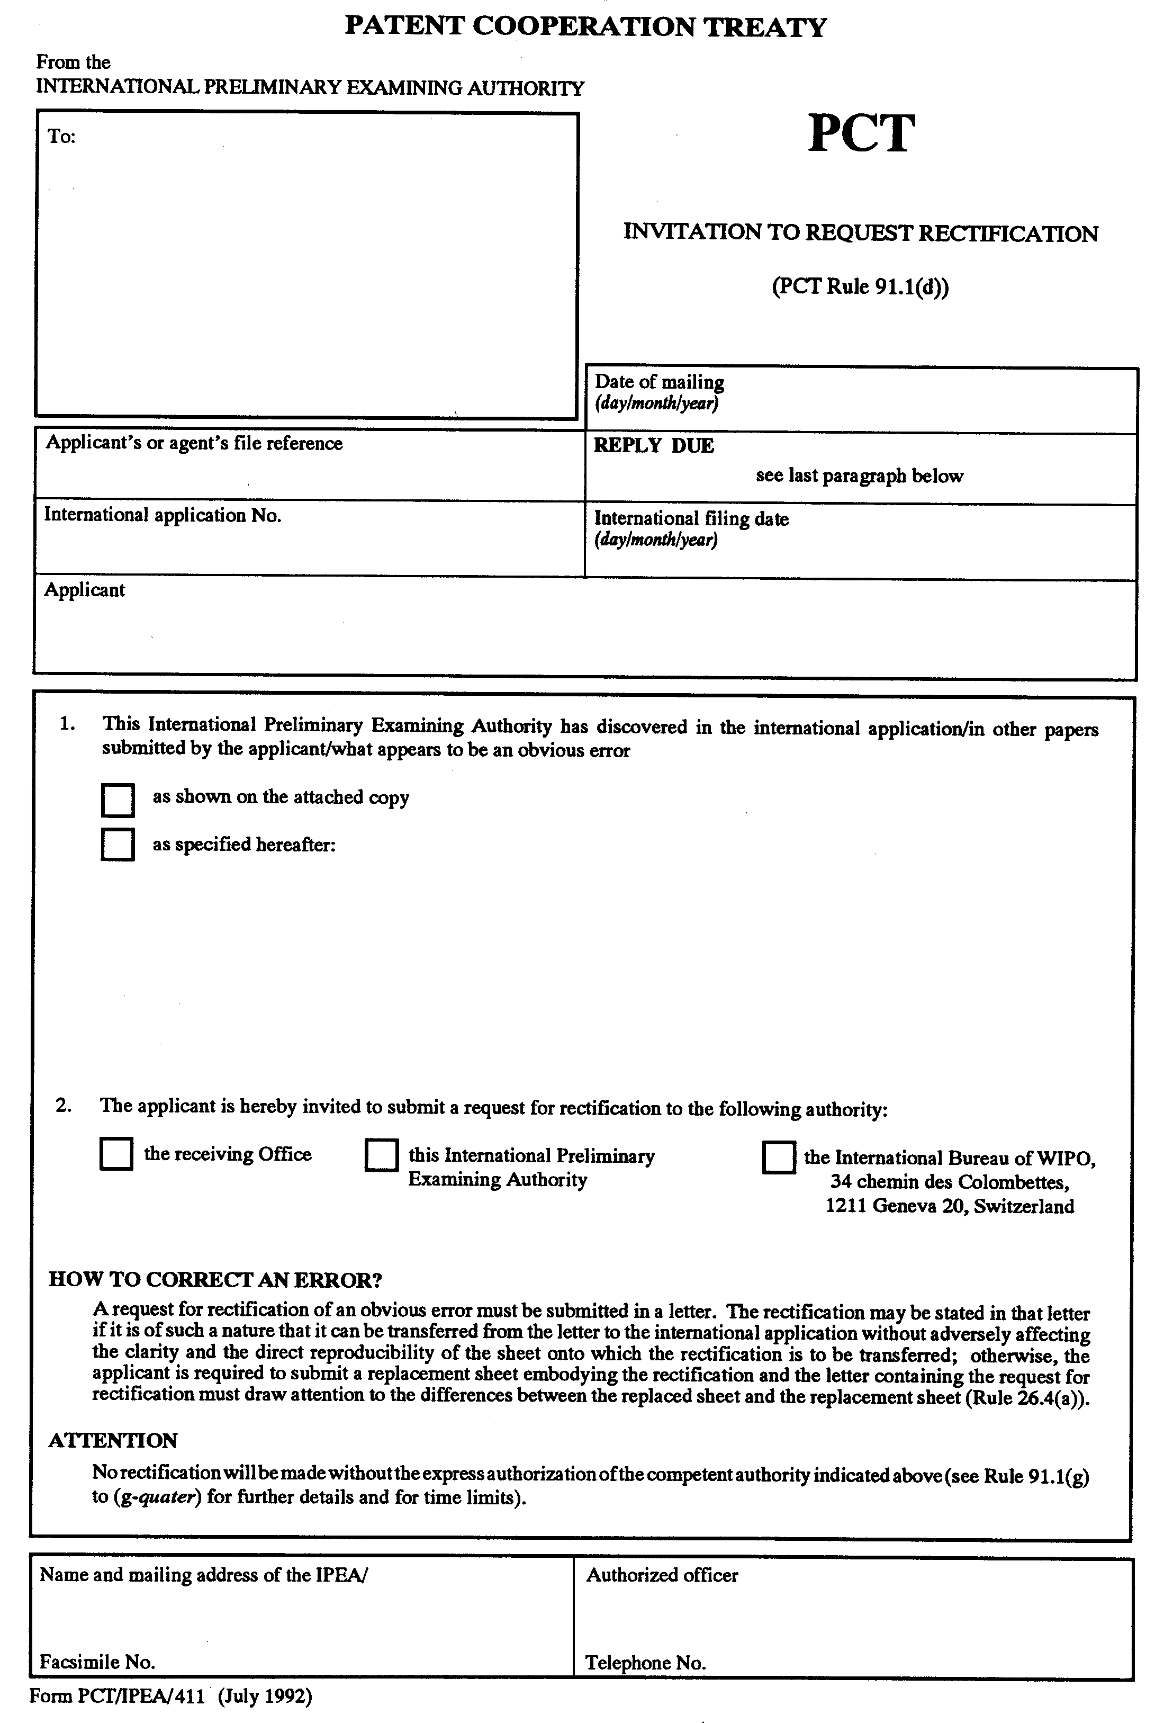

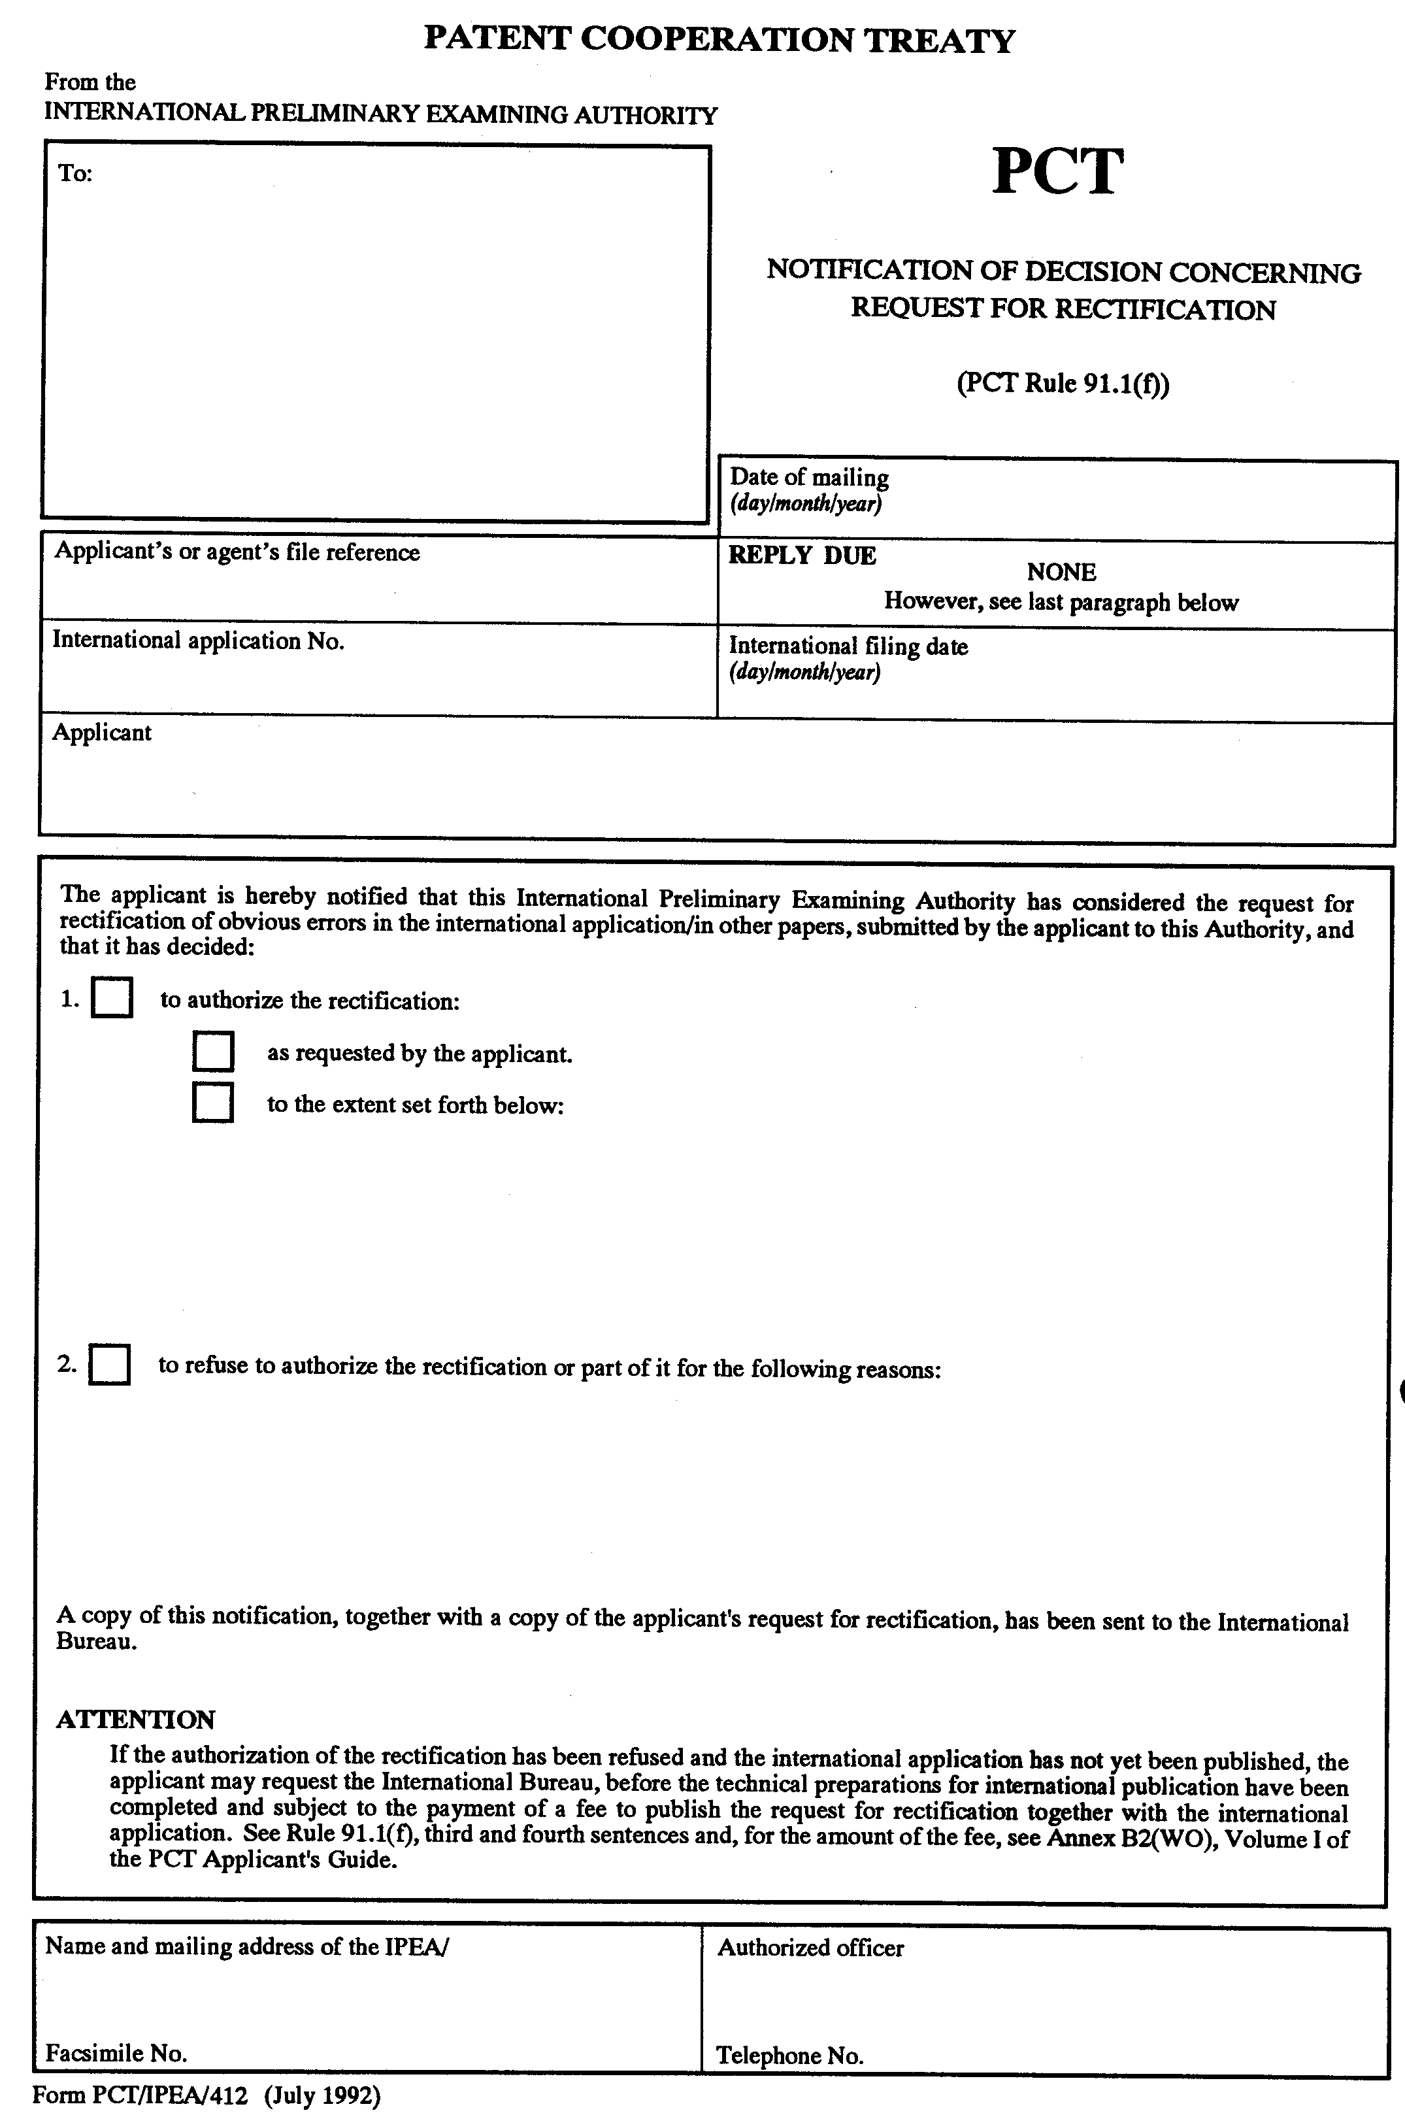

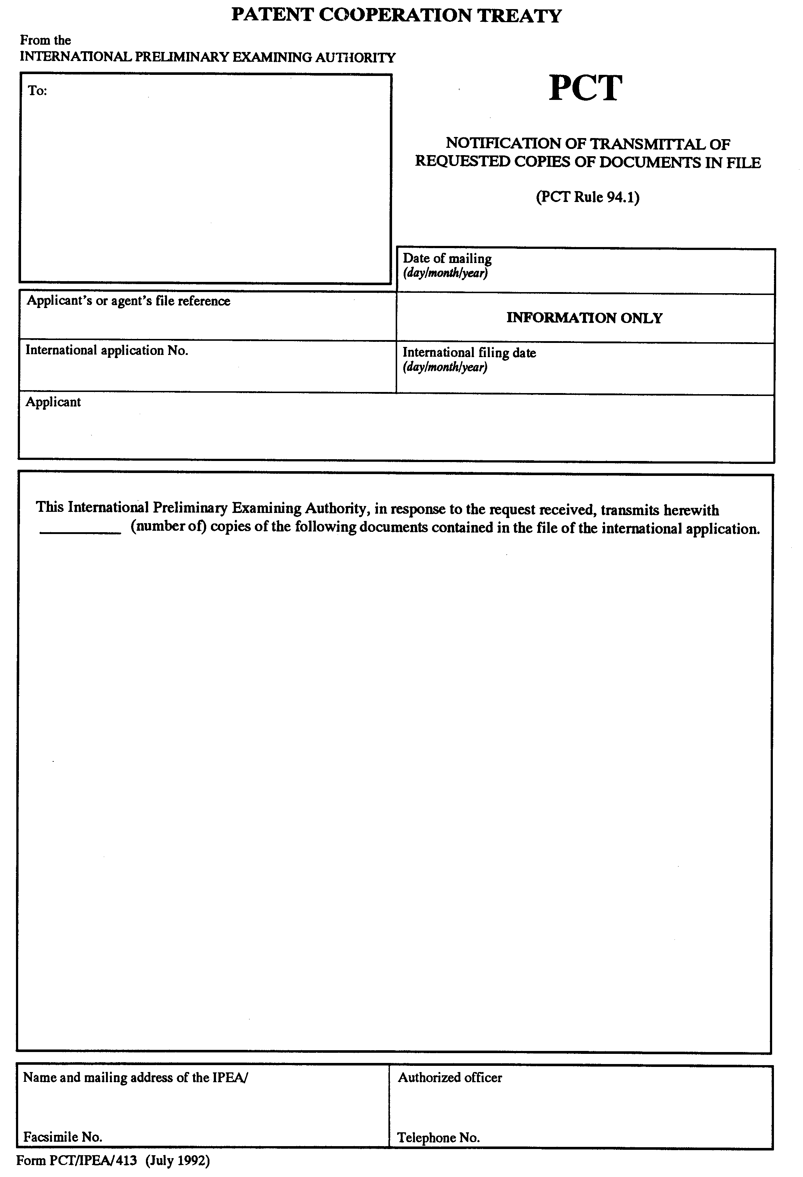

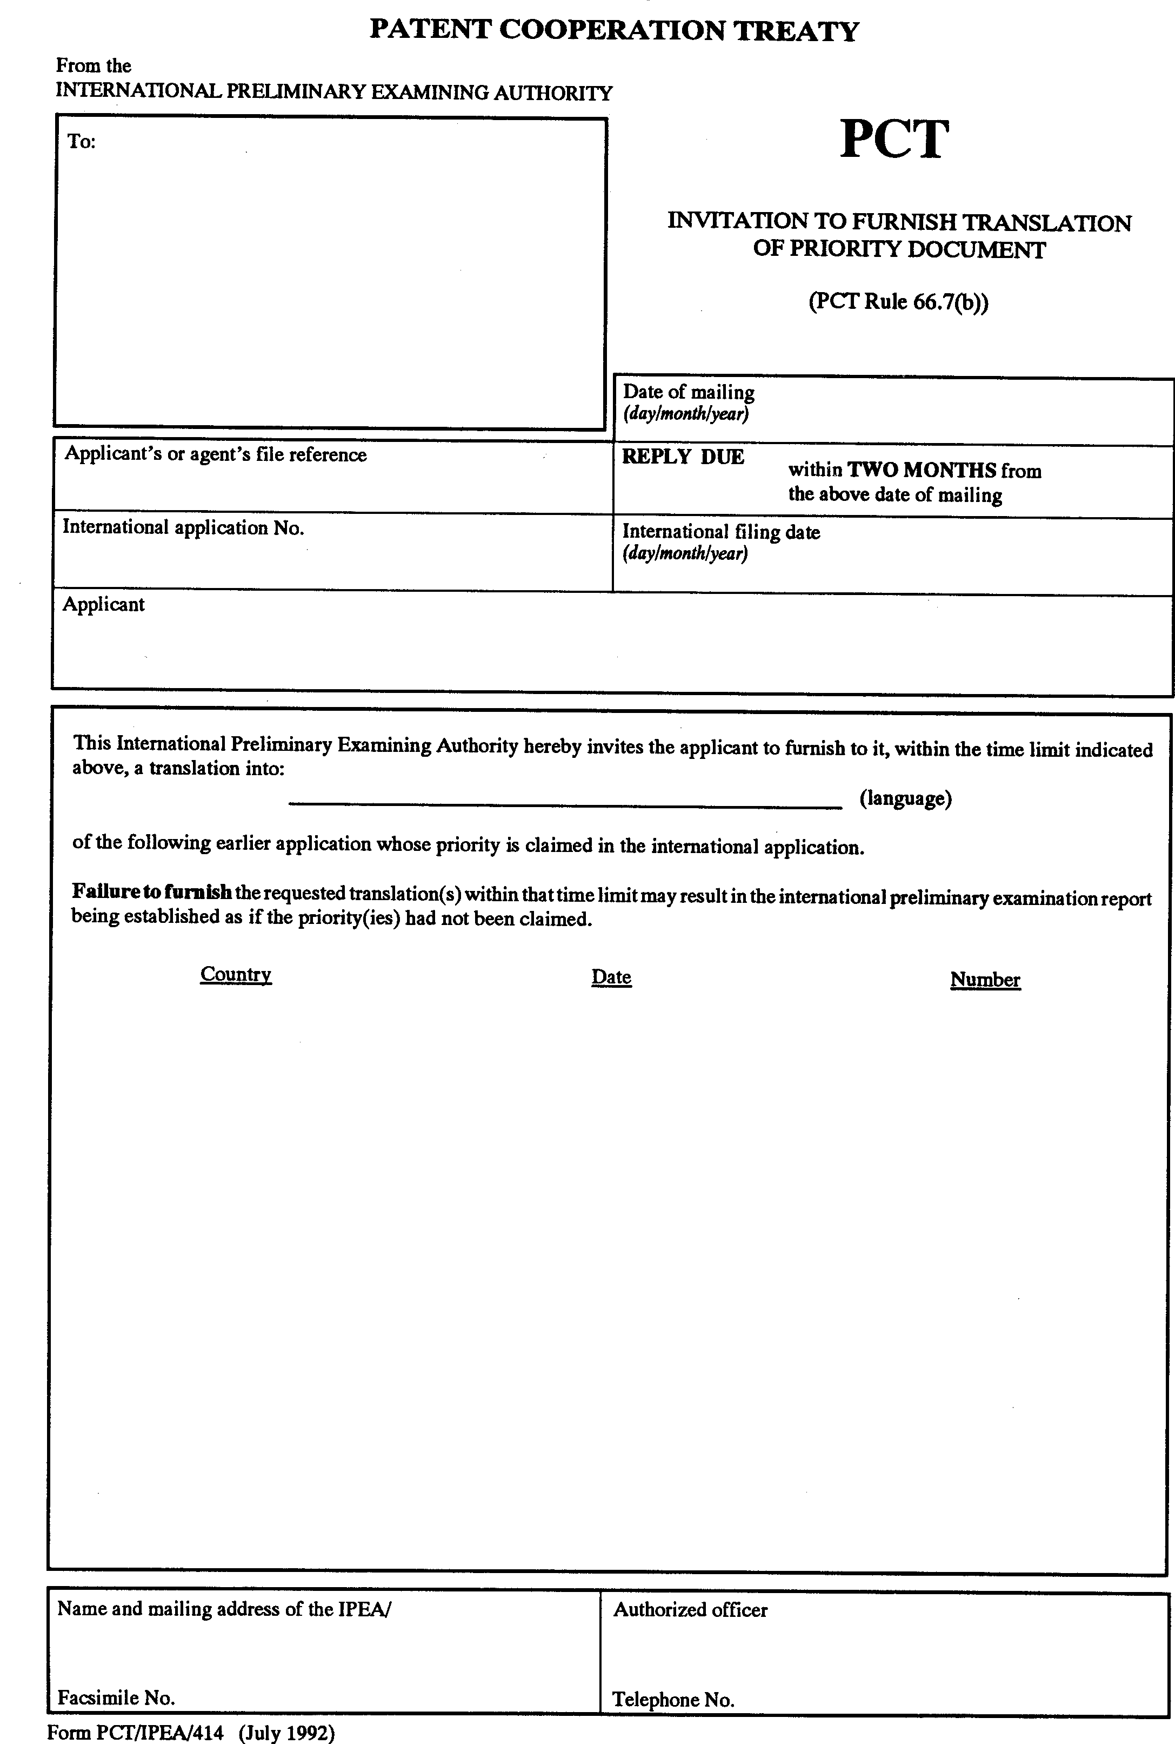

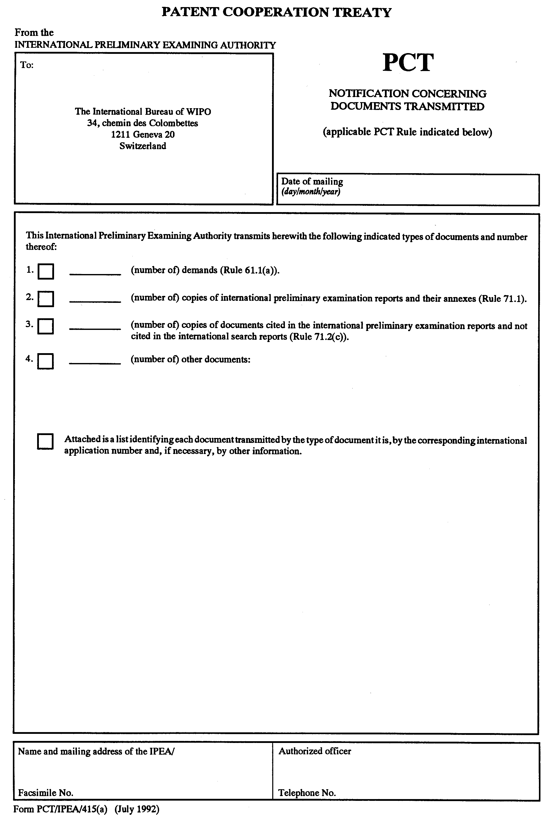

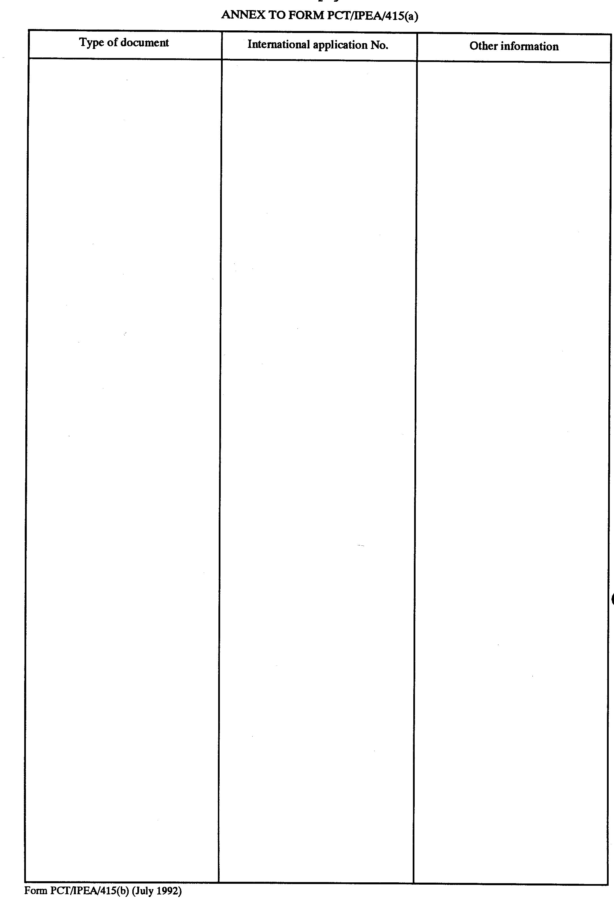

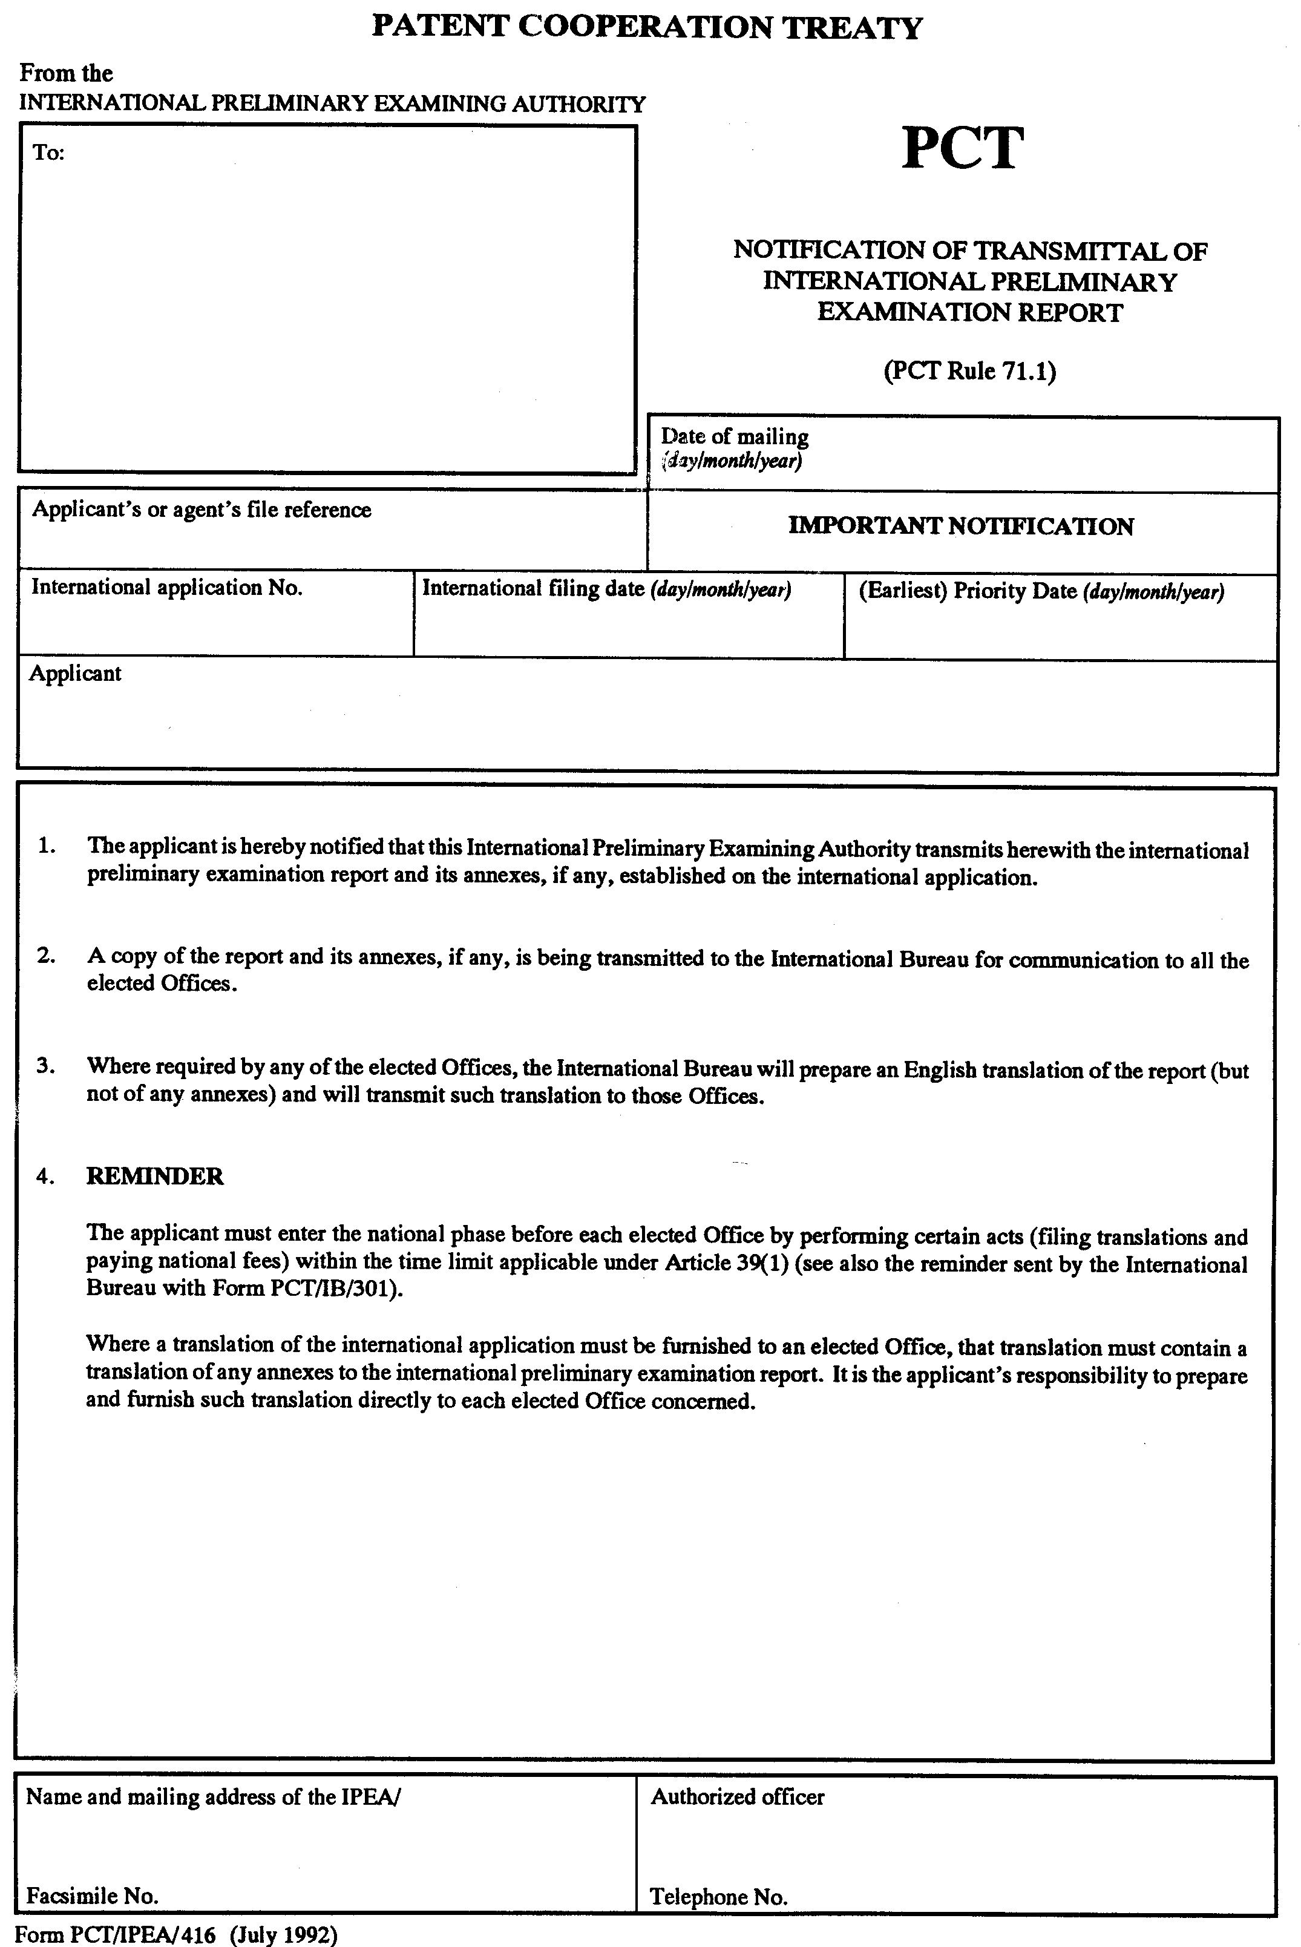

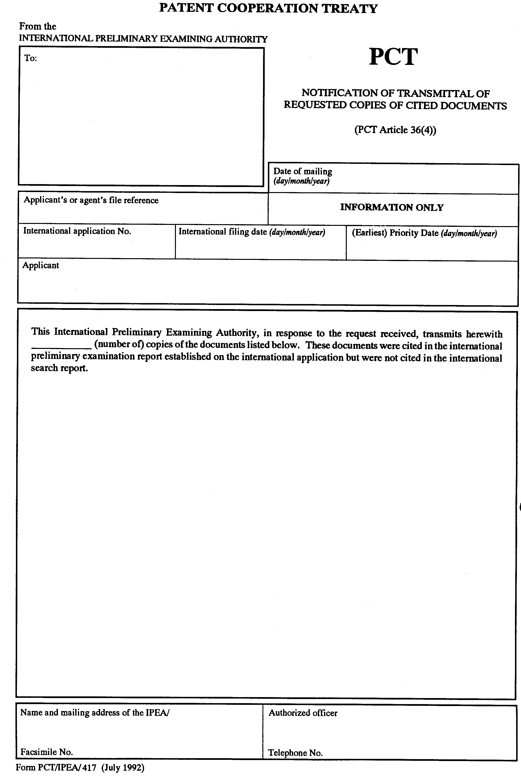

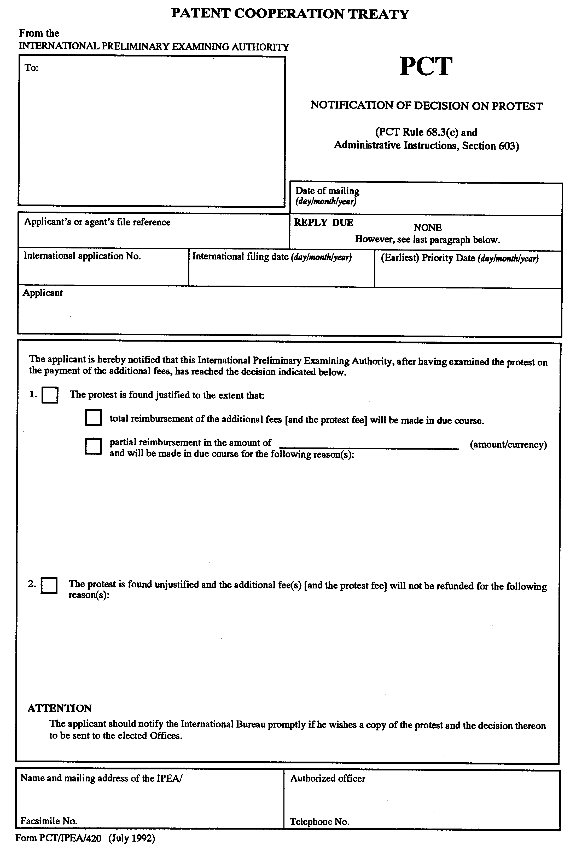

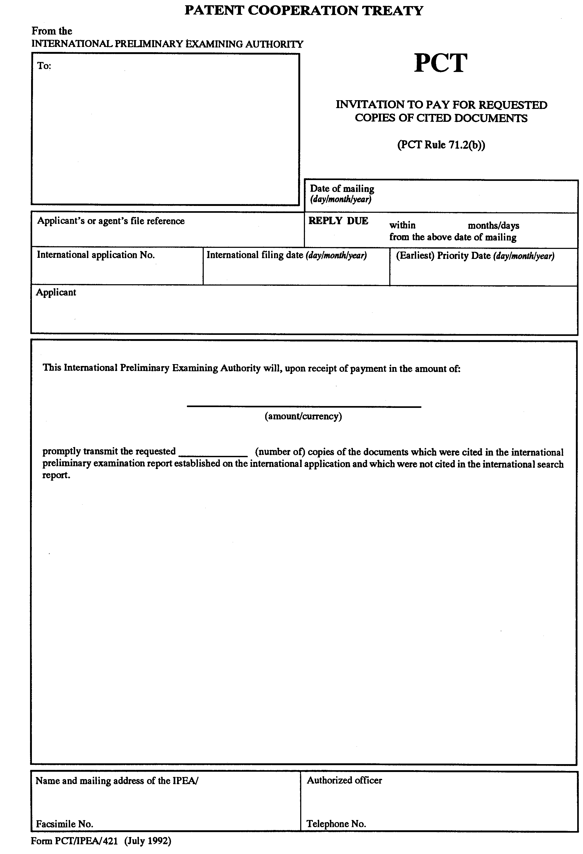

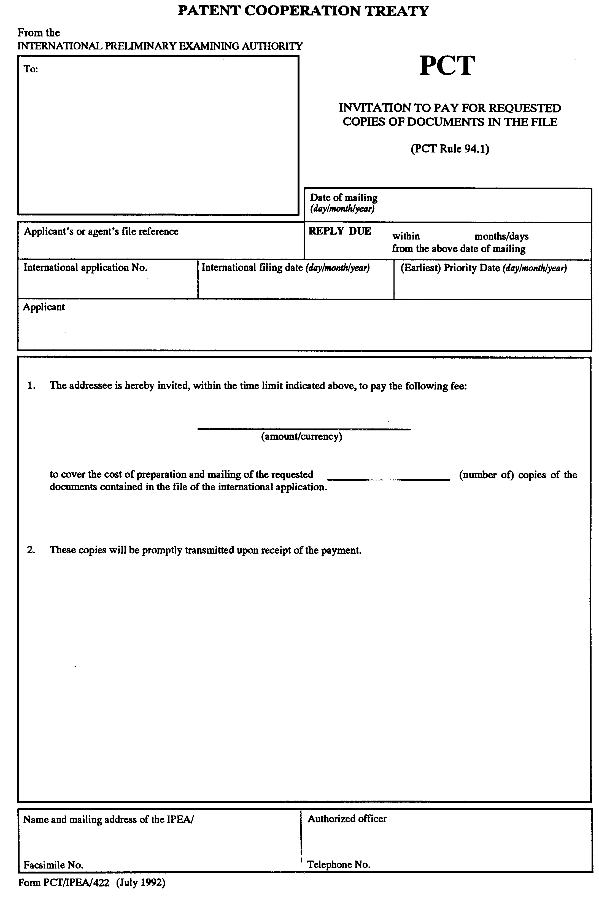

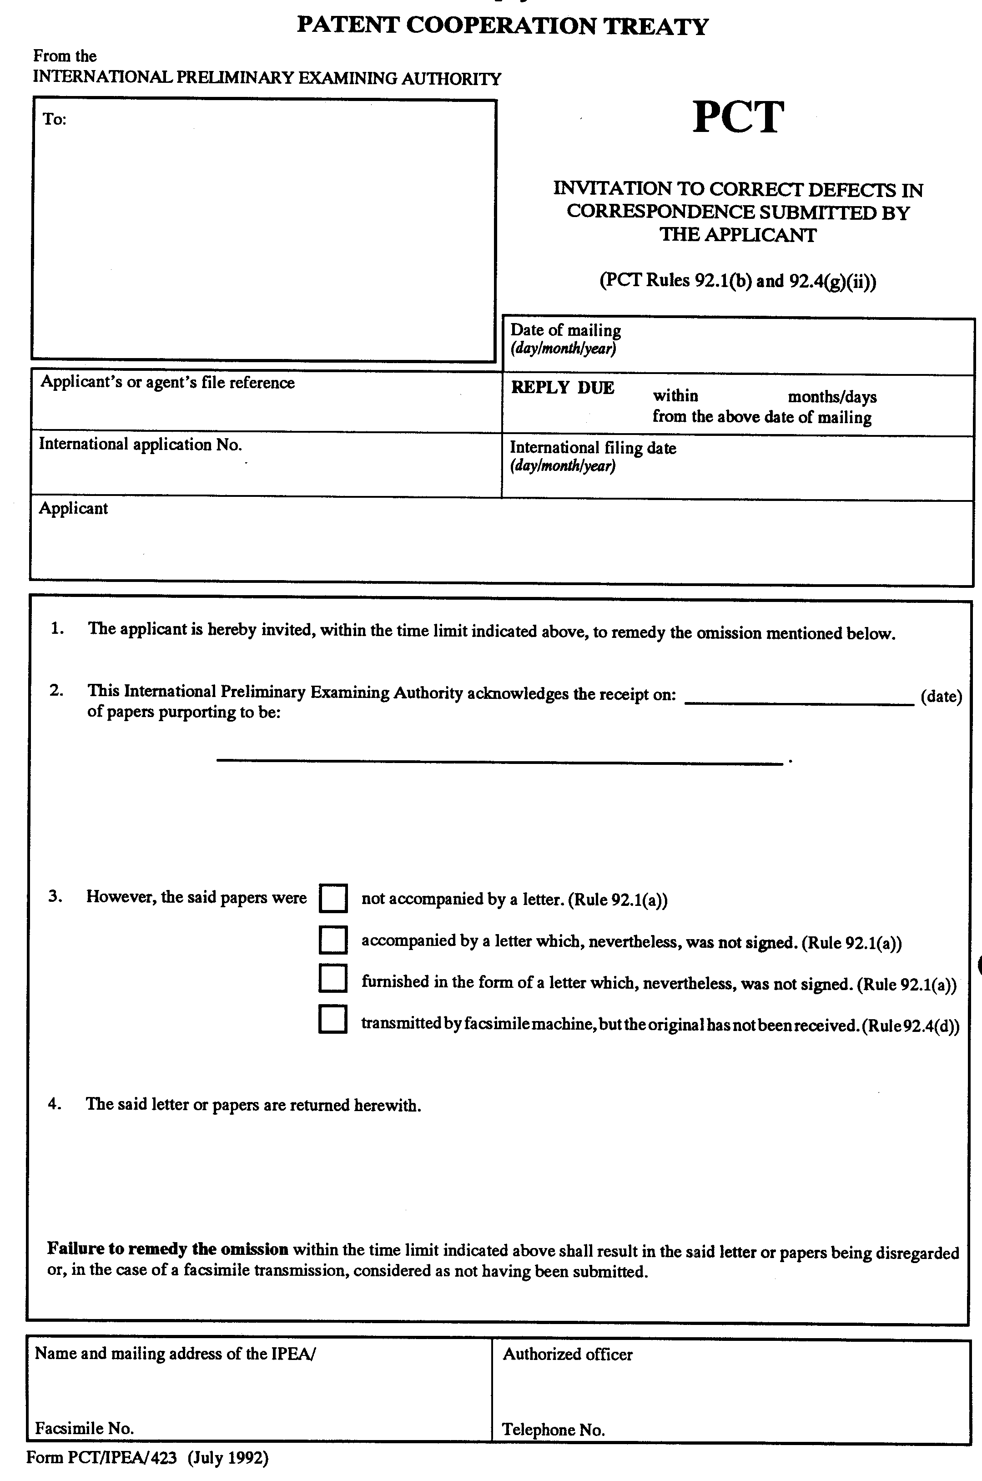

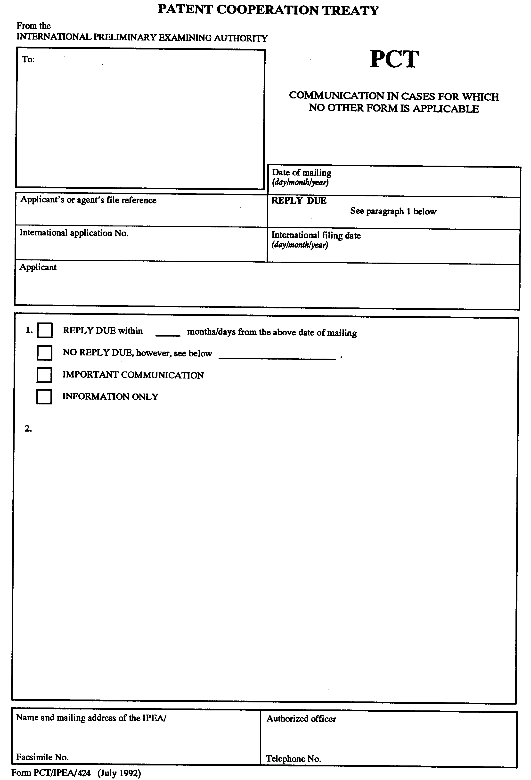

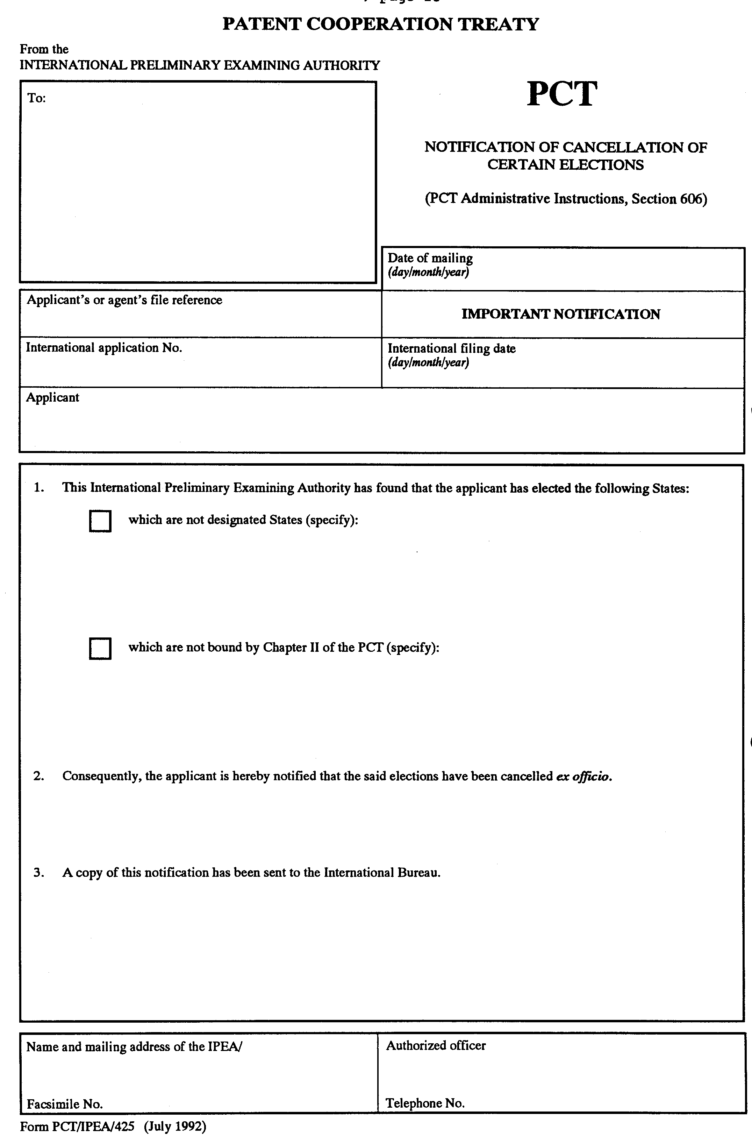

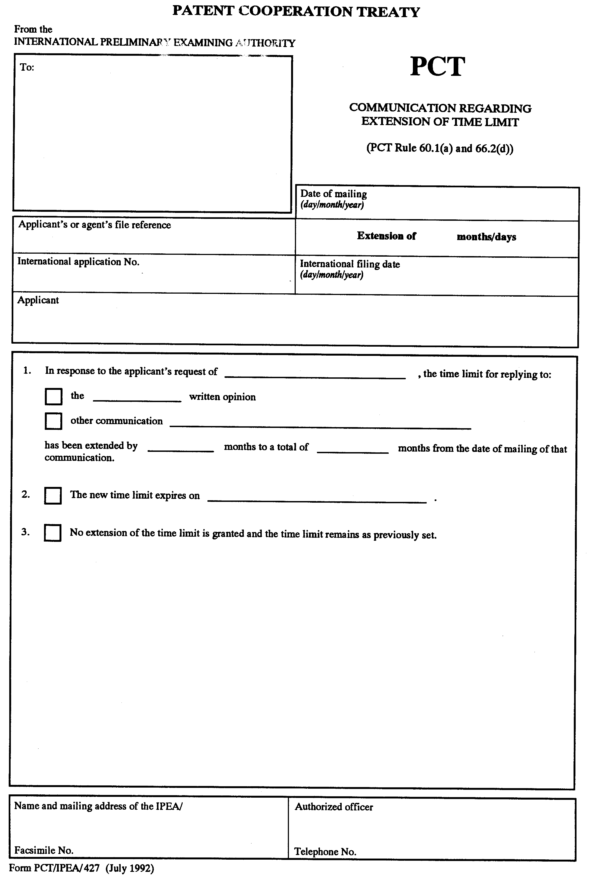

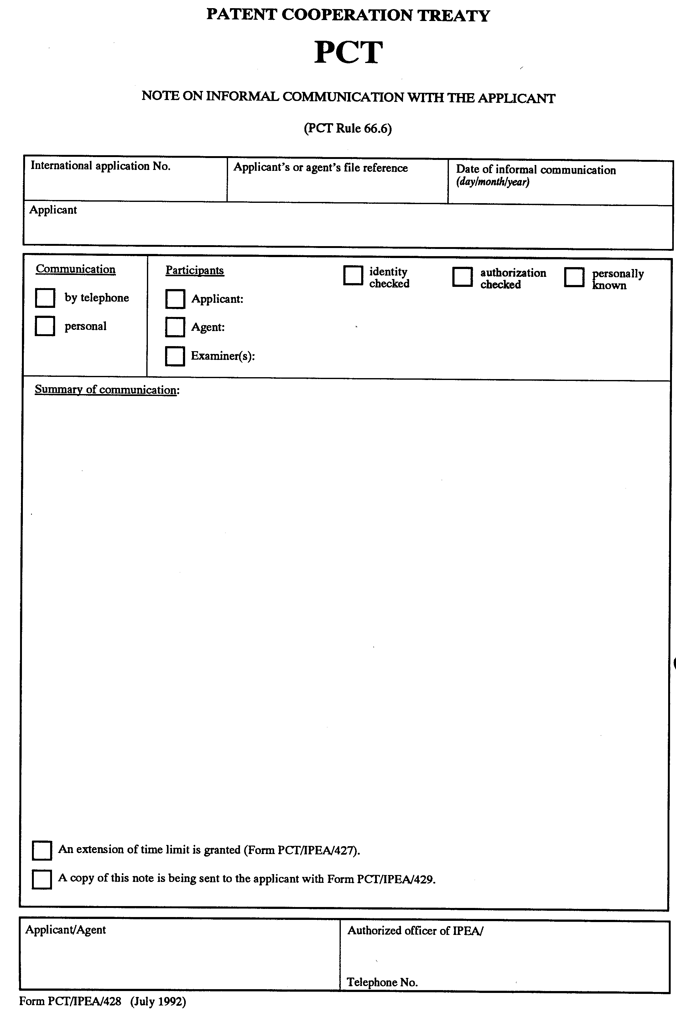

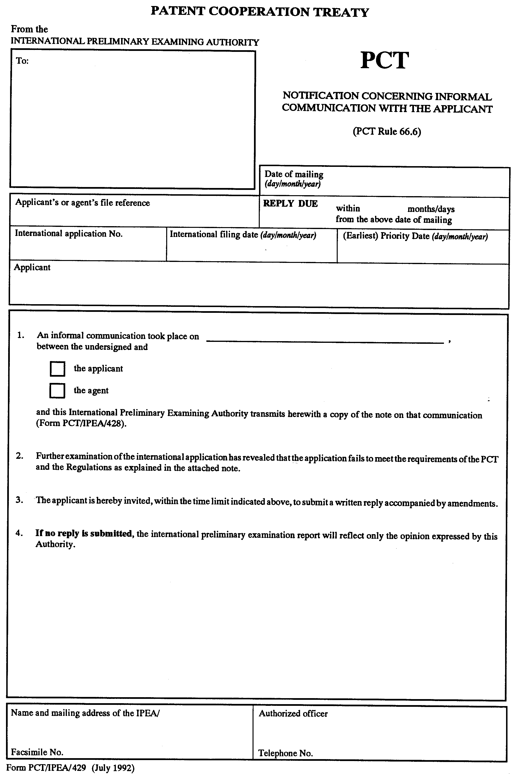

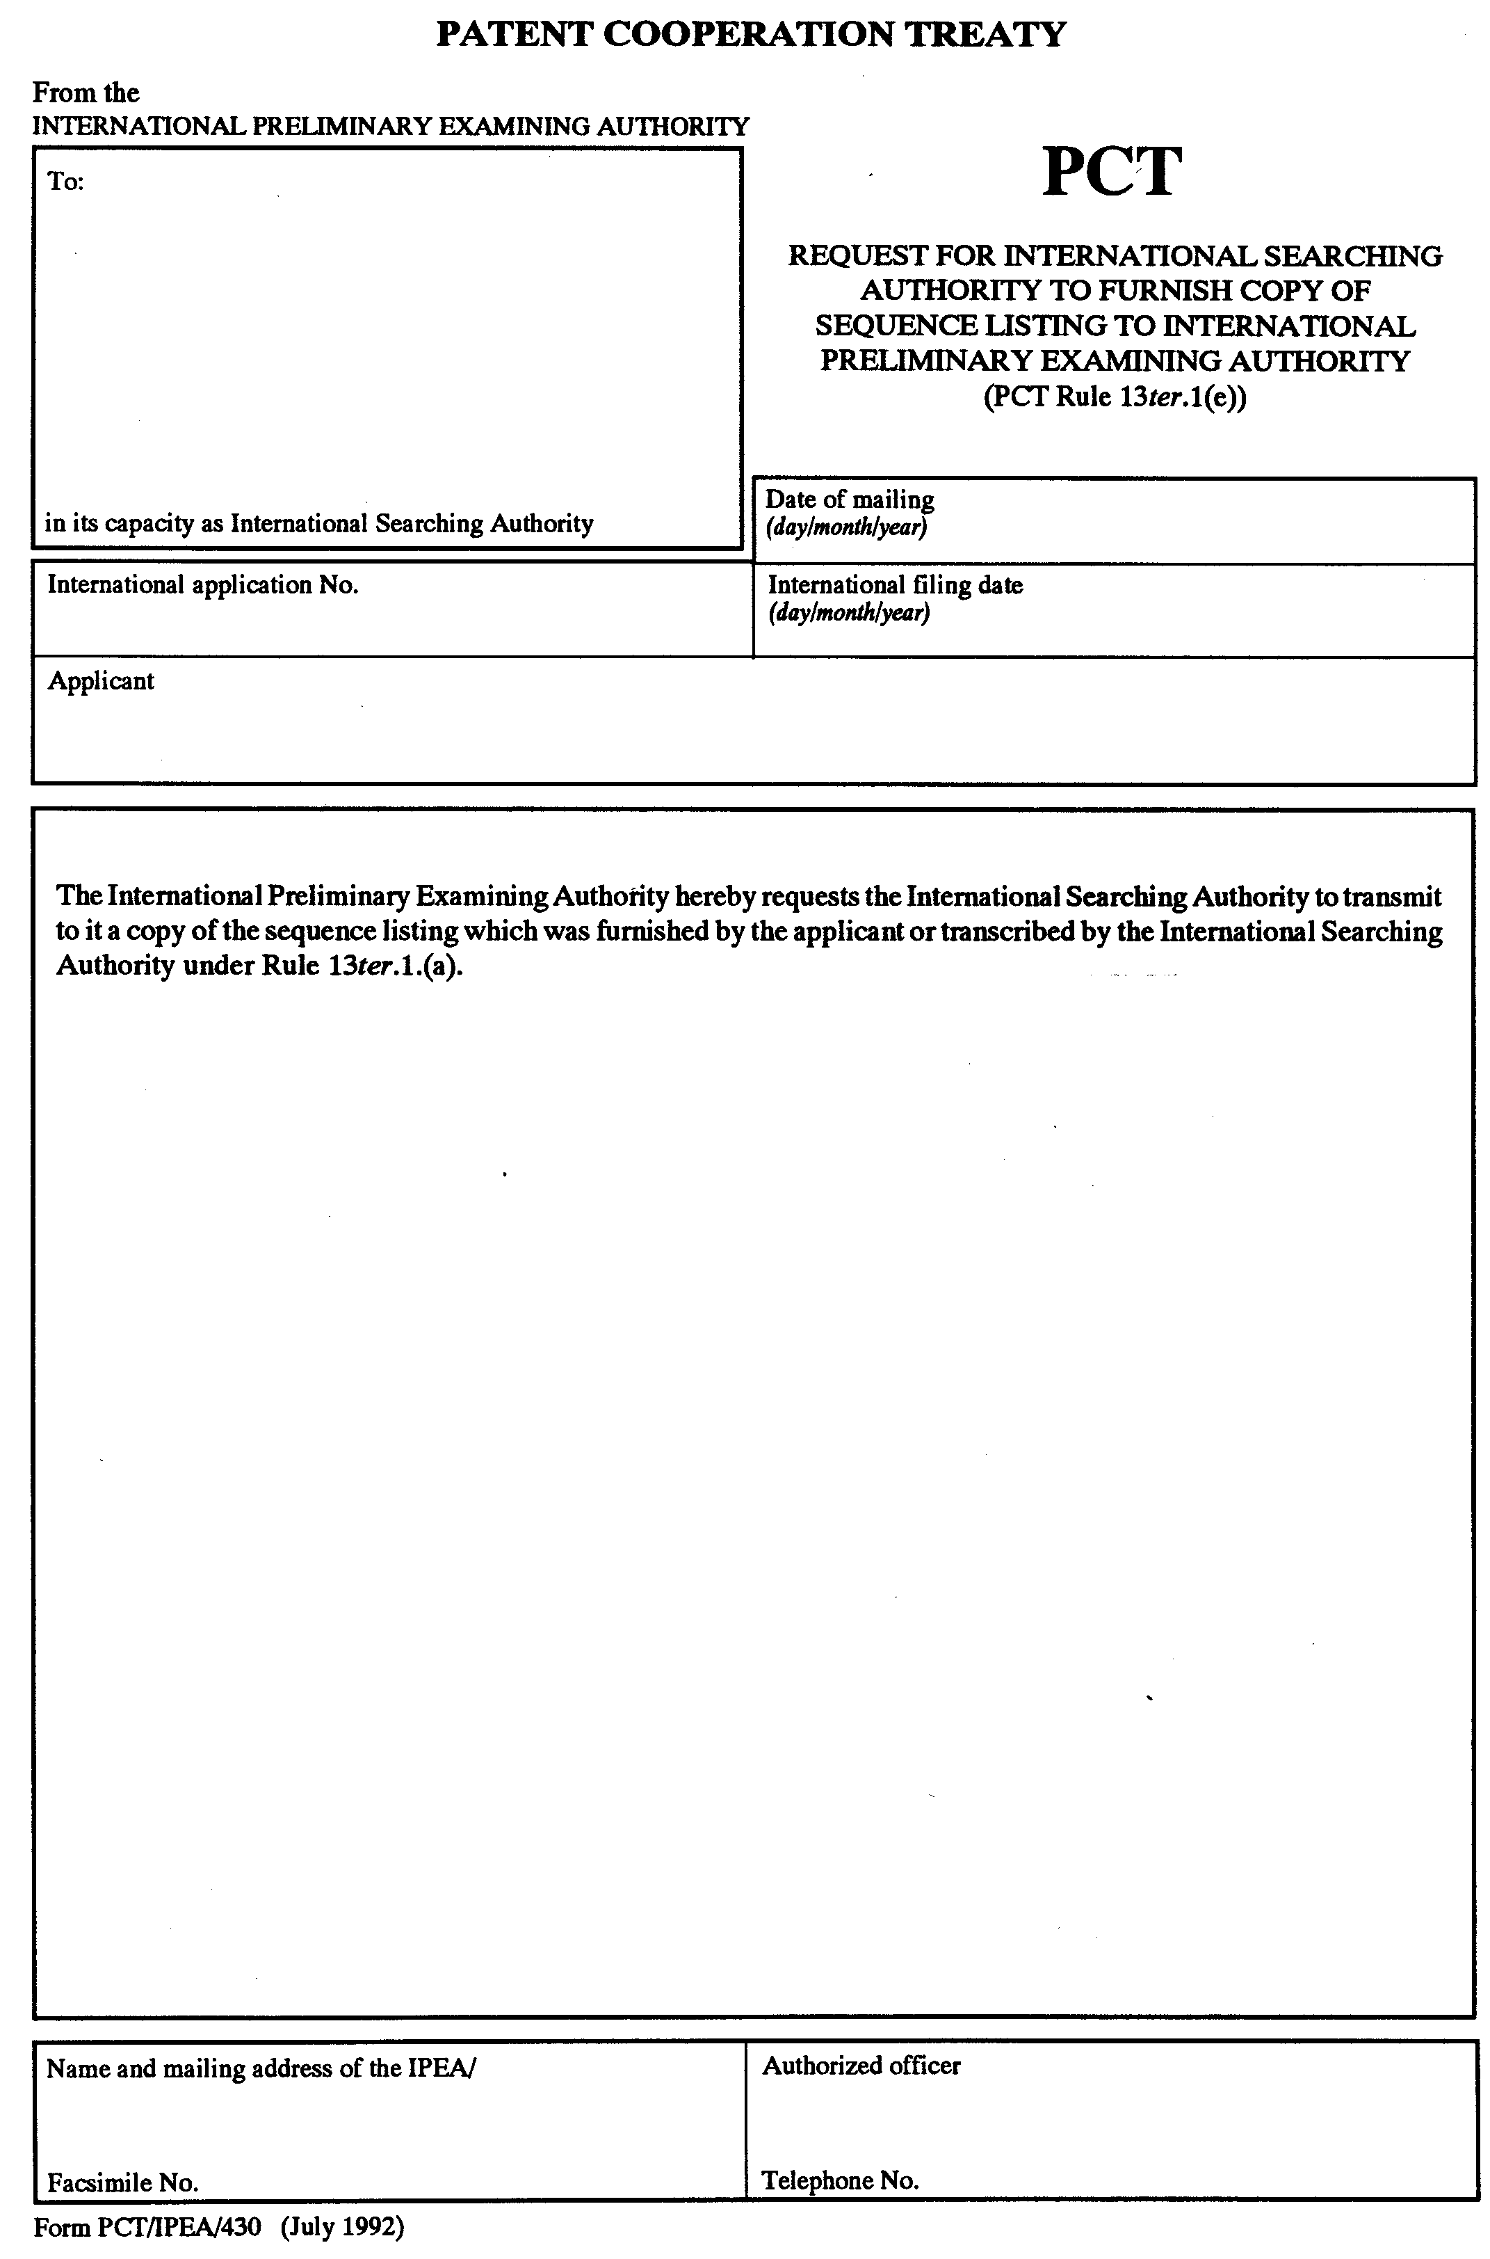

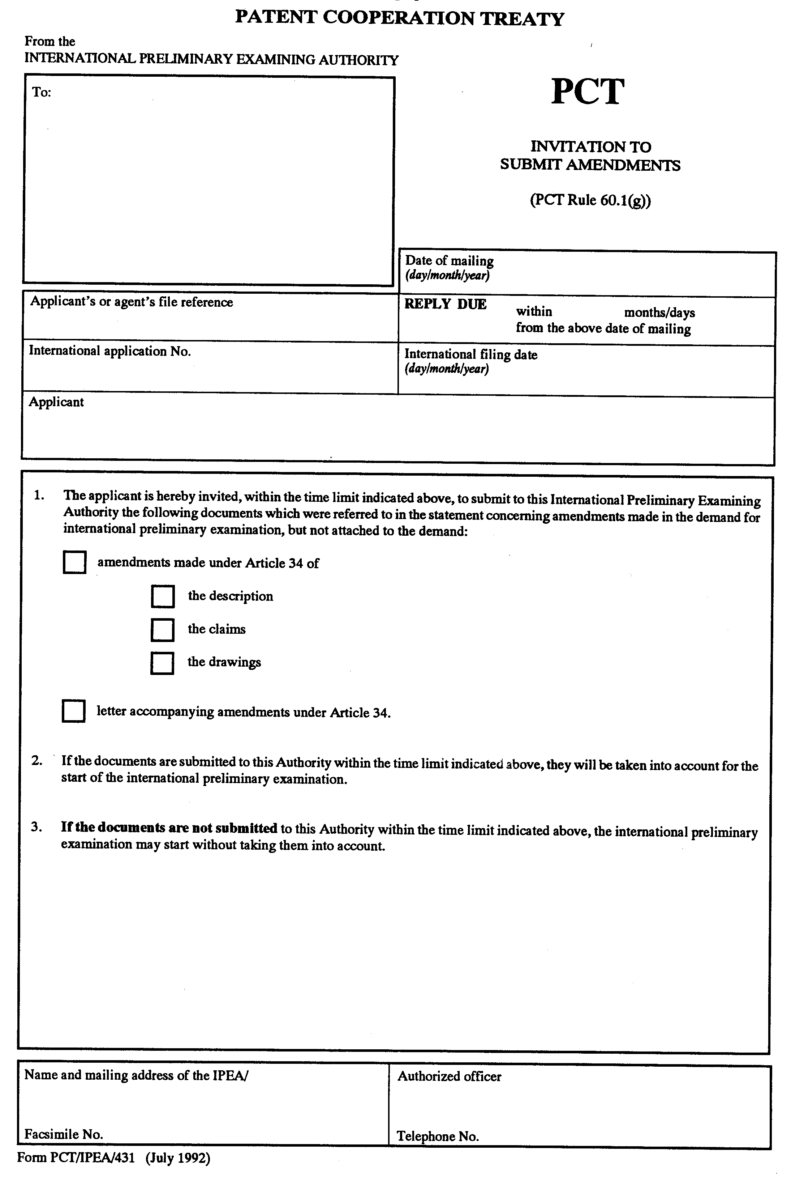

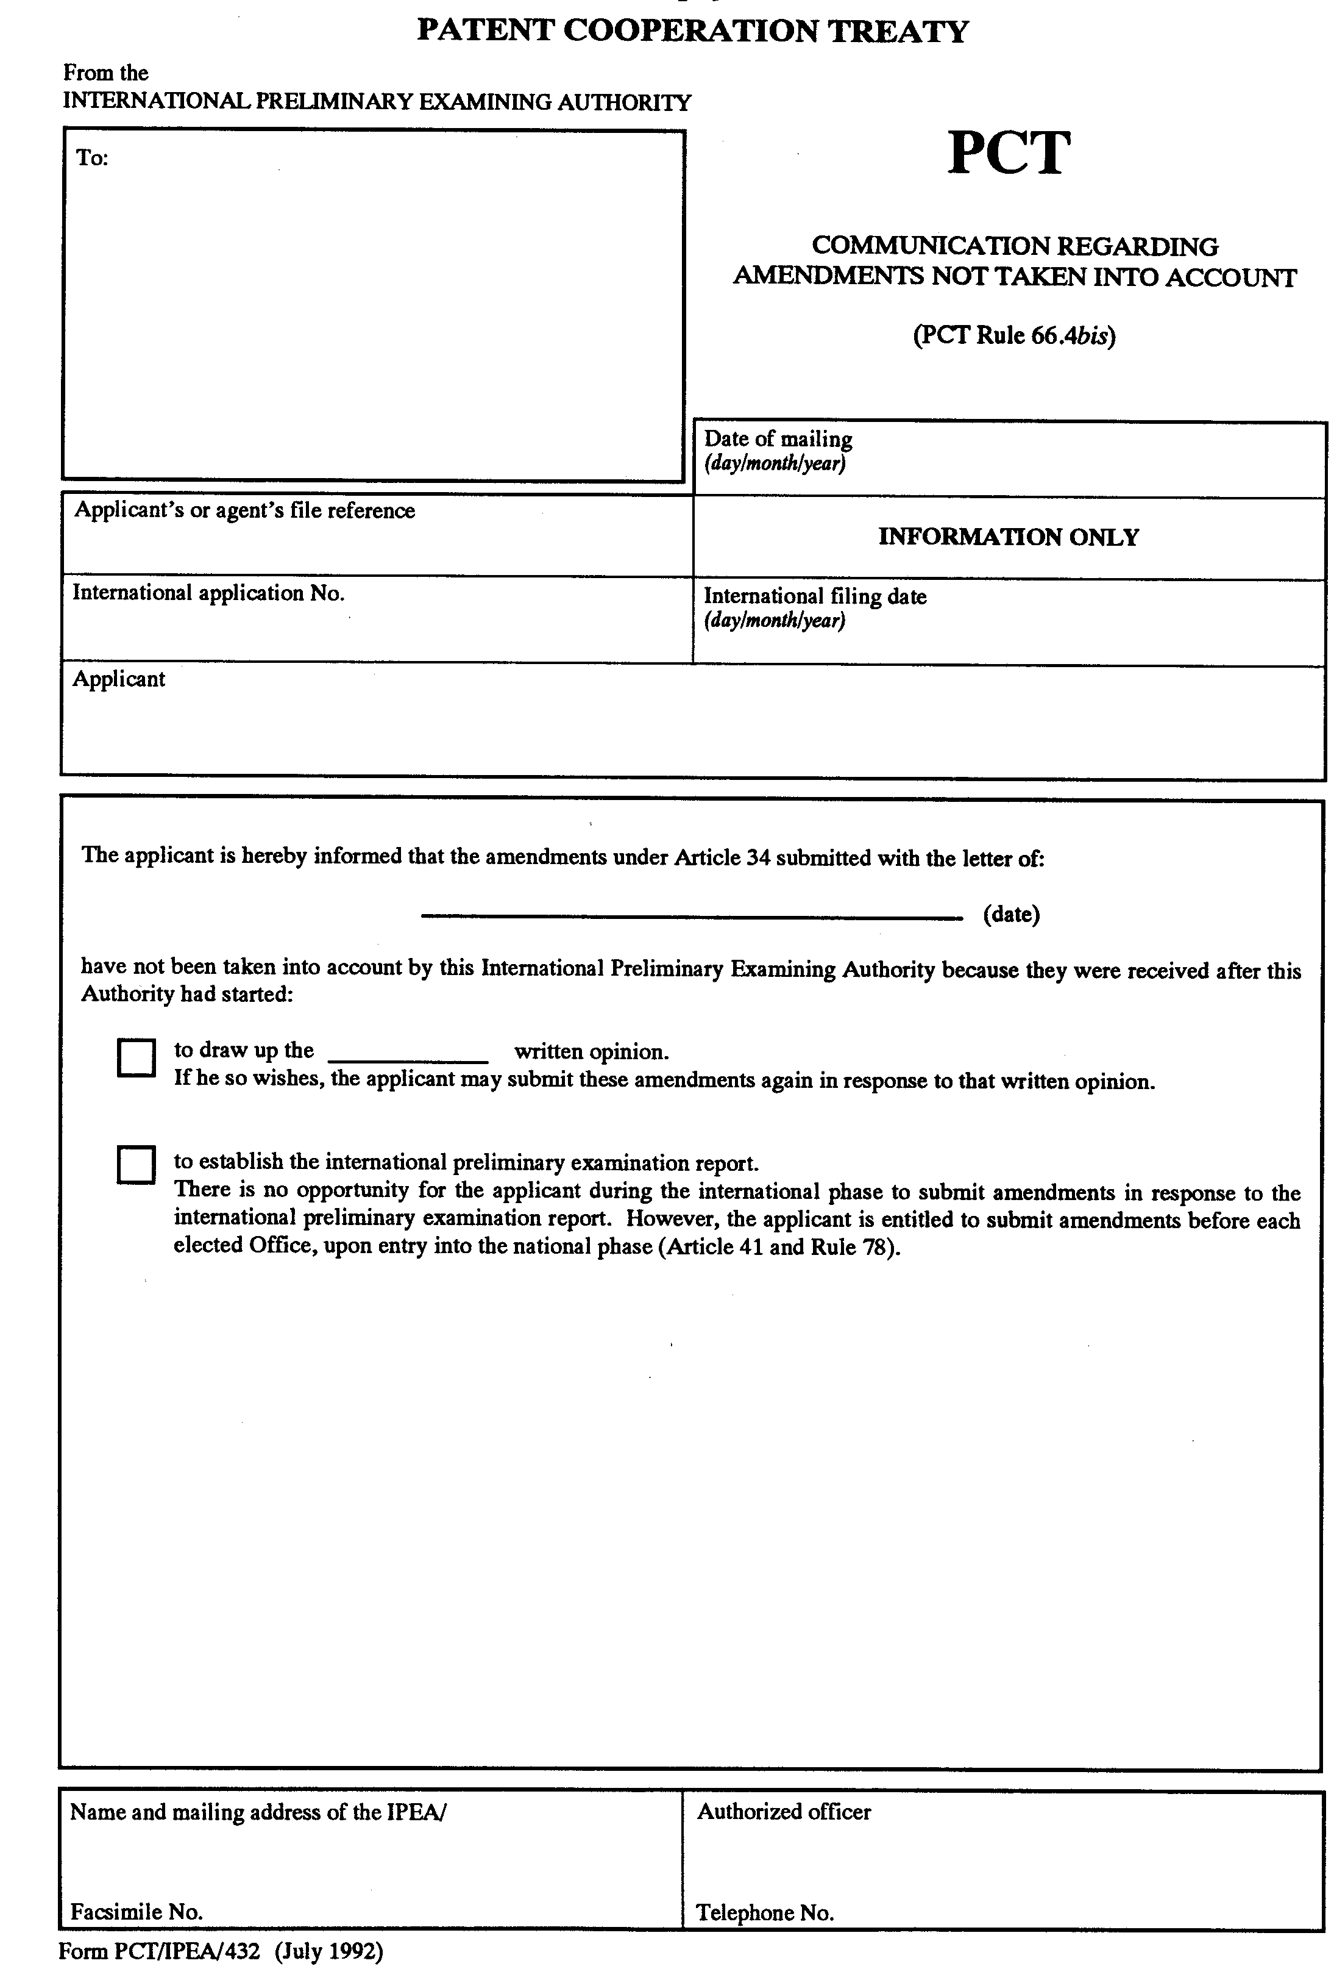

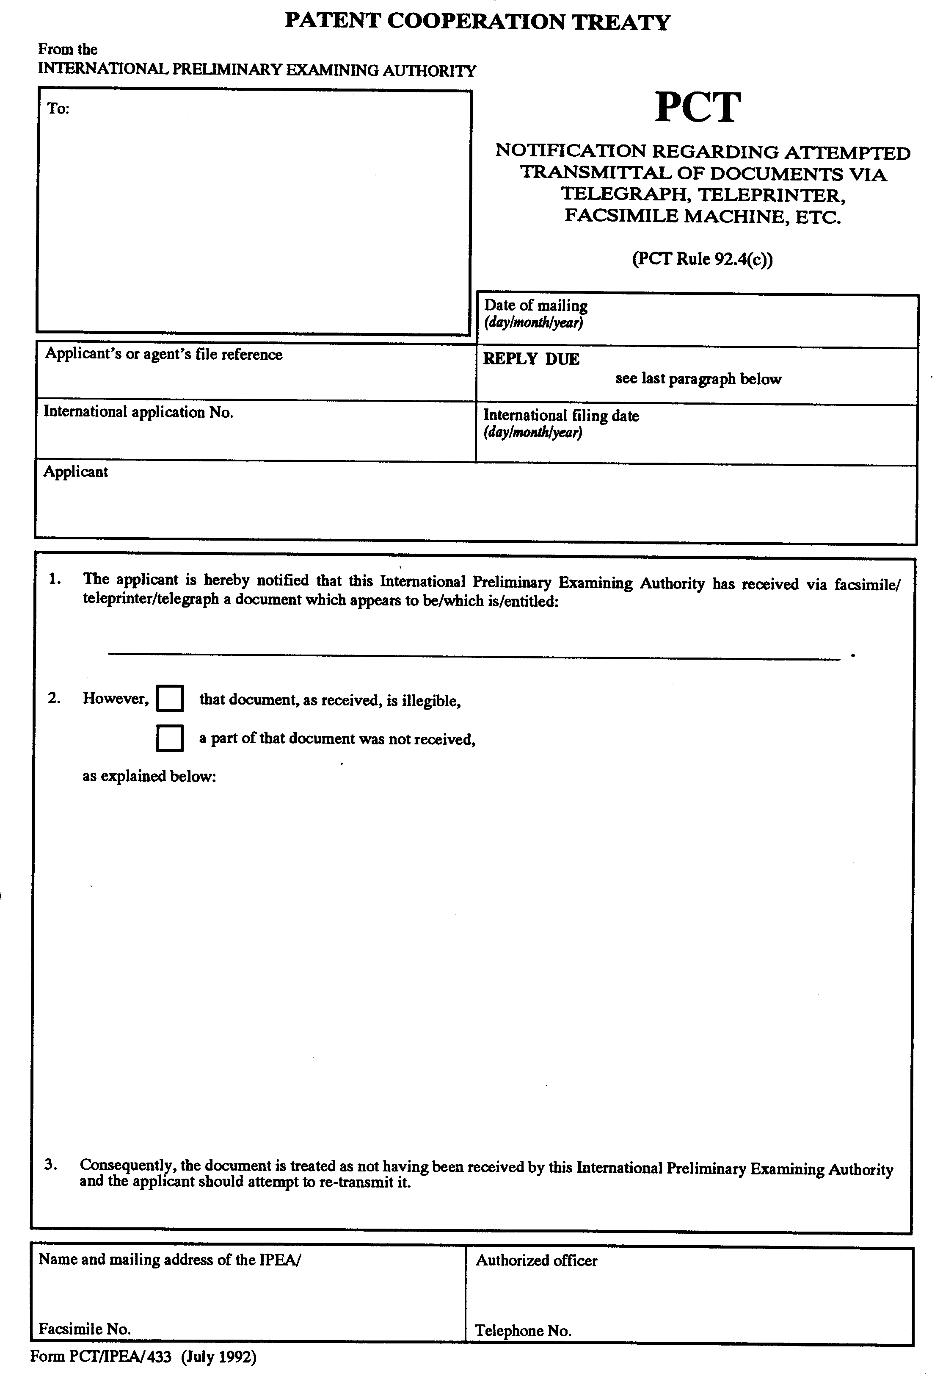

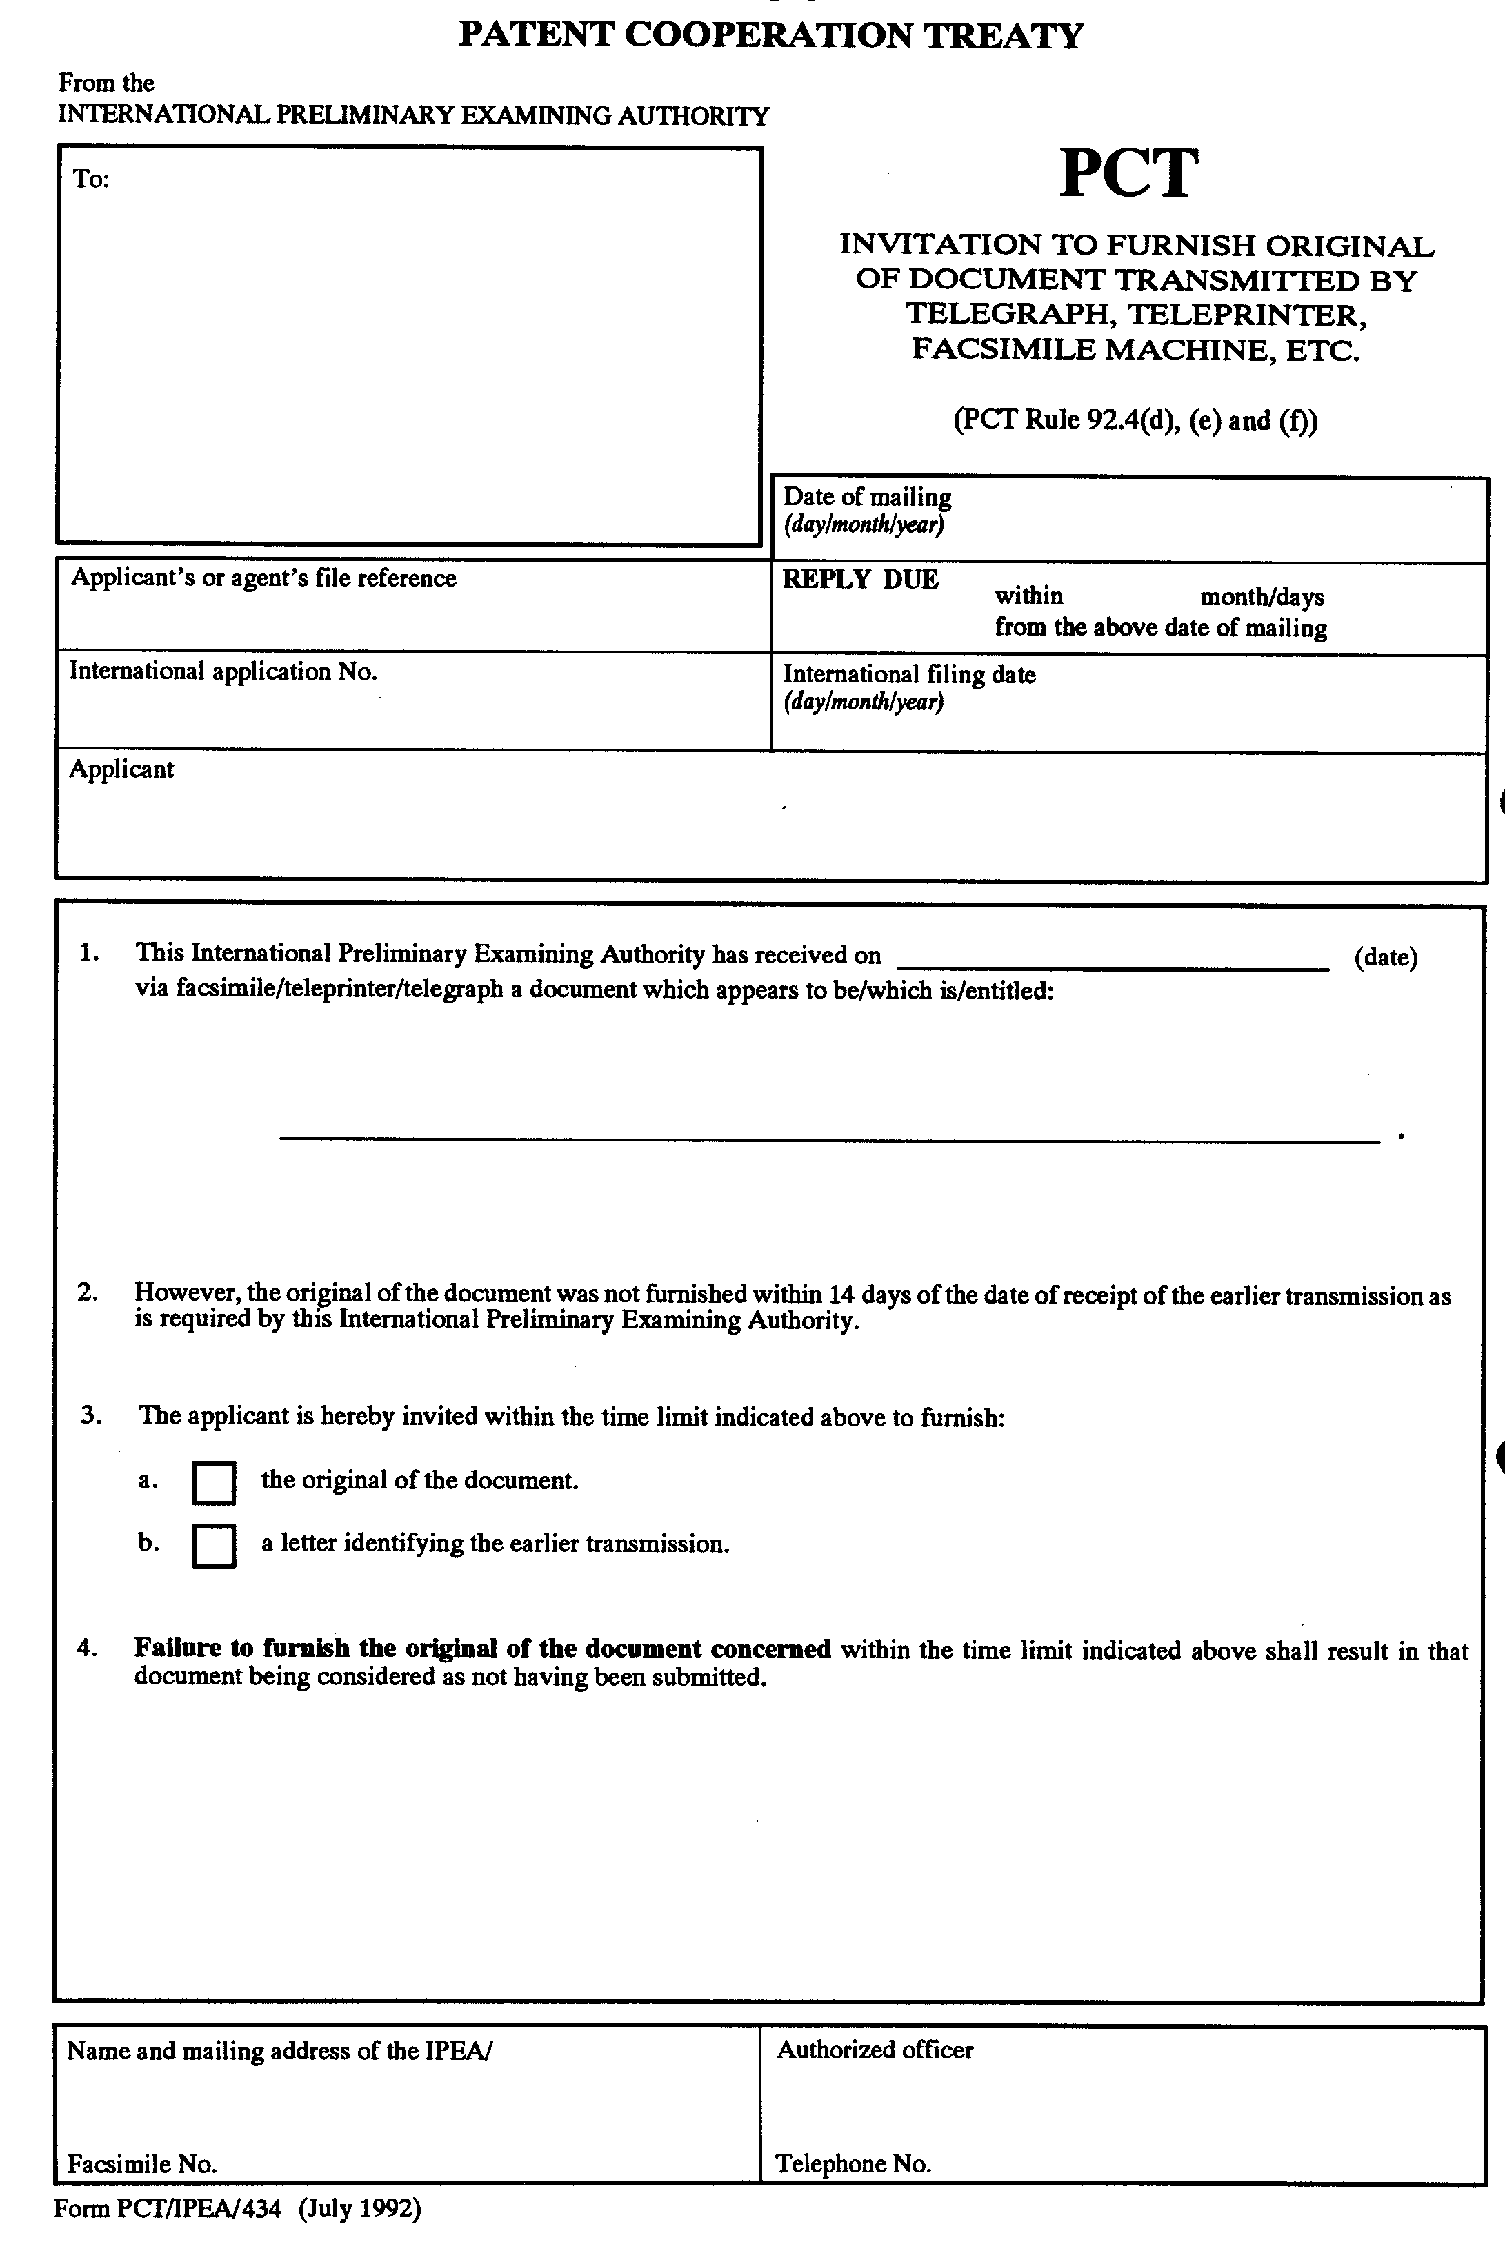

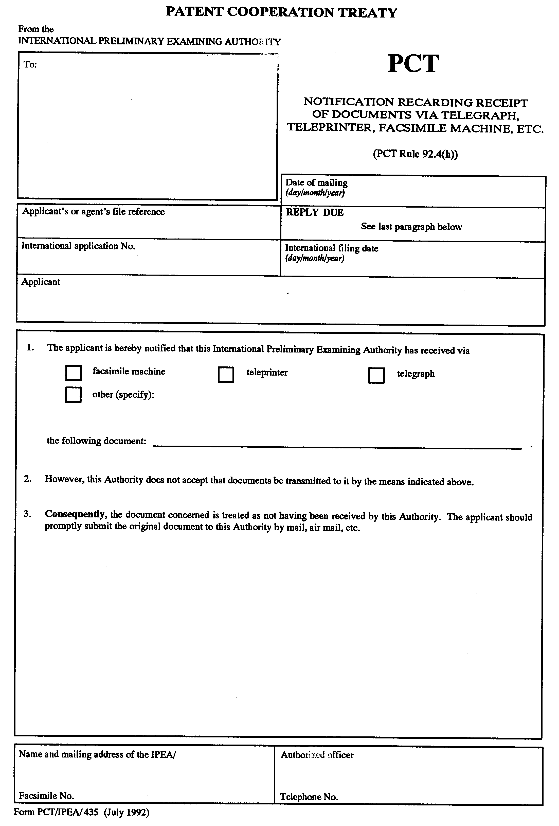

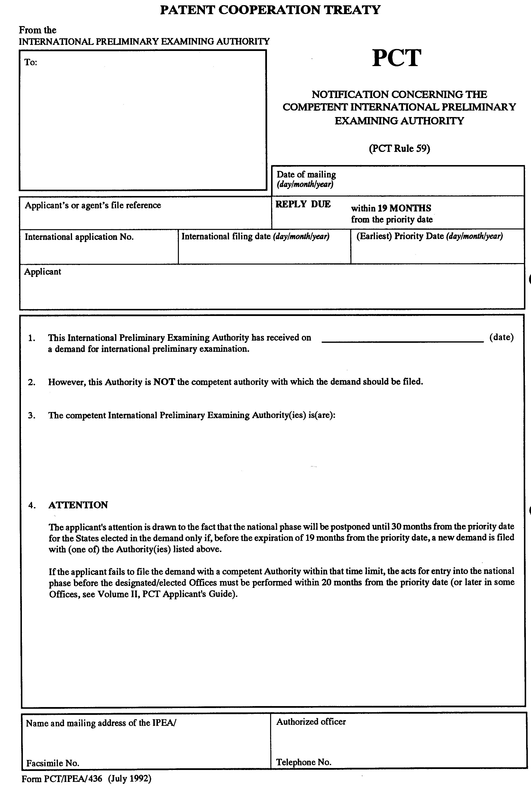

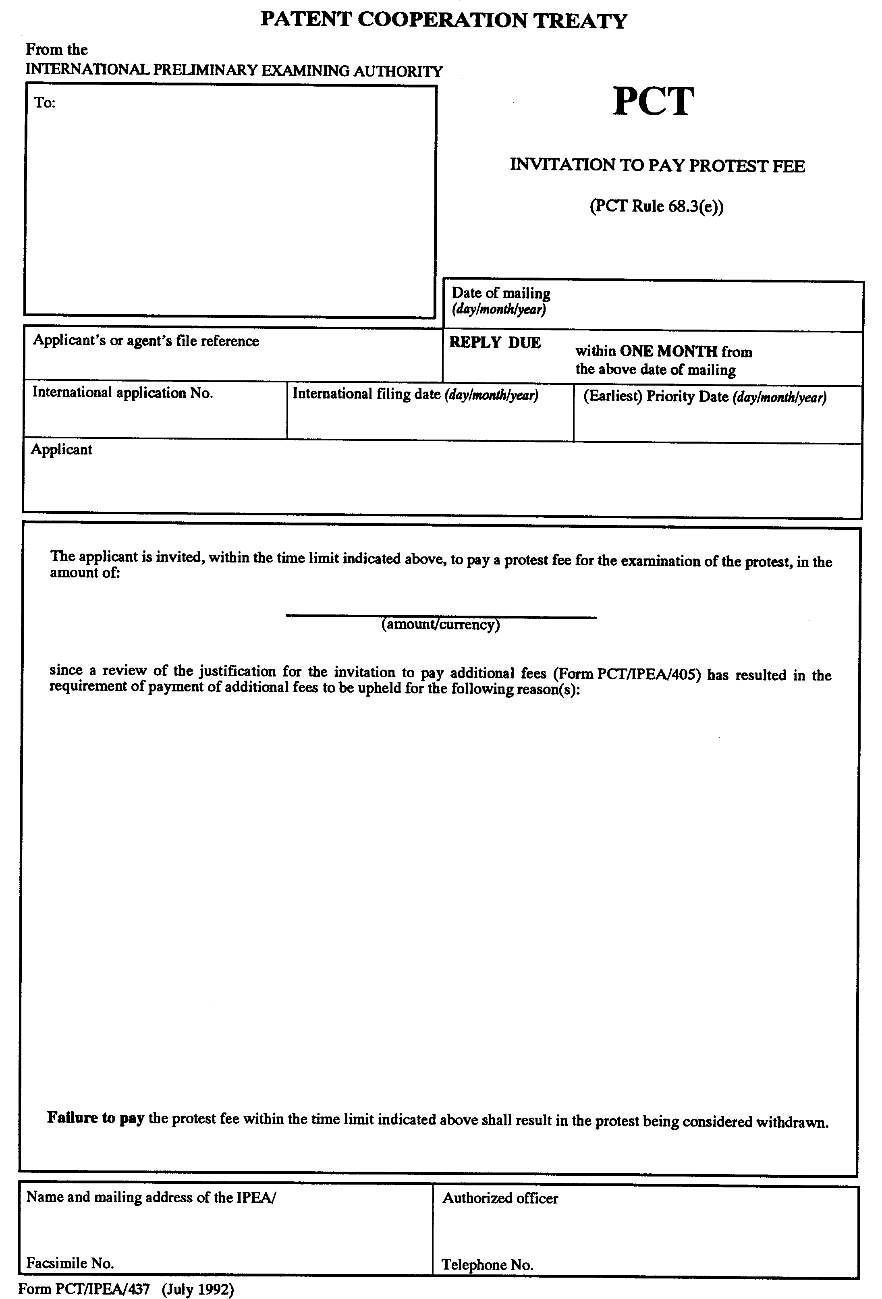

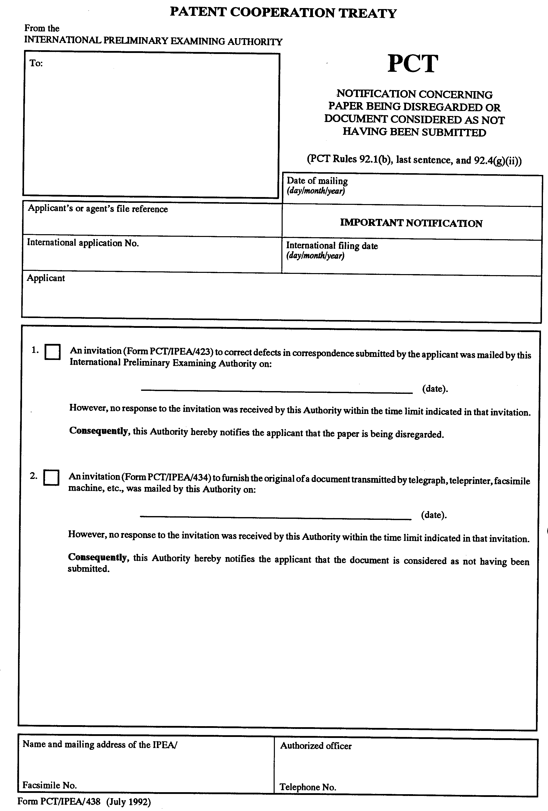
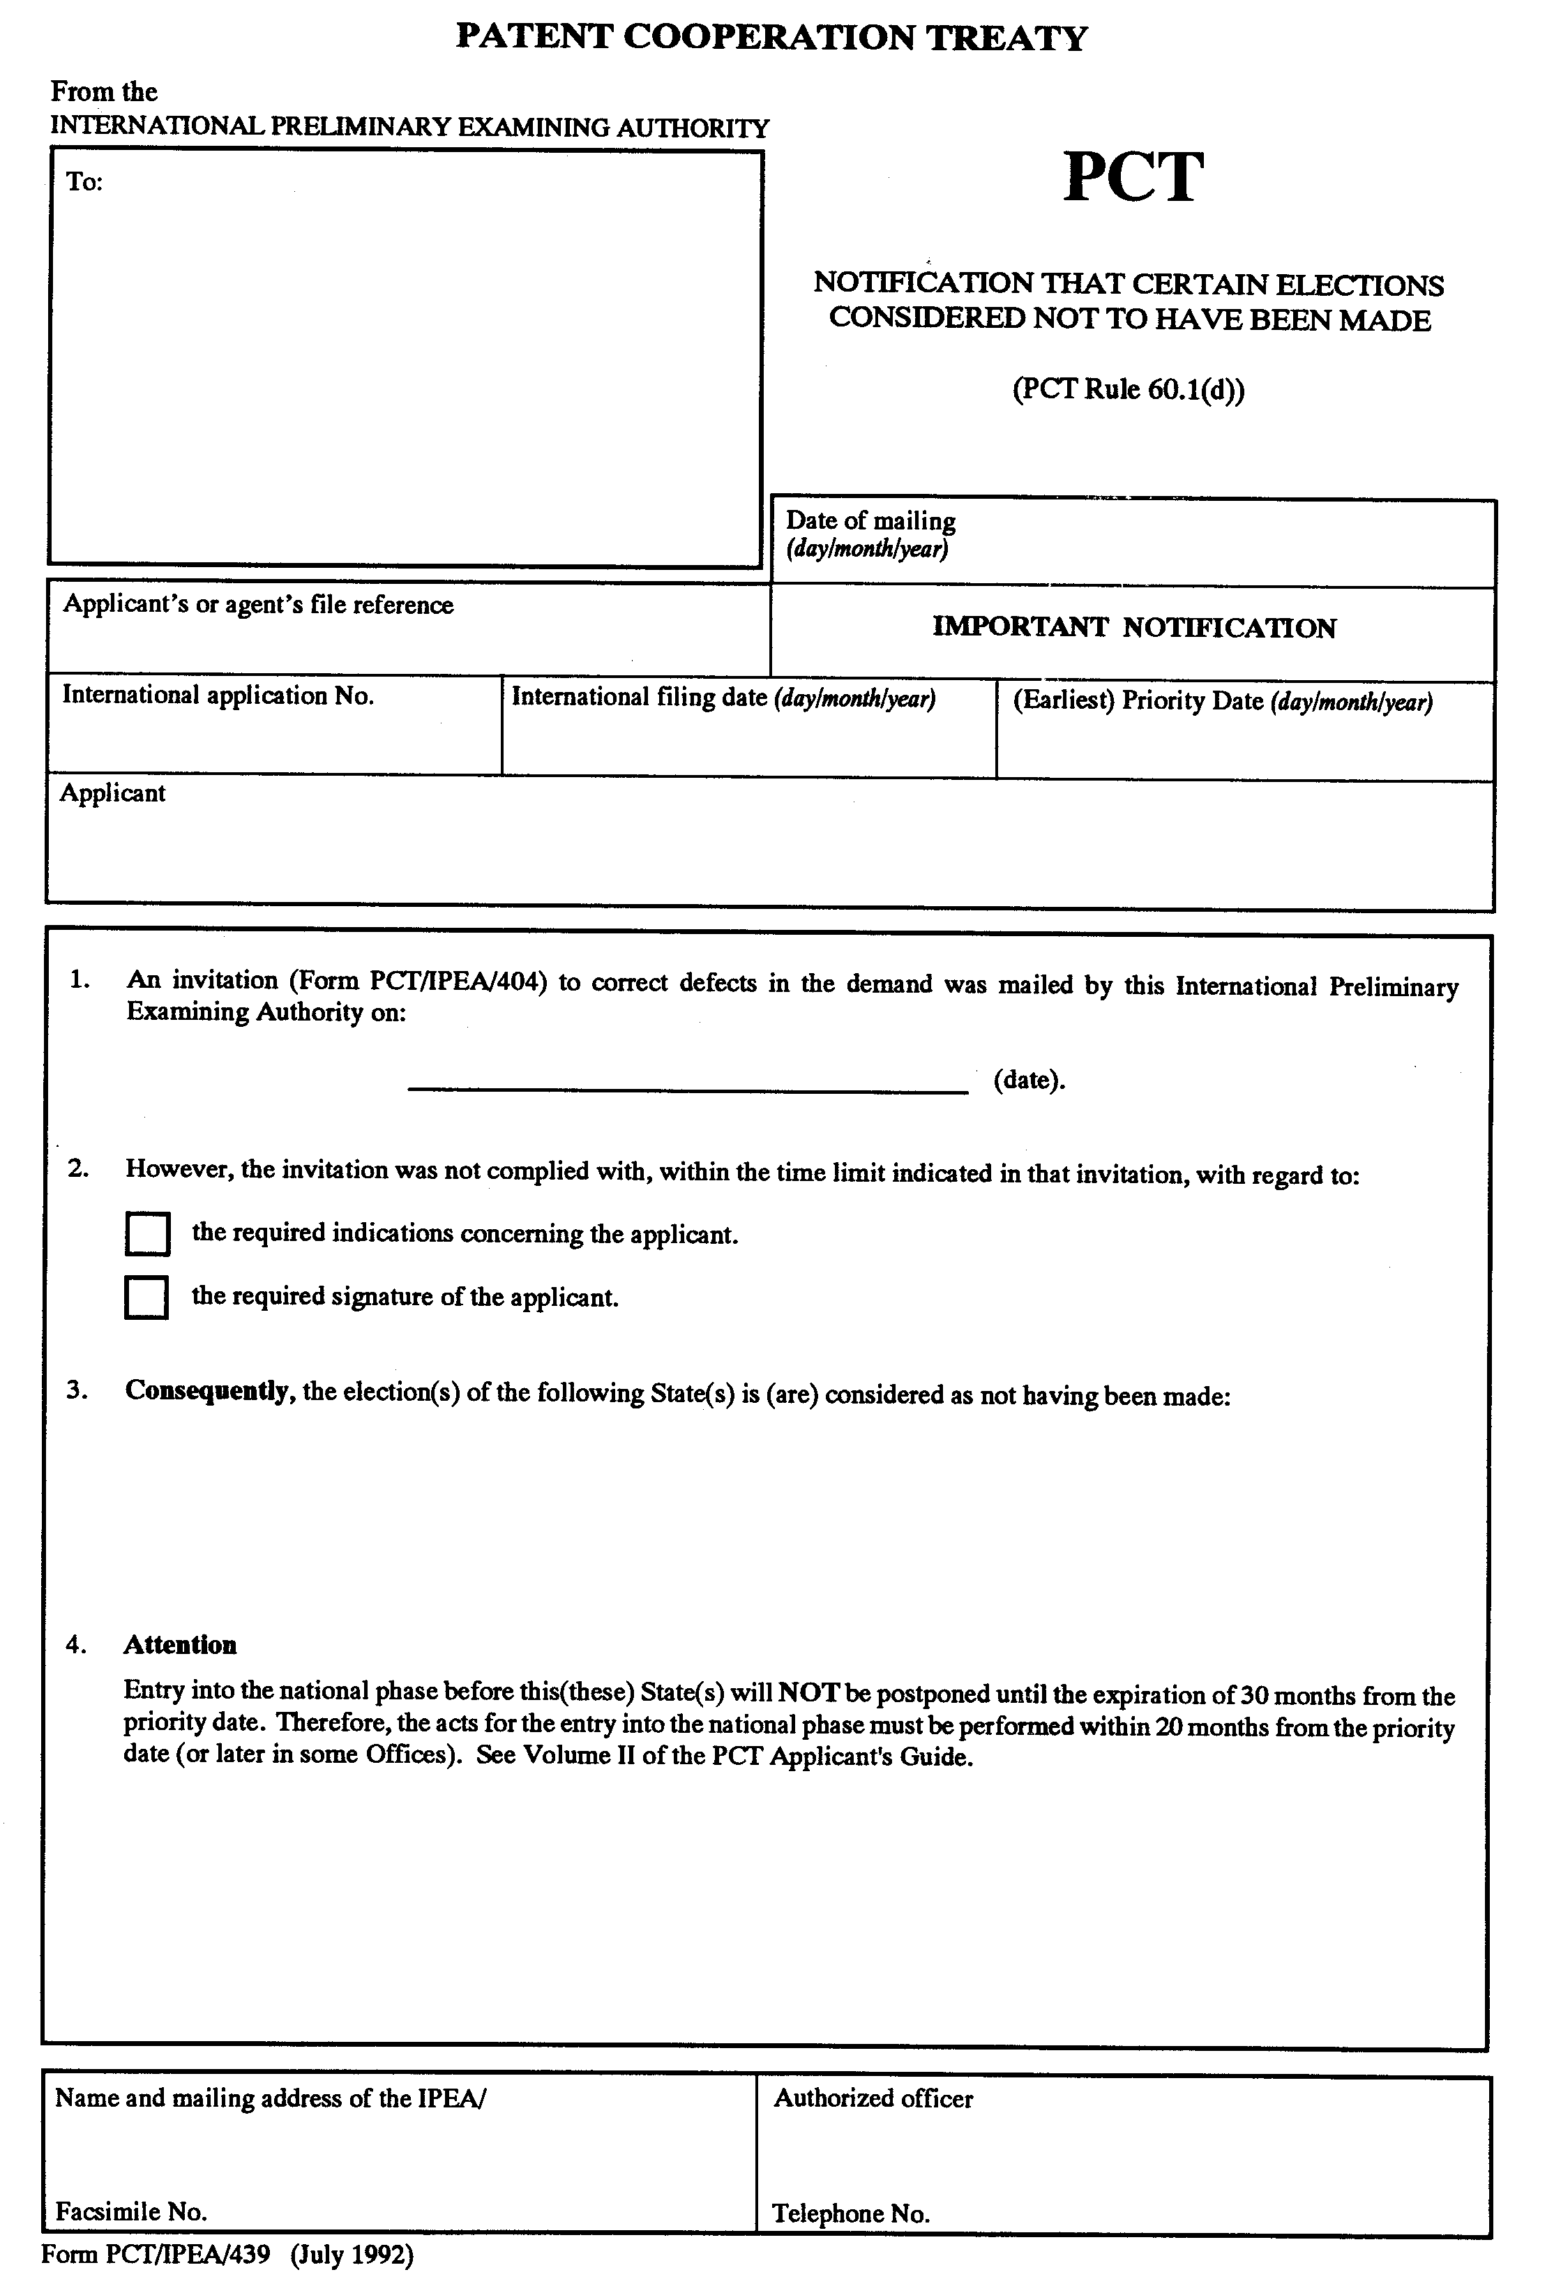
[End of Annex and of document]

