WIPO |  | PCT/MIA/I/3  ORIGINAL: English  DATE: November 20, 1989
WORLD INTELLECTUAL PROPERTY ORGANIZATION
GENEVA
International patent cooperation union
(PCT union)
Meeting of international authorities
under the PCT
First Session
Geneva, January 15 to 19, 1990
revision of the international search guidelines
Memorandum prepared by the International Bureau
1 The present document contains three annexes.

2 Annex I reproduces the comments received from some International Searching Authorities on the proposed draft of revised PCT Search Guidelines as contained in document PCT/GL/2 Prov. of June 12, 1989.

3 Annex II reproduces those parts of the PCT Search Guidelines as contained in document PCT/GL/2 Prov. which have been further modified, in particular on the basis of the comments reproduced in Annex I to this document. The majority, but not all, of the proposals for modification have been taken into account. All further modifications have been made in handwriting on copies of the relevant pages of document PCT/GL/2 Prov. in order to show exactly what has been changed. The two-letter country code in a circle indicates the International Searching Authority (“ISA”) which proposed the modification. The letters “IB” indicate that the related modification was made by the International Bureau. Where the letters “IB” follow a two-letter country code identifying an ISA, the proposed modification has been further amended by the International Bureau. To the extent that the comments contained in Annex I are not reflected by the modifications contained in Annex II, any required additional modification will be made after the comments have been considered by the Meeting.

4 Annex III contains the draft proposal for a modified Form, Form PCT/ISA/206, which is the form for the invitation to pay additional search fees in case of lack of unity of invention and for submission of the partial international search report. The modification of this form is proposed consequential to the proposal to amend Chapter VII, Unity of Invention, of the PCT Search Guidelines and to issue a partial international search report together with the invitation to pay additional search fees.

5 The Meeting is invited

(a) to consider the comments reproduced in Annex I.

(b) to approve the further modification to the PCT Search Guidelines contained in Annex II, and

(c) to consider the draft of the modified Form PCT/ISA/206.

[Annexes I to III follow]

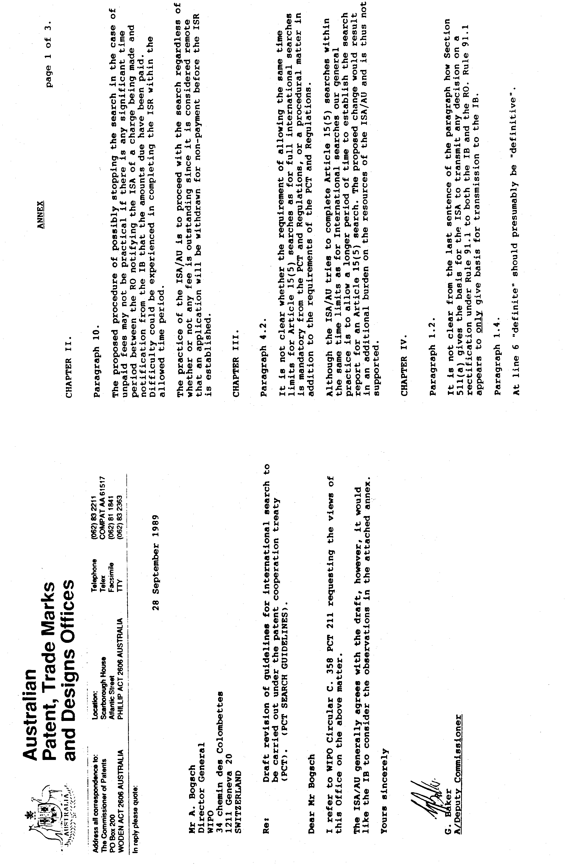
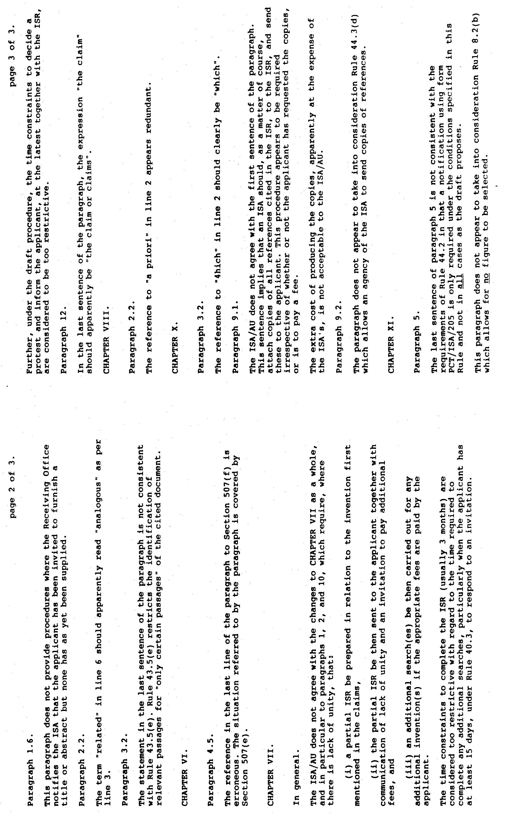

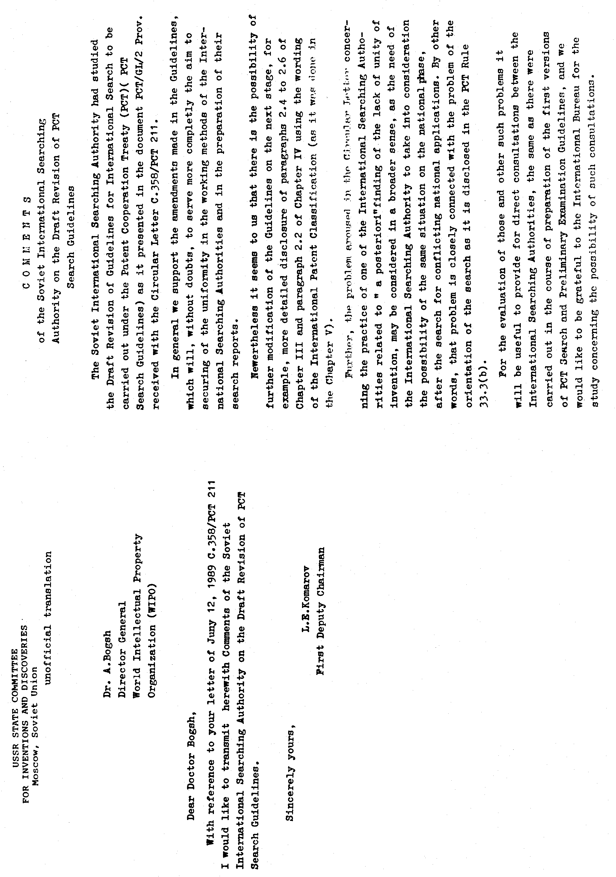

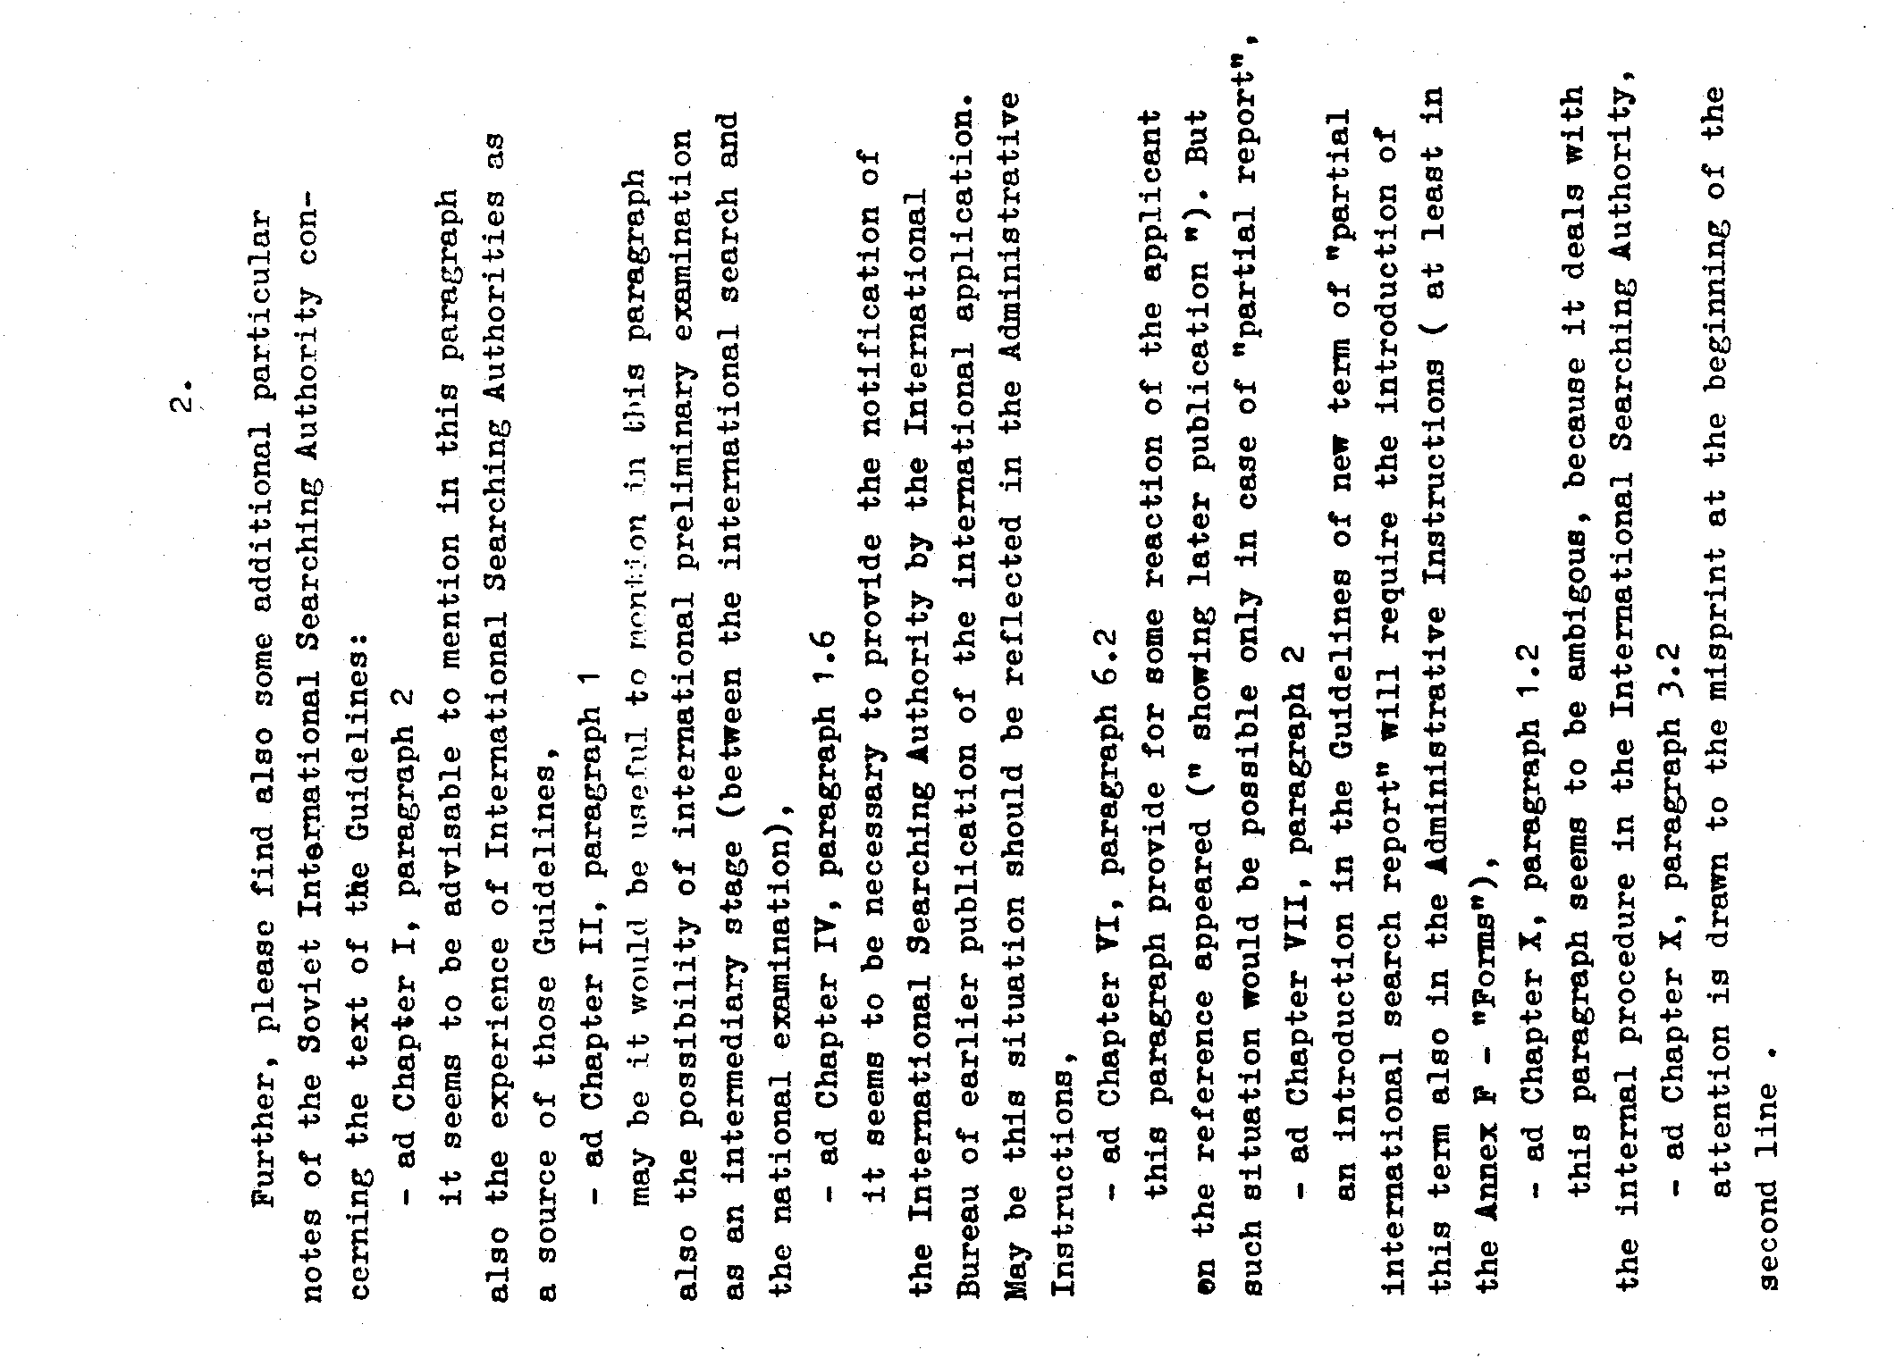

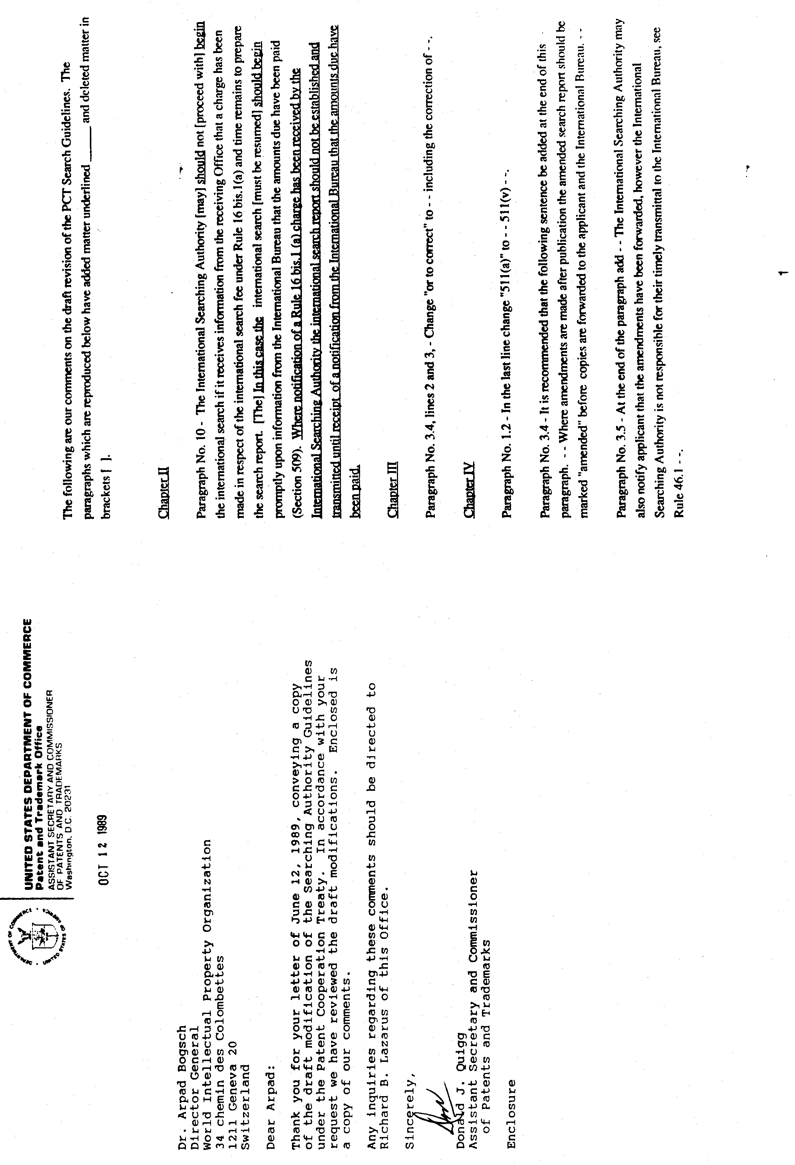

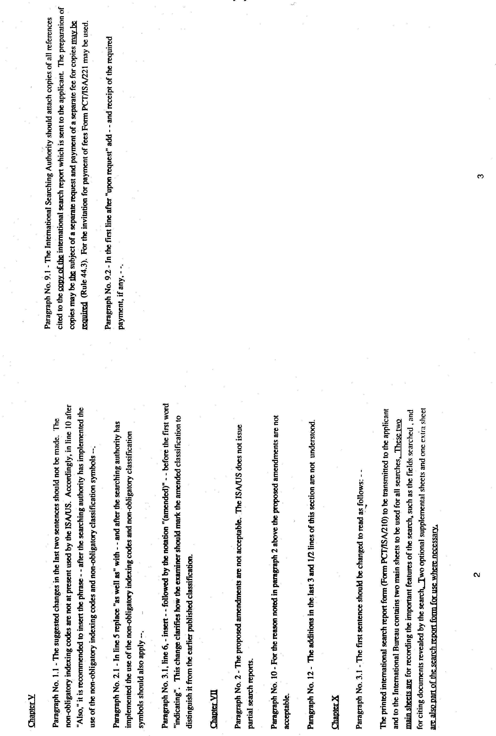

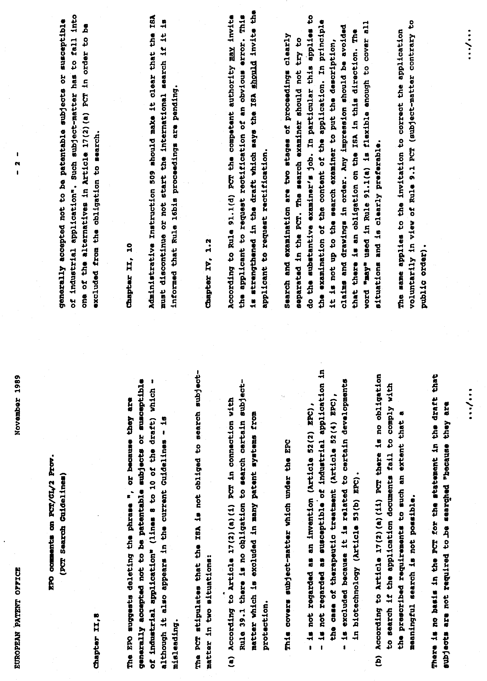
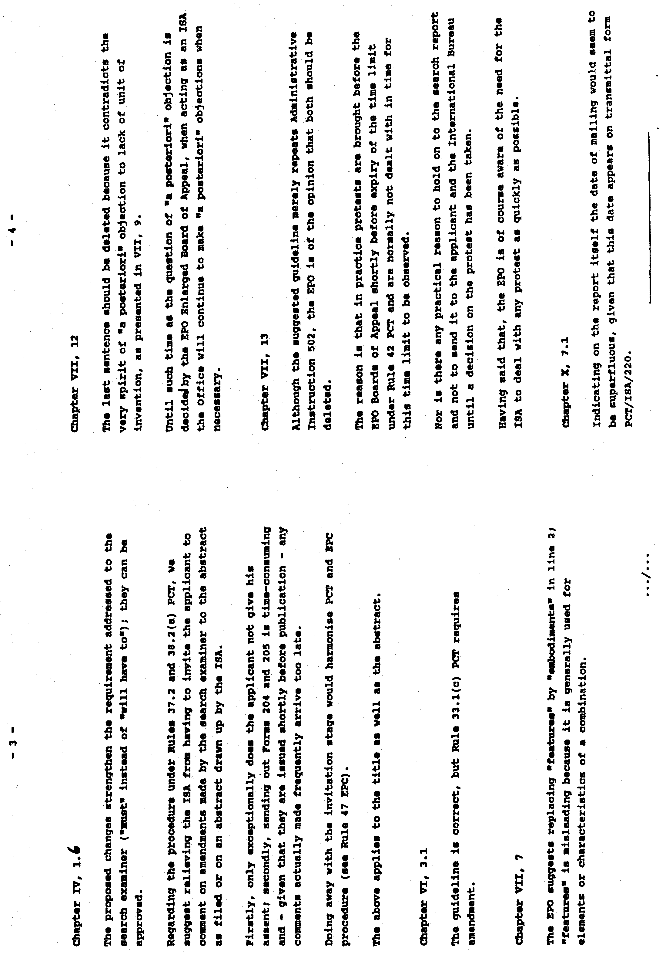

[Annex II follows]

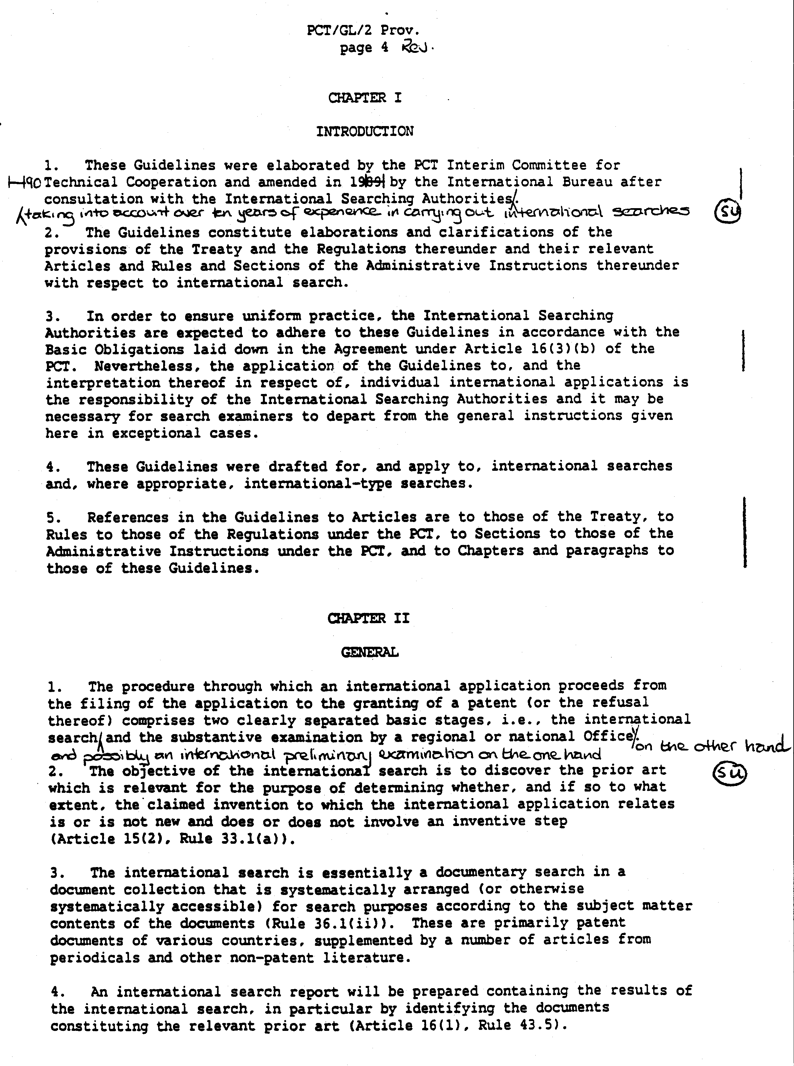

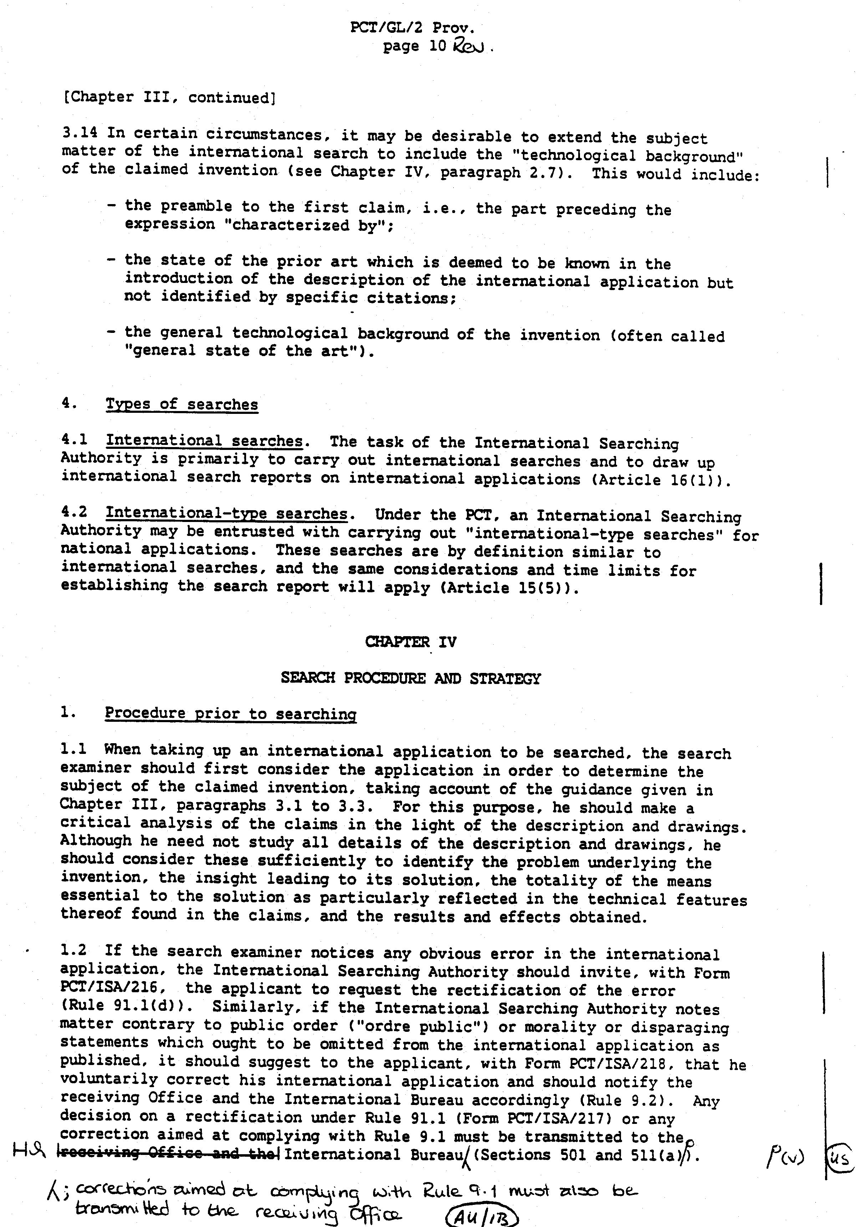

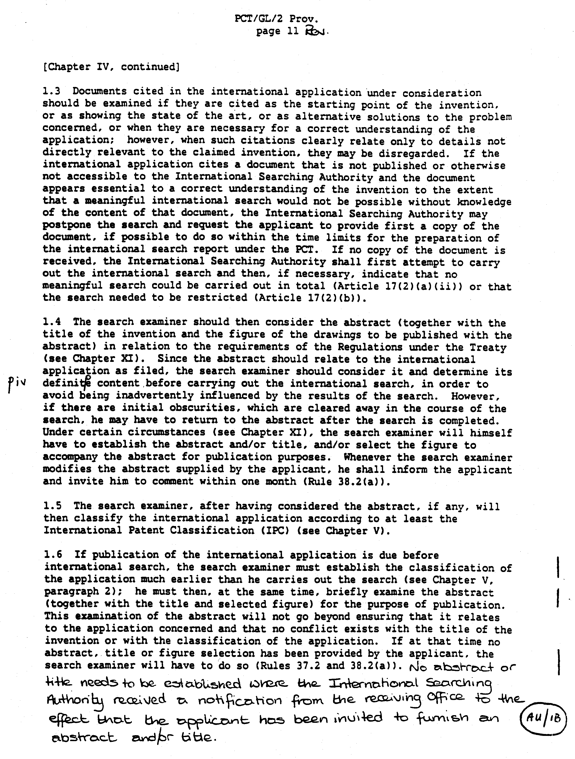

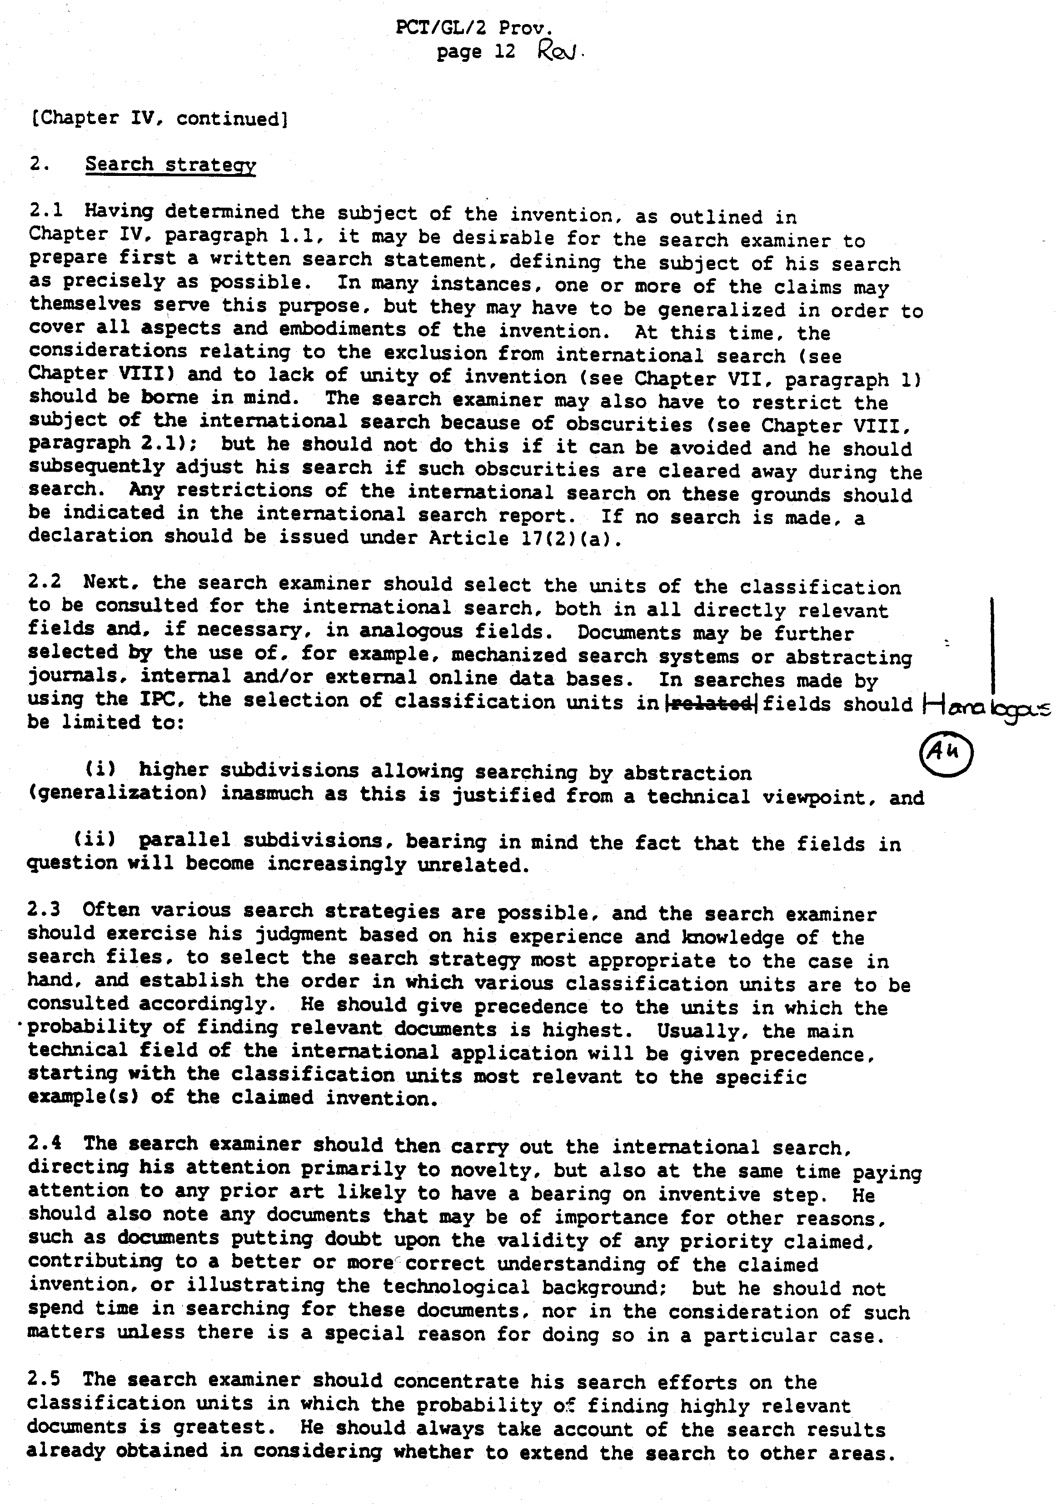

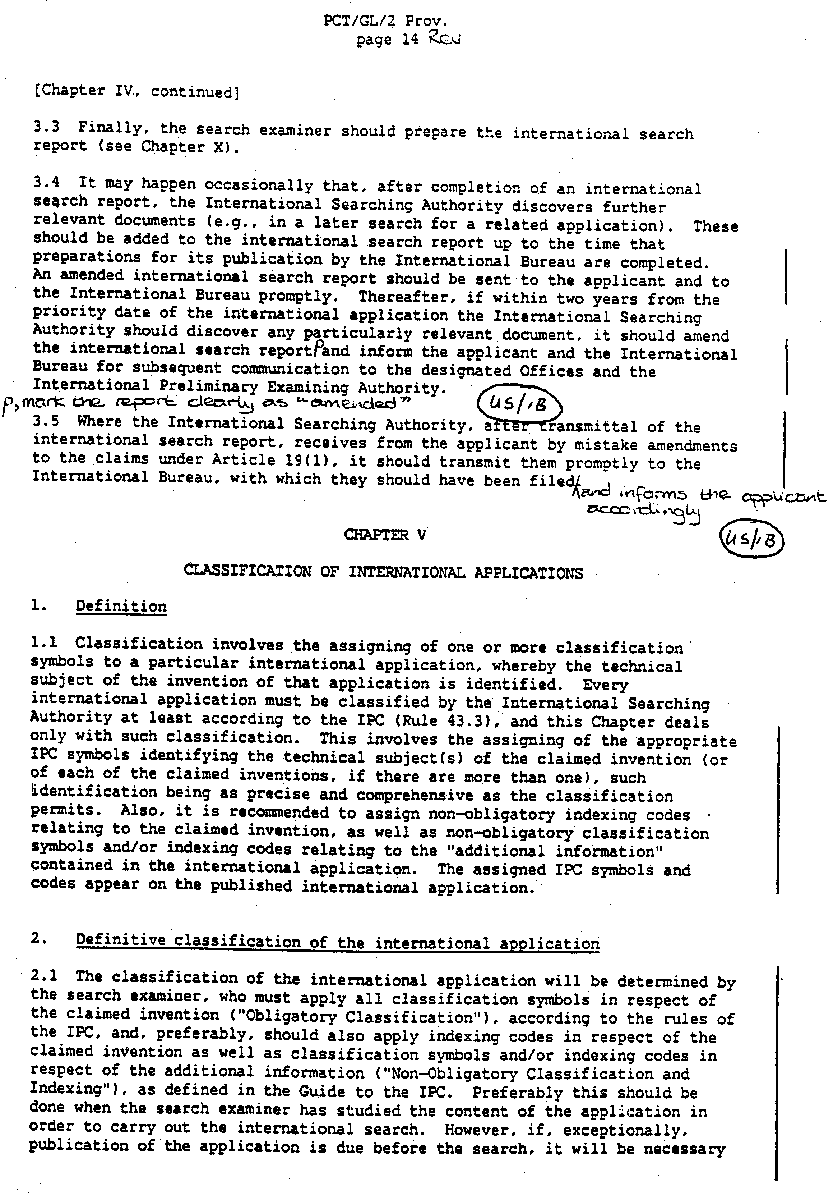

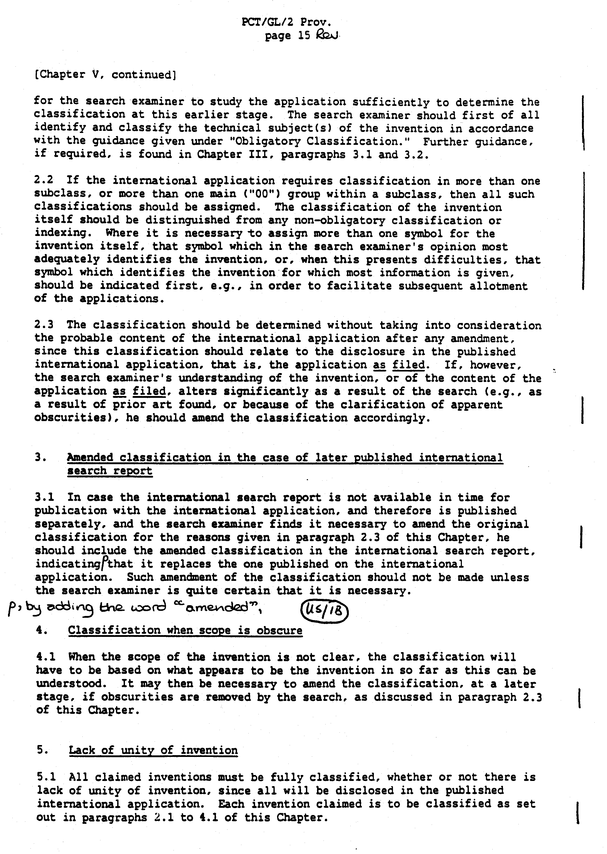

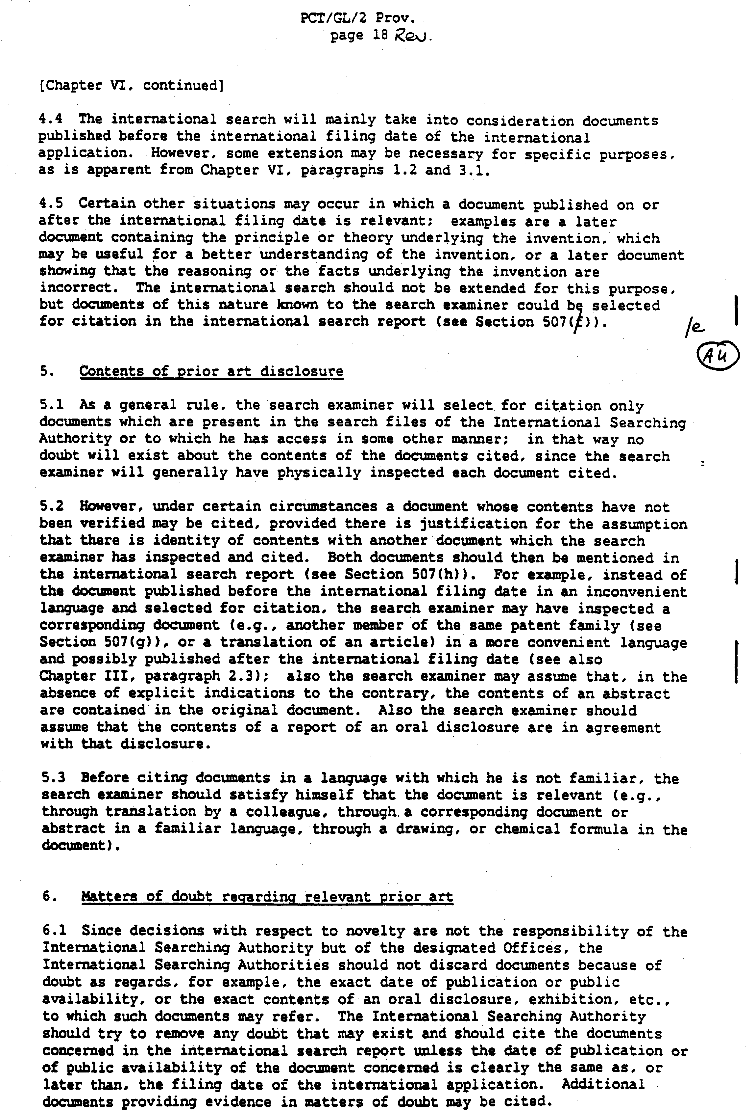

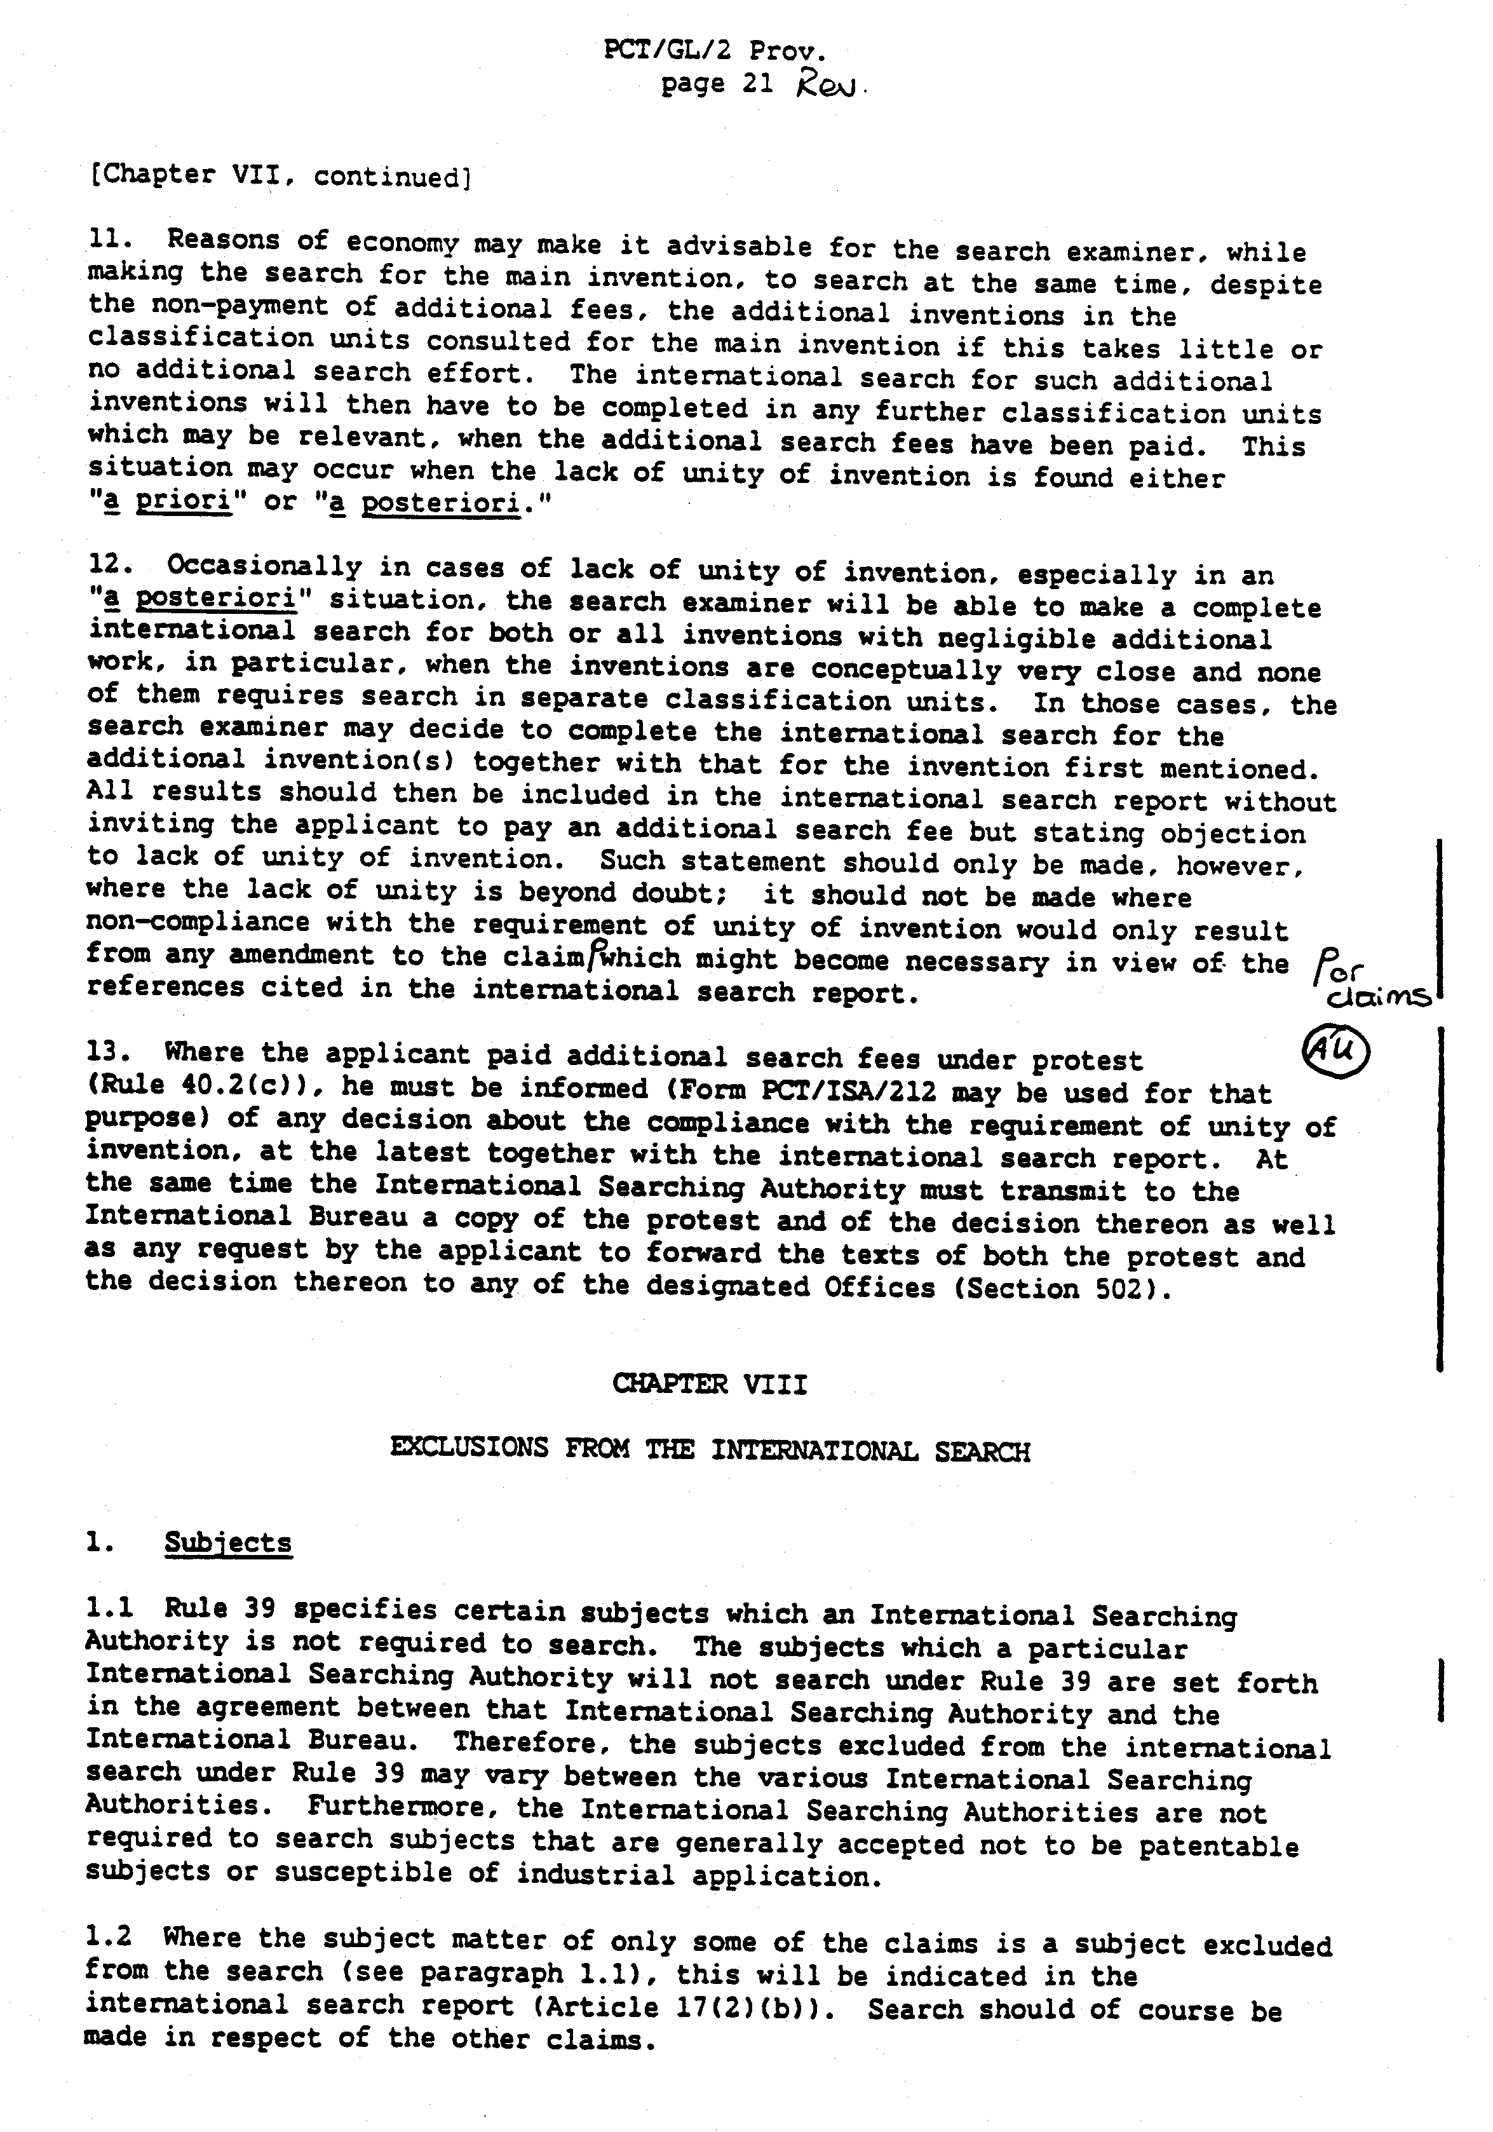

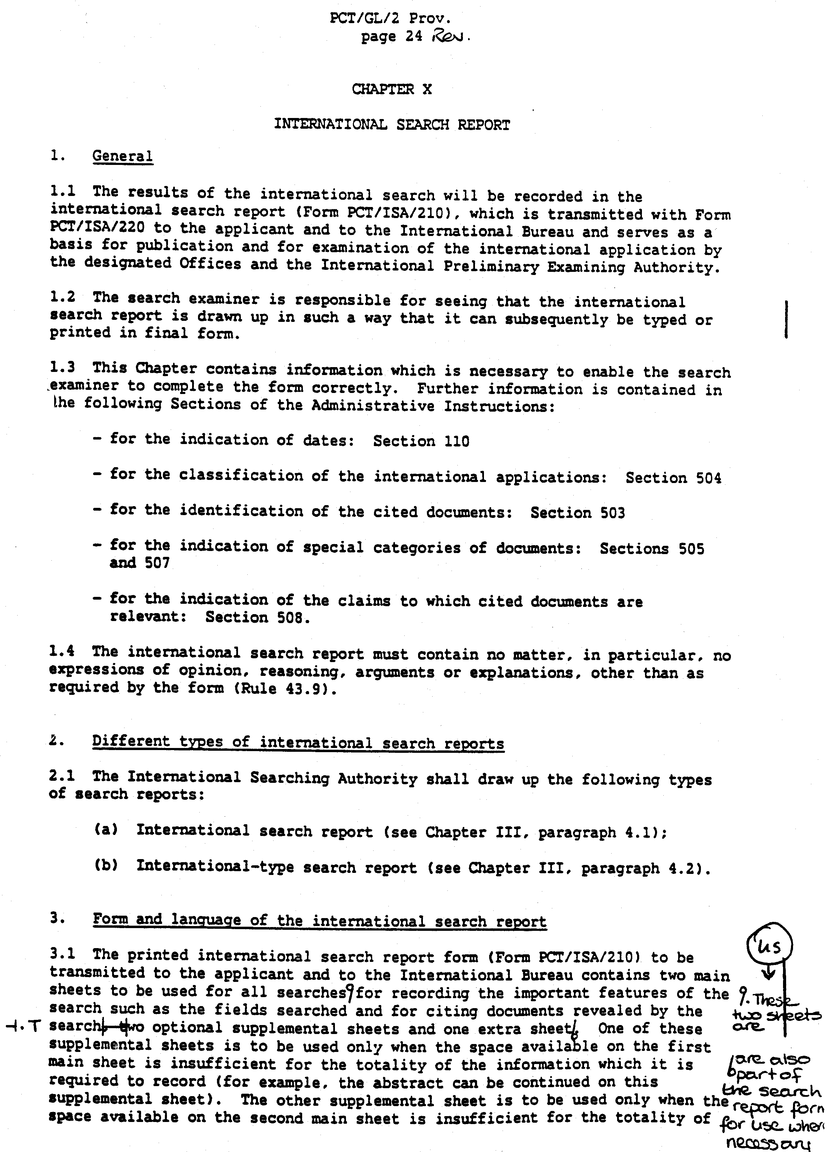

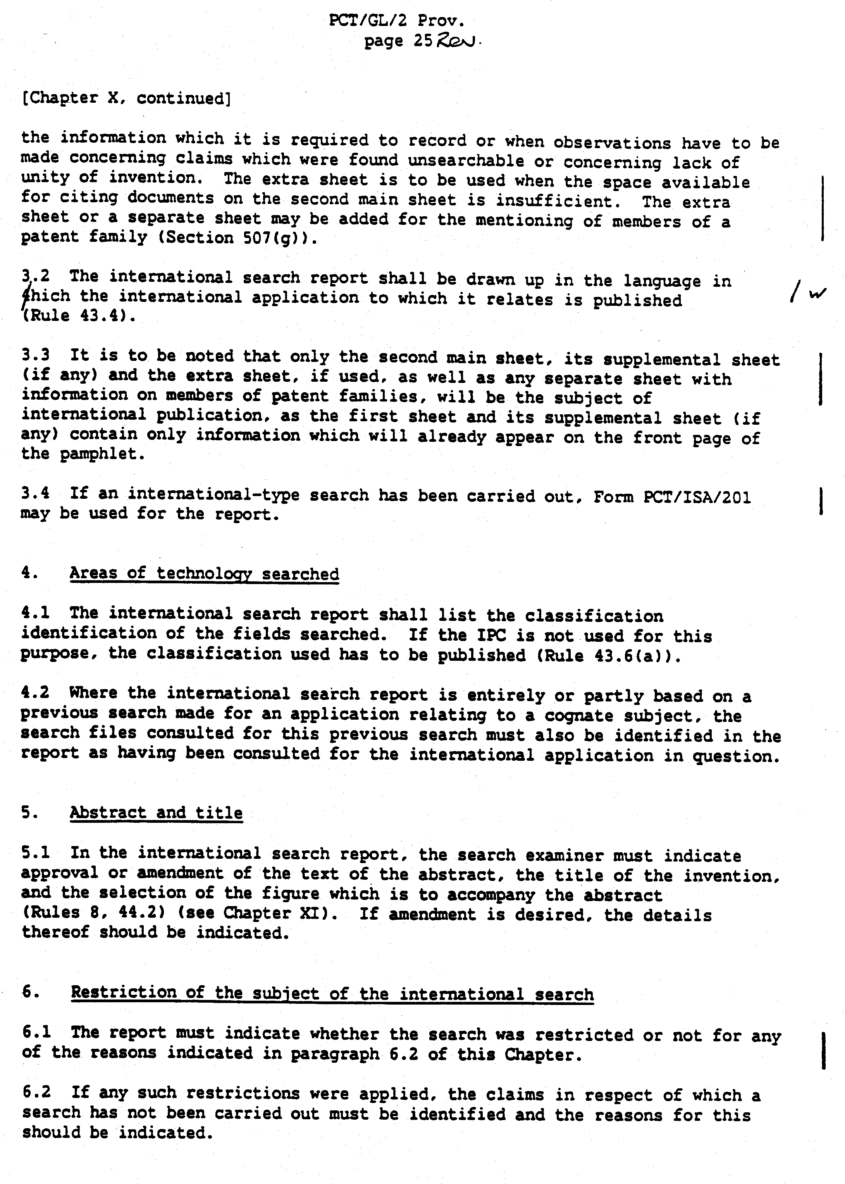

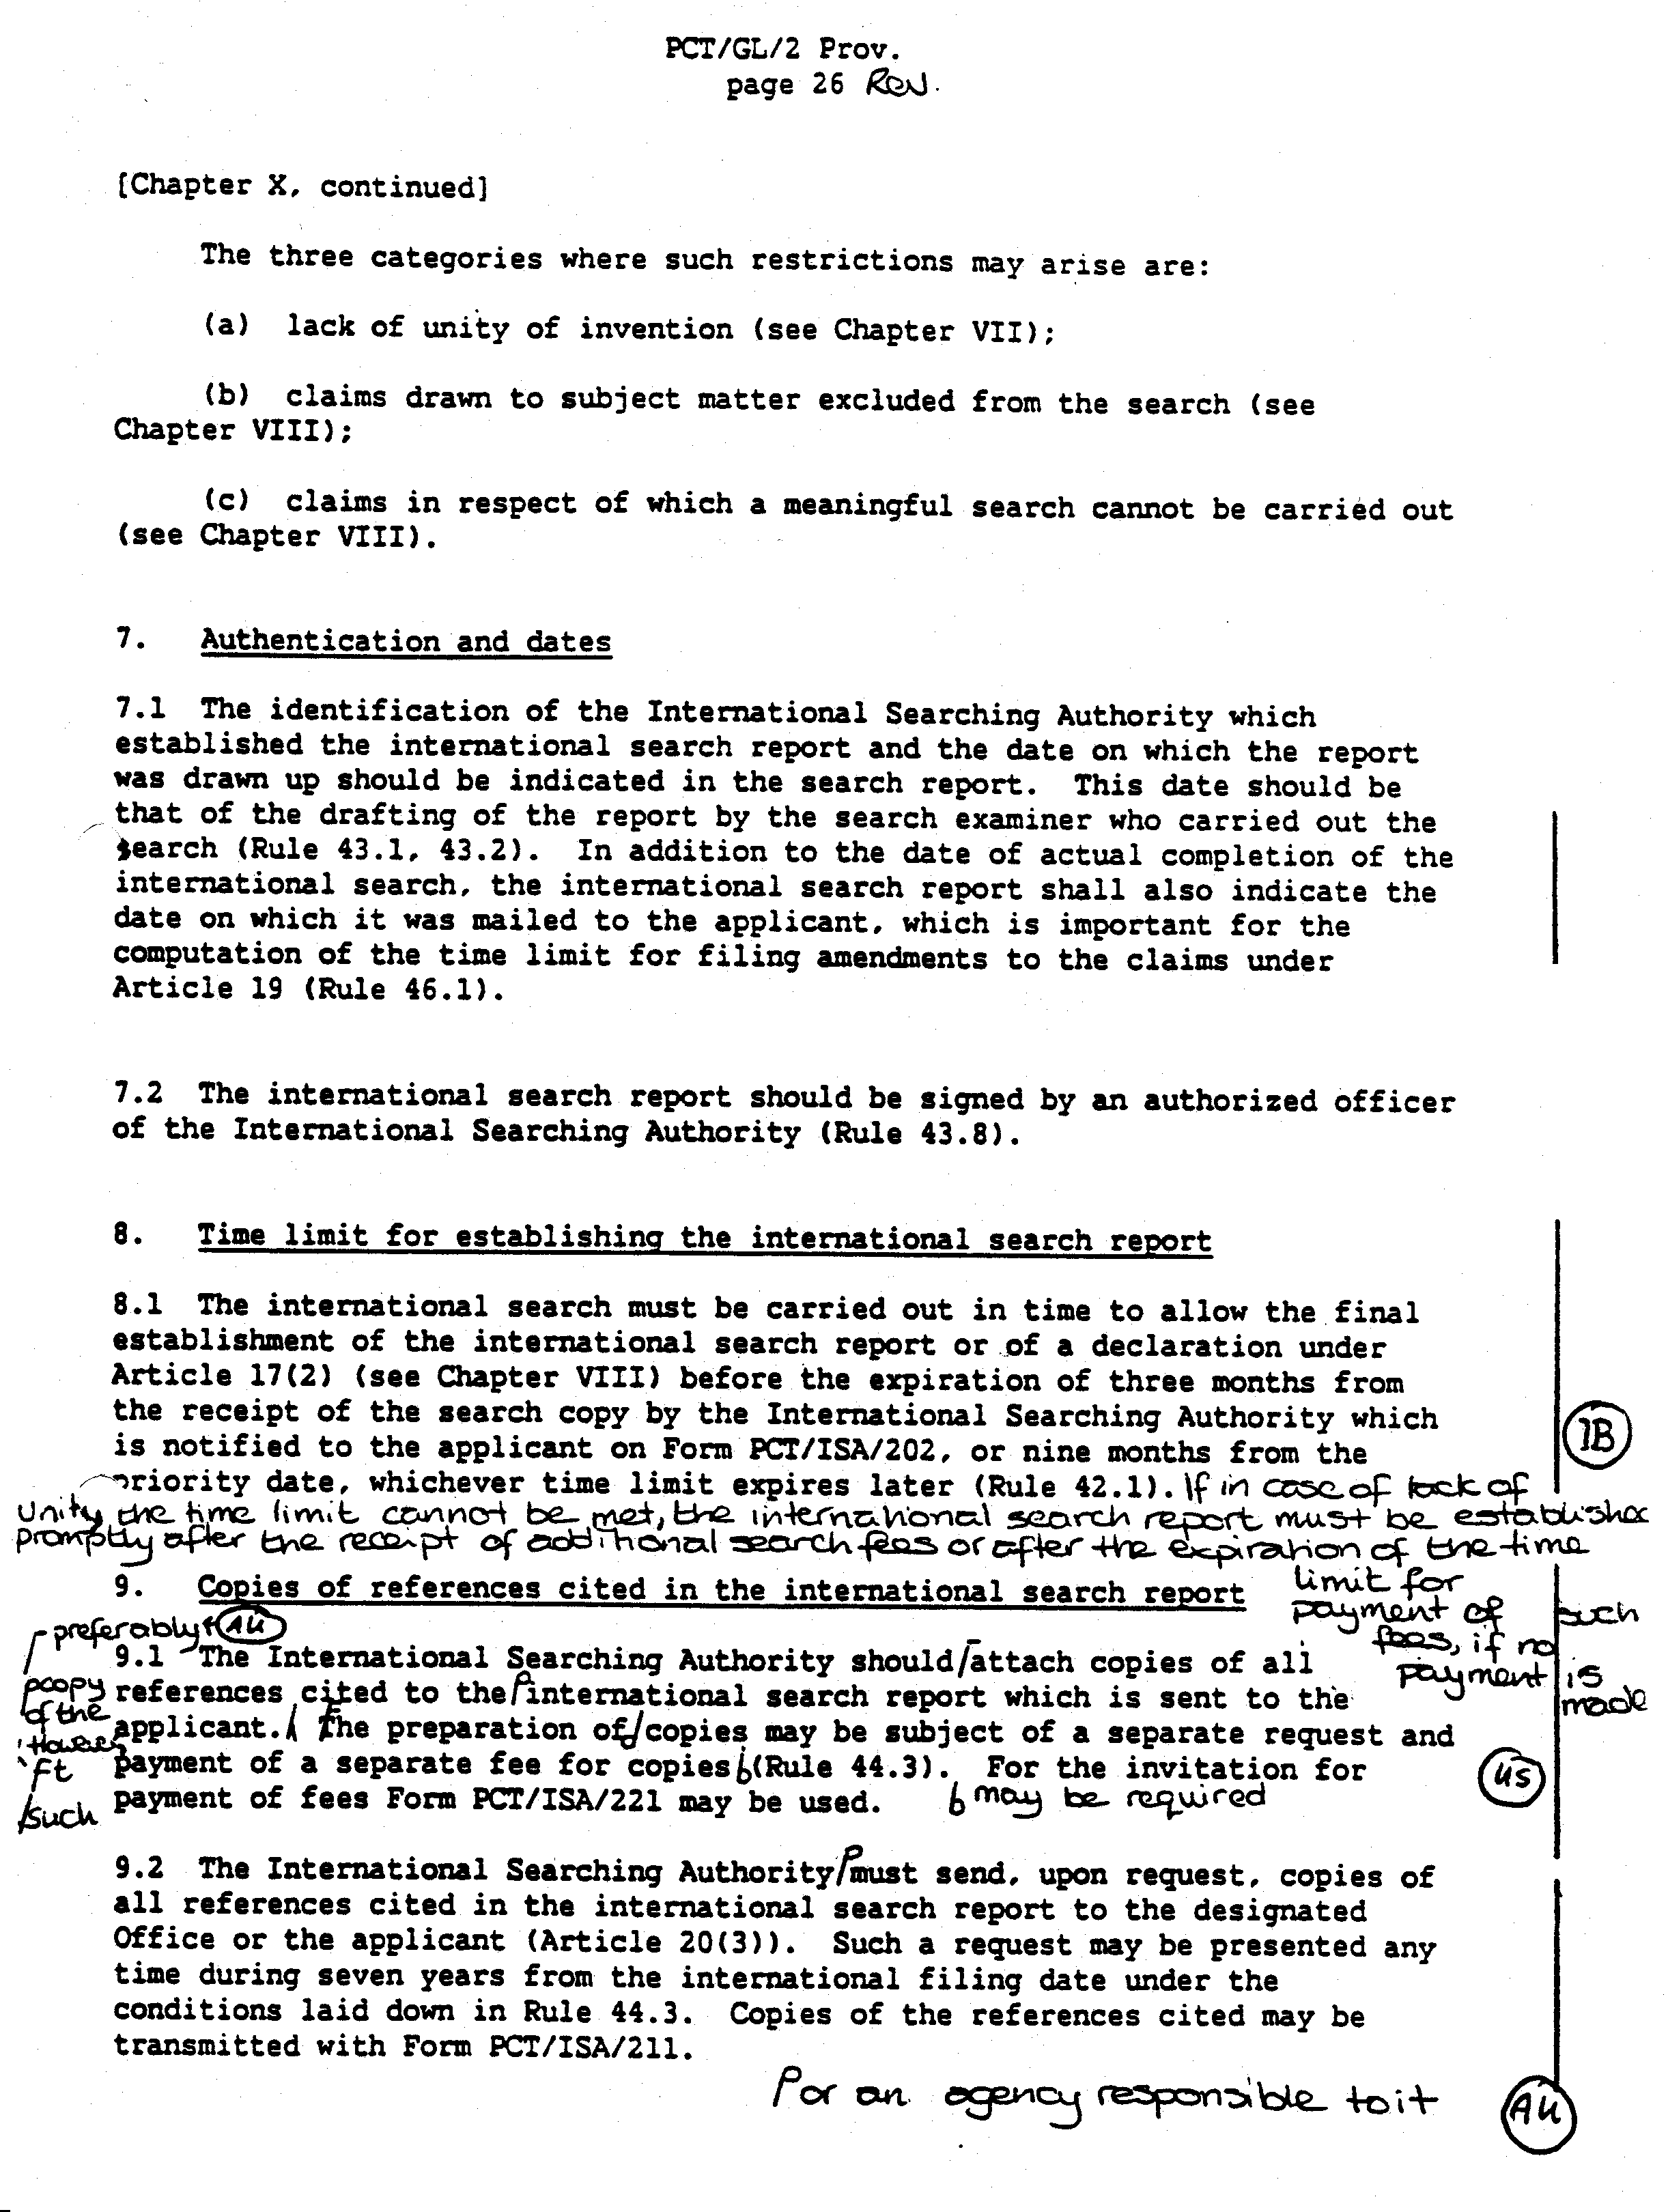

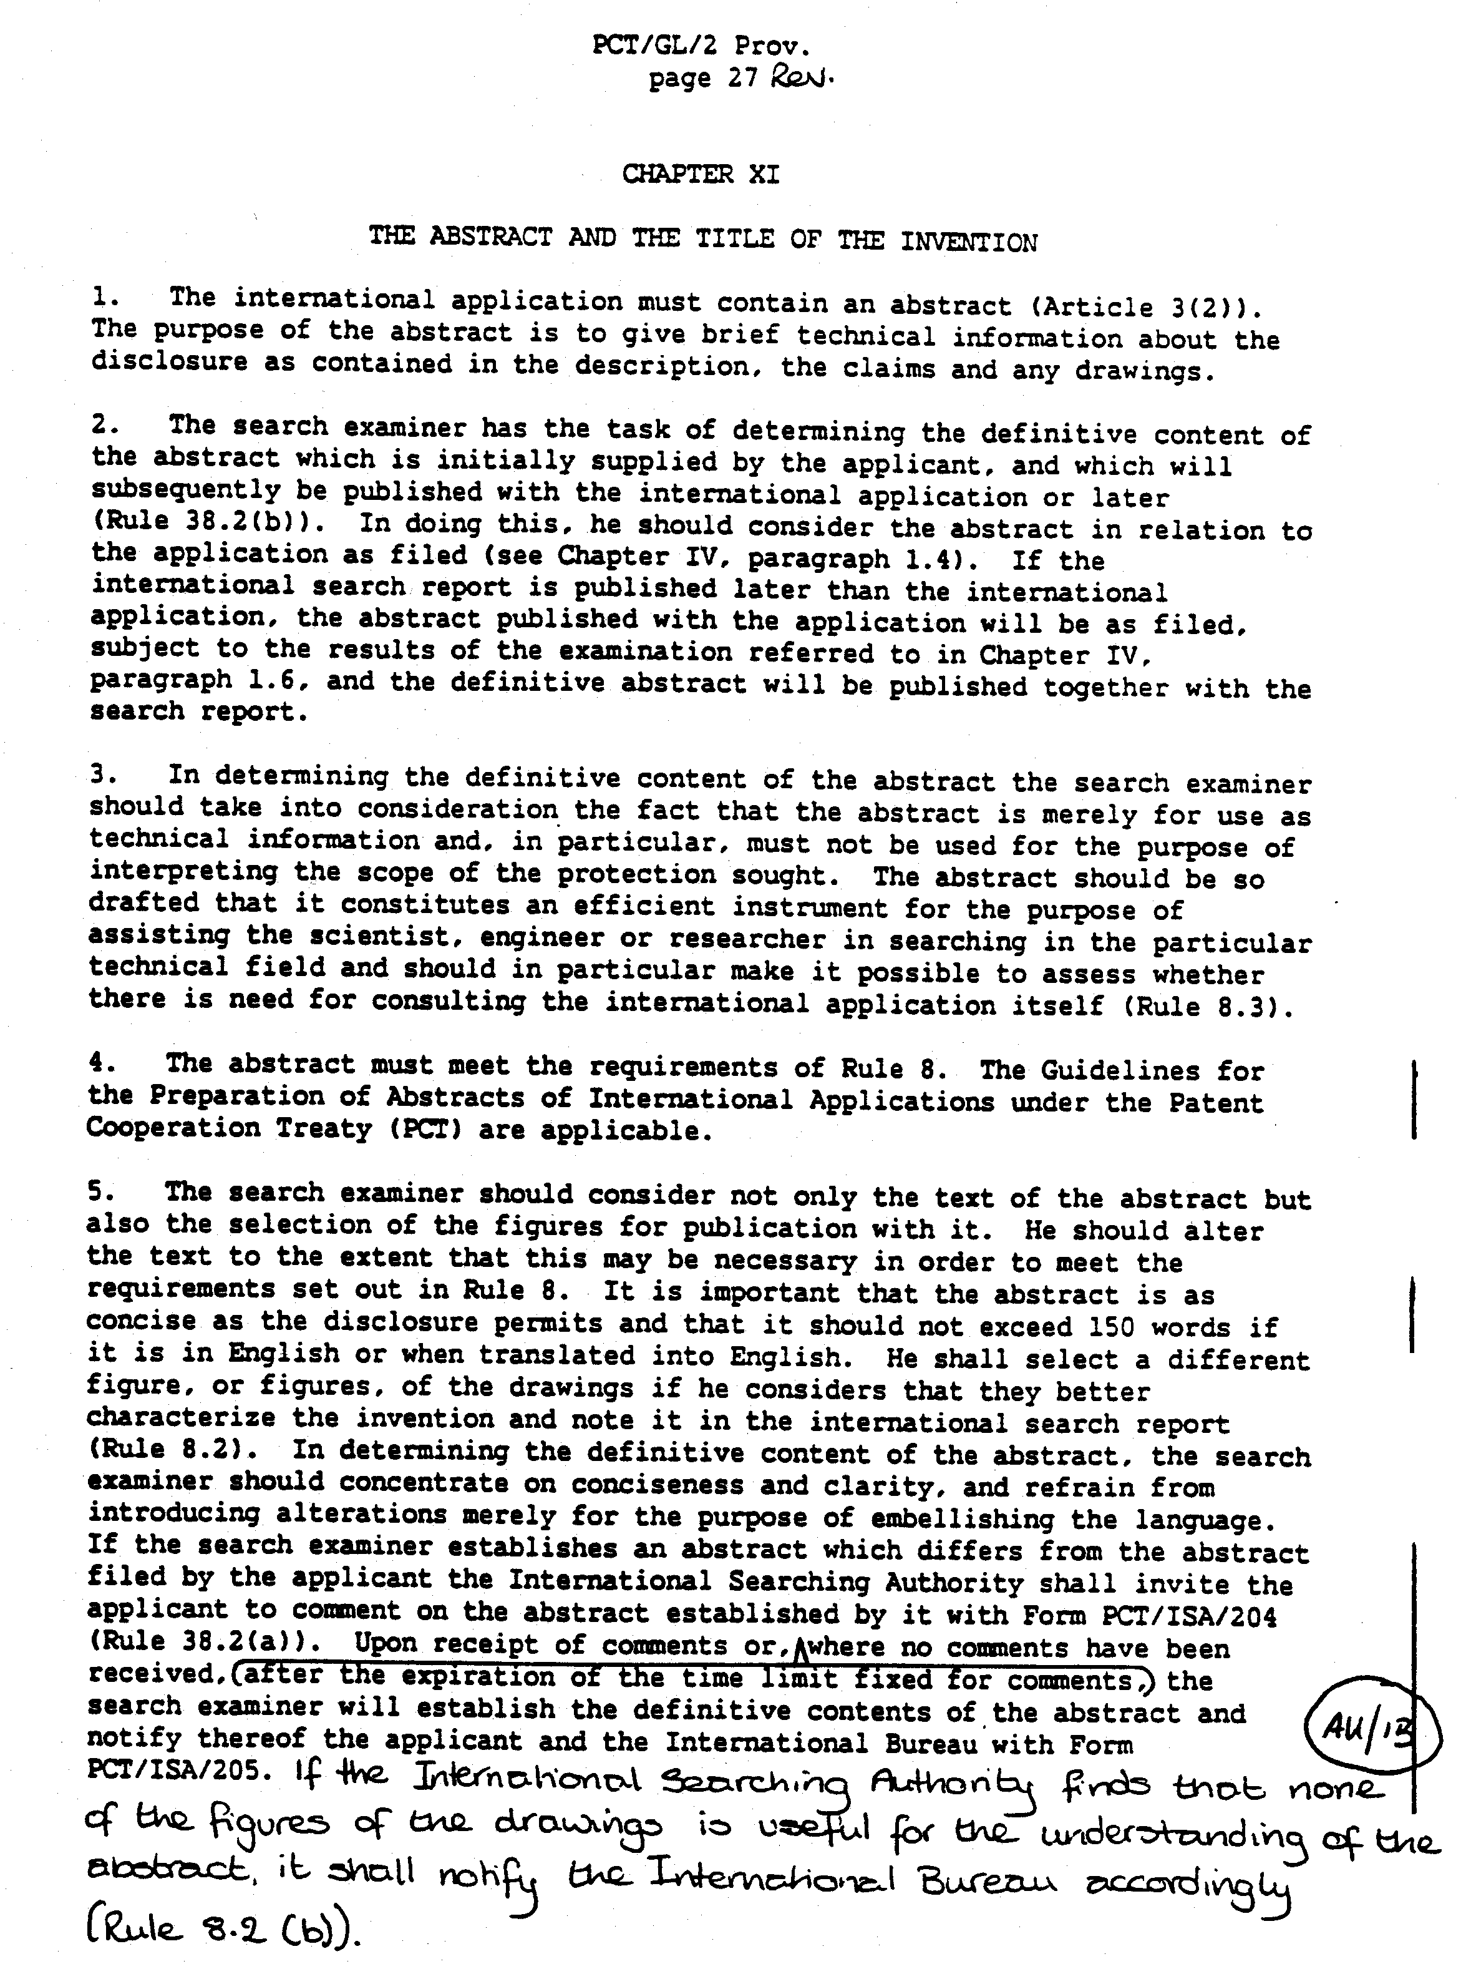
[Annex III follows]

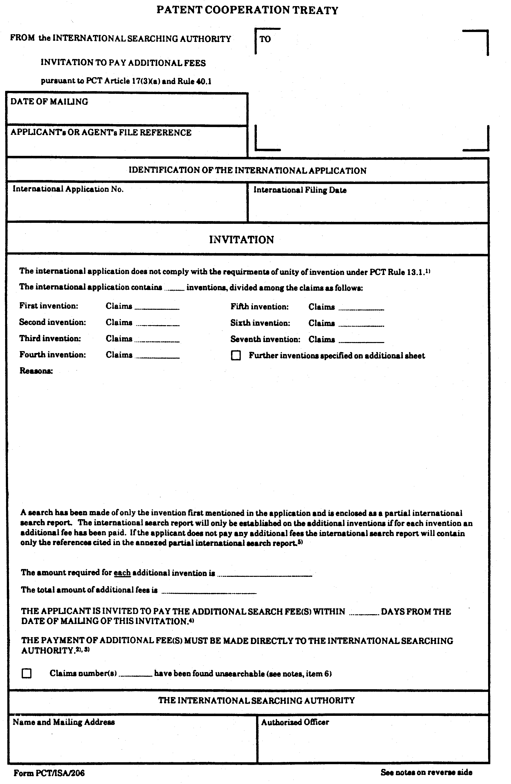

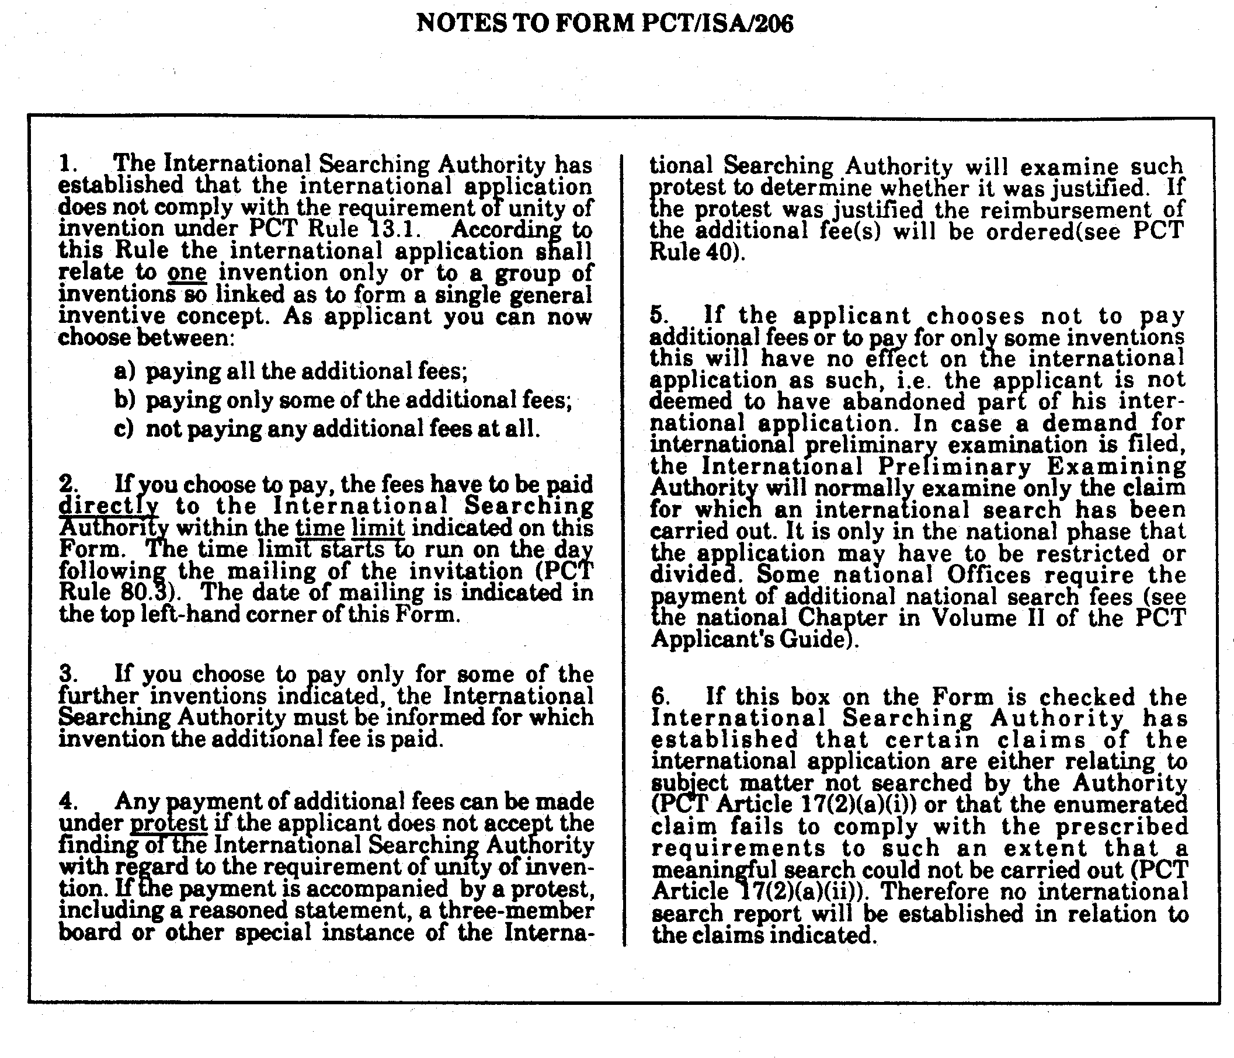

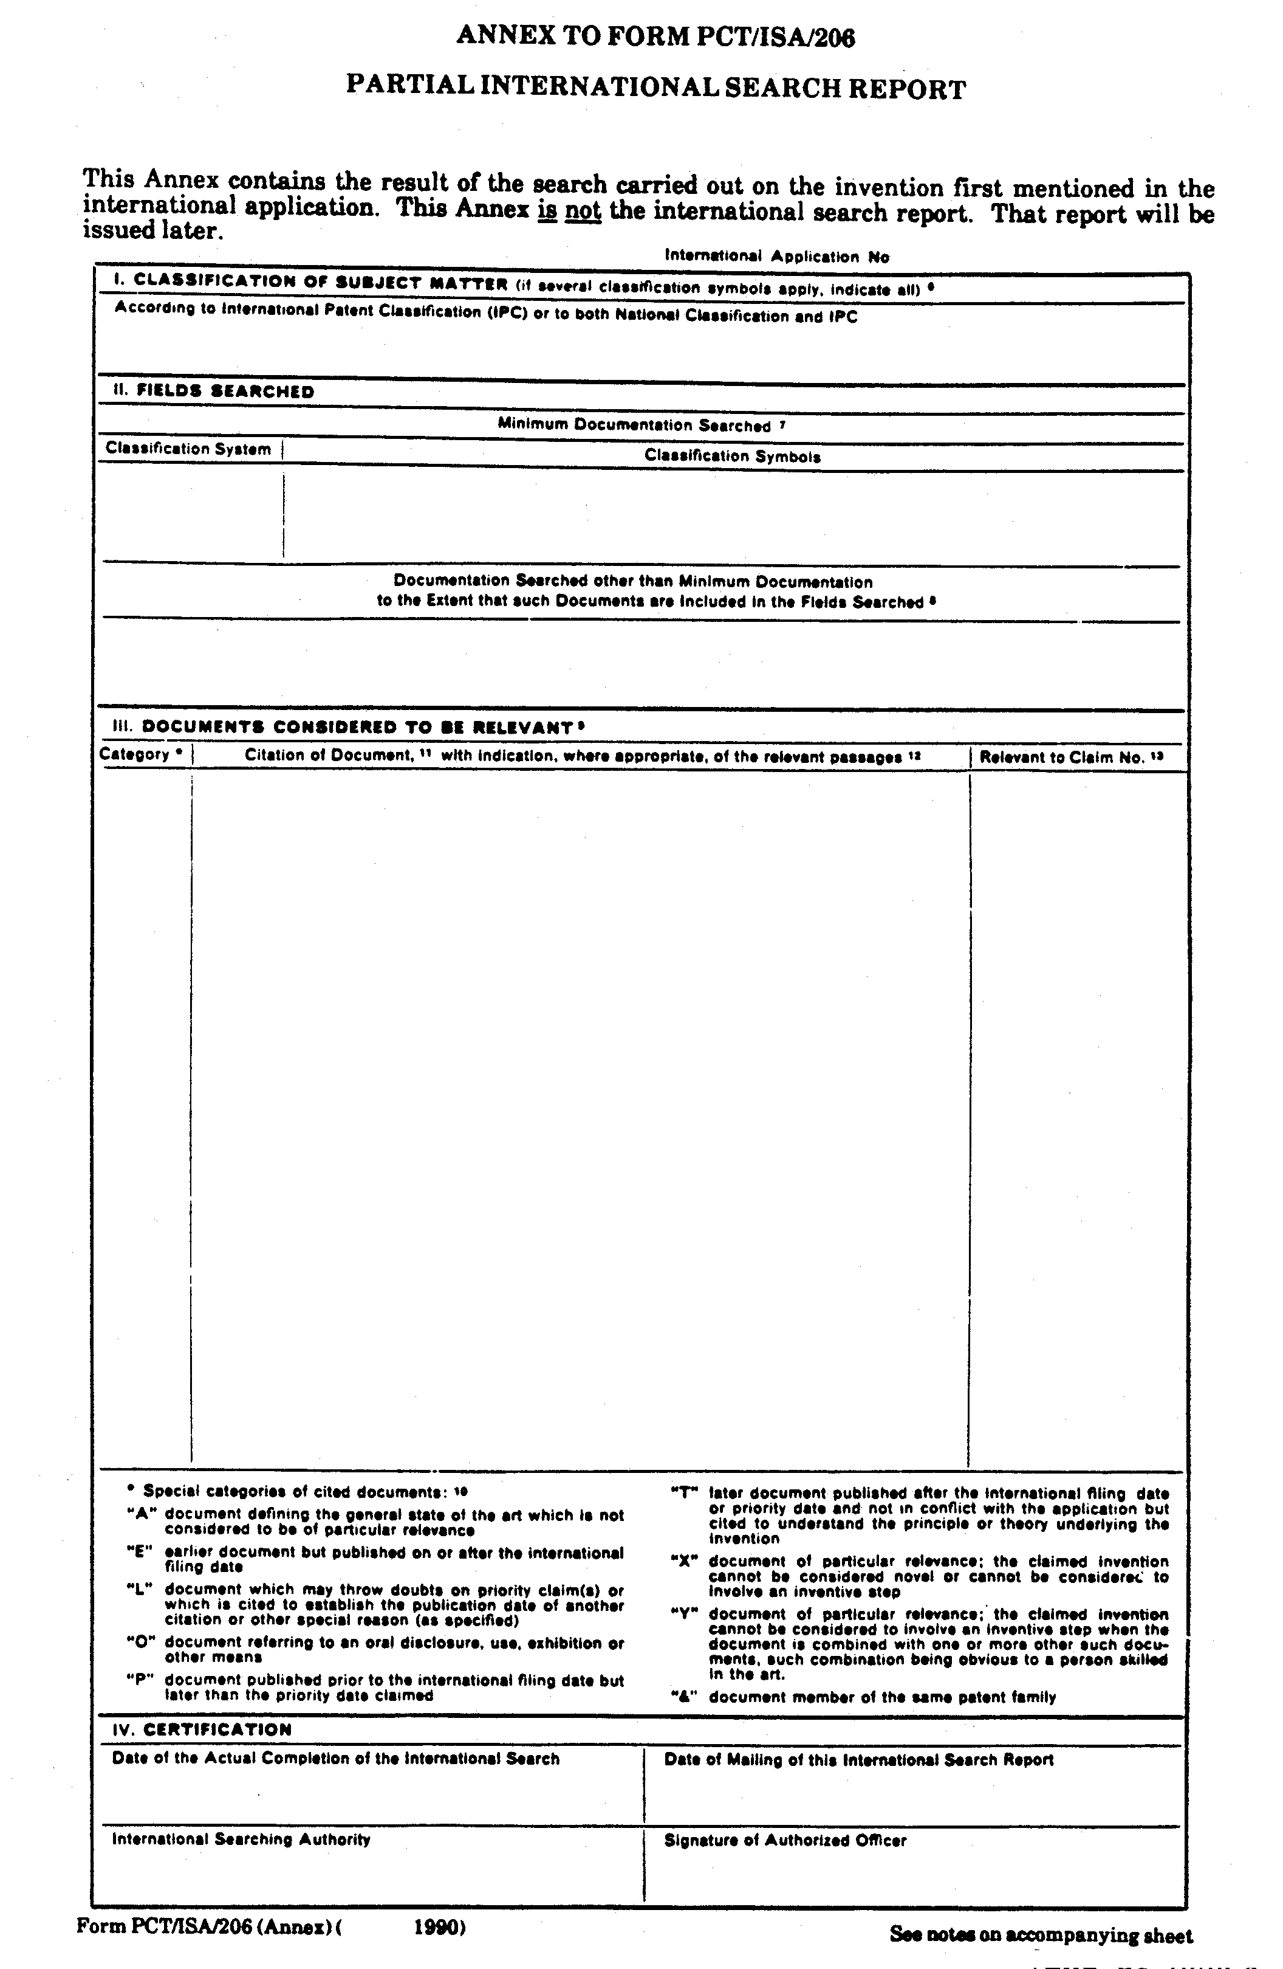
[End of Annex
and of document]

