WIPO |  | PCT/MIA/I/2 Add.1  ORIGINAL: English  DATE: January 15, 1990
WORLD INTELLECTUAL PROPERTY ORGANIZATION
GENEVA
International patent cooperation union
(PCT union)
Meeting of international authorities
under the PCT
First Session
Geneva, January 15 to 19, 1990
CONSIDERATION OF REPORTS BY THE INTERNATIONAL AUTHORITIES
CONCERNING THEIR PRACTICE AND EXPERIENCE AS
INTERNATIONAL SEARCHING AND/OR
PRELIMINARY EXAMINING AUTHORITIES
(ADDendum 1)
Document compiled by the International Bureau
The Annexes to this document contain the reports which have been submitted by the United Kingdom Patent Office (Annex E) and the European Patent Office (Annex F) which were received after the publication of document PCT/MIA/I/2.

[Annexes E and F follow]

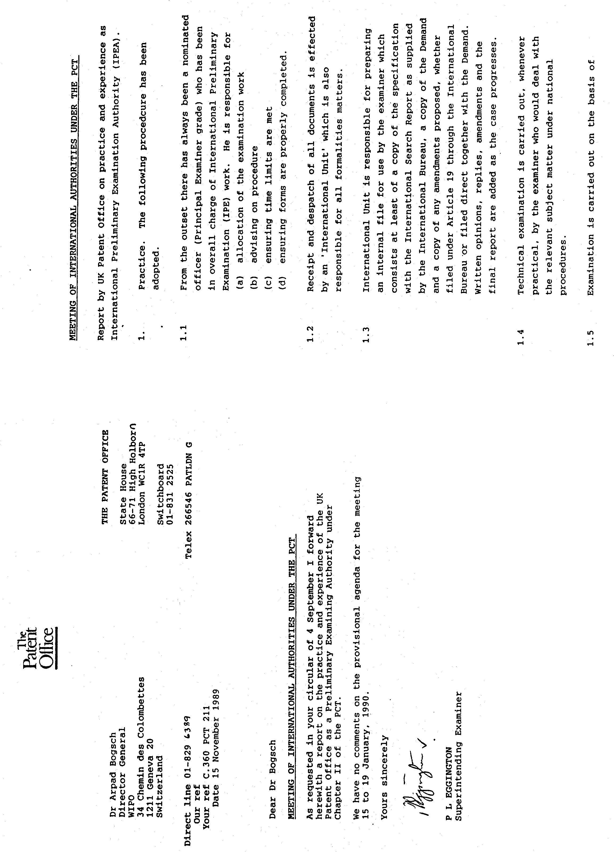

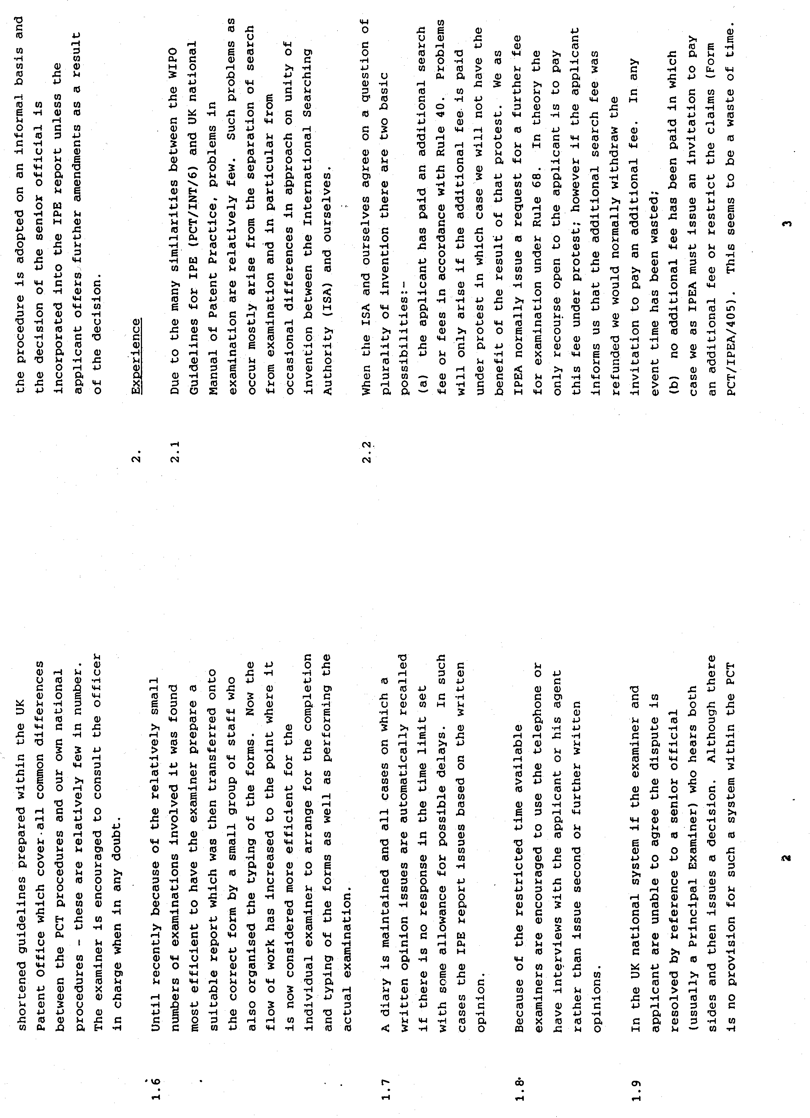

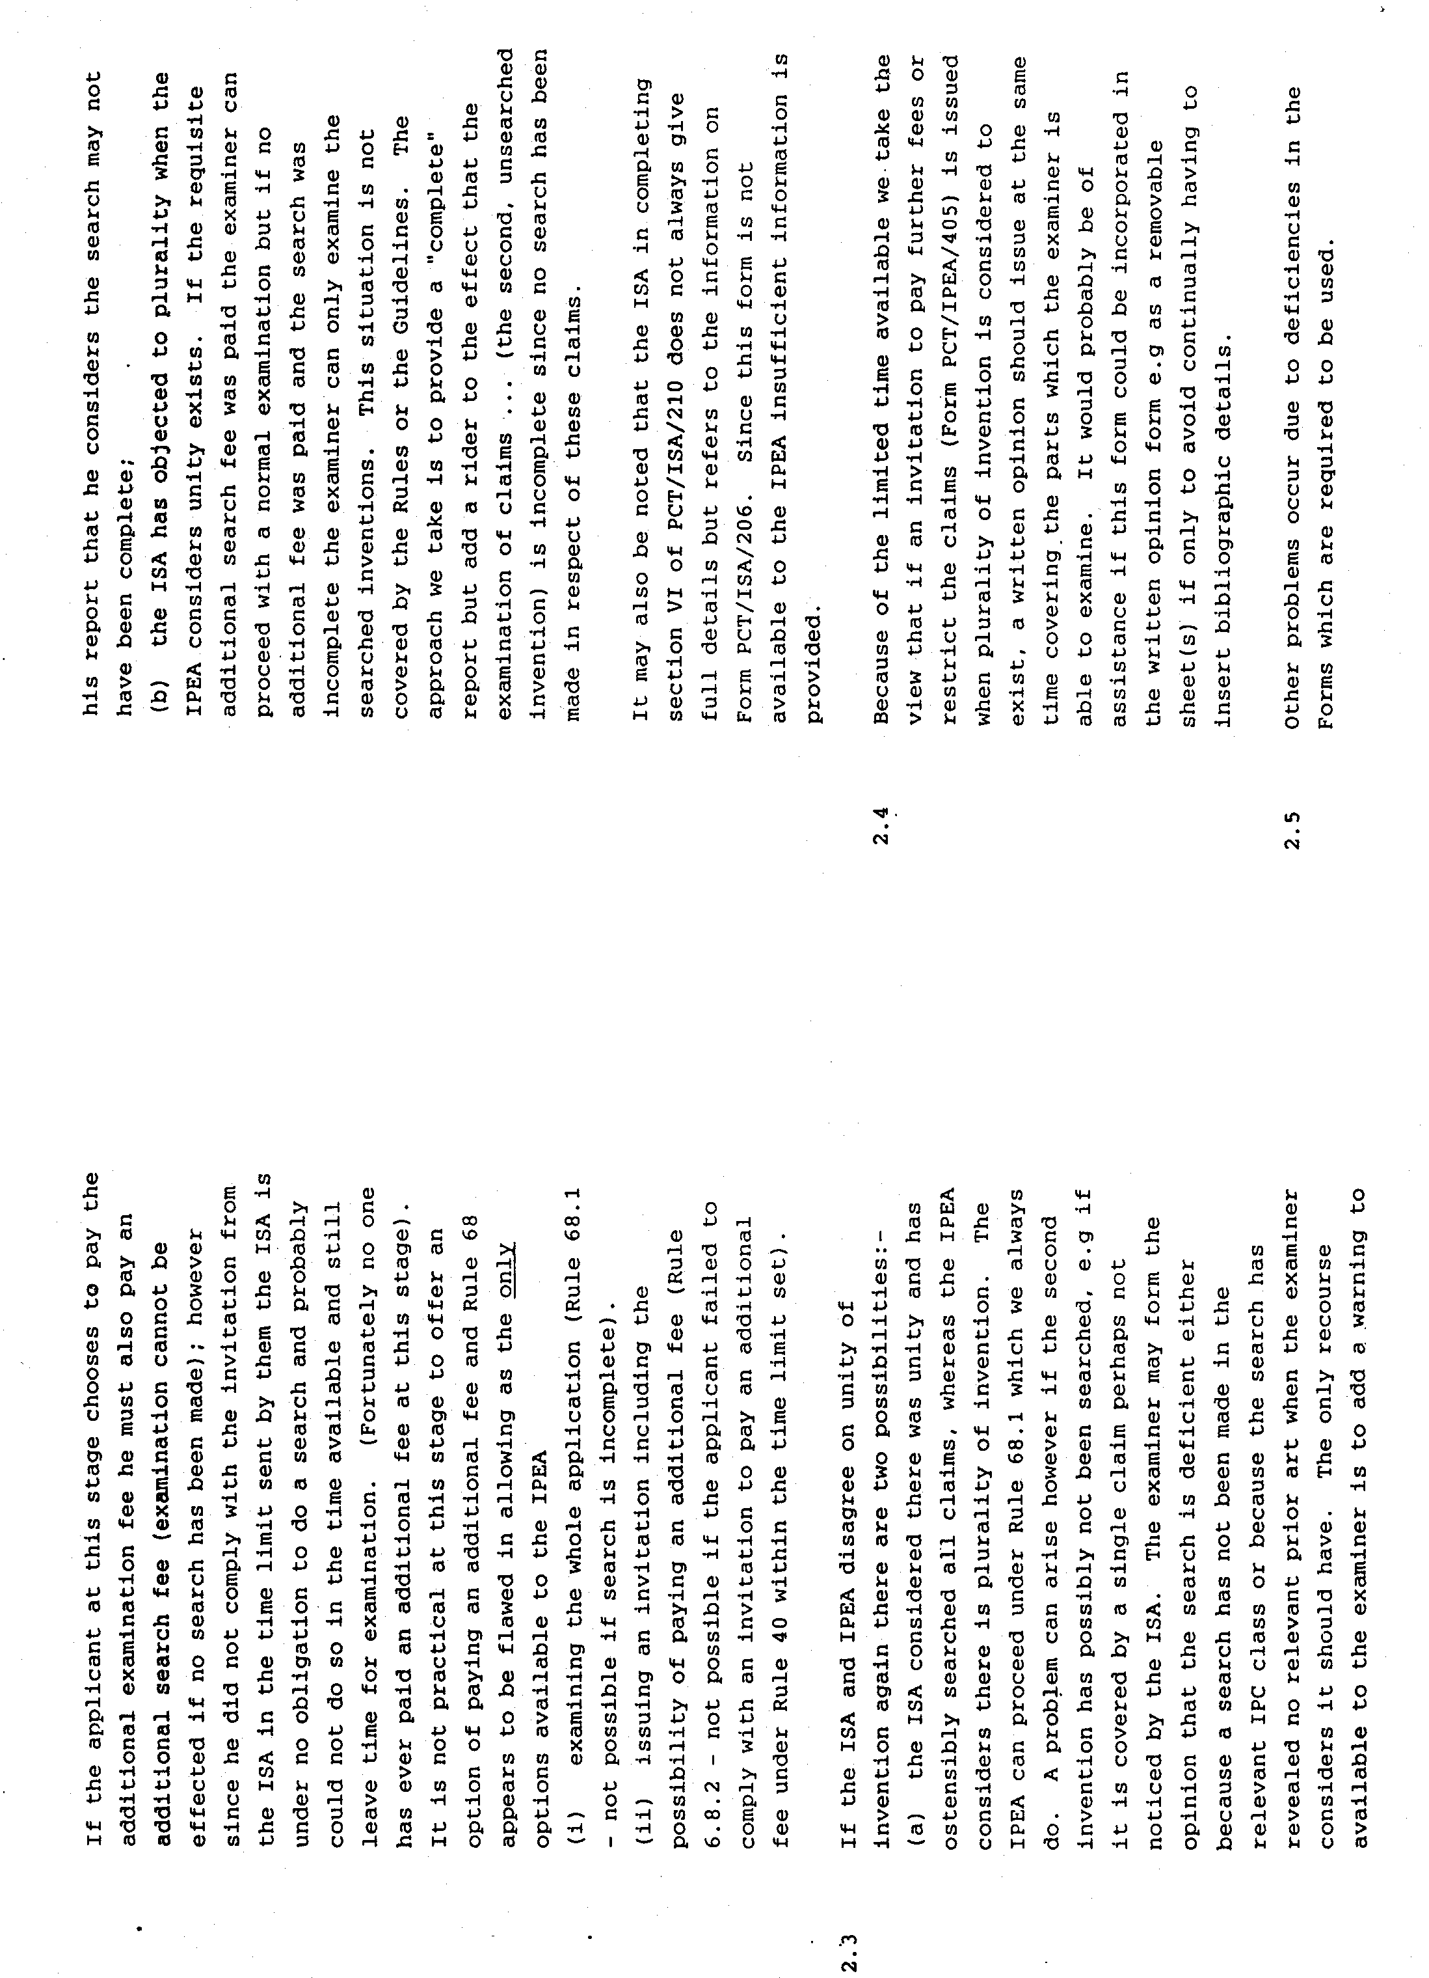

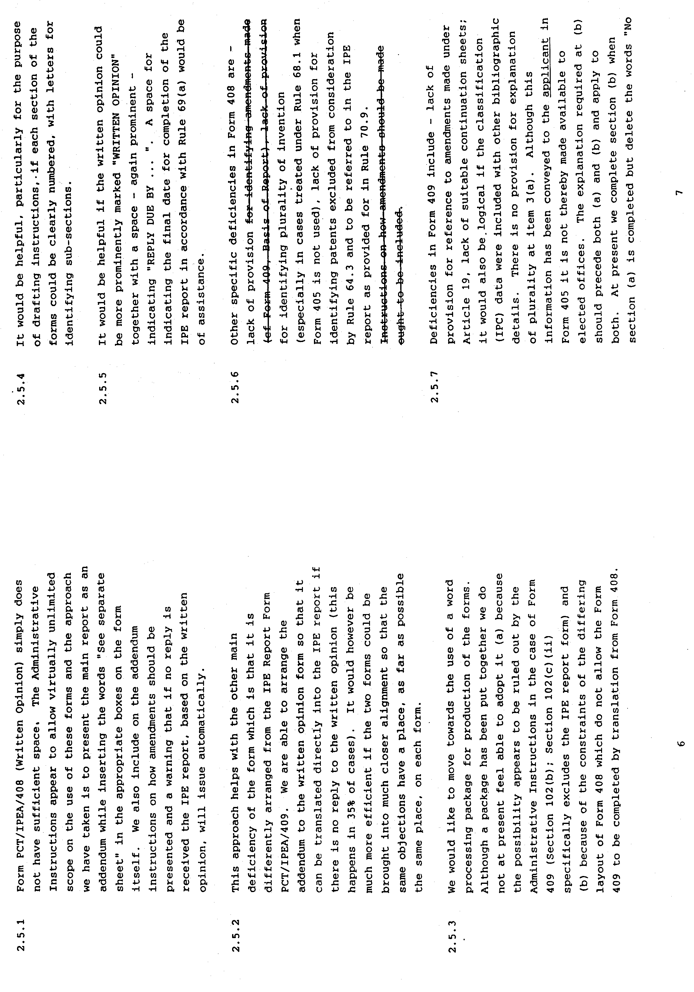

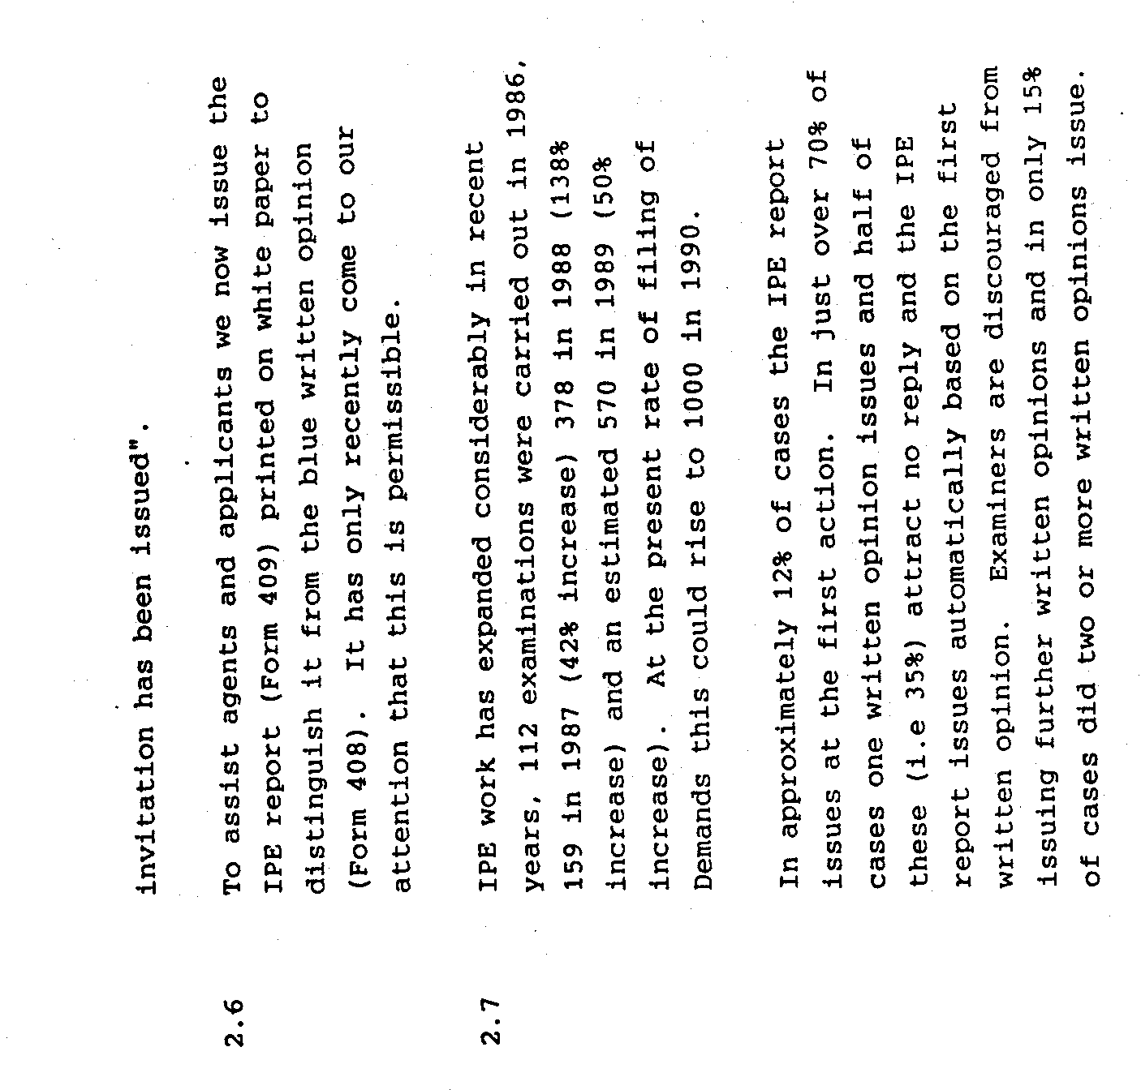

[Annex F follows]

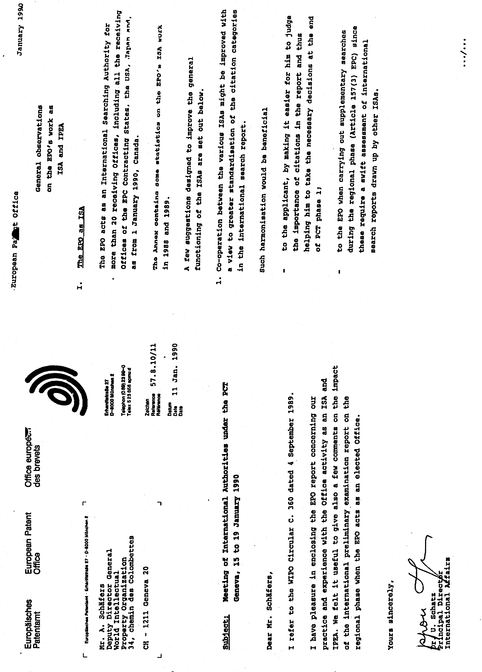

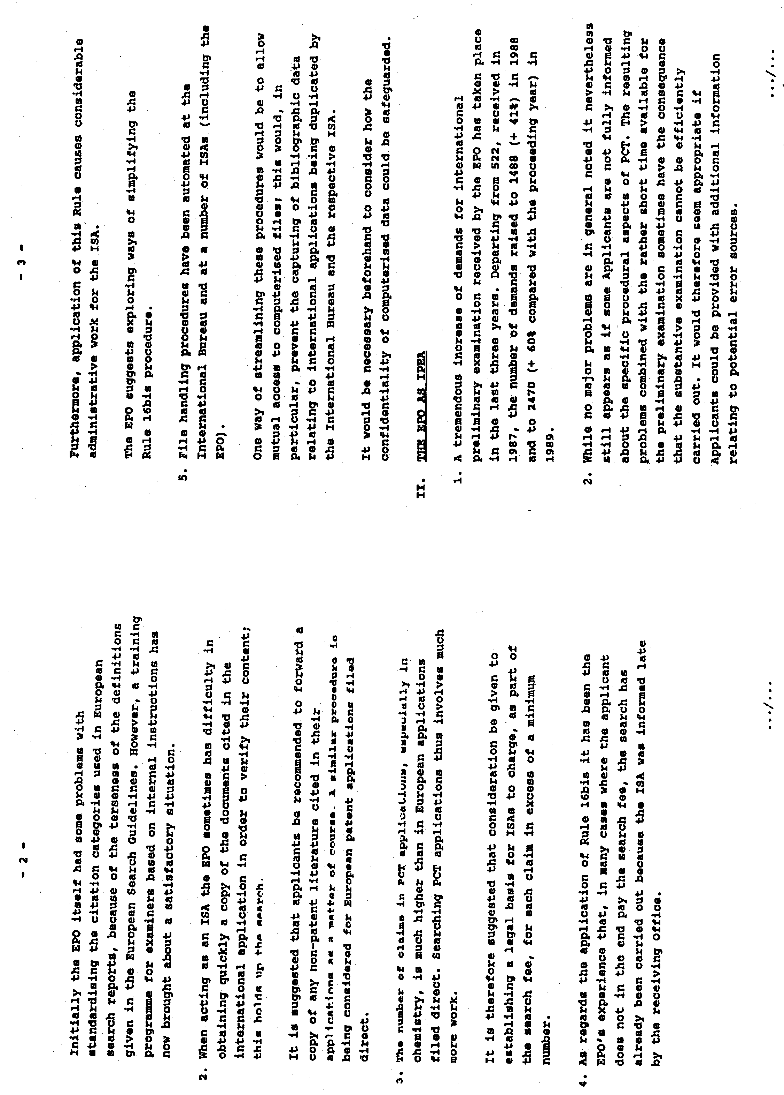

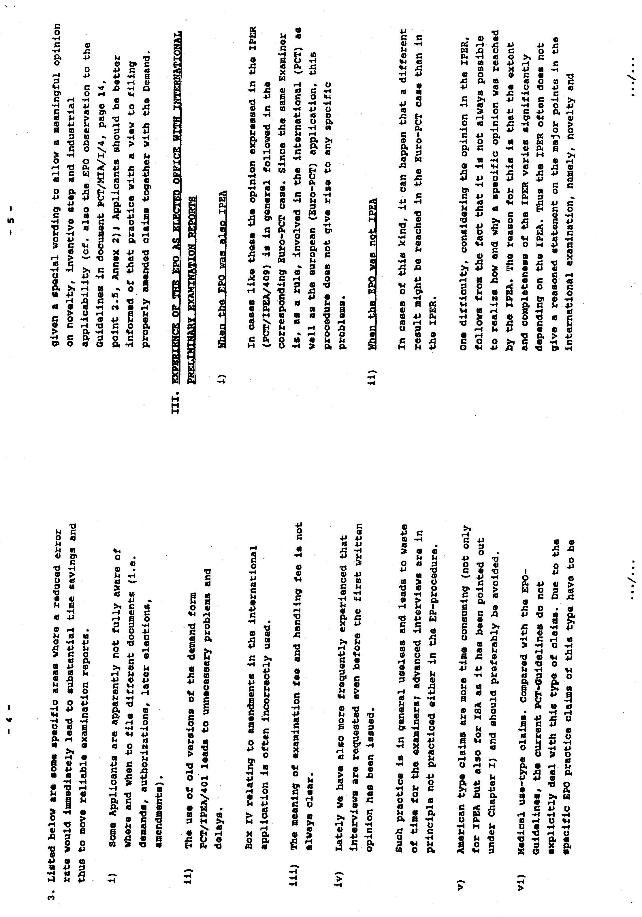

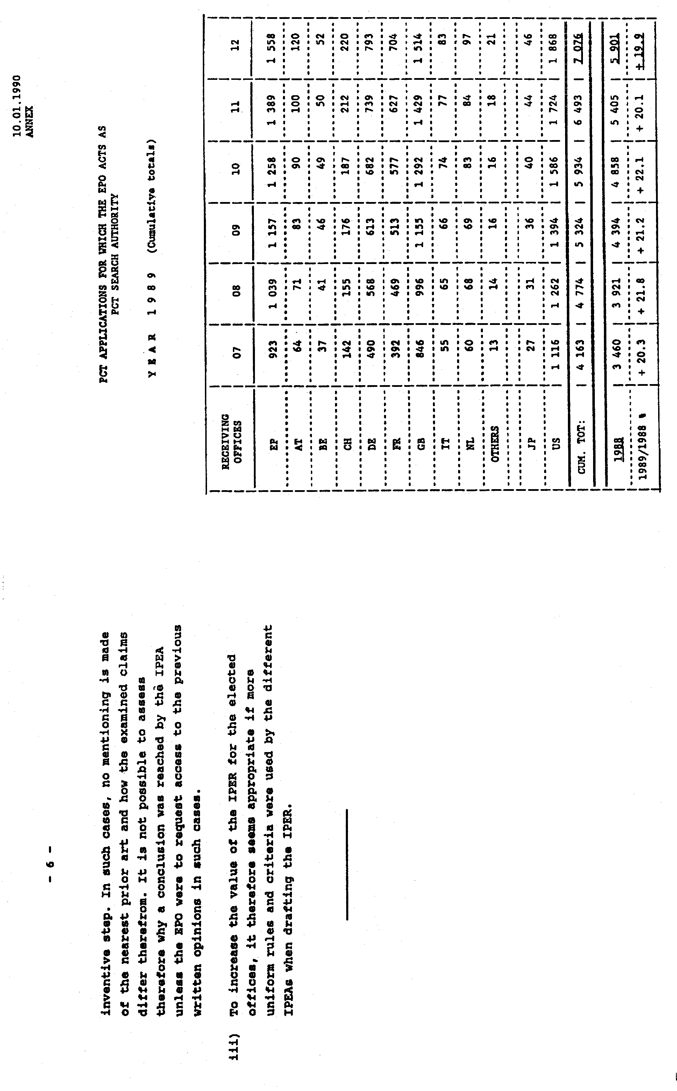[End of Document]

