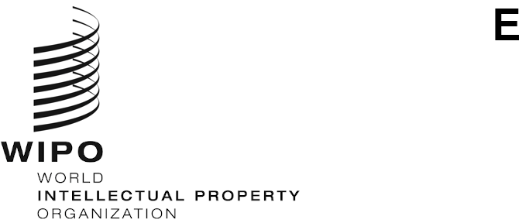
PCT/MIA/29/7
ORIGINAL: English Only
DATE: May 30, 2022

Meeting of International Authorities

under the Patent Cooperation Treaty (PCT)

Twenty-Ninth Session

Geneva, June 20 to 22, 2022

Proposal to Promote the Improvement of the International Search Report and the Written Opinion
Document prepared by the China National Intellectual Property Administration

Summary
- Following the proposal at the twenty-eighth session of the Meeting, the International Authorities are invited to comment on the report of the survey on the International Search Report (ISR) and the Written Opinion (WOSA), as well as next steps proposed by the China National Intellectual Property Administration (CNIPA).

Background
- At the twenty-sixth session of the Meeting of International Authorities (PCT/MIA) in February 2019, the CNIPA proposed to design a questionnaire and conduct a survey with a view to improving the layout, content and format of the ISR and the WOSA, so as to promote the improvement of the quality of ISR and the WOSA. The CNIPA proposed to implement related work in the following three steps: designing a questionnaire; conducting a survey; and completing an analysis report to raise potential areas and/or specific suggestions to aid in future improvement of the ISR and WOSA at the practical level based on the survey results. At the twenty-seventh session of the Meeting, the ISAs agreed to discuss the content and methodology of the survey on the Quality Subgroup electronic forum with a view to reaching agreement to conduct the survey. At the twenty-eighth session of the Meeting, the ISAs agreed to the schedule of the project. The CNIPA completed the draft of the report based on the survey, and the ISAs commented on the Quality Subgroup electronic forum. Up to January 2022, the ISAs had commented for two rounds on the report.

Draft of the Report
- In the first half of 2021, the CNIPA drafted the report based on the results of survey and feedback from the ISAs at the Meeting, and further solicited comments from all ISAs via the Quality Subgroup electronic forum in September 2021. The ISAs offered suggestions and proposals on the methodology of presenting results of the survey, showing the valuable suggestions integrally, providing the quantity of each suggestion and so on. In December 2021, the CNIPA revised the report and made an explanation, then uploaded the revised report to the Quality Subgroup electronic forum for further comments. By the end of January 2022, responses from six ISAs were received, and further discussion was welcomed.

Content of the Draft Report
- The draft report consists of four sections, which are review of the progress, participation of the survey, analysis of the results and summary. The analysis of results is mainly about comments on the layout, the content, and the format, in which the modification of specific boxes, wording and writing requirements of forms are focused.
 | PCT/ISA/210 | PCT/ISA/237
Comments on the layout | 5
 | 5 | 5
Comments on the content | 3 | 3
Comments on the format | 3
Recommendations for optimizing the forms to account for recent developments of PCT System | 5

- Five recommendations for the International Search and Preliminary Examination Guidelines were received, too.

Next Steps
- On the basis of the draft report, the CNIPA will lead the discussion and finalize the report after the PCT/MIA in 2022. The CNIPA proposes the schedule as follows:
  - By July 2022, the CNIPA will finalize the report.
  - By August 2022, the CNIPA will solicit comments and suggestions from ISAs on the priority items mentioned in the report via the Quality Subgroup electronic forum.
  - By October 2022, the CNIPA will list the priority items considering the suggestions from ISAs.
  - By December 2022, the CNIPA will solicit comments and suggestions from ISAs on the priority items list via the Quality Subgroup electronic forum.
  - In 2023, the CNIPA will report to PCT/MIA.
- The Meeting is invited to comment on the proposed schedule contained in paragraph 6 of the document.
[End of document]

