E
PCT/MIA/23/10
ORIGINAL: English
DATE: January 6, 2015

Meeting of International Authorities
under the Patent Cooperation Treaty (PCT)

Twenty-Third Session
Santiago, January 20 to 22, 2016

PCT Minimum Documentation:
Indian Traditional Knowledge Digital Library

Document prepared by the International Bureau

- At its 22nd session, the Meeting of International Authorities supported in principle a proposal to add the Indian Traditional Knowledge Digital Library (TKDL) to the PCT minimum documentation. The discussions were summarized as follows (paragraphs 66 to 69 of document PCT/MIA/22/22):
“66. Discussions were based on document PCT/MIA/22/8 and a presentation given by a representative from the Indian Council of Scientific and Industrial Research.
“67. All Authorities which took the floor on the matter supported in principle the proposal to add the Indian Traditional Knowledge Digital Library (TKDL) to the PCT minimum documentation, noting that it would greatly enhance the quality of international search, as confirmed by those Authorities which had already been given access to the TKDL.
“68. Several Authorities expressed concerns about certain provisions contained in the draft access agreement set out in Annex II to the document, notably in relation to the confidentiality and non-disclosure requirements, the necessity to monitor and report statistics on the use of citations from the TKDL, and the implications for an International Searching Authority losing access to the full PCT minimum documentation if the access agreement to the TKDL was terminated under the termination provisions of the draft agreement. One Authority emphasized the importance for Authorities to be able to load the data from the TKDL into the Authorities’ own IT systems. One Authority stated that if added to the PCT minimum documentation, the TKDL should have the same level of access as other collections in the PCT minimum documentation and should be equally available to the applicant. The Representative of the Indian Council of Scientific and Industrial Research clarified that this access would be available as per the terms and conditions of the TKDL access agreement, which provided for uninterrupted access to the TKDL.
“69. The International Bureau stated that it would be happy to closely work with the Indian Patent Office and the Indian Council of Scientific and Industrial Research in the coming months with a view to finding appropriate arrangements, to be set out in the draft access agreement, which would be acceptable to all International Searching Authorities and thus allow all of them to agree to the addition of the TKDL to the PCT minimum documentation. Agreement by all Authorities did not have to wait for another year until the next Meeting of International Authorities but could also be achieved by consulting with Authorities in the coming months through PCT Circulars.”
- In a letter dated December 23, 2015, the Government of India indicated that it was willing to revise the access agreement to address legitimate concerns in the draft access agreement set out in Annex II to document PCT/MIA/22/8 and reproduced in the Annex to this document. The Government of India further proposed that the Meeting approve the addition of the Indian TKDL to the PCT minimum documentation, subject to the terms of the access agreements being suitably modified after due consultation.
- The Meeting is invited to :
(i) agree that the Indian TKDL be added to the PCT minimum documentation, subject to the terms of the access agreement being suitably modified;
(ii) identify issues which Authorities consider require revision in the draft access agreement; and
(iii) agree that further consultations on the modifications to the access agreement be made on the basis of a revised draft proposal, to be prepared by the Government of India and presented through a PCT Circular.

[Annex follows]
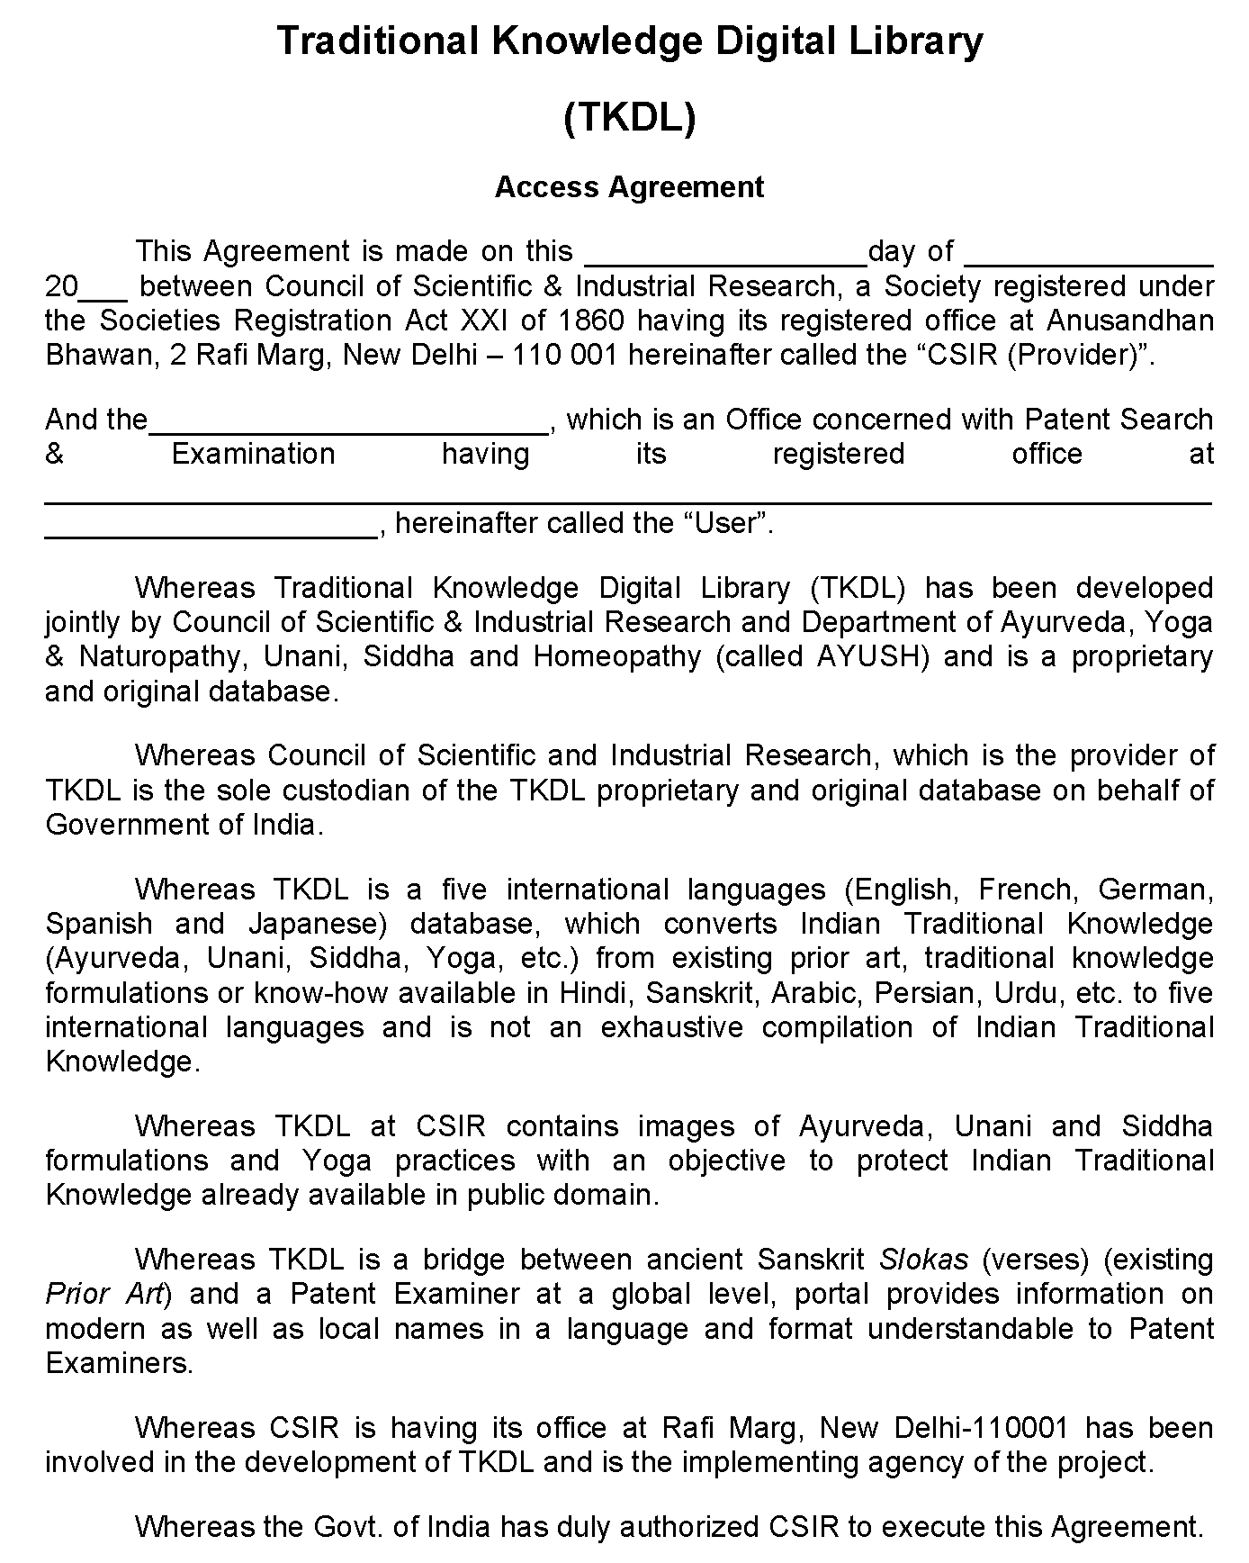

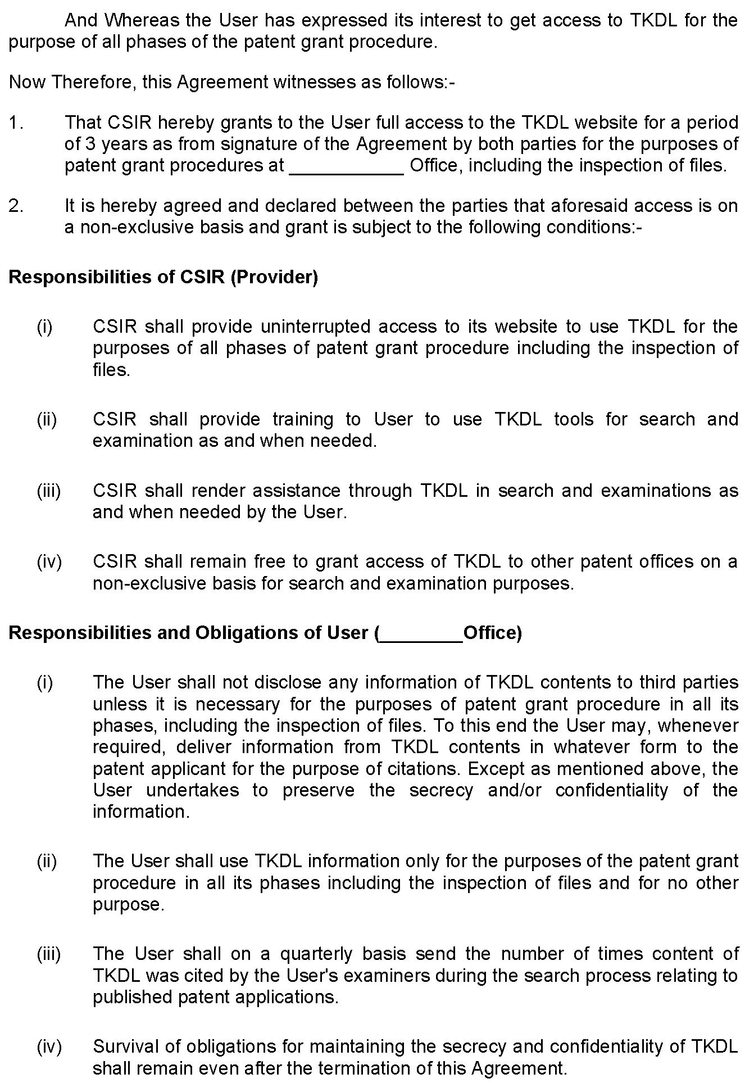

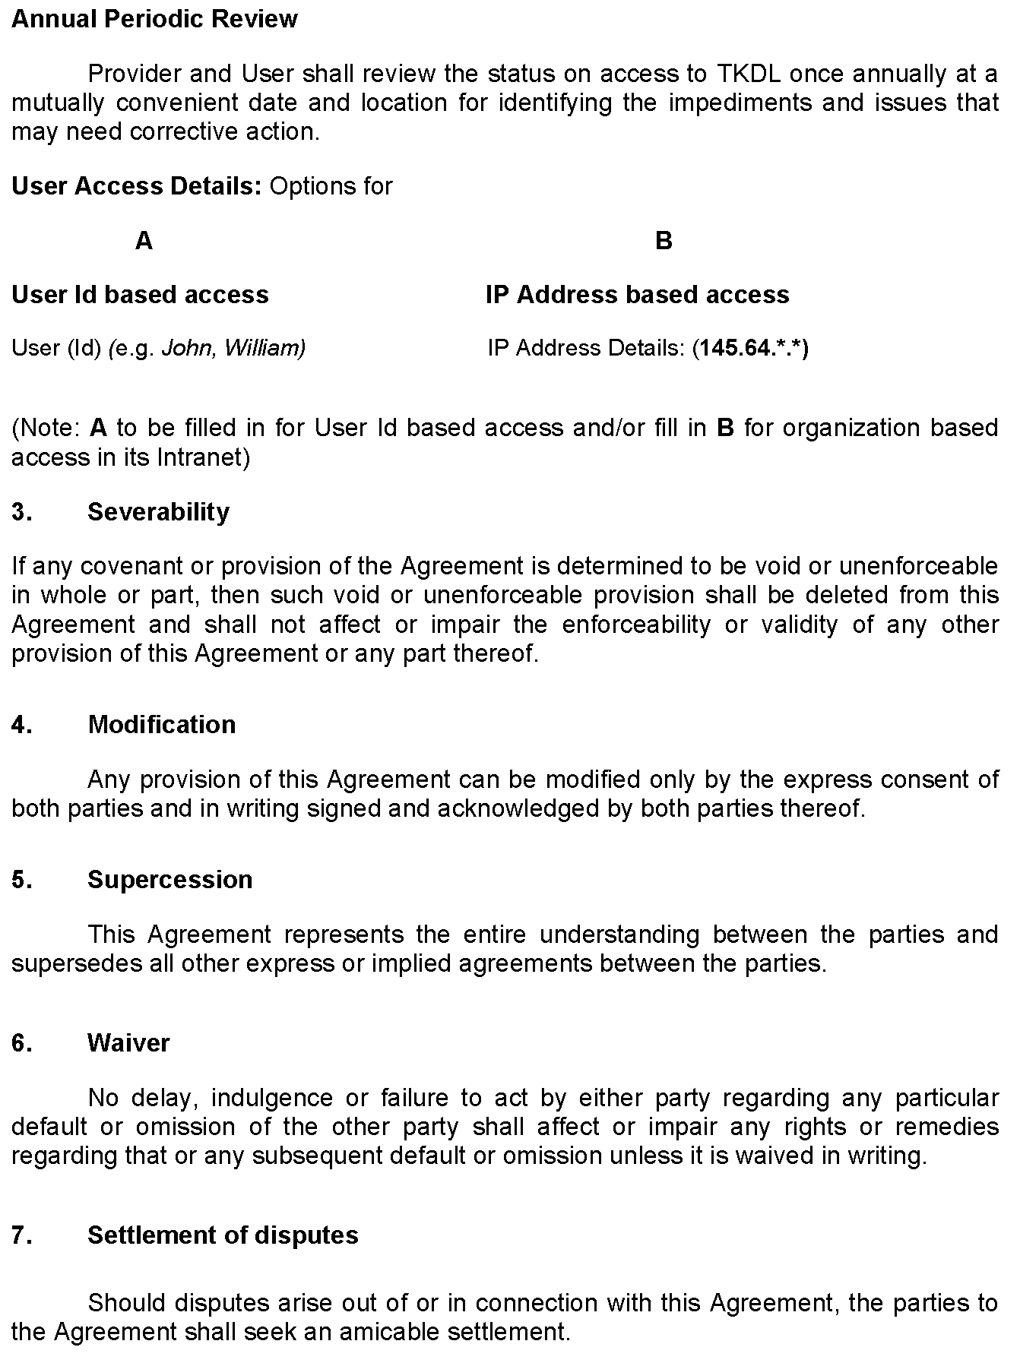

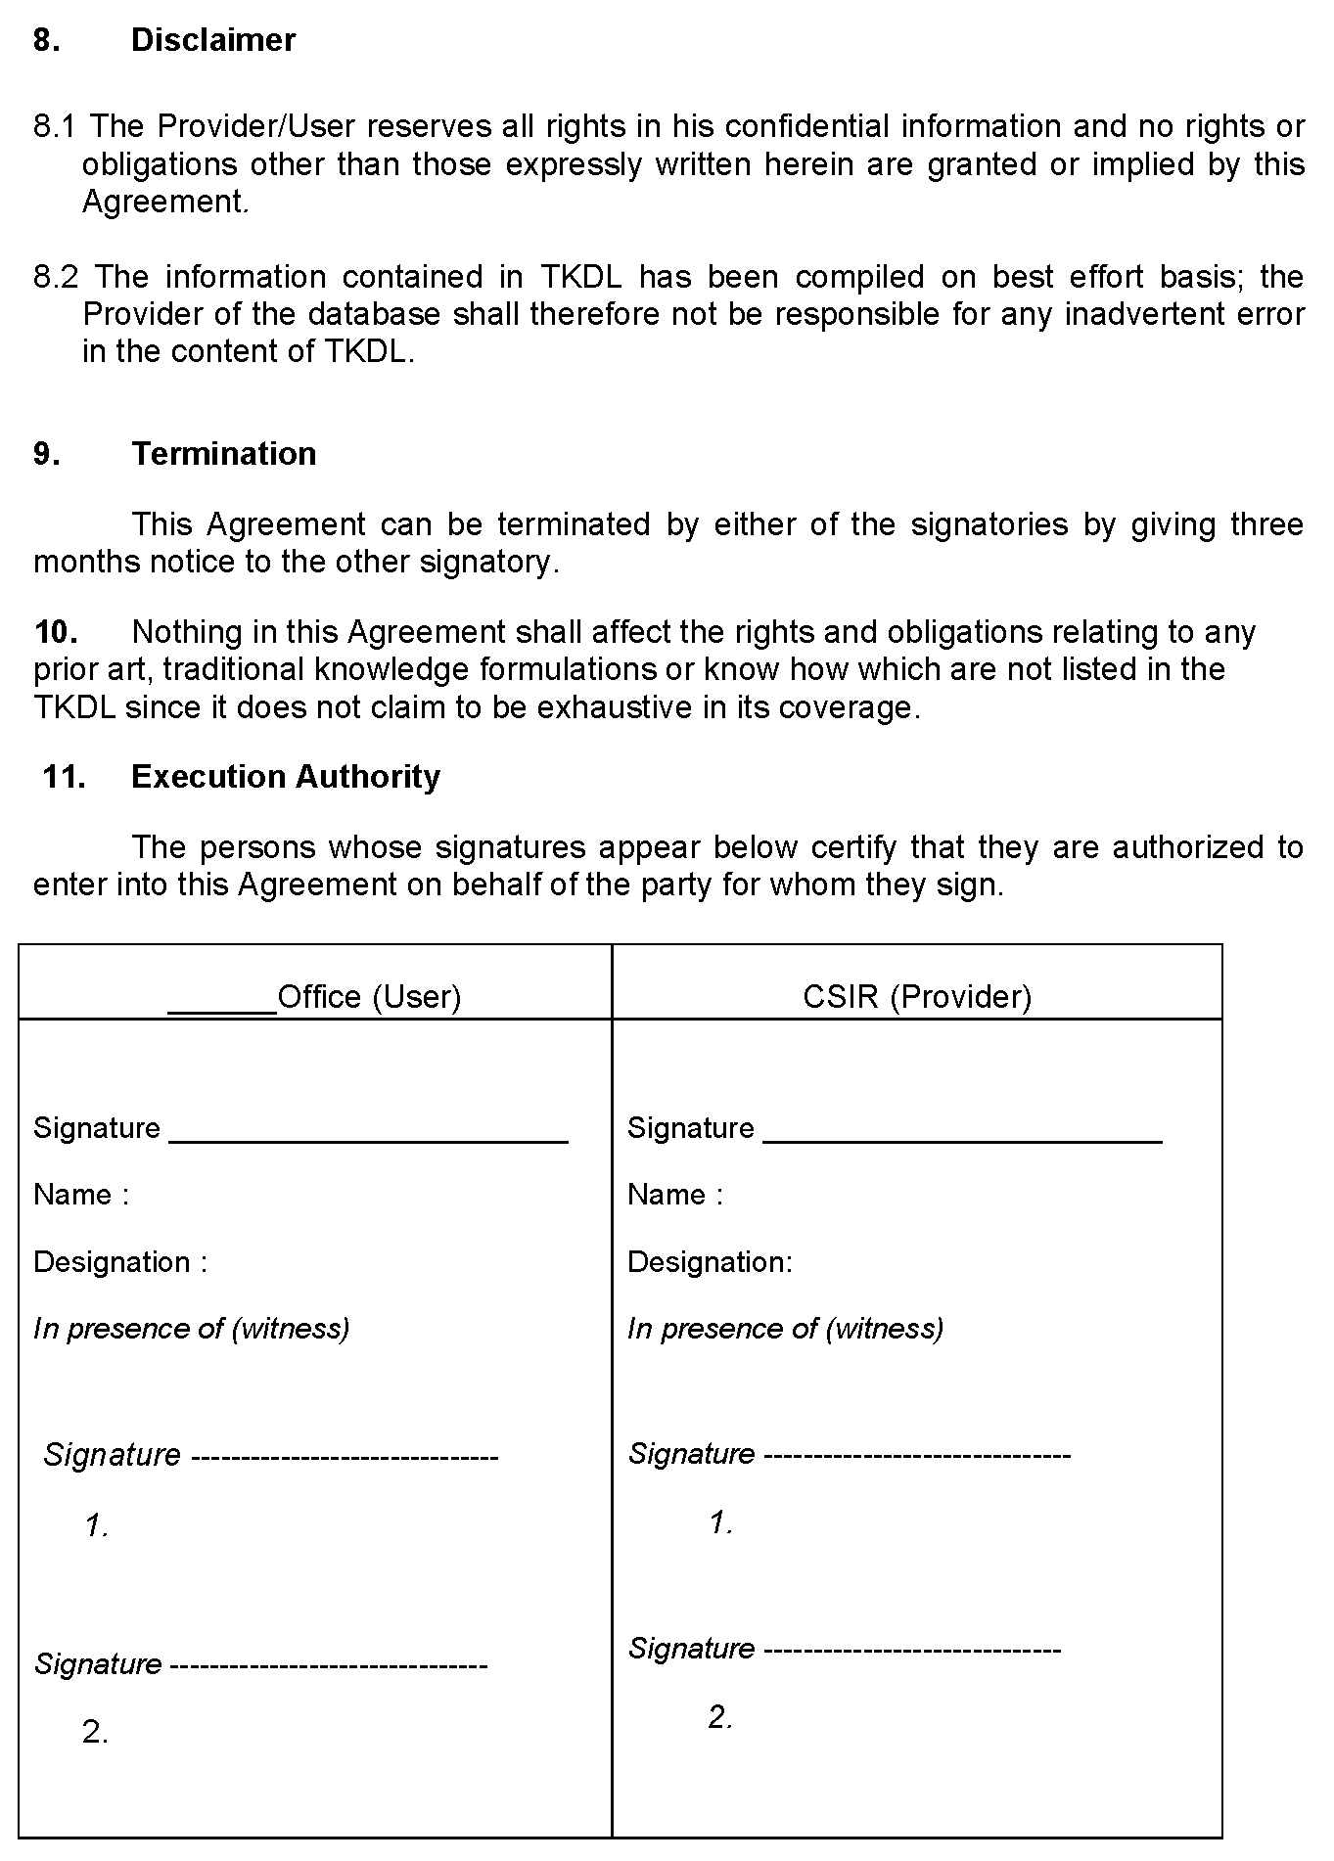

[End of Annex and of document]

