E
pct/mia/22/8
ORIGINAL: English
DATE: January 19, 2015

Meeting of International Authorities
under the Patent Cooperation Treaty (PCT)

Twenty-Second Session
Tokyo, February 4 to 6, 2015

PCT MINIMUM DOCUMENTATION: INDIAN TRADITIONAL KNOWLEdGE DIGITAL LIBRARY

Document submitted by India

- It is hereby requested that the Indian Traditional Knowledge Digital Library (“TKDL”) be added to the PCT minimum documentation.
- Annex I to this document contains information concerning the TKDL.
- In the context of considering the request to add the TKDL to the PCT minimum documentation, the Meeting may wish to note, in particular, that access to the TKDL requires individual International Patent Offices to sign a TKDL (Non-disclosure) Access Agreement. A template for such agreement is contained in Annex II. Such an agreement requires the Indian Council of Scientific and Industrial Research to provide uninterrupted access to the TKDL website and offer training to the Office if required. In return, the Office takes on certain obligations. The key conditions which should be taken into account are as follows:
  - The Office may not disclose any information of TKDL contents to third parties unless it is necessary for the purposes of patent grant procedure in all its phases, including the inspection of files. To this end the Office may, whenever required, deliver information from TKDL contents in whatever form to the patent applicant for the purpose of citations. Except as mentioned above, the Office undertakes to preserve the secrecy and/or confidentiality of the information.
  - The Office shall use TKDL information only for the purposes of the patent grant procedure in all its phases, including the inspection of files and for no other purpose.
  - The Office shall, on a quarterly basis, send the number of times content of TKDL was cited by the user's examiners during the search process relating to published patent applications.
  - Survival of obligations for maintaining the secrecy and confidentiality of TKDL shall remain even after the termination of the agreement.
5. The Meeting is invited to add the Indian traditional Knowledge Digital Library to the PCT minimum documentation and to decide on a date from which the addition should be effective.

[Annex I follows]
PCT/MIA/22/8

ANNEX I

SUMMARY OF THE INDIAN
TRADITIONAL KNOWLEDGE DIGITAL LIBRARY

INTRODUCTION
- The Indian Traditional Knowledge Digital Library (TKDL) initiated as a collaborative project between Council of Scientific and Industrial Research (CSIR), Ministry of Science and Technology and Department of Ayurveda, Yoga & Naturopathy, Unani, Siddha and Homoeopathy (AYUSH), Ministry of Health and Family Welfare. The work began in 2001 and is being implemented by CSIR through a team of interdisciplinary team of experts from traditional medicine, patent examiners, IT experts and scientists.
- The TKDL provides information on traditional knowledge existing in the country, in languages and formant understandable to examiners at International Patent Offices (IPOs), so as to prevent the grant of wrong patents. The TKDL thus acts as a bridge between the documented traditional knowledge (prior-art) existing in local languages and the patents examiners at IPOS. This is done by converting the publicly available traditional knowledge from the existing literature related to Ayurveda, Unani, Siddha and Yoga into five International languages using an Innovative Classification System i.e. Traditional Knowledge Resource Classification (TKRC) and Information Technology tools.

FORMAT AND CONTENTS OF THE TRADITIONAL KNOWLEDGE DIGITAL LIBRARY
- The TKDL can be seen in two versions:
  - A public search facility available at http:/tkdl.res.in/ shows the general scope of the system, allowing advanced Boolean search of a limited, representative database of 1200 traditional medicinal formulations, using keywords, IPC codes, more detailed (TKRC) codes, titles, bibliographic information or disease names. The results are shown as a summary of the matching formulations in the chosen one of the five interface languages (English, French, German, Japanese and Spanish).
  - A full search facility is open to patent Offices under an TKDL (Non-disclosure) Access Agreement, as described below. This offers access to the full database, at present consisting of 0.292 million traditional medicinal formulations, including scanned images of relevant prior-art existing in the original traditional literature.
- The full search facility is available through [a dedicated web interface with access controlled by IP address(es) notified by each Office in its access agreement]

TRADITIONAL KNOWLEDGE RESOURCE CLASSIFICATION (TKRC)
- A presentation on Traditional Knowledge Resource Classification (TKRC) to the International Patent Classification (IPC) Union led to the creation of a WIPO-TK Task Force, consisting of the United States Patent and Trademark Office (USPTO), the European Patent Office (EPO), the Japan Patent Office (JPO), China and India, the aim of which was to enhance the subgroups in IPC for classifying the TK related subject matter and to consider the linking of the TKRC with the IPC. In February 2002, a Committee of Experts recommended the inclusion of approximately 200 subgroups on TK against the existing one subgroup on medical plants, and linking of the TKRC to the IPC and thus, a new main group was included in the IPC, i.e. A61K 36/00, with 207 subgroups covering different categories of plants, as shown below:
S.NO | IPC Codes | IPC Categories | No. of Subgroups in IPC
1. | Algae | A61K 36/02 to 36/05 | 4
2. | Fungi & Lichens | A61K 36/06 to 36/09 | 10
3. | Bryophyta | A61K 36/10 | 1
4. | Pteridophytes | A61K 36/11 to 36/126 | 3
5. | Gynosperms | A61K 36/13 to 36/17 | 5
6. | Angiosperms | A61K 36/18 | 1
7. | Dicotyledons | A61K 36/185 to 36/87 | 148
8. | Monocotyledons | A61K 36/88 to 36/9068 | 35
Total number of Subgroups |  |  | 207

- At present, the TKRC has evolved to include 27,000 subgroups against a single subgroup that was available in earlier version of the IPC, related to medicinal plants, minerals, animals, resources, effects and diseases, methods of preparations, mode of administration, etc. It enables retrieval of data similar to IPC and is available in five International languages, namely, English, French, German, Spanish and Japanese.

STATUS OF TRANSCRIPTION OF TRADITIONAL MEDICINAL FORMULATIONS
- The present status of transcription of the traditional medicine formulations in the Traditional Knowledge Digital Library is given in the following table:
Discipline | No of texts (including volumes) used for transcription | Transcribed
Ayurveda | 75 books  http:/www.tkdl.res.in/tkdl/langdefault/common/sourceinfo. Asp#A | 97,337
Unani | 10 books  http:/www.tkdl.res.in/tkdl/langdefault/common/sourceinfo. Asp#U | 175,150
Siddha | 50 books  http:/www.tkdl.res.in/tkdl/langdefault/common/sourceinfo. Asp#S | 23,016
Yoga | 15 books  http:/www.tkdl.res.in/tkdl/langdefault/common/sourceinfo. Asp#Y | 1,680
Total | 150 books | 292,662

- The TKDL project so far has a total of 292,662 formulations that have been transcribed and the database represents the contents of 34 million A4-sized pages of original documents.

ACCESS TO THE TKDL DATABASE TO INTERNATIONAL PATENT OFFICES
- Access to the TKDL database has been given to the European Patent Office (EPO), the United States Patent and Trademark Office (USPTO), the German Patent and Trademark Office, the United Kingdom Intellectual Property Office, the JPO, the IP Australia, the National Institute of Industrial Property of Chile, the Indian Patent Office and the Canadian Intellectual Property Office. Negotiations are in advance stage for conclusion of the Access Agreement with Russian Patent Office (ISA) and Malaysian Patent Office (MyIPO). The access to the TKDL database is provided under a TKDL (Non-disclosure) Access Agreement, permitting database only to the extent necessary for patent search and examination, and requiring the Office to provide statistical reports, such as the number of times the TKDL was cited during the year. Access will be provided to all International Searching and Preliminary Examining Authorities from the effective date of incorporation of the TKDL in the pct minimum documentation, after signing of TKDL (Non-disclosure) Access Agreement individually by each of the offices as already signed by some of the ISAs namely United States of America, European Patent Organization, Japan, Canada and Australia.

MAJOR ACHIEVEMENTS AND IMPACTS
- Beginning July 2009, 5100 patent applications at USPTO, EPO, CIPO, GPO, UKPTO, IP Australia and Indian Patent Office (CGPDTM) have been identified with the help of TKDL, with respect to Indian Systems of Medicine and TKDL evidences have been filed at pre-grant stage under relevant provisions at these Patent Offices in more than 1131 cases till December 2014. Success has been achieved in 196 cases where the patent applications have been withdrawn/cancelled/declared dead/claims amended by applicants/rejected by the Examiner(s), on the basis of TKDL prior art evidences in few weeks of time and without any cost, whereas Agricultural and Processed Food Products Export Development Authority (APEDA) spent 1.03 million US$ only towards legal fees, for invalidation of few claims of single wrong patent on Basmati at USPTO.
- Some of the other major achievements of the TKDL include:
  - Standards used for creation of the TKDL database have been adopted by the World Intellectual Property Organization (WIPO) as International standards for the creation of databases on Traditional Knowledge.
  - WHO has recognized the effort and recommends the replication of TKDL in other countries.
  - World Intellectual Property Organization (WIPO), Geneva, has proposed to internationalize the TKDL for protection of traditional knowledge of other countries, especially developing nations. In March 2011 WIPO in collaboration with CSIR organized an International Conference on ‘Utilization of TKDL as a Model for protection of traditional knowledge’ wherein 33 countries participated. In 2013 also, WIPO in collaboration with CSIR and DIPP organized a ‘Study Visit to TKDL’ for 19 countries interested in replicating TKDL for protection of traditional knowledge of their country. Several countries are approaching India firstly for getting TKDL replicated (mainly developing nations) and for getting access to TKDL for improving quality of examination of patent applications filed on traditional knowledge, which include developed nations also.
  - The EPO has described the TKDL as a unique encyclopedia which is very precise and shall prevent bio-prospectors from digging up ancient medical wisdom and laying claim upon them.
  - The EPO has acknowledged that with the TKDL, examiners have improved access to background information at an early stage of patent examination vis-a-vis a scenario where a patent may have been granted and the countries had to present evidence against it.
  - The USPTO considers the TKDL as a part of the very important work being done internationally with respect to TK databases. India has successfully concluded TKDL (Non-disclosure) Access Agreement with the USPTO in November 2009 with the sideline visit of Prime Minister of India to Washington DC.
  - The Director General of WIPO, in one of his recent communications, has stated that “the TKDL has made unparalleled contributions in the International policy context of the patent system.”

[Annex II follows]
PCT/MIA/22/8

ANNEX II

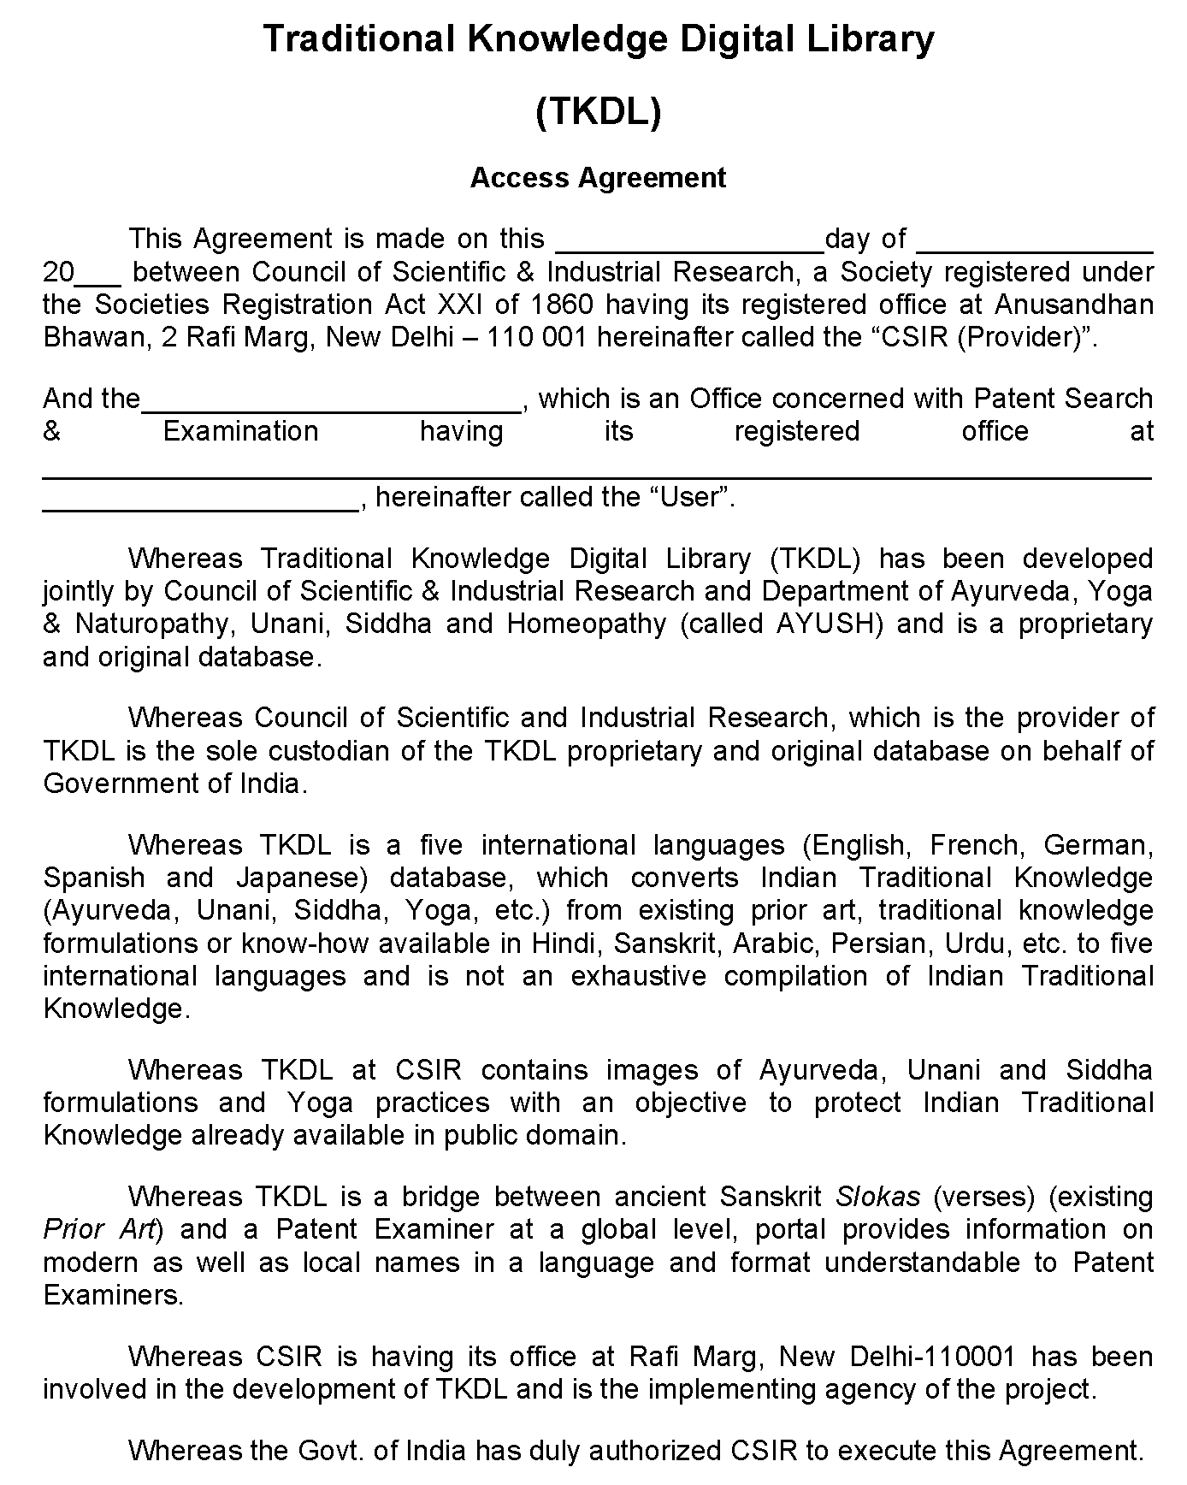

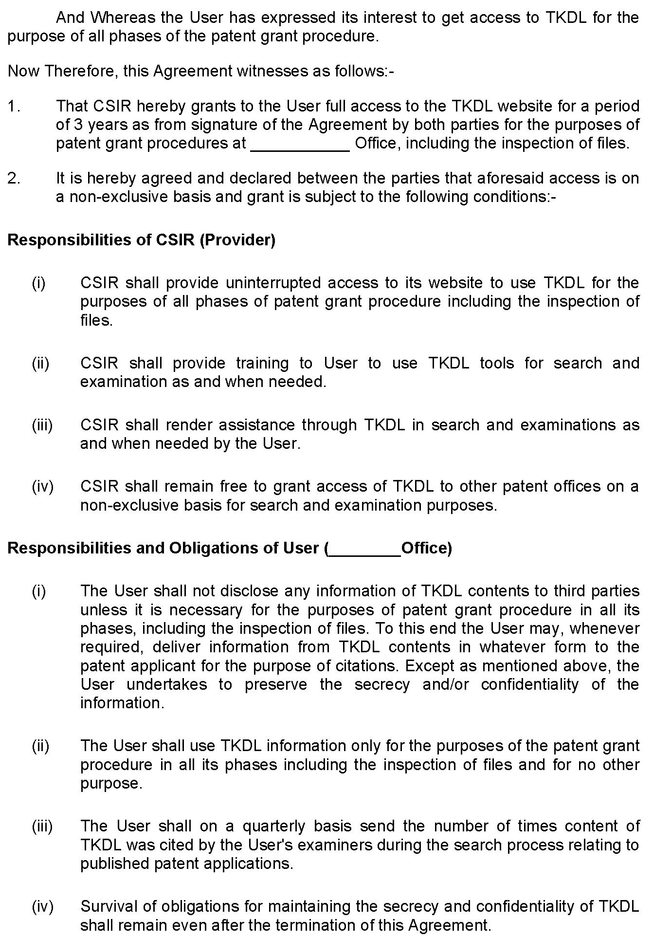

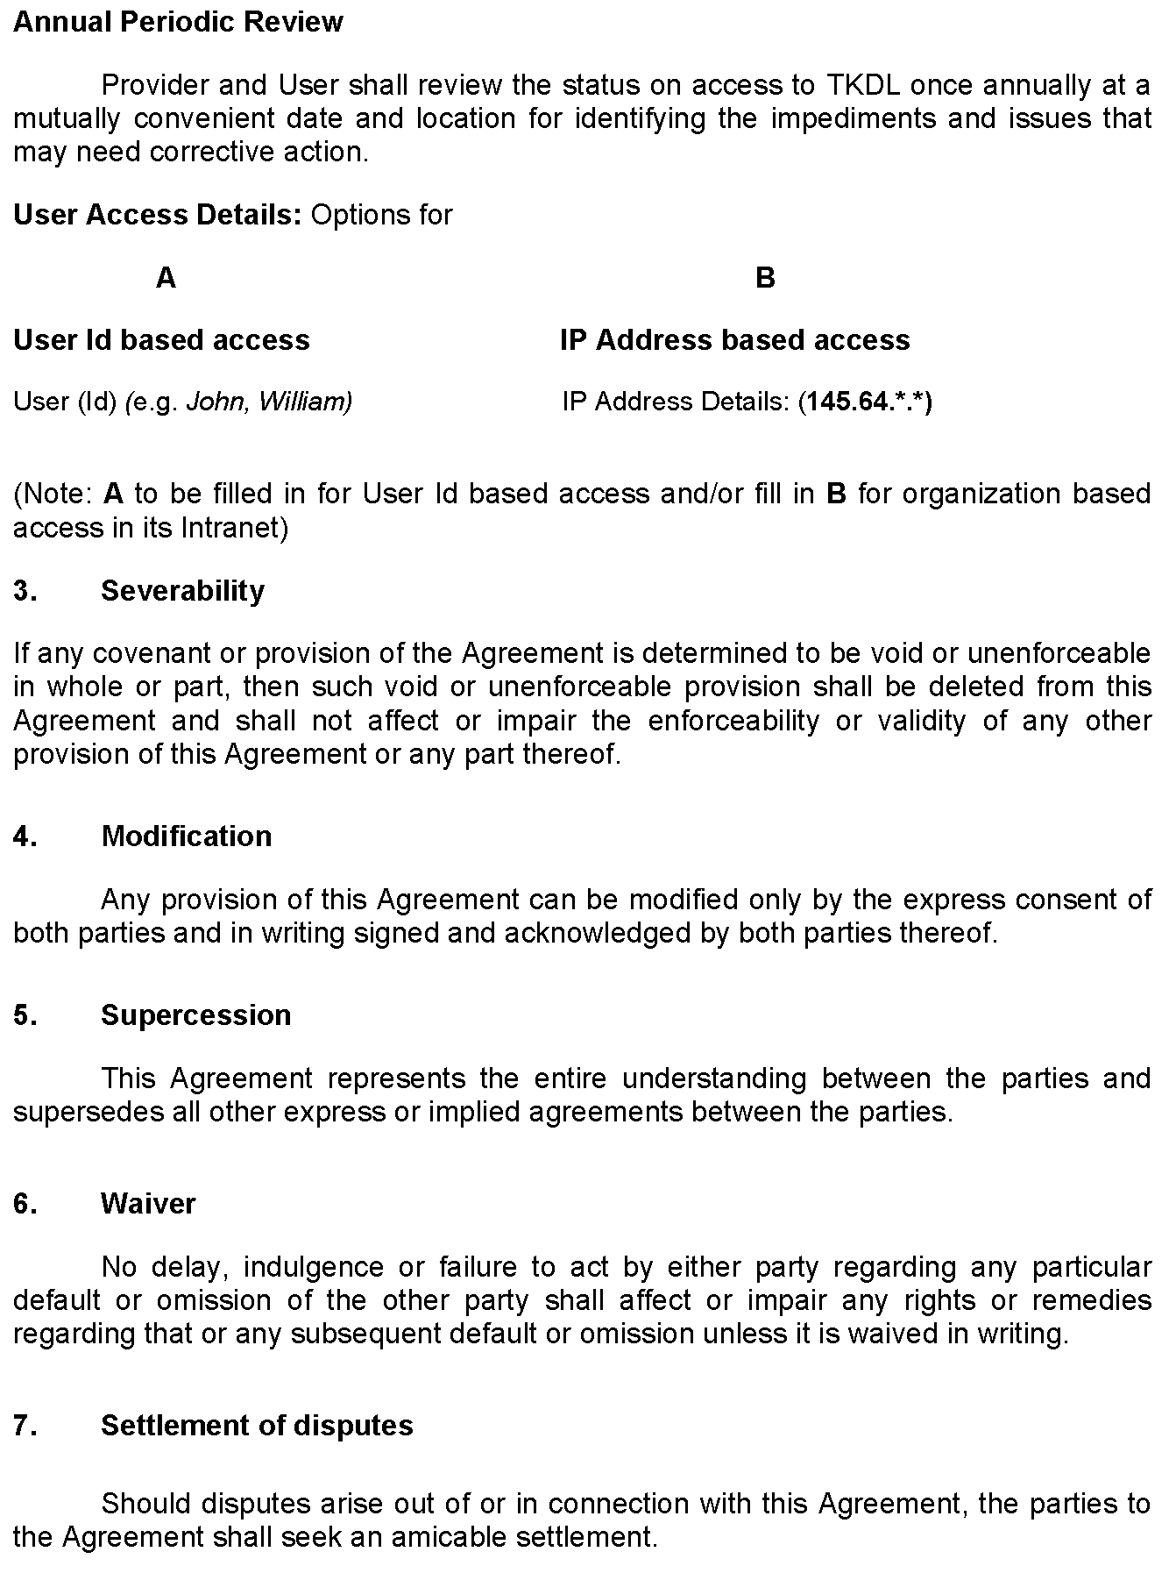

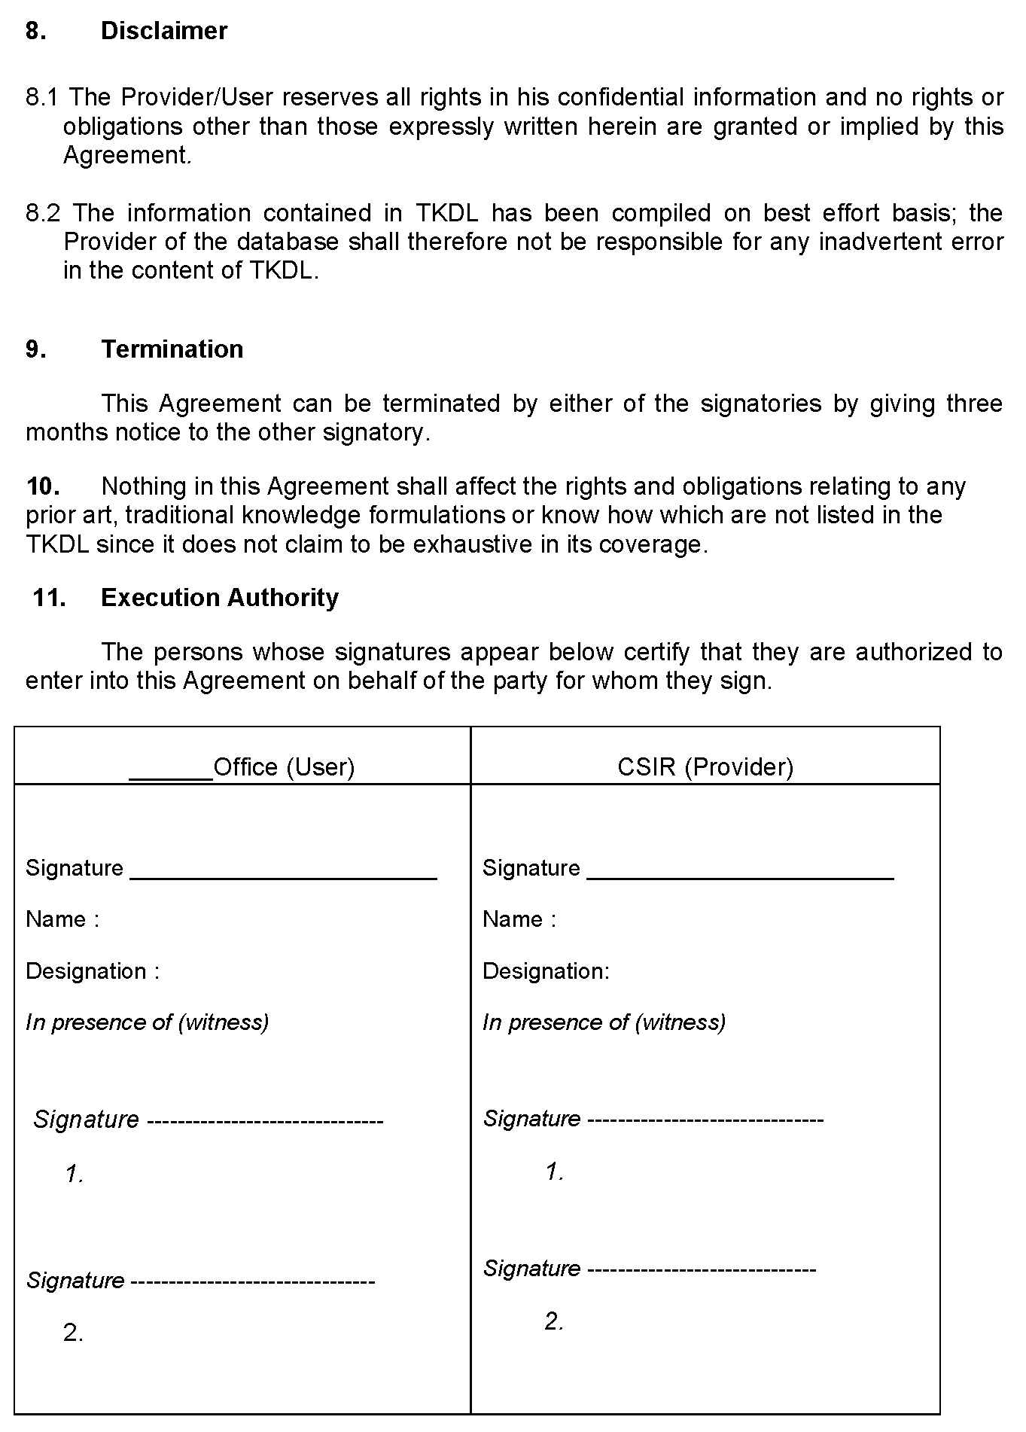

[End of Annex II and of document]

http://www.wipo.int/edocs/mdocs/tk/en/wipo_grtkf_ic_2/wipo_grtkf_ic_2_6.doc
https://www.cbd.int/doc/world/in/in-nr-04-p2-en.pdf
http://www.tkdl.res.in/TKDL/Conference/pdf_files/Report_of_Conference.pdf
http://www.epo.org/news-issues/press/releases.html
http://www.epo.org/news-issues/press/releases.html
http://www.uspto.gov/news/pr/2009/09-30.jsp
http://www.wipo.int/edocs/mdocs/mdocs/en/cdip_8/cdip_8_inf_3.doc

