
E
PCT/mia/18/6
OriGINAL: English only
DATE: March 4, 2011
Meeting of International Authorities under the Patent Cooperation Treaty (PCT) Working Group
Eighteenth Session
March 15 to 17, 2011, Moscow
Quality Feedback System
Document prepared by the International Bureau

Summary
It is recommended that quality feedback for International Authorities from designated Offices should be provided by two main methods:
examiners from designated Offices should be able to use an extension to the third party observation system to make specific comments on an individual case when they feel it appropriate (the main subject of this document); and
all designated Offices conducting searches in the national phase should be encouraged to routinely make their national search reports available through the Patentscope® system so that International Authorities can analyze the additional fields of search and cited documents in any case that they wish to assist their own quality assessment procedures (in addition to the benefits which this will bring to other designated Offices and third parties).
Towards the same goals, International Authorities may wish to consider ways of allowing examiners in different Offices dealing with similar subject matter to contact one another to discuss appropriate databases and search techniques together proactively, independent of specific international applications.

Quality Feedback System
At its seventeenth session, the Meeting agreed that a system for providing quality feedback from designated Offices to International Authorities should be developed together with a system for providing third party observations (see documents PCT/MIA/17/3 and paragraphs 30 to 35 of document PCT/MIA/17/12). It was intended that the proposals for quality feedback should be considered by the quality subgroup, but delays in preparing the proposals for the third party observation system have prevented this.
The International Bureau’s proposals for a third party observations system are set out in document PCT/MIA/18/5. This type of arrangement would need the following extensions to make it useful for examiner feedback:
an appropriate authentication system which can distinguish examiners in national Offices from third parties;
additional fields for data entry available only to such examiners;
the information in the additional fields being made available only to the quality department of the relevant International Authority.

Authentication
The third party observations system proposed in document PCT/MIA/18/5 will make use of a general WIPO identity management system which will permit accounts to be set up for individual users which can be recognized as being examiners in an International Authority. However, maintaining these accounts reliably for all examiners will probably not be practical for any but the smallest of national Offices. Consequently, it is proposed that an alternative login page should be provided which authenticates an Office as a whole, probably using a high level digital certificate installed in the gateway which establishes the connection to WIPO’s servers. For Offices authenticating in this way, the individual examiners would not need to log in themselves, but would simply be requested to enter their names (which might also be possible to automate, depending on the exact arrangements agreed). Offices would be requested to provide a link to this alternative authentication page from their intranet, though links from Patentscope® could also be considered.

Fields for Data Entry
It is envisaged that the screens for entering quality feedback would appear almost the same as the third party observation system, save for the addition of one or more additional tabs to provide further information and minor differences such as the possibility of noting that Article 34 amendments or national phase amendments had occurred.
Since it is envisaged that this system will only be used for a small proportion of applications, there does not appear to be any benefit in complicating the interface with many different fields to complete. As such, it is suggested that the additional fields could be simply as follows, all placed on a single tab:
Additional databases searched.
Additional classification terms searched (this would usually be IPC, but could also include other classification systems where another system, such as ECLA, is used by both the designated Office and the International Searching Authority).
Other feedback.
The form for entering this information might then appear as below.
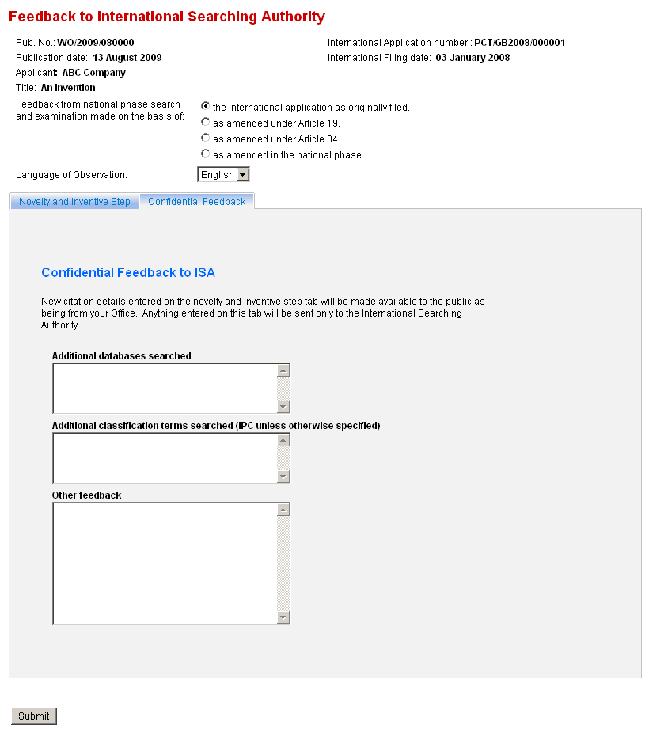
The checkbox proposed in the equivalent screen for a member of the public making third party observations, allowing for the sender’s name to be suppressed, is not included. Instead, any new citation information which was made available to the public would be shown as coming from the relevant national Office, rather than from the specific examiner.

Making the Information Available
The information entered would then be processed in two ways:
The contents of the novelty and inventive step tab would be made available to the public on Patentscope® together with any third party observations, but marked as being submissions by a national Office to distinguish them from normal third party observations.
The contents of both tabs would be compiled into a document which would not be made public, but which would be automatically sent to the International Searching Authority for its consideration. Preferably, this would be done by automatically placing the document as a “feedback” document type into PCT-EDI for retrieval by the International Searching Authority. Alternatively, it might be e-mailed to the quality department of the relevant International Searching Authority if the Authority wished to provide an address specifically for that purpose.

Availability of National Phase Search and Examination Reports
As noted in paragraph 7, above, it seems likely that national phase examiners would only take the time to use this system in a small proportion of cases, which are likely to be ones where a major problem was found with the international search report. While this information is valuable, it will not assist greatly in an overall assessment of the degree to which international search reports are found acceptable and usable by designated Offices. Consequently, this proposal needs to be seen in the context of providing one type of feedback amongst others which can provide different information. National Offices are separately being encouraged to make their national phase search and examination reports publicly available. This should be done in a manner which allows International Searching Authorities to use them to assess what further citations have been found in the national phase and whether they could and should have been cited in the international phase.

Discussion Between Examiners
It is also observed that feedback given through the proposed system will tend to give feedback on cases where the international search was defective, several years after the international search was conducted. International Authorities may also wish to seek ways of allowing examiners in different Offices dealing with similar subject matter to get to know one another and discuss databases and particular challenges relevant to their subject matter in a more pro-active manner.
The Meeting is invited to comment on the proposed quality feedback system set out in paragraphs to and on the issues raised in paragraphs and .

[End of document]

