WIPO |  | E  PCT/MIA/16/4  ORIGINAL: English only  DATE: March 5, 2009
WORLD INTELLECTUAL PROPERTY ORGANIZATION
GENEVA
INTERNATIONAL PATENT COOPERATION UNION
(PCT UNION)
MEETING OF INTERNATIONAL AUTHORITIES
UNDER THE PATENT COOPERATION TREATY (PCT)
Sixteenth Session
Seoul, March 16 to 18, 2009
Content and Format of International Search
and Preliminary Examination Reports
Document prepared by the International Bureau

Summary

International Authorities are invited to review both the content and format of international search and preliminary examination reports, having regard to the ease of reports in production and transmission of tagged character coded (XML) format, the ease of use of reports by applicants, Offices and the International Bureau, and the effectiveness of the reports for the purposes of assisting national processing.

Background

At its seventh to tenth sessions, the Meeting considered a number of proposals by the European Patent Office for a “linear” format of report, to replace the box-style which is currently used for international search reports, written opinions and international preliminary reports on patentability. This could simplify the production of reports by examiners, who currently (depending on the particular systems of International Authorities) may need to fill in a set of box-style forms and make reference to separate continuation sheets for much of the substantive content. It might also make the reports more easily read by applicants, agents, designated Offices and third parties. Annex I reproduces the example international search report which was shown in Annex I of document PCT/MIA/10/7.

In document PCT/MIA/16/3, the Meeting is asked to consider measures which might be taken to make international preliminary examination more useful. Among the issues to be considered are whether the standards against which international applications are tested are useful for assisting the determination of whether national standards are met, and the extent to which it is useful for international reports to cover issues other than novelty, inventive step and industrial applicability. It would be useful to consider the substance and the presentation of reports in parallel in order to ensure that any developments are of maximum use to applicants, third parties and designated and elected Offices.

The International Bureau is particularly keen to begin receiving international search reports, written opinions and international preliminary reports on patentability in text-based electronic formats and especially in XML format since this is an area where, to a much greater extent than for the application body, there is an opportunity for quick and significant improvements in the quality, efficiency and scope of the services delivered by the International Bureau. However, the detail of how reports are rendered for viewing is essential for ensuring that potential benefits can actually be realized and that the reports are as valuable as possible to applicants, third parties and designated and elected Offices.

Main Considerations

The content and format of international search and preliminary examination reports need to meet the following requirements:

the information provided must be useful to applicants, third parties and designated Offices – in particular, comments made in accordance with the PCT should be as relevant as possible to the questions which must be addressed in order to determine whether an invention is patentable in any particular Contracting State;

the information must be presented in a sufficiently standardized format that users of the system who read many reports (notably, but not limited to examiners in designated Offices, patent attorneys and frequent applicants) are able to easily understand the reports and find different types of information, no matter which International Authority has established the report and noting that many users will be reading the document (whether the original or a translation into English) in a language which is not their native language;

there needs to be sufficient flexibility in the format to ensure that a wide variety of complex interrelations between different issues can be explained effectively;

it must be possible for examiners to prepare the reports efficiently without the need for Authorities to maintain excessively complicated IT systems to support them;

the reports must be easily processed by the International Bureau, including extracting certain items of information from documents in any language of publication, separating the various sections (which may be published or made available in different ways and at different times), and efficiently translating the content of certain parts.

The main requirements referred to in paragraph , above, are considered in document PCT/MIA/16/3, but should always be kept in mind when addressing the remaining requirements.

“Box-Style” vs “Linear” output

As noted in paragraph , above, the European Patent Office (EPO) has for some years advocated moving to a “linear” output of report instead of the traditional “box” format. Examples of each type are shown in the Annexes: in Annex I, an international search report in linear format and in Annex II an international preliminary report on patentability in box format. There is a particular need to consider this matter again in the near future because of an intention within the EPO to move to new IT systems with XML-based output.

Some of the advantages of a linear format include:

simplicity of production;

efficiency in use of space (particularly relevant when printing paper copies in an International Authority which performs large numbers of international searches and international preliminary examinations);

the ability to include as much information as required in any section without having to refer to continuation sheets; and

(depending on the particular implementation) flexibility, allowing material to be presented in different orders depending on what may be most effective for the particular case.

One aspect which is both an advantage and a disadvantage of a linear format is that it is easy to omit sections which do not appear to be of relevance. This saves space and makes it less difficult to find the important material which might otherwise be lost amongst pages of boxes, few of which are checked. On the other hand, it is essential to consider carefully whether any particular item should be omitted since the fact that a checkbox is not marked may in some circumstances itself be important information which requires a positive statement. In adopting any linear format, it will be necessary to make clear which pieces of information which are currently represented by checkboxes (or places for numbers, dates or similar structured information) must always be included, even if they are presenting “negative” information.

The main advantage of the box format is consistency: the same information can be found in the same place on any form, no matter what language it is prepared in. This permits experienced users to locate and (for the highly structured sections) understand, even when looking at a document which is in a foreign language, any particular piece of information very rapidly. In particular, it allows them to pick out certain pieces of information without needing to read the surrounding standard text – and there is a greater confidence that such text is genuinely “standard”, rather than having been manually adjusted to present a different meaning.

Processing Requirements of the International Bureau

Within the International Bureau, the consistency offered by the box format is used to maintain the efficiency of processing and translation (noting that at present no International Authorities send international search and preliminary examination reports in an electronic format which can be automatically processed):

Processing teams are able very quickly to locate the items of information which need to be input into the International Bureau’s systems, such as the date of mailing, any modified title, abstract or drawing figures, and IPC codes.

At present, the standard information on reports which require translation is quickly transferred to a blank English form by staff who do not necessarily read the language of the original form. This minimizes the amount of work which requires the active attention of translators. Any departure from the box format for the standard text (as distinct from the use of word processor documents as “continuation sheets” containing most of the free text information) would cause a major loss in efficiency of translation at the International Bureau, unless the structured information is made available in a form which can be processed easily and reliably by the International Bureau, or else the overall report is presented and transmitted in a form which is usable directly by computer-aided translation tools.

Consequently, the International Bureau would have a number of concerns about any move away from the box format by Authorities which send the reports to the International Bureau on paper, as image files or even as conventional word-processor files (though it would be useful to receive these for the purpose of assisting the translation of the free text parts of the reports). Any move away from the box format (other than, perhaps, for the part of the search report recording citations) would need to be carefully reviewed to ensure that it remained possible to process reports efficiently.

On the other hand, in the case where the reports are established in Annex F-compliant XML format, all of the structured information would be automatically available in largely language-independent form, so that translations of those parts would require only that the English (or, indeed, any other desired language) “style sheet” be used to generate the standard texts. In this case, while such style sheets could generate a box format report, the International Bureau agrees that a linear report would be significantly easier to develop and maintain, minimizing costs and increasing the speed with which developers could respond to changing needs, or customize the style sheets to provide output suitable for use in national phases.

Furthermore, while there is a need for as much consistency as possible in international reports to avoid confusion amongst regular users of the system, it is unlikely that there would be any significant difficulty as long as the styles could be limited to just one “box” format and one “linear” format, rather than there being a proliferation of different formats.

Consequently, subject to comments by designated and elected Offices and representatives of user groups as to their needs, the International Bureau would support the development of style sheets for XML international search and preliminary examination reports to deliver reports whose viewable versions are in a linear format along the general lines shown in Annex I. Subject to the possible exception in paragraph , below, the Administrative Instructions would probably continue to require the use of the standard box format, except that Authorities which provided their reports in XML would be permitted to generate the linear format output by the common international style sheet.

One of the essential requirements of any such style sheets would be that sections which require different processing start on new pages so that the different parts of the human-readable version can be separated efficiently. Notably, the international search report contains a part for publication and a part which is used for other internal processing. Furthermore, careful consideration would need to be given to which information must always be shown, even where it is equivalent to leaving a box on the conventional form empty. Finally, there should be careful consideration of how to present the standard text sections so as to clearly distinguish them from the structured information content and the free text sections so as to ensure that regular readers of reports are able to read them efficiently in a similar manner to the structured information of the box format.

The International Bureau would be willing to consider the use by Authorities of a linear format for at least some parts of reports which were delivered on paper or in non-XML electronic format, provided that these were closely consistent with the results of the XML style sheets and it had been shown that the results could be reliably processed automatically, including, where appropriate, ensuring that the output permitted accurate OCR and/or providing electronic copies in a text-based format. However, this should only be considered on the basis of careful consultations between the International Bureau and the relevant Authority before any work on such a change begins.

Content and Flexibility

As noted in paragraph , above, document PCT/MIA/16/3 considers the main issues concerning the content of international reports, such as whether comments on clarity and support should be included and whether special categories of citations such as oral disclosures and “secret prior art” should be reported in the same way as normal citations, rather than merely being listed as at present.

Nevertheless, the manner in which the content is presented can strongly affect how useful it is to applicants and Offices. One example of this is whether it is possible to explain defects in a logical order, for example, if matters of novelty can only be understood following an explanation of how the claim has been interpreted given a serious lack of clarity.

Furthermore, if international reports are to be truly useful, it should be possible for them to be used directly in the national phase: a designated or elected Office might either require applicants to respond to defects noted in the international preliminary reports on patentability before any national examination begins, or else a first national phase report might take the content of the international preliminary report on patentability as a basis, to be adjusted slightly according to the specific needs of the national law.

In either case, it would be beneficial to know of barriers to direct use of the international preliminary report on patentability which stem from the presentation of the reports. Furthermore, for the benefit of work-sharing in general, it would be beneficial to be able to develop at least the XML standards for search and examination reports (and possibly the paper reports) in such a way that national Offices might see it as desirable to move towards a common standard for reports which could then be more easily transferred between Offices, understood by examiners and used as a direct basis for assisting the creation of national reports in other Offices. For this, it would be useful to consider the types of information which need to be recorded in national reports, for which there is no space in the international report.

Proposed Way Forward

It is proposed that, following comments in the Meeting:

the International Bureau should seek comments from other Offices and users on the requirements of the presentation of reports;

the International Bureau should prepare any revisions which appear desirable to the paper international search reports, written opinions and international preliminary reports on patentability.

the International Bureau should work in cooperation with the European Patent Office and any other interested Offices to develop a stylesheet for XML search and examination reports which meet the requirements of all interested parties for international reports and which are easily extended to meet the requirements of any national Office, both for the PCT national phase and more generally.

The Meeting is invited to comment on the issues raised in this document and the proposed way forward.

[Annex I follows]
FOR FURTHER ACTION See Notification of Transmittal of ISR (Form PCT/ISA/220) as well as, where applicable, abstract information below

Applicant's or agent's file reference: AGGR/01/01

International application No: PCT/EP01/98989

International filing date: 01 April 2001 (01/04/2001)

(Earliest) priority date: 02 April 2000 (01.04.2000)

Applicant: Heath Robinson

This international search report has been prepared by this International Searching Authority (ISA) and is transmitted to the applicant according to Article 18. A copy is being transmitted to the International Bureau.

It consists of two parts: Part 1 contains comments on the international application. Part 2 contains the results of the search, the subject matter classification and the fields searched.

It is also accompanied by a copy of each prior art document cited in this report.

(1) Basis of the report

With regard to the language, the international search was carried out on the basis of a translation of the international application furnished to this Authority (Rule 23.1(b)).

With regard to any nucleotide and/or amino acid sequence disclosed in the international application, and necessary to the claimed invention, the international search was carried out on the basis of:

A sequence listing and table(s) related to the sequence listing;
in written format and in computer readable form;
contained in the international application as filed;
furnished subsequently to this Authority for the purposes of search.

In addition, as more than one version or copy of a sequence listing and/or table relating thereto has been filed or furnished, the required statements that the information in the subsequent or additional copies is identical to that in the application as filed or does not go beyond the application as filed, as appropriate, were furnished.

(2) Certain claims were found unsearchable

This report has not been established in respect of certain claims under Article 17(2)(a) for the following reasons:

Claim(s) No(s): 1,2

because they relate to subject matter not required to be searched by this Authority, namely:

Claims 1,2 directed to an instruction manual with particular wording are considered to be mere presentations of information and is subject matter the ISA is not required to search under Article 17(2)(a)(i) and Rule 39.1(v).

Claim(s) No(s): 3,4

because they relate to parts of the international application that do not comply with the prescribed requirements to such an extent that no meaningful international search can be carried out, specifically:

Claims 3,4 seek protection for a “whatsit” which has no generally-recognised meaning and is undefined in the application as filed.

(3) Unity of invention is lacking

This International Searching Authority found multiple inventions in this international application, as follows:

- Claims 1 - 18 directed to a sealing body and an instruction manual for its use

- Claim 19 - 28 directed to an apparatus, but not limited to an apparatus comprising the sealing body of claims 3 - 18

No required additional search fees were timely paid by the applicant. Consequently, this International Search Report is restricted to the invention first mentioned in the claims; it is covered by claims Nos. 3-18

(4) Title

The text is approved as submitted by the applicant.

(5) Abstract

The text is approved as submitted by the applicant.

(6) Drawings

The figure of the drawings to be published with the abstract is Figure No: 1 as suggested by the applicant.

** End of Part 1 of the ISR **
(21) International application No.: PCT/EP01/98989

(51) CLASSIFICATION OF SUBJECT MATTER
IPC⁷: G06K11/14

(58) FIELDS SEARCHED
Minimum documentation searched:
IPC⁷: G06K

Documentation searched other than minimum documentation to the extent that such documents are included in the fields searched:
Not applicable

Electronic database consulted during the international search:
EPO-Internal, PAJ, WPI Data

DOCUMENTS CONSIDERED TO BE RELEVANT
(Citation of document, with indication, where appropriate, of the relevant passage(*),
followed by category and claim(s) No(s))

(1) US 5 332 238 A (BORUCKI G) 26 July 1994; cited in the application
*column 2, line 1-27; figures 4,5*
Category: Y Claims: 1,6,7,9
*column 7, line 32-55*
Category: X Claims: 18

(2) US 5 784 054 A (KENT JOEL C ET AL) 21 July 1998; cited in the application
*column 6, line 61-65; figures 1,2,4,8, column 7, line 35-65*
Category: X Claims: 1,6,7,14,15,18

(3) US 4 816 811 A (BOGATIN ERIC L ET AL) 28 March 1989
*column 4, line 57,58; figures 2-4*
Category: A Claims: 1,9

(4) EP 0 740 264 A (GORE & ASS) 30 October 1996
*column 8, line 7-10; figure 1; column 9, line 18-column 13, line 8*
Category: Y Claims: 1,6,7,9
Category. A Claims: 2, 18

(5) WO 98 52184 A (ELO TOUCHSYSTEMS INC) 19 November 1998
*page 21, line 9-1; figures 5,6*
Category: A Claims: 1, 18

(6) US 5 852 433 A (TODA KOHJI) 22 December 1998
*column 6, line 20-28; figure 1*
Category: A Claims: 1, 18

Special categories of cited documents:

A: document defining the general state of the art which is not considered to be of particular relevance.

X: The claimed invention cannot be considered novel or cannot be considered to involve an inventive step when the document is taken alone.

Y: The claimed invention cannot be considered to involve an inventive step when the document is combined with one or more other such documents, such combination being obvious to a person skilled in the art.

Patent family information

* US 4 816 811 A:
EP 0 196 186 A,B 01.10.1986
JP 61223932 A 04.10.1986
US 4 816 811 A 28.03.1989
CA 1 270 309 A 12.06.1990
DE 3 682 927 D 30.01.1992
KR 9 309 671 B 08.10.1993

* EP 0 740 264 A:
JP 9044291 A 14.02.1997

* WO 98 52184 A:
AU 7 151 098 A 08.12.1998
JP 11065765 A 09.03.1999
EP 1 019 897 A 19.07.2000
BR 9 809 121 A 01.08.2000
CN 1 269 043 T 04.10.2000
AU 732877 B 03.05.2001
US 6 236 391 B 22.05.2001

ISA/Examiner: European Patent Office
SPIGARELLI, Alfred
PB 5818, Patentlaan 2
NL 2280 HV Rijswijk
Tel. +31 - 70 340 2040
Fax. +31 - 70 340 3016

Search completed: 24 July 2001
ISR mailed: 28 July 2001

** End of the ISR **

[Annex II follows]
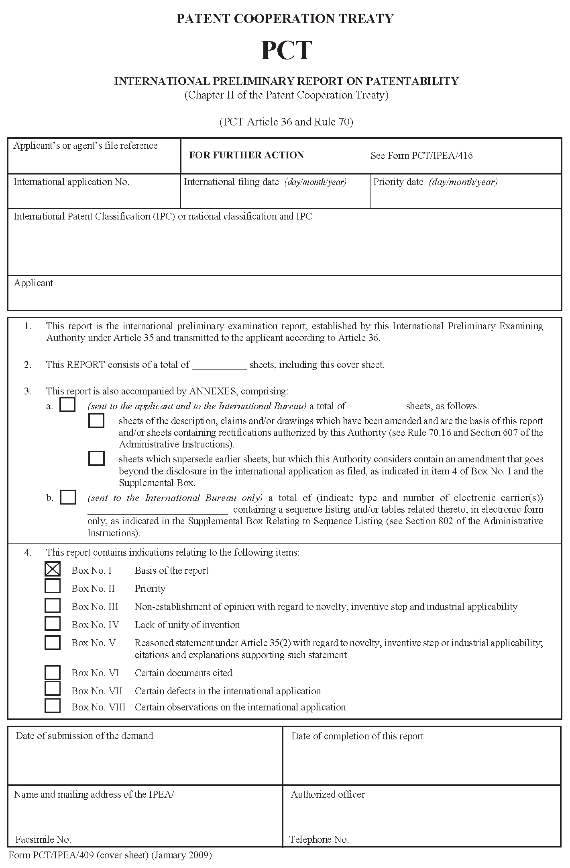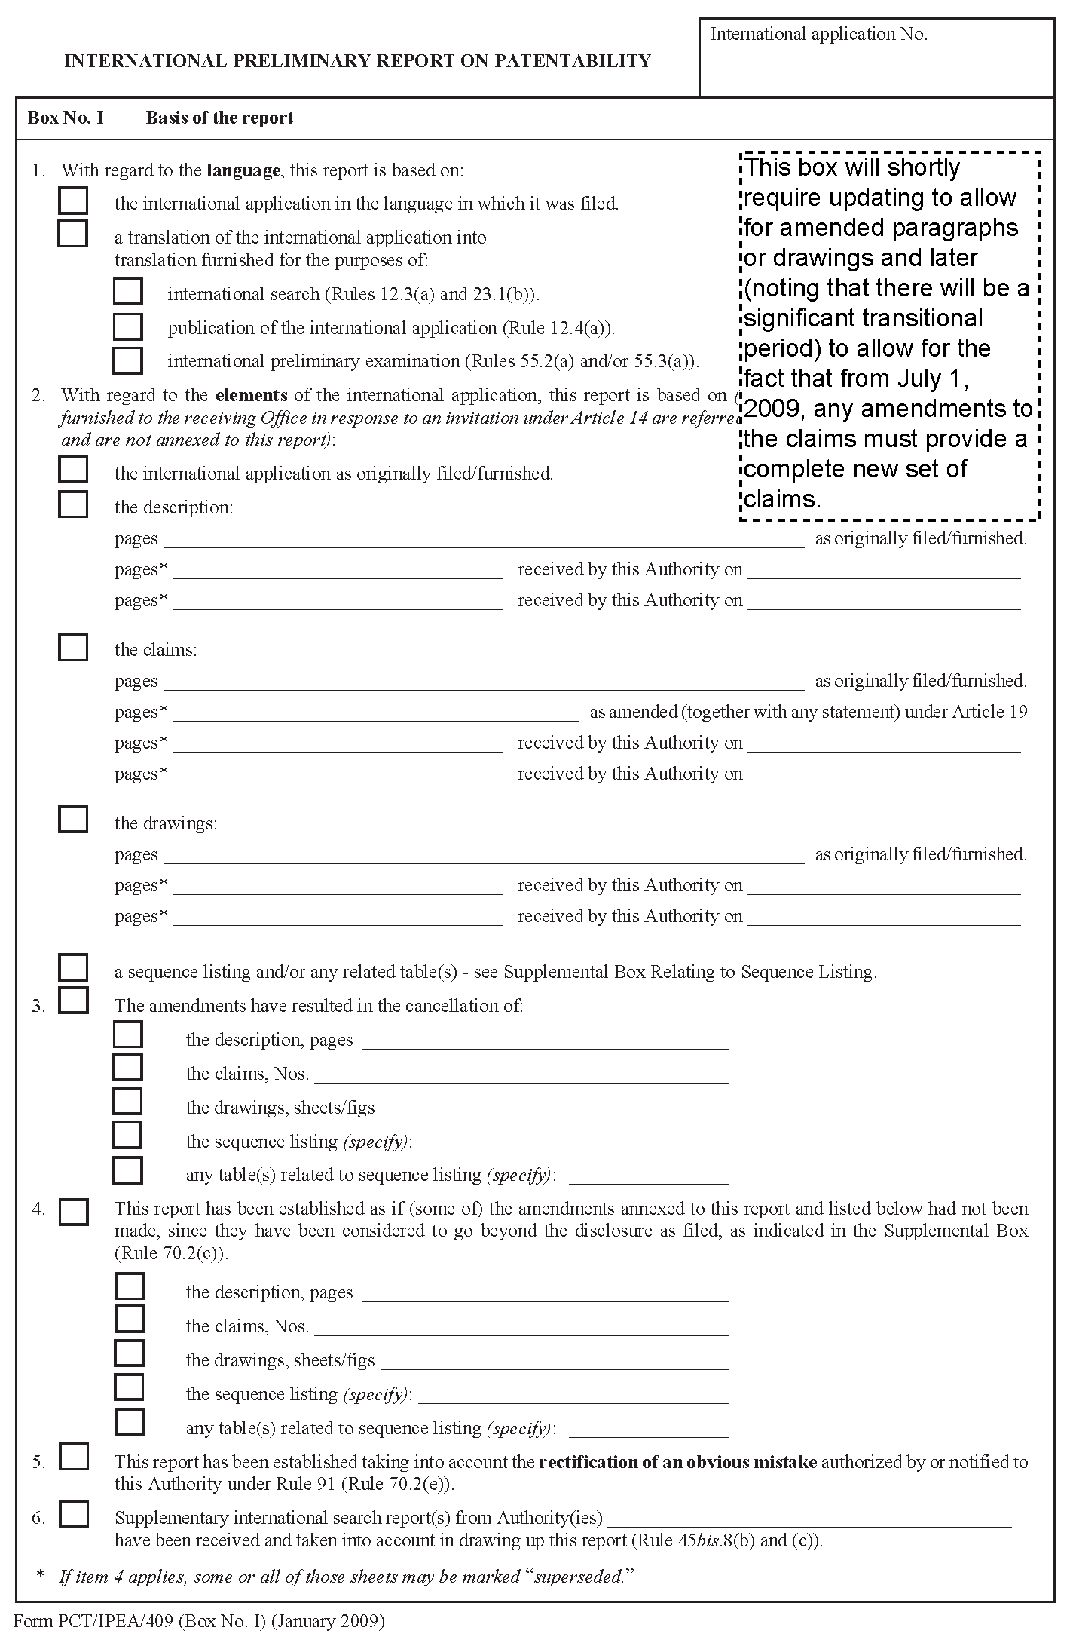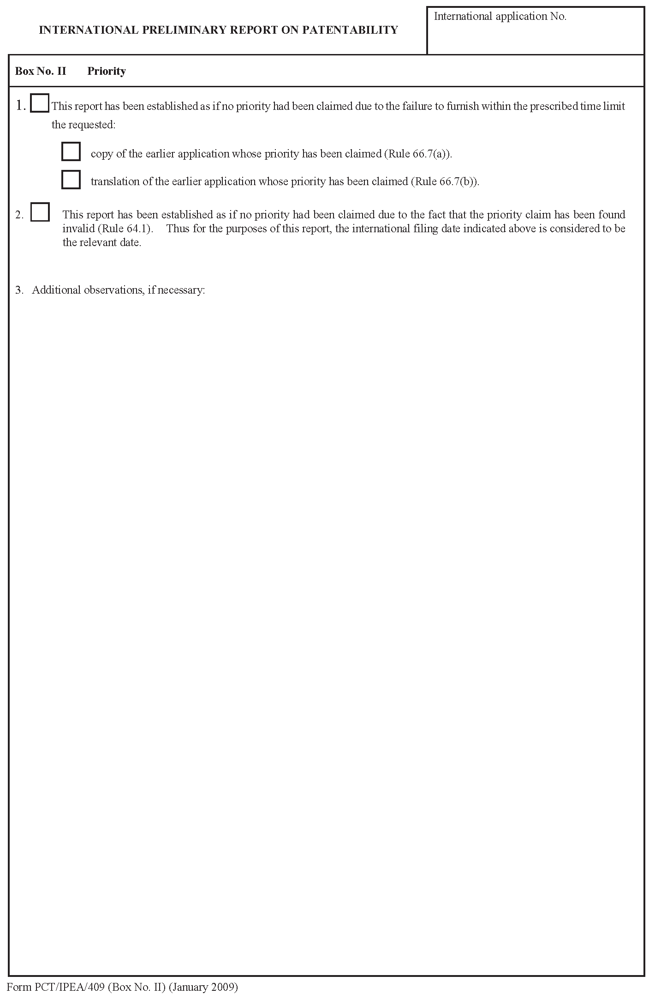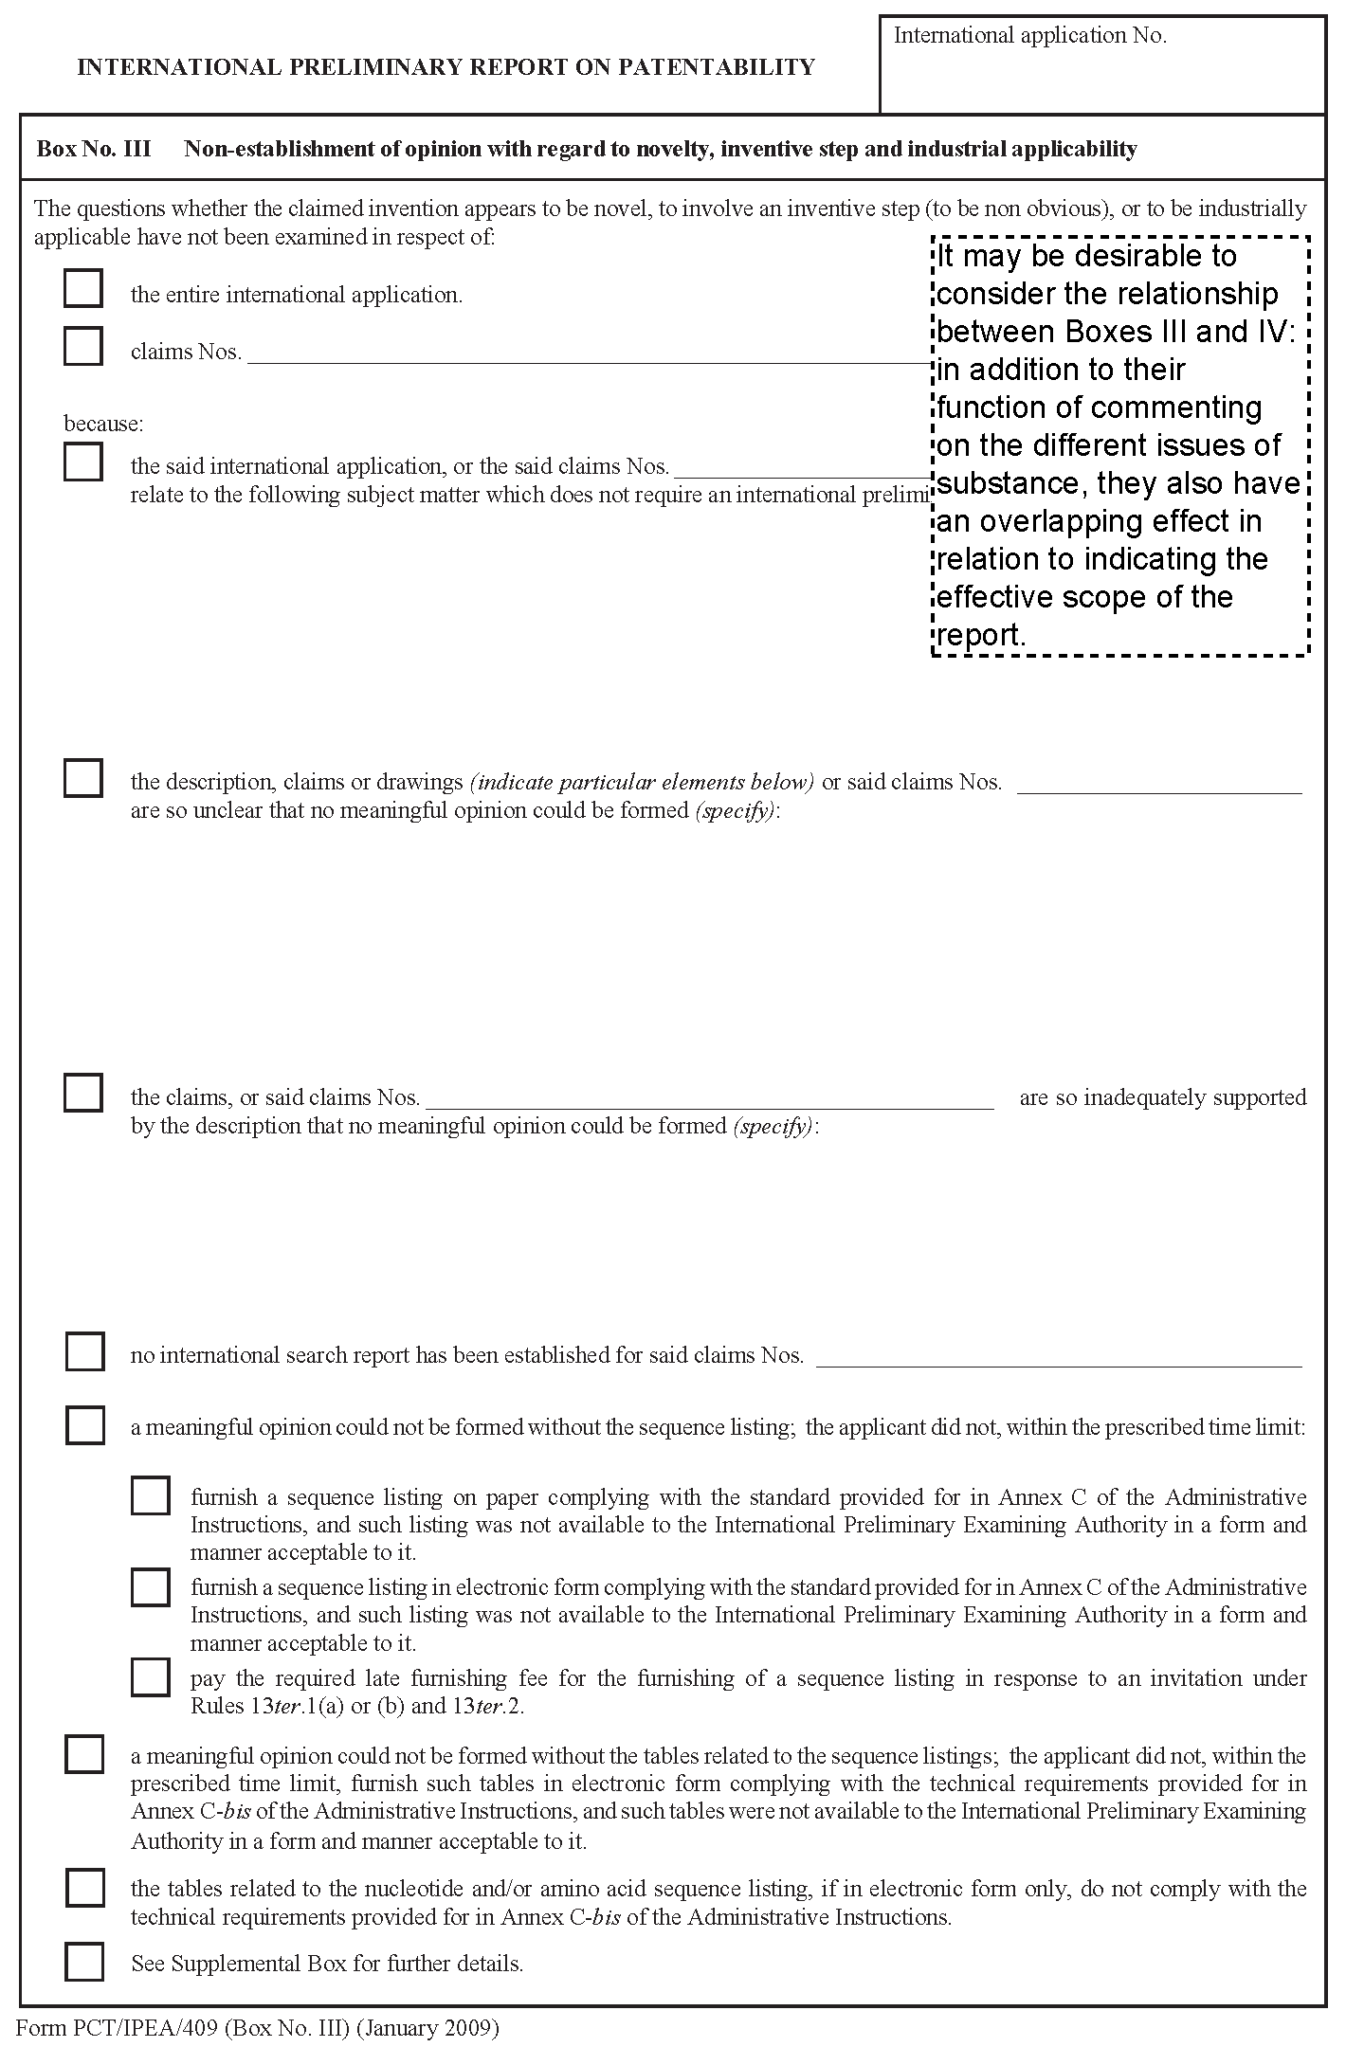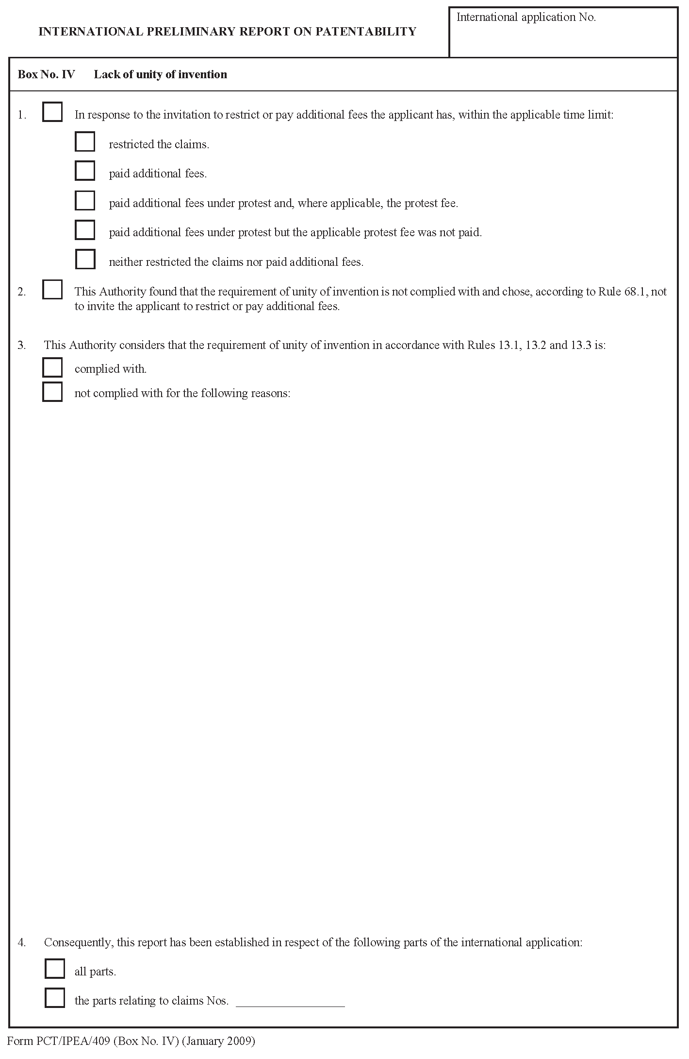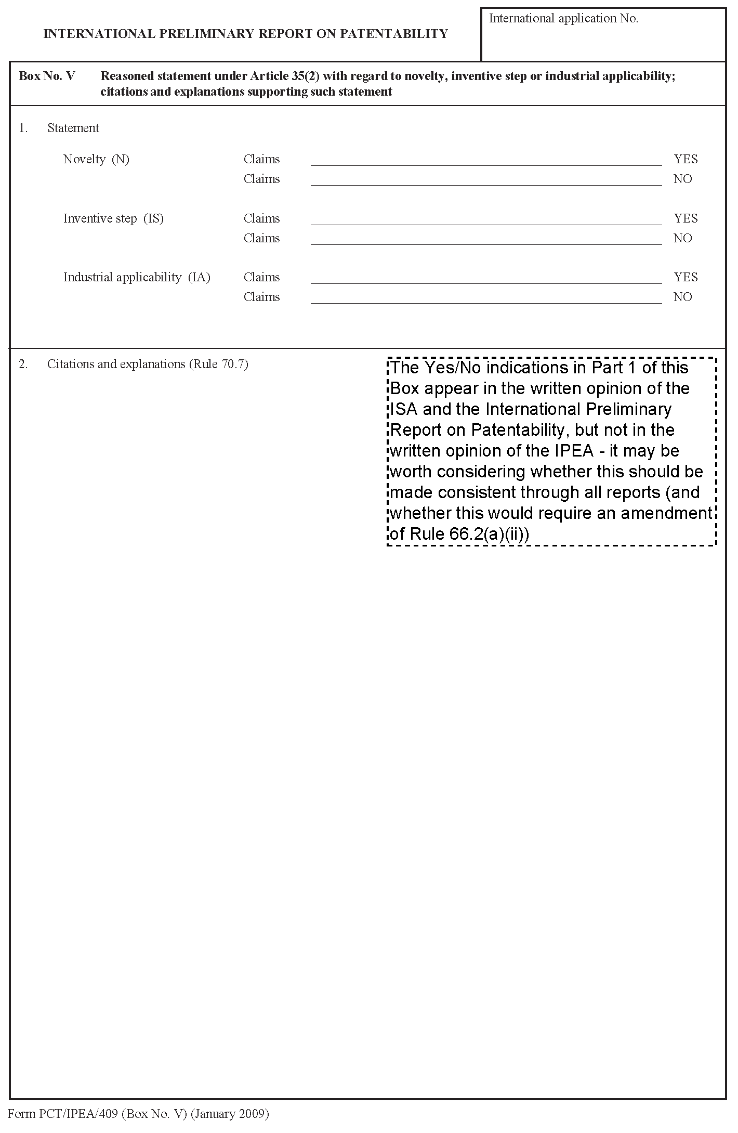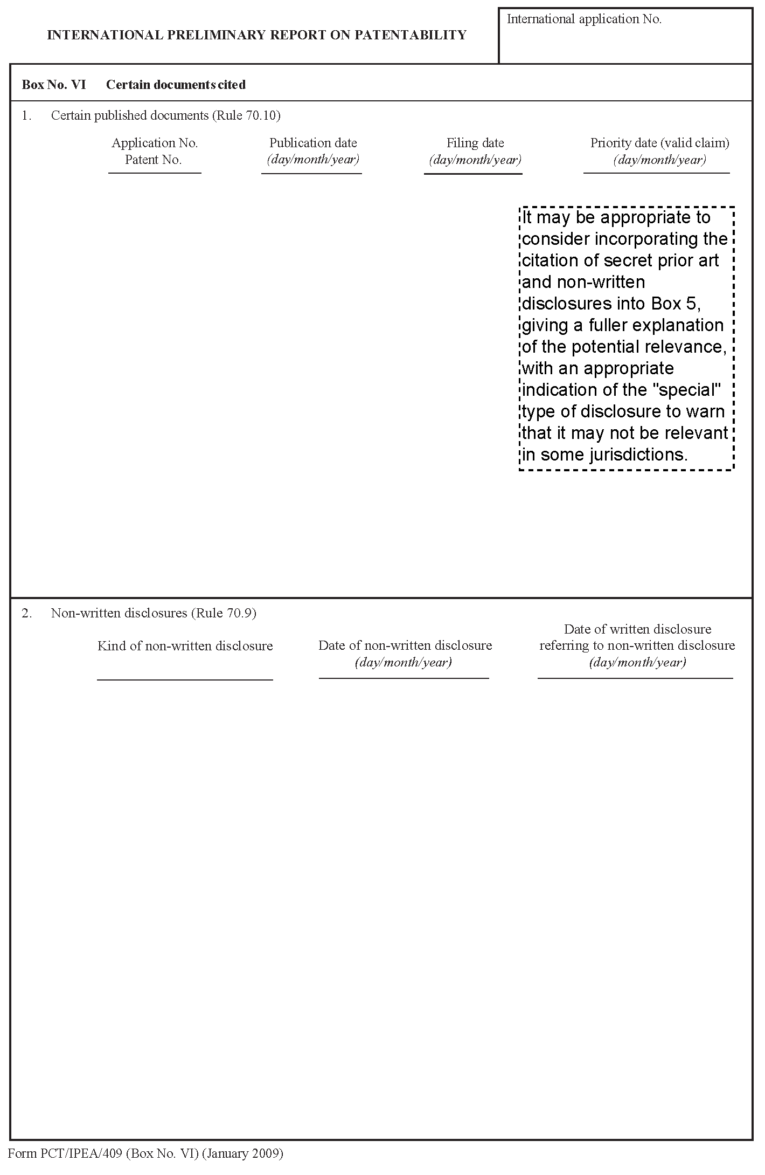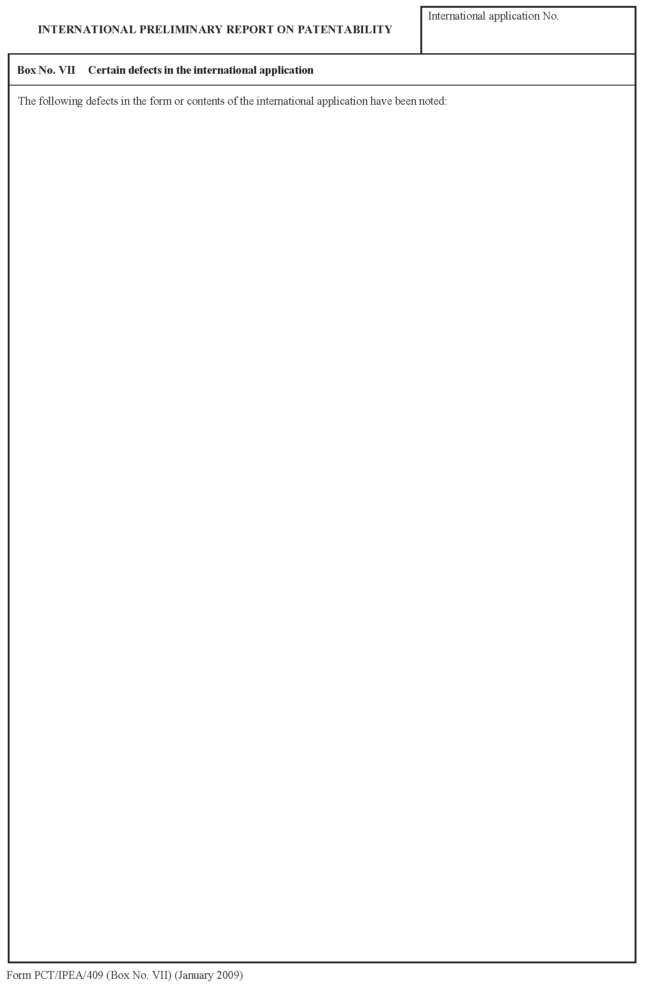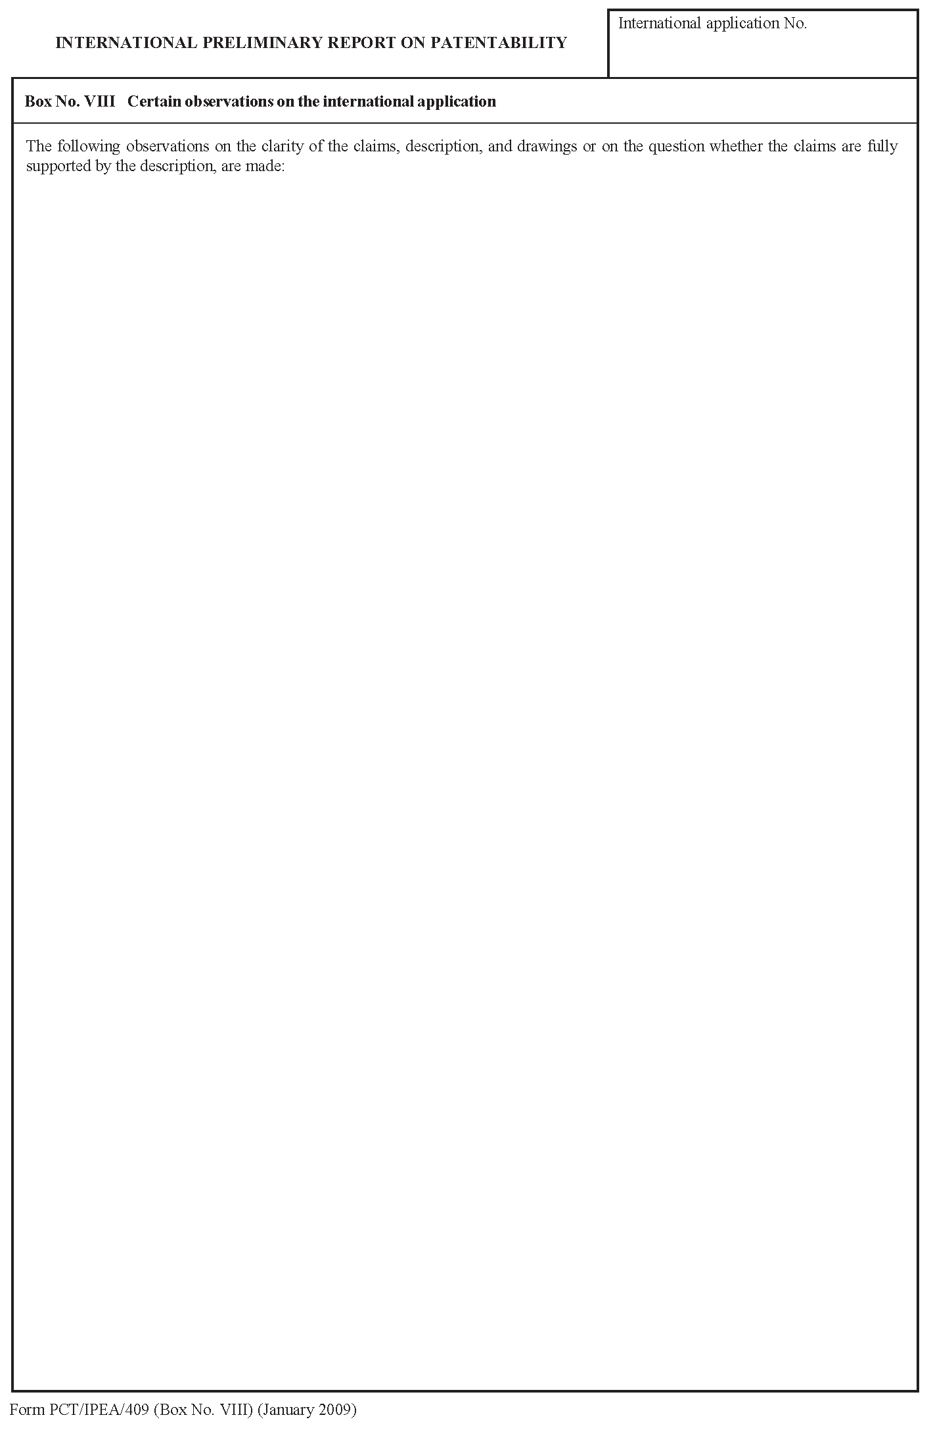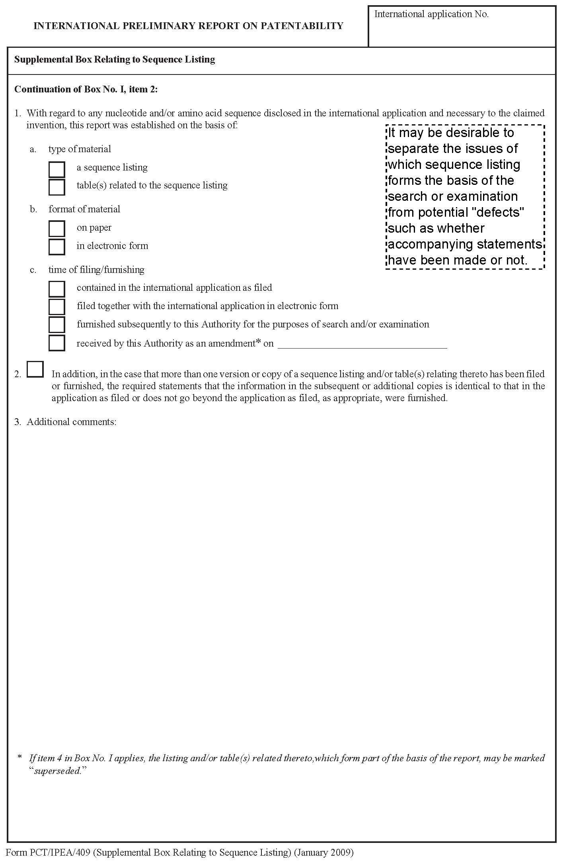
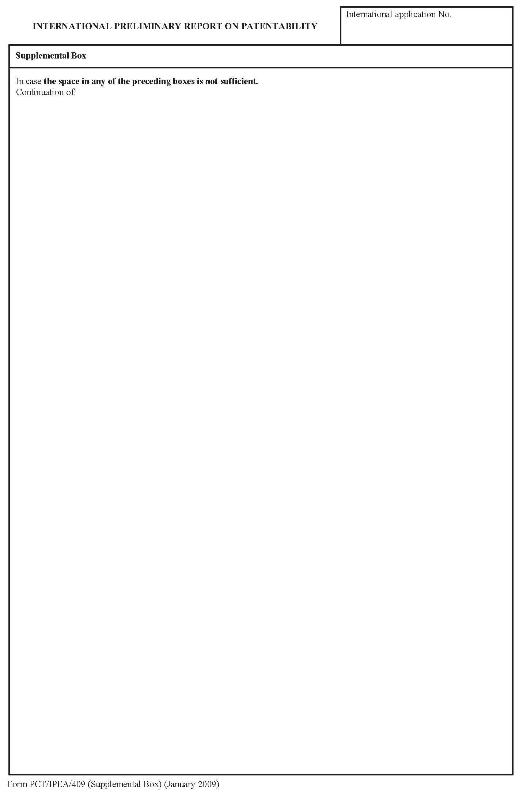
[End of Annex II and of document]

