WIPO |  | E  PCT/MIA/15/8  ORIGINAL: English only  DATE: April 1, 2008
WORLD INTELLECTUAL PROPERTY ORGANIZATION
GENEVA
INTERNATIONAL PATENT COOPERATION UNION
(PCT UNION)
MEETING OF INTERNATIONAL AUTHORITIES
UNDER THE PATENT COOPERATION TREATY (PCT)
Fifteenth Session
Vienna, April 7 to 9, 2008
Proposal for Modification of PCT Administrative Instructions
proposed by the European Patent Office, the Japan Patent Office and the United States Patent and Trademark Office
Document prepared by the Japan Patent Office

Summary

1. In November 2007, the European Patent Office, the Japan Patent Office and the United States Patent and Trademark Office (the Trilateral Offices) agreed on finalization of a Common Application Format (CAF) and publicized the agreement on the Trilateral website. Annex I to this document contains the document related to the CAF agreement.

2. When applications drafted according to the CAF agreement are also acceptable as international applications under the PCT, it is expected that this will bring more significant benefits to applicants than those brought by the CAF agreement among the Trilateral Offices.

3. Under the current Regulations and Administrative Instructions under the PCT, it is considered that an application in accordance with the CAF be accepted as a international application under the PCT by any of ROs. However, the current Administrative Instructions recommend other headings than those in the CAF. It is preferable to modify the Administrative Instructions, by adding an option of the headings in the CAF.

4. A draft of proposed modification of PCT Administrative Instructions is presented in Annex II to this document. The Meeting is invited to comment on the proposal.

BaCKGROUND

5. In November 2005, the Trilateral Offices established a Technical Working Group on the Formal Aspects of Patent Applications in response to a request made by the Industry Trilateral that the Trilateral Offices begin working on the standardization of formal aspects of patent applications. The Trilateral Offices have come to an understanding with respect to a common format for patent applications in response to the request from users, after having intensive discussions at six Working Group meetings from 2006 to 2007. As a result, the Trilateral Office agreed on finalization of a Common Application Format (CAF) and publicized the agreement on the Trilateral website in November 2007.

6. Annex I to this document contains the document related to the CAF agreement. The document consists of the paper titled “Basic Principles of the Common Application Format” and two Annexes thereto, that is, Annex I titled “Common Requirements for All Types of Documents” and Annex II titled “Comparative Table of Examples for Each Type of the Applications.”

summary of the agreed-upon Common Application Format

7. As described in the document noted above, an application which complies with the CAF shall be accepted without any further amendment by any of the Trilateral Offices as a national/regional application as far as the agreed-upon formal requirements are concerned. The details of the requirements are described in Annex I of the agreement.

8. Each of the Trilateral Offices may provide requirements which are more favorable for applicants than the requirements provided for by the CAF.

9. The CAF allows an applicant wishing to file an application in each office need only prepare a single application in the CAF, and it will be accepted by each office without the need for amendments (except for amendments made in response to substantive objections/rejections that may be required by national/regional law after filing). The need to prepare only a single application will result in a considerable cost savings to applicants.

PROPOSAL FOR MODIFICATION OF PCT ADMINISTRATIVE INSTRUCTIONS

10. When applications drafted according to the CAF agreement are also acceptable as international applications under the PCT, it is expected that this will bring more significant benefits to applicants than those brought by the CAF agreement among the Trilateral Offices.

11. Actually, under the current Regulations and Administrative Instructions under the PCT, it is considered that an application in accordance with the CAF be accepted as a international application under the PCT by any of ROs. However, the current Administrative Instructions recommend other headings than those in the CAF, for example, not “Summary of Invention,” but “Disclosure of Invention.” It is preferable to modify the Administrative Instructions, by adding an option of the headings in the CAF.

12. The proposed text is contained in Annex II to this document. This proposal is co-sponsored by the European Patent Office, the Japan Patent Office and the United States Patent and Trademark Office.

13. First, the proposed marked-up text of Section 204 that provides for “Headings of the Parts of the Description” is presented in Annex II. Modifications on this proposal shown as underlined blue italic portions, that is, addition of the headings “Summary of Invention,” “Description of Embodiments” and “Title of Invention” is related to the provisions of the item “e. Section Titles and Order” in Annex I of the CAF agreement.

14. Meanwhile, as for Section 204, “Draft Revision 3 of Annexes to Circular C.PCT 1074” has been presented by the International Bureau. Consequently, the marked-up text of Section 204 is included changes due to this Circular (shown as underlined green and strikethrough red). However, this indication is just for explanatory purpose. The heading “Sequence Listing Tables” is not included in the agreed-upon CAF and not directly related to this proposal.

15. In addition, addition of Section 204bis regarding “Numbering of Claims” is proposed. This is related to the provision of the CAF agreement, Annex I, 1, “l. Claims,” as follows.

“Each of the claims shall be preceded by a sign that shows that it is a claim (“Claim”), space, and with an Arabic numeral that designates the claim. (e.g., Claim 1, Claim 2)”

entry into force and transitional arrangements

16. This amendment of the Administrative Instructions shall enter into force on January 1, 2009, and shall apply to international applications whose international filing date is on or after that date.

In the Future

17. In the future, a circular regarding this proposal will be sent to the PCT Contracting States. In addition, This introduction and proposal regarding the CAF will also be presented at the first session of the Patent Cooperation Treaty Working Group (PCT/WG/1) to be held on May 26 to 30, 2008.

18. The Meeting is invited to comment on the proposal contained in Annex II to this document.

[Annexes follow]

ANNEX I

THE AGREEMENT ON THE COMMON APPLICATION FORMAT

MADE BY the Trilateral Offices DATED ON noVEMBER 30, 2007

TABLE OF CONTENTS

Basic Principles of the Common Application Format

Annex I: Common Requirements for All Types of Documents

Annex II: Comparative Table of Examples for Each Type of the Applications
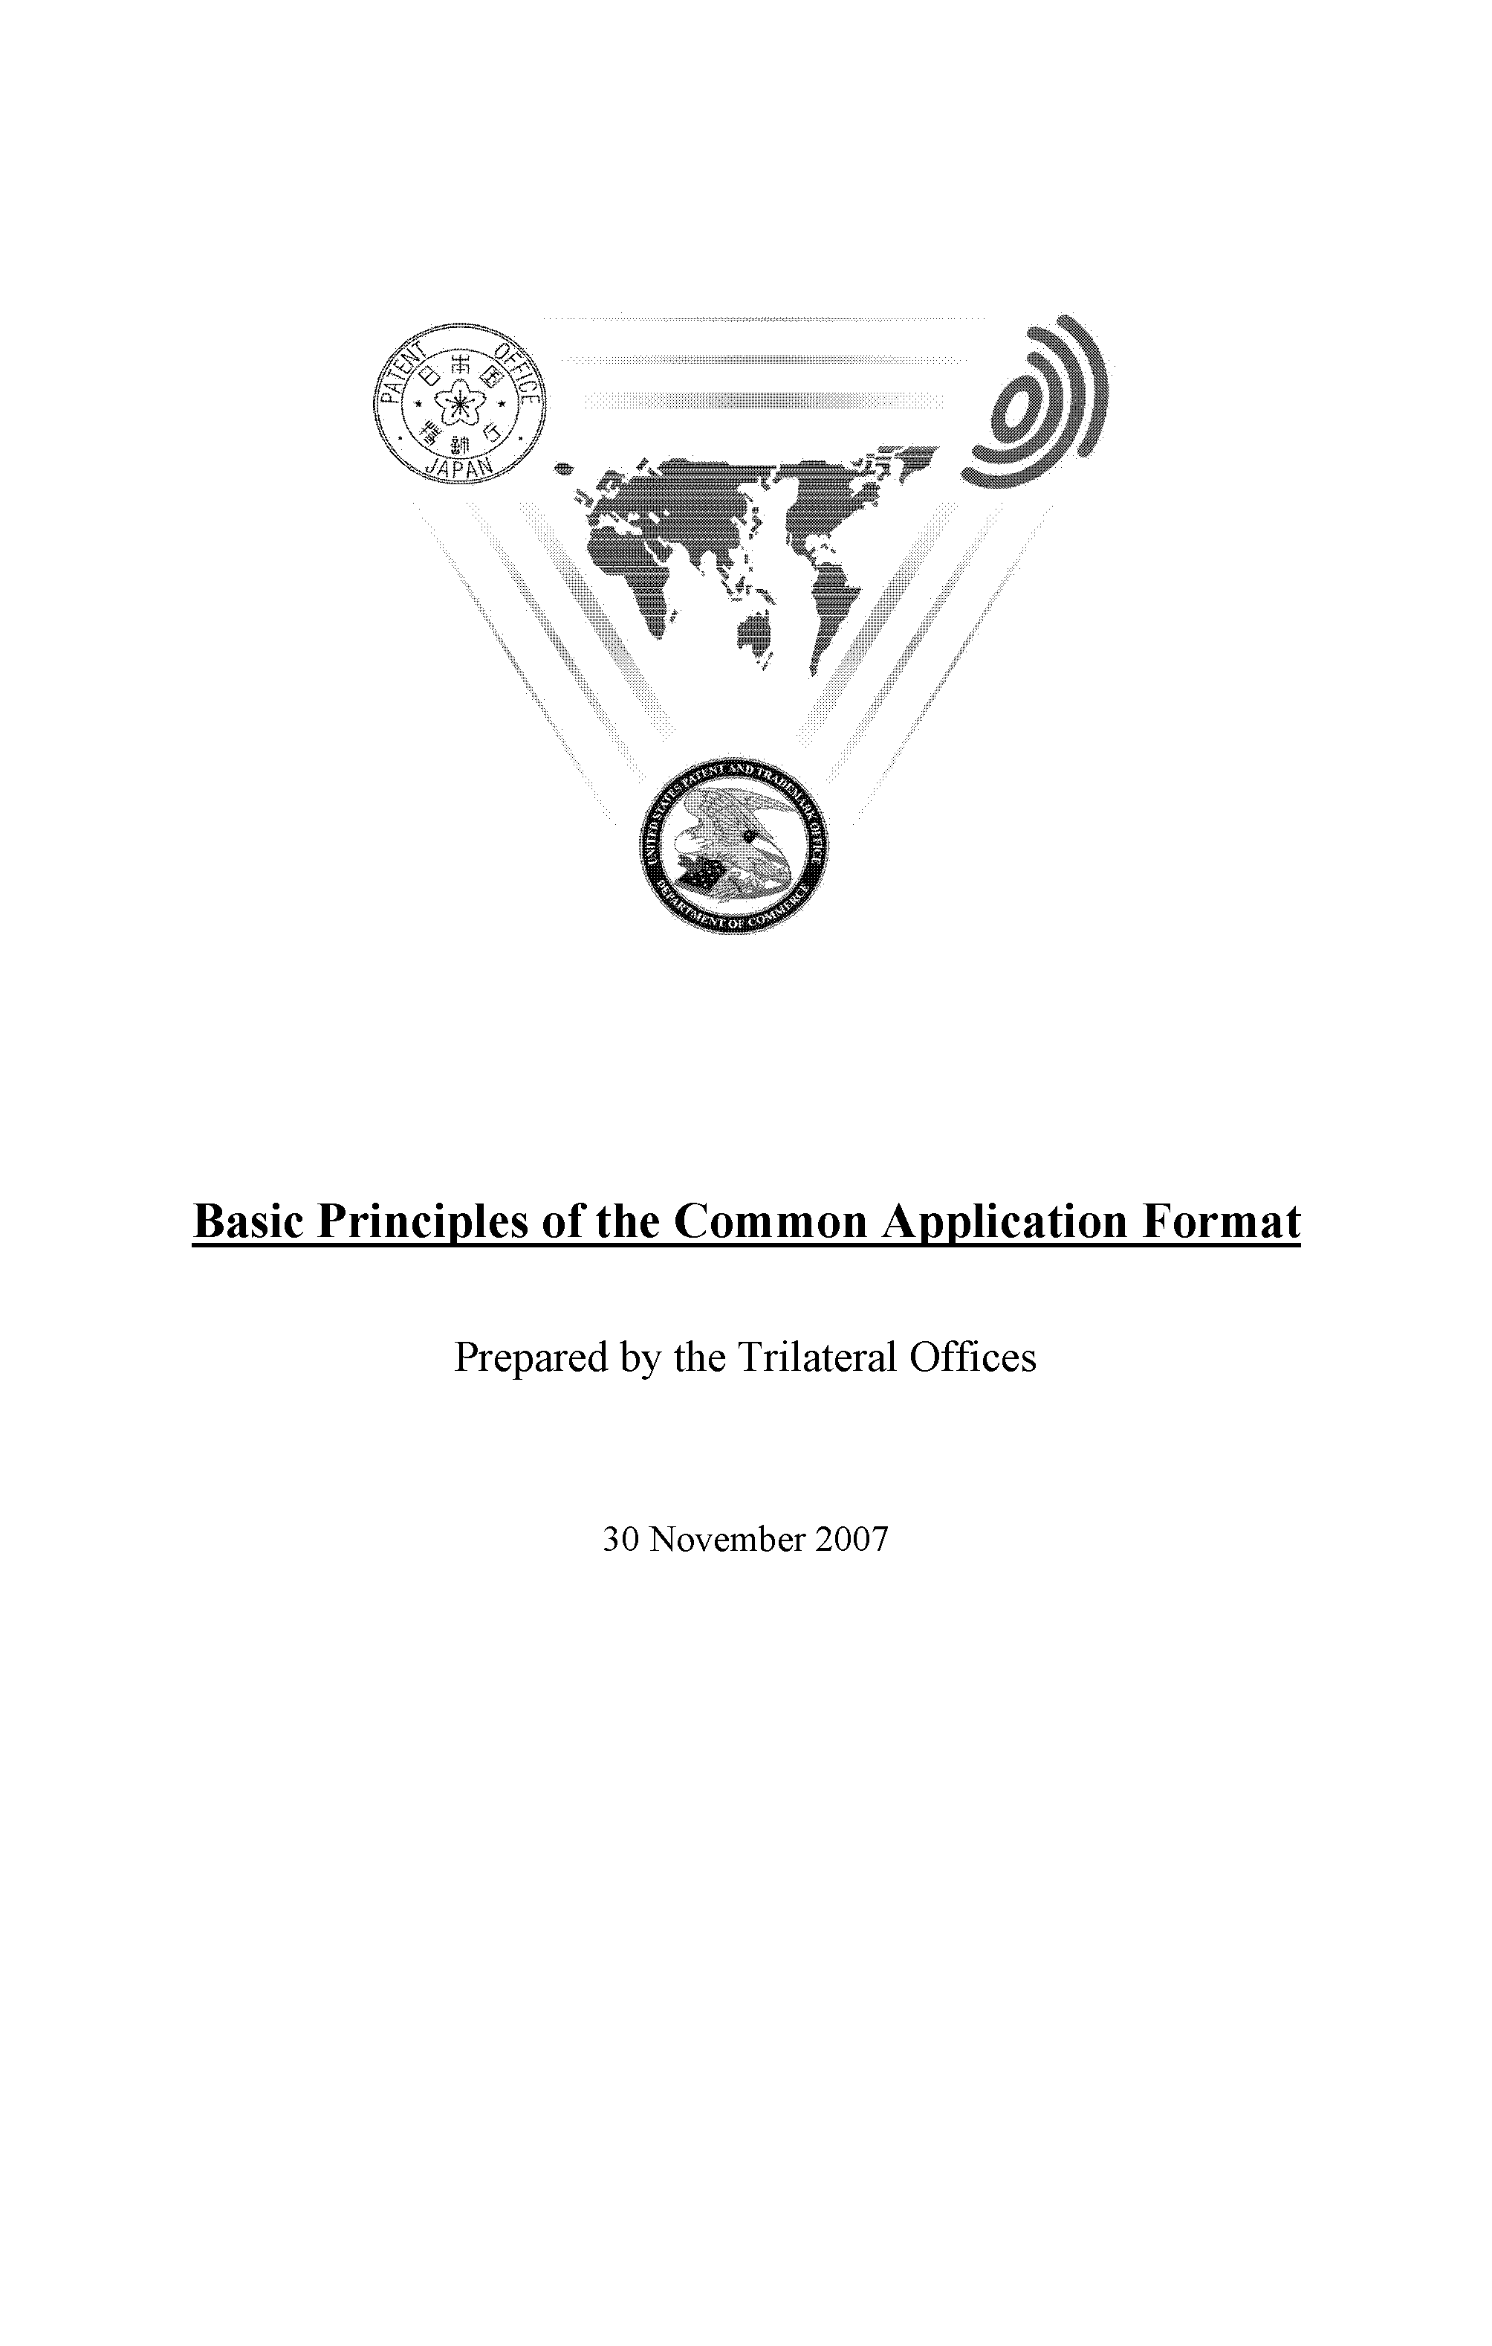
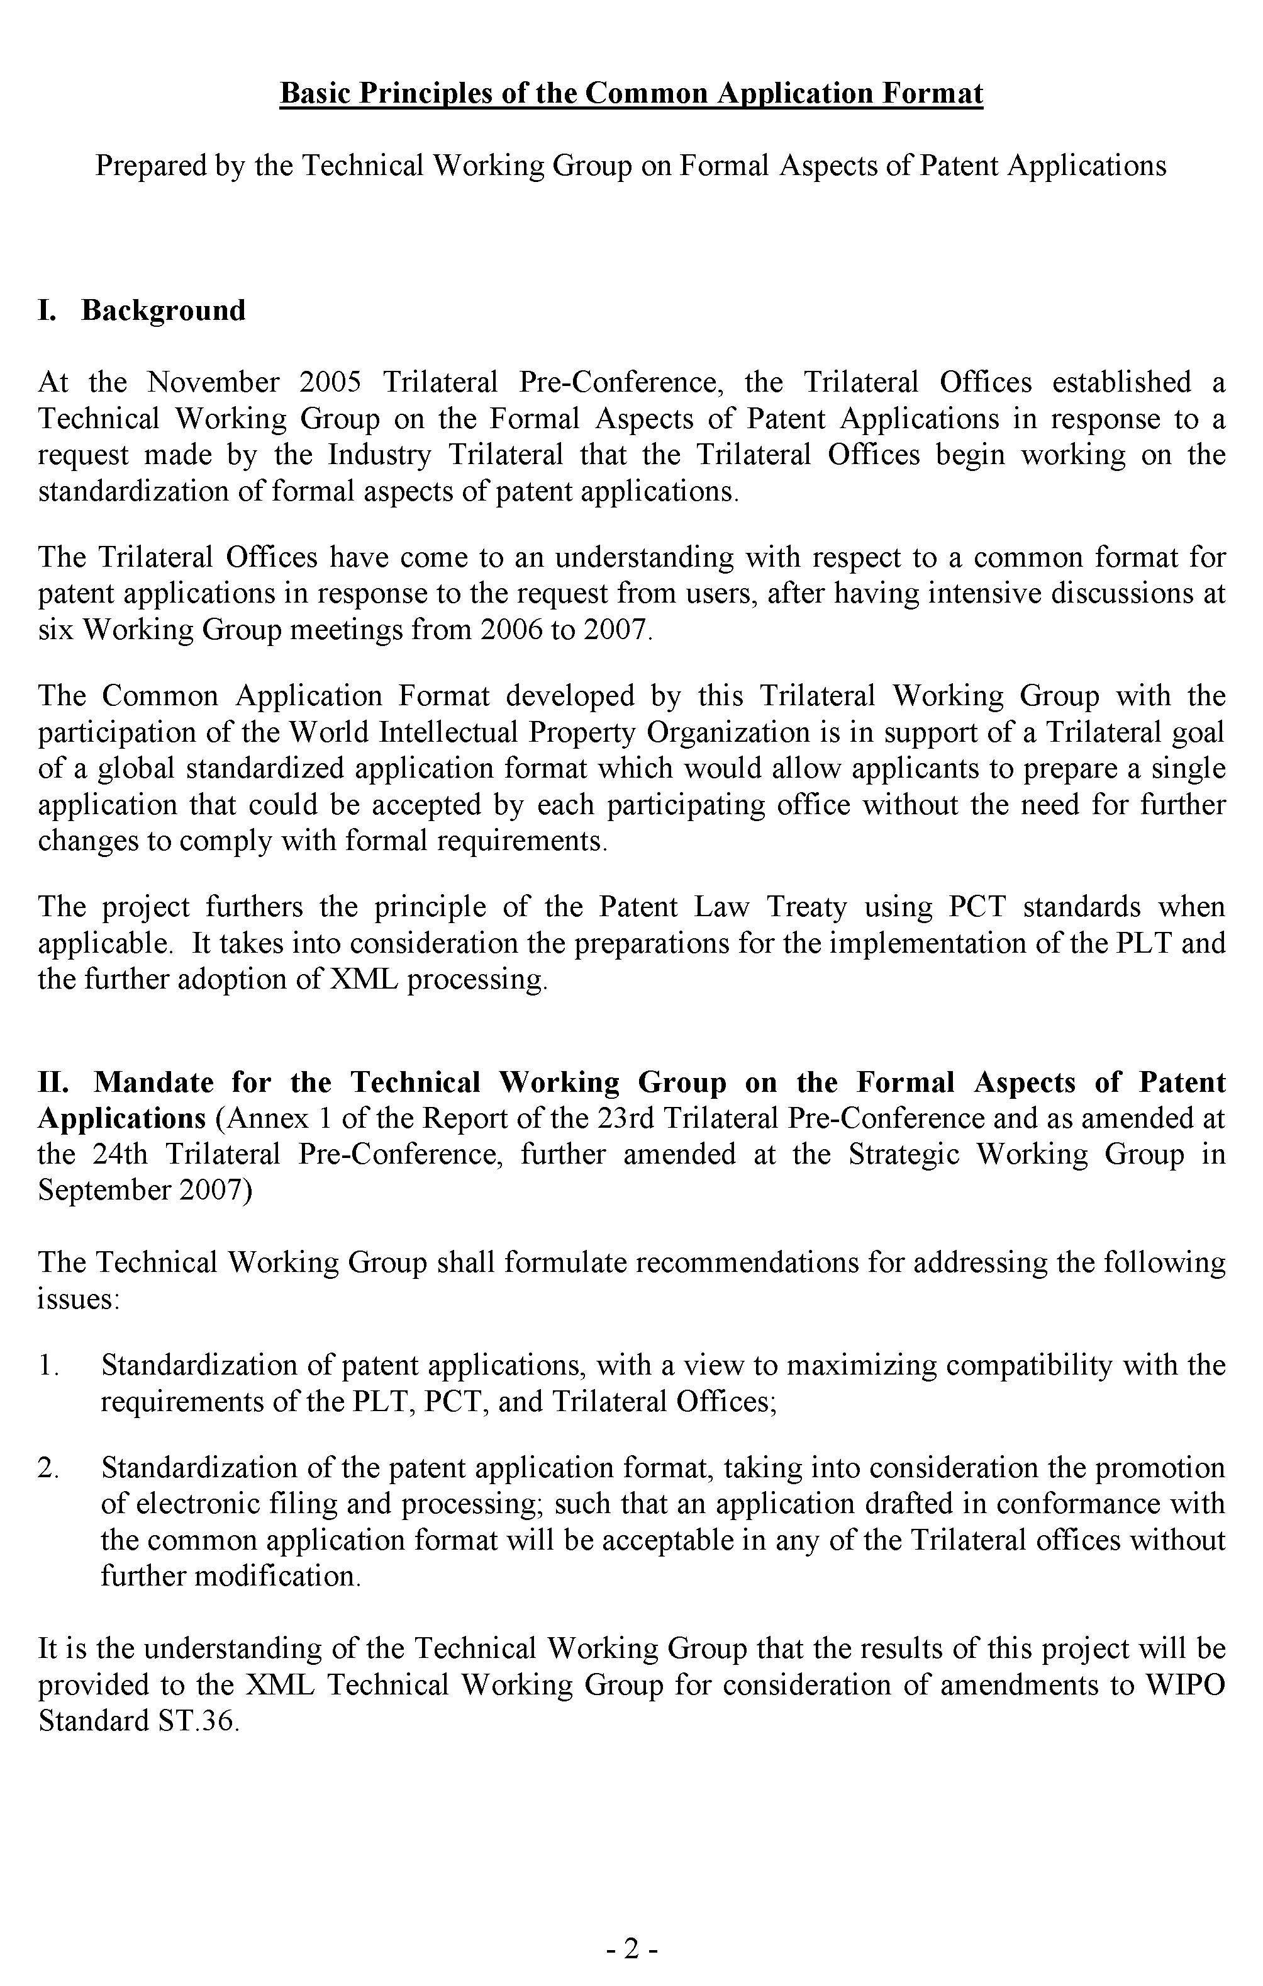
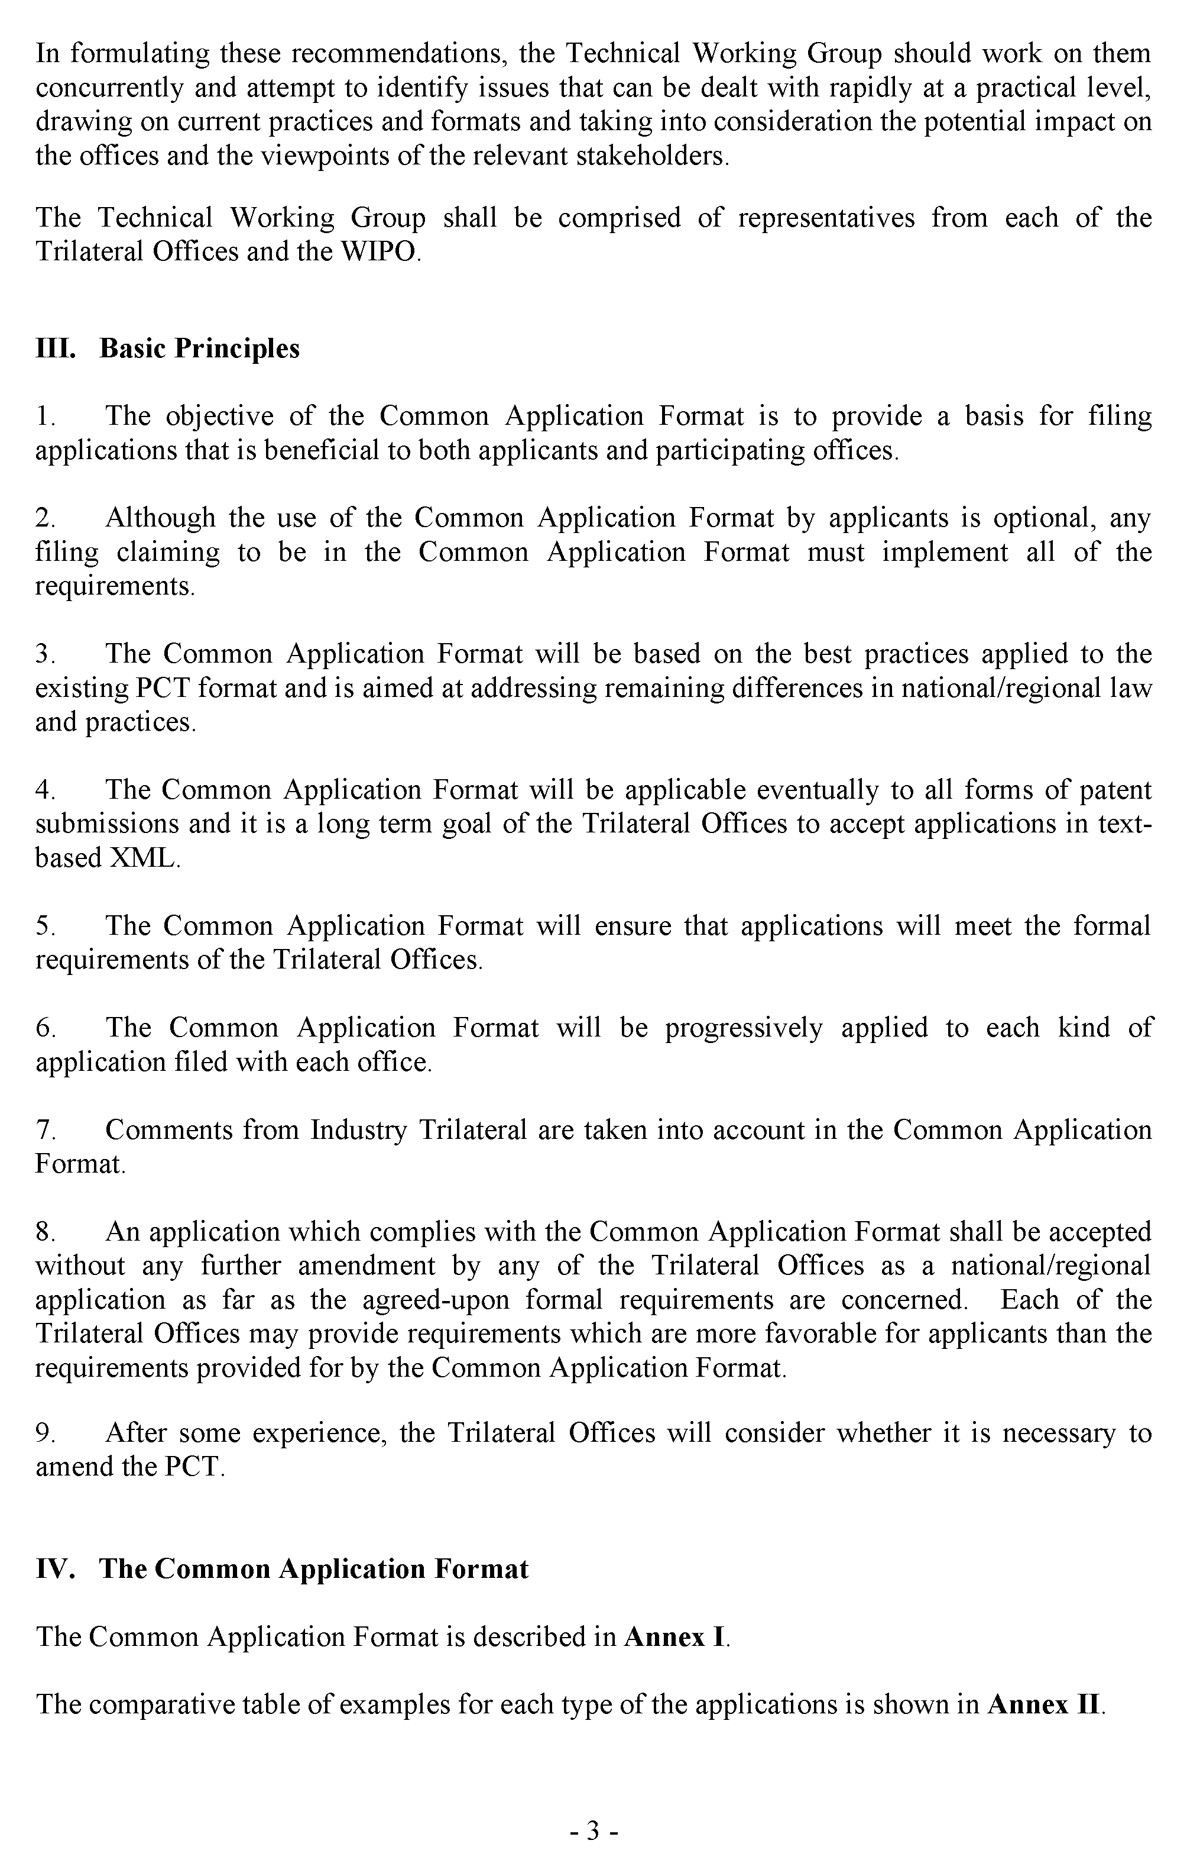
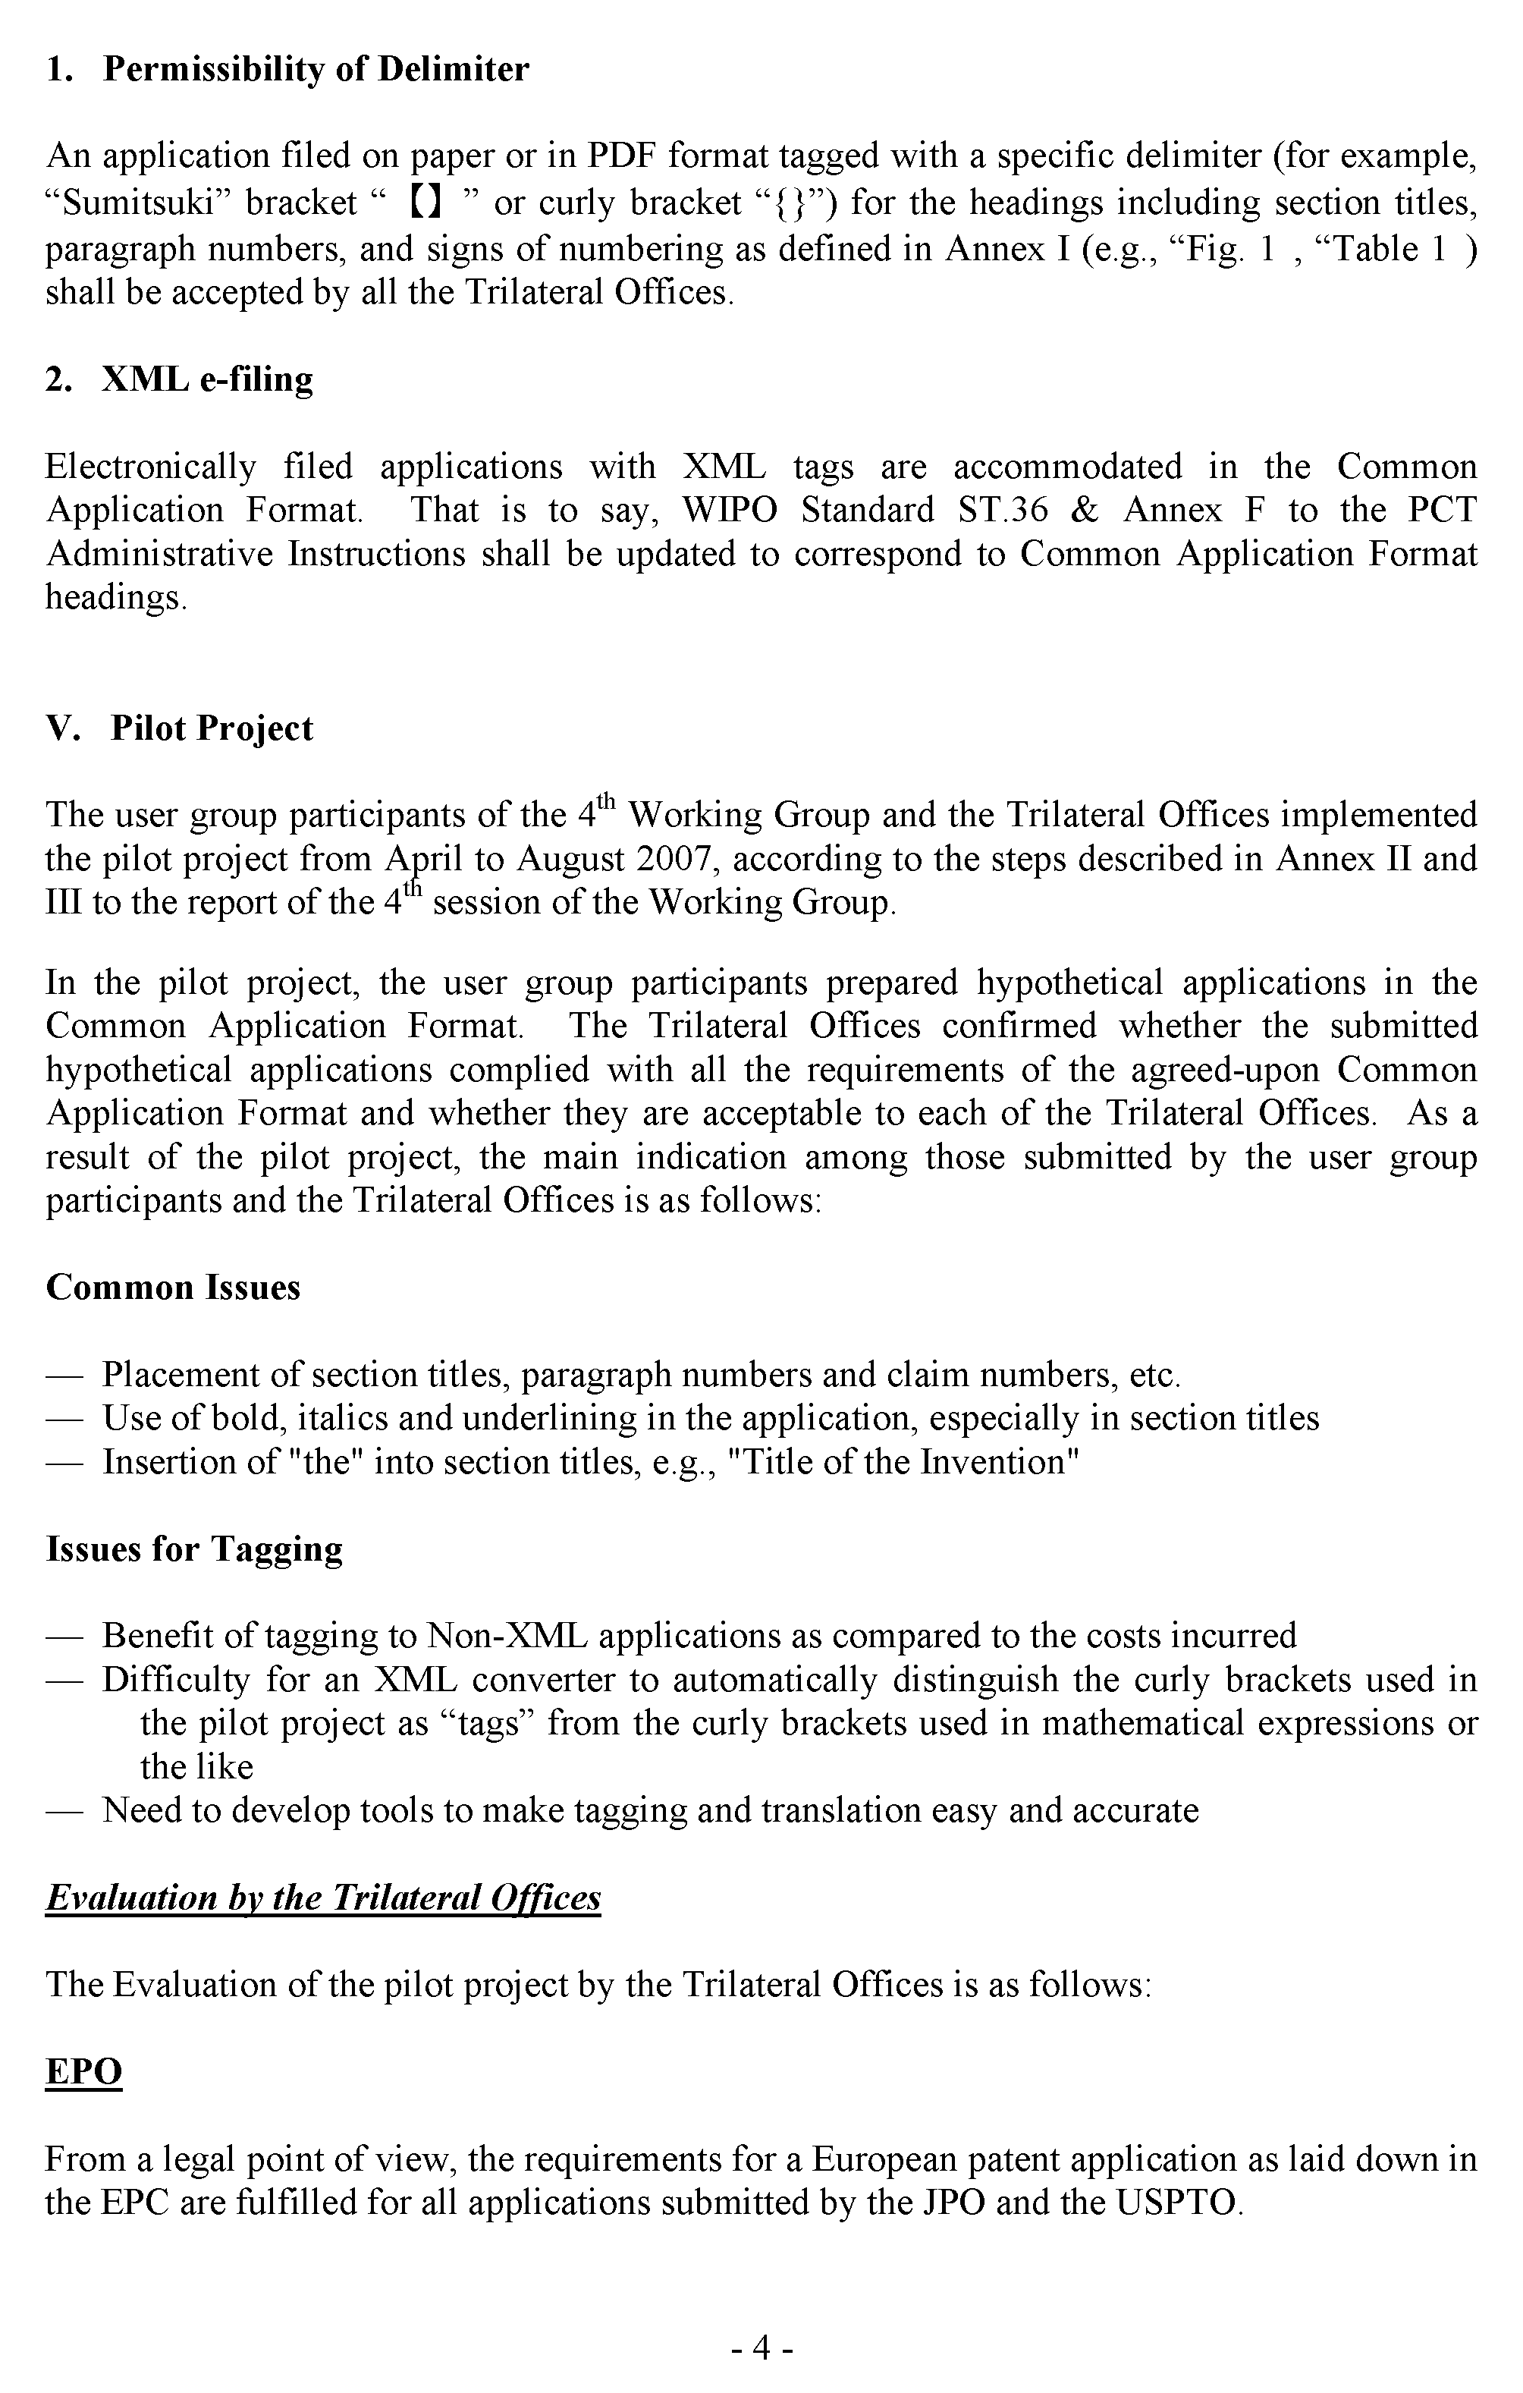
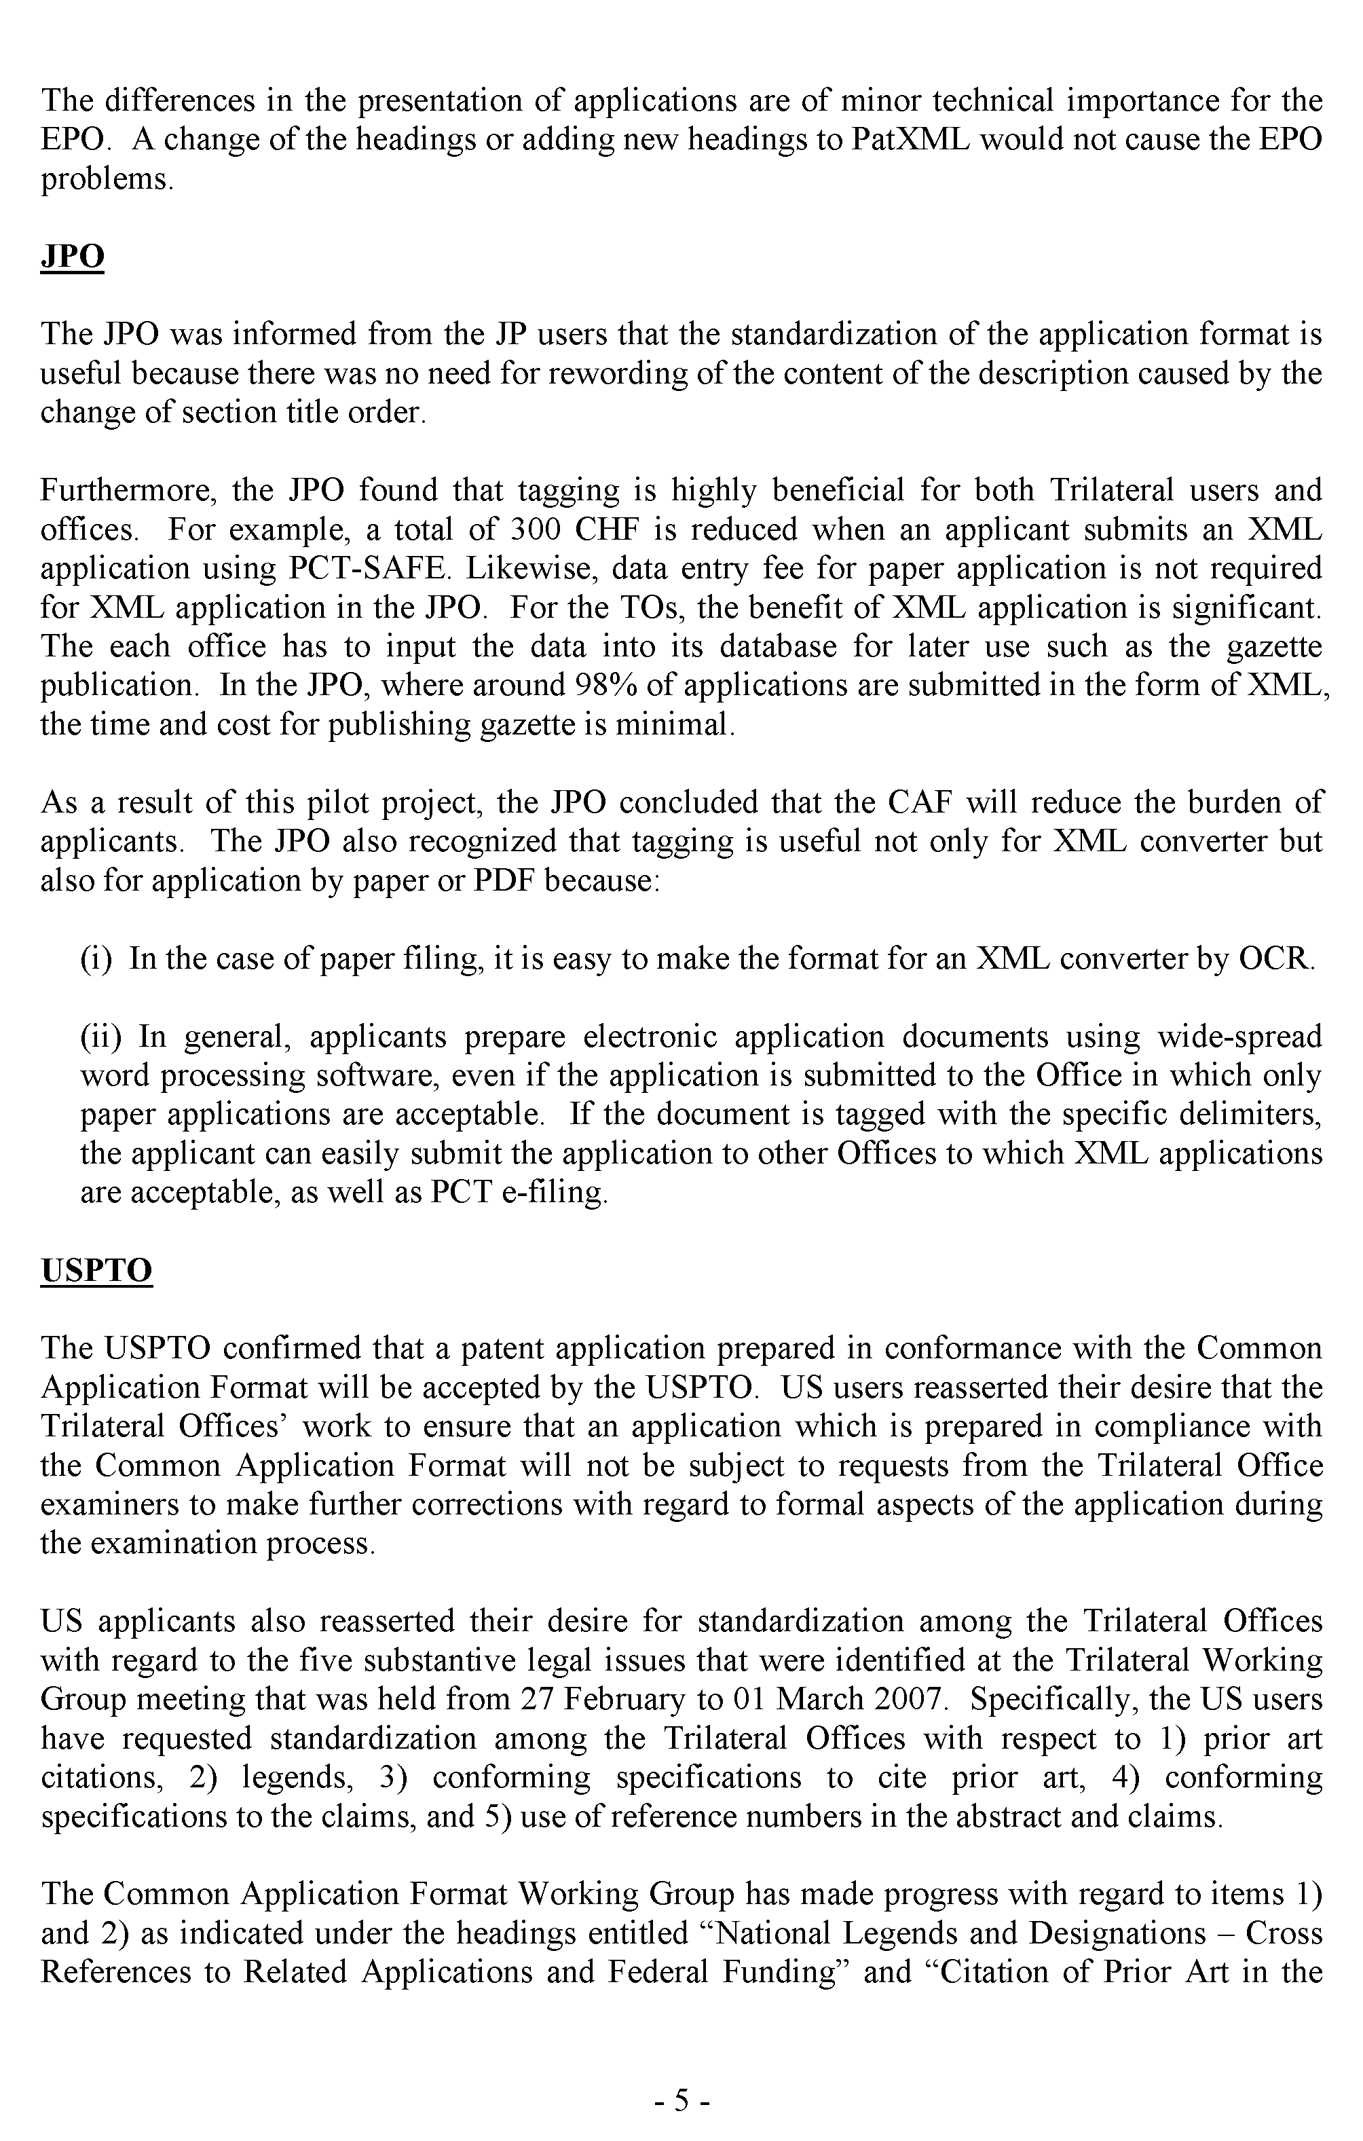
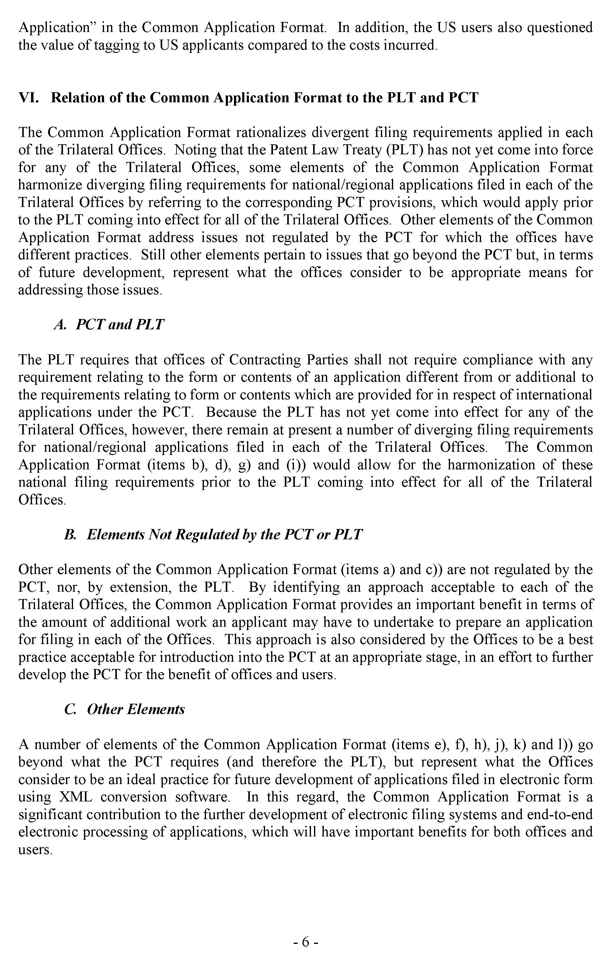
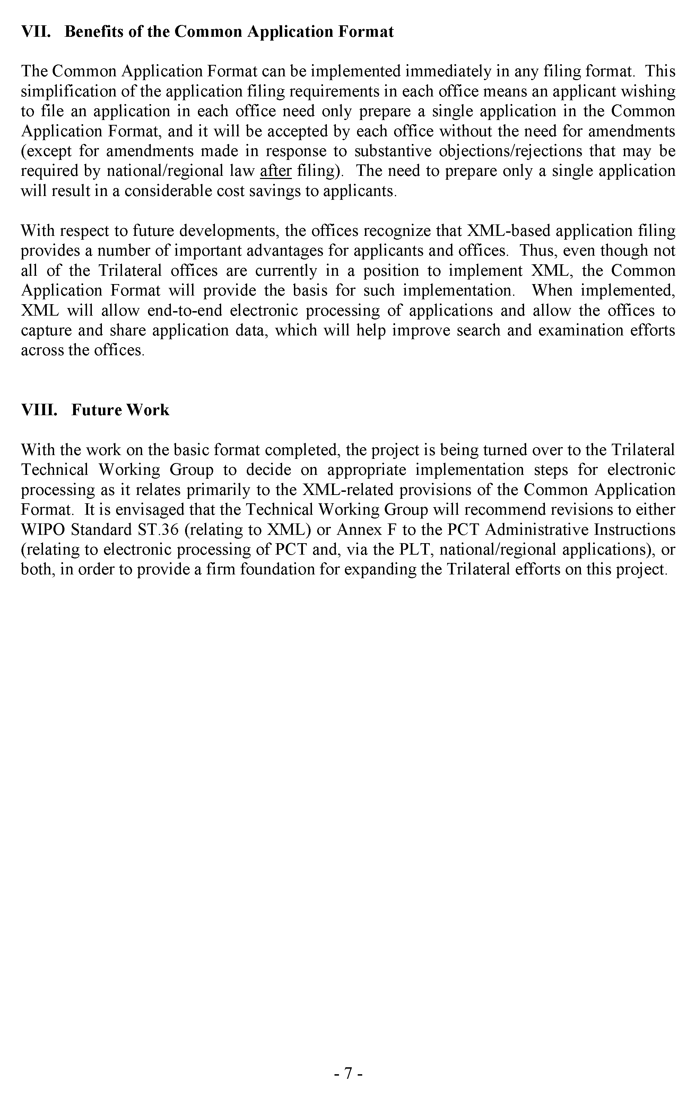
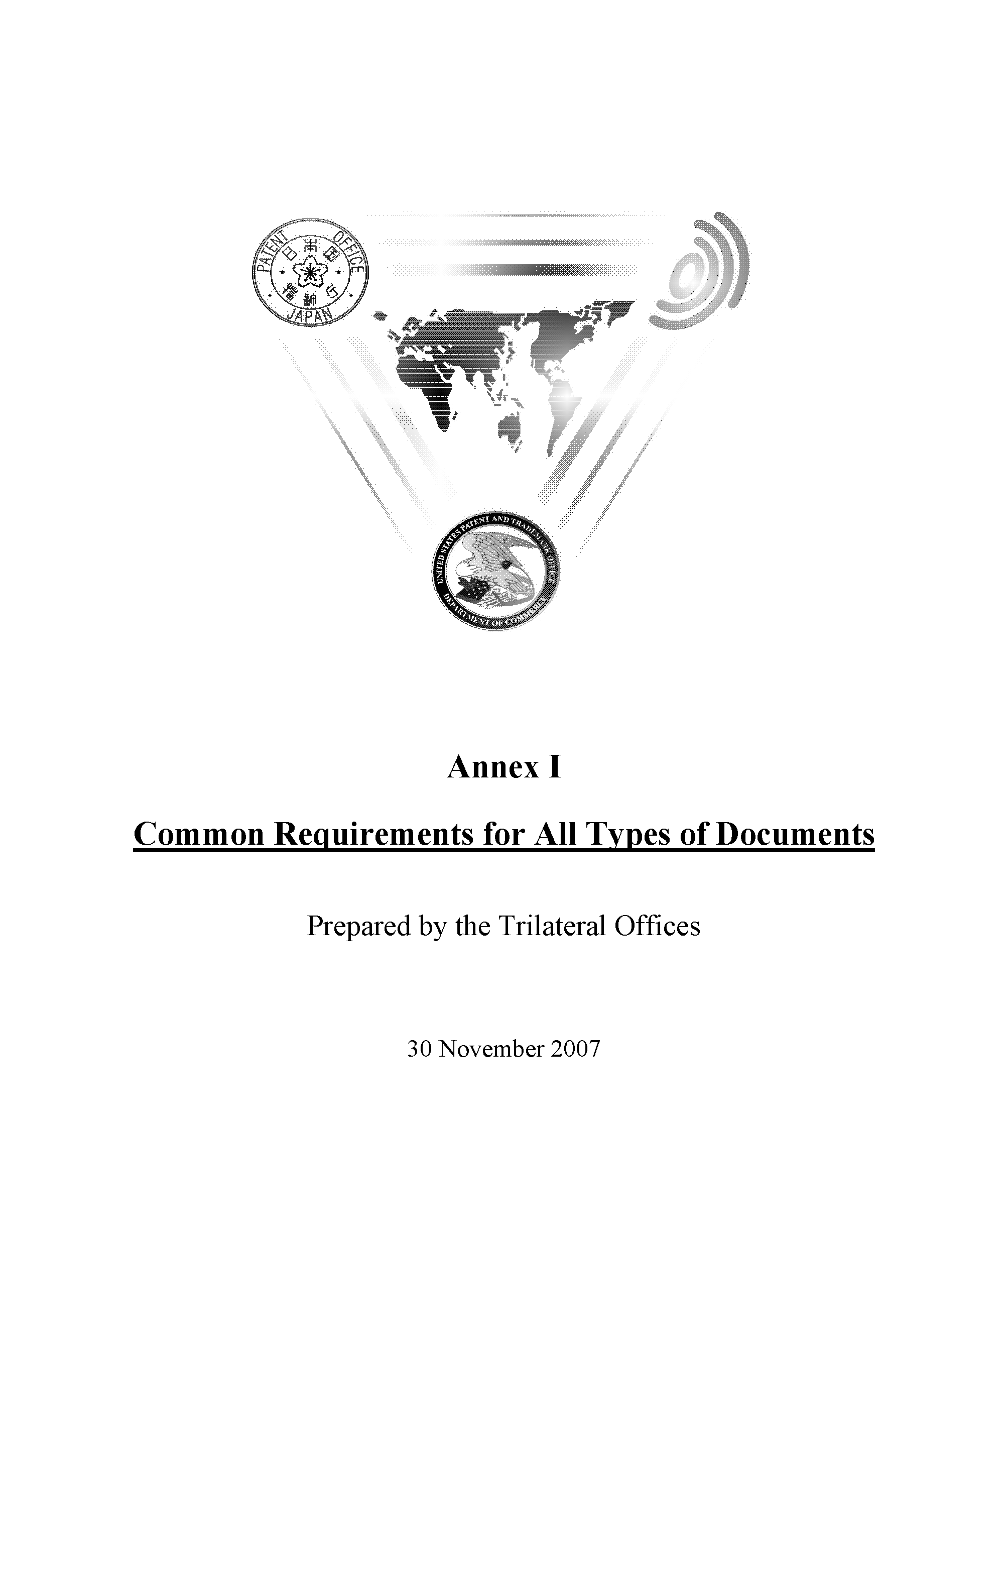
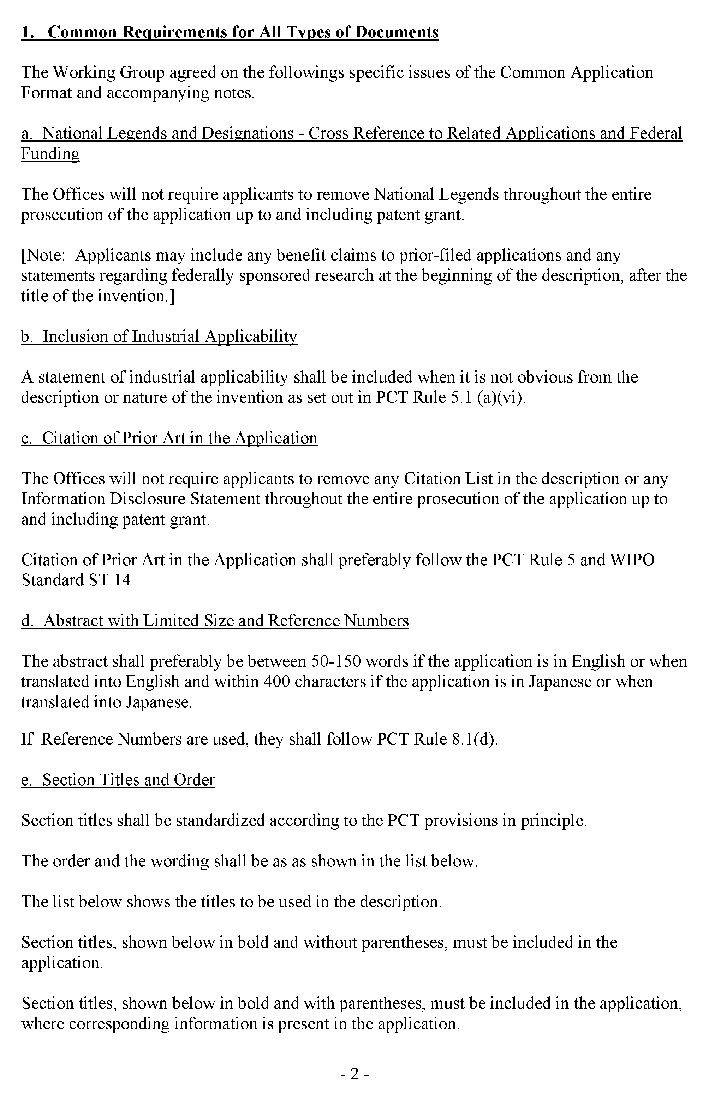
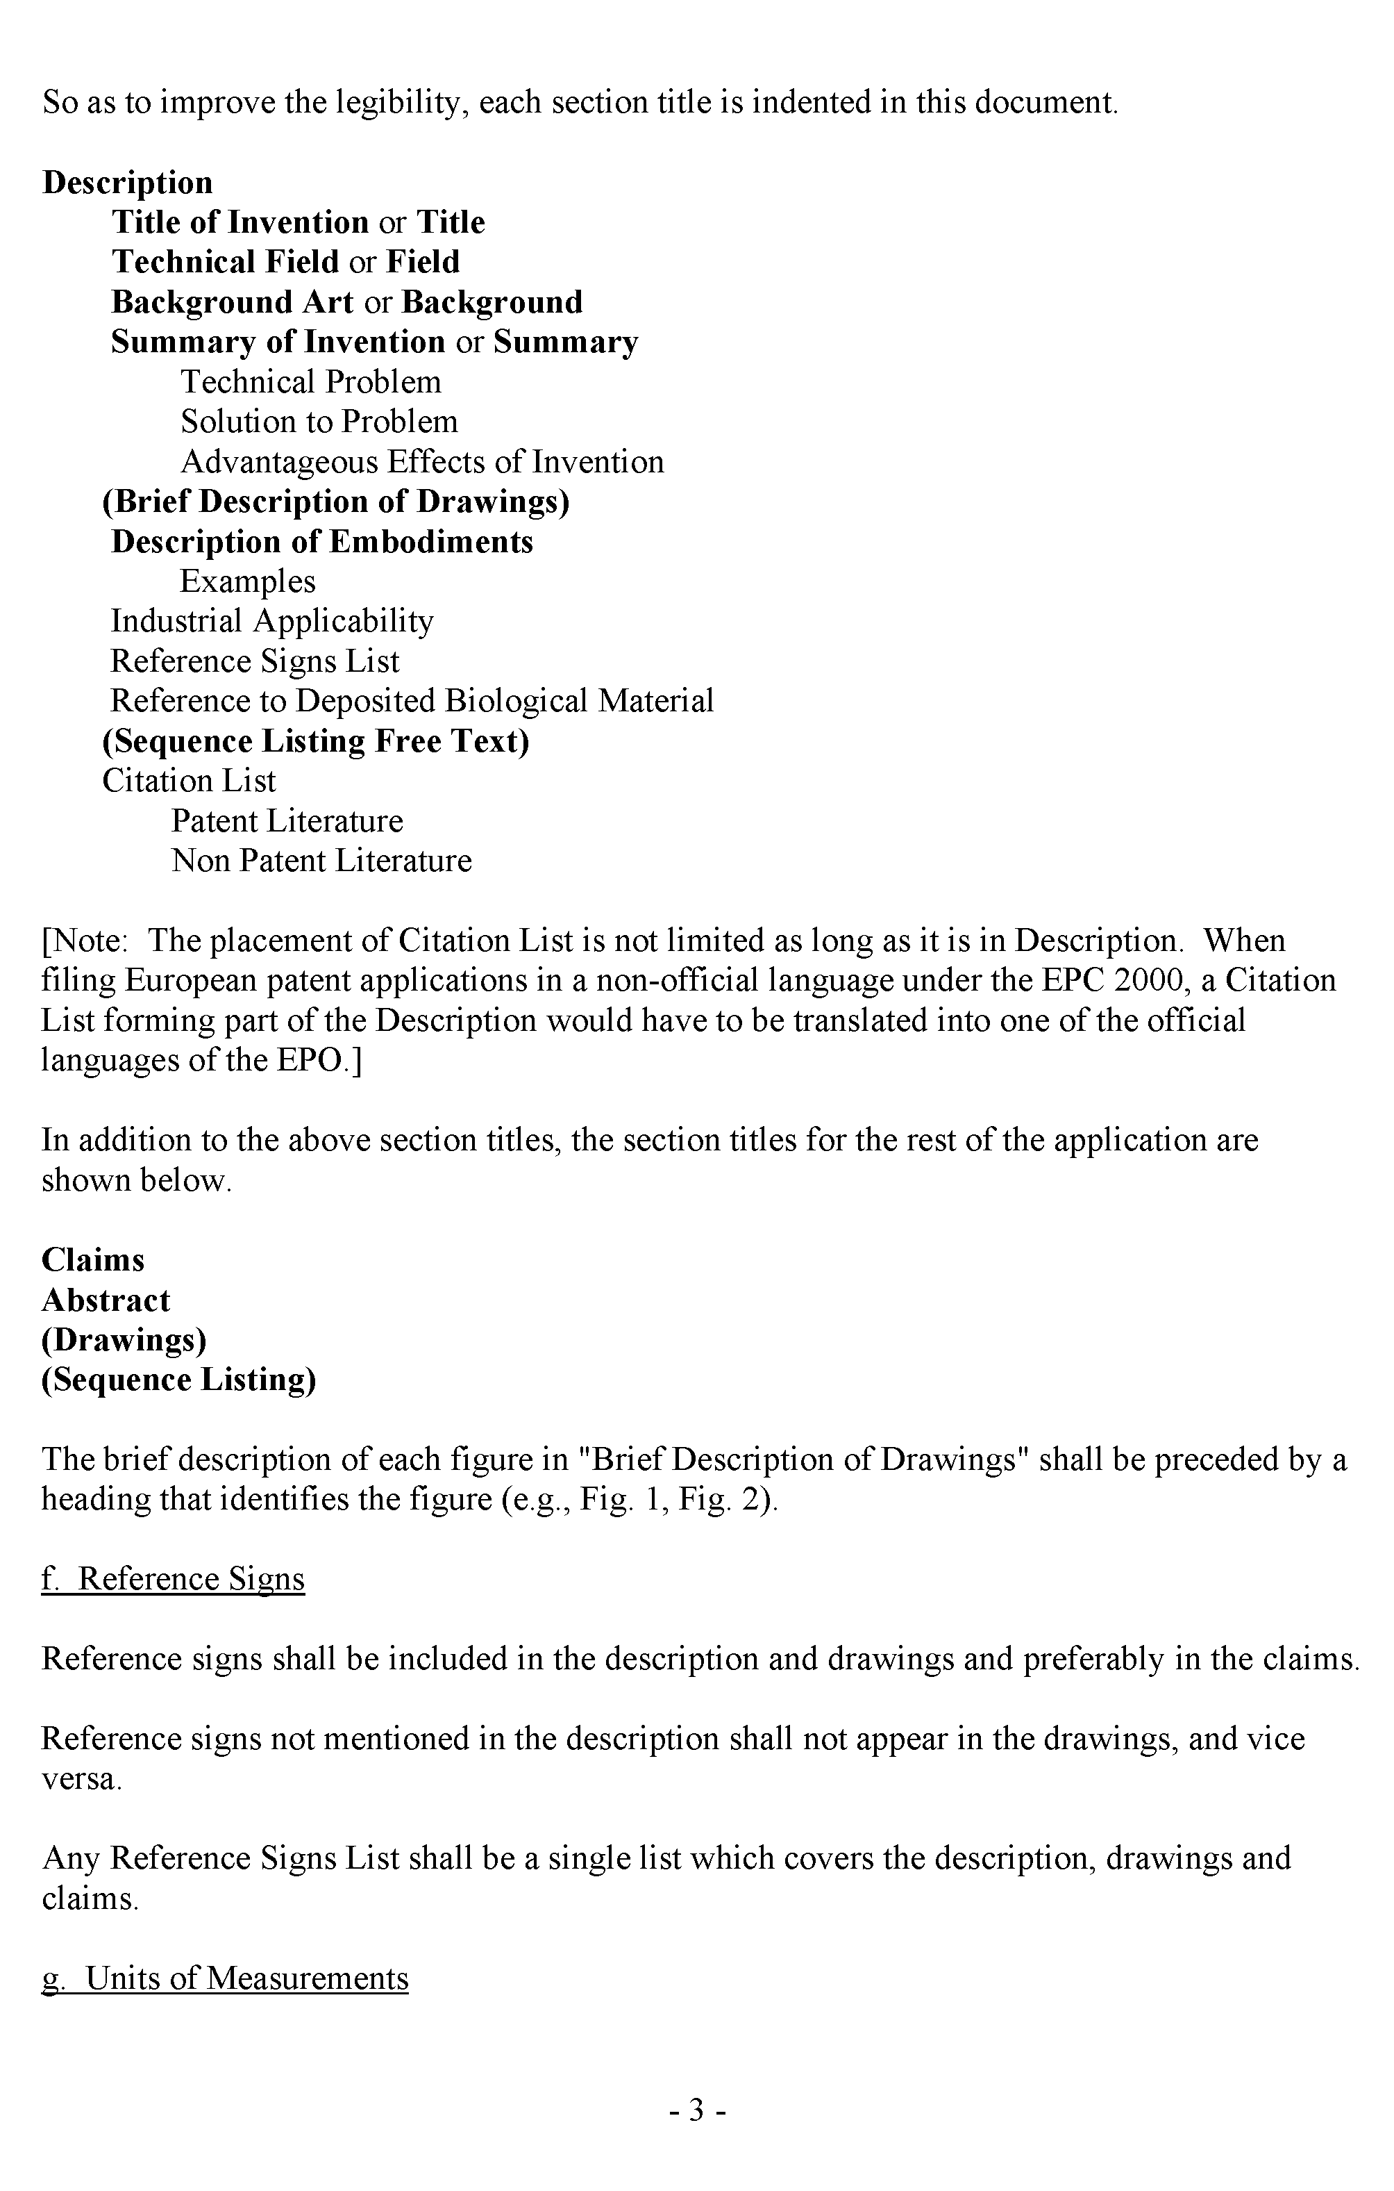
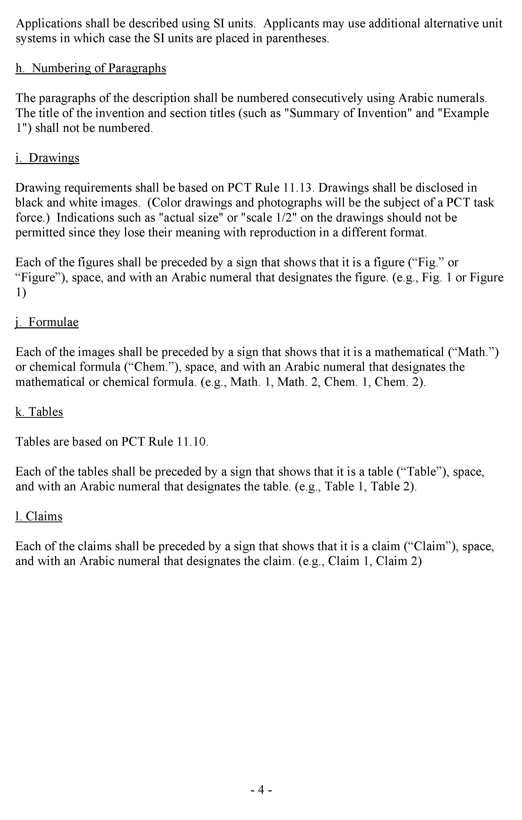
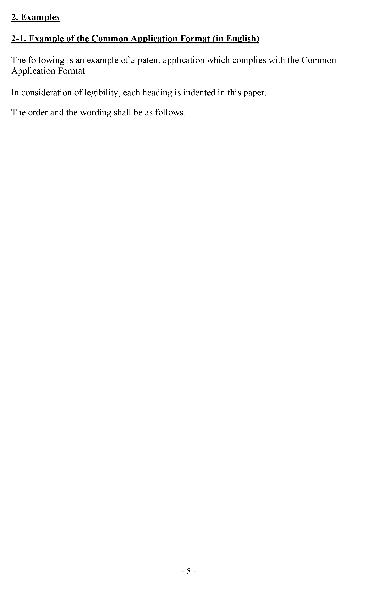
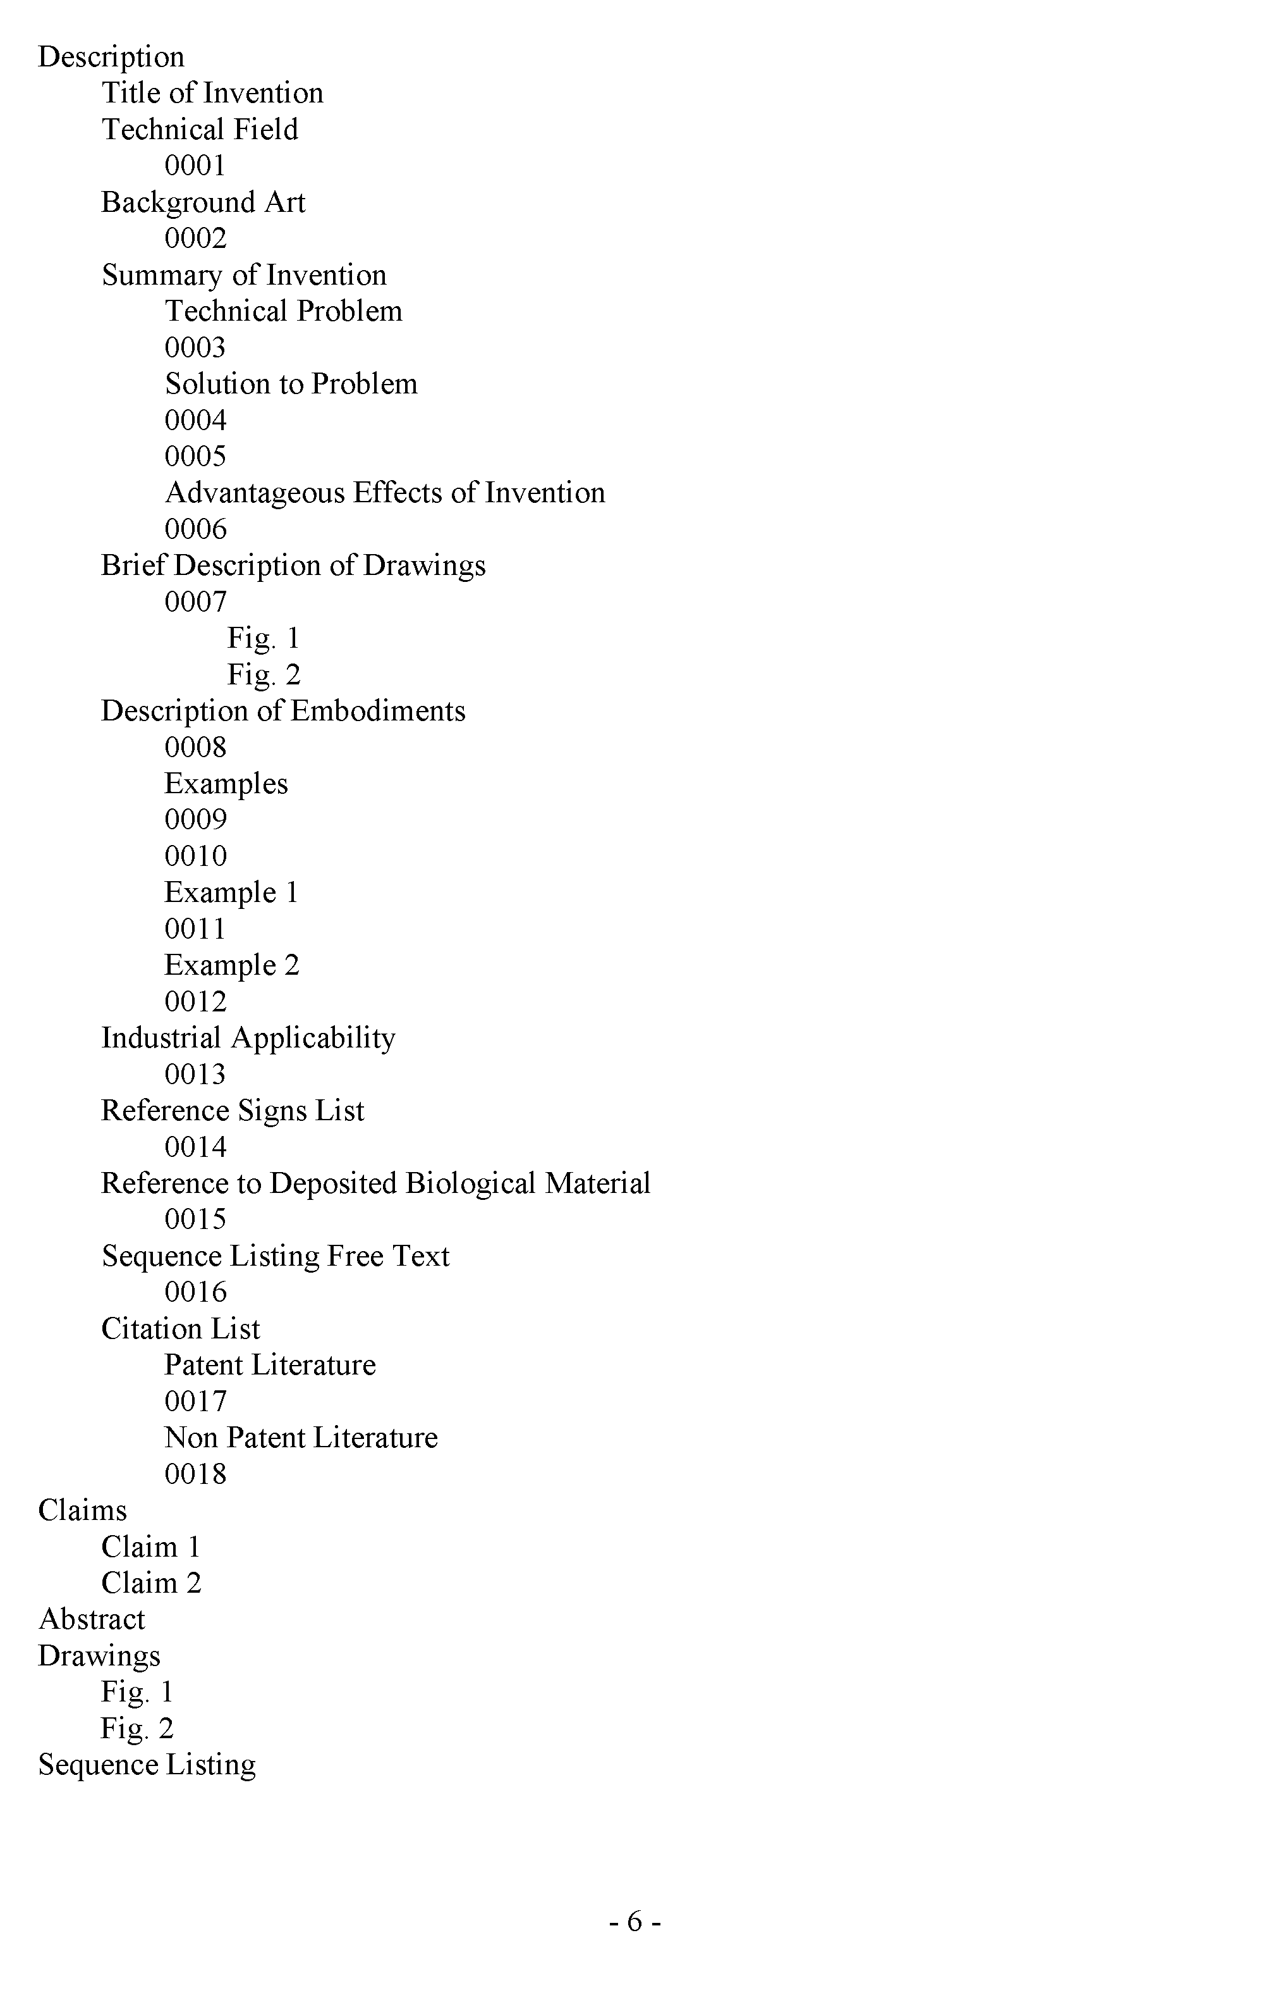
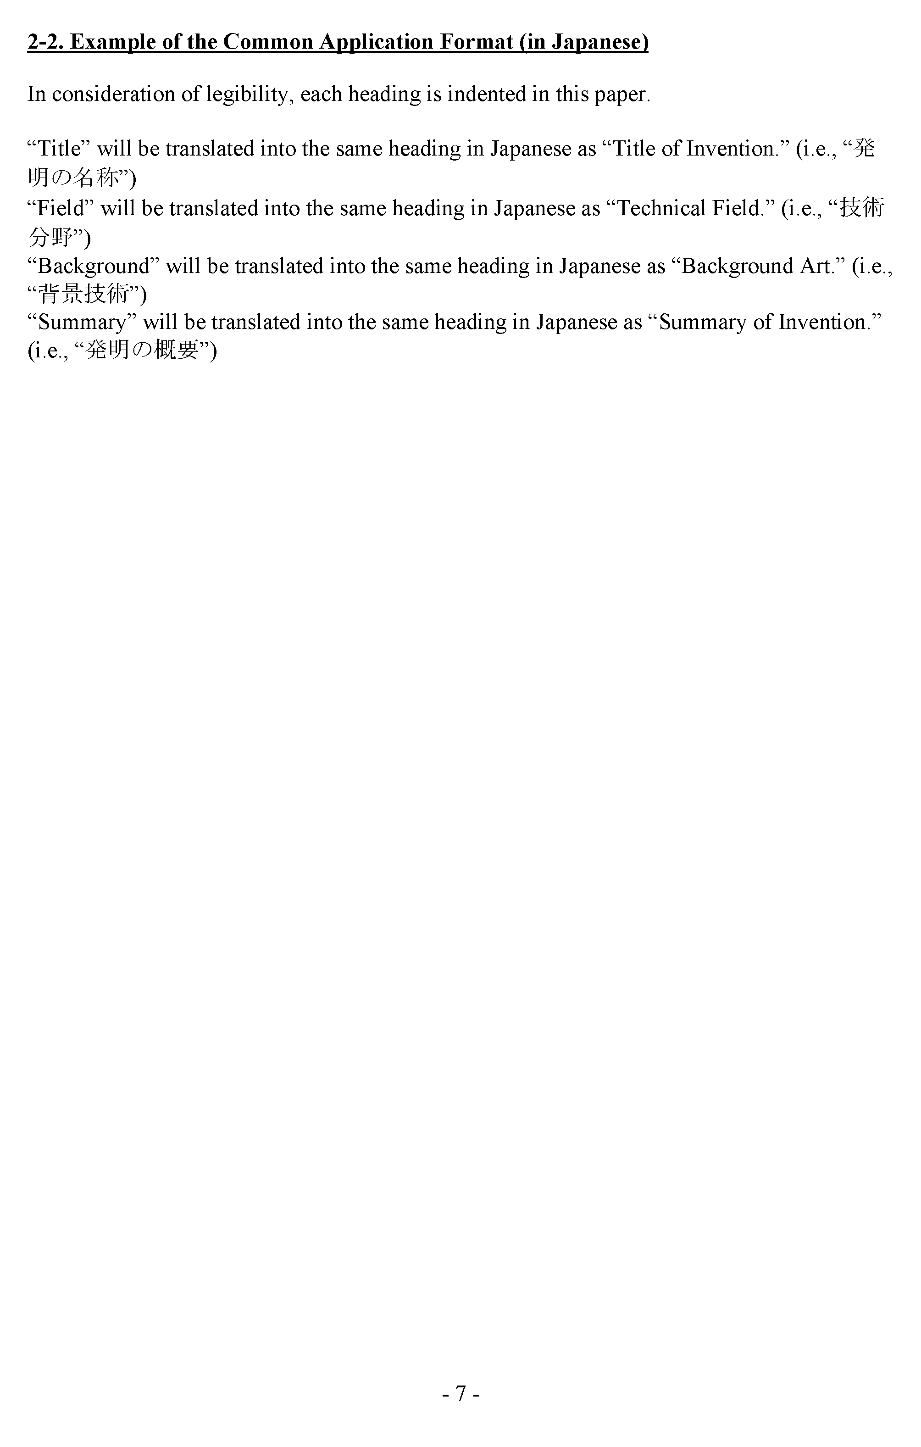
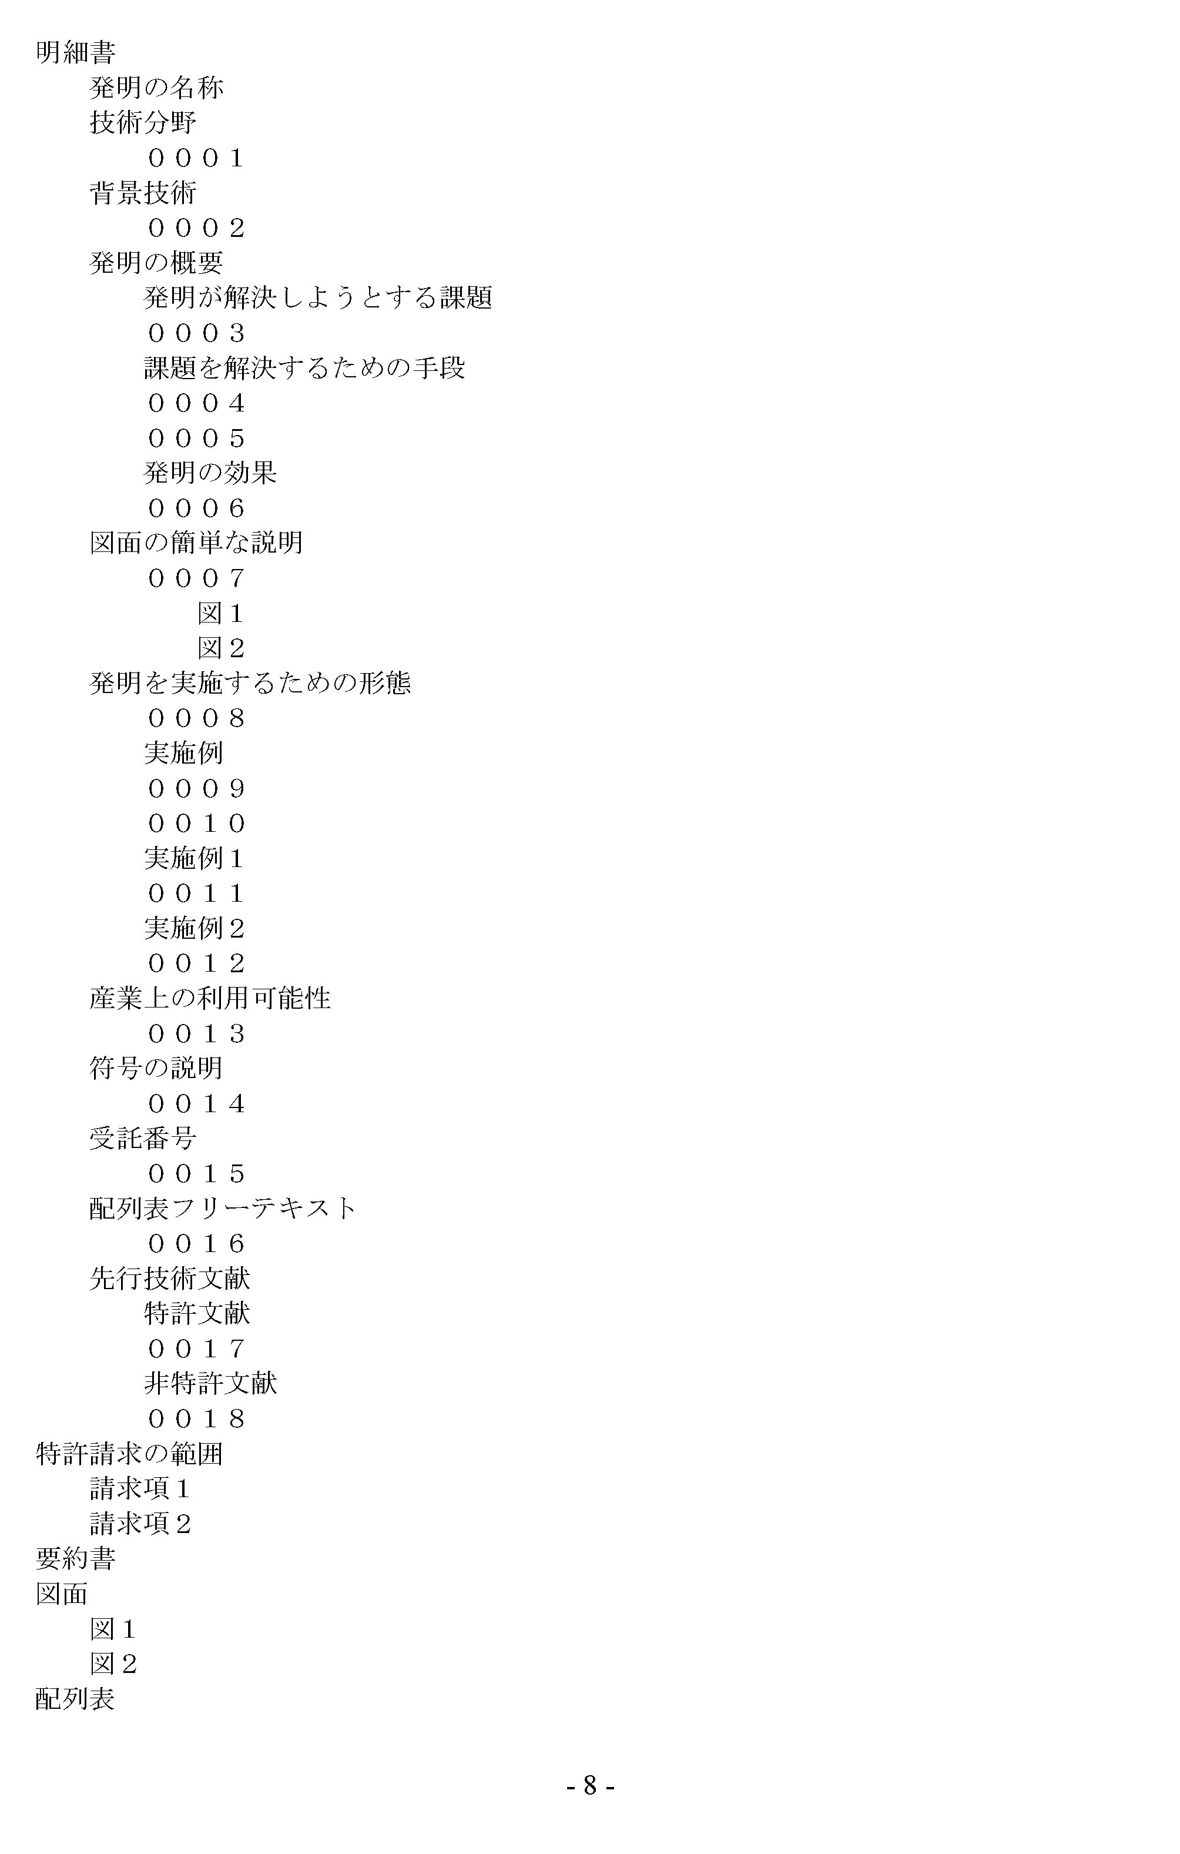
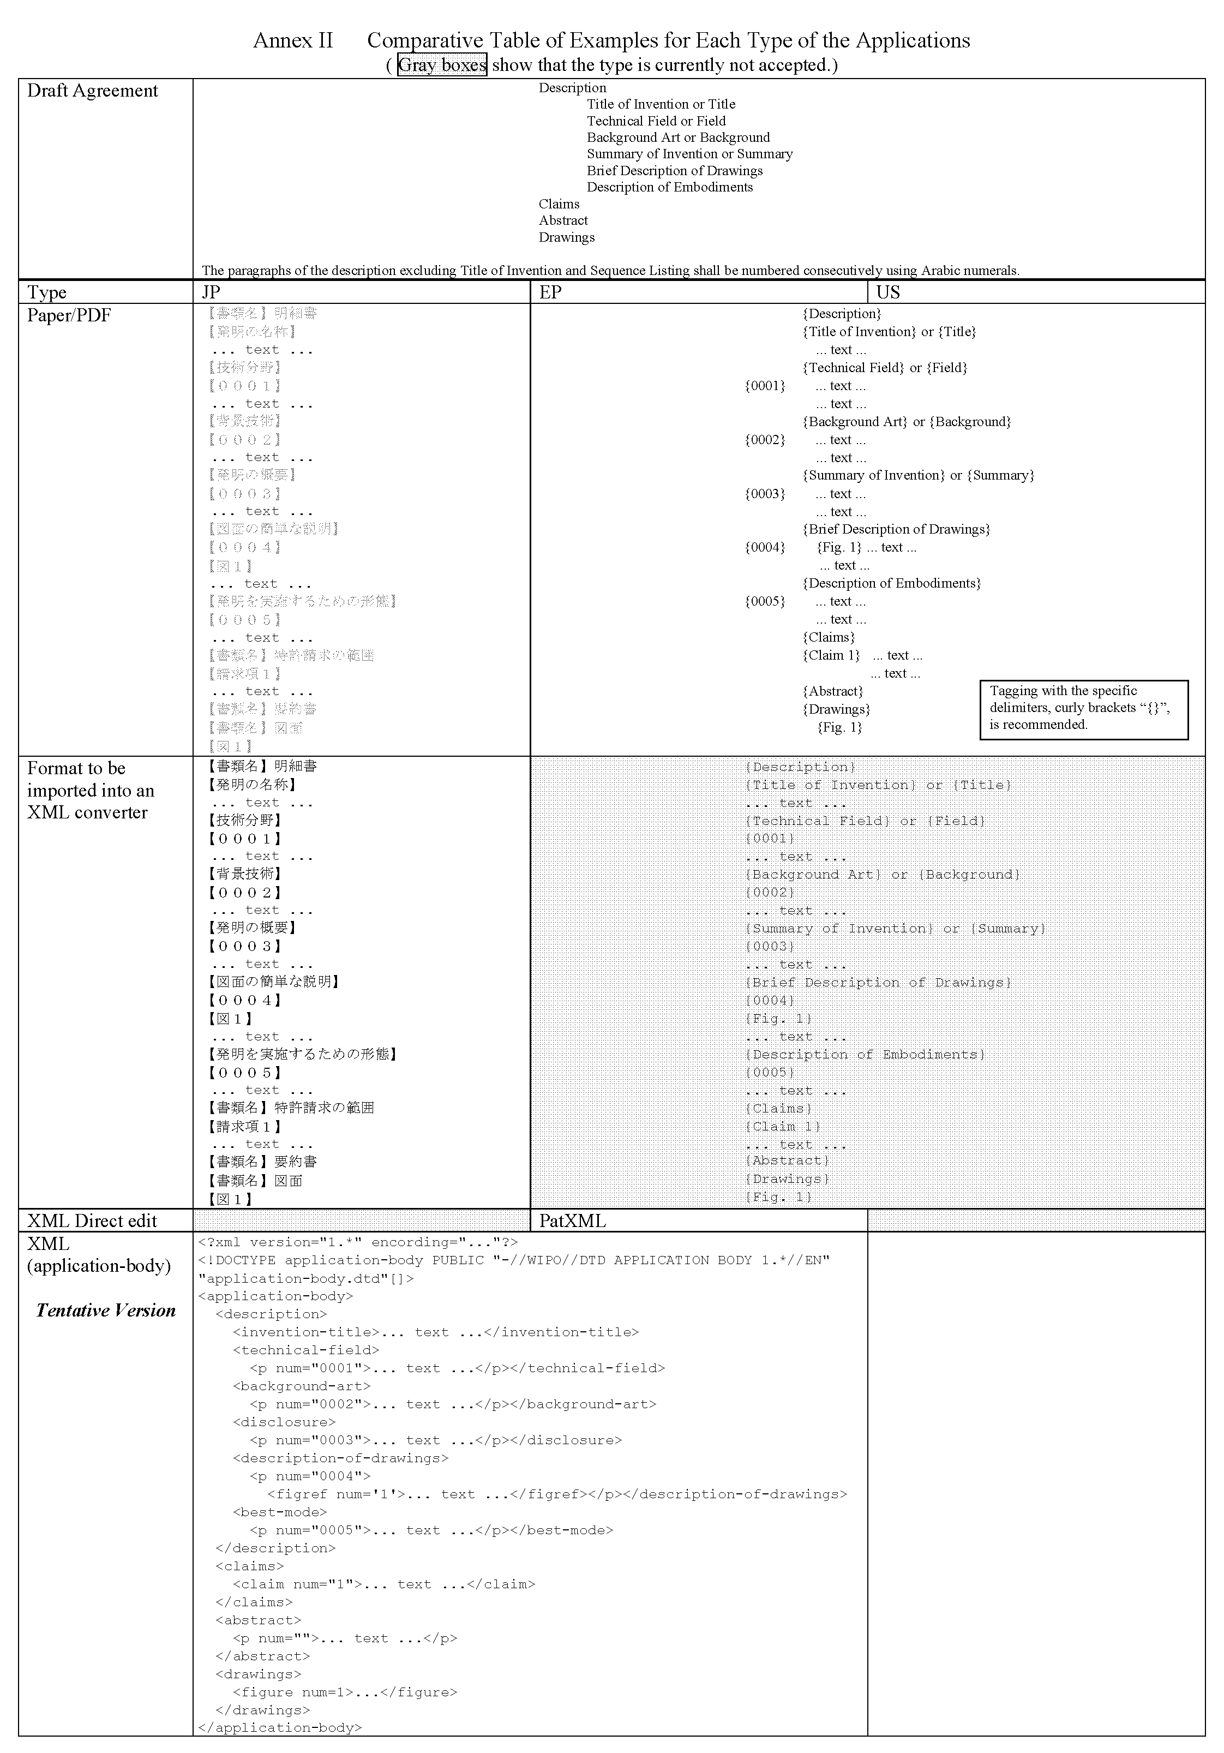

[Annex II follows]

ANNEX II

DRAFT AMENDMENTS OF the PCT ADMINISTRATIVE INSTRUCTIONS

Proposed by the European Patent Office, the Japan Patent Office and the United States Patent and Trademark Office

TABLE OF CONTENTS

Section 204 Headings of the Parts of the Description............................................................. 2
Section 204bis Numbering of Claims...................................................................................... 3

Section 204
Headings of the Parts of the Description
(a) The headings of the parts of the description shall preferably should be as follows:
(i) and (ii) [No change]
(iii) for matter referred to in Rule 5.1(a)(iii), “Disclosure of Invention” or “Summary of Invention”;
(iv) [No change]
(v) for matter referred to in Rule 5.1(a)(v), “Best Mode for Carrying out the Invention,” or, where appropriate, “Mode(s) for Carrying out the Invention” or “Description of Embodiments”;
(vi) [No change]
(vii) for matter referred to in Section 208(b), “Sequence Listing Tables”;
(viii) (vii) for matter referred to in Rule 5.2(a), “Sequence Listing”;
(ix) (viii) for matter referred to in Rule 5.2(b), “Sequence Listing Free Text.”

(b) Where the description states the title of the invention under Rule 5.1(a), the heading “Title of Invention” shall preferably precede the title of the invention.
[COMMENT: See paragraph 13 in the main body of this document. As for “Sequence Listing Tables,” see paragraph 14 in the main body of this document.]

Section 204bis
Numbering of Claims
The number of each claim referred to in Rule 6.1(b) shall preferably be preceded by the expression “Claim” (for example, Claim 1, Claim 2, Claim 3).
[COMMENT: See paragraph 15 in the main body of this document.]

[End of Annex II and of document]

