WIPO |  | E  PCT/MIA/15/11  ORIGINAL: English only  DATE: April 1, 2008
WORLD INTELLECTUAL PROPERTY ORGANIZATION
GENEVA
INTERNATIONAL PATENT COOPERATION UNION
(PCT UNION)
MEETING OF INTERNATIONAL AUTHORITIES
UNDER THE PATENT COOPERATION TREATY (PCT)
Fifteenth Session
Vienna, April 7 to 9, 2008
SUPPLEMENTARY INTERNATIONAL SEArCH
Document prepared by the Secretariat
SUMMARY

The Meeting is invited to note the actions which are required for an International Searching Authority to offer the service of supplementary international search, and to comment on what Forms and additional guidelines may be required. International Authorities are also invited to indicate whether and when they may be able to offer such a service and whether further action is required in relation to the quality of international searches.

Background

At its 36th session in September–October 2007, the PCT Assembly approved proposals regarding the provision of international supplementary search under the PCT, including amendments to the PCT Regulations and approval of new provisions which any International Searching Authority wishing to offer such a service would be permitted to include in its agreement with the International Bureau in accordance with PCT Article 16(3)(b). The relevant new Rules are set out in Annex I for reference.

The Assembly decided that the Rules would enter into force such that, provided at least one International Searching Authority is prepared to offer the service, applicants will be able to request supplementary international searches on international applications where the deadline for requesting the service has not yet expired by January 1, 2009.

At the same time, the Assembly (see paragraph 153(iv) to (vi) of document PCT/A/36/13):

urged all International Searching Authorities to continue to make efforts to improve the quality of the main international search, and decided that the quality of the international search shall be reviewed by the Meeting of International Authorities under the PCT;

decided that the International Bureau shall report to the Meeting of International Authorities under the PCT and to the Assembly on the financial and operational situation of the supplementary international search system; and

decided that the Assembly shall review the supplementary international search system three years after the date of entry into force of the system.

Supplementary International Search

The scope of the supplementary international search is to be defined by each participating Authority in its agreement with the International Bureau. However, the general procedure apart from that is similar to the main international search, save for certain matters such as unity of invention and the fact that certain actions, such as classification, checking of the abstract, and establishment of a written opinion are not included.

Annex II contains extracts from some of the preliminary drafts of Forms which may be required for the substantive aspects of the procedure, as follows:

Supplementary international search report – other than title and number of the Form, the differences from the international search report would be:

on the cover page, an additional possible type of translation and a reference to whether the main international search report had been taken into account;

in Box No. II (unsearchable claims), an additional possibility exists for not searching claims, where they were not the subject of the main international search;

in Box No. III (lack of unity)

on the “second sheet” (fields searched and documents considered relevant), no space is required for classification of the international application.

Declaration of non-establishment of supplementary international search report – similar to a declaration on Form FCT/ISA/203 by the International Searching Authority, save for the additional possibility (item 1) of non-establishment of the supplementary search report because of non-establishment of the main international search report.

Finding of non-compliance with the requirement of unity of invention – possibly required if unity is considered as a preliminary issue before the supplementary international search report is established; otherwise, similar contents might be distributed between the supplementary international search report and an explanatory covering note (similar to Form PCT/ISA/220).

Notification of decision on review of opinion – similar to Form PCT/ISA/212, but adjusted to the possible outcomes of the request for review under Rule 45bis.6(c) of the examiner’s opinion on unity of invention, rather than of the normal protest procedure.

Annex III contains preliminary draft modifications of the PCT International Search and Examination Guidelines containing the main issues relating to the procedures within the Authority specified for supplementary international search.

Formal consultations will be conducted later this year on these matters, including also additional Forms relating to procedural matters such as transmittal of documents and consequential modifications to various other parts of the PCT International Search and Preliminary Examination Guidelines. However, preliminary views are invited on the matters raised within the drafts, and especially on whether the procedure outlined for handling unity of invention is considered appropriate, where the supplementary international search report is established immediately and subsequently corrected if the review shows it to be necessary, rather than having a two step process which will delay the availability of the results and usually be unnecessary.

Offering the Service of Supplementary International Search

As referred to in paragraph , above, the Assembly approved new provisions to be inserted into the agreement between the International Bureau and any International Authority wishing to offer the service of supplementary international search. The relevant changes would be as follows:

the addition of the following paragraph to Article 3 (Competence of Authority):

“(4) The Authority shall conduct supplementary international searches in accordance with Rule 45bis, covering at least the documentation referred to in Annex E to this agreement, subject to any limitations and conditions set out in that Annex.”

the addition of a new item to Article 11(3) (Amendment) covering the amendments which can be made by a mere notification to the Director General by the Authority:

“(iv) amend the indications and information concerning supplementary international searches contained in Annex E to this Agreement.”

the addition of the relevant fees to Annex C;

the addition of a new Annex:

“Annex E
“Supplementary International Search:
Documentation Covered; Limitations and Conditions”

“[the relevant indications and information to be included in Annex E to be provided by the Authority concerned]”

In view of the fact that fees would be added, the amendments should be made at least one month before taking effect – that is, by December 1, 2008 if the Authority wishes to offer supplementary international searches from January 1, 2009. However, in order to prioritize the development of processes and IT systems within the International Bureau, and to announce the availability of the service effectively, it is highly desirable that plans are known well in advance of that date.

International Authorities are invited to comment on whether and when they might be able to offer the service of supplementary international search.

Quality of International Searches

Of the decisions of the Assembly referred to in paragraph , above, no action is required on two until the supplementary international search system is actually in effect. However, International Authorities should consider whether any further action is required beyond that already under way in relation to the quality framework referred to in document PCT/MIA/15/6 in order to improve the quality of the main international search or in respect of reviewing the quality of the international search.

The Meeting is invited:

to comment on the preliminary draft Forms and Guidelines in Annexes II and III;

(ii) to discuss whether any further legal or administrative changes are necessary or desirable prior to the service of supplementary international search being offered;

(iii) to comment on whether and when Authorities may be able to offer the service of supplementary international search; and

(iv) to consider whether further action is necessary in relation to the Assembly’s decision concerning the development and assessment of the quality of the international search.

[Annex I follows]
RELEVANT NEW RULES

TABLE OF CONTENTS
page
Rule 45bis Supplementary International Searches 2
45bis.1 Supplementary Search Request 2
45bis.2 Supplementary Search Handling Fee 3
45bis.3 Supplementary Search Fee 3
45bis.4 Checking of Supplementary Search Request; Correction of Defects; Late Payment of Fees; Transmittal to International Searching Authority 4
45bis.5 Start, Basis and Scope of Supplementary International Search 5
45bis.6 Unity of Invention 6
45bis.7 Supplementary International Search Report 7
45bis.8 Transmittal and Effect of the Supplementary International Search Report 7
45bis.9 International Searching Authorities Competent to Carry Out Supplementary International Search 8

Rule 45bis
Supplementary International Searches
45bis.1 Supplementary Search Request
(a) The applicant may, at any time prior to the expiration of 19 months from the priority date, request that a supplementary international search be carried out in respect of the international application by an International Searching Authority that is competent to do so under Rule 45bis.9. Such requests may be made in respect of more than one such Authority.
(b) A request under paragraph (a) (“supplementary search request”) shall be submitted to the International Bureau and shall indicate:
(i) the name and address of the applicant and of the agent (if any), the title of the invention, the international filing date and the international application number;
(ii) the International Searching Authority that is requested to carry out the supplementary international search (“Authority specified for supplementary search”); and
(iii) where the international application was filed in a language which is not accepted by that Authority, whether any translation furnished to the receiving Office under Rule 12.3 or 12.4 is to form the basis of the supplementary international search.
(c) The supplementary search request shall, where applicable, be accompanied by:
(i) where neither the language in which the international application was filed nor that in which a translation (if any) has been furnished under Rule 12.3 or 12.4 is accepted by the Authority specified for supplementary search, a translation of the international application into a language which is accepted by that Authority;
(ii) preferably, a copy of a sequence listing in electronic form complying with the standard provided for in the Administrative Instructions, if required by the Authority specified for supplementary search.
(d) Where the International Searching Authority has found that the international application does not comply with the requirement of unity of invention, the supplementary search request may contain an indication of the wish of the applicant to limit the supplementary international search to one of the inventions as identified by the International Searching Authority other than the main invention referred to in Article 17(3)(a).
(e) The supplementary search request shall be considered not to have been submitted, and the International Bureau shall so declare:
(i) if it is received after the expiration of the time limit referred to in paragraph (a); or
(ii) if the Authority specified for supplementary search has not stated, in the applicable agreement under Article 16(3)(b), its preparedness to carry out such searches or is not competent to do so under Rule 45bis.9(b).
45bis.2 Supplementary Search Handling Fee
(a) The supplementary search request shall be subject to the payment of a fee for the benefit of the International Bureau (“supplementary search handling fee”) as set out in the Schedule of Fees.
(b) The supplementary search handling fee shall be paid in the currency in which the fee is set out in the Schedule of Fees or in any other currency prescribed by the International Bureau. The amount in such other currency shall be the equivalent, in round figures, as established by the International Bureau, of the amount as set out in the Schedule of Fees, and shall be published in the Gazette.
(c) The supplementary search handling fee shall be paid to the International Bureau within one month from the date of receipt of the supplementary search request. The amount payable shall be the amount applicable on the date of payment.
(d) The International Bureau shall refund the supplementary search handling fee to the applicant if, before the documents referred to in Rule 45bis.4(e)(i) to (iv) are transmitted to the Authority specified for supplementary search, the supplementary search request is withdrawn or considered not to have been submitted.
45bis.3 Supplementary Search Fee
(a) Each International Searching Authority carrying out supplementary international searches may require that the applicant pay a fee (“supplementary search fee”) for its own benefit for carrying out such a search.
(b) The supplementary search fee shall be collected by the International Bureau. Rules 16.1(b) to (e) shall apply mutatis mutandis.
(c) As to the time limit for payment of the supplementary search fee and the amount payable, the provisions of Rule 45bis.2(c) shall apply mutatis mutandis.
(d) The International Bureau shall refund the supplementary search fee to the applicant if, before the documents referred to in Rule 45bis.4(e)(i) to (iv) are transmitted to the Authority specified for supplementary search, the supplementary search request is withdrawn or considered not to have been submitted.
(e) The Authority specified for supplementary search shall, to the extent and under the conditions provided for in the applicable agreement under Article 16(3)(b), refund the supplementary search fee if, before it has started the supplementary international search in accordance with Rule 45bis.5(a), the supplementary search request is considered not to have been submitted.
45bis.4 Checking of Supplementary Search Request; Correction of Defects; Late Payment of Fees; Transmittal to International Searching Authority
(a) Promptly after receipt of a supplementary search request, the International Bureau shall check whether it complies with the requirements of Rule 45bis.1(b) and (c)(i) and shall invite the applicant to correct any defects within a time limit of one month from the date of the invitation.
(b) Where, by the time they are due under Rules 45bis.2(c) and 45bis.3(c), the International Bureau finds that the supplementary search handling fee and the supplementary search fee have not been paid in full, it shall invite the applicant to pay to it the amount required to cover those fees, together with the late payment fee under paragraph (c), within a time limit of one month from the date of the invitation.
(c) The payment of fees in response to an invitation under paragraph (b) shall be subject to the payment to the International Bureau, for its own benefit, of a late payment fee whose amount shall be 50% of the supplementary search handling fee.
(d) If the applicant does not furnish the required correction or does not pay the amount in full of the fees due, including the late payment fee, before the expiration of the time limit applicable under paragraph (a) or (b), respectively, the supplementary search request shall be considered not to have been submitted and the International Bureau shall so declare and shall inform the applicant accordingly.
(e) On finding that the requirements of Rule 45bis.1(b) and (c)(i), 45bis.2(c) and 45bis.3(c) have been complied with, the International Bureau shall promptly, but not before the date of receipt by it of the international search report or the expiration of 17 months from the priority date, whichever occurs first, transmit to the Authority specified for supplementary search a copy of each of the following:
(i) the supplementary search request;
(ii) the international application;
(iii) any sequence listing furnished under Rule 45bis.1(c)(ii); and
(iv) any translation furnished under Rule 12.3, 12.4 or 45bis.1(c)(i) which is to be used as the basis of the supplementary international search;
and, at the same time, or promptly after their later receipt by the International Bureau:
(v) the international search report and the written opinion established under Rule 43bis.1;
(vi) any invitation by the International Searching Authority to pay additional fees referred to in Article 17(3)(a); and
(vii) any protest by the applicant under Rule 40.2(c) and the decision thereon by the review body constituted in the framework of the International Searching Authority.
[Rule 45bis.4, continued]
(f) Upon request of the Authority specified for supplementary search, the written opinion referred to in paragraph (e)(v) shall, when not in English or in a language accepted by that Authority, be translated into English by or under the responsibility of the International Bureau. The International Bureau shall transmit a copy of the translation to that Authority within two months from the date of receipt of the request for translation, and shall at the same time transmit a copy to the applicant.
45bis.5 Start, Basis and Scope of Supplementary International Search
(a) The Authority specified for supplementary search shall start the supplementary international search promptly after receipt of the documents specified in Rule 45bis.4(e)(i) to (iv), provided that the Authority may, at its option, delay the start of the search until it has also received the documents specified in Rule 45bis.4(e)(v) or until the expiration of 22 months from the priority date, whichever occurs first.
(b) The supplementary international search shall be carried out on the basis of the international application as filed or of a translation referred to in Rule 45bis.1(b)(iii) or 45bis.1(c)(i), taking due account of the international search report and the written opinion established under Rule 43bis.1 where they are available to the Authority specified for supplementary search before it starts the search. Where the supplementary search request contains an indication under Rule 45bis.1(d), the supplementary international search may be limited to the invention specified by the applicant under Rule 45bis.1(d) and those parts of the international application which relate to that invention.
(c) For the purposes of the supplementary international search, Article 17(2) and Rules 13ter.1, 33 and 39 shall apply mutatis mutandis.
(d) Where the international search report is available to the Authority specified for supplementary search before it starts the search under paragraph (a), that Authority may exclude from the supplementary search any claims which were not the subject of the international search.
(e) Where the International Searching Authority has made the declaration referred to in Article 17(2)(a) and that declaration is available to the Authority specified for supplementary search before it starts the search under paragraph (a), that Authority may decide not to establish a supplementary international search report, in which case it shall so declare and promptly notify the applicant and the International Bureau accordingly.
(f) The supplementary international search shall cover at least the documentation indicated for that purpose in the applicable agreement under Article 16(3)(b).
(g) If the Authority specified for supplementary search finds that carrying out the search is excluded by a limitation or condition referred to in Rule 45bis.9(a), the supplementary search request shall be considered not to have been submitted, and the Authority shall so declare and shall promptly notify the applicant and the International Bureau accordingly.
45bis.6 Unity of Invention
(a) If the Authority specified for supplementary search finds that the international application does not comply with the requirement of unity of invention, it shall:
(i) establish the supplementary international search report on those parts of the international application which relate to the invention first mentioned in the claims (“main invention”);
(ii) notify the applicant of its opinion that the international application does not comply with the requirement of unity of invention and specify the reasons for that opinion; and
(iii) inform the applicant of the possibility of requesting, within the time limit referred to in paragraph (c), a review of the opinion.
(b) In considering whether the international application complies with the requirement of unity of invention, the Authority shall take due account of any documents received by it under Rule 45bis.4(e)(vi) and (vii) before it starts the supplementary international search.
(c) The applicant may, within one month from the date of the notification under paragraph (a)(ii), request the Authority to review the opinion referred to in paragraph (a). The request for review may be subjected by the Authority to the payment to it, for its own benefit, of a review fee whose amount shall be fixed by it.
(d) If the applicant, within the time limit under paragraph (c), requests a review of the opinion by the Authority and pays any required review fee, the opinion shall be reviewed by the Authority. The review shall not be carried out only by the person who made the decision which is the subject of the review. Where the Authority:
(i) finds that the opinion was entirely justified, it shall notify the applicant accordingly;
(ii) finds that the opinion was partially unjustified but still considers that the international application does not comply with the requirement of unity of invention, it shall notify the applicant accordingly and, where necessary, proceed as provided for in paragraph (a)(i);
(iii) finds that the opinion was entirely unjustified, it shall notify the applicant accordingly, establish the supplementary international search report on all parts of the international application and refund the review fee to the applicant.
(e) On the request of the applicant, the text of both the request for review and the decision thereon shall be communicated to the designated Offices together with the supplementary international search report. The applicant shall submit any translation thereof with the furnishing of the translation of the international application required under Article 22.
[Rule 45bis.6, continued]
(f) Paragraphs (a) to (e) shall apply mutatis mutandis where the Authority specified for supplementary search decides to limit the supplementary international search in accordance with the second sentence of Rule 45bis.5(b), provided that any reference in the said paragraphs to the “international application” shall be construed as a reference to those parts of the international application which relate to the invention specified by the applicant under Rule 45bis.1(d).
45bis.7 Supplementary International Search Report
(a) The Authority specified for supplementary search shall, within 28 months from the priority date, establish the supplementary international search report, or make the declaration referred to in Article 17(2)(a) as applicable by virtue of Rule 45bis.5(c) that no supplementary international search report will be established.
(b) Every supplementary international search report, any declaration referred to in Article 17(2)(a) as applicable by virtue of Rule 45bis.5(c) and any declaration under Rule 45bis.5(e) shall be in a language of publication.
(c) For the purposes of establishing the supplementary international search report, Rules 43.1, 43.2, 43.5, 43.6, 43.6bis, 43.8 and 43.10 shall, subject to paragraphs (d) and (e), apply mutatis mutandis. Rule 43.9 shall apply mutatis mutandis, except that the references therein to Rules 43.3, 43.7 and 44.2 shall be considered non-existent. Article 20(3) and Rule 44.3 shall apply mutatis mutandis.
(d) The supplementary international search report need not contain the citation of any document cited in the international search report, except where the document needs to be cited in conjunction with other documents that were not cited in the international search report.
(e) The supplementary international search report may contain explanations:
(i) with regard to the citations of the documents considered to be relevant;
(ii) with regard to the scope of the supplementary international search.
45bis.8 Transmittal and Effect of the Supplementary International Search Report
(a) The Authority specified for supplementary search shall, on the same day, transmit one copy of the supplementary international search report or the declaration that no supplementary international search report shall be established, as applicable, to the International Bureau and one copy to the applicant.
(b) Subject to paragraph (c), Article 20(1) and Rules 45.1, 47.1(d) and 70.7(a) shall apply as if the supplementary international search report were part of the international search report.
(c) A supplementary international search report need not be taken into account by the International Preliminary Examining Authority for the purposes of a written opinion or the international preliminary examination report if it is received by that Authority after it has begun to draw up that opinion or report.
45bis.9 International Searching Authorities Competent to Carry Out Supplementary International Search
(a) An International Searching Authority shall be competent to carry out supplementary international searches if its preparedness to do so is stated in the applicable agreement under Article 16(3)(b), subject to any limitations and conditions set out in that agreement.
(b) The International Searching Authority carrying out the international search under Article 16(1) in respect of an international application shall not be competent to carry out a supplementary international search in respect of that application.
(c) The limitations referred to in paragraph (a) may, for example, include limitations as to the subject matter for which supplementary international searches will be carried out, beyond those which would apply under Article 17(2) to the international search, and limitations as to the total number of supplementary international searches which will be carried out in a given period.

[Supplementary search handling fee in Schedule of Fees not reproduced here]

[Annex II follows]
DRAFT NEW FORMS

CONTENTS

Supplementary international search report
First sheet 2
Box Nos. II (unsearchable claims) and III (lack of unity) 3
Second sheet (fields searched and documents considered relevant) 4

Declaration of non-establishment of supplementary international search report 5

Finding of non compliance with the requirement of unity of invention 6

Notification of decision on review of opinion 7

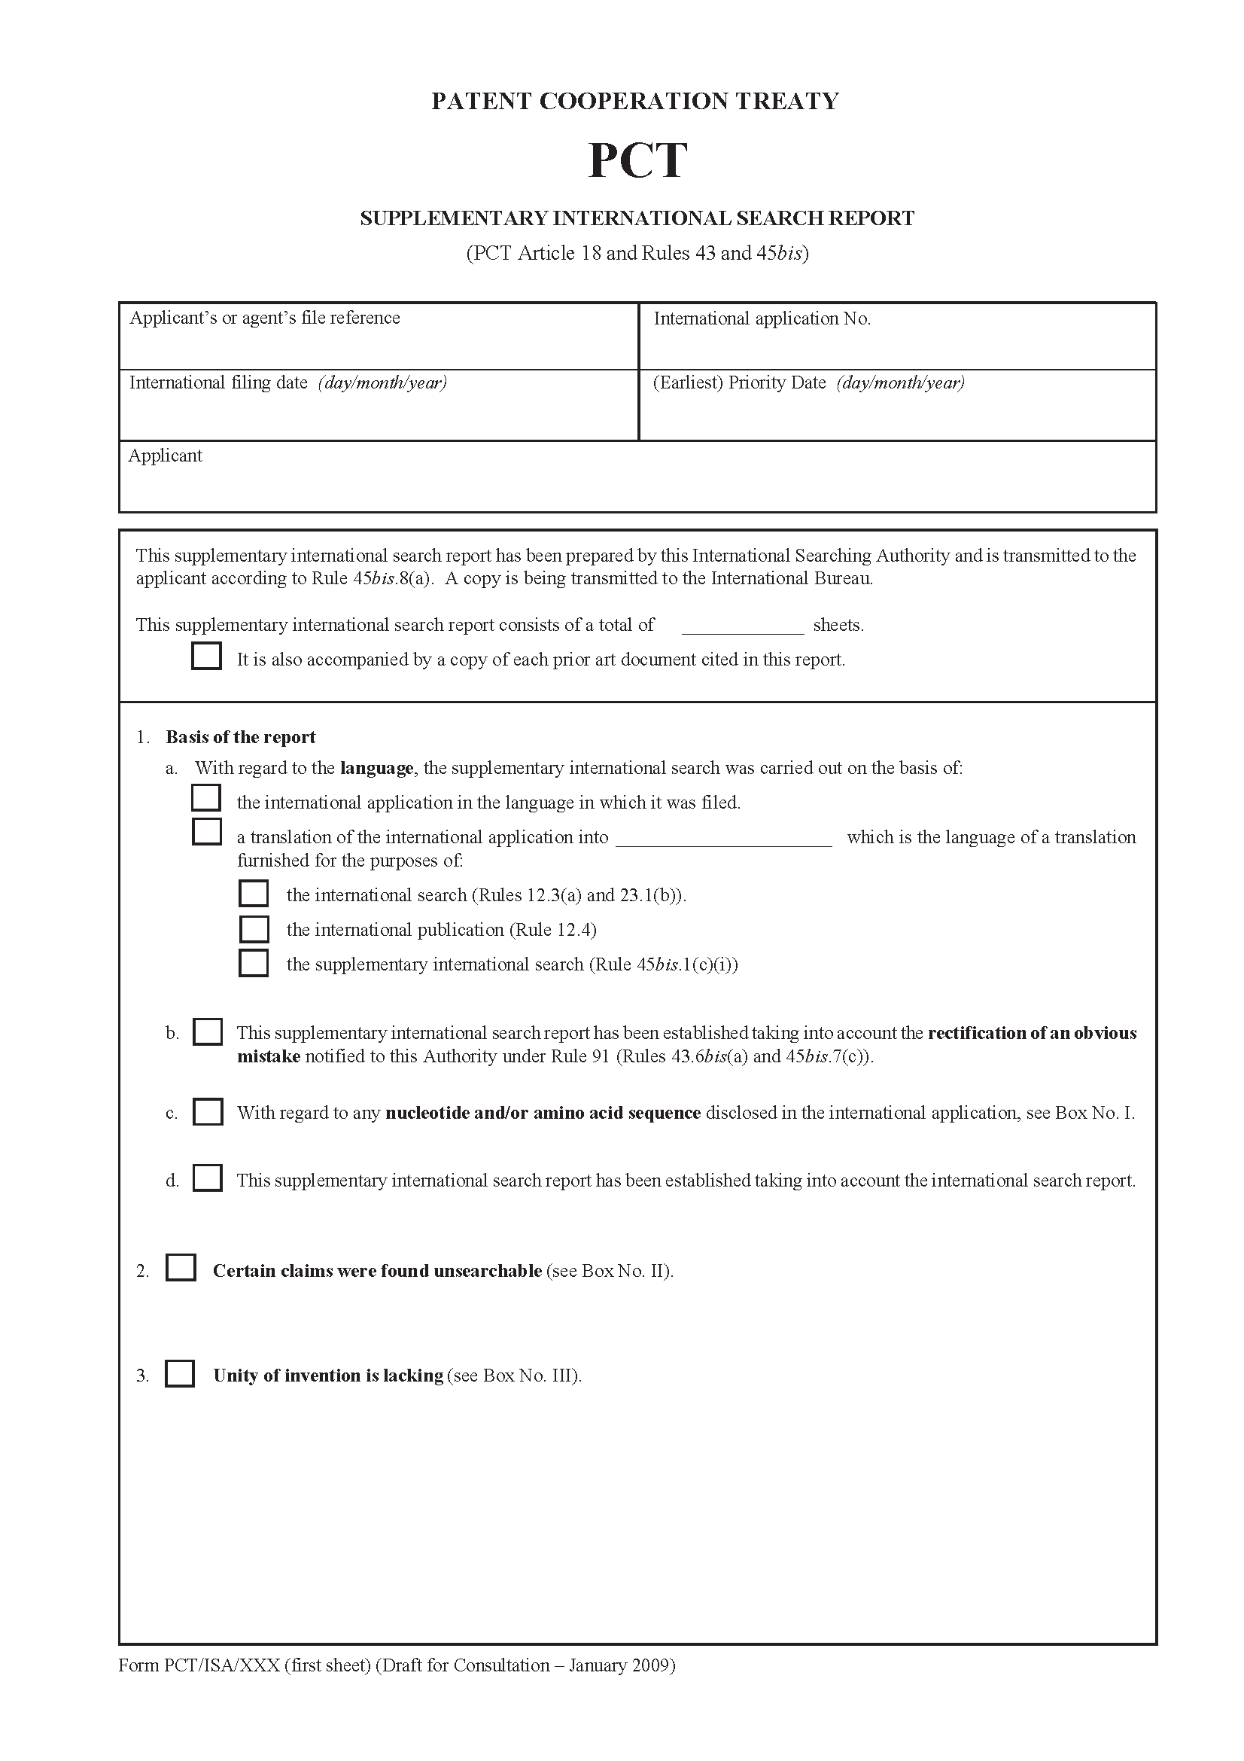
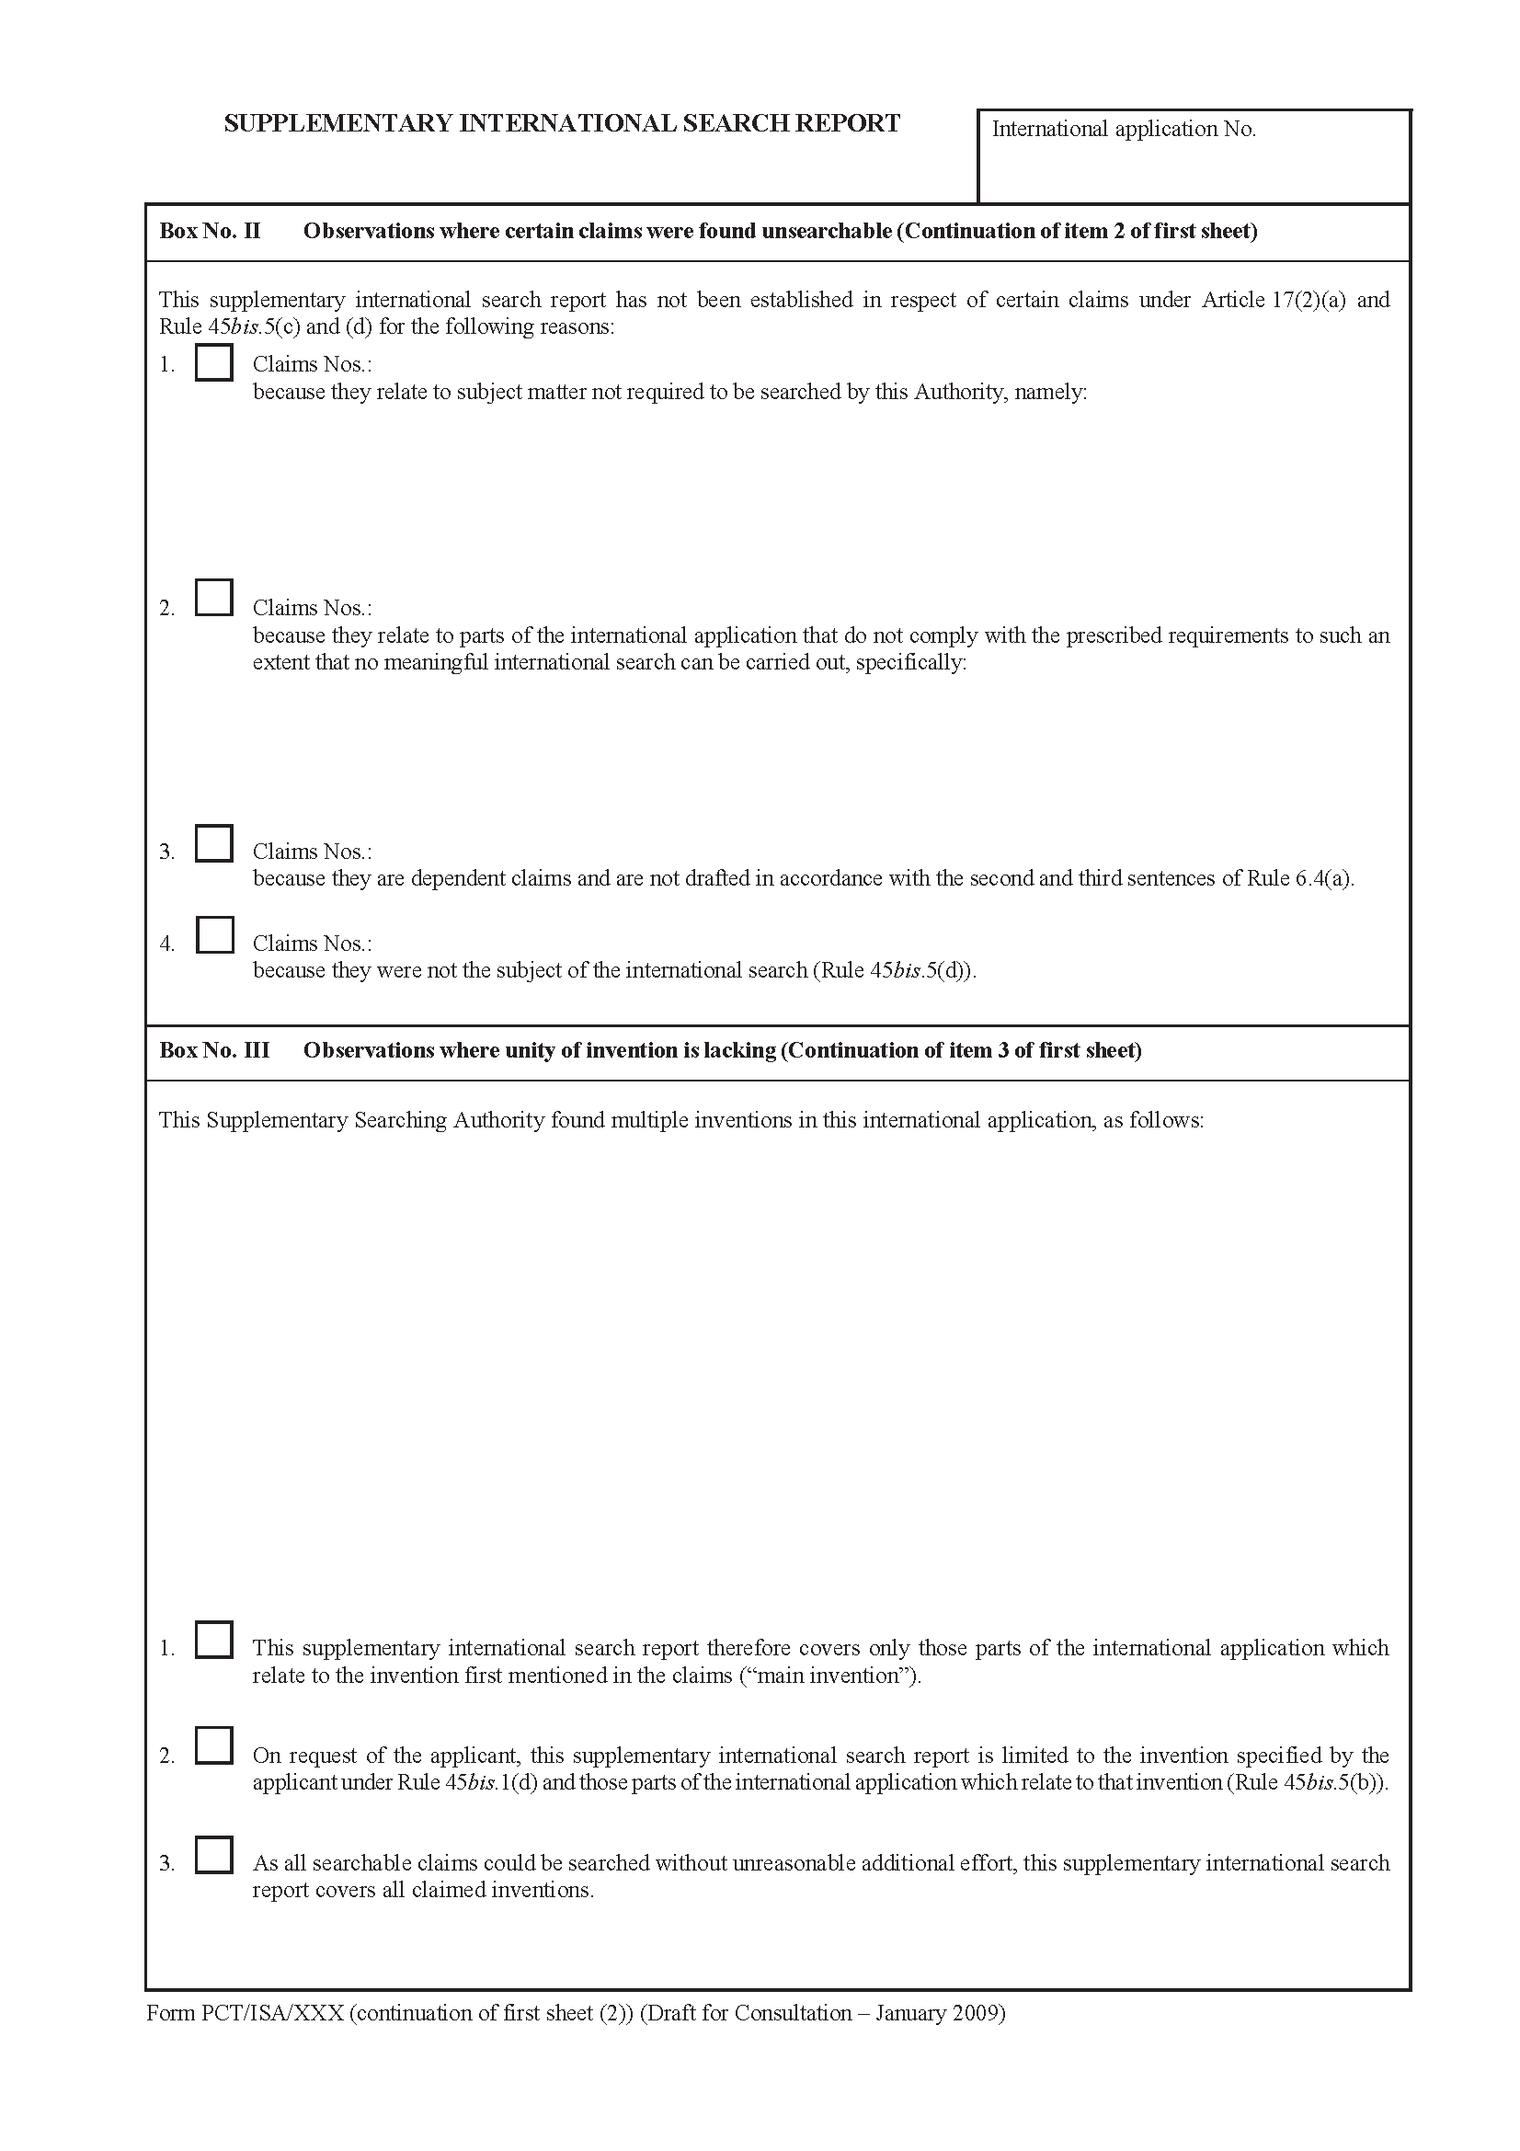
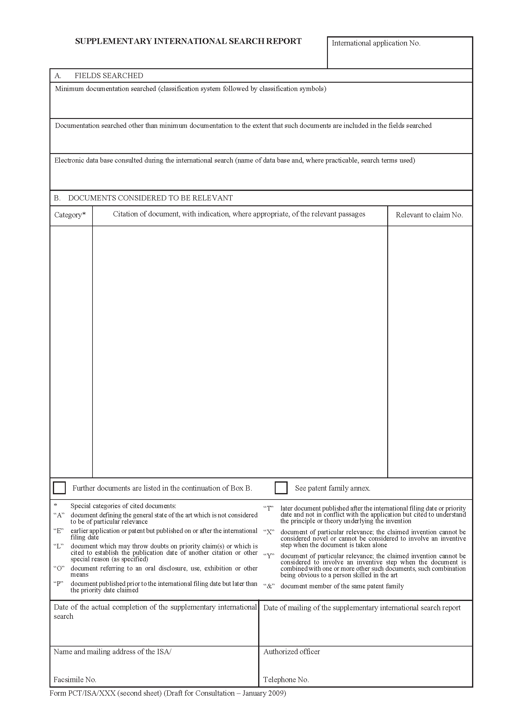
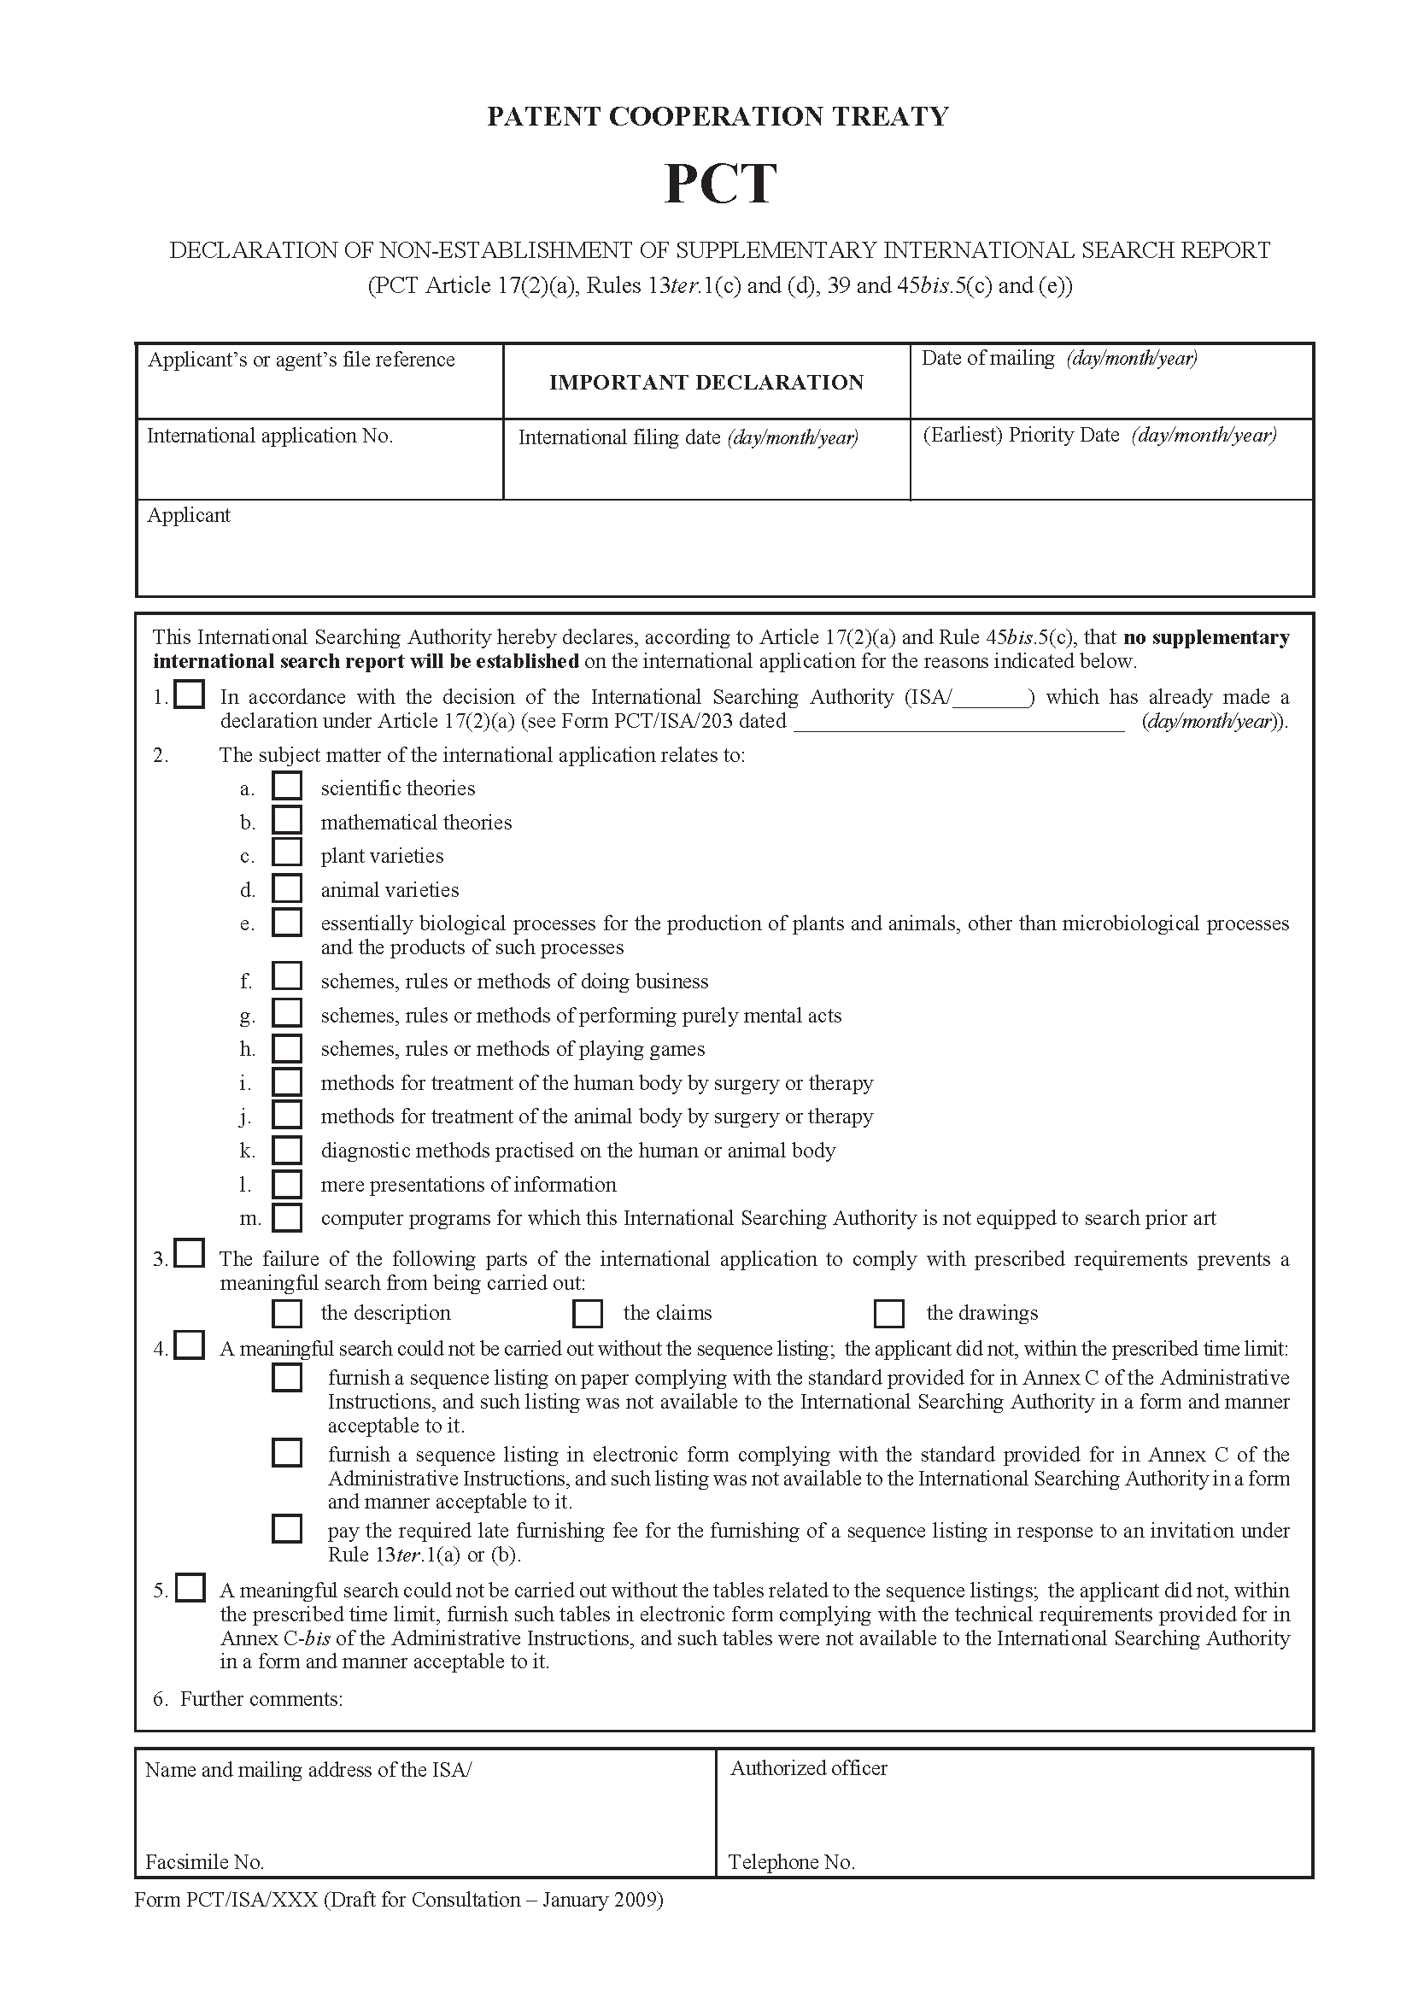
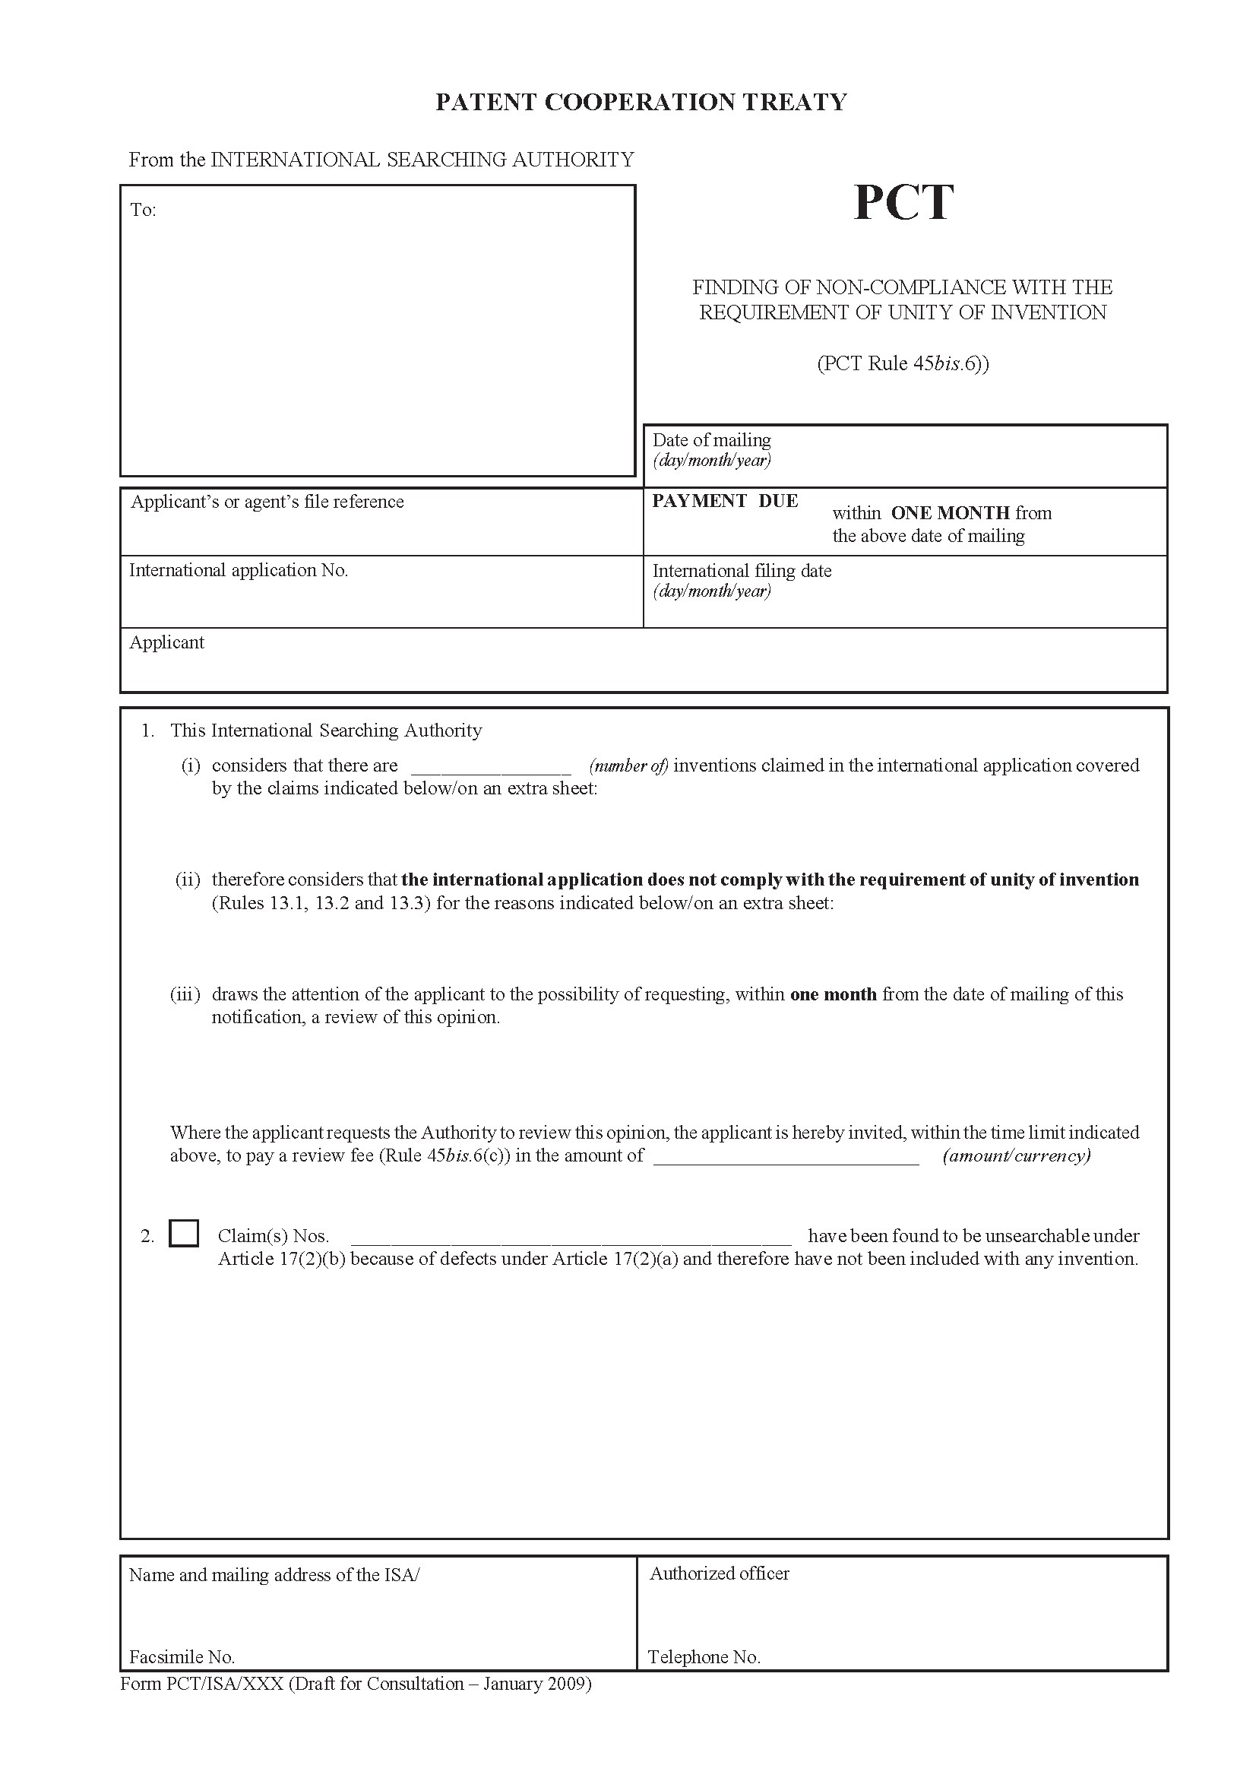
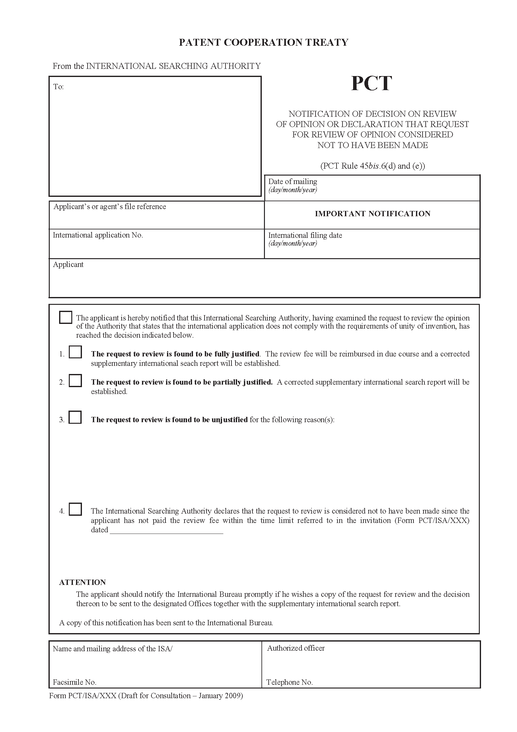

[Annex III follows]
Preliminary Draft Modified Guidelines

Chapter 15
The International Search

…

Supplementary International Search
15.71 Supplementary international search is an optional service offered by some International Searching Authorities. It is intended as a supplement to the main international search, recognizing the fact that no search can be completely exhaustive and is particularly relevant to the situation where the Authority conducting the supplementary international search has particular language specializations which may not be available in the International Searching Authority which conducts the main international search.
15.72 Many of the details of the service provided are decided by the Authority which is to carry out the supplementary international search. The scope of the service is defined in an annex to the agreement between the International Bureau and the International Authority and details are published in the PCT Applicant’s Guide.

Requesting Supplementary International Search
Rules 45bis.1 and 45bis.4
15.73 If the applicant wishes a supplementary international search to be carried out, he must submit a request to the International Bureau within 19 months from the priority date and pay the relevant fees within one month of submitting the request. It is expected that a request for supplementary international search will usually only be made after the applicant has seen and considered the main international search report, but this is not a requirement.
15.74 If the request is valid and all the fees and necessary additional items (translations and copies of sequence listings in electronic form) are provided, the International Bureau will, once it has received the international search report or after the expiration of 17 months from the priority date, whichever occurs first, transmit to the Authority specified for supplementary search a copy of each of the following:
(i) the supplementary search request;
(ii) the international application;
(iii) any sequence listing furnished with the request for supplementary international search;
(iv) any translation furnished by the applicant which is to be used as the basis of the supplementary international search;
and, at the same time or promptly after their later receipt by the International Bureau:
(v) the international search report and the written opinion established under Rule 43bis.1;
(vi) any invitation by the International Searching Authority to pay additional fees referred to in Article 17(3)(a); and
(vii) any protest by the applicant under Rule 40.2(c) and the decision thereon by the review body constituted in the framework of the International Searching Authority.

Start of Supplementary International Search
Rule 45bis.5(a)
15.75 The Authority specified for supplementary search starts the supplementary international search promptly on receipt of the documents indicated in items (i) to (iv) of paragraph 15.74, above, save that the Authority may, at its option, delay the start of the search until it has also received the international search report and written opinion of the International Searching Authority, or until the expiration of 22 months from the priority date, whichever occurs first.

Basis of the Supplementary International Search
Rule 45bis.5
15.76 Although the applicant will often have had an opportunity to file amended claims under Article 19 by the time that the supplementary search is carried out, the supplementary search is performed on the basis of the international application as filed (or a translation thereof) so that it is easier for a truly complementary search to be performed and for the results to be considered together by the applicant or a designated Office.

Claims Excluded from Supplementary International Search
Rule 45bis.5(c) to (e) and (g)
15.77 The supplementary search may exclude:
(i) any claims which would not be the subject of international search by the Authority carrying out the supplementary search, whether for reasons of clarity, subject matter or failure to provide, after a warning and opportunity to comply, a sequence listing in an appropriate form (see paragraphs 15.11 and 15.29);
(ii) where the international search report or a declaration under Article 17(2)(a) has been established before the start of the supplementary search, any claims which were not the subject of the international search; and
(iii) any claims which are excluded by a limitation or condition specified in the part of the agreement between the International Bureau and the International Authority stating the scope of its service.
15.78 If such exclusions mean that no supplementary international search report will be established, the Authority so declares and promptly notifies the applicant and the International Bureau using Form PCT/ISA/XXX. On the other hand, if some claims are excluded, but a supplementary search report is nevertheless established, the limitations are indicated in Box No. II of the supplementary international search report (Form PCT/ISA/XXX).

Unity of Invention
Rules 45bis.5(b) and 45bis.6
15.79 Contrary to the case for the main international search, no opportunity is offered to pay additional fees in case it is found that the international application lacks unity of invention. Rather, the supplementary international search report is immediately established on those parts of the international application which relate to the main invention. Normally, this will mean the invention first mentioned in the claims. However, the examiner should also consider the following in determining whether there is unity of invention and, if so, what is considered to be the main invention:
(i) though not bound by the views of the International Searching Authority, due account should be taken of any opinion on unity of invention included in the documents indicated in items (vi) and (vii) of paragraph 15.74, above;
(ii) if the International Searching Authority has found a lack of unity of invention, the applicant may, under Rule 45bis.1(d) have specified a wish that the supplementary search be limited to one of those inventions (for example, because the first invention is clearly not novel and he does not wish to pursue it further) – if the examiner agrees with the assessment of unity of invention and the relevant claims are not excluded for any reason, the supplementary international search should focus on that invention;
(iii) where the invention first claimed would not be searched for any reason, the first searchable invention should be considered instead;
(iv) if other inventions are easily searched, it may be appropriate to include those inventions within the scope of the supplementary search report (see paragraph 10.64).
15.80 The examiner’s opinion on unity of invention and the consequent scope of the supplementary international search should be reported on the supplementary international search report in the same way as for the main international search.
Rule 45bis.6
15.81 The normal protest procedure (see paragraphs 10.66 to 10.70) does not apply to requests for supplementary international search. However, the applicant may, within one month of the date of notification of the supplementary international search report, request the Authority to review the examiner’s opinion on unity of invention. This request may be subject to a review fee. The results of the review are promptly notified to the applicant using Form PCT/ISA/XXX. If the examiner’s opinion is found to be at least partly unjustified, the Authority should issue a corrected supplementary search report, stating the revised view on unity of invention and, where appropriate, including the search results for all claims which should have been included. If the opinion was entirely unjustified, the applicant should also have any review fee refunded.

Extent of Search
Rule 45bis.5(f)
15.82 The minimum extent of a supplementary search is set out in the agreement between the International Bureau and the Authority specified for supplementary search. This will in general be different from the PCT minimum documentation under Rule 34 since it is expected that the main international search should, subject to the language-related exceptions in paragraph (e) of that Rule, cover that documentation fully.

Establishment of the Supplementary International Search Report
Rule 45bis.7(a)
15.83 The supplementary international search report (Form PCT/ISA/XXX) shall be established, or declaration that no such report shall be established (Form PCT/ISA/XXX) must be made within 28 months from the priority date and transmitted to the applicant and to the International Bureau.
Rule 45bis.7(b)
15.84 The report or declaration is made in a language of publication: normally either the language of publication of the international application, or else the language of the translation provided for the purpose of the supplementary international search, though there may be cases where the first is not a language offered by the Authority and the second is not a language of publication.
Rule 45bis.8
15.85 The contents of the supplementary international search report are essentially the same as for the main international search report, save for the following:
(i) an indication should be given on the cover sheet of whether the examiner was able to take into account the main international search report;
(ii) the examiner does not classify the international application or make any indication of its classification on the supplementary international search report;
(iii) it is not necessary to include the citation of any document cited in the main international search report, unless it is considered to have additional relevance when cited in conjunction with other documents not cited in the main international search report;
(iv) explanation may be included with regard to the citations considered to be relevant: this is to allow short comments to be included to indicate what the relevant features of a document are in view of the fact that no additional written opinion is established and citations may frequently be in a language not easily understood by the applicant – the explanation is not intended to be a full explanation of the document’s relevance to novelty and inventive step of the sort expected in a written opinion;
(v) explanation may be included with regard to the scope of the supplementary international search, for example to indicate any assumptions made relating to the appropriate scope of search where the main international search report was not established and transmitted to the Authority specified for supplementary search in time to be considered during the search.

Copies of Documents
Rule 45bis.7(c)
15.86 The Authority must provide copies of cited documents to the applicant or any designated Office, subject to the payment of any relevant fees, on request at any time within 7 years from the international filing date, as would be the case for the International Searching Authority under Article 20(3) and Rule 44.3.

[End of Annex III and of document]

The Table of Contents is included for convenience; it does not form part of the amendments.

