WIPO |  | E  PCT/MIA/15/10  ORIGINAL: English only  DATE: April 2, 2008
WORLD INTELLECTUAL PROPERTY ORGANIZATION
GENEVA
INTERNATIONAL PATENT COOPERATION UNION
(PCT UNION)
MEETING OF INTERNATIONAL AUTHORITIES
UNDER THE PATENT COOPERATION TREATY (PCT)
Fifteenth Session
Vienna, April 7 to 9, 2008
Use of Searches by Offices Other than the One Acting as International Searching Authority
Document prepared by the Secretariat

Summary

The Meeting is invited to note the effect of and actions which may be required from certain new Rules which come into force July 1, 2007, relating to the use of searches conducted by other Offices, and to consider what additional guidelines and collective action may be appropriate to make these Rules increasingly beneficial to applicants and Offices in the future.

Background

At its 36th session in September–October 2007, the PCT Assembly adopted, with effect from July 1, 2008, a new PCT Rule 12bis and amendments to PCT Rules 4.12 (previously Rule 4.11(a)(i) and (ii)), 16.3 and 41, permitting applicants to request the International Searching Authority to take into account the results of an earlier search which has been carried out by an Office other than that which is acting as International Searching Authority, in addition to the existing possibility of basing the search on one which it had itself previously performed.

The relevant new Rules are set out in Annex I for reference.

The Assembly also noted (see paragraph 137 of document PCT/A/36/13):

in connection with the addition of new Rule 4.12, that an “earlier search” under that Rule includes an earlier search carried out under the responsibility of an Authority or Office which contracts out searches as well as a search carried out by an Authority or Office itself; and

in connection with the addition of new Rules 4.12(ii) and 12bis.1(e), that an international application is only considered to be “substantially the same” as the application in respect of which the earlier search was carried out (where applicable, except that the international application is filed in a different language) if both applications are the same in substance, including the inventions described and claimed; any changes may relate only to minor clerical or administrative matters, such as formatting, correction of minor errors, or inclusion or omission of matter not specific to the invention but which is required for applications in some States but not others (for example, details of public funding used in the development of the invention); any International Searching Authority would be free to require the applicant to clarify what the differences were between the international application and the earlier application concerned.

New and modified Forms relating to the amended Rules were proposed in Circular C. PCT 1132, dated February 21, 2008. Relevant extracts are reproduced in Annex II.

These Rules use a term “take into account”, which was not the subject of any note or understanding by the Assembly, but which was understood by the Working Group on Reform of the PCT as follows (see paragraph 134 of document PCT/R/WG/9/8):

“134. After some discussion, it was agreed that, throughout the proposed amendments of the Regulations, the term “take into account” (the results of an earlier search) should be retained and not replaced by another term such as “use”, “consider”, or “base … on”. The term “take into account” was to be understood as meaning that the International Searching Authority found the results of the earlier search useful and beneficial for the purposes of establishing the international search report, as distinct from merely reading, studying or considering the results of the earlier search.”

The long-term aim of these rules is to promote work-sharing between Offices such that earlier work is taken into account in a manner which reduces the work burden of the International Searching Authority or increases the quality of the international search report which is established. Preferably both objectives should be achieved and the system should never be used to the detriment of quality. However, as was pointed out by several Offices in the Working Group on Reform of the PCT, work-sharing between Offices is still at an early stage. Quality systems and search results vary widely between examining Offices.

Various pilot schemes are studying how best to use the results of search and examination work which have been performed elsewhere, including the Utilization Pilot Project in the context of the European Patent Network and various projects led by the Trilateral Offices (European Patent Office, Japan Patent Office and United States Patent and Trademark Office) and it is expected that understanding of how to use reports from different Offices effectively will increase over time. Consequently, the rules were written to allow a large amount of flexibility for International Authorities, so that use of work carried out in other Offices could begin quickly, without tying Authorities down to assumptions on practice which may prove inappropriate in the future.

Effects on International Searching Authorities

Procedural Issues

The applicant has a right under Rule 4.12 to indicate that he wishes the International Searching Authority to take into account an earlier search, irrespective of whether it was carried out by that Office or by another Office. Consequently, receiving Offices are likely to begin to receive copies of earlier search reports or other documents listing prior art cited by other Offices (or requests to provide copies of such documents from the files of the receiving Office), and these will be forwarded to the International Searching Authority together with the search copy. The International Searching Authority may also be requested to retrieve copies of earlier searches from their own files or digital libraries but, for the present, this will usually only be relevant to the existing case where the Authority itself carried out the earlier search.

Rule 12bis gives the International Searching Authority the right to invite the applicant to furnish other documents, such as a copy of the earlier application or translations of the application or search report. A new Form PCT/ISA/238 was proposed in Annex III to Circular C. PCT 1132 and is reproduced in Annex II. Although not specifically provided for in the Rules, it is likely that some such documents will also be provided by the applicant to the receiving Office at the outset in some cases, particularly if it is apparent that the particular International Searching Authority will require them. It is intended to provide in the Receiving Office Guidelines that such documents should be forwarded to the International Searching Authority with the search copy.

Use of the Earlier Search

According to Rule 41.1, the International Searching Authority is only obliged to take into account earlier reports for which it carried out the search itself (whether in its capacity as an International Searching Authority or otherwise). For other reports, it has complete discretion over the extent to which they will be used. However, it will receive search reports from the receiving Office and, as a minimum, it is hoped that the examiner will review the earlier search report to see whether the fields of search and cited documents are relevant and whether they provide inspiration for databases, classification terms or terms of art which may be of use in improving the quality of the international search which is conducted. Whether the results of the search can be taken into account in the sense described under paragraph , above, producing a significantly higher quality result or else significantly reducing the amount of searching required without lowering the quality of result, will depend on the policy of the Authority and the extent to which the examiner considers the results useful in the particular circumstances.

It is hoped that Authorities will analyse their experiences of the use of searches carried out by other Offices (both under the PCT and during national work-sharing systems) so that future sessions of this Meeting may be able to share experience of how to make use of these details effectively and to consider what might be done to make the system more useful, such as development of common standards in reporting the results of searches, or improved access to search strategies.

Draft modifications to the PCT International Search and Examination Guidelines are set out in Annex III.

Fee Issues

At present, each agreement between the International Bureau and an International Searching Authority (except for that with the United States Patent and Trademark Office) has a provision in Part II of Annex C indicating what refund is given in the event of the Authority benefiting from an earlier search. In some cases, there are differing amounts stated depending on the extent to which the examiner considers that the Authority has benefited.

Most of these refunds are stated in terms of “Where the Authority benefits from an earlier search …”, without stating that the earlier search had to be one which had been conducted by that Office – such a statement was irrelevant since the applicant was not permitted to request the Authority (in the terms of the Rules prior to amendment) to base the international search on any other type of search. For Authorities whose agreements are set out in this way, the refunds will (to the extent that the search is taken into account) equally apply, irrespective of the Office which carried out the earlier search, with effect from July 1, 2007. If a different approach is intended (for example, to offer larger discounts where the earlier search was carried out by the same Office than where it was carried out by a different Office), it will be necessary to amend the relevant provision in the agreement.

On the other hand, the agreements with the European Patent Office, the Spanish Patent and Trademark Office, the National Board of Patents and Registration of Finland, and the Federal Service for Intellectual Property, Patents and Trademarks (Russian Federation) include specific statements that the refunds apply only in the case of searches carried out by those Offices. In these cases, it will be necessary to amend the agreements if it is desired to offer refunds where the Authority takes into account earlier searches conducted by other Offices.

Ideally, these provisions in the agreements should be modified to use the terms of the new wording of Rule 16.3, preferably in as consistent a manner as possible between Authorities. Possible examples might include:

“Where the Authority takes into account, under Rule 41.1, the results of an earlier search, 25% or 50% of the search fee shall be refunded, depending on the extent to which the Authority benefits from that earlier search.”

or

“Where the Authority takes into account, under Rule 41.1, the results of an earlier search:

“(i) 50% of the search fee shall be refunded if the earlier search was carried out by the Authority; or

“(ii) 25% of the search fee shall be refunded if the earlier search was carried out by any other Office.”

Ideally, any difference between amounts of refund should be appropriate to the differences in benefit which are found, for example because where the Authority conducted the earlier search itself, it has access to fuller records in a format completely familiar to the examiner (who may even be the examiner who conducted the earlier search).

In view of the fact that the effect remains clear irrespective of the exact wording, immediate amendment appears only to be necessary if it is desired to change the amount of refund which will apply, or to introduce the ability to offer refunds which would otherwise be excluded for the case of earlier searches conducted by other Offices. Given that in many cases the refunds are stated in terms taken from national legislation which requires approval by a parliament or governing body, it is likely that changes simply to follow the wording of the new Rules will only be worth pursuing in conjunction with substantive changes to the particular International Authority’s fees.

Where a change is needed to reduce the refund which will be available for taking into account a search which is carried out by another Office, it will be necessary to notify the Director General in accordance with Articles 11(3) and (4) by June 1, 2008 in order for the change to be effective for international applications filed from July 1, 2008. In principle, amendments increasing the refund available could be made at any time before July 1, 2008, though in practice a month’s notice is highly desirable so that the changes can be published in the PCT Gazette and Applicant’s Guide before coming into force.

The Meeting is invited:

(i) to note the effects of the new Rules on International Searching Authorities and their agreements with the International Bureau;

(ii) to comment on the draft modifications to the Forms set out in Annex II and the PCT International Search and Examination Guidelines set out in Annex III; and

(iii) to consider whether any further Administrative Instructions, guidelines or development of common approaches may be appropriate.

[Annexes follow]
Rule 4
The Request (Contents)
4.1 to 4.11 [Not relevant]
4.12 Taking into Account Results of Earlier Search
If the applicant wishes the International Searching Authority to take into account, in carrying out the international search, the results of an earlier international, international-type or national search carried out by the same or another International Searching Authority or by a national Office (“earlier search”):
(i) the request shall so indicate and shall specify the Authority or Office concerned and the application in respect of which the earlier search was carried out;
(ii) the request may, where applicable, contain a statement to the effect that the international application is the same, or substantially the same, as the application in respect of which the earlier search was carried out, or that the international application is the same, or substantially the same, as that earlier application except that it is filed in a different language.
4.13 to 4.19 [Not relevant]

Rule 12bis
Copy of Results of Earlier Search
and of Earlier Application; Translation
12bis.1 Copy of Results of Earlier Search and of Earlier Application; Translation
(a) Where the applicant has, under Rule 4.12, requested the International Searching Authority to take into account the results of an earlier search carried out by the same or another International Searching Authority or by a national Office, the applicant shall, subject to paragraphs (c) to (f), submit to the receiving Office, together with the international application, a copy of the results of the earlier search, in whatever form (for example, in the form of a search report, a listing of cited prior art or an examination report) they are presented by the Authority or Office concerned.
[Rule 12bis.1, continued]
(b) The International Searching Authority may, subject to paragraphs (c) to (f), invite the applicant to furnish to it, within a time limit which shall be reasonable under the circumstances:
(i) a copy of the earlier application concerned;
(ii) where the earlier application is in a language which is not accepted by the International Searching Authority, a translation of the earlier application into a language which is accepted by that Authority;
(iii) where the results of the earlier search are in a language which is not accepted by the International Searching Authority, a translation of those results into a language which is accepted by that Authority;
(iv) a copy of any document cited in the results of the earlier search.
(c) Where the earlier search was carried out by the same Office as that which is acting as the receiving Office, the applicant may, instead of submitting the copies referred to in paragraphs (a) and (b)(i) and (iv), indicate the wish that the receiving Office prepare and transmit them to the International Searching Authority. Such request shall be made in the request and may be subjected by the receiving Office to the payment to it, for its own benefit, of a fee.
(d) Where the earlier search was carried out by the same International Searching Authority, or by the same Office as that which is acting as the International Searching Authority, no copy or translation referred to in paragraphs (a) and (b) shall be required to be submitted under those paragraphs.
(e) Where the request contains a statement under Rule 4.12(ii) to the effect that the international application is the same, or substantially the same, as the application in respect of which the earlier search was carried out, or that the international application is the same, or substantially the same, as that earlier application except that it is filed in a different language, no copy or translation referred to in paragraphs (b)(i) and (ii) shall be required to be submitted under those paragraphs.
(f) Where a copy or translation referred to in paragraphs (a) and (b) is available to the International Searching Authority in a form and manner acceptable to it, for example, from a digital library or in the form of the priority document, and the applicant so indicates in the request, no copy or translation shall be required to be submitted under those paragraphs.
Rule 16
The Search Fee
16.1 and 16.2 [Not relevant]
16.3 Partial Refund
Where the International Searching Authority takes into account, under Rule 41.1, the results of an earlier search in carrying out the international search, that Authority shall refund the search fee paid in connection with the international application to the extent and under the conditions provided for in the agreement under Article 16(3)(b).
Rule 41
Taking into Account Results of Earlier Search
41.1 Taking into Account Results of Earlier Search
Where the applicant has, under Rule 4.12, requested the International Searching Authority to take into account the results of an earlier search and has complied with Rule 12bis.1 and:
(i) the earlier search was carried out by the same International Searching Authority, or by the same Office as that which is acting as the International Searching Authority, the International Searching Authority shall, to the extent possible, take those results into account in carrying out the international search;
(ii) the earlier search was carried out by another International Searching Authority, or by an Office other than that which is acting as the International Searching Authority, the International Searching Authority may take those results into account in carrying out the international search.

[Annex II follows]
CONTENTS

PCT/RO/101 (Request)
Box No. VII (International Searching Authority; Use of Results of Earlier Search) 2
Box No. IX (Checklist; Language of Filing) 3

PCT/ISA/210 (International Search Report)
Item 1 (Basis of the Report) 4
Second Sheet [No change] (Fields Searched) 5

PCT/ISA/238 (Invitation to Furnish Documents in Connection with Earlier Search) 6
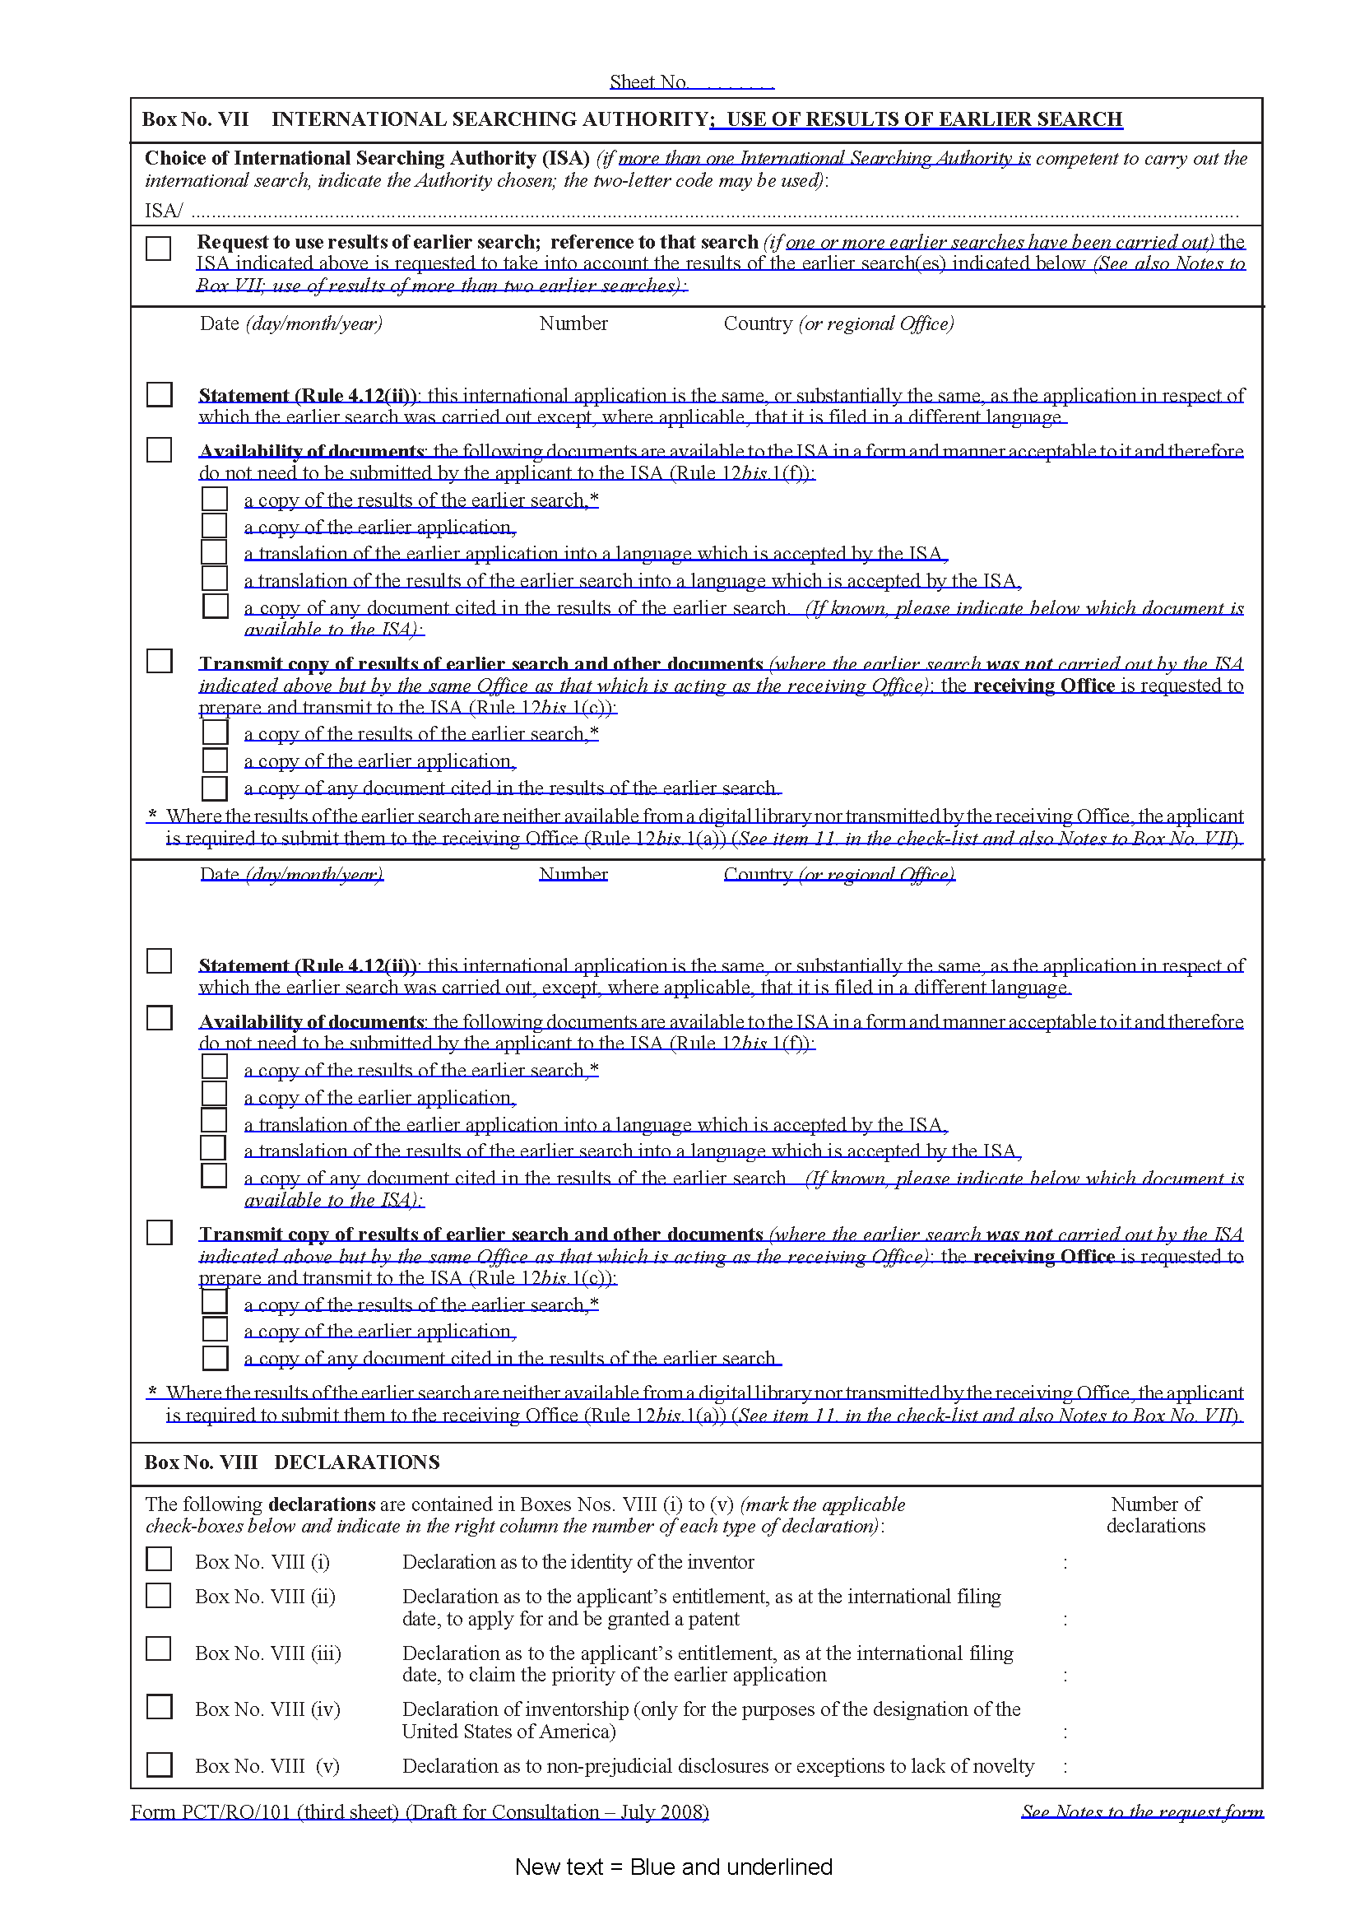
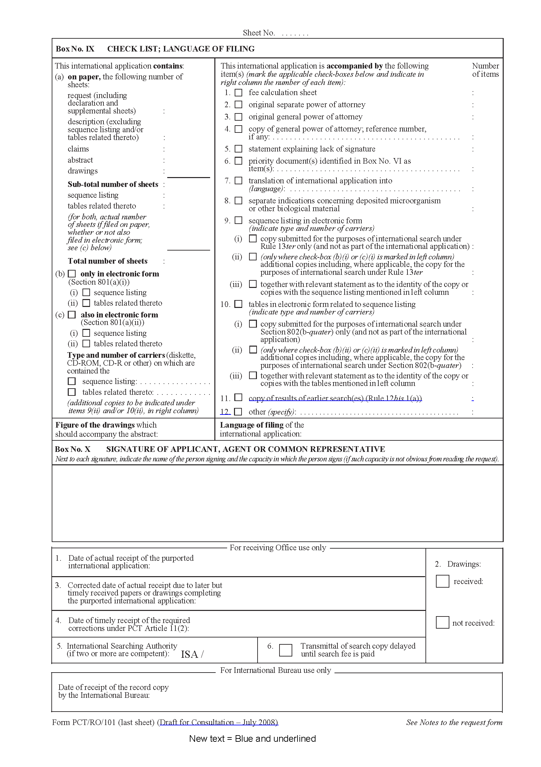
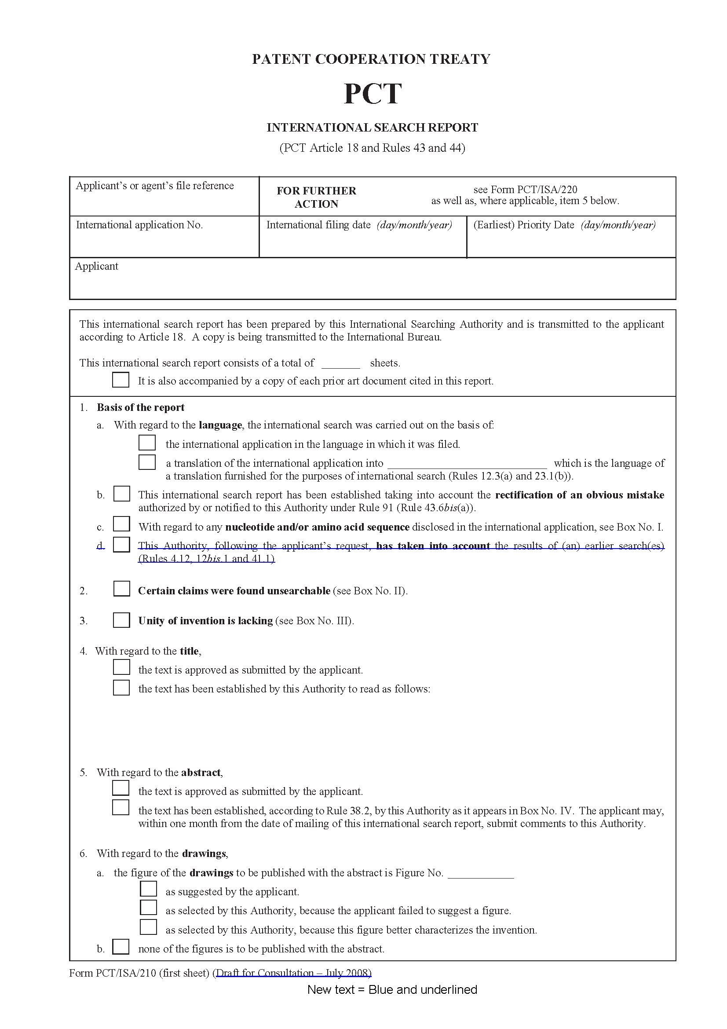
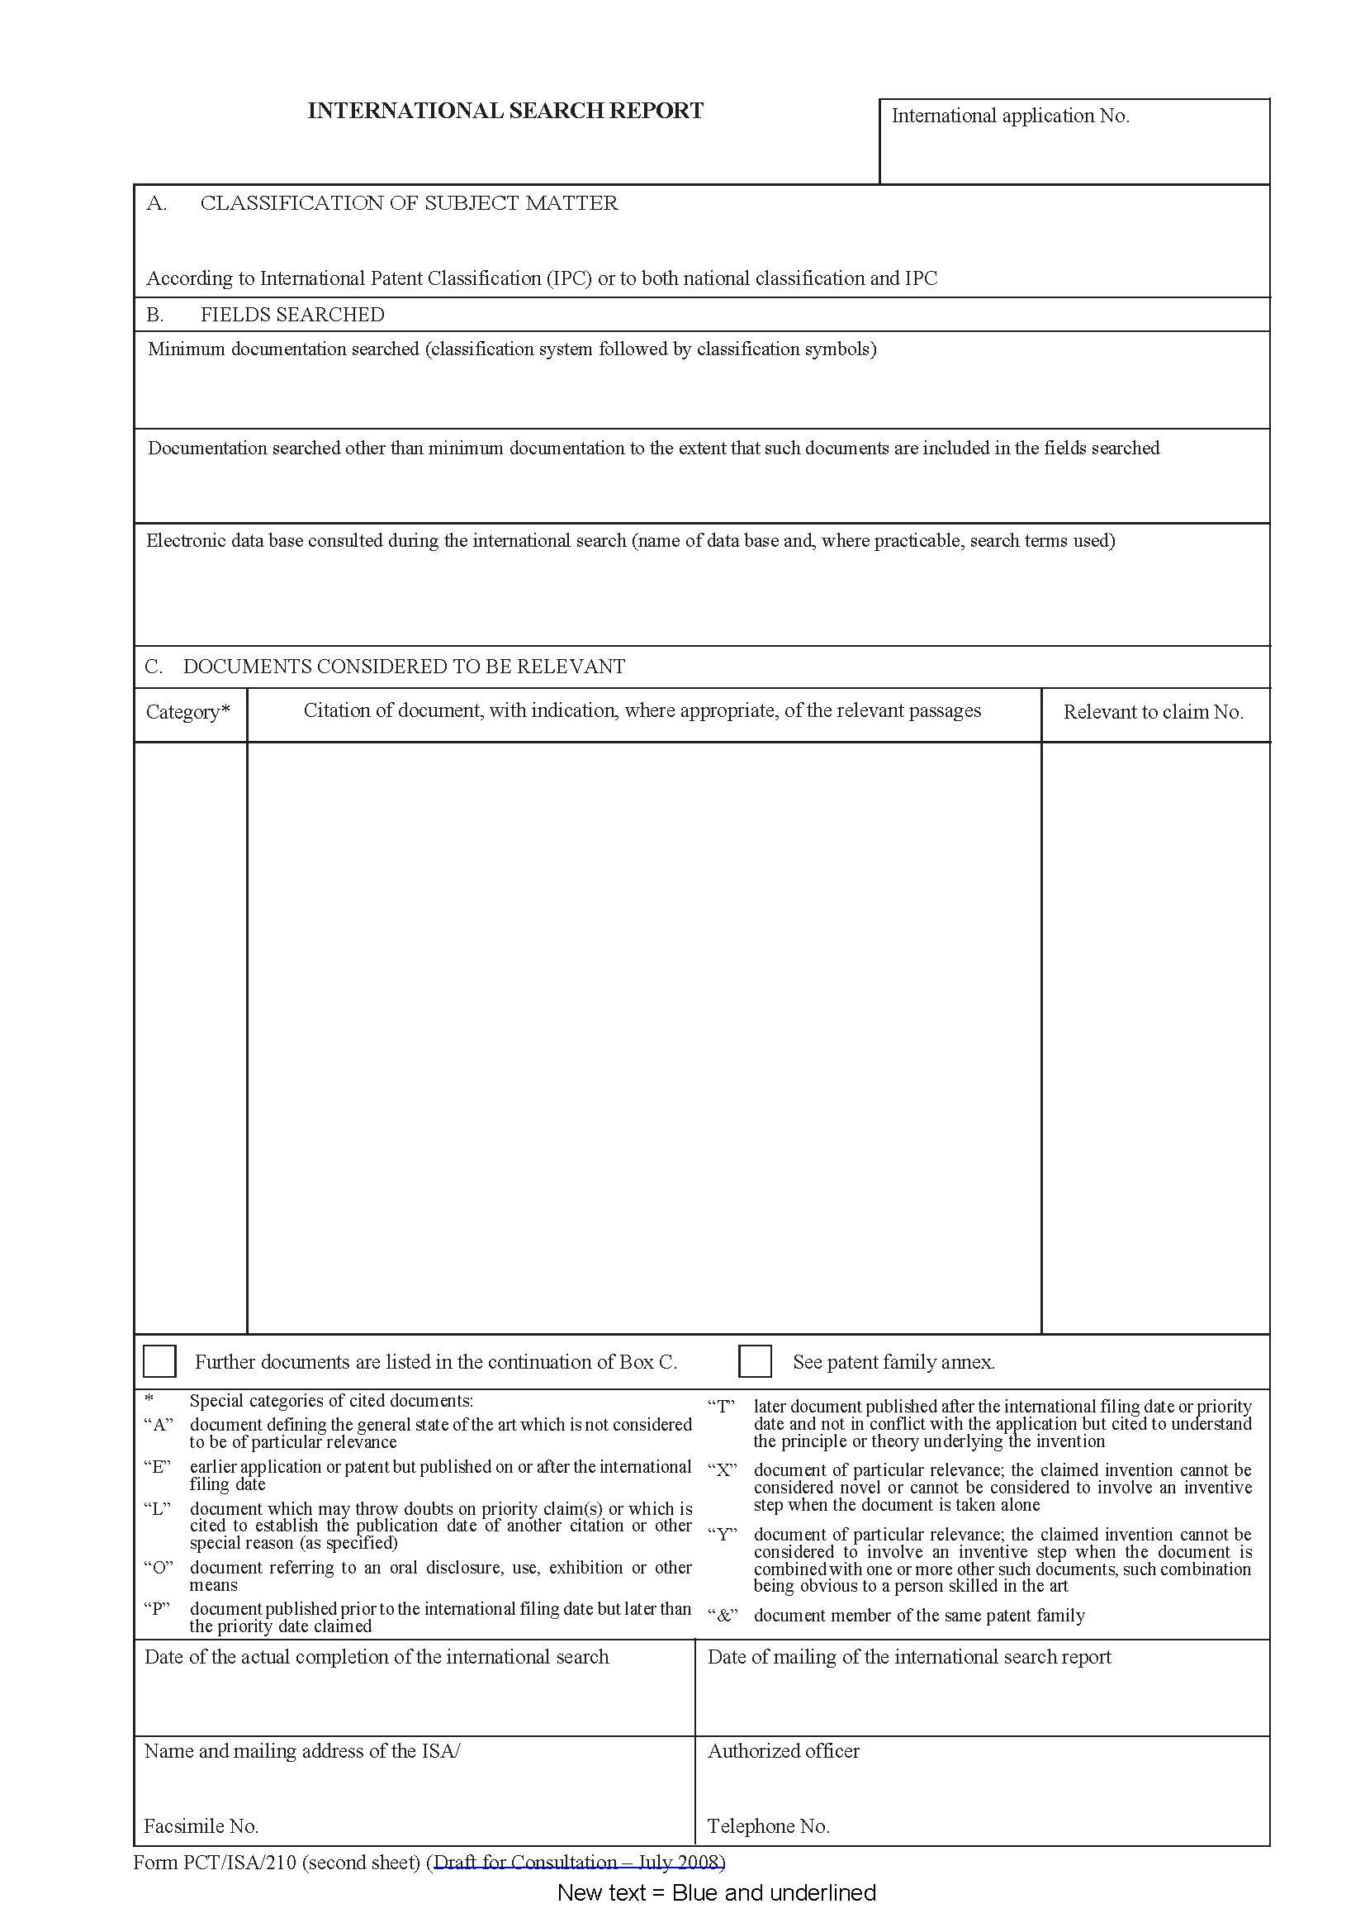
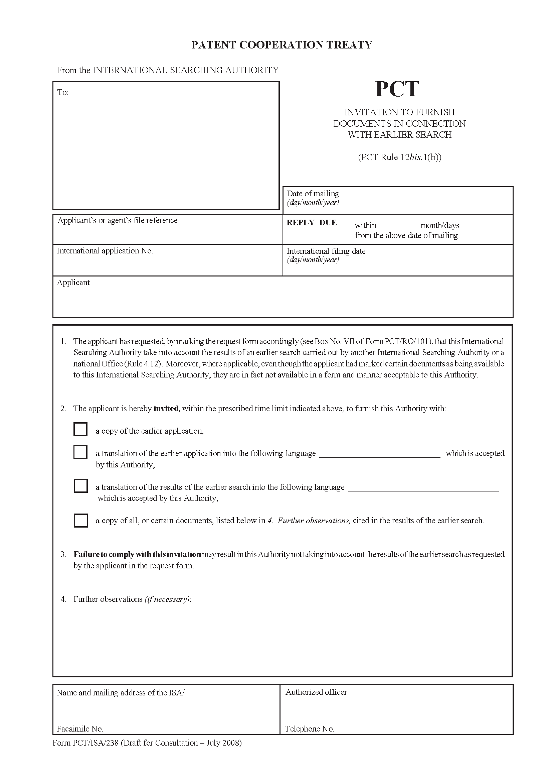
[Annex III follows]
PART IV
THE INTERNATIONAL SEARCH

Chapter 15
The International Search

…

Basis of the Search
…

Rules 4.12 and 12bis
15.13.1 The applicant may request the International Searching Authority to take into account the results of an earlier search carried out by that Office or by another Office. In this case, either a copy of the earlier search report (or other document listing cited prior art) will be sent by the receiving Office with the search copy, or else the International Searching Authority will be requested to retrieve a copy for itself where either it prepared the earlier search report itself, or else has access to it in a form and manner acceptable to it, for example from a digital library.
15.13.2 The Authority may additionally invite the applicant (optionally using Form PCT/ISA/238) to furnish the following items within a time limit reasonable under the circumstances, where they have not been transmitted by the receiving Office and are not already available to it from its own records or from a digital library which it is prepared to use for the purpose (and, if necessary, where the applicant has informed the Authority that the document is so available):
(i) a copy of the earlier application concerned;
(ii) where the earlier application is in a language which is not accepted by the International Searching Authority, a translation of the earlier application into a language which is accepted by that Authority;
(iii) where the results of the earlier search are in a language which is not accepted by the International Searching Authority, a translation of those results into a language which is accepted by that Authority;
(iv) a copy of any document cited in the results of the earlier search.
However, no copy or translation of the earlier application may be required if the applicant indicates in the request that the earlier application is “substantially the same” as the international application. By this, it is meant that the inventions described and claimed are the same and any changes, beyond accurate translation where relevant, relate solely to formatting and correction of minor errors, inclusion or removal of matter not specific to the invention, but which is required in some States (such as details of public funding used in the development of the invention).
Rules 16.3 and 41.1
15.13.3 Where the earlier search which the applicant requests to be taken into account was carried out by the same Office which is acting as an International Searching Authority, that Authority must, to the extent possible, take the results into account in establishing the international search report. Where the earlier search was conducted by another Office, the Authority may take the results into account. “Taking the results into account” in this context means finding a real benefit in those results to the extent that the earlier search may be considered to stand in place of a part of the international search. In any case, the examiner should consider the fields of search and cited documents in order to determine their relevance and whether they offer assistance in determining appropriate databases, classifications or terms of art in order to improve the quality of the international search.

…

Chapter 16
International Search Report

…

Filling Out the International Search Report (Form PCT/ISA/210)
…

Basis of the Report
16.23 If the search has been conducted on the basis of a translation of the international application (see paragraph 15.13), this is indicated in item 1 of the first sheet of the international search report. This item also includes indications of whether a rectification of an obvious mistake has been taken into account, a reference to any details relating to sequence listings used, and an indication of whether an earlier search has been taken into account (see also paragraphs 15.13.1 to 15.13.3 and 16.56).
…

Previous Search
16.56 [No change] Where the international search report is entirely or partly based on a previous search made for an application relating to a similar subject, the previous application number and the relevant search history consulted for this previous search is, where appropriate, identified as having been consulted for the international application in question, except in those instances where the details of an earlier search cannot be ascertained, or whenever it is impractical to record the full details of the earlier search. In the later case, a summary of the earlier search should be included. Where the previous application has been published, this information is recorded in the international search report; if the previous application has not yet been published, the information may be sent to the applicant informally when the international search report is transmitted. See paragraph 16.53.
…

[End of Annex III and of document]

