WIPO |  | PCT/CTC/XIX/3  ORIGINAL: English  DATE: April 29, 1997
WORLD INTELLECTUAL PROPERTY ORGANIZATION
GENEVA
INTERNATIONAL PATENT COOPERATION UNION
(PCT UNION)
PCT COMMITTEE FOR TECHNICAL COOPERATION
Nineteenth Session
Geneva, May 26 to 30, 1997
APPOINTMENT OF THE KOREAN INDUSTRIAL PROPERTY OFFICE AS
INTERNATIONAL SEARCHING AUTHORITY AND AS INTERNATIONAL
PRELIMINARY EXAMINING AUTHORITY
Document prepared by the International Bureau
1 In a letter dated April 4, 1997, the Korean Industrial Property Office (KIPO) expressed
the wish to be appointed as an International Searching Authority (ISA) and as an International
Preliminary Examining Authority (IPEA) under the Patent Cooperation Treaty (PCT). The
letter from KIPO is reproduced as an Annex to this document.

2. Article 16(3)(e) of the PCT provides that “Before the Assembly [of the PCT Union]
makes a decision on the appointment of any national Office [as an ISA]..., the Assembly
shall…seek the advice of the Committee for Technical Cooperation...” (hereinafter referred to
as the PCT/CTC).

3. According to Article 32(3) of the PCT, the provisions of Article 16(3) shall apply,
mutatis mutandis, in respect of the appointment of an IPEA.

4. The advice given by the PCT/CTC at its nineteenth session in respect of the request by
KIPO will be submitted, together with that request and a draft agreement between KIPO and
the International Bureau in respect of KIPO’s functioning as an ISA and IPEA, to the
Assembly of the PCT Union for consideration at its next session to be held in
September 1997.

5. The PCT/CTC is invited to give its
advice on this matter.

[Annex follows]

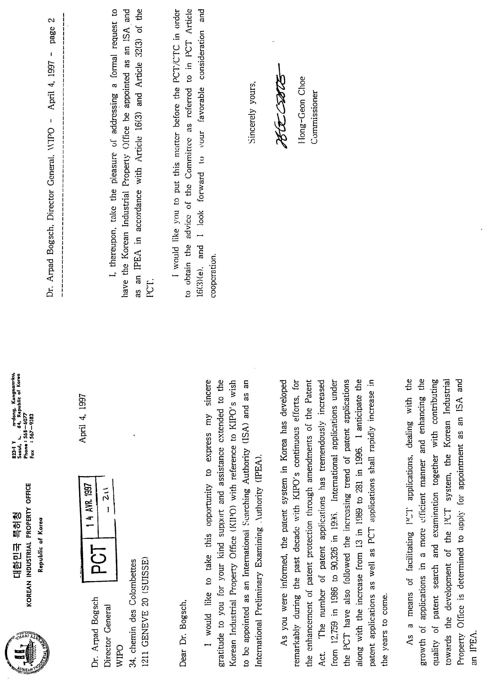

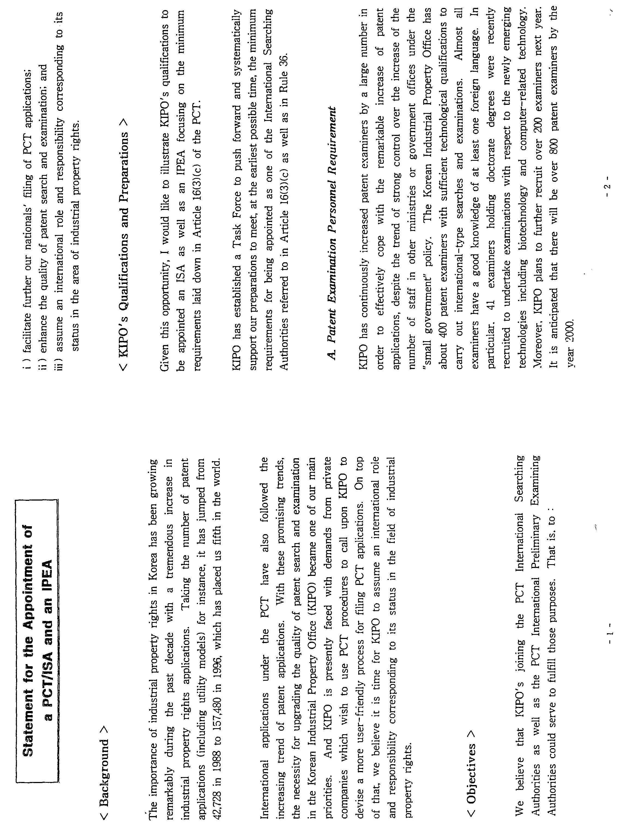

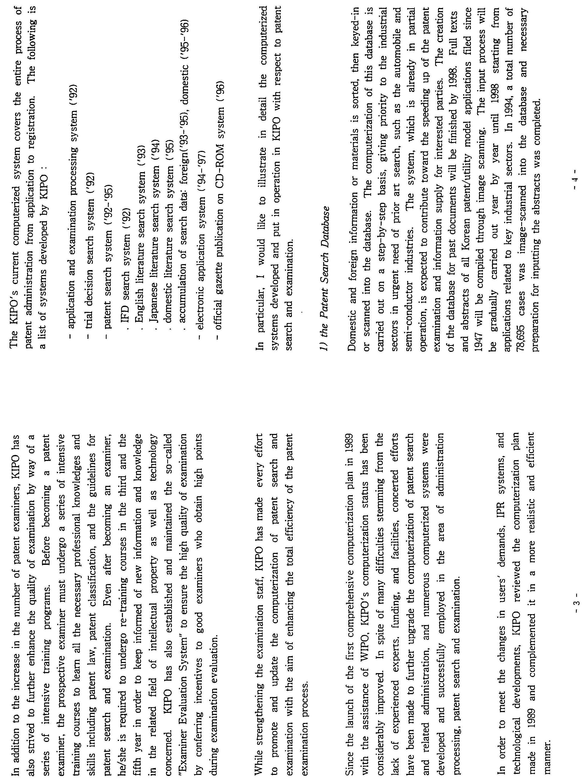

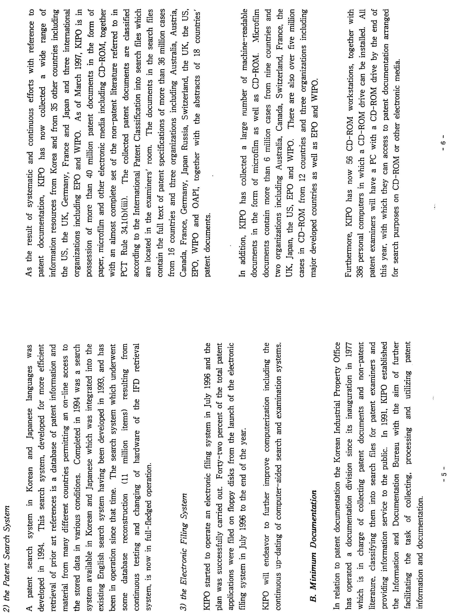

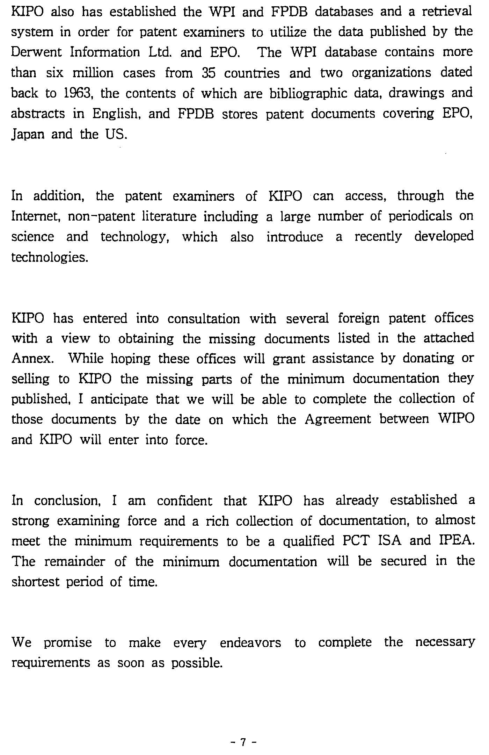
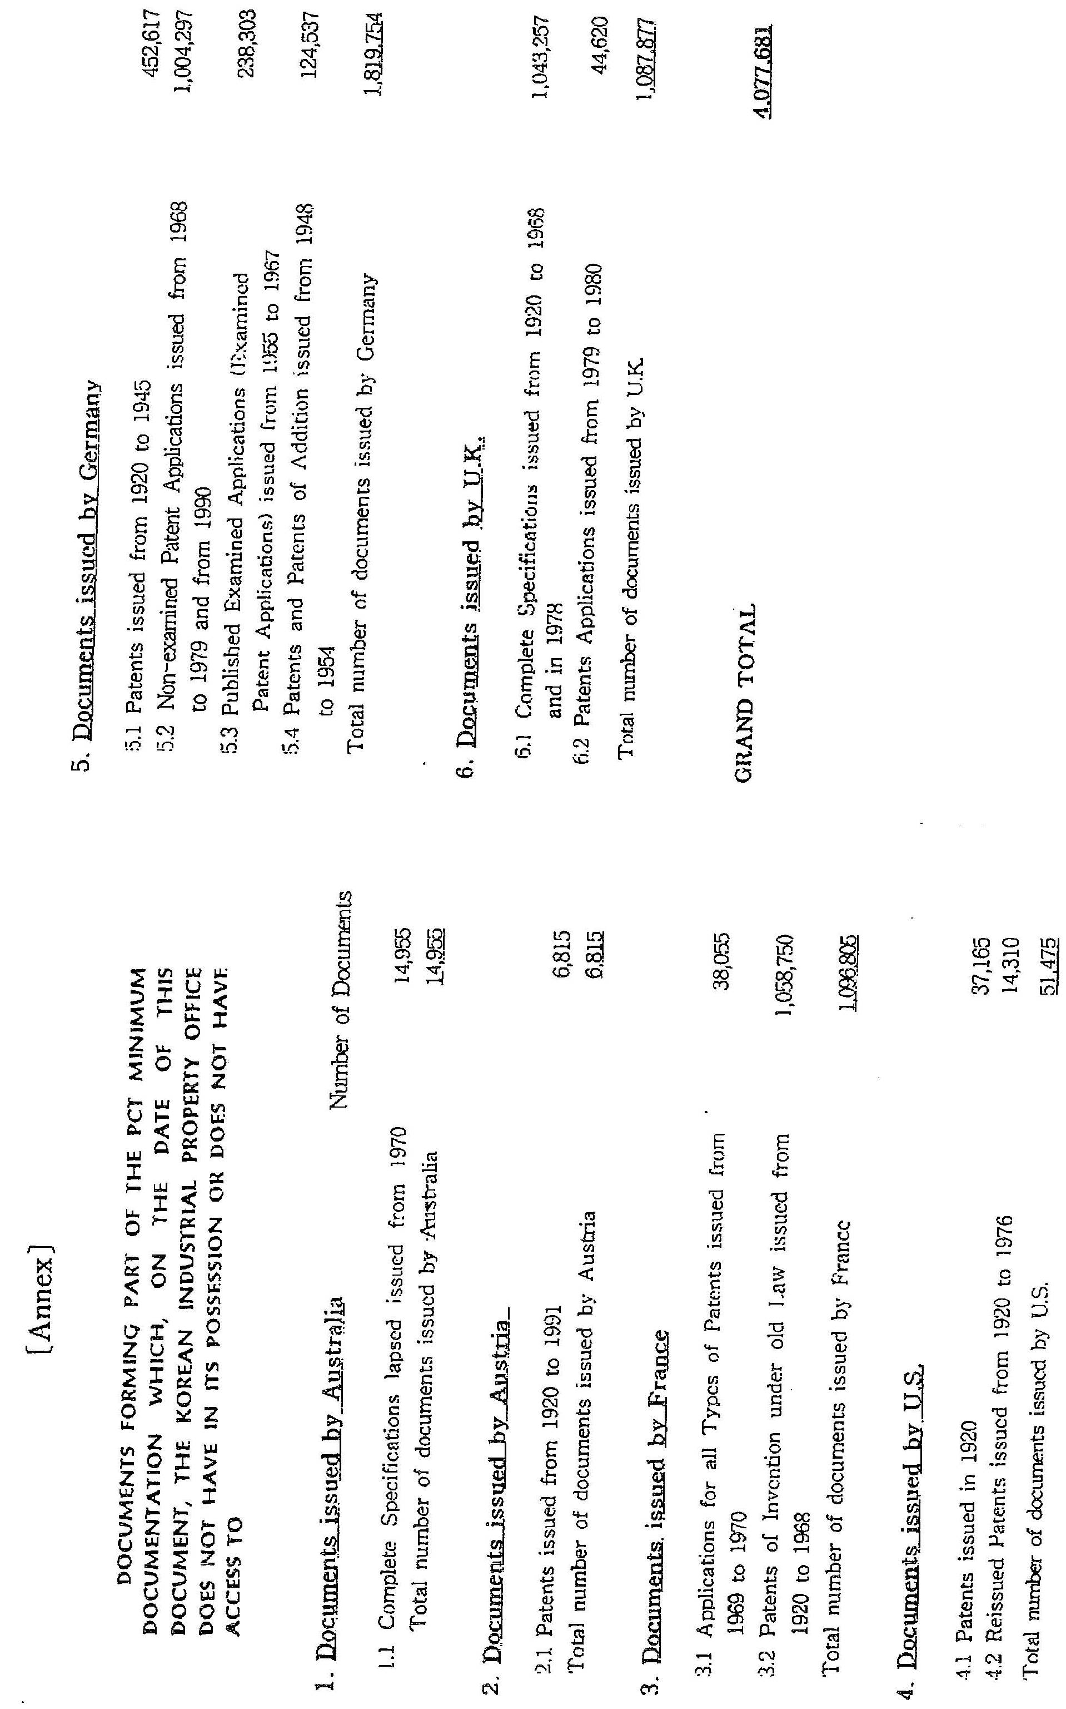

[End of Annex and of document]

