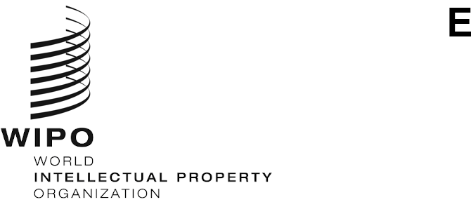
PCT/CTC/31/3
ORIGINAL: English
DATE: October 8, 2020

Patent Cooperation Treaty (PCT)
Committee for Technical Cooperation

Thirty-First Session
Geneva, October 5 to 8, 2020

Summary by the Chair

Agenda Item 1: Opening of the session
- Mr. Daren Tang, Director General of WIPO, opened the session, together with the thirteenth session of the PCT Working Group, and welcomed the participants. Mr. Michael Richardson (WIPO) acted as Secretary to both meetings.

Agenda Item 2: Election of a Chair and two Vice-Chairs
- The Committee unanimously elected Ms. Dong Cheng (China) as Chair and Ms. Rekha Vijayam (India) and Mr. Charles Pearson (United States of America) as Vice-Chairs for both meetings.

Agenda Item 3: Adoption of the agenda
- The Committee adopted the revised draft agenda as proposed in document PCT/CTC/31/1 Prov.2.

Agenda Item 4: Advice to the Assembly of the PCT Union on the proposed appointment of the Eurasian Patent Office (EAPO) as an International Searching and Preliminary Examining Authority under the PCT
- Discussions were based on document PCT/CTC/31/2 Rev.
- The Committee unanimously agreed to recommend to the Assembly of the PCT Union that the Eurasian Patent Office be appointed as an International Searching and Preliminary Examining Authority under the PCT.

Agenda Item 5: Summary by the Chair
- The Committee noted this summary, established under the responsibility of the Chair, and agreed to make it available to the Assembly of the PCT Union as a record of the advice given under agenda item 4.
- The Committee noted that the Secretariat would circulate a draft report of the session after the meeting for adoption by correspondence.

Agenda ITem 6: Closing of the session
- The Chair closed the session on October 8, 2020.

[End of document]

