E
pct/ctc/26/2
ORIGINAL: English
DATE: August 5, 2013

Patent Cooperation Treaty (PCT)
Committee for Technical Cooperation

Twenty-Sixth Session
Geneva, September 23 to October 2, 2013

Appointment of the State Intellectual Property Service of Ukraine as an International Searching and Preliminary Examining Authority under the PCT

Document prepared by the International Bureau

INTRODUCTION
- The Committee is invited to give advice to the PCT Assembly on the proposed appointment of the State Intellectual Property Service of Ukraine as an International Searching and Preliminary Examining Authority under the PCT.

Background
- In a letter received at the International Bureau on July 29, 2013, the text of which appears in Appendix I, accompanied by further details set out in Appendices II and III, the Chairman of the State Intellectual Property Service of Ukraine requested that the State Intellectual Property Service of Ukraine be appointed as an International Searching Authority (ISA) and an International Preliminary Examining Authority (IPEA) under the PCT
- The appointment of ISAs and IPEAs under the PCT is a matter for the Assembly of the PCT Union and is governed by Articles 16 and 32(3) of the PCT.
- Articles 16(3)(e) and 32(3) of the PCT require that, before the Assembly makes a decision on such an appointment, it shall seek the advice of the PCT Committee for Technical Cooperation. The Committee’s advice, which is sought by the present document, will be submitted to the Assembly during its forty-fourth session, which is being held during the same period as the session of the Committee.

Requirements to be Satisfied
- The minimum requirements for an Office to act as an International Searching Authority are set in PCT Rule 36.1 as follows:
“The minimum requirements referred to in Article 16(3)(c) shall be the following:
“(i) the national Office or intergovernmental organization must have at least 100 full-time employees with sufficient technical qualifications to carry out searches;
“(ii) that Office or organization must have in its possession, or have access to, at least the minimum documentation referred to in Rule 34, properly arranged for search purposes, on paper, in microform or stored on electronic media;
“(iii) that Office or organization must have a staff which is capable of searching the required technical fields and which has the language facilities to understand at least those languages in which the minimum documentation referred to in Rule 34 is written or is translated;
“(iv) that Office or organization must have in place a quality management system and internal review arrangements in accordance with the common rules of international search;
“(v) that Office or organization must hold an appointment as an International Preliminary Examining Authority.”
- PCT Rule 63.1 sets out equivalent minimum requirements for acting as an International Preliminary Examining Authority, except that item (v) requires the Office to hold an appointment as an International Searching Authority, so that, in order to meet the requirements, it is essential to be appointed as both types of Authority.
- The Committee is invited to give its advice on this matter.

[Appendices follow]

Text of Letter from the Chairman of the State Intellectual Property Service of Ukraine to the Director General of WIPO

(Received July 29, 2013)

Mr. Francis Gurry
Director General
World Intellectual Property Organization
34, chemin des Colombettes
CH-1211 Genève 20
Switzerland
Fax (41 22) 733 54 28

Honorable Director General, Mr. Gurry,

The State Intellectual Property Service of Ukraine (SIPS) in accordance with the Articles 16(3) and 32(3) of the PCT is pleased to submit documentation to the PCT Committee for Technical Cooperation (PCT / CTC) for advice, and to the PCT Union Assembly, for its approval, with the purpose of being appointed as an International Searching Authority (ISA) and an International Preliminary Examining Authority (IPEA).

Preparatory work was carried out by SIPS in consultation with the Director of the Patent Cooperation Treaty Business Development Division Mr. Claus Matthes and his team, which, upon the request, undertook a technical mission to Ukraine on this subject.

We are convinced that as an ISA / IPEA, SIPS will present the best standards of quality, promote innovation activity in the region. Also, we are ready to reduce the workload of other ISAs.

We would like to emphasize that this initiative received wide-ranging support among the governmental, as well as non-governmental organizations, different unions, associations and users in Ukraine.

Consequently, we would request that this matter be considered during the 51st series of meetings of the Assemblies of Member States of WIPO in September─October 2013.

Taking this opportunity we would like to express our sincere appreciation for the valuable assistance, Distinguished Director General, in progress and promotion of successful cooperation established between WIPO and Ukraine.

Yours sincerely,

[signed by
Mykola Kovinya
Chairman
State Intellectual Property Service of Ukraine]

[Appendix II follows]

Appointment of the State Intellectual Property Service of Ukraine as an international searching and preliminary examining Authority under the PCT

Background

Context, History and Overview
- Human intellect and creative work have always been the keystones to progress on the way of the human society development. Radical structural innovative changes in economy, rapid advance of competitive high-technology fields all over the world are oriented on the broadest possible use of intellectual property rights. Our country cannot fail to engage in this process. It is intellectual property rights that gradually and steadily become one of the most valuable elements of the social product and therefore require more rigorous legal enforcement and constant support on the part of the state.
- Ukraine has been confidently earning the world reputation of a state with a high intellectual potential and an up-to-date state system of intellectual property legal protection. The State Intellectual Property Service of Ukraine (SIPSU) as the central executive power body realizing the state policy in the intellectual property sphere invariably concerns itself with the proper level of intellectual property legal protection and enhances the procedures aimed at ensuring the high quality level of the process of intellectual property rights acquisition.
- The SIPSU is a modern, powerful and well-developed institution possessing the best human and technical resources to fulfill the tasks of the International Searching Authority and International Preliminary Examining Authority and capable not only of providing quality services, but of interacting with the international intellectual property system as a whole.
- The ISA and IPEA organization emersion in Ukraine will become the confirmation of a significant level of legal intellectual property protection and will facilitate the improvement of entrepreneurial activity, enhance intellectual property protection quality and Ukrainian companies’ foreign economic activity intellectual security.
- Taking into consideration of the abovementioned information, Ukrainian manufacturers and entrepreneurs union and state bodies support the SIPSU in acquiring the ISA and IPEA statuses and consider this a momentous step in the process of Ukraine's economy innovative component reinforcement , the state's positioning as an active interstate subject in the field of intellectual property.
- On January 27, 1992, according to the Resolution of the Cabinet of Ministers of Ukraine № 29, the State Patent Office of the Committee on Scientific and Technical Progress under the Cabinet of Ministers of Ukraine (SPO of Ukraine) was created. The SPO of Ukraine was entrusted with the task of ensuring the legal protection of industrial property rights, granting patents and other titles of protection for inventions and industrial designs, as well as providing the functioning of a single patent system on the territory of Ukraine.
- In March of the same year a Research and Development Centre of Patent Examination (RDCPE) was created, later reorganized into the State Enterprise “Industrial Property Institute”.
- With the aim to ensure the legal protection of all kinds of industrial property rights in Ukraine including rationalization proposals, as well as efficient functioning of a single patent system, the Order of the President of Ukraine of September 18, 1992 № 479/92 endorsed a Provisional regulation on the legal protection of industrial property rights and rationalization proposals in Ukraine which indicated that the right for industrial property rights is protected by the State and which regulated property relations and personal non-property relations connected with them arising in conjunction with creation, legal protection and use of such rights.
- In December 1992 the first patents of Ukraine for inventions were granted.
- In December 1993 the Law of Ukraine “On Protection of Rights for Inventions and Utility Models” was passed.
- According to the Order of the President of Ukraine of December 15, 1999 № 1572 “On the System of Central Executive Power Bodies” the Cabinet of Ministers of Ukraine by its decree of June 20, 2000 № 997 endorsed the Regulation on the State Intellectual Property Department (further – State Department). The State Department was a government body of the state administration acting within the Ministry of Education and Science and being subordinate to it.
- Throughout the recent nearly 10 years the State Department duly ensured the implementation of the state policy in the intellectual property sphere.
- With the view of optimizing the system of central executive power bodies, the SIPSU was created by the Order of the President of Ukraine № 1085/2010 of December 09, 2010; the SIPSU activities are directed and coordinated by the Cabinet of Ministers of Ukraine through the Minister of Education and Science of Ukraine.
- The principal tasks performed by the SIPSU are:
implementing the state policy in the intellectual property sphere;
submitting proposals on forming the state policy in the intellectual property sphere to the attention of the Minister.
- According to the tasks entrusted to it, the SIPSU:
(1) summarizes the practice of application of legislation on the matters falling under its competence, develops proposals on enhancement of legislative acts, acts of the President of Ukraine and the Cabinet of Ministers of Ukraine, regulatory legal acts by Ministries, and submits them to the Minister under the established procedure;
(2) under the established procedure organizes the examination of intellectual property rights, grants patents/certificates for intellectual property rights;
(3) effects the state registration and record keeping of intellectual property rights, carries out the registration of agreements on assignment of intellectual property rights protected on the territory of Ukraine and license agreements;
(4) designates authorized examination bodies and commissions them with carrying out the examination of applications.
- The state system of intellectual property legal protection comprises the State Enterprise “Ukrainian Industrial Property Institute” (further – SE “UIPI”) created in 2000 on the basis of the State Patent Office of Ukraine and the State Enterprise “Industrial Property Institute”. The SE “UIPI” functions under the management of the SIPSU.
- The SE “UIPI” is a body carrying out examination of applications for industrial property rights (inventions, utility models, industrial designs, trademarks and service marks, integrated circuit topographies, indication of origin of goods) as to their conformity with the conditions of legal protection provision, draws conclusions on examination of applications, provides preparation for state registration on intellectual property rights and official publication of information about them, ensures the maintenance of respective state registers, ensures, within its powers, the implementation of international commitments of Ukraine in the intellectual property protection sphere.

statistics
- As of May 1, 2013 (since 1992) a total of 383,861 titles of protection have been registered, 106,927 of them being patents for inventions.
- Within the period from 1992 to 2012, over 96.5 thousand applications for inventions were submitted; among them nearly 31.4 thousand are those which were filed under the PCT procedure by foreign applicants and entered the national phase. In 2012, similarly to previous years, the highest filing activity was shown by applicants from the USA (27 per cent), Germany (16.9 per cent), Switzerland (10.3 per cent), France (6.1 per cent), Great Britain (4.2 per cent), Japan (4.1 per cent), Italy (3.2 per cent), the Netherlands and Russian Federation (3 per cent each). The number of applications coming from these countries constitutes almost 78 per cent of the total amount of the applications filed under the PCT procedure.
- During the mentioned period, almost 1.2 thousand applications from national applicants were filed for patenting inventions under the PCT procedure in foreign countries. Among them, over 250 applications (24 per cent) were filed in 2011-2012.
- Now the term of patent applications examination is 17 to 19 months. Such processing time is constant for a few years and SIPSU supports it at that level. The achievement of such terms with simultaneous maintaining high quality of searches and examination is due to the attention that is paid to the internal training of examiners. To new examiners tutors are appointed, regular trainings for examiners are performed at different levels, e.g. for study all modern and highly secured search systems (like EPOQUENet) to optimize and develop the best strategies for search.
- Examiner meetings considering all appeals in cases of complaints are held regularly, also the best practices of leading patent offices of the world like the Federal Service for Intellectual Property, Patents and Trademarks (Rospatent) and the European Patent Office (EPO), are used during searching and examination process.
- At SIPSU much attention is paid to quality matters. The three leveled system of quality control of searches and examination process is introduced in SIPSU: at the Head of division, Head of department and Deputy Director in examination matters.
- Also at these levels the processing time of applications and responding to requests is monitored.
- Terms of applications examining, answers to incoming documents are monitored at that levels as well.
- All data of the monitoring are reported to the top management twice a year, instructions are developed on report bases, also workload of examiners and the distribution of applications are revised, and the need for new search systems or increasing the access to that available is analyzed.
- Shorten the period the examination of applications while maintaining high quality search and examination is also due to a high level of process of automatization of examining process.
- All of the above, undoubtedly, is sufficient to meet the needs when examining the array of national applications and will provide the possibility to deal with the growing number of international applications in the shortest time while keeping the high quality.
- Within the period from 1992 to 2012, over 60.5 thousand patents for inventions were registered; among them almost 16 thousand patents were granted on the basis of applications filed under the PCT procedure.
- In 2012, some 5,000 applications for inventions were received, approximately 43 per cent of them being PCT applications (national phase). During 2012, 2,215 PCT applications entered the national phase. In 2012, the SIPSU as receiving office received and considered 121 international applications filed by domestic applicants.
- In the course of a year around 4,500 examinations are considered by the examiners.
- The statistical figures of the SIPSU activities displayed above demonstrate its active role in the realm of international patenting.

Application to be Appointed as an International Authority

Reasons for Seeking Appointment

Benefit to the PCT system
- According to Rule 19 of the Regulations under the PCT, an international application is filed with a competent receiving office. The requirements on receiving international applications prescribed by the PCT to a receiving office are fulfilled in Ukraine on a high level. The competent International Searching Authorities for Ukraine are the Federal Service for Intellectual Property, Patents and Trademarks (Rospatent) and the European Patent Office (EPO).
- As of March 1, 2011, according to Rule 89ter of the Regulations under the PCT and Section 102bis of the Administrative Instruction under the PCT, international applications (requests and abstracts) are accepted in the PCT-EASY format together with PCT-EASY physical media (CD-R, CD-RW, DVD-R, DVD-RW).
- The appointment of the SIPSU as international authority will be beneficial for the PCT system as a whole; it will result to PCT system popularization in Ukraine and to increasing of number of PCT application filed by Ukrainian applicants.
- The use at the SIPSU of English, German, French and Russian languages as working languages as well as capability and intention of the SIPSU to provide high-quality services in search and examination in the shortest term will allow to turn to the SIPSU, by their discretion, applicants from any countries – PCT members.
- The SIPSU intends to acquire the ISA/IPEA status and offer the search and examination services to users (applicants) from the Contracting States.
- The fulfillment of the tasks charged to this international authority, as well as the high quality of reports will be ensured by the examiners having considerable experience in a wide range of PCT-related matters.
- The emergence of a new International Searching Authority and International Preliminary Examining Authority is significant for avoiding possible delays in the process of examination of international applications filed under the PCT procedure.
- The total number of examiners working full time at the SIPSU is 131 persons. The experience and knowledge of said examiners allow to carry out high-quality search and examination in such fields as nanotechnologies, pharmacy, chemistry, biotechnology, agriculture, metallurgy, electronics, telecommunications etc.
- Currently, there is sufficient examiner resource for search and examinations. In case of workload increasing required number of new examiners will be recruited and proper training for them will be provided not affecting quality and terms of search and examination.
- The management of SIPSU analyzes the examiners’ workload on week and month basis and together with Personnel department determines needs for recruitment of new examiners and training of existing ones.

Compliance with the PCT Minimum Requirements

Human Resources
- The total number of examiners working full time and performing the examination of applications for inventions and patent information search for this purpose (including PCT applications examination) is 131 persons. All patent examiners have a specialist's/master's degree in technology or natural sciences; among them there are also 6 PhD degree holders.
- All examiners have a second university degree in the intellectual property sphere and a qualification level of intellectual property specialist or master.
- All examiners are fluent in Ukrainian, Russian and English; some of the examiners also have sufficient knowledge of German, French, Spanish, Polish and Japanese.
- The Department of Examination of Applications for Inventions, Utility Models and Integrated Circuit Topographies consists of the following divisions: Pharmaceutics, Chemistry and Metallurgy, Chemical and Biological Technologies, Construction and Mining, Light and Printing Industry, General Mechanical Engineering, Metal Working and Welding, as well as the Telecommunications Sector and other subdivisions: Division of Filing Date Determination, Formal Examination Division, International Applications Division, Patent Search Division, Documentation Handling Division and Sector of Patent Information Databases Analysis.
- The search and examination processes are regulated according to the legislation of Ukraine, regulatory legal acts, relevant WIPO standards, PCT International Search and Preliminary Examination Guidelines for International Authorities. Thus, no need exists to introduce considerable modifications in these processes in case the status of International Authority is obtained by SIPSU.
- All examiners are qualified examiners in various fields of natural and technical sciences. They all graduated from such world-famous best universities of Ukraine as Taras Shevchenko National University of Kyiv, National Technical University of Ukraine "Kyiv Polytechnic Institute" etc. Many of them have extended experience of working in the institutions of the Academy of Sciences of Ukraine, higher education institutions of Ukraine, various key industrial fields. Some of the examiners have the PhD degree which enables them to perform searches and examination on an outstandingly high level and have thorough knowledge in a wide scope of specific matters.
- All examiners are fluent in Ukrainian, English and Russian; some of the examiners also have ample knowledge of German, French, Spanish, Polish and Japanese. Most of the examiners are able to use two foreign languages in their work.
- Newly recruited examiners are assigned a tutor from experienced senior examiners having the signing authority. Such tutors organize trainings and check the work performed by junior examiners; they are also engaged in the training program concerning examination and searches compulsory for junior examiners; the program comprises trainings on division and department levels, participation in the WIPO DL-101 program, introduction to the search databases used by examiners for patent information searches and practice searches in these databases.
- The training of examiners is organized on an ongoing basis in the form of exercise examinations with the emphasis on case studies and trainings dedicated to performing and documenting searches.
- Examiners participate in trainings held by WIPO, in webinars on examination and search, arranged by EPO and WIPO, in seminars on training matters and other events of on-line training dedicated to examination and patent information searches organized by EPO and WIPO as well as seminars in other matters connected with optimization of the use of EPOQUENet retrieval system, train the trainers of EPOQUENet; they also take part in other events regularly organized by EPO on the matters of quality control in patent searches and examination and other examination and patent search-related matters.
- The participation in the activities of the Working Groups of the IPC Union Committee of Examiners carried out under the WIPO auspices is also organized on the ongoing basis.
- Great attention is paid to the study visits and/or seminars organized by the WIPO to promote sharing experience and networking of representatives of the PCT receiving offices on the matters of international applications proceeding, processing of international applications filed in the electronic form using the WIPO PCT-SAFE software and the use of electronic services (ePCT and/or PCT-ROAD systems in particular).
- In order to keep the high level of knowledge in different natural and technical fields, our examiners regularly take part in seminars and conferences organized by the National Academy of Sciences and branch Academies of Sciences of Ukraine.
- For provision of high-quality search and examination in the shortest terms the system of examiners' training is implemented at the SIPSU. It is obligatory for recruitment in SIPSU to have the second higher education in intellectual property. In addition to training of new examiners great attention is drawn to examiners education at an internal level - a permanent study of examiners at levels of field divisions and invention examination department is being held. This education is a regular practice. The education covers modern and secured search systems (i.e. EPOQUENet) for the best search strategy optimization and development, search and examination approach trainings, complicated applications at examiner's councils discussions, new regulatory and methodical documents studies, etc. Examiner's councils are held regularly with Deputy director on examination matters, where all complains and appeals are considered.
- The internal training system involves the best practices in search and examination of leading patent offices of the world, such as EPO, Rospatent and USPTO.
- The SIPSU examiners participate in training events arranged by said patent offices and WIPO, namely:
  - Regular participation in the WIPO distance learning program:
DL-101 (general course) certificates were received by almost all examiners.
Regular participation in DL-320, DL-318, DL-301, DL-202, DL-204 (advanced level) courses.
  - Routine participation in on-line training events dedicated to the matters of examination and patent information searches organized by EPO, business trips on training and other matters connected with optimization of the use of EPOQUENet retrieval system.
  - Events regularly organized by EPO on the matters of quality control in patent searches and examination and other examination and patent search-related matters.
  - The ongoing participation in the activities of the Working Groups of the IPC Union Committee of Examiners.
  - Study visits and/or seminars organized by the WIPO to promote sharing experience and networking of representatives of the PCT receiving offices on the matters of international applications proceeding, processing of international applications filed in the electronic form using the WIPO PCT-SAFE software and the use of electronic services (ePCT and/or PCT-ROAD systems in particular).
- Events organized in Ukraine:
1. International Scientific and Practical Conference "Actual Problematic Issues of Intellectual Property" (bi-annually).
2. Yearly seminars "Peculiarities of Applications for Inventions" and "Use of Paperless Information Technologies in the Processes of Acquisition of Industrial Property Rights".
3. Training of examiners on the matters of examination and use of databases (STN, REAXYS, EPOQUENet, DWPI etc.) conducted in particular by the providers of the mentioned databases.
4. Seminars and conferences organized by the National Academy of Sciences and branch Academies of Sciences of Ukraine.
5. Regional seminars organized with the aim of raising awareness of the Ukrainian public of the PCT system.
Within the course of 2012 our examiners took part in 15 scientific and practical conferences, seminars and other events.

Access to PCT Minimum Documentation
- The minimum requirements for an Office to act as an International Searching Authority with regard to search resources are set out in PCT Rule 36.1 as follows:
"The minimum requirements referred to in Article 16(3)(c) shall be the following:
"(ii) that Office or organization must have in its possession, or have access to, at least the minimum documentation referred to in Rule 34, properly arranged for search purposes, on paper, in microform or stored on electronic media".
- Thus, the PCT minimum documentation is one of the most crucial factors and express conditions for ensuring the quality of examination of international applications. The main provisions as to the minimum documentation are set out in Rule 34.1 of the Regulations under the PCT according to Article 15(4) of the said Treaty.
- The patent information collection at SIPSU covers patent documents from organizations and patent offices of the countries of the PCT minimum documentation (Annex 1, Table 1, 2).
- Batching of the patent information collection for almost 20 years has been carried out mainly through the international cooperation with WIPO, EPO and national offices. In 2003, under the Law of Ukraine "On the Protection of Rights to Inventions and Utility Models", UIPI was declared to be the center of international exchange of publications that provides the legislative environment for the specified field of activity.
- National patent documents in the patent information collection are provided for in the form of the Official Bulletin "Promyslova Vlasnist" (hereinafter referred to as the Official Bulletin) on paper (published since 1993 until now) and CD-ROM/DVD (published since 2005 until now), specifications to patents of Ukraine for inventions on paper (published since 1993 thru 2011), which are also published on CD-ROM "Inventions in Ukraine" (since 2005 until now), as well as the regional patent information product of CIS countries on CD-ROM - CISPATENT (published since 2002 until now), which comprises, in particular, specifications to patents of the Russian Federation and EAPO for inventions.
- Last decade provided new alternatives to access the PCT minimum documentation (patent documents and non-patent literature) via Internet, allowing increase in number and improvement of quality of the available information resources.
- At a certain stage, examiners, who carry out substantive examination of applications for inventions, obtained critical experience to perform the search of patent documents in the national patent information collection and on the Internet, which enabled considerable enlargement of the scope of the available information used to determine prior art, as well as to improve the quality of the search and to reduce relevant expenses.
- Since 2007, foreign commercial databases providing the access to the PCT minimum documentation (patent documents and non-patent literature), appropriate reference information, and equipped with more complicated, but highly efficient search tools, are used. As of June 1, 2013, 10 foreign commercial databases, access to which is provided under the appropriate contracts and agreements, are used in the course of examination (Annex 1, Table 3).
- Moreover, an agreement with the State Public Scientific and Technical Library of the Russian Federation, covering the access to electronic copies of the necessary information resources within its collection, was made to boost the level of supply of examiners with non-patent literature
- For searches, the examiners use both free and commercial databases. But considering safety issues, now the main focus is on use of safe systems - mainly, EPOQUENet.
- The main search tool among the foreign Internet resources, which are used by examiners to ensure efficient and quality patent search within the substantive examination of applications for inventions and utility models, is EPO's EPOQUENet since it contains patent documents from a large number of countries as required to meet the requirements relating to accessibility to the PCT minimum documentation for offices, which operate not in Japanese, Korean, Russian, or Spanish official language
- Access to EPOQUENet has been provided since 2007 under the appropriate agreements. Thus, in 2013, EPOQUENet was used under the agreement for a period from January 1, 2012, thru December 31, 2013.
- Currently, access to EPOQUENet is provided by six workstations. Starting from 2013 EPO implemented new price policy according to which a number of authorized EPOQUENet users does not depend on workstation number. Consequently, the number of authorized EPOQUENet users having permanent access to said search system can be regulated depending on demand.
- Examiners of SIPSU, which are trainers of EPOQUENet, undergo continuous training at EPO. The system of internal training is implemented in SIPSU which involves the best practices of EPOQUENet use. It allows to increase number of EPOQUENet users at any time and to ensure proper level of qualification of such users.
- In order to make the use of EPOQUENet more advantageous, a permanent Working group was created, whose members exchange personal experience, process the information received on the EPO seminars and training sessions for EPOQUENet users, develop the ways to improve the patent search strategy with the due account of the experience of the EPO and world leading patent offices.
- Due to the change of the pricing policy and policy for distribution of the EPOQUENet data, which came into effect on January 1, 2013, a set of works aimed at concluding the new 4-year agreement with EPO before June 30, 2013, is carried out.
- Provision of the guaranteed access to EPOQUENet by examiners under the new agreement for the specified term is also important due to the possibility to access the Derwent World Patent Index via EPO's database.
- To provide information support for the examination of applications for inventions with non-patent literature, the list of which is agreed by International Searching Authorities under the Rule 34.1(b)(iii) of the PCT Regulations, public national and foreign Internet resources, in particular, electronic digital libraries and collections (digital primarily) of seven largest national-level public libraries of Ukraine, 29 libraries of the specialized scientific institutions of the National Academy of Sciences of Ukraine, six libraries of scientific institutions of the Academy of Medical Sciences of Ukraine, six libraries of institutions of the Academy of Agricultural Sciences of Ukraine, eight libraries at the lead higher educational institutions, etc. (Annex 1, Table 4), are also widely used, in complex with foreign commercial databases listed in the Table 3, Annex 1. Electronic copies of the ordered information sources, in particular, articles in periodicals, are received via the electronic document delivery system.
- Today, foreign commercial databases, private information resources, as well as public collections at 59 largest national and specialized libraries (including national electronic digital libraries and electronic collections), used to carry out the search, ensure the access to the PCT minimum documentation to the fullest extent.

International Patent Classification (IPC)
- Ukraine joined the Strasbourg Agreement regarding the International Patent Classification which was ratified by the Law of Ukraine on December 2008 and took into force on 7 April, 2010.
- Therewith, taking into account the overall value of the International Patent Classification and its importance for all member states of the Paris Convention for the protection of Industrial Property, during the whole period of existence in Ukraine The State System of Intellectual Property Legal Protection (from the year 2000) the works concerning the translation of current versions to Ukrainian are carried out in order to fulfill the assigned obligations and to provide possibilities for the IPC usage by examiners and general national public in translation of the state language as the exclusive international classification system and the main element of search tool to the world patent information resources.
- Examiners have the opportunity to use the IPC-2013.01 in English, Ukrainian and Russian, which took into force from the 1st January, 2013.
- For a wide range of users the access to IPC-2013.01 is provided free of charge via SIPSU web-portal.
- To further implement international commitments to Strasbourg Agreement, and due to the fact that WIPO annually introduces new IPC versions, the range of work directed to timely implementation of revised IPC in Ukrainian to be used in examination of inventions and by applicants, will be performed in future on permanent basis.
- In the context of fulfillment of said work the examiners constantly participate in sessions of the WIPO Working Group on IPC revision, in particular, they participated in the 29th session (May 13 to 17, 2013).
- It should be noted that SIPSU examiners widely use CPC classification when making searches through EPOQUENet.

Patent examination tools
- In their work, our examiners chiefly employ two tools - the workflow management tool ("Inventions" AS) and both internal and external search systems.
- The "Inventions" AS is designed to support the proceeding of applications for inventions. Thanks to this automated system, the examiners handle virtually no paper documents, using their electronic copies instead. The "Inventions" AS is built according to the modular approach, so that should the need arise, for example adaptation to the legislation changes is necessary, certain functions (modules) can be modified, new ones can be added or unnecessary ones can be blocked. These operations are performed in the course of the automated system maintenance.
- As of today, 227 automated functions providing the full cycle of the examination of applications for inventions are implemented in the "Inventions" AS.
- As an example, an image of the client window of the "Inventions" AS is presented below. In the left part of this window, the list of functions at the disposal of the system administrator is displayed (Fig. 1).
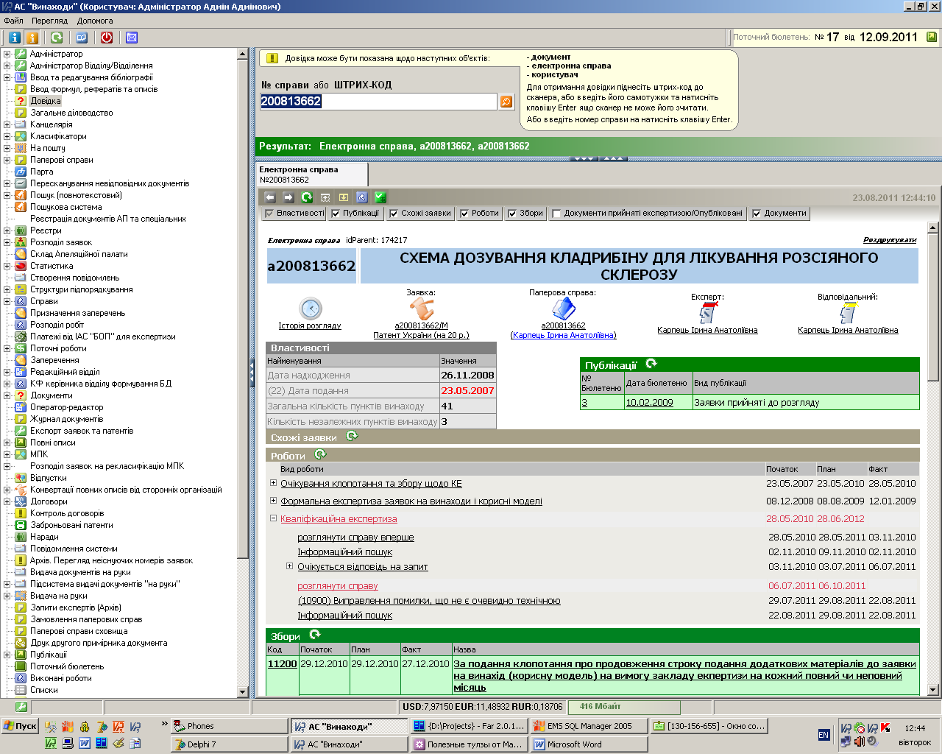
Figure 1 – Main client window of the “Inventions” AS at the disposal of the system administrator
- Depending on the proceeding state of the application and the authority of the examiner considering the application, the number of the functions available varies. As an example, the window of the client part of the “Inventions” AS for a user with an examiner rights is shown below (Fig. 2):
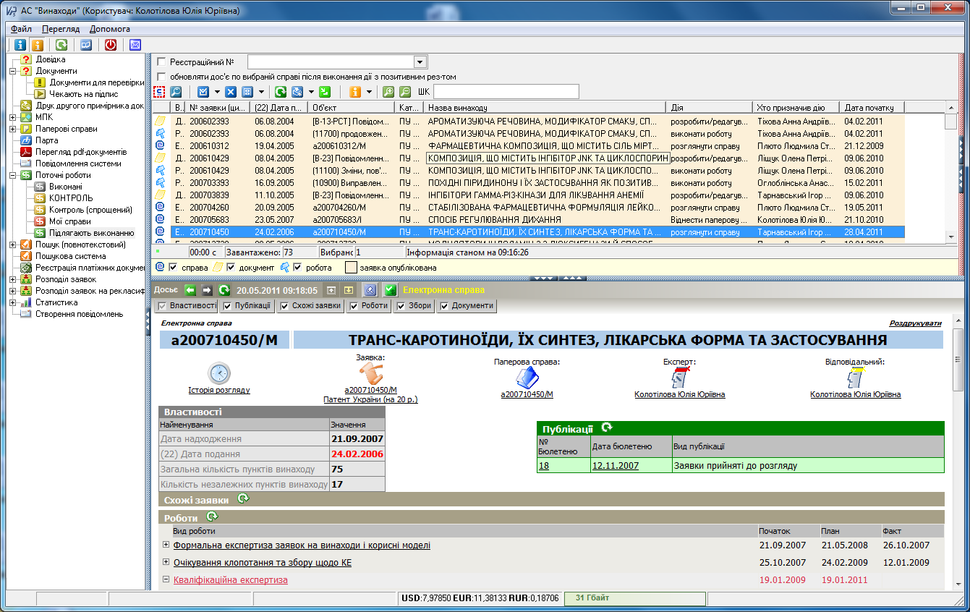
Figure 2 - Main client window of the “Inventions” AS at the disposal of an examiner
using the “to be executed” function
- For the purpose of their work, an examiner may choose any of the functions available. Each function has a certain interface. As an example, the images of the main window of the “Inventions” AS for the “to be executed” function (Fig. 2) and the “IPC. Reclassification (stage II)” function can be compared (Fig. 3).
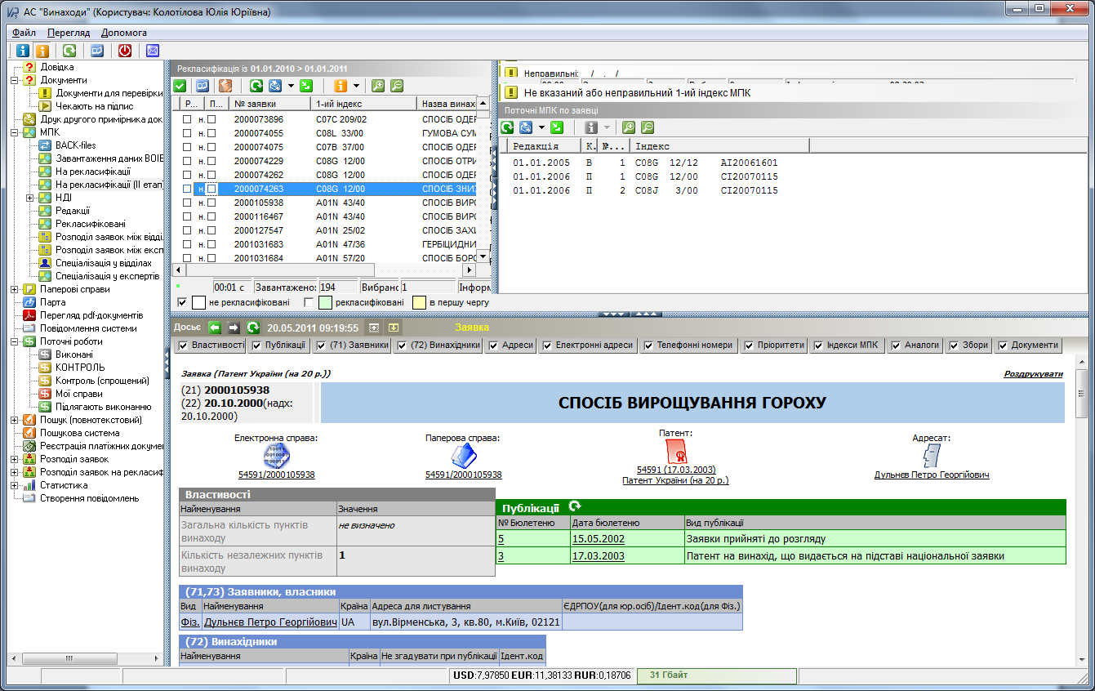
Figure 3 - Main client window of the “Inventions” AS at the disposal of an examiner
using the “IPC Reclassification (stage II)” function
- The “Inventions” AS is also equipped with the functions of standard and full-text search. The following figure demonstrates the image of the full-text search window (Fig. 4).
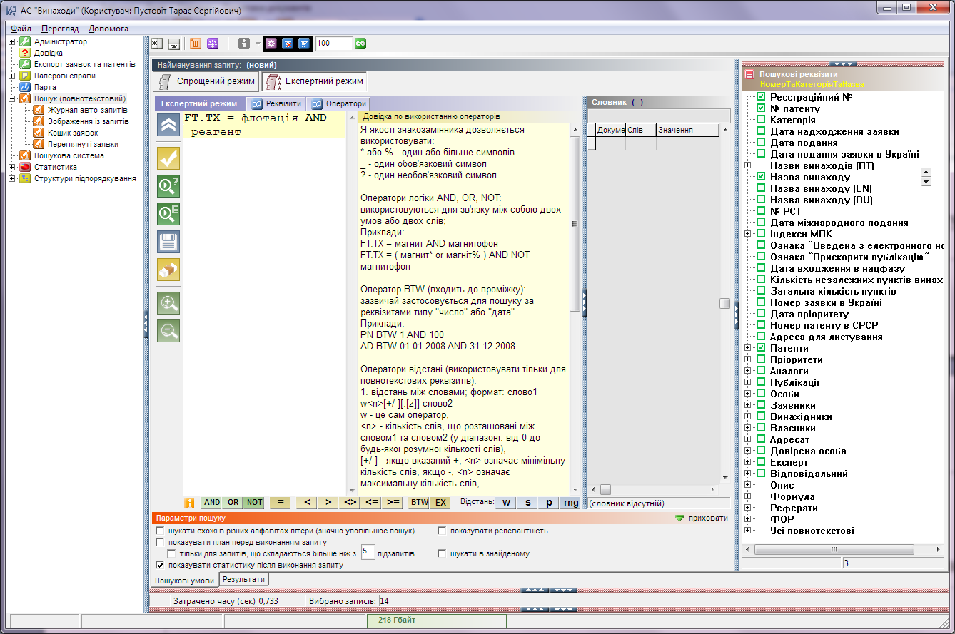
Figure 4 - Main client window of the “Inventions” AS at the disposal of an examiner
using the “Search (full-text)” function
- In this window, search parameters are specified by an examiner. After the search has been completed, the “Inventions” AS will display another window (Fig. 5):
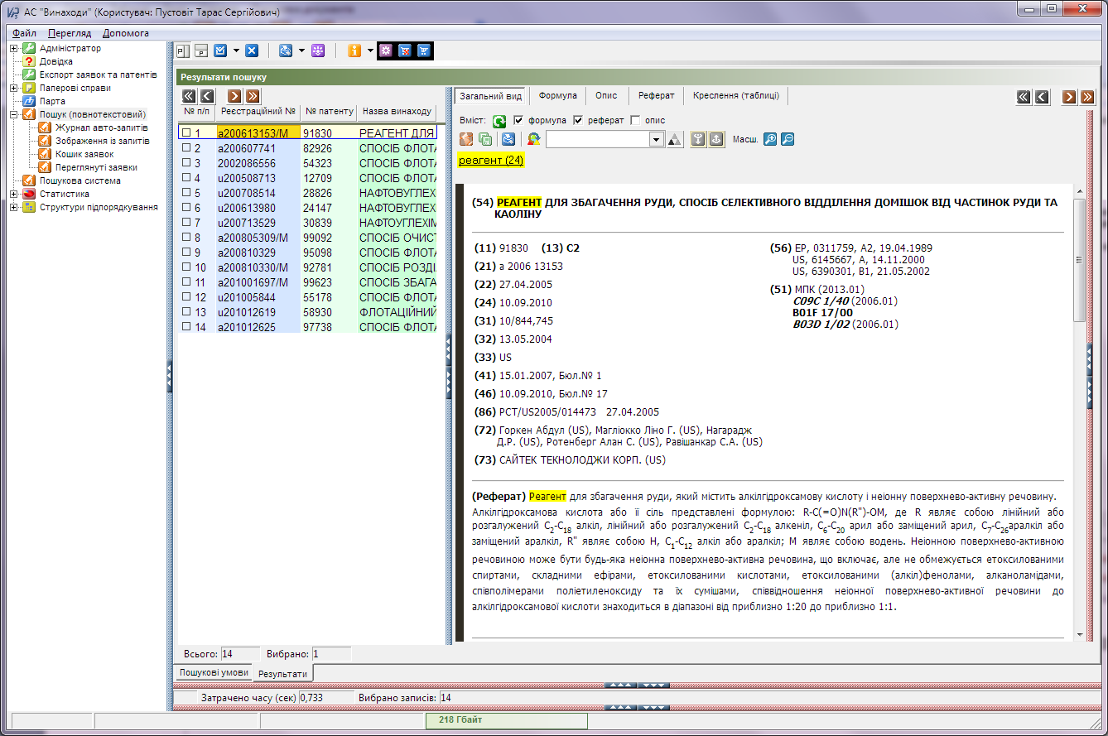
Figure 5 - Main client window of the “Inventions” AS search results
- In this window the system generates the list of inventions found. Selecting them one by one, the examiner will be able to view each of the retrieved documents.
- Another important examiner's tool is the Search Portal. This tool has been created to automate searches and enable searching patent information and non-patent literature sources by examiners on the substantive examination stage.
- The Search Portal is equipped with multifunctional search mechanism and information viewers enabling to:
– perform full-text search in selected sources or a group of sources;
– view search results for each source;
– quickly jump to the text fragment which contains search terms;
– generate reports based on the search results;
– keep the search term history;
– print documents out;
– export documents.
- For example, search parameters have been specified (Fig. 6):
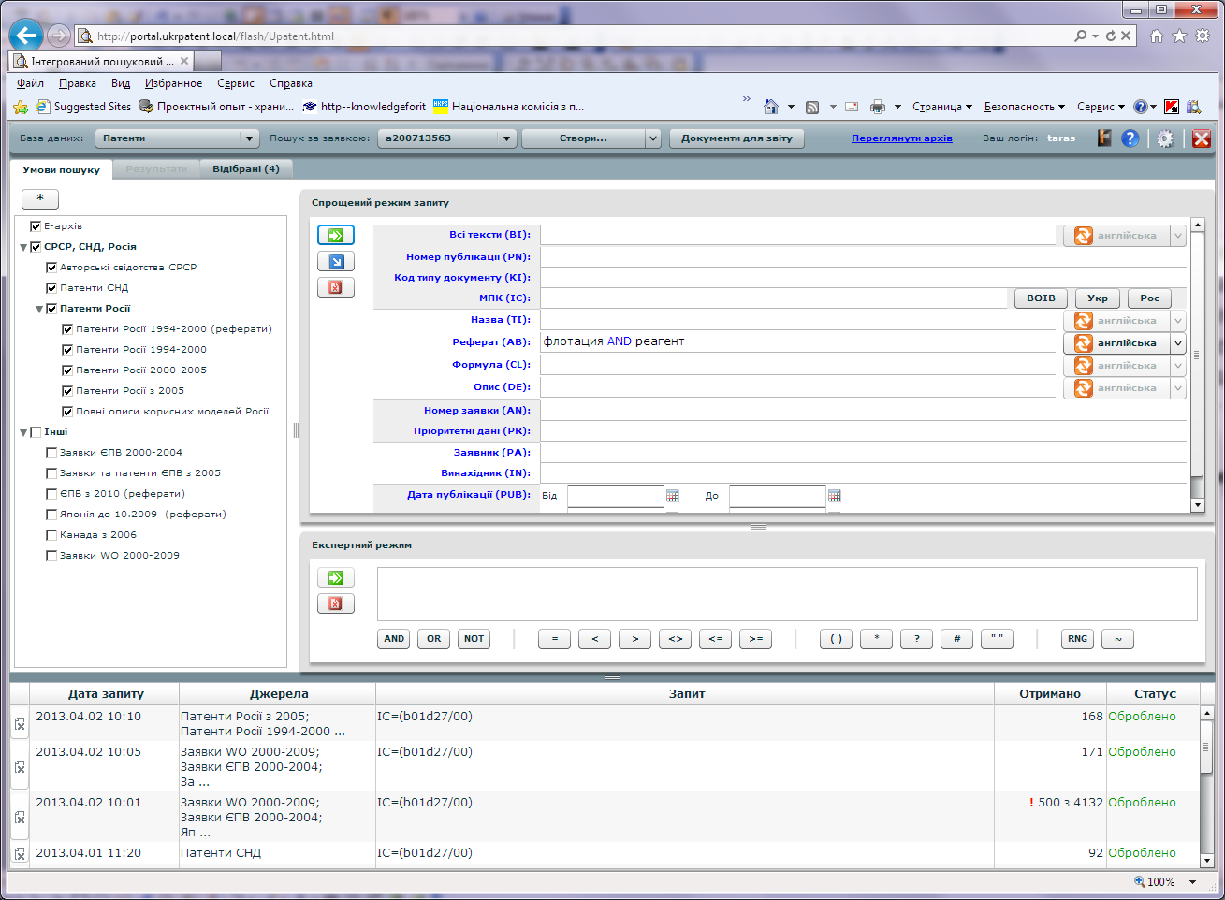
Figure 6 - Main window of the Search Portal
- Having performed the search query, an examiner will receive a respective result (Fig. 7):
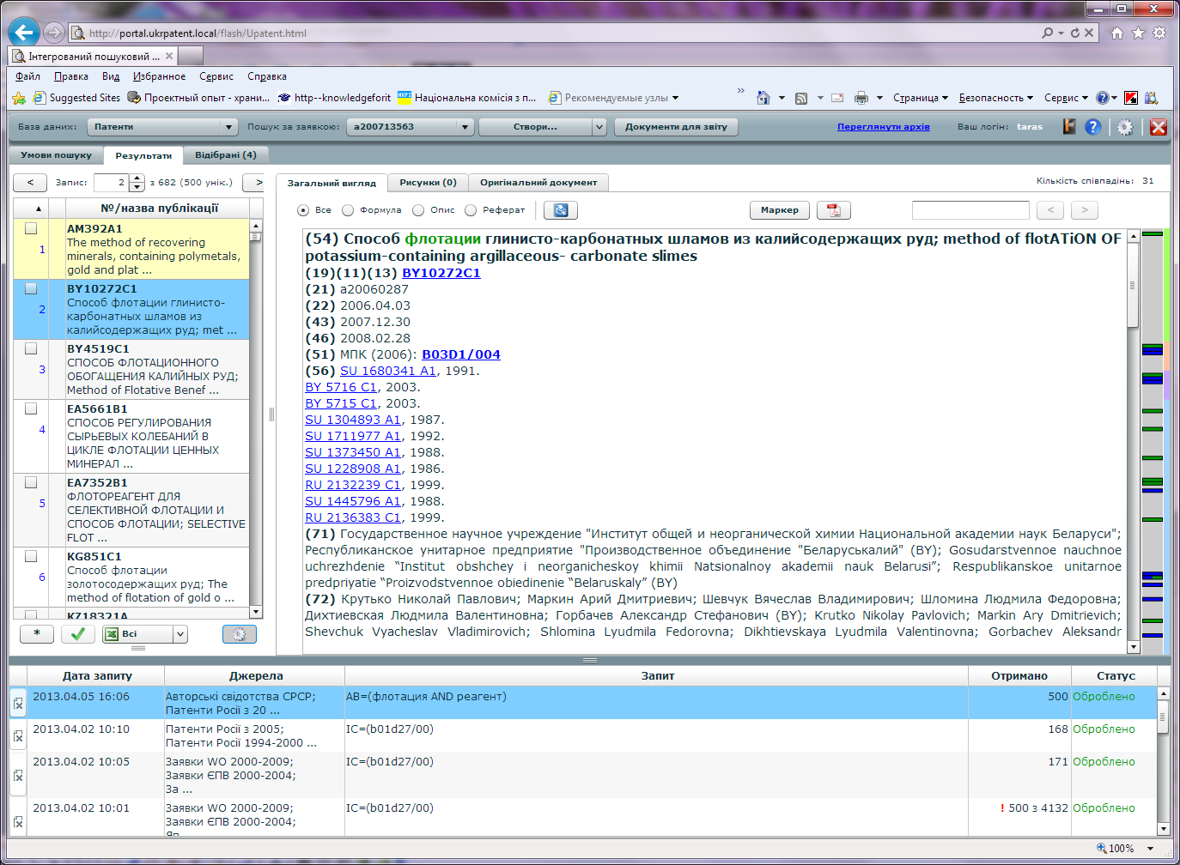
Figure 7 – Window of the Search Portal containing search results
- To perform the substantive examination procedures, examiners enjoy high-speed Internet access to a wealth of search resources, including the WIPO resources, EPOQUENet, STN, REAXYS, DWPI search systems etc.

Quality Management System
- When performing all the above-mentioned procedures, significant attention is paid to the quality matters.
- Filed Initial Report on Quality Management Systems (Annex III) comprises detailed information about the compliance of QMS requirements introduced in SIPSU to the Chapter 21 of PCT International Search and Preliminary Examination Guidelines.
- In October 2012 the certificate of the quality management system compliance to the requirements of the ISO 9001:2008 standard was issued, confirming that the implemented and maintained quality management system corresponds to the requirements of the said standard.
- Certification area:
(1) examination of applications for intellectual property rights (inventions, utility models, industrial designs, trademarks and service marks, integrated circuit topographies, indication of origin of goods) as to their compliance with the conditions of obtaining legal protection and examination support processes;
(2) provision of preparation for the state registration of intellectual property rights and official publication of information relating thereto;
(3) search and examination of applications for inventions according to the Patent Cooperation Treaty (PCT).
- The certificate has been issued on the grounds of audit report No. Z-A 710312/A12/U/9001 and is valid up to 16.10.2015.
- In September 2013, compliance audit of the quality management system by an independent certification organization is planned.
- As mentioned in Chapter 2, 131 full-time examiners are currently employed, a significant number of them have over 10 years' experience in respective fields of science and technology. The examiners have sufficient language facilities to understand at least those languages in which the minimum documentation referred to in Rule 34 of the Regulations under the PCT is written or is translated, and are also proficient in several other languages.
- The SIPSU spares no effort to implement technologies of the highest possible level, as is described in Chapter 3.
- To provide the high quality examination and searches, each examiner has been provided access from their own workplace to international and national regulatory legal acts (in particular, Paris Convention for the Protection of Intellectual Property, Patent Cooperation Treaty (PCT), Regulations under the PCT, PCT Administrative Instructions, Patent Law Treaty (PLT), Regulations under the PLT, WIPO standards, PCT International Search and Preliminary Examination Guidelines, legislative documents of Ukraine), methodical and methodological materials etc.
- Matters related to the access to the PCT minimum documentation referred to in Rule 34 of the Regulations under the PCT are dealt with in Chapter 4 and Annex 1.
- The SIPSU prioritizes the matter of examiner training in order to maintain the high level of their knowledge and competences, which is dwelled upon in Chapter 2.

Administration
- All procedures connected with acquisition of legal protection of inventions, including all measures taken to provide quality, are documented and stored in the "Inventions" AS. This ensures the possibility of continuous quality provision process monitoring by means of generating statistical reports and further data analysis. The results of such analysis are used to study fluctuations in the demand for services and to regulate the distribution of pending applications backlog.
- Additionally, the mechanism of analyzing feedback from applicants concerning filed applications has been implemented. Applicants' requests are scrutinized; a mechanism of automated control of response to such requests is in use to ensure timely actions are taken. All requests must be considered within a month from the date of their filing; their response timeliness is controlled by the management. To analyze such requests, a special Sector for consideration of applicants' requests has been created.
- Organization of free-of-charge seminars and conferences for applicants, round tables and meetings with patent attorneys, in particular on quality-related matters, as well as distribution of questionnaires concerning the satisfaction of applicants' and patent attorneys' needs are the general practice.
- The SIPSU web site contains consultation materials on search and examination matters.

Quality Guarantee
- A quality support system has been implemented and maintained to provide a unified approach to the examination and search processes in all industry divisions. To this effect, respective control is carried out on the level of the Head of the Department of Examination of Applications for Inventions (further - Department) and by individuals appointed to fulfill the functions of quality provision in the Department, as well as by the members of the Quality Coordination Board.
- In order to achieve a higher level of examination and search quality and to ensure the highest possible level of correspondence of applications subject matter to the specialization of the industrial division examiners, automated distribution of applications to examiner groups has been implemented (using topical fields which include the combinations of IPC classification symbols and keywords).
- With the aim of ensuring high-quality and timely examination and searches, a system for controlling the timeliness of consideration of applications for inventions by examiners, controlling the timeliness of search performance and monitoring the proceeding state of any application considered by each examiner was implemented. The control and monitoring are automated and realized through the "Inventions" AS on the level of the Department Head and individuals appointed to fulfill the functions of quality provision in the Department, as well as by the members of the Quality Coordination Board.
- On the basis of the data collected in the course of such automated monitoring, a statistical report is generated and passed to the Department Head, and then analyzed on a meeting held by the Quality Coordination Board. The collected analytical data are summarized and the results are forwarded to the respective industry division heads to ensure more effective monitoring of the examiners' workload.
- All examiners have access to such statistical data and are able to control their own workload and the order of applications consideration and searches.
- Routine control of the outgoing documents quality is carried out on the level of an industry division head who daily randomly checks current works and the quality of outgoing documents in the respective division.
- On the level of the Department Head and individuals responsible for the quality control in the Department, random control of outgoing documents quality is undertaken.
- All decisions about non-compliance of an invention with the patentability criteria are made by 3 persons: an examiner, Division Head and Department Head (Deputy Department Head).
- When checking search reports, requests and preliminary opinions, the controlling person can pass a resolution and return respective documents for improvement through the "Inventions" AS.
- At the end of each month all such resolutions are collected and analyzed in order to detect typical mistakes. After the mentioned matters have been studied, a summary is drawn up and an appropriate kind of training is carried out both for examiners and for industry division heads. The "Inventions" AS provides access to the methodical materials elaborated on the basis of such trainings to all examiners.
- After the initial analysis of such emerging quality-related issues the most significant ones requiring correction are selected. To ensure the compliance with the quality standards, quarterly meetings of the Quality Coordination Board are held to consider the selected issues.
- With the aim to assure search quality, a special Sector of Patent Information Databases Analysis has been created. The above-mentioned division's tasks include monitoring and optimization of examiners' usage of search systems and search quality control.

Additional Information

IT System
- Since its foundation in 1992, Ukrainian Patent Office started developing informational infrastructure for industrial property rights protection execution. At present, the infrastructure constitutes a complex automated informational system, which includes all stages of invention applications prosecution and the functioning of the inventions patent register:
- filling an application
- application registration
- publication of filed invention applications data (application layout)
- formal and substantive application examination
- granting a patent
- granting a patent notification publication in the official bulletin
- inventions patent register functioning
- other operations concerning application prosecution and inventions patent register functioning execution.

Automation
- The primary objects of automation are the invention applications prosecution and register functioning processes.
- The “Inventions” automated system (AS) is the core of the applications prosecution system and is based on the electronic workflow principles. The “Inventions” AS provides data input, application’s “electronic profile” formation, the complete examination cycle, state register, archive, and statistical report generation.
- All the “Inventions” components are constructed with due consideration of the respective WIPO standards, including ST.36 “Recommendations for the patent information processing using XML (eXtensible Markup Language)”.
- Incoming documents are initially registered by the “Incoming documents electronic register” automated workstation (AWS) and a work card of a new file is created. Afterwards, the bibliographic data is input using the “Incoming documents electronic register” AWS. All paper documents are scanned and uploaded to the electronic archive database. The documents acquired through the online application system, are automatically sent to the electronic archive. Thus, the “electronic profile” of the invention application is formed.
- After information input, the examiner can access the application information, firstly for formal examination, afterwards for the substantive examination.
- The “Inventions” AS includes automatic terms and examiners actions control, automatic applicants’ and patent holders fee payment messaging and monitoring, on the examination and the maintenance stages respectively, components.
- The Search Portal was developed and implemented for search which provides access to patent and non-patent literature.
- The informational infrastructure comprises the official web site with information published in English and Ukrainian. The site is equipped with a search system that is filled up and maintained both in English and Ukrainian. The industrial property rights information is published twice a month in the official bulletin. The web site provides public access to interactive online databases and information systems comprising inventions and utility models application information, their prosecution stage and patents granted.
- A bilateral communication channel was set for providing electronic documents exchange between Ukrainian Patent Office and the WIPO International Bureau through the PCT-EDI.
- Also, access to the ePCT was set up, by means of which the International applications department sends documents, converted into electronic form, which are PCT applications.

Network infrastructure
- The network infrastructure consists of Cisco PIX525 containing VPN and Firewall modules for internet connection and internal router built on a UNIX server, for internal network support. Two firewalls enhance the network security.
- Cisco and HP equipment is used as switchboards.
- The internal network is divided into eight virtual networks (VLANs).

Network’s technical resources
- The following technical resources are used in the network:
(1) HP, Intel, Supermicro servers, as well as virtual servers on VMware ESXi and HYPER-V(Microsoft);
(2) HP, IBM, and Infortrend information storages;
(3) SAN network equipment;
(4) Windows Server 2008R2, Windows Server 2008, Windows Server 2003, and UNIX operating systems;
(5) Database management systems – MS SQL 2008R2, MS SQL 2005, MS SQL 2000.
- For domain structure resiliency several domain controllers are implemented.
- The WSUS server provides server operating systems and client computers update. The antivirus server “Kaspersky antivirus” ensures all antivirus software management on user computers, antivirus bases updating, and generating the base update and existing threats reports.
- Magnetic tapes and disk storages are used for data backup. A scheme of all servers and services restoration after a crash was set up.
- The computer network includes 600 PCs, 30 servers and other equipment.
E-filing
- In 2010 development and testing of the electronic application filing system was completed. As of 2011 the system was put into operation. The system’s functional capabilities provide for filing applications and two-way electronic document exchange between applicants and the SE “UIPI”. In 2011, 911 applications for intellectual property rights were filed in the electronic document form (as electronic applications); in 2012 the number of electronic applications filed reached 1867.
- Generation of an electronic application requires filling in the fields of the electronic application form and annexing application materials to it. Application materials are signed and encoded with the help of an electronic digital signature ensuring data integrity and confidentiality during their transmission from an applicant. The fields of the electronic form are automatically checked.
- The filed applications are stored in the applicant’s personal application archive.
- The system provides the possibility to view examination documents (notifications, conclusions, decisions etc.) for each electronic application.
- Notifications about incoming new documents from the examiner concerning electronic applications are sent to the applicant’s e-mail in the real-time mode.
- Besides, the system allows the applicant to use standard templates (layout keys) of secondary documents.
- The process diagram depicting the filing of an application in the electronic document form is presented below:
- The electronic filing system is realized in the form of a web-site equipped with special facilities and relevant reference materials.
- After the application materials have been generated and sent, automated algorithms of firmware functional interaction take place. As a result of such interaction, the information about application registration is entered to the receipt sent to the applicant by e-mail. All application materials are uploaded into respective technological databases.
- After the electronic application materials entered the buffer database, these documents are forwarded to the technological database, where the application is entered on the queue to examination. Further operations with the electronic application documents virtually do not differ from the operations with paper documents.
- To view the proceeding state of the applications filed earlier, applicants use the system interface below:
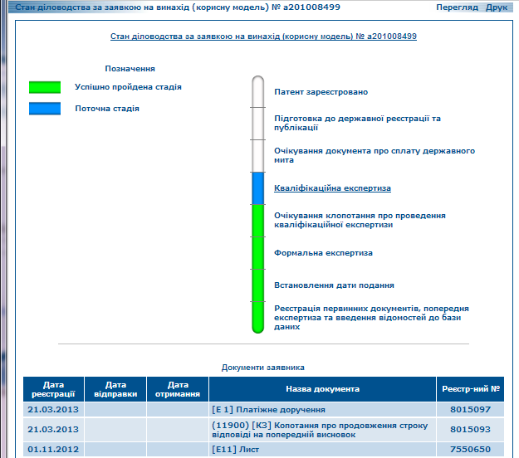
- Applicants are also able to view all documents they have received and sent. Should the need to communicate with the system administrator arise, applicants can use the built-it e-mail address.

Conclusions
- The State Intellectual Property Service of Ukraine:
concerning human resources:
– employs 131 full-time examiners with sufficient technical qualifications to carry out searches and examination; has a staff which is capable of searching the required technical fields and which has the language facilities to understand at least those languages in which the minimum documentation referred to in Rule 34 of the Regulations under the PCT is written or is translated;
concerning the PCT minimum documentation:
– has in its possession the minimum documentation referred to in Rule 34 of the Regulations under the PCT, properly arranged for search and examination purposes, and has access to it;
concerning the quality management system:
– has in place a quality management system and internal review arrangements in accordance with the common rules of international search.
- Thus, the State Intellectual Property Service of Ukraine meets the minimum requirements for it to be appointed an International Searching Authority and International Preliminary Examination Authority set out in Rules 36 and 63 of the Regulations under the PCT.

[Annex I of Appendix II follows]

ANNEX I, Table 1
Patent Information File (on CD-ROM/DVD)
used for providing access to the patent literature
of the PCT minimum documentation

№ | Name of country/ organization publishing the documents | ST.3  Code | Available patent documents  Publication year
1. | Austria | AT | Complete specifications to patents and bibliographic data thereof: since 1993
2. | African Intellectual Property Organization (OAPI) | OA | Patents for inventions: 1966 – 1992
3. | Great Britain | GB | Complete specifications to patent applications: since 2005.  Patent document abstracts: GlobalPat (1971-2003)
4. | Eurasian Patent Office (EAPO) | EA | Abstracts and complete specifications to Eurasian patents: since 2002 (CISPATENT ESPACE)
5. | European Patent Office (EPO) | EP | Complete specifications to European applications: 1978-2004  Complete specifications to European patents: 1980-2004  Complete specifications and bibliographic data of European applications and patents: 2005-2009  Complete specifications and abstracts of European applications and PCT applications: 1978-2009  Bibliographic data and facsimile images of first pages of European patent applications and PCT international applications: 1978-2005  Patent document abstracts: GlobalPat (1971-2003)
6. | Canada | CA | Title page data and complete specifications to applications for inventions: 1999-2000, since 2002  Title page data and complete specifications to patents for inventions: 2000, since 2002
7. | WIPO International Bureau | WO | Bibliographic data and complete specifications to PCT applications: 1978-2009  Bibliographic data and abstracts of European applications and PCT applications: 1978-2009  Patent document abstracts: GlobalPat (1971-2003)
8. | Germany | DE | Patent documents: 1991-1994  Bibliographic data and application and patent abstracts: 1991-2004  Complete specifications and bibliographic data of patent documents (utility models): from 1995 to 05.2011  Patent document abstracts: GlobalPat (1971-2003)
9. | Soviet Union (former) | SU | Complete specifications of inventions to author’s certificates and patents of the USSR: 1924-1993 (with gaps)
10. | Russian Federation | RU | Complete specifications to patents of Russia: since 1994 (since 2005 – Official Bulletin “Inventions. Utility Models” with complete specifications of inventions)  Complete specifications to patents of Russia (CISPATENT): since 2002  Bibliographic data and abstracts of specifications of inventions to patents of Russia (information retrieval apparatus to specifications of inventions): 1994-2010  “Specifications of utility models to titles of protection of Russian Federation”: since 1994
11. | United States of America | US | Complete specifications to patent applications: 2001-2011.  Complete specifications to patents: 1790-1999 (archive), 1975-2011  Patent document abstracts: GlobalPat (1971-2003)
12. | France | FR | Bibliographic data and abstracts of patent documents of France, EPO, РСТ: 1978-2007  Complete specifications to applications: 1992-2007  Patent document abstracts: GlobalPat (1971-2003)
13. | Switzerland | CH | Complete specifications to patents: 1993-2008  Patent document abstracts: GlobalPat (1971-2003)
14. | Japan | JP | Complete specifications to applications for inventions and utility models: 1994-2002, since 2004  Complete specifications to patents: 1994-2002, since 2004  English abstracts of patent applications: since 1976  Bibliographic data of English abstracts: since 1998
ANNEX I, Table 2
Patent Bulletins of the PCT minimum documentation countries on paper and electronic carriers available in the patent information file

№ | Name of country/ organization publishing the documents | ST.3  Code | Carrier | Publication Year | Notices
1. | Australia | AU | paper  CD-ROM | 2002-2003  2003-2009 | Since 2010 – online
2. | Austria | AT | paper  paper | 1993-2002  (inventions)  1995-2002  (utility models) | Since 2003 – online  Since 2003 – online
3. | Great Britain | GB | paper  CD-ROM | 1994-2003  (inventions)  2004-2005  (inventions) | Since 2006 – online
4. | WIPO | WO | paper  CD-ROM | 1992-1998  1998-2005 | Since 2006 – online
5. | Eurasian Patent Office | EA | paper  CD-ROM | 1996-2006  з 2007
6. | European Patent Office | EP | paper  CD-ROM  DVD | 1995-2004  1996-2005  1978-2009 | Since 2004 – online
7. | Russian Federation | RU | paper  CD-ROM/ DVD | 1994-2004 (inventions,  utility models)  since 2005 –  Official Bulletin  “Inventions. Utility Models”  (with complete specifications of inventions to patents)
8. | Soviet Union (former) | SU | paper | 1963-1990  (inventions)
9. | United States of America | US | paper  CD-ROM | 1993-2002  2002-2011 | Since 2012 - online
10. | France | FR | paper | 1997-2006 | Since 2007 - online
11. | Switzerland | CH | paper  CD-ROM | 1993-2006  1996-2001 | Since 2002 - online
12. | Japan | JP | paper | 1993-1994
ANNEX I, Table 3
List of commercial databases providing access to the PCT minimum documentation
(patent and non-patent literature)

№ | Provider  (name, country) | Database (search system) name and contents | Access conditions
1. | European Patent Office (Germany) | EPOQUENet search system  Contains patent documentation of a large number of countries in the volume needed to meet the PCT minimum documentation requirements for the offices whose official languages are not Japanese, Korean, Russian or Spanish | Test access:  from 09.01.2007 to 09.10.2008  Full access:  from 22.09.2008 to the present
2. | STN International:  FIZ Karlsruhe, STN European Service Centre (Germany) | “Chemical Abstracts Service” (CAS, USA)  Specialized database in the fields of organic chemistry, pharmaceutics, medicine and biotechnology and other technology fields | Used from July 2008 to the present
3. | Elsevier Information Systems GmbH (Germany) | REAXYS  Unique information retrieval complex providing access to integrated and unified patent information and non-patent literature in the fields of chemistry, medicine, pharmaceutics and biology | Used from 01.01.2011 to the present
4. | “Thomson Reuters (PROFESSIONAL) UK LIMITED” (Great Britain) | Derwent World Patent Index  Polythematic patent database providing access to the documents of over 40 national and international patent organizations since 1963 | Used from April 2011 via the EPO’s EPOQUE Net search system to the present
5. | ELSEVIER B.V. (the Netherlands) | Science Direct Article Choice  World largest electronic resource of full-text scientific and technical information providing on-line access to full text of nearly 10 million articles from over 2,500 titles of scientific and technical journals and over 11,000 books from Elsevier collection | Used  from June 2009 to the present
6. | All-Russian Institute of Scientific and Technical Information (VINITI) of the Russian Academy of Sciences | VINITI database  Contains polythematic information in abstracts since 1981 | Used from 2005 to the present
7. | TVINKOM (Russia) | “All Encyclopedias of Rubicon” database  Access portal to encyclopedias, dictionaries and reference books | Used from 2004 to the present
8. | World Intellectual Property Organization (WIPO) (Switzerland) | WIPO ARDI (Access to Research for Development and Innovation) program | Test access:  from December 2011  to 16.09.2012  Paid access:  from September 2012  to the present
9. | Institute of Electrical and Electronics Engineers (IEEE) (USA) | IEEE Xplore Digital Library  Specialized database in the field of electrical engineering, computer science, electronics, physics, bioengineering and metallurgy | Used from January 2013
10. | American Chemical Society (ACS) (USA) | “Journals of American Chemical Society” database  (downloading of full-text articles of specialized foreign journals) | Used from February 2013
ANNEX I, Table 4
National specialized library collections and open foreign electronic Internet-resources
used free of charge to cover the examination need for PCT minimum documentation,
including non-patent literature

№ | Library/information resource name
 | Libraries of the national level
1. | National Library of Ukraine named after V.I. Vernadsky
2. | National Scientific Medical Library of Ukraine
3. | State Scientific and Technical Library of Ukraine
4. | National Parliamentary Library of Ukraine
5. | State Scientific Library of Architecture and Civil Engineering named after V.G. Zabolotny
6. | State Scientific Agricultural Library of the National Academy of Agrarian Sciences of Ukraine
7. | Central Scientific and Technical Library of Food and Processing Industry of Ukraine
Libraries of the Institutes
of the National Academy of Sciences of Ukraine
8. | Institute of Biocolloid Chemistry named after F.D. Ovcharenko
9. | Institute of Bioorganic Chemistry and Petrochemistry
10. | O.V. Palladin Institute of Biochemistry
11. | Botany Institute named after M.G. Kholodny
12. | Gas Institute
13. | Institute of Geological Sciences
14. | Institute of Geophysics named after S.I. Subbotin
15. | Institute of Geochemistry, Mineralogy and Ore Formation named after M.P. Semenenko
16. | Institute of Hydrobiology
17. | Institute of Electric Welding named after Ye.O. Paton
18. | Institute of General and Inorganic Chemistry named after V.I. Vernadsky
19. | Institute of Zoology named after I.I. Schmalhausen
20. | Institute of Colloid Chemistry and Water Chemistry named after A.V. Dumansky
21. | Institute of Physics of Metals named after G.V. Kurdiumov
22. | Institute of Microbiology and Virology named after D.K. Zabolotny
23. | Institute of Molecular Biology and Genetics
24. | Institute of Superhard Materials named after V.M. Bakul
25. | Institute of Organic Chemistry
26. | Institute of Problems of Material Science named after I.M. Frantsevych
27. | Institute for Problems of Strength named after G.S. Pysarenko
28. | Institute of Engineering Thermophysics
29. | Institute of Physiology named after O.O. Bohomolets
30. | Institute of Plant Physiology and Genetics
31. | Institute of Physics
32. | Institute of Semiconductor Physics
33. | Institute of Physical Chemistry named after L.V. Pysarzhevsky
34. | Institute of Chemistry of Macromolecular Compounds
35. | Institute of Chemistry of Surface named after O.O. Chuiko
36. | Physico-Technological Institute of Metals and Alloys
 | Libraries of the Institutes of the Academy of Medical Sciences of Ukraine
37. | Gerontology Institute
38. | Institute of Ecohygiene and Toxicology named after L.I. Medved
39. | Institute of Neurosurgery named after A.P. Romodanov
40. | Oncology Institute
41. | Institute of Cardiovascular Surgery named after M.M. Amosov
42. | Institute of Pharmacology and Toxicology
 | Libraries of the Institutes of the Academy of Agrarian Sciences of Ukraine
43. | Institute of Apiculture named after P.I. Prokopovych
44. | Institute of Bioenergy Crops and Sugar Beet
45. | Institute of Veterinary Medicine
46. | Institute of Water Problems and Land Reclamation
47. | Scientific Library of the Institute of Fishing Industry
 | Libraries of Educational Institutions
48. | The Scientific and Technical Library named after G.I. Denysenko of the National Technical University of Ukraine “Kyiv Polytechnic Institute”.  Provides free-of-charge use of electronic resources subscribed by the library:  - EBSCO host Research Databases – 12 universal and thematic databases comprising full-text and bibliographic information from over 7,000 titles of journals, gazettes, news bulletins, reference books with deep back file archive;  - World eBook Library containing over 1 million books in PDF format in more than 100 world languages. The library comprises 125 electronic book and document collections published in the Internet.
49. | Scientific Library of the National University “Kyiv-Mohyla Academy”.  Provides free-of-charge use of electronic resources subscribed by the library:  - EBSCO host Research Databases – 12 universal and thematic databases comprising full-text and bibliographic information from over 7,000 titles of journals, gazettes, news bulletins, reference books with deep back file archive;  - Springer eBook collection – 1700 full-text books in various disciplines;  - Springer eJournal collection – access to over 2,000 scientific journals of Springer publishing house in mathematics and technology, medicine and biomedicine, chemistry, biochemistry etc. The collection also comprises some 200 editions in economics, sociology and law. The collection contains full archives of journals form Volume 1, Issue 1.  - Oxford Journals – 211 academic journals in humanities, life and social sciences, law and medicine published by Oxford University Press. Access provided to the archive from 1996 to the present;  - Academic Search Premier; Business Source Premier; ERIC; GreenFILE; Health Source - Consumer Edition; Health Source: Nursing/Academic Edition; Library - Information Science & Technology Abstracts; MasterFILE Premier; MEDLINE; Newspaper Source; Regional Business News.
50. | Scientific Library named after M. Maksymovych of the Taras Shevchenko Kyiv National University
51. | Scientific and Technical Library of the National University of Food Technologies
52. | Scientific Library of the National University of Life and Environmental Sciences of Ukraine
53. | Scientific and Technical Library of the National Aviation University
54. | National Medical Academy of Post-Graduate Education named after P.L. Shupik
55. | Ukrainian State Medical University named after O.O. Bohomolets
 | Libraries of Oil and Gas Industry Enterprises
56. | VNIPITRANSGAZ (designing of main gas and oil pipelines, underground gas storages, gas processing plants, development of gas, gas condensate and oil pools)
57. | Subsidiary Enterprise “Scientific-Research Institute of Oil and Gas Industry”
58. | Institute of Oil Transportation
59. | Ukrainian Institute for Designing Objects of Gas Industry (“Ukrgazproekt”)
 | Free-of-Charge (Open) Electronic Internet Resources
1. | ABC Chemistry – collection of full-text peer-reviewed chemical journals in English. Archive consists of 2 parts, one being a directory of journals full texts of which are permanently available in the Internet, the other one being a directory of journals free access to which is provided temporarily. A separate list of Russian-language journals is available.
2. | Biology&Science database comprising articles and research works in biology, life sciences, healthcare and general biology. Most publications are freely available, for other publications the date when the article will become available is indicated. Articles and journals are organized into categories and by publication dates. The database provides open access to 205 peer-reviewed journals in biology, medicine, technology and related sciences.
3. | BioMed Central provides on-line access to all research articles immediately after their publication.
4. | Directory of Open Access Journals – access to full-text peer-reviewed scientific journals in all fields of knowledge.
5. | Free Medical Journals – access to full texts of medical journals.
6. | Open J-Gate – one of the world largest open-access databases. Comprises 4,595 scientific journals (2,487 of them peer-reviewed) and over 1 million journal articles.
7. | PubMed – abstract database (digital article archive) in medicine and pharmaceutics of the US National Library of Medicine.
8. | HIGH WIRE Stanford University – provides access to 1,764 titles of peer-reviewed scientific journals in biology, medicine and physics, as well as to other scientific publications.
9. | Other open-access Internet-resources containing foreign periodicals.

[Annex II of Appendix II follows]
ANNEX II
INFORMATION TECHNOLOGIES DATABASES

Information technologies

Since the moment of its creation in 1992, the Patent Office of Ukraine started the development of the information technologies infrastructure to support the procedures of industrial property rights protection. At present, this infrastructure is continued to be developed and presents a complex automated information system covering all the stages of the proceeding of applications for inventions and functioning of the register of patents for inventions:
– filing of an application;
– application registration;
– publication of the data of the applications for inventions filed (applications laid open);
– formal and substantive examination of an application;
– grant of a patent;
– publication of the notification about the grant of a patent in the Official Bulletin;
– functioning of the register of patents for inventions;
– other operations part of the proceeding of applications for inventions and functioning of the register of patents for inventions

Automation
The main objects of automation are the processes of proceeding of applications for inventions and functioning of the register.
An electronic filing system is used for application filing.
The core of the application proceeding system is the «Inventions» (“Inventions”) automated system (AS) based on the electronic workflow principles. The «Inventions» AS provides the input of the application data, the complete functional of examination, state register, archive, and statistical report generation.
All the components of the «Inventions» AS are built with due consideration of the respective WIPO standards, including standard ST. 36 “Recommendation for the processing of patent information using XML (eXtensible Markup Language)”.
Incoming documents are initially registered with the help of the “Electronic Incoming Document Register” automated workstation (AWS); a work card of a new file is created; then, with the help of the “Bibliography Input” AWS, bibliographic data are entered. All the filed documents are scanned and uploaded to the database, thus creating the electronic file of an application for invention.
After the information about the application has been entered, it becomes available for examiners to perform first formal, and then substantive examination.
For the purposes of substantive examination (novelty and inventive step assessment), examiners enjoy high-speed Internet access to a large number of search resources, including the WIPO resources (PCT database), the EPO search system among many others.
The Search Portal was developed and implemented to facilitate search in the process of assessing the novelty of applications.
Next, information is automatically transmitted to the stage of generating the Official Bulletin and preparing titles of protection.
After the above-mentioned procedures have been finished, information is forwarded to the register.
Subsequent works concerning inventions are carried out in the register with the use of the “State Register of Inventions” AWS.
All the above-mentioned automated workstations use information form a single database.
The «Inventions» AS comprises elements for automated tracing and notification of receipt of payments from applicants on different examination stages and from owners of titles of protection with the aim of keeping them valid.
The information infrastructure includes the web-site where information is published both in English and Ukrainian. The web-site is equipped with a search system which is also filled and maintained in English and Ukrainian. The information about industrial property rights is published in the Official Bulletin twice a month. Public access to the interactive (on-line) databases and information and reference systems comprising information about applications for inventions and utility models, and their proceeding state, as well as about registered titles of protection is provided through the web-site.

General Application Proceeding Pattern
According to the general application proceeding pattern, an application is filed on paper. The application is checked as to the concordance with the prescribed requirements (completeness and correctness of the prepared documents), and in case of the set of the documents being complete, a paper file for the application for invention is formed. Then all paper documents are scanned and uploaded into the «Inventions» AS database and the central electronic document archive. Thus an electronic dossier of an application is generated.
After the application file has been generated, it is forwarded to the formal examination stage where it is checked for the concordance of the filed documents with the prescribed requirements. If disconformities with the prescribed requirements are found or the need for the applicant to file any additional materials arises, the examiner is able to automatically generate necessary documents. The electronic copies of these documents are entered to the database.
Thereafter the application is forwarded to the substantive examination stage.
At this stage, the application is checked as to concordance with the patentability criteria. If necessary, notifications and requests to applicants are generated, electronic copies of which, bearing examiners’ signatures, are saved in the database.
Replies from applicants on paper carriers are scanned and uploaded to the database. Thus, a dossier of an application for invention is generated both in paper and electronic forms. When the substantive examination stage is over, the contents of the application dossier on paper is fully identical with the set of electronic documents in the database.
As of 2008, a new version of the «Inventions» AS built according to the electronic workflow principles was implemented. All the incoming documents are scanned. The document images received as a result are automatically uploaded to the database. Such documents as claims, abstract and specification of invention are automatically recognized and afterwards edited by correctors. Images and recognized text are stored in the database.
After scanning, all paper documents are forwarded to the archive and only electronic documents are dealt with in the system. Thus, the general pattern can be presented as follows:

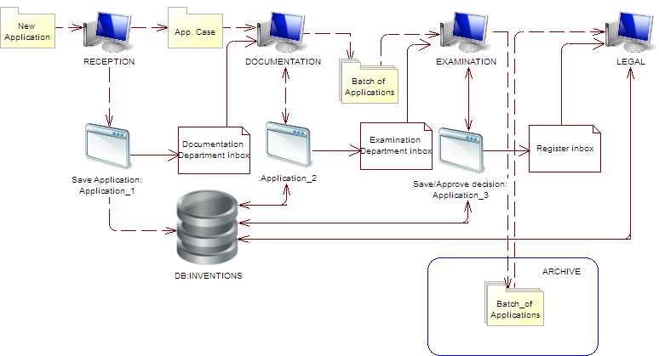

Network Infrastructure
The network infrastructure is composed of Cisco PIX525E containing VPN and Firewall modules on internal router built on a UNIX server. The presence of the two firewalls enhances the network security.
Cisco and HP equipment is used as switchboards.
The internal network is divided into the following Vlan:
– Vlan for inventions;
– Vlan for trademarks;
– Vlan for accounting;
– Vlan for security.
The following items are used in the network:
– HP (Hewlett Packard), Intel and Supermicro servers, as well as virtualized servers on VMware ESX and Hyper-V (Microsoft);
– Windows 2003, Windows 2008, Windows 2008R2 and UNIX operating systems.
The Active Directory domain provides the management of the users’ work environment setting and computers of the network, namely:
– divides users and computers into groups;
– uses group policies for each user group and for each workstation;
– supports infrastructure – DNS, DHCP.
To organize the domain structure fail-safety, the following two domain controllers are used:
– WSUS server which provides the updating of the operating systems of all servers and client computers;
– “Kaspersky Antivirus” antivirus server which provides the management of all antivirus software on client computers, the updating of antivirus bases, and the generation of the base update and existing threats report.
The following servers are used:
– database servers (MS SQL 2000, MS SQL 2005, MS SQL 2008R2);
– file servers for information exchange in the internal network;
– backup servers;
– web-servers www.SIPSU.gov.ua, www.uipv.org;
– mail server;
– EPOQUE server for providing access to the EPOQUENet database to authorized users according to the specified IP-addresses.

For data backup information storages and magnetic tapes are used. The scheme of restoration of all servers and services has been arranged.
Hardware:
The information system is deployed on the internal local computer network where application software operates and Internet connection is effected for information search and viewing.
The local computer network includes 600 PCs, 25 servers and other equipment as indicated below:

Usage | Type
Server virtualization | HP DL380, Dell 2950
Active Directory server | Virtual
Additional domain controller server | Virtual
Database server | Compaq ML570, HP DL380, Intel SE7520JR, Intel SE7501WV, Supermicro 6025B
File server | Intel SE7501WV
Server application | HP DL380, Intel SE7501WV
Unix router | Local brand
Web server | Virtual
Mail server | Virtual
Proxy server | Virtual
Network switch’s | Cisco 2650, HP Procurve 2910, HP Procurve 2510, 3Com 4500
PIX 525E | Cisco
EPOQUE Net system  - EPOQUE server  - Network switch  - Router | - IBM Xseries 206 Type 8482  - Cisco 2950  - Cisco 2691
Workstation Computers | Local brand
Printers | HP-LJ 4100, HP- LJ P2055D, HP- LJ 3015X, HP- LJ 4015X, HP- LJ 1200, HP- LJ 1300, HP- LJ 1320, HP- LJ 3005, HP- LJ 2420 (2400), HP- LJ 4000, 4050, HP- LJ 4200, HP- LJ 4250, HP-LJ 5000, HP- LJ 2015, HP- LJ 5500color, HP-LJ 3700, Samsung ML-1210, Samsung ML-2010, Epson Stylus 830U, Epson R390, Epson R340, Epson StylusC86, Canon LBP-800, Canon LBP-2460, Xerox PH3450 DN
Scanners | Canon CanoScan Lide100, Fujitsu fi-5120C, Fujitsu fi-5220C, Fujitsu fi-4120C2, Fujitsu fi-5530C, Fujitsu fi-4220C, HP SJ 7400C, HP SJ 8290, HP SJ 3800, HP SJ 2410G, HP SJ 5550C, HP SJ 8200, HP SJ G2710, UMAX Astra 6700, Mustek 2400CU

Software:
– Microsoft Windows Server 2008R2, 2008, 2003
– Microsoft Windows 7, XP
– Microsoft SQL 2008R2, 2005, 2000
– Microsoft Office 2010, 2007, 2003
– Kaspersky Antivirus (KAV).

[Appendix III follows]
REPORT ON THE QUALITY MANAGEMENT SYSTEM
prepared by the STATE INTELLECTUAL PROPERTY SERVICE OF UKRAINE
The Authority should provide general background information relevant to the quality management system (QMS) as set forth in this template.
The descriptions below each main heading of this template should be considered examples of the type and arrangement of information that should be included under each heading. Each Authority may provide additional information beyond that set forth in this template as desired.
Abbreviations used in the document
SIPSU | – State Intellectual Property Service of Ukraine
SE “UIPI” | – State Enterprise “Ukrainian Industrial Property Institute”
INTRODUCTION (CHAPTERS 21.01 – 21.03)
If applicable, the Authority may at this point indicate any recognized normative reference or basis for their quality management system besides Chapter 21, such as ISO 9001, under the heading “Normative Reference for QMS”
For example: “Normative reference for QMS: ISO 9001, EQS (European Quality System)”
Each authority should then provide at least the information indicated in the descriptive boxes, under the following headings
A quality management system (QMS) in conformity with the ISO 9001:2008 standard requirements has been implemented and used in the SIPSU.
The certificate of the QMS compliance with the ISO 9001:2008 standard obtained by the SIPSU in October 2012 covers the following areas of activity: examination of applications for intellectual property rights (inventions, utility models, industrial designs, trademarks and service marks, integrated circuit topographies and indications of origin of goods) as to their compliance with the conditions for obtaining legal protection as well as examination support processes; provision of preparation to the state registration of intellectual property rights and the official publication of information relating thereto; searching and examination of applications for inventions under the Patent Cooperation Treaty.
In September 2013, compliance audit of the QMS by an independent certification organization is planned.
1. LEADERSHIP AND POLICY
21.04 Confirm that the following are clearly documented, and that this documentation is available internally:
(a) The quality policy established by top management.
(b) The roles and names of those bodies and individuals responsible for the QMS, as delegated by top management.
(c) An organizational chart showing all those bodies and individuals responsible for the QMS.
(a) The quality policy established by the top management
In the Conception of Development of the State System of Intellectual Property Legal Protection for 2009-2014, one of SIPSU priority tasks is defined as the improvement of examination of applications for industrial property rights by means of:
– implementation of electronic proceedings of examination of applications for industrial property rights;
– improvement of the technology of applications for industrial property rights consideration on the basis of the automated systems implementation;
– enhancement of the methodological support of the processes of examination of applications for industrial property rights, provision of identical application of legislative norms, and precedent formalization;
– implementation of the system of application filing through the Internet in electronic form and minimizing the volume of applications filed on paper carriers;
– keeping the pendency time of applications for industrial property rights on the level provided by the applicable convention priorities under the Paris Convention for the Protection of Industrial Property;
– improvement of applications examination quality control.
Within the framework of the preparatory measures for applying for the International Searching Authority (ISA) and International Preliminary Examining Authority (IPEA) statuses within the Patent Cooperation Treaty (PCT) international system and provision of fulfilling the international ISO 9001:2008 standard requirements, the Quality Coordination Board has been created in the SIPSU, a quality management representative has been appointed, authorized persons in the matters of the QMS implementation and maintenance in structural divisions have been appointed; the necessary documented procedures have been determined and developed.
The quality policy is determined and presented in the Quality Manual endorsed by the order № 221 of 21.08.2012.
(b) The roles and names of those bodies and individuals responsible for the QMS; as delegated by the top management
To coordinate the works on development, implementation and maintenance of the functioning of the QMS processes, prepare and submit to the top management summarized information concerning the QMS functioning, effectiveness and needs of its improvement, Serhii Mosov, Deputy Director on information and technical support of examination, has been appointed the quality management representative.
The Quality Coordination Board is a standing consultative collegial body under the SIPSU management.
The main tasks of the Quality Coordination Board are: policy making and goal setting in the quality sphere; determination of the QMS principles, processes and model conforming to the requirements set out in ISO 9001:2008 and Part VII of the PCT International Search and Preliminary Examination Guidelines and satisfy customers’ needs; the QMS control and management, its analysis and improvement.
The Quality Coordination Board meets at least once every six months.
The QMS organizational structure is presented below.
(c) An organizational chart showing all those bodies and individuals responsible for the QMS

State Intellectual Property Service of Ukraine

SIPSU Head
State Enterprise
“Ukrainian Industrial Property Institute”

Director

First Deputy Director

Deputy Director on Examination Matters
Deputy Director on Information and Technical Support of Examination

Deputy Director on Legal Provision
Department of Examination of Applications for Designations and Industrial Designs

Public Relations and Protocol Events Department

Procurement Division

Personnel Division

Front Office

System Accounting, Document Control Archive-Keeping Division

Analysis and Economic Planning Substantiation Division

Department of Examination of Applications for Inventions, Utility Models and Integrated Circuit Topographies
Organizational Work and Order Execution Control Division

Quality Coordination Board
Department of application registration, editing and preparation of official publications
Computerization and Information Technologies Department

Patent Information Support Department
Economic Forecasting and Statistics Division

Department of Legislation Development in the Industrial Property Sphere
SIPSU Board
QMS Implementation and Audit Sector
Industrial Property Economic Regulation Division
Rights Enforcement Management Department

Legal Provision and Rights Enforcement Division
European Integration and International Cooperation Division

Control over IPR Use Division

Financial-Administrative Division

Structure of the Department of Examination of Applications for Inventions, Utility Models and Integrated Circuit Topographies

Department Head

Deputy Department Head

Chemistry and Metallurgy Division
Sector of Patent Information Databases Analysis

Pharmaceutics Division
International Applications Division
Chemical and Biological Technologies Division
Documentation Handling Division
General Mechanical Engineering, Metal Working and Welding Division
Formal Examination Division
Telecommunications Sector
Division of Filing Date Determination
Construction and Mining Division

Light and Printing Industry Division
Patent Search Division

21.05 Indicate (e.g. by means of a table) the extent of compatibility between the Authority's QMS and the requirements of Chapter 21 of these International Search and Preliminary Examination Guidelines.
Alternatively, indicate where the Authority is not yet compliant with these requirements.

Chapter 21 requirement |  |  | Extent of compliance
 |  |  | full | Part | No
21.04 | (а) | Quality policy available
 | (b) | Identified roles and names for QMS responsibility
 | (c) | Organizational chart available
21.05 |  | Established compatibility of QMS with Chapter 21
21.06 | (a) | Mechanisms to ensure effectiveness of the QMS
 | (b) | Control of the continual improvement process
21.07 | (a) | Communication of management about this standard to staff
 | (b) | The PCT Guidelines are in line with the Authority's QMS
21.08 | (a) | Management reviews take place
 | (b) | Quality objectives are reviewed
 | (c) | Communication of quality objectives throughout the Authority
21.09 | (a) | Performance of a yearly internal review of the QMS in/to
 | (b) | (i) determine the extent to which the QMS is based on Chapter 21
 |  | (ii) determine the extent to which S&E complies with PCT Guidelines
 | (c) | an objective and transparent way
 | (d) | using input incl. information according paragraph 21.17
 | (e) | recording the results
21.10 |  | Assurance to monitor and adapt to actual workload
21.11 | (a) | Infrastructure in place to ensure that a quantity of staff
 |  | (i) sufficient to deal with the inflow of work
 |  | (ii) which maintains tech. qualifications to S&E in all technical fields
 |  | (iii) which maintains the language facilities to understand languages according to Rule 34
 | (b) | Infrastructure to provide a quantity of skilled administrative staff
 |  | (i) at a level to support the technically qualified staff
 |  | (ii) for the documentation records
21.12 | (a) | (i) Ensuring appropriate equipment to carry out S&E
 |  | (ii) Ensuring documentation accord. to Rule 34
 | (b) | (i) Instructions to help staff understand and act accord. the quality criteria and standards
 |  | (ii) Instructions to follow work procedures accurately and they are kept up-to-date.
21.13 |  | (i) L&D program to ensure and maintain necessary skills in S&E
 |  | (ii) L&D program to ensure awareness of staff to comply with the quality criteria and standards.
21.14 | (a) | System in place for monitoring resources required to deal with demand
 | (b) | System in place for monitoring resources required to comply with the quality standards in S&E
21.15 | (a) | Control mechanisms to ensure timely issue of S&E reports
 | (b) | Control mech. regarding fluctuations in demand and backlog
21.16 | (a) | Internal quality assurance system for self-assessment
 |  | (i) for compliance with S&E Guidelines
 |  | (ii) for channeling feedback to staff
 | (b) | A system for measurement of data and reporting for continuous improvement
 | (c) | System for verifying the effectiveness of actions taken to correct deficient S&E work
21.17 | (a) | Contact person helping identify best practice between Authorities
 | (b) | Contact person fostering continual improvement
 | (c) | Contact person providing for effective comm. with other Authorities for feedback and evaluation
21.18 | (a) | (i) Appropriate system for handling complaints
 |  | (ii) Appropriate system for taking preventive/corrective actions
 |  | (iii) Appropriate system for offering feedback to users
 | b) | (i) A procedure for monitoring user satisfaction & perception
 |  | (ii) A procedure for ensuring their legitimate needs and expectations are met
 | c) | Clear and concise guidance on the S&E process for the user
 | d) | Indication where and how the Authority makes its quality objectives publicly available
21.19 |  | Established comm. with WIPO and desig./ elected offices
21.20 |  | QMS of Authority clearly described (e.g. Quality Manual)
21.21 | (a) | Documents making up the Quality Manual have been prepared and distributed
 | (b) | Media available to support the Quality Manual
 | (c) | Document control measures are taken
21.22 | (a) | Quality policy of the Authority and commitment to QMS
 | (b) | Scope of QMS
 | (c) | Organizational structure and responsibilities
 | (d) | the documented processes are carried out in the Authority
 | (e) | Resources available to carry out processes
 | (f) | a description of the interaction between the processes and the procedures of the QMS.
21.23 | (a) | Records which documents are kept and where they are kept
 | (b) | Records of results of management review
 | (c) | Records about training, skills and experience of staff
 | (d) | Evidence of conformity of processes
 | (e) | Results of reviews of requirements relating to products
 | (f) | Records of the S&E process carried out on each application
 | (g) | Record of data allowing individual work to be tracked
 | (h) | Record of QMS audits
 | (i) | Records on actions taken re. non-conforming products
 | (j) | Records on actions taken re. corrective actions
 | (k) | Records on actions taken re. preventive actions
 | (l) | Records referring to search process documentation
21.24 | (a) | (i) Recording of the databases consulted during search
 |  | (ii) Recording of keywords, combination of words and truncations during search
 |  | (iii) Recording of the languages used during search
 |  | (iv) Recording of classes and combinations thereof consulted during search
 | (b) | Records about other information relevant to the search
 | (c) | (i) Records about limitation of search and its justification
 |  | (ii) Records about lack of clarity of the claims
 |  | (iii) Records about lack of unity
21.25 |  | Report on its own internal review processes
21.26 – 21.28 |  | Additional information on further inputs to its internal reviews
21.29 |  | Initial report called for by paragraph 21.19

21.06 Indicate with reference to the organizational chart those bodies and mechanisms management uses to ensure:
(a) the effectiveness of the QMS; and
(b) that the process of continual improvement progresses.
(а) the effectiveness of the QMS
The quality policy making and implementation are the responsibilities of the SIPSU management and the quality management representative.
In order to assess the QMS efficiency, the SIPSU management yearly develops and formulates measuring goals and indicates the divisions and/or division heads responsible for ensuring their achievement, and approves the QMS internal auditing program.
The results of the internal audits are discussed and analyzed and the Quality Coordination Board meeting, and summarized conclusions are submitted for consideration to the SIPSU Head in order for respective decisions aimed at the quality activities improvement to be made.
(b) that the process of continual improvement progresses
The quality management representative carries out general management and coordination of the activities of the authorized persons in the matters of the QMS implementation and maintenance in structural divisions, as well as of the QMS implementation and audit sector in the matters of the QMS efficient development, implementation and improvement.
The most crucial issues and prepared propositions are discussed on the Quality Coordination Board meetings and management talk-ins; the decisions made during such meetings and talk-ins are recorded in protocols, orders and directions.
21.07 Indicate how management of the Authority communicates to its staff the importance of meeting treaty and regulatory requirements including:
(a) those of this standard; and
(b) complying with the Authority's QMS.
The SIPSU communicates to the staff the importance of fulfillment of the QMS requirements, including requirements under the PCT, relating to the international search and international preliminary examination quality provision, through orders and directives of the SIPSU management, weekly operational meetings with the SIPSU Head, training seminars, Quality Coordination Board reports and protocols, SIPSU annual reports; the information about these events and documents is promptly distributed by e-mail and through the internal information network.
Beside this, the SIPSU brings the requirements of quality management-related standards and regulatory documents to the examiners’ attention through the specially created Reference and Information Section in the “Inventions” automated system (AS) accessible to all examiners from their own workstations.
21.08 Indicate how and when top management of the Authority or delegated officers:
(a) conducts management reviews and ensures the availability of appropriate resources;
(b) reviews quality objectives; and
(c) ensures that the quality objectives are communicated and understood throughout the respective Authority.
(a) Conducts management reviews and ensures the availability of appropriate resources
The SIPSU management develops and forms dimensional goals, directed toward quality improvement, based on the Quality Policy.
QMS analysis and goal achievement level are performed twice a year at Quality Coordination Council proceedings.
A QMS functioning report is a summary document from the management, based on which the management works out QMS development plans, elaborates QMS modification and/or improvement decisions, and assigns resources required for QMS functioning.
In 2013, the management plans the QMS analysis to be held in August and December.
(b) Reviews quality objectives
The SIPSU management reviews are carried out by the QMS implementation and audit sector under the SIPSU Head orders according to the QMS auditing program.
Should the need arise, unscheduled reviews on separate matters can be carried out.
The QMS tasks are reviewed in the course of planning the SIPSU activities for the following year.
(c) Ensures that the quality objectives are communicated and understood throughout the respective Authority
The personnel has the ability of promptly accessing necessary documents and viewing the results of the QMS functioning through the orders or directives sent to the structural divisions and published on the SIPSU Intranet-portal, as well as in the course of staff meetings in divisions.
Beside this, the information on the results of examination quality checks, new operation procedures and other information concerning the SIPSU activities is sent to the heads of examination divisions to be forwarded to the divisions’ staff and for further reference.
21.09 Indicate whether top management or delegated officers of the Authority perform an internal review of the QMS in accordance with paragraphs 21.25-21.28:
(a) at least once per year (cf. paragraph 21.25);
(b) in accordance with the minimum scope of such reviews as set out in Section 8, namely:
(i) to determine the extent to which the QMS is based on Chapter 21 (cf. paragraphs 21.25, 21.27(a));
(ii) to determine the extent to which Search and Examination work complies with PCT Guidelines (cf. paragraphs 21.25, 21.27(a));
(c) in an objective and transparent way (cf. paragraph 21.25);
(d) using input including information according to paragraphs 21.27 (b)-(f);
(e) recording the results (cf. paragraph 21.28).
See 21.05, 21.08.
Each month, meetings with the participation of the Deputy director on examination matters, Deputy director on information and technical support of examination, Head of the Department of examination of applications for inventions, utility models and integrated circuit topographies, as well as members of staff responsible for quality control are held.
The meetings are dedicated to discussing current quality management issues, availability of necessary resources and measures to be taken to satisfy immediate needs.
The results of such meetings are brought to the attention of respective examination divisions or individual examiners for further reference.
Beside this, internal automated routine and randomized examination quality control is provided in the SIPSU.
Routine quality control is carried out on the level of heads of examination divisions.
Randomized control is carried out on the level of the Head/Deputy Head of the Department of examination of applications for inventions, utility models and integrated circuit topographies and members of staff responsible for quality control in the Department.
All decisions about non-compliance of an invention with the patentability criteria are made by 3 persons: the examiner, Division Head and Department Head (Deputy Department Head).
When carrying out searches, examiners must:
– check the observance of the invention unity principle;
– correct the primary classification;
– adhere to the PCT minimum documentation when performing patent information search;
– determine relevant categories in search reports;
– bring forward clear arguments in case an invention does not comply with the novelty and inventive step criteria.
2. RESOURCES
21.10 Explanatory note: The granting of ISEA status means that the Authority has demonstrated it has the infrastructure and resources to support the search and examination process. Chapter 21 calls for assurance that the Authority can continually support this process while accommodating changes in workload and meeting QMS requirements. The responses to Sections 21.11 to 21.14, below, should provide this assurance.
21.11 Human resources:
(a) Provide information about the infrastructure in place to ensure that a quantity of staff:
(i) sufficient to deal with the inflow of work;
(ii) which maintains the technical qualifications to search and examine in the required technical fields; and
(iii) which maintains the language facilities to understand at least those languages in which the minimum documentation referred to in Rule 34 is written or is translated is maintained and adapted to changes in workload.
(b) Describe the infrastructure in place to ensure that a quantity of appropriately trained/skilled administrative staff is maintained and adapted to changes in workload:
(i) at a level to support the technically qualified staff and facilitate the search and examination process;
(ii) for the documentation of records.
(a) Provide information about the infrastructure in place to ensure that a quantity of staff:
The total number of examiners performing the examination of inventions is 131 persons.
All of them are employed full time and have a higher education (specialist’s/master’s degree) in respective field and second university degree in the intellectual property sphere; among them there are also 6 PhD degree holders. SIPSU examiner’s experience and knowledge allow high-level search and examination in the following fields: nanotechnologies, pharmaceuticals, chemistry, biotechnologies, agriculture, metallurgy, electronics, telecommunications, etc.
All examiners are fluent in Ukrainian, Russian and English; some of the examiners also have sufficient knowledge of German, French, Spanish, Polish and Japanese.
The Deputy director on examination matters, Deputy Director on information and technical support of examination, Head of the Department of examination of applications for inventions, utility models and integrated circuit topographies, Head of human resources division and members of staff responsible for quality control matters rate the necessity in human resources on a regularly basis at the monthly management meetings according to the present work volumes.
At these meetings, decisions about new examiners recruitment are made, their background requirements for examination performance. Also, educational and/or professional development activities schedule is approved at the monthly management meetings.
Newly recruited examiners are assigned a tutor from among the experienced chief examiners having the signing authority. Such tutors organize trainings and check the work performed by junior examiners.
The training of examiners is organized on an ongoing basis in the form of trainings dedicated to performing and documenting searches and case studies.
Beside this, examiners are able to improve their qualification within the international cooperation framework and taking part in the events organized in Ukraine.
(b) Describe the infrastructure in place to ensure that a quantity of appropriately trained/skilled administrative staff is maintained and adapted to changes in workload:
(i) at a level to support the technically qualified staff and facilitate the search and examination process;
To provide the high quality examination, each examiner has been provided access from their own workplace to document processing regulations, materials on examination methodology, instructions, directives and interpretations provided both by the legal function and given on the Department level based on the results of respective training by placing them in the reference and information section of the “Inventions” AS.
Access to legislative documents of Ukraine, WIPO standards, Paris Convention for the Protection of Intellectual Property, Patent Cooperation Treaty (PCT), Regulations under the PCT, PCT Administrative Instructions, Patent Law Treaty (PLT), Regulations under the PLT, PCT International Search and Preliminary Examination Guidelines etc. is provided in the same way.
Within the international cooperation framework examiners take part in the following events:
1. World Intellectual Property Organization (WIPO) distance learning program (on an ongoing basis).
DL-101 (general course) certificates were received by almost all examiners.
Those examiners who have received DL-101 certificates take part in further learning programs DL-320, DL-318, Dl-301, DL-202, DL-204 (advanced level).
2. On-line training on the matters of examination and patent information searches organized by the European Patent Office (EPO), business trips on training and other matters connected with optimization of the use of EPOQUE Net retrieval system (regularly).
3. Training events regularly organized by EPO on the matters of quality control in patent searches and examination and other examination and patent search-related matters.
4. The participation in the meetings of the Working Groups of the International Patent Classification (IPC) Union Committee of Experts.
5. Study visits and/or seminars organized by the WIPO to promote sharing experience and networking of representatives of the PCT receiving offices on the matters of international applications proceeding, processing of international applications filed in the electronic form using the WIPO PCT-SAFE software and the use of electronic services (еРСТ and/or PCT-ROAD systems in particular).
Events organized in Ukraine:
1. International Scientific and Practical Conference “Actual Problematic Issues of Intellectual Property” (bi-annually).
2. Yearly seminars “Peculiarities of Applications for Inventions and Utility Models” and “Use of Paperless Information Technologies in the Processes of Acquisition of Industrial Property Rights”.
3. Training of examiners on the matters of examination and use of databases (STN, REAXYS, EPOQUENet, DWPI etc.) conducted in particular by the providers of the mentioned databases.
4. Seminars and conferences organized by the National Academy of Sciences and branch Academies of Sciences of Ukraine.
5. Regional seminars organized with the aim of raising awareness of the Ukrainian public of the PCT system.
(ii) for the documentation of records.
Computerization and Information Technologies Department provides additional support to technically qualified employees by supplying them with the necessary software and equipment.
21.12 Material resources:
(a) Describe the infrastructure in place to ensure that
(i) appropriate equipment and facilities such as IT hardware and software to support the search and examination process are provided and maintained;
(ii) at least the minimum documentation referred to in Rule 34 is available, accessible, properly arranged and maintained for search and examination purposes. State whether it is on paper, in microform or stored on electronic media, and where.
(b) Describe how instructions
(i) to help staff understand and adhere to the quality criteria and standards, and
(ii) to follow work procedures accurately and consistently are documented, provided to staff, kept up-to-date and adapted when necessary.
For information support, all up-to-date methods, forms and means are utilized: the Internet (the SIPSU web-portal, the SE “UIPI” web-site, Intranet-portal, the Digital Patent Library web-site), official and specialized publications, printed and electronic mass media, international cooperation in the sphere of patent information and documentation. Specific functions concerning constituent elements of the set of works on information support are entrusted to the respective structural divisions of SE “UIPI”, in particular Patent Information Support Department and Computerization and Information Technologies Department.
(a) Describe the infrastructure in place to ensure that
(i) appropriate equipment and facilities such as IT hardware and software to support the search and examination process are provided and maintained
Information and technical support is ensured by Computerization and Information Technologies Department. This Department consists of:
– Division of Information Technologies Implementation and Maintenance which provides software development, implementation, maintenance and operation as well as database administration;
– Division of Automated Systems Operation which provides hardware servicing;
– Division of Systems Integration and Communication Technologies which ensures the work of communication systems and server equipment;
– Sector of Information Technologies System Analysis which provides implementation and administration of the system of electronic filing of applications for industrial property rights, administration of the Digital Patent Library and Internet databases administration;
– Sector of Key Certification Centre Abonent Registration which carries out registration and servicing of abonents of the accredited key certification center, provides generation of personal keys and electronic digital signature (EDS) certificates; providing consultations to registered abonents and respective structural divisions of the SIPSU on the matters of EDS use and work with EDS means; providing guidance to users of electronic application filing system.
Each examiner has at their disposal an up-to-date personal computer connected to the Internet. Special client software is installed on these computers to fulfill the examiner functions in the “Inventions” AS which provides the full cycle of the document workflow of examination of both national and PCT applications (national phase).
In addition, a bilateral connection between the SIPSU and WIPO International Bureau has been established through the PCT-EDI system. This channel is used by the International Applications Division which fulfills the functions of a Receiving Office for documents exchange (international phase). Notifications on applications status are generated automatically and forwarded to the International Bureau each month.
Also, access to the ePCT system has been established; the system is intended to provide safe on-line access to the documents of international applications, their viewing and downloading.
The SE “UIPI” receives documentation both on paper carriers and in electronic form.
All documents received on paper are scanned to produce color image, and recognized. As a result, a file in PDF/A format is sent to the database. The text of the document is indexed to further enable full-text searches. Documents are stored in technological databases managed by the Microsoft SQL Server 2008 database management system (DMS).
In the SE “UIPI” a system of electronic document filing with the use of electronic digital signature is deployed. Documents in electronic form are also forwarded through a special buffer to the same technological databases and stored there in the original form together with the electronic digital signature. These electronic documents are converted into PDF/A format and stored in the technological databases alongside with the original files.
(ii) at least the minimum documentation referred to in Rule 34 is available, accessible, properly arranged and maintained for search and examination purposes. State whether it is on paper, in microform or stored on electronic media, and where.
The patent information collection in the SIPSU covers patent documents from organizations and patent offices of the countries of the PCT minimum documentation.
Batching of the patent information collection for almost 20 years has been carried out mainly through the international cooperation with WIPO, EPO and national offices. In 2003, under the Law of Ukraine “On the Protection of Rights to Inventions and Utility Models”, UIPI was declared to be the center of international exchange of publications that provides the legislative environment for the specified field of activity.
National patent documents in the patent information collection are provided for in the form of the Official Bulletin “Promyslova Vlasnist” (hereinafter referred to as the Official Bulletin) on paper (published since 1993 until now) and CD-ROM/DVD (published since 2005 until now), specifications to patents of Ukraine for inventions on paper (published since 1993 thru 2011), which are also published on CD-ROM “Inventions in Ukraine” (since 2005 until now), as well as the regional patent information product of CIS countries on CD-ROM – CISPATENT (published since 2002 until now), which comprises, in particular, specifications to patents of the Russian Federation and EAPO for inventions.
Last decade provided new alternatives to access the PCT minimum documentation (patent documents and non-patent literature) via Internet, allowing increase in number and improvement of quality of the available information resources.
At a certain stage, experts, who carry out substantive examination of applications for inventions, obtained critical experience to perform the search of patent documents in the national patent information collection and on the Internet, which enabled considerable enlargement of the scope of the available information used to determine prior art, as well as to improve the quality of the search and to reduce relevant expenses.
Since 2007, foreign commercial databases providing the access to the PCT minimum documentation (patent documents and non-patent literature), appropriate reference information, and equipped with more complicated, but highly efficient search tools, are used. As of June 1, 2013, 10 foreign commercial databases, access to which is provided under the appropriate contracts and agreements, are used in the course of examination, namely:
– All Rubricon Encyclopedias (since 2004);
– Database of the All-Russian Institute of Scientific and Technical Information (VINITI) of the Russian Academy of Sciences (since 2005);
– EPOQUENet (since 2007);
– Chemical Abstracts Service (since 2008);
– Science Direct Article Choice (since 2009);
– Derwent World Patent Index (since 2011);
– REAXYS (since 2011);
– Access to Research for Development and Innovation (ARDI) Program (since2012);
– IEEE Xplore Digital Library (since 2013);
– Journals and Publications of the American Chemical Society (since 2013).
Moreover, an agreement with the State Public Scientific and Technical Library of the Russian Federation, covering the access to electronic copies of the necessary information resources within its collection, was made to boost the level of supply of examiners with non-patent literature.
The main search tool among the foreign Internet resources, which are used by examiners to ensure efficient and quality patent search within the substantive examination of applications for inventions and utility models, is EPO’s EPOQUENet since it contains patent documents from a large number of countries as required to meet the requirements relating to accessibility to the PCT minimum documentation for offices, which operate in Japanese, Korean, Russian, or Spanish official language.
Access to EPOQUENet has been provided since 2007 under the appropriate agreements. Thus, in 2013, EPOQUENet was used under the agreement for a period from January 1, 2012, thru December 31, 2013.
Due to the change of the pricing policy and policy for distribution of the EPOQUENet data, which came into effect on January 1, 2013, a set of works aimed at concluding the new 4-year agreement with EPO before June 30, 2013, is carried out.
Provision of the guaranteed access to EPOQUENet by examiners under the new agreement for the specified term is also important due to the possibility to access the Derwent World Patent Index via EPO’s database.
To provide information support for the examination of applications for inventions with non-patent literature, the list of which is agreed by International Searching Authorities under the Rule 34.1(b)(iii) of the PCT Regulations, public national and foreign Internet resources, in particular, electronic digital libraries and collections (digital primarily) of 7 largest national-level public libraries of Ukraine, 29 libraries of the specialized scientific institutions of the National Academy of Sciences of Ukraine, 6 libraries of scientific institutions of the Academy of Medical Sciences of Ukraine, 6 libraries of institutions of the Academy of Agricultural Sciences of Ukraine, 8 libraries at the lead higher educational institutions, etc., are also used widely along with commercial databases. Electronic copies of the ordered information sources, in particular, articles in periodicals, are received via the electronic document delivery system.
Today, foreign commercial databases, private information resources, as well as public collections at 59 largest national and specialized libraries (including national electronic digital libraries and electronic collections), used to carry out the search, ensure the access to the PCT minimum documentation to the fullest extent.
To support patent searches for determining the compliance of the claimed invention to the patentability criteria, each examiner has access to the Search Portal. The Portal is functionally integrated with the technological automated systems and adapted to the patent information sources (databases), including the national file and foreign patent document collections received on optical carriers.
In order to simplify the use and enhance search efficiency and speed, all patent documents received on optical carriers or via FTP are converted into a single electronic database structure stored in the information warehouse under the PostgreSQL DMS.
To provide access and support searches in the patent databases, a multifunctional search mechanism and information viewers have been realized in the Search Portal. The search mechanism and information viewers allow to:
– perform full-text search in selected sources or a group of sources;
– view search results for each source;
– quickly jump to the text fragment which contains search terms;
– generate reports based on the search results;
– keep the search term history;
– print documents out;
– export documents.
The Search Portal is used by all examiners to perform patent searches.
With the use of the Search Portal examiners can carry out full-text searches using advanced features, for example limitation of intervals between words, search stemming etc.
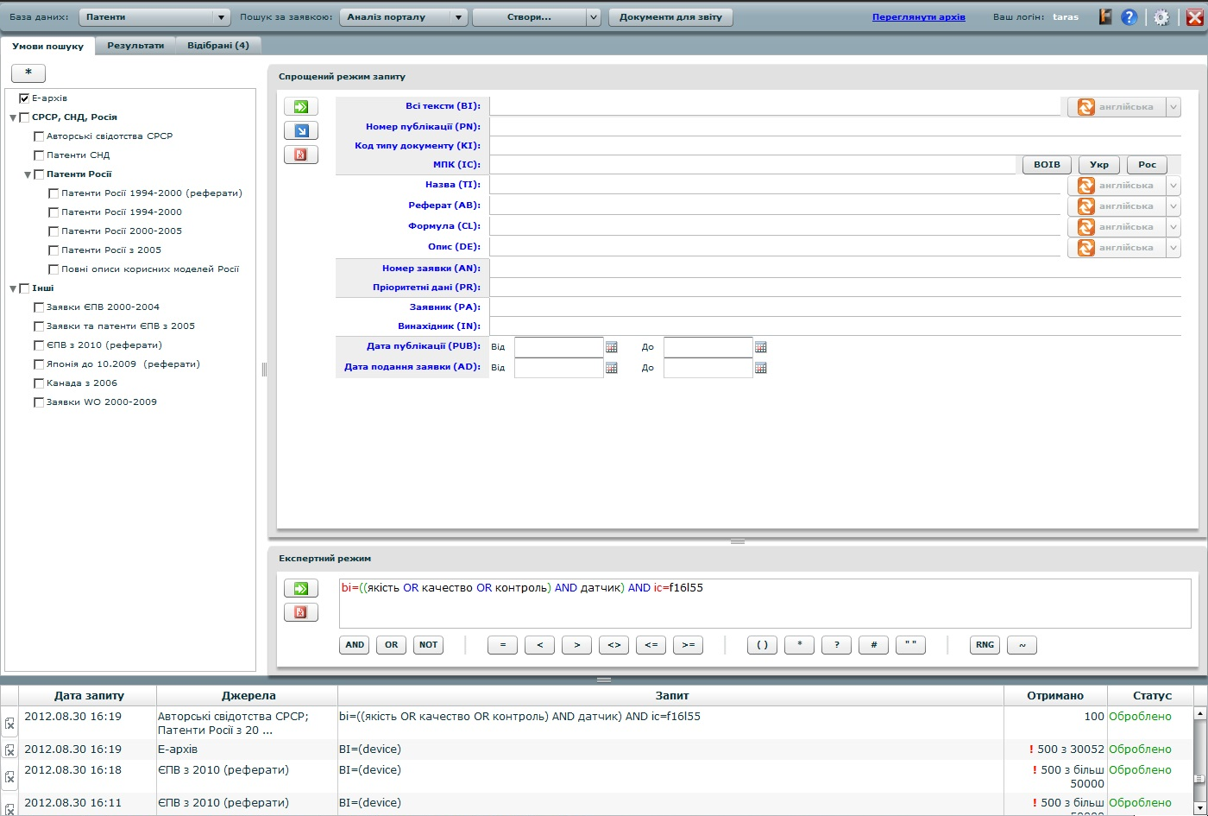

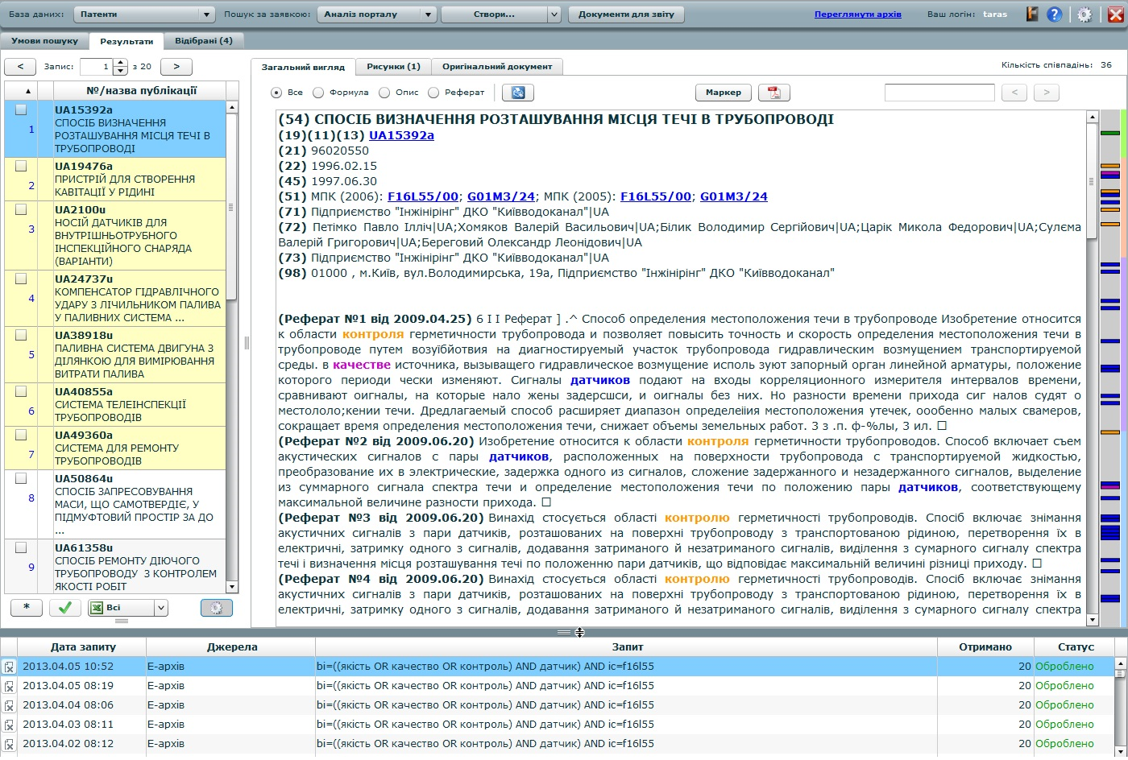

The Search Portal is designed to be able to forward data to the “Inventions” AS for automatic search report generation.
The System Accounting, Document Control Archive-Keeping Division provides the procedures of system accounting of documents concerning industrial property rights (IPR), controls their proceeding in the information and technological process of the IPR application prosecution and provides continuous storing of the IPR application materials and IPR registration files in the archive.
When necessary, the procedure of automated patent search may be supplemented by the traditional search procedure with the use of information on paper carriers available in special archival depositories.
Information documents can be handed to examiners both on paper carriers and in the form of electronic documents circulated via the internal information network.
(b) (і)– (іі)
Control of QMS documents is a part of the "Control of the Quality Management System Documents” process regulated by Methodology of Control of the Quality Management System Documents and Workflow Management Regulations and is provided by operation of the respective automated document flow system. The Methodology and Workflow Management Regulations specify: the order of QMS documents approval; the order of reviewing, updating and re-approving QMS documents; the ways and means of identifying changes and current revision status of the QMS documents; the order of QMS documents distribution; requirements as to the documents legibility and identification; the order of identification and distribution management of documents of external origin; actions to prevent unintended use of obsolete documents and the order of application of suitable identification in case such documents are retained for any purpose; requirements as to identification of the QMS documents retention period.
The QMS documentation can be retained and distributed in electronic form via computer network, document workflow automated system or electronic information carriers provided that controlled copies of respective documents on paper carrier and/or in graphic format of PDF are necessarily available. The quality management representative is responsible for control of QMS documents. Document workflow control and compliance with the documents control requirements are fulfilled by the front office, division heads and employees responsible for QMS development.
Through the reference and information section of the “Inventions” AS each examiner has access from their workplace to relevant standards, regulations, instructions, interpretations, regulatory and legal documentation, notices, presentations, prescriptions, information notices sent by WIPO etc. This enables the examiners to maintain a high level of awareness, provides the ability to promptly react to changes and improvements of the quality provision system and guarantees the quality of examination and searches.
21.13 Training resources:
Describe the training and development infrastructure and program which ensures that all staff involved in the search and examination process:
(i) acquire and maintain the necessary experience and skills; and
(ii) are fully aware of the importance of complying with the quality criteria and standards.
The need in personnel training is determined by the division heads on the basis of the personnel’s competence level evaluation and with necessary consideration of the requests of the employees wishing to improve their skills. The meeting results are also used for this purpose. The costs necessary for training and skills improvement are allocated according to the yearly planned estimate of expenditures.
Once in three years, a planned employee performance review is undertaken, during which the results of their work, business and professional qualities disclosed in the course of their professional duties fulfillment are estimated. Within the period between the reviews the employees’ fulfillment of the tasks and duties imposed on them are assessed. The review and assessment results are documented in relevant SIPSU records and orders retained in the Personnel Division.
The training takes the following forms:
– seminars for examiners;
– special workshops on the matters of intellectual property, patent search and examination;
– distance learning under the WIPO program;
– discussion forums with representatives and professional organizations in the intellectual property sphere, including applicants and patent attorneys;
– skill improvement courses for IT specialists;
– providing the second university degree in the “Intellectual Property” specialty.
With the aim of sharing experience and best practices of foreign offices (including ISA/IPEA) in examination matters, in particular patent searches using various databases, search reports preparation, emergence of new databases, use of the IPC and other classification systems, the matters of legislation development in the industrial property sphere in the countries of the world, respective measures have been taken to promote studying of such experience, its implementation into the activities of the state system of intellectual property legal protection and improvement of employees’ skills, first of all examiners’ skills.
Alongside this, the records of the skills improvement events are kept and monthly reports about them are prepared according to the set standard forms and forwarded to the Personnel Division to be further processed, summarized and become the basis of respective propositions.
Describe the training and development infrastructure and program which ensures that all staff involved in the search and examination process:
(i) acquire and maintain the necessary experience and skills
Newly recruited examiners are assigned a tutor from among the experienced chief examiners having the signing authority. Such tutors organize trainings (the training program is designed to last a year) and check the work performed by junior examiners.
After the examiner’s competence and skills have undergone rigorous assessment, the examiner is entrusted with the signing authority, which enables him to make independent decisions about the invention’s conformity with the patentability criteria and perform patent information searches for this purpose.
Their decisions are now subject only to internal control without the tutor’s constant participation; all decisions concerning the refusal in providing legal protection are, however, to be checked on the level of the Examination Department Head.
The training of all examiners is organized on an ongoing basis in the form of performing and documenting searches and case studies (see 21.11).
The reference and information section of the “Inventions” AS provides all examiners with continuous access to the following materials:
– presentations and training materials, interpretations, instructions and methodologies of examination and search techniques;
– comments on specialized matters concerning carrying out searches in chemistry, pharmaceutics and molecular biology;
– internal training programs and clarifications of the matters of EPOQUENet system use (based on the materials presented by EPO);
– training and clarification materials on the IPC and IPC reclassification matters;
– information and training materials concerning the Common Patent Classification (CPC).
The materials of trainings and workshops organized on SIPSU level, as well as external seminars and conferences held, in particular, by the search systems providers (STN, EPOQUENet) and examiners’ meetings with representatives of respective industrial sectors are accessible through the Intranet.
Great attention is paid to training examiners to perform searches via EPOQUENet. Examiners regularly attend webinars and other on-line training events organized by the EPO, as well as in train-the-trainer seminars in order to be able to share the obtained knowledge with other examiners using EPOQUENet.
In order to make the use of EPOQUENet more advantageous, a permanent Working group was created, whose members exchange personal experience, process the information received on the EPO seminars and training sessions for EPOQUENet users, develop the ways to improve the patent search strategy with the due account of the experience of the EPO and world leading patent offices.
Examiners constantly receive information via e-mail about free-of-charge trainings and webinars on Patent Cooperation Treaty (PCT) matters held by WIPO, webinars organized by EPO to highlight the news and latest developments in the patent information services field and new patent information systems and services.
Describe the training and development infrastructure and program which ensures that all staff involved in the search and examination process:
(ii) are fully aware of the importance of complying with the quality criteria and standards
Thanks to the above-mentioned forms of training and provision of access to the materials mentioned in 21.13(і), examiners are constantly knowledgeable of the important matters concerning maintaining the quality criteria and quality standards when performing examination and patent information searches.
21.14 Oversight over resources:
Describe the system in place for continuously monitoring and identifying the resources required:
(a) to deal with demand; and
(b) comply with the quality standards for search and examination
See 21.08, 21.09, 21.16.
(a) to deal with demand
The SIPSU possesses the necessary resources, principal of which are the following: skilled personnel with appropriate level of expertise; optimal infrastructure ensuring compliance with the requirements for services; maintained and controlled operation environment providing the proper material and social conditions for the work, motivation, demands compliance, and staff performance.
The SIPSU managing staff performs constantly the analysis of compliance of the level of provision/sufficiency of these resources with current needs in quality examination and search, depending on the workload of examiners, based on the results of review of the monthly reports by the heads of the respective structural divisions. Outcome of such analysis results in decisions and corrective (remedial) actions.
(b) comply with the quality standards for search and examination
The Deputy Director on examination matters representing the management is the person responsible for supporting the process of fulfillment the requirements regarding standards in patent search and examination.
The procedure of the quality control of the examination and searches is described in details in Section 21.16.
In order to control the resources used for patent searches, improvement, quality enhancement and adherence to unified methodological approaches when performing patent searches, a respective order regulates the performance of patent searching in the course of substantive examination of applications for inventions; in particular, the list of in-house electronic information resources, free Internet resources and foreign commercial databases comprising, above all, the PCT minimum documentation and necessary for use is determined.
Works intended for regular replenishing the in-house patent information file, as well as providing seamless use of the determined foreign commercial databases within the agreements signed with WIPO, EPO and foreign providers are carried out on the on-going basis.
Additionally, the information concerning the generally accessible Internet resources (IPR databases, scientific and technical databases and reference resources) is systematically monitored, updated and placed on the SIPSU web resources.
3. MANAGEMENT OF ADMINISTRATIVE WORKLOAD
21.15 Indicate how the following practices and procedures for handling search and examination requests and performing related functions such as data-entry and classification are implemented:
(a) Effective control mechanisms regarding timely issue of search and examination reports to a quality standard as set by the respective Authority; and
(b) Appropriate control mechanisms regarding fluctuations in demand and backlog management
With the aim of ensuring high-quality and timely examination and searches, an automated control system has been implemented within the “Inventions” AS enabling to monitor:
– the timeliness of consideration of applications for inventions by examiners:
– the timeliness of search performance;
– the proceeding state of the applications considered by each examiner.
This system enables the management of the examination division to receive complete on-line information on the examiners’ compliance with deadlines of the initial application consideration, providing responses to the applicant, generation of preliminary conclusions and requests, drafting search reports, and to take any necessary corrective and preventive measures to ensure no deviations from the set procedures occur.
Beside this, a monthly statistical report is generated by an authorized person based on the results of such monitoring of the application processing, which is subsequently forwarded for the consideration of the Head of the Department of examination of applications for inventions, utility models and integrated circuit topographies and analyzed in the course of a working meeting held by the Deputy Director on examination matters. Summarized analytical data and decisions made on such meetings are brought to the attention of the heads of divisions included to the Department of examination of applications for inventions, utility models and integrated circuit topographies so that respective measures can be taken by them to provide a more effective monitoring of examiners’ workload and application distribution.
All examiners also have access to such statistical data and are able to control the order of applications consideration and searches.
4. QUALITY ASSURANCE
21.16 The following are required quality assurance measures for timely issue of search and examination reports of a quality standard in accordance with the Guidelines. Indicate how the following are implemented:
(a) An internal quality assurance system for self-assessment, involving verification, validation and monitoring of searches and examination work:
(i) for compliance with these Search and Examination Guidelines;
(ii) for channeling feedback to staff.
(b) A system of measurement and collection of data and reporting. Show how the Authority uses the system to ensure the continuous improvement of the established processes.
(c) A system for verifying the effectiveness of actions taken to correct deficient S&E work, eliminate the causes, and to prevent issues from recurring.
All procedures connected with acquisition of rights (from application filing to patent grant or refusal) including all measures taken to provide quality, are documented and stored in the “Inventions” AS. This ensures the possibility of quality provision process monitoring on the whole by using the current state of application processing.
Each examination division is responsible for the quality of examination in their particular field. The quality guarantee system includes peer review carried out by senior examiners and quality checks performed by division heads and the Department Head. The control system comprises the following double checks:
– quality check performed by senior examiner of the division – up to 50-70 % of all decisions made by examiners;
– quality check performed by department head – up to 7 % of all decisions made by examiners.
Alongside this, division heads carry out daily random checks of the examiners’ reports. Without the head’s endorsement (signature) the work (report) cannot be submitted.
To settle complicated controversial issues, a competent methodical board has been created within the Examination Division consisting of the examiners with the most expertise.
The examiners’ searches are checked and controlled by the sector of patent information database analysis as well as by chief examiners who monitor the correctness of search reports preparation and timeliness of their submission.
Internal control is performed by division heads and chief examiners. This control is organized routinely and takes place either immediately in the course of the works or on the stage preceding the submission of the work results. As a rule, internal control includes checking the compliance of the search and examination with the set requirements.
A quality support system has been implemented and maintained. The aim of the system is to provide a unified approach to the examination and search processes in all industry divisions. To this effect, respective control is carried out on the level of the Examination Department by the members of the Quality Coordination Board appointed to fulfill the functions of quality provision. These individuals are the most experienced examiners having significant expertise in performing searches using various search systems and databases. Such control is provided by randomized and routine checks of search reports, optimal use of search systems and databases, suitability of opposition of the retrieved documents and assessment of their relevance.
All search reports are first checked by tutors, then randomly by the heads of industry divisions and the Department Head. The checks of the next level are provided by a member of the Quality Coordination Board.
The process of report quality provision includes the following steps:
– examiner’s self-checking with the help of checklist where the list of quality requirements is given;
– routine automated checking by the tutor or head of industry division;
– randomized automated checking by a Quality Coordination Board member.
When considering an application for invention, an examiner must, according to the manual, check the invention unity, invention distinctiveness and corroboration, adhere to the defined search area and use the respective symbols of the IPC and, if needed, the CPC.
In the process of examination and searches for both national and PCT applications for inventions, the “Inventions” AS is used.
In order to ensure the timely consideration of applications for inventions and search performance, automated control of deadlines for necessary actions connected with the applications and search report generation, as well as control of initial application consideration deadlines and of responses to requests and examiners’ preliminary decisions has been implemented.
To ensure the quality in this automated system, the functions of necessary actions performance monitoring provision have been implemented.
In order to achieve a higher level of examination and search quality and to ensure the highest possible level of correspondence of applications subject matter to the specialization of the industrial division, automated distribution of applications to examiner groups has been implemented (using topical fields which include the combinations of IPC classification symbols and keywords).
Based on the results of checking of search reports, requests and preliminary decisions, the controlling person necessarily passes a resolution and in case of need has the right to return respective documents for improvement.
At the end of each month all such resolutions are collected and analyzed in order to detect typical mistakes. After the mentioned matters have been studied, an appropriate kind of training is carried out both for examiners and for industry division heads. The reference and information section of the “Inventions” AS provides access to the methodical materials elaborated on the basis of such trainings.
After the initial analysis of such quality-related issues the most significant ones requiring correction actions in order to ensure the compatibility to quality standards are selected. In case of need, the selected issues are considered at the meetings of the Quality Coordination Board.
To ensure the quality of examination and searches, all examiners have on-line access to the Patent Cooperation Treaty (PCT), Regulations under the PCT, PCT Administrative Instructions, respective WIPO standards and all necessary regulatory acts and guidelines via the reference and information section of the “Inventions” AS.
5. COMMUNICATION
21.17 Inter-Authority communication:
Provide the name, job title and contact details of the Authorities designated quality contact person who will take responsibility for:
(a) helping identify and disseminate best practice among Authorities;
(b) fostering continual improvement; and
(c) providing for effective communication with other Authorities to allow for prompt feedback from them so that potential systemic issues can be evaluated and addressed.
The person responsible for information exchange between patent offices is Mariia Stoianova
Tel.: (0038044) 494-06-54
Fax: (0038044) 494-06-69
e-mail: m.stoianova@sips.gov.ua
International exchange of patent documentation with regional organizations and foreign patent offices has been carried out since 1993. Within the framework of such exchange the following items of the national patent documentations were sent in 2012: Official Bulletin “Promyslova Vlasnist” on DVD – to 26 foreign countries and organizations, the National CD-ROM “Inventions v Ukraini” – to seven offices.
The exchange of Annual Reports on SIPSU activities with a great number of foreign patent offices exists on a regular basis – the Report for 2012 will be sent to WIPO, EPO and 58 intellectual property offices.
Within the framework of the international cooperation with WIPO, SIPSU Annual Technical Reports are prepared yearly according to the established form and set to WIPO.

21.18 Communication and guidance to users:
Describe the system in place for monitoring and using customer feedback including at least the following elements:
(a) An appropriate system for
(i) handling complaints and making corrections;
(ii) taking corrective and/or preventative action where appropriate; and
(iii) offering feedback to users.
(b) A procedure for:
(i) monitoring user satisfaction and perception; and
(ii) for ensuring their legitimate needs and expectations are met.
(c) Clear, concise and comprehensive guidance and information to users (particularly unrepresented applicants) on the search and examination process, giving details of where it is to be found e.g. link to Authority’s web site, guidance literature.
(d) An indication of where and how the Authority makes its quality objectives publicly available for the users.
(а) – (b) In order to control the SIPSU activity, improvement of effective interaction with the public, taking into account the public opinion by formation and implementation of intellectual property policy the Community board – the standing collegiate advisory body was formed in the SIPSU.
In addition, in order to determine the demands and satisfaction level of users and persons concerned on such matters as quality service, accessibility and completeness of information, procedure and terms of solving any appearing problems, the secure feedback system with all possible modern means, in particular telephone/facsimile communications, regular and electronic mail communication permanently active on the official web-portal of the SIPSU in 'Communication' Section ', is implemented at the SIPSU, etc.
Each applicant has the possibility to communicate with the examiner face-to face during carrying out the examination procedure or to communicate with him/her through telephone/fax, electronic mail etc. Compulsory all necessary information is delivered to the applicant.
All appeals of applicants are fixed in the corresponding electronic registry and the terms of making responses are under control of the Department of work organization and control of executing orders, which weekly submits reports regarding the results of this control to the management.
During carrying out conferences, symposiums, seminars, round-table discussions, meetings and other events on intellectual property issues the SIPSU conducts surveys (using questionnaires etc.) among the participants suggesting them to estimate the activity of the SIPSU and to give their proposals regarding the quality improvement of SIPSU services or questions which are needed to be settled or proposed to be discussed within the following similar events.
Based on the information analysis, received from applicants and public, the management of the SIPSU takes measures to correct these mistakes (corrective actions) and to prevent further mistakes (preventive actions), in particular by trainings for examiners, clarifications on problematic matters and suggestions regarding the quality work improvement of examiners, etc.
(c) Clear, concise and comprehensive guidance and information to users (particularly unrepresented applicants) on the search and examination process, giving details of where it is to be found e.g. link to Authority’s web site, guidance literature.
To introduce users to the information and regulations relating to patent search and examination, the general information concerning the process of obtaining the rights to inventions under PCT with relevant links to regulations and indexes on the WIPO website is provided on SIPSU web-portal. Also, interactive databases and information and reference systems, containing the texts of legal acts, including international agreements, and other information, necessary to draft and file an application, are provided for on SIPSU web-portal. Moreover, the digital patent library, a separate information resource, is available.
Users can obtain all relevant information and advices relating to filing and examination of the national and international applications under PCT by addressing the Consulting and PR Department.
(d) An indication of where and how the Authority makes its quality objectives publicly available for the users.
The users have an opportunity to get familiar with Program and Conception of intellectual property state system protection development, SIPSU plans of works regarding the realization of the principle directions and priority goals of its activity, including the quality sphere, etc. on the web-portal of the SIPSU.
Users are also informed on the matters of examination quality provision in the course of scientific and practical conferences and seminars.
21.19 Communication with WIPO and designated and elected Offices:
Describe how the Authority provides for effective communication with WIPO and designated and elected offices. In particular describe how the Authority ensures that WIPO feedback is promptly evaluated and addressed
Exchange between WIPO and SIPSU is carried out via mail, facsimile communication and e-mail. European Integration and International Cooperation Division is responsible for the matters of such communication.
The whole volume of incoming foreign correspondence and documents received from WIPO (directives, circulars, letters, notifications, including on the meetings of the WIPO General Assembly, Assemblies of the WIPO member states and of each Union, Standing Committees and their Working Groups, questionnaires, forms, information about the preparation of annual technical and statistical reports, printed publications of International Classifications of Industrial Property Rights, free WIPO publications, including periodicals, and other documents), EPO, foreign patent offices, other foreign companies, organizations and institutions (primarily in English, but also in French, German and other languages) are processed under the set procedure, which provides that every document:
– is registered in the “General Record Management” AS;
– undergoes information and analytical processing, during which the contents of the document is studied and analyzed preliminarily, the cover letter (if any) is translated, the received documents are selectively translated, a respective summary is prepared.
Information and analytical processing of the document is completed by the preparation of an Information notice under the set form (to which copies of the necessary documents are annexed or the reference to their storage place is given), which is then submitted to the top manager.
Having considered this notice, the top manager passes a resolution-instruction to their deputies (considering their scope of responsibilities), appointing responsible executors and the deadline for fulfilling the instruction.
The document is further forwarded from the deputies of the top manager (responsible executors) to executors.
All resolutions, written instructions and deadlines are sent to the “General Record Management” AS. Further, in case of necessity, certain fragments of the document or the whole document are translated.
The described procedure of processing the incoming document flow ensures their prompt consideration and systematic control of fulfillment of instructions connected therewith by the respective division within the framework of the “General Record Management” AS; in order to provide such control, the AS provides automatic generation of information by the number and date of the incoming document, incoming registration number, sender, responsible executor, immediate executor, appointed deadline for the given instruction etc.
Free WIPO publications, including periodicals, are forwarded under the set procedure to the SE “UIPI” library or a public patent library operating within the state system of intellectual property legal protection.
6. DOCUMENTATION
21.20 Explanatory note: The QMS of the Authority needs to be clearly described and implemented so that all processes in the Authority and the resulting products and services can be monitored, controlled, and checked for conformity. This is done in the documents that make up the Quality Manual of the Authority (see paragraph 21.21).
(Note: This point is informative. No response is required by the template to paragraph 21.20)
21.21 The documents that make up the Quality Manual serve to document the procedures and processes affecting the quality of work, such as classification, search, examination and related administrative work. In particular, the Quality Manual indicates where to find instructions on the procedures to be followed.
For the purposes of this report indicate:
(a) the documents making up a Quality Manual that have been prepared and distributed;
(b) the media on which it is supported (e.g. Internal Publication, Internet, Intranet); and
(c) document control measures taken e.g. version numbering, access to latest version.
The SIPSU QMS has been developed and implemented according to the ISO 9001:2008 standard requirements and applicable legislative and regulatory requirements and is applied to the activities of all structural divisions and responsible executors included into the QMS.
The QMS is applied to:
– receipt and examination of applications for IPR as to their compliance with the conditions of legal protection provision;
– information support of the operation of the state industrial property protection system, including creation, updating and operability assurance of the patent information file necessary for examination, as well as of the reference and search tools thereof;
– providing physical persons and legal entities with information on IPR;
– consideration of oppositions and complaints concerning the issuance of titles of protection and other addresses in the IPR protection-related matters.
The process approach has been applied to the QMS development, implementation, operability assurance and improvement. The processes sequence and interaction, the efficiency criteria and process management means have been defined; the QMS processes and service quality monitoring has been provided on all relevant stages of the QMS processes implementation. The QMS processes are divided into the following groups:
– processes related to the management activities and documentation management;
– processes of provision of resources to the QMS;
– processes of the services life cycle;
– measuring, analysis and improvement processes.
The Quality Manual sets out the requirements to the SIPSU QMS and contains its description.
The QMS documentation is presented both on paper and electronic carriers.
Information concerning the SIPSU QMS documents, procedures and processes, and links to the relevant information provided by WIPO are also available on the internal SIPSU web-site.
Examiners working with the “Inventions” AS are able to receive the necessary information at any time via the annexed instructive and regulatory materials. The users may address the reference and information section of the “Inventions” AS. When the reference or regulatory documentation is updated, the latest versions of the documents become available for all users of the “Inventions” AS simultaneously.
21.22 Indicate whether the documents making up the Quality Manual include the following:
(a) the quality policy of the Authority including a clear statement of commitment to the QMS from top management;
(b) the scope of the QMS, including details of and justification for any exclusions;
(c) the organizational structure of the Authority and the responsibilities of each of its departments;
(d) the documented processes carried out in the Authority such as receipt of incoming applications, classification, distribution, search, examination, publication and support processes, and procedures established for the QMS, or references to them;
(e) the resources available for carrying out the processes and implementing the procedures; and
(f) a description of the interaction between the processes and the procedures of the QMS.
The SIPSU QMS documentation comprises the following documents:
– quality policy;
– quality objectives;
– quality manual;
– the QMS documented methodologies;
– provisions (concerning structural divisions, management bodies, operations etc.);
– instructions (staff, occupational safety, safe operation, operational etc.);
– schedules;
– structure charts;
– records (protocols);
– regulation documents of external origin;
– other documents used in the QMS processes.
The following QMS documented methodologies have been developed and implemented at SIPSU:
– methodology № 01-QMS “Control of quality management system documents”;
– methodology № 02- QMS “Control of quality management system records (protocols)”;
– methodology № 03- QMS “Quality management system internal audit”;
– methodology № 04- QMS “Control of nonconforming services”;
– methodology № 05- QMS “Corrective action”;
– methodology № 06- QMS “Preventive action”;
– methodology № 07- QMS “Monitoring of the Quality Management System processes’.
21.23 Indicate which types of records the Authority maintains, such as:
(a) a definition of which documents are kept and where they are kept;
(b) results of management review;
(c) training, skills and experience of personnel;
(d) evidence of conformity of processes, resulting products and services in terms of quality standards;
(e) results of reviews of requirements relating to products;
(f) the search and examination processes carried out on each application;
(g) data allowing individual work to be tracked and traced;
(h) records of QMS audits;
(i) actions taken re. non-conforming products, e.g. examples of corrections;
(j) actions taken re. corrective action;
(k) actions taken re. preventative action; and
(l) search process documentation as set out in Section 7.
According to the ISO 9001 standard requirements, SIPSU provides retaining and maintenance of the following documents:
– Quality Manual;
– procedures and work instructions for quality provision;
– management control results;
– records concerning personnel training;
– records concerning staff qualification and experience;
– reports on improvement of examiners’ skills based on the results of conferences and seminars;
– records on processes’ conformity with the requirements;
– records on control of the requirements related to the product;
– records on corrective and preventive action;
– records on actions taken in relation to nonconforming products;
– records on QMS control;
– records on the results of patent search and patent examination for each patent application;
– summarized reports on routine controls of the search report and examiners’ decisions quality.
7. SEARCH PROCESS DOCUMENTATION
21.24 For internal purposes the Authority should document its search process.
The Authority should indicate
(a) which of the following are included in this record:
(i) the databases consulted (patent and non-patent literature);
(ii) the keywords, combinations of words and truncations used;
(iii) the language(s) in which the search was carried out;
(iv) the classes and class combinations searched, at least according to the IPC or equivalent;
(v) a listing of all search statements used in the databases consulted.
(b) which other information relevant to the search itself is included in this record e.g. a statement of the subject of search; details of special relevance to internet searching; a record of documents viewed; on-line thesaurus, synonym or concept databases, etc.
(Explanatory note: The IA is requested to list other information it may collect to monitor and improve the search process)
(c) which special cases are documented and whether records are kept denoting any:
(i) limitation of search and its justification
(ii) lack of clarity of the claims; and
(iii) lack of unity.

21.24 For internal purposes the Authority should document its search process.
The Authority should indicate
(a) which of the following are included in this record:
A patent search report comprises the following information:
– concerning the observance of the invention unity requirement;
– invention claims considered in the course of the search;
– classification of the invention subject matter (using the IPC symbols);
– search area (using the IPC symbols);
– patent documentation and non-patent literature databases;
– keywords, word and IPC symbols combinations used in the course of the search;
– in case of lack of the invention unity, a special notice is provided concerning the group of inventions considered in the course of the search;
– special notices on the amended claims considered in the course of the search;
– indication of the date and person performing the search.
(b) which other information relevant to the search itself is included in this record e.g. a statement of the subject of search; details of special relevance to internet searching; a record of documents viewed; on-line thesaurus, synonym or concept databases, etc.
The records of the search process are stored in the Search Portal and “Inventions” AS, as well as in the search systems used by examiners, namely EPOQUENet, DWPI via EPOQUENet, STN etc.
The search history information, in particular search subject matter, query texts, lists of retrieved documents, marked viewed documents, is automatically stored on the Search Portal.
This information is then stored indefinitely and allows both performing internal control of the quality of searches carried out by examiners and using search results for further work.
The list of relevant documents obtained as a result of the search performed via the Search Portal can be transmitted to automatically generate the search report via the “Inventions” AS.
The Search Portal provides for the statistical data generation, in particular concerning the databases used, examiners which performed searches, the number of search queries and documents viewed.
These statistical data and search history data for every search performed are available to the persons carrying out the internal control.
8. INTERNAL REVIEW
21.25 Explanatory note: The Authority should report on its own internal review arrangements. These reviews determine the extent to which it has established a QMS based on the model of Chapter 21 and the extent to which it is complying with the QMS requirements and the Search and Examination Guidelines. The reviews should be objective and transparent to demonstrate whether or not those requirements and guidelines are being applied consistently and effectively and should be undertaken at least once a year. With reference to point 21.08 of this template, the Authority may provide additional information on its internal review arrangements under this section if it so wishes.
21.26-21.28 These arrangements are reported according to this template in Section 1, above, at points 21.04 - 21.09. The Authority may provide additional information on further inputs to its internal reviews under this section, if it so wishes
Internal QMS audits are carried out twice a year. External audit is undertaken yearly. The audit aim is to confirm the QMS conformity with the ISO 9001 standard.
9. ARRANGEMENTS FOR AUTHORITIES TO REPORT TO THE MIA
21.29 There are two stages in the reporting arrangements. The document up to this point relates to the initial report called for by paragraph 21.29. It will be supplemented annually by further reports in accordance with paragraph 21.30.
The SIPSU report is prepared to be considered on the meeting of international patent offices.

[End of Appendix III and of document]

