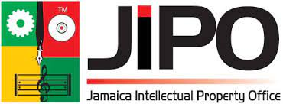  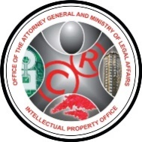 | 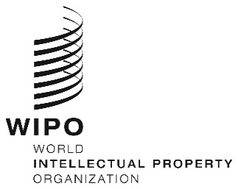 | 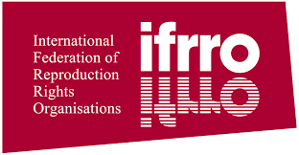
WEBinar
ORIGINAL: english
DATE: March 17, 2022

Webinar on educational licensing for the Caribbean region

organized by

the World Intellectual Property Organization (WIPO)

the Intellectual Property Office of Jamaica (JIPO)

the Intellectual Property Office of Trinidad and Tobago (TTIPO)

the International Federation of Reproduction Rights Organisations (IFRRO)

Virtual, March 21, 2021 (Port of Spain time)

Provisional program

prepared by the International Bureau

9:00 – 9:20 | OPENING SESSION  Opening Remarks by:  - Ms. Lilyclaire Bellamy, Executive Director, Intellectual Property Office of Jamaica (JIPO), Kingston  - Mr. Regan Asgarali, Controller, Intellectual Property Office of Trinidad and Tobago (TTIPO), Port of Spain  - Mr. Benoît Müller, Director, Copyright Management Division, World Intellectual Property Organization (WIPO), Geneva  - Ms. Caroline Morgan, Chief Executive and Secretary General, International Federation of Reproduction Rights Organisations (IFRRO), Brussels
9:20 – 9:35  9:35 – 9:45 | Topic 1: Educational licensing on a collective basis: The legal and licensing framework and WIPO’s reprography projects around the world  Facilitator: Mr. Richard Aching, Manager, Technical Examination, TTIPO, Port of Spain  Speaker: Ms. Anita Huss-Ekerhult, Counsellor, Copyright Management Division, WIPO, Geneva  Q&A Session
9:45 – 10:15 | Topic 2: Legal framework for educational licensing in the Caribbean region: examples of Jamaica and Trinidad and Tobago  Facilitator: Ms. Miyuki Monroig, Program Officer, Copyright  Management Division, WIPO, Geneva  Speakers: Ms. Shantal English, Manager, Copyright and Related Rights, JIPO, Kingston  Ms. Lyrinda Persaud, Legal Officer II, TTIPO, Port of Spain
10:15 – 10:25  10:25 – 11:15  11:15 – 11:25  11:25 – 12:15  12:15 – 12:25  12:25 – 12:55  12:55 – 13:00 | Q&A Session  Topic 3: Roundtable discussion: Practice and challenges for national and regional educational licensing of schools and universities in the Caribbean region, including regional licensing of regional entities and territorial licensing of national entities  Facilitator: Ms. Caroline Morgan, IFRRO, Brussels  Speakers: Ms. Felene Cayetano, Vice-President, Belize Copyright Licensing Agency (BECLA), Benque Viejo del Carmen  Mr. Antonio Rudder, President, Barbados Copyright Agency (B-COPY), St. Michael  Mr. Irvin Durrand, President/Chair, Eastern Caribbean Copyright Licensing Association (ECCLA), Saint Lucia  Ms. Philippa Davies, Assistant General Manager, Jamaican Copyright Licensing Agency (JAMCOPY), Kingston  Mr. Nicholas Lue Sue, President, Trinidad and Tobago Reprograghic Rights Organisation (TTRRO), El Socorro  Ms. Dianne Daley McClure, Chairman, Caribbean Reproduction Rights Organisations’ Agency (CARROSA), Kingston  Q&A Session  Topic 4: International good practice for educational licensing on a collective basis  Facilitator: Ms. Anita Huss-Ekerhult, WIPO  Speakers: Ms. Caroline Morgan, IFRRO  Ms. Madeleine Pow-Jones, Policy and International Relations Manager, Copyright Licensing Agency (CLA), London  Ms. Leemisa Molapisi, Operations Manager, Dramatic, Artistic and Literary Rights Organisation (DALRO), Braamfontein, South Africa  Q&A Session  Topic 5: Roundtable discussion: Possible next steps for the Caribbean  Faciliators: Ms. Shantal English, JIPO; Mr. Regan Asgarali, TTIPO  Speakers: All participants  Closing

[End of document]

