E
 | 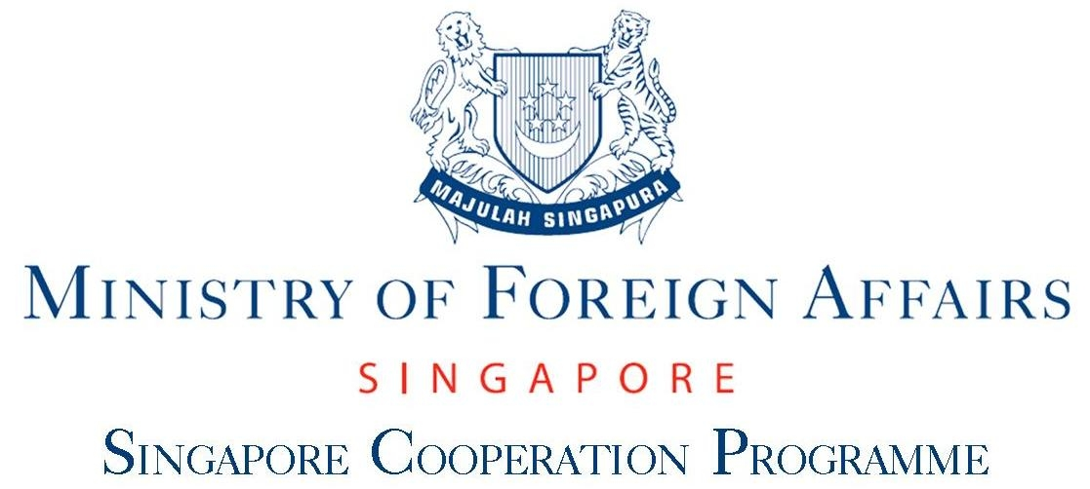 | 
Regional WORKSHOP
WIPO/VIP-PPD/SIN/12/INF/1
ORIGINAL: English
DATE: 6 November 2012

Regional Workshop on Copyright Exceptions and Limitations for Visually Impaired Persons/Persons with Print Disabilities

organized by
the World Intellectual Property Organization (WIPO)

in cooperation with
the Singapore Cooperation Programme of the Singapore Ministry of Foreign Affairs

and with the assistance of
the Intellectual Property Office of Singapore (IPOS)

Singapore, November 6 and 7, 2012

Program

prepared by the Secretariat

Tuesday, November 6, 2012

9.30 – 10.00 | Welcome and Opening Address:
 | Mr. Candra Darusman, Deputy Director, World Intellectual Property Organization (WIPO), Office in Singapore, Singapore
 | Mr. Daren Tang, Deputy Chief Executive, Registries Group and Legal Policy and International Affairs Department, Intellectual Property Office of Singapore (IPOS), Singapore
 | Ms. Denise Cheng, Third Country Training Programme Section, Singapore Cooperation Programme Policy Branch, Technical Cooperation Directorate, Ministry of Foreign Affairs, Singapore
10.00 – 11.00 | Topic 1 | Copyright and the Needs of Visually Impaired Persons/ Persons with Print Disabilities
 | Speakers: | Mr. Rahul Cherian Jacob, Head, Policy Initiatives, Inclusive Planet; World Blind Union (WBU) Representative, Chennai
 |  | Mr. Jens Bammel, Secretary General, International Publishers Association (IPA), Geneva
11.00 – 11.30 | Coffee Break
11.30 – 12.30 | Topic 2 | International Legal Framework: United Nations Convention on the Rights of Persons with Disabilities. WIPO Initiative.
 | Speaker: | Mr. Carlos Castro, Copyright Law Division, Culture and Creative Industries Sector, WIPO, Geneva
12.30 – 14.00 | Welcome lunch by the Ministry of Foreign Affairs
14.00 – 15.00 | Topic 3 | Survey on National Copyright Limitations and Exceptions
 | Speaker: | Ms. Judith Sullivan, Consultant, Copyright and Government Affairs, Ruislip, Middlesex, United Kingdom
15.00 – 15.30 | Coffee Break
15.30 – 16.15 | Topic 4 | The Role of Reproduction Rights Organizations
 | Speaker: | Ms. Anita Huss-Ekerhult, Deputy Secretary General and General Counsel, The International Federation of Reproduction Rights Organisations (IFRRO), Brussels

16.15 – 17.30 | Topic 5 | The Role of Authorized Entities, Licensing Mechanisms and the WIPO TIGAR Project
 | Speaker: | Ms. Margaret McGrory, Vice President and Executive Director, Canadian National Institute for the Blind (CNIB) Library, Toronto
17.30 – 18.30 | WIPO Reception

Wednesday, November 7, 2012

8.30 – 9.30 | Topic 6 | Technical Issues: Accessibility, Standards, Hardware
 | Speaker: | Mr. Dipendra Manocha, Director, Regional Resource Centre, DAISY for All, DAISY Consortium, New Delhi
9.30 – 10.00 | Coffee Break
10.00 – 12.30 | Topic 7 | National Experiences: Country Reports
 | Speakers: | Participants of the Workshop
12.30 – 14.00 | Lunch Break
14.00 – 15.00 | Topic 8 | National Experience in Canada
 | Speakers: | Ms. Margaret McGrory
15.00 – 15.30 | Coffee Break
15.30 – 16.30 | Topic 9 | Current Work in the Standing Committee on Copyright and Related Rights (SCCR): Working Document on Limitations and Exceptions for Visually Impaired Persons/Persons with Print Disabilities
 | Speakers: | Mr. Kelvin Sum, Deputy Director/Legal Counsel/Senior Research Associate, Legal Policy and International Affairs Department, IPOS, Singapore
 |  | Mr. Carlos Castro
16.30 – 17.30 | Wrap-Up Discussion
17.30 – 17.45 | Closing

[End of document]

