E
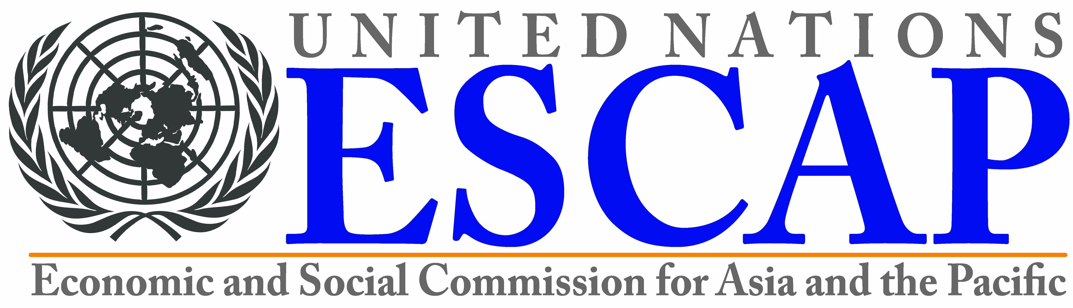 |  | 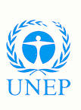
Economic and social  commission for Asia and the pacific | Asia-pacific  research and training  network on trade | United Nations  Environment  Programme (UNEP)
REGIONAL WORKSHOP
WIPO-UN-ESCAP-UNEP/IP/BKK/13/INF/1
ORIGINAL: English
DATE: NOVEMBER 19, 2013

The Environmentally Safe Disposal of Intellectual Property-Infringing Goods

- Exploring the Interplay Between Trade in Intellectual Property-Infringing Goods, Development and Environmental Sustainability

organized by

the United Nations Economic and Social Commission for Asia and the Pacific (UN ESCAP)

the Asia-Pacific Research and Training Network on Trade (ARTNeT)

the United Nations Environment Programme (UNEP)

and

the World Intellectual Property Organization (WIPO)

Bangkok, November 21 and 22, 2013

pROGRAM

Thursday, November 21, 2013

08:30 – 09:00 | Registration
09:00 – 09:30 | Welcome remarks by:  Ms. Louise van Greunen, Director, Building Respect for IP Division,  World Intellectual Property Organization (WIPO), Geneva  Dr. Mia Mikic, Chief, Trade Policy and Analysis Section, the United Nations Economic and Social Commission for Asia and the Pacific (UN ESCAP) and project coordinator for Asia-Pacific Research and Training Network on Trade (ARTNeT), Bangkok  Mr. Young-Woo Park, Regional Director and Representative for Asia and the Pacific, United Nations Environment Programme (UNEP), Bangkok
09:30 – 10:00 | Topic 1: Strategic Goal VI of WIPO: Building Respect for Intellectual Property (IP)  Speaker: Ms. Louise van Greunen
10:00 – 10:30 | Topic 2: Overview of Trade in IP-Infringing Goods in the ASEAN  Speaker: Mr. Teemu Alexander Puutio, Trade Policy and Analysis Section, the United Nations Economic and Social Commission for Asia and the Pacific (UN ESCAP), Bangkok
10:30 – 11:00 | Group Photo & Networking Break
11:00 – 11:30 | Topic 3: Disposal of IP-Infringing Goods from Customs Perspective
- Cross-Border Movement of IP-Infringing Goods in the Asian Region

Speaker: Mr. Joon Hyoung Bae, Intelligence Analyst, World Customs Organization (WCO), Regional Intelligence Liaison Office for Asia and the Pacific

- IPR Capacity Building for Customs in the Asia Pacific Region

Speaker: Mr. James KW Wong, Program Manager (SEA), World Customs Organization (WCO), Asia Pacific Regional Office for Capacity Building (ROCB A/P), Bangkok

11:30 – 12:30 | Topic 4: Environmentally Friendly Disposal of IP-Infringing Goods: Opportunities for Establishing Harmonized Environment Rules  - Normative Environment Framework for the Disposal of IP-Infringing Goods  Speaker: Mr. Mushtaq Memon, Programme Officer, International Environmental Technology Centre (IETC), UNEP, Bangkok  - Policies, Best Practices and Experiences on the Disposal of IP-Infringing Goods and / or the Integrated Solid Waste Management  Speakers: Mr. Hiroyuki Shimagaki, IPR specialist, IPR National Center, Japan Customs, Japan  Ms. Hye-Young Han, Manager, Environment Statistics Team, Korea Environment Corporation (KEC), Republic of Korea  - Key Recommendations from the 2012 Workshop  Speaker: Ms. Kakuko Nagatani-Yoshida, Compliance Assistance Programme, UNEP, Bangkok  - Plenary Discussion

Moderator: Mr. Mushtaq Memon

12:30 – 13:30  13:30 – 13:45  13:45 – 14:15 | Lunch Break  Topic 5: Disposal Orders in terms of Part III of the Agreement on Trade-Related Aspects of Intellectual Property Rights (TRIPS Agreement)  Speaker: Ms. Eun-Joo Min, Senior Legal Counsellor,  Building Respect for IP Division, WIPO  Topic 6: The WIPO Disposal Study: Comparative Scope of the Problem and Methodologies Used for Destruction in the Asia Pacific Region  Speaker: Mr. David Blakemore, Executive Director, Asia Pacific Secretariat, IPR Business Partnership, Christchurch
14:15 – 15:30 | Topic 7: Challenges and Experiences in the Environmentally Safe Disposal of IP-Infringing Goods: Country Reports  Moderator: Ms. Eun-Joo Min  Speakers: ASEAN Member States:  Cambodia  Indonesia  Philippines  Thailand
15:30 – 15:45 | Networking Break
15:45 – 17:00 | Topic 7: Country Reports (continued)  Moderator: Dr. Mia Mikic  Speakers: ASEAN Member States:  Brunei Darussalam  Lao PDR  Malaysia  Myanmar  Viet Nam
18:30 – 20:30 | Reception at Royal Princess

Friday, November 22, 2013

09:00 – 10.30 | Topic 8: Recent Developments Concerning Trade and Disposal of IP-Infringing Goods  Moderator: Ms. Kakuko Nagatani-Yoshida  - CDs and DVDs:  Mr. Piset Chiyasak, General Manager, Thai Entertainment Content Trade Association (TECA), Bangkok  - Clothes and Shoes/ Garments:  Mr. Alan Adcock, Tilleke & Gibbins  - Food Items:  Mr. Stéphane Passeri, Promotion of Rural Development through Development of Geographical Indications (GI) at Regional Level in Asia, Food and Agriculture Organization (FAO) Regional Office for Asia and the Pacific, Bangkok  - Fake Refrigerants – Scale, Detection and Disposal:  Ms. Kakuko Nagatani-Yoshida  - Fake Pesticides  Dr. Siang-Hee Tang, Executive Director, CropLife Asia  - Ms. Vikran Duangmanee, IP Manager, IP Management, SCG Chemicals Co., Ltd., Bangkok  - The Japanese Experience:  Mr. Yasuo Ohkuma, Director, Intellectual Property  Department, Attache for JAPAN PATENT OFFICE (JPO),  JETRO, Bangkok  - The U.S. Experience:  Mr. Peter Fowler, IP Attaché, U.S. Embassy, Bangkok
10:30 – 10:50 | Networking Break
10:50 – 12:00 | Topic 9: Public / Private Sector Collaboration  Moderator: ESCAP  Speakers: Ms. Jittima Srithaporn, Head, Policy  Development Division, Office of Prevention and Suppression of IPR Violation, Department of Intellectual Property, Bangkok  Mr. Tae-Sung Kim, Regional Business and Market Manager, Fluorochemicals, APEJ, DuPont (Korea) Inc.  Mr. David Blakemore
12:00 – 13:00  13:00 – 14:00 | Lunch Break  Break-Out Session  Moderator: Mr. Suho Seong, Regional Office for Asia and the Pacific (ROAP), United Nations Environment Programme (UNEP), Bankgok
14:00 – 15:00 | Topic 10: Roundtable on International Cooperation  - Opportunities for Cooperation among ASEAN Member States  - Plenary Discussion  Moderator: Ms. Louise van Greunen  Speakers: Mr. Ricardo R. Blancaflor, Director General, Intellectual Property Office of Philippines  Mr. Suho Seong  Dr. Mia Mikic  Mr. Stéphane Passeri
15:00 – 15:30 | Networking Break
15:30 – 16:30 | Topic 11: Enhanced Inter-Agency and Public/Private Sector Collaboration to Achieve Common Goals  - Normative environment framework  - Capacity building & awareness-raising  - Piloting disposal schemes
16:30 – 17:00 | Closing remarks

The views expressed by invited speakers are those of the speakers and not necessarily those of the Secretariats of WIPO, UN ESCAP or UNEP or of their Member States.

[End of document]

