E
 | 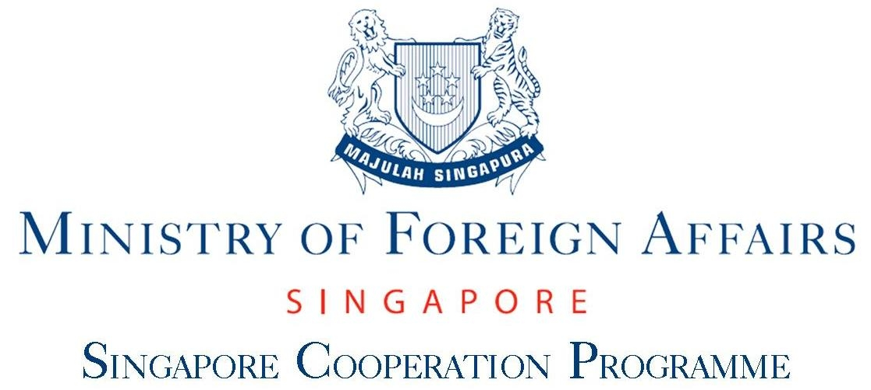 | 
Regional seminar
WIPO/REG/IP/SIN/11/INF/2
ORIGINAL: English
DATE: 12 JUly 2012

WIPO Regional Seminar on Intellectual Property (IP) Management and Commercialization of IP Assets

organized by
the World Intellectual Property Organization (WIPO)

in cooperation with
the Singapore Cooperation Programme of the Singapore Ministry of Foreign Affairs

and with the assistance of
the Intellectual Property Office of Singapore (IPOS)

Singapore, July 12 to 13, 2012

SPEAKERS’ LIST

prepared by the Secretariat

CANDRA N. DARUSMAN

Mr. Darusman, a national of Indonesia, had previously lived in Yugoslavia, Mexico, the former Soviet Union and occasionally in Switzerland. Joined WIPO Geneva, in April 2001, as a Consultant, he currently holds the position as the Deputy Director of the WIPO Office in Singapore. Until 2001, he was the General Manager of the Indonesian Collective Management Organization (KCI), a position which he held since the establishment of the organization in 1990. He was also the Secretary General of The Indonesian Musicians Foundation (YAMI).

He is an economist graduate (Doctorandus – PhD. candidate) from the Faculty of Economics, University of Indonesia, and from 1982 to 1985 was a researcher, lecturer and served as assistant Professor at the Faculty, specializing on Macroeconomics and Microeconomics. From 1985 to1986 he worked as a banker at Citibank and in 1987 he entered into the music production and recording business. From 1986 to 1991 he served as Director to the Indonesian Guild of Composers. From 1994 to 1996 he was appointed as a member of the Indonesian National Copyright Council by presidential decree. He served as Director of the Indonesian Musicians Cooperative (KOSMINDO), a small and medium enterprise cooperative with the task of seeking venture capital for artist-entrepreneurs. At the same period Mr. Darusman was also an active member of the Anti-Piracy Coalition of the Indonesian copyright industries.

Mr. Darusman was previously a musician and is still an active composer. His songs are being performed in Indonesia as well as in neighboring countries. He is now based in Singapore with his wife and third child.

YOSHIYUKI IWAI

Mr. Yoshiyuki Iwai graduated from the Faculty of Law, Tokyo University in 1978. In 1978 he joined the Ministry of Economy, Trade and Industry (METI). Mr. Iwai then in 1987 became the Chief of Police Administration Department, Kagawa Prefectural Police Headquarters.

In 1992 he held the position of Director-General of Office in Bruxelles, of the Japan External
Trade Organization (JETRO). In 1995 he went back to METI and served as the Director,
Security Export Control Division, International Trade Administration Bureau; further as the
Director, Technology Promotion Division, General Affairs Department, Agency of Industrial
Science and Technology. In 1997, he held the position as the Director, Electric Power
Administration Division, Public Utilities Department, Agency for Natural Resources and Energy
(ANRE)

In 2000 became the Chief of Police, Wakayama Prefectural Police Headquarters.

In 2002 he went on to become the Director, Trade Finance and Economic Cooperation Division, METI and 2003 as the Director, Budget and Accounts Division, Minister’s Secretariat, METI. Further he served as Director-General, Energy Conservation and Renewable Energy Department, ANRE, in 2003. Further he held several positions as the Deputy Director-General for Policy Coordination, Minister’s Secretariat, METI; Director-General, Natural Resources and Fuel Department, ANRE; and further Director-General for Small and Medium Enterprise Policy, Small and Medium Enterprise Agency; Director-General for Acquisition Reform, Ministry Of Defense (MOD); Defense Councilor (Director-General), MOD.

Currently he is the Commissioner, Japan Patent Office, since 2010.

YUMIKO HAMANO

Mrs. Yumiko Hamano, a national of Japan, currently works in the Innovation Division at the World Intellectual Property Organization. She is responsible for the WIPO University Initiative Program, a WIPO’s project aiming at assisting universities and R&D institutions in enhancing their IP and technology management capacity.

She first joined WIPO for setting up the Japanese operation lines for processing international patent applications from Japan under the Patent Cooperation Treaty (PCT). In this function, she was responsible for Publication, Examination and Translation procedures of PCT international applications from Japan and supervised the Japanese operations team. She also has a long experience in translating the PCT International Preliminary Examination Reports (IPERs) established by the Japan Patent Office.

Later she worked for the two consecutive Senior Directors of the Office of the PCT as the executive assistant. During this period, she also served as the Trilateral Coordinator from WIPO in the context of the Trilateral Technical Cooperation between the European Patent Office, the Japan Patent Office and the United States Patent and Trademark Office.

After extensive experience in the PCT Sector, Mrs. Hamano moved to the Division for Infrastructure Services and Innovation Promotion, where she was responsible for technical cooperation for universities and R&D institutions on matters related to innovation and technology transfer.

Prior to taking up these duties at WIPO, Mrs. Hamano worked as an IP portfolio manager and a technical translator of patent documents in public and private sectors in Japan.

She is a holder of BA: English-American Literature, BA: Education and MBA: specialized in Management in International Organizations from University of Geneva, Switzerland. She is currently completing LLM Program in Intellectual Property Law at School of Law, University of Edinburgh, United Kingdom.

She is fluent in Japanese, English and French, and has good command of Chinese.

OLIVIA LUM

Ms. Olivia Lum is Executive Chairman and Group Chief Executive Officer of Hyflux Ltd. She founded Hydrochem (the precursor to Hyflux) in 1989 with two staff and a start-up capital of S$20,000 to distribute chemicals and water treatment systems.

Today, Hyflux is one of the world’s leading desalination suppliers and a fully-integrated water solutions company. Hyflux is a publicly traded company employing over 2,300 people in operations and projects in Southeast Asia, China, India and the Middle East and North Africa. Hyflux has strategically expanded its human capital and capabilities in order to position for the uptrend in the water industry and capture growth opportunities in its key markets.

Hyflux's track record includes Singapore's first water recycling plant and first seawater reverse osmosis (SWRO) desalination plant, China's largest SWRO desalination plant in Tianjin Dagang and the world's largest SWRO desalination plant in Magtaa, Algeria. Hyflux has also been selected to develop Singapore's second and largest desalination plant.

A former Nominated Member of Singapore Parliament, Ms. Lum holds several positions in the public service. She is a member of the Singapore Business Federation Council, Singapore-Tianjin Economic & Trade Council, the Singapore-Jiangsu Cooperation Council, Singapore-Zhejiang Economic and Trade Council as well as the Advisor for Singapore Institute of International Affairs. In June 2011, she was accorded the Ernst & Young World Entrepreneur of the Year 2011, in Monte Carlo.

MATTHEW RAINEY

Mr. Matthew (Matt) Rainey is Director of the Innovation Division at the World Intellectual Property Organization in Geneva. He is responsible for matters relating to innovation policy and infrastructure, SMEs (small-to-medium enterprises) and other IP rights holders, universities and technology transfer issues and processes.

He recently joined WIPO after nearly thirty years of IP law practice in both large and small companies and law firms, in the United States and for some time in Munich. His legal work has involved patent, trade secret, copyright and trademark protection, strategies and litigation. He has focused on patent law, and in recent years has specialized in IP and innovation policy, including working on legislative, judicial and administrative matters.

Mr. Rainey graduated from the University of Southern California School of Law in 1983 and holds a degree in Physics from the University of Maryland.

SURESH SACHI

Mr. Suresh Sachi is the Deputy Managing Director and General Counsel of A*STAR. He currently oversees the corporate and legal functions for the Agency and supporting the Research Councils and Exploit Technologies including Finance, Corporate Communications, Infrastructure Planning & Facilities Management, and Information Systems & Technology. Part of his role is to ensure that A*STAR’s resources are deployed in an efficient and integrated manner.

As the Agency’s General Counsel, Suresh Sachi has responsibility for all its legal and intellectual property matters. He is responsible for establishing, implementing and maintaining A*STAR’s legal, intellectual property, risk management and compliance policies.

Before joining A*STAR, Suresh Sachi was in private legal practice in a leading law firm where he was a partner in the Technology and Intellectual Property Department.

Suresh Sachi has served on the Boards of a number of A*STAR companies, including Exploit Technologies. He was on the Board of Governors of the IP Academy for several years and currently serves as an advisor to the IP Academy. Suresh Sachi is a founding member, Past-President, and currently Vice-President of the Licensing Executives Society Singapore. Suresh Sachi served for more than 10 years on the Ethics Committee of the Singapore Eye Research Institute and is now a member of the SingHealth Centralised Institutional Review Board. He was an active member of the Biomedical Sciences Executive Committee, Intellectual Capital Working Group (Intellectual Property Sub-Committee) and is a member of the Intellectual Property Office of Singapore Mentorship Funding Scheme Committee.

DATO MOHAMED SHARIFF

Prof Dato’ Mohamed Shariff a national of Malaysia, and has been teaching in Universiti Putra Malaysia (UPM) (formerly known as University Pertanian Malaysia) for the last 35 years. He is a veterinary doctor specialized in fish diseases. His invention “The FastTarget” a rapid PCR nested diagnostic kit for detection of white spot shrimp virus won him several medals including the WIPO gold medal in 2000. He then commercialized his kit to help reduces losses to the shrimp farming industry.

In 2006, Prof Shariff was appointed the founding Director of Innovation and Commercialisation Centre (ICC) in UPM. He started the centre from scratch and had 27 staff members under three divisions 1) Commercialisation, 2) Promotion and Training and 3) Intellectual Property. ICC was recognized as a good model in Malaysia for patent management and commercialization of university technologies. The centre won the National IP award from Malaysian Intellectual Property Corporation (MyIPO) in 2008 and again in 2011.

Prof Shariff has attended several courses on intellectual property and commercialisation organized by WIPO and Malaysian Intellectual Property Corporation (MyIPO). He was actively involved in creating awareness to the university community regarding intellectual property, evaluation of IPs, strategies of IP management and commercialisation of university R&D technologies. His centre commercialized more than 20 products/technologies and formed 5 joint venture companies.

Prof Shariff has served as resource person to share his experience at WIPO organized seminars in Brazil, Japan, Jordan, Korea, Malaysia, Mauritius, Morocco, Oman, Sri Lanka, Saudi Arabia and Vietnam.

Currently Prof Shariff is the Director of Putra Science Park in UPM.

[End of document]

