E
  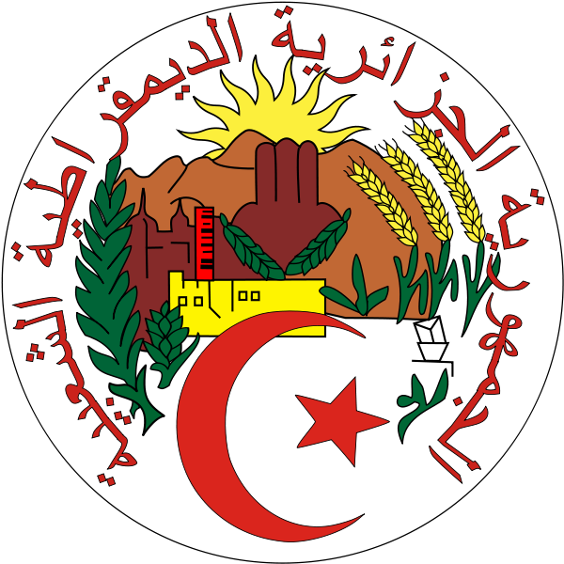  THE PEOPLE’S democratic  Republic of algeria | 
Regional Consultation MEETING
WIPO/REG/IP/ALG/13/1 PROV.
ORIGINAL: english
DATE: December 6, 2012

WIPO Regional Consultation Meeting on Technology Transfer: The Development Agenda Project on Intellectual Property and Technology Transfer: “Common Challenges – Building Solutions”
organized by
the World Intellectual Property Organization (WIPO)

in cooperation with
the Ministry of Industry, Small and Medium Enterprises (SMEs) and Investment Promotion

Algiers, January 29 to 30, 2013

provisional program

prepared by the International Bureau of WIPO

Tuesday, January 29, 2013

8.30 – 9.00 | Registration
9.00 – 10.00 | Opening Ceremony
 | Welcome addresses by:
 | His Excellency Mr. Chérif Rahmani, Minister, Ministry of Industry, Small and Medium Enterprises (SMEs) and Investment Promotion (MIPMEPI), Algiers
 | Other Minister
 | Other Minister
 | The Representative of the World Intellectual Property Organization (WIPO), Geneva, Switzerland
10.00 – 10.15 | Coffee Break
THEME I: | TECHNOLOGY TRANSFER AND WIPO’S DEVELOPMENT AGENDA
10.15 – 10.45 | Topic 1 | The Development Agenda Thematic Project on Intellectual Property and Technology Transfer: “Common Challenges – Building Solutions” (Recommendations 19, 25, 26 and 28)
 | Speaker: | Mr. Matthew Rainey, Director, Innovation Division, Innovation and Technology Sector, WIPO
10.45 – 11.15 | Topic 2 | From United Nations Conference on Trade and Development (UNCTAD)’s Code of Conduct to the World Trade Organization (WTO)’s Trade-Related Aspects of Intellectual Property Rights (TRIPS) Agreement: Global Efforts for Technology Transfer
 | Speaker: | Dr. Ahmed Abdel Latif, Senior Programme Manager, International Centre for Trade and Sustainable Development (ICTSD), Geneva, Switzerland
11.15 – 12.00 | Topic 3 | New Trends in International Technology Transfer and WIPO’s Efforts for the Promotion of Innovation and Technology Transfer
 | Speaker: | Dr. Ali Jazairy, Head, Innovation and Technology Transfer Section, Innovation Division, Innovation and Technology Sector, WIPO
12.00 – 13.00 | Lunch Break
THEME II: | BEST PRACTICES AND CASE STUDIES OF TECHNOLOGY TRANSFER IN THE AFRICAN AND ARAB REGIONS
13.00 – 13.30 | Topic 4 | The Ecosystem for Sustainable Innovation in Algeria: Models and Achievements
 | Speaker: | Dr. Khadidja Guenachi, Professor, Director of the Laboratory for Research on Industrial, Technological and Environmental Risks (RITE), University of Oran, Oran
13.30 – 14.00 | Topic 5 | Technology Transfer in the Arab World : Opportunities  in the Pharmaceutical and Telecommunications Areas
 | Speaker: | Dr. Zoubir Benleulmi, Founder and Director, White Sea  Business School, Sidi Abdellah Cyberpark, Zeralda,  Algiers, Algeria, with the collaboration of Dr. Mohamed  Hannache, Head, Innovation Division, MIPMEPI
14.00 – 14.30 | Topic 6 | The Global Innovation Index: Guidelines for the Promotion of Innovation and Technology Transfer
 | Speaker: | Dr. Bruno Lanvin, Executive Director, eLab, Institut Européen d'Administration des Affaires (INSEAD), Paris, France
14.30 – 15.00 | Topic 7 | Innovation and Technology Transfer in Morocco
 | Speaker: | Dr. Adel El-Maliki, Director General, Office Marocain de la Propriété Industrielle et Commerciale (OMPIC), Casablanca, Morocco
15.00 – 15.15 | Coffee Break
15.15 – 15.45 | Topic 8 | International Technology Transfer in South Africa: Case Studies
 | Speaker: | Ms. Suhayfa Zia, Director, Department of International Relations and Cooperation (DIRCO), Pretoria, South Africa
15.45 – 16.15 | Topic 9 | Three Success Cases in Kenya for Technology Transfer: Ushaidi, M-Pesa and Kickstart
 |  | Dr. Henry Kibet, Director, Kenya Industrial Property Institute (KIPO), Nairobi, Kenya
16.15 – 18.00 | Discussion | National Experiences and Technology Transfer Systems in Africa and the Arab World, Presentations of Participating Countries: Presentations of the Strengths, Weaknesses, Opportunities, and Threats (SWOT) for Individual Countries
 | Moderator: | Dr. Bruno Lanvin
 | Reporter: | Dr. Ali Jazairy
18.00 – 18.30 | Topic 10 | Review of SWOT and Summary of Best Practices for International Technology Transfer in Africa and the Arab World
 | Speakers: | Dr. Zoubir Benleulmi, Prof. Mohamed Taïbi
18.30 | End of Session

Wednesday, January 30, 2013

THEME III: | TOOLS and Platforms for Effective Technology Transfer and Diffusion
9.00 – 10.00 | Topic 1 | Changing the Future: Intellectual Power and Technology Transfer are Strategic Business Necessities
 |  | Dr. Mohammed Al-Ansari, Technology Program Director, Technology Management, Saudi Aramco, Saudi Arabian Oil Company, Dhahran, Saudi Arabia
10.00 – 10.30 | Coffee Break
10.30 – 12.00 | Roundtable 1 | Technology Transfer – Common Challenges
 | Moderator: | Prof. Mohamed Taïbi
 | Panelists: | Dr. Khadidja Guenachi,  Dr. Abdelkader Djeflat,  Dr. Adel El-Maliki,  Dr. Bruno Lanvin,  Ms. Suhayfa Zia,  Dr. Henry Kibet
 | Reporter: | Dr. Ali Jazairy
12.00 – 13.00 | Lunch Break
13.00 – 15.30 | Roundtable 2 | Building Solutions: Intellectual Property-Related Mechanisms and Initiatives for Promoting Technology Transfer in the African and Arab Regions
 | Moderator: | Dr. Ahmed Abdel Latif
 | Panelists: | Dr. Mohammed Al-Ansari,  Dr. Zoubir Benleulmi,  Ms. Suhayfa Zia,  Dr. Adel El-Maliki
 | Reporter: | Dr. Ali Jazairy
15.30 – 16.00 | Coffee Break
16.00 – 17.30 | Roundtable 3 | Regional Consultation Recommendations for the African and Arab Regions
 | Moderator: | Dr. Bruno Lanvin
 | Panelists: | Dr. Ahmed Abdel Latif,  Dr. Mohammed Al-Ansari,  Ms. Suhayfa Zia,  Dr. Henry Kibet,  Dr. Adel El-Maliki
 | Reporter: | Dr. Ali Jazairy
17.30 – 18.30 | Evaluation and Closing Ceremony
 | Closing Address by:
Professor Abderazak Henni, Secretary General, Ministry of Industry, Small
and Medium Enterprises (SMEs) and Investment Promotion, Algiers
[End of document]

