E
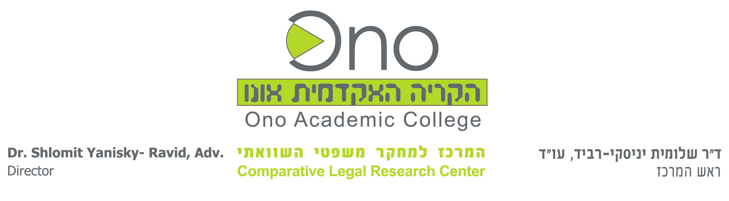 | 
ONO ACADEMIC COLLEGE
seminar
WIPO-ONO/IPR/GE/13/inf/1.
ORIGINAL: English
DATE: December 2013

Current Issues in Intellectual Property Rights

organized by
the World Intellectual Property Organization (WIPO)

in cooperation with
the Comparative Legal Center, Ono Academic College (ONO)

Geneva, December 10 to 12, 2013

Provisional Program

prepared by the International Bureau of WIPO

Monday, December 9, 2013

Tour to the Old Town of Geneva

Tuesday, December 10, 2013 (NB 3.502)

09.30 – 09.45 Opening Ceremony

Welcome addresses by:

Dr. Shlomit Yanisky-Ravid, Professor, the Shalom Comparative Legal Research Center, Ono Academic College, Kiryan Ono, Israel

Mr. Michal Svantner, Director, Department for Transition and Developed Countries (TDC), World Intellectual Property Organization (WIPO), Geneva

09.45 – 10.15 Topic 1 the Work of WIPO

Speaker: Ms. Cathy Jewell, Senior Information Officer,
Editor, WIPO Magazine, WIPO

10.15 – 10.45 Topic 2 Privacy as Intellectual Property Right

Speaker: Ms. Patricia S. Abril, Associate Professor, Business Law, School of Business Administration, University of Miami, Florida

10.45 – 11.15 Topic 3 Limitations and Exceptions to Copyright and Neighboring Rights

Speakers: Mr. Paolo Lanteri, Assistant Legal Officer, Copyright Law Division, WIPO

Mr. Rafael Ferraz Vazquez, Consultant, Copyright Law Division, WIPO

11.15 – 11.30 Coffee Break

11.30 – 12.00 Topic 4 Arbitration and Mediation in Intellectual Property Disputes

Speaker: Ms. Judith Schallnau, Legal Officer, IP Disputes Management Section, WIPO Arbitration and Mediation Center, WIPO

12.00 – 12.30 Topic 5 Intellectual Property and Traditional Knowledge, Traditional Cultural Expressions and Genetic Resources

Speaker: Mr. Oluwatobiloba Moody, Assistant Legal Officer, Traditional Knowledge Division, WIPO

12.30 – 14.00 Lunch Break- hosted by the Department for Transition and Developed Countries (TDC), WIPO (13th Floor)

14.30 – 15.00 Topic 6 Developments in International Patent Law

Speakers: Mr. Marco M. Aleman, Acting Director, Patent Law Division, WIPO

15.00 – 15.30 Topic 7 Intellectual Property and Competition Law; Issues related to the Management of a Patent Case; following recent court decisions

Speaker: Ms. Li Maor, Program Analyst, Department for Transition and Developed Countries, WIPO

15.30 – 15:45 Coffee Break

15.45 – 16.15 Topic 8 Improving Innovation Lessons from the Israeli Case

Speaker: Dr. Shlomit Yanisky-Ravid

16.15 – 16.45 Topic 9 Online Dispute Resolution in Intellectual Property

Speakers: Ms. Judith Schallnau, WIPO

Ms. Joanne Teng, Legal Officer, Internet Dispute Resolution Section, WIPO Arbitration and Mediation Center

20.00 Dinner- Hosted by the ONO Academic College

Wednesday, December 11, 2013 (Morning- WIPO Library, Afternoon- NB 3.502)

09.00 – 10.30 Introduction to Case Study Analysis

Speaker: Dr. Shlomit Yanisky-Ravid

10.30 – 13.00 Working in Groups (coffee breaks at 10 and at 11.30)

Moderator: Dr. Shlomit Yanisky Ravid

13.00 – 14.30 Lunch Break

14.30 – 15.15 Topic 10 Valuation of Intellectual Property Assets

Speaker: Mrs. Olga Spasic, Head, Innovation Structures Section, Innovation Division, Innovation and Technology Sector, WIPO

15.45 Visit to the International Red Cross and Red Crescent Museum

Thursday, December 12, 2013 (NB 1.502)

09.30 – 12.30 Presentations of Case Studies by the Groups (coffee break at 11.30)

Moderator: Dr. Shlomit Yanisky-Ravid

12.30 – 13.15 Lunch Break

14.00 – 18.00 Visit to the Centre of Comparative, European and International Law (CDCEI), Lausanne

[End of document]

