Workshop
 | 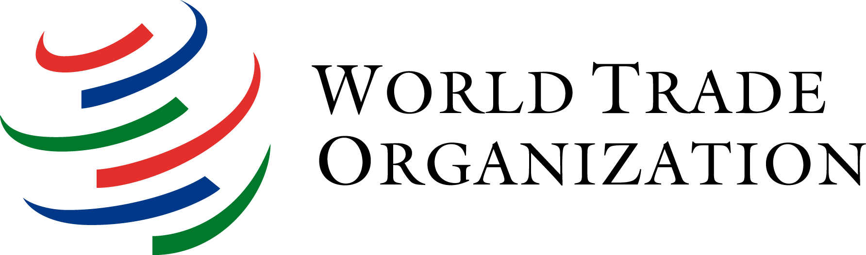
E
WHO/IP/WK/GE/11/INF/1
OriGINAL: English
DATE: fEBRUARY 17, 2011
Patent Searches and Freedom to Operate
Organized by
the World Health Organization (WHO),
the World Intellectual Property Organization (WIPO)
and the World Trade Organization (WTO)

Geneva, WIPO, WIPO Academy Training Room
(P&G Building, Ground Floor, 1, rue du Pré-de-la-Bichette, Geneva), February 17, 2011
Intended as an introduction for those who also wish to attend the Technical Symposium on Access to Medicines, Patent Information and Freedom to Operate, February 18, 2011, at the World Health Organization (WHO)
Program

Whereas the Symposium on Access to Medicines, Patent Information and Freedom to Operate (FTO) of February 18, 2011 will focus on broader aspects related to patent information and FTO, illustrated by specific patent landscape reports and FTO case studies, the goals of this workshop are to introduce participants to the basic concepts of how to do patent searches and FTO analysis.

The workshop will consist of two 90 minute sessions, one focusing on how to search for patent information in different freely-accessible patent databases, and one focusing on how to conduct an FTO. The former will also address added value of commercial patent databases, and resources for researching legal status of patents and related issues. The latter will be based on a prosthetic limb product which could have broad applicability in developing countries where landmine injuries are all-too-common. Searches will be conducted using both keyword and patent classification strategies. Both active and expired patents should be considered, as well as patent applications (e.g. PCT applications); the legal status of different members of patent families will be assessed. Results will be discussed broadly, both with respect to FTO and the value of patent database searching generally as an important tool in the R&D and deployment of critical, inclusive innovations.

14.00 Welcome and introduction | Anatole Krattiger, WIPO
14.10 Overview of patent information resources | Lutz Mailänder, WIPO
14.45 Patent information mining: the basics and how to do “product deconstruction” | Stanley P. Kowalski, University of New Hampshire School Law
15.20 Coffee break
15.30 Hands-on workshop on how to do patent  searches for a prosthetic limb product | Stanley Kowalski and Lutz Mailänder
16.45 What it all means in the context of access and FTO strategies followed by discussion | Moderated by Anatole Krattiger
17.30 Adjourn for fondue dinner

[End of document]

