E
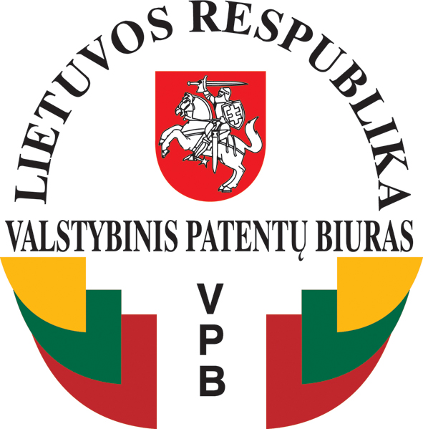
STATE PATENT BUREAU OF
THE REPUBLIC OF LITHUANIA

International Conference

WIPO/IP/VIL/11

OriGINAL: English
DATE: march 2011
Industrial Property for Competitiveness: EU and Global Experience
Organized by
the World Intellectual Property Organization (WIPO)
and
the State Patent Bureau of the Republic of Lithuania

Vilnius, April 12 and 13, 2011

PROVISIONAL PROGRAM
document prepared by the International Bureau of WIPO

Tuesday, April 12, 2011

Moderator: Mr. Martii Enajarvi, President, Federation of Paasikivi Societies in Finland, Helsinski

9.30 – 10.00 Registration

10.00 – 10.30 Opening Ceremony

Welcome addresses by:

Mr. Gytis Andrulionis, Vice-minister, Ministry of Justice of the Republic of Lithuania

Mr. Johannes Christian Wichard, Deputy Director General, World Intellectual Property Organization (WIPO)

Mr. Benoît Battistelli, President of the European Patent Office

Mr. Rimvydas Naujokas, Director of the State Patent Bureau (SPB) of the Republic of Lithuania

10.30 – 10.50 Topic 1: Industrial Property for Competitiveness in Small and Medium Economies

Speaker: Mr. Johannes Christian Wichard

10.50 – 11.10 Topic 2: Industrial Property Policy in the European Union (EU): Where are We Going?

Speaker: Mr. Olivér VÁRHELYI, Head of Unit, European Commission, Directorate General Internal Market and Services Industrial Property Rights Unit (D2)

11.10 – 11.30 Topic 3: Patent as a Tool for Competitiveness: The Role of European Patent System

Speaker: Mr. Georg Artelsmair, Head of Department, European Affairs/Member States, European Patent Office (EPO)

11.30 – 11.50 Coffee Break

11.50 – 12.10 Topic 4: Intellectual Property Enforcement: New Initiatives (ACTA and Others)

Speaker: Ms. Jolita Bacevičienė, Director, Department of Legal Institutions, Ministry of Justice of the Republic of Lithuania

12.10 – 12.30 Topic 5: Industrial Property and Innovation – a Key to Boosting Competitiveness of Lithuania

Speaker: Mr. Almantas Danilevičius, Director, Innovation Department, Ministry of Economy of the Republic of Lithuania

12.30 – 12.50 Topic 6: Challenges and Possibilities of Industrial Property Rights in Lithuania

Speaker: Mr. Žilvinas Danys, Deputy Director, SPB

12.50 – 14.30 Lunch Break

14.30 – 14.50 Topic 7: International Protection of Trademarks

Speaker: Mrs. Asta Valdimarsdottir, Head, Operations Service, International Registries of Madrid and Lisbon, Brand and Designs Sector, WIPO

14.50 – 15.10 Topic 8: Community Trademark and Design Systems: One Size Fits for all?

Speaker: Mr. Vincent O‘Reilly, Director, Department for Industrial Property Policy, Office of Harmonization for the Internal Market (OHIM)

15.10 – 15.30 Topic 9: The Role of National Patent Offices in the Innovation Environment

Speaker: Mr. Jesper Kongstad, Director General, Danish Patent and Trademark Office

15.30 – 15.50 Coffee Break

15.50 – 16.30 Topic 10: Key Speech Industrial Property as a Prerequisite for Competitiveness: Which Way to Go?

Speaker: Ms. Li Maor, Consultant, Division for Certain Countries in Europe and Asia (DCEA), WIPO

16.30 – 16.45 Conclusions

Speaker: The moderator of the Session

17.00 WIPO Awards and Celebration of the 20th Anniversary of the State Patent Bureau of the Republic of Lithuania

Wednesday, April 13, 2011

Moderator: Mr. Žilvinas Danys, Deputy Director, SPB

9.30 – 10.00 Registration

10.00 – 10.20 Topic 1: Industrial Property: Effective Exploitation by the Small and Medium Sized Enterprises (SMEs)

Speaker: Ms. Otilija Klimaitienė, the representative of AIPPI Lithuanian group

10.20 – 10.40 Topic 2: Management of IP and Knowledge Transfer in Kaunas Technology University. Efforts to Approach International Practice.

Speaker: Ms. Violeta Kaunelienė, Head, Innovations Division, Kaunas Technology University

10.40 – 11.00 Coffee Break

11.00 – 11.20 Topic 3: Technology Transfer in Lithuania: Time has Come to Boost Intellectual Property Commercialization

Speakers: Ms. Austė Kiškienė, Director, technological park Sunrise Valley; Ms. Gailė Sakalaitė, lawyer, Sunrise Valley

11.20 – 11.40 Topic 4: Intellectual Property Management in Practice

Speaker: Mr. Gediminas Račiukaitis, EKSPLA, Lithuanian enterprise

11.40 – 12.00 Conclusions

Speaker: The moderator of the Session

[End of document]

