E
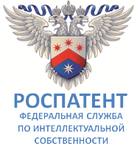 | 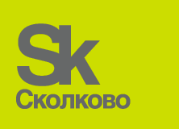 | 
RUSSIAN FEDERAL SERVICE FOR INTELLECTUAL PROPERTY (ROSPATENT) | SKOLKOVO FOUNDATION
international conference
WIPO/IP/MOW/18/INF2/PROV.2
ORIGINAL: english
DATE: JANUARY 25, 2018

Intellectual Property in the New Technological Order

organized by
the World Intellectual Property Organization (WIPO)

in cooperation with
the Russian Federal Service for Intellectual Property (Rospatent)
and
the Skolkovo Foundation

Moscow, February 1 and 2, 2018

GENERAL INFORMATION

prepared by the International Bureau of WIPO

CONFERENCE VENUE

The conference will take place in Moscow, the Russian Federation, at Matrex building, Skolkovo Innovation Center (2, Blaise Pascal st., Skolkovo Innovation center, Moscow, 143026), tel.: +7 (495) 956 00 33. For further information on the venue please visit the following webpage: http://sk.ru/news/.

Matrex building is located in Z1 area (Please see attached map).

Smoking will be forbidden at the venue.

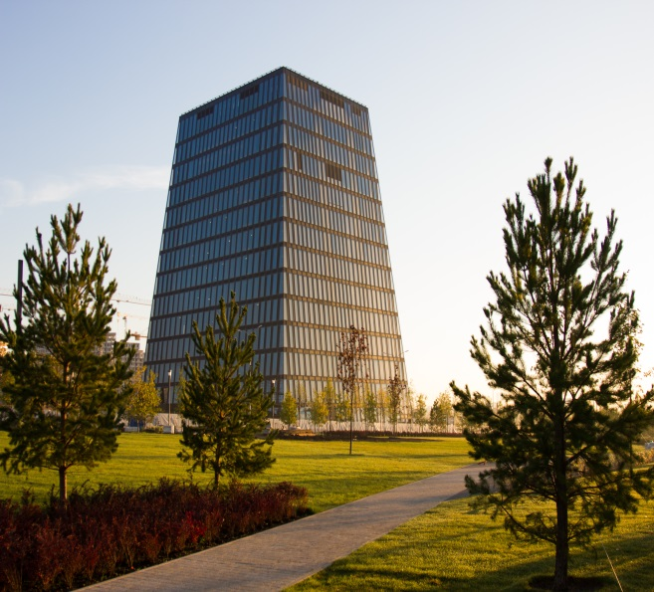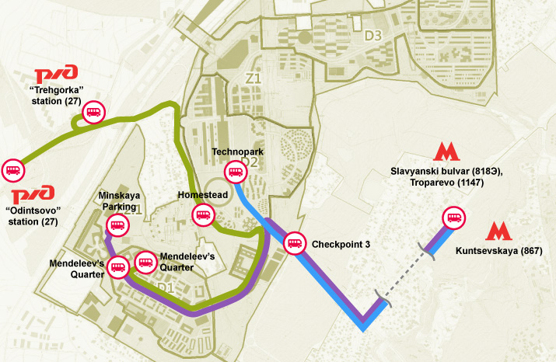

TRANSPORT

For registered participants of the International Conference, a shuttle service will be organized from Borodinskaya Panorama (metro station Park Pobedy) to Matrex building, Skolkovo Innovation Center. Busses from Park Pobedy will run from 08:30 to 09:00.

Shuttle busses will be also organized from Azimut Hotel Smolenskaya at 08:20 and Marriot Hotel Novy Arbat at 8:45 to the Conference venue for those who are staying at these hotels.
The busses will be also available in the evening after the cocktail reception at 20:00 from the Conference venue back to the hotels.

Participants may also use public transport. Regular buses are available from metro station Slavyanski Bulvar to the Skolkovo Innovation Center. For further information on getting to Skolkovo Innovation Center by public transport please visit the following webpage: https://sk.ru/city/transport/p/public.aspx.

INTERPRETATION

Simultaneous interpretation will be provided for participants of the International Conference in English and Russian.

CATERING

Catering service with light food and soft drinks will be available to participants during the conference. Drinking water will also be available to all participants at the conference.

ENTRY REQUIREMENTS FOR THE RUSSIAN FEDERATION

Participants are responsible for obtaining their own visas. They should be in possession of valid entry visas before commencing their travel. Please contact the Embassy or Consulate of the Russian Federation in your country of residence to learn about the visa requirements in your specific case.

ACCOMMODATION

For those who stays in Special room rates have been negotiated for registered participants at the Azimut Hotel Smolenskaya Hotel: AZIMUT Hotel Smolenskaya.

Single room – RUR 5500,00 per day (breakfast and 18% tax included).
Double room – RUR 6000,00 per day (breakfast and 18% tax included).

Please, use promo code WIPO to get the special rate above and follow the instruction on booking through the web of the hotel in the attachment.

TAXI SERVICES

Taxi Services are available at airports, hotels, and hotel staff can assist in ordering a taxi for you. Participants are recommended on using official taxis from authorized taxi counters at the airport.

CLIMATE

Moscow has a humid continental climate with warm, sometimes hot, somewhat humid summers and long, cold winters. In the winter, temperatures normally drop to approximately −10 °C (14 °F), though there can be periods of warmth with temperatures rising above 0 °C (32 °F) (based on meteorological averages).

LOCAL TIME and ELECTRICITY

The local time for Moscow is UTC + 3 hours. Electricity in Russia uses 220V, 50Hz and power sockets are of type C and F.

CURRENCY

The local currency in the Russian Federation is the Russian Ruble (RUB or RUR), which is divided into 100 kopeks. The exchange rate is approximately $1=RUR 59.65 and €1=RUR 69.00 (subject to change). There are currency exchange counters in the arrival area of the international airports and in the hotels.

TOUR OF THE SKOLKOVO INNOVATION CENTER (February 2, 2018)

A tour of the Skolkovo Innovation Center will be organized for registered participants of the International Conference by the Skolkovo Foundation on February 2, 2018 11:00 to 12:00 AM. Shuttle service for the tour participants will be organized from Azimut Hotel Smolenskaya at 09:50 and from Marriot Hotel Novy Arbat at 10:15 to the Skolkovo Innovation Center. After the completion of the tour the shuttle busses will depart from Technopark, Skolkovo back to the hotels at 13:00.

The contact person and coordination of the tour:

Mr. Boris Chubarov (WIPO): + 79262820745, boris.chubarov@wipo.int

CONTACTS

For general issues and overall coordination:
Mr. Parviz Emomov (WIPO): +79169157728, parviz.emomov@wipo.int.
Ms. Galina Mikheeva (Rospatent): +79162674218, rospat163@rupto.ru.
Mr. Maxim Proksh (the Skolkovo Foundation): + 79653327775, MProksh@sk.ru.

Attachment

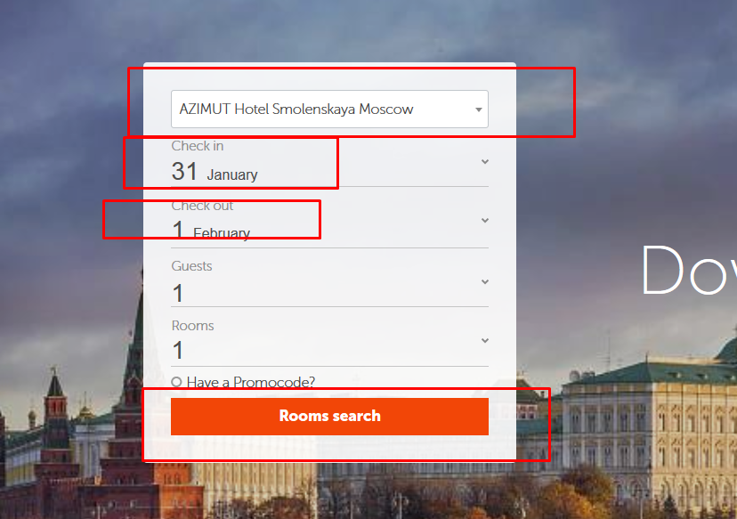

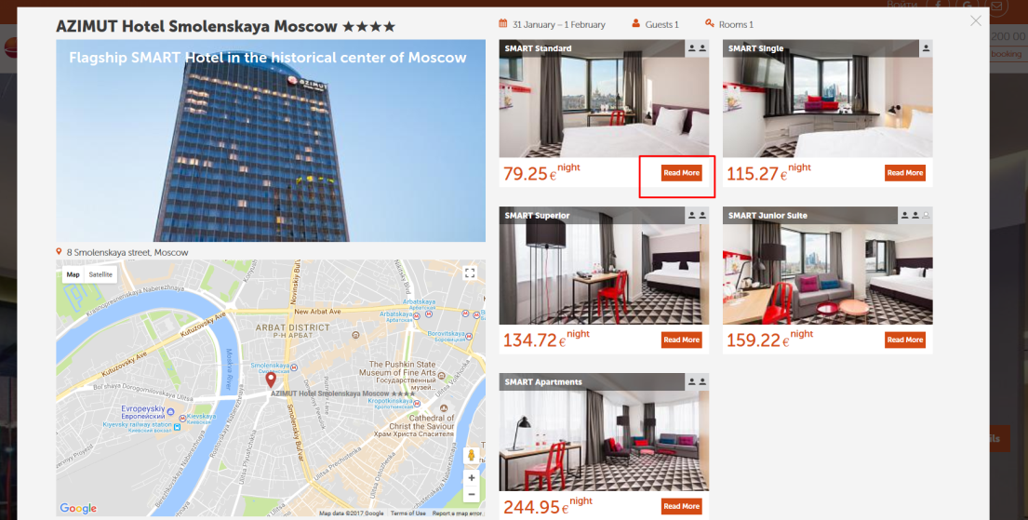

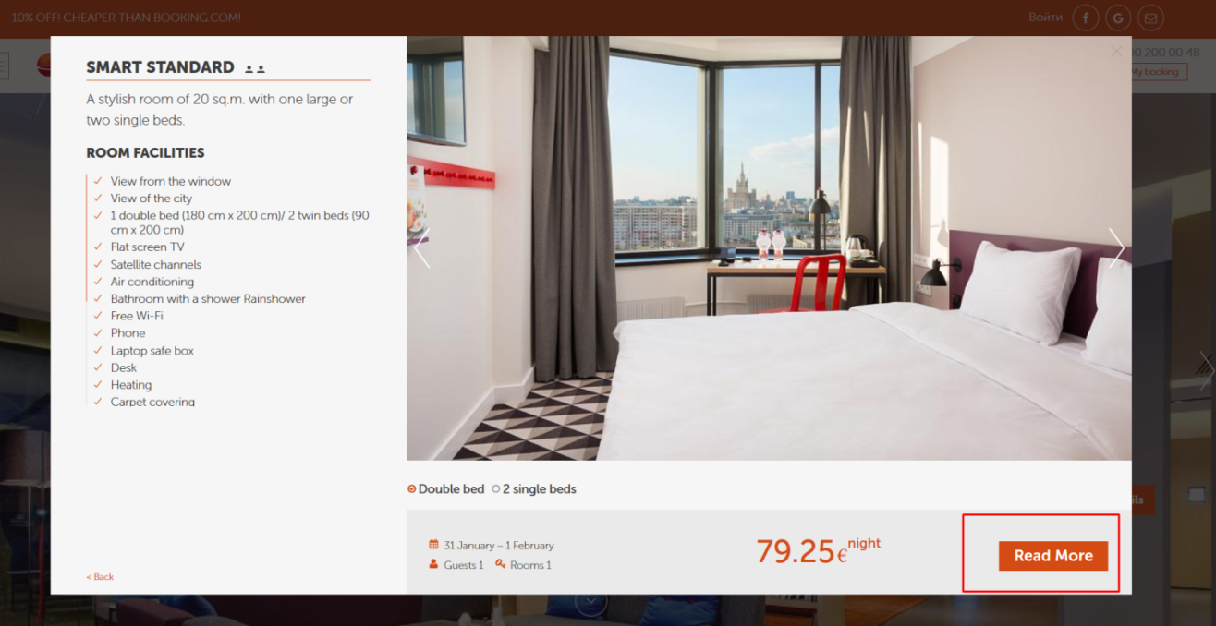

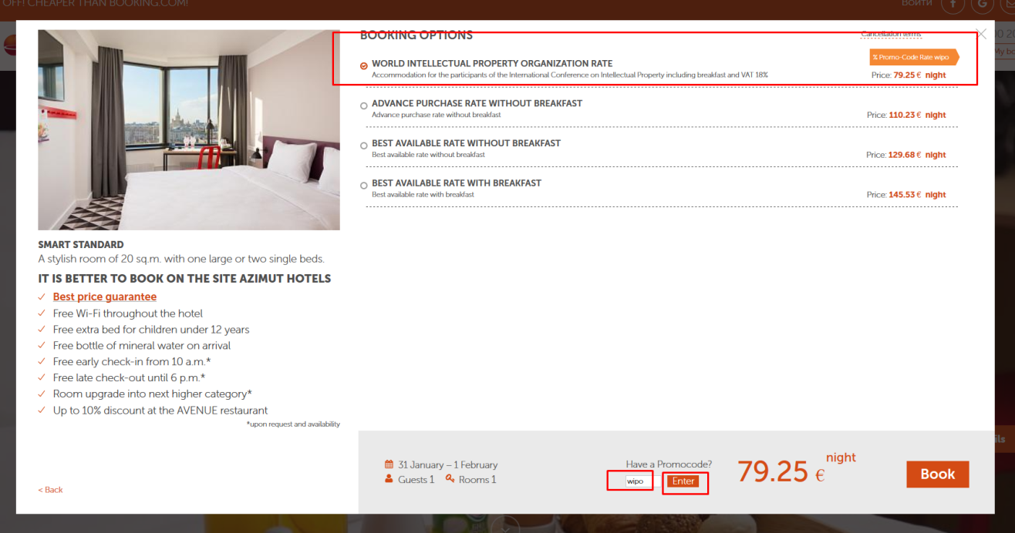

[End of document]

