|  |  |  |
| --- | --- | --- |
| **E** | | |
| D:\Users\Gorokhova\Desktop\Роспатент лого.png | http://sk.ru/themes/generic/images/sklogo_ru.png | WIPO-E |
| RUSSIAN FEDERAL SERVICE FOR INTELLECTUAL PROPERTY (ROSPATENT) | SKOLKOVO FOUNDATION |
|  | | |
| **international conference** | | |
| WIPO/IP/MOW/18/INF2/PROV | | |
| ORIGINAL: english | | |
| DATE:  December 5, 2017 | | |

**Intellectual Property in the New Technological Order**

organized by

the World Intellectual Property Organization (WIPO)

in cooperation with

the Russian Federal Service for Intellectual Property (Rospatent)

and

the Skolkovo Foundation

**Moscow, February 1 and 2, 2018**

GENERAL INFORMATION

*prepared by the International Bureau of WIPO*

CONFERENCE VENUE

The seminar will take place in Moscow, the Russian Federation, at Skolkovo Technopark (42, Bolshoi boulevard, Skolkovo Innovation center, Moscow, 143026), tel.: +7 (495) 956 00 33. For further information on the venue please visit the following webpage: <https://sk.ru/technopark/>.

Smoking will be forbidden at the venue.

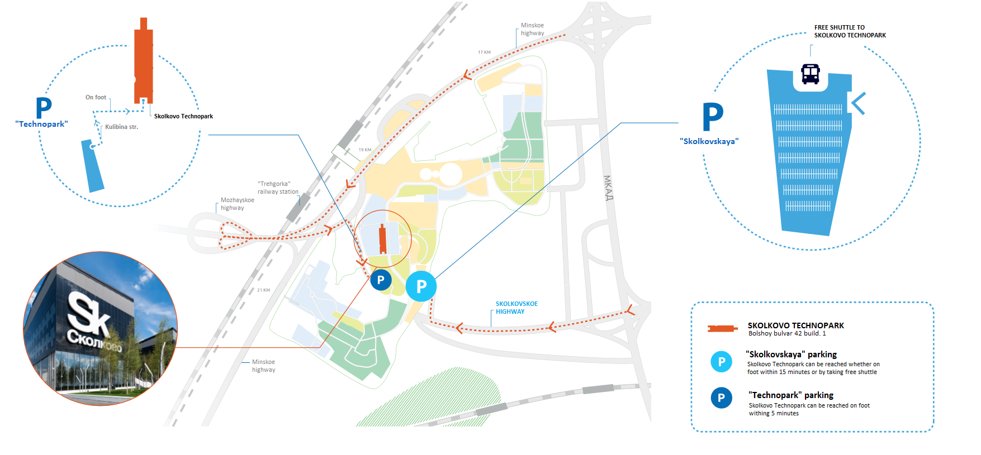

TRANSPORT

For registered participants of the International Conference, a shuttle service will be organized from Borodinskaya Panorama (metro station Park Pobedy) to Technopark Skolkovo.

Participants may also use public transport. From metro station Slavyanski Bulvar to Technopark the regular buses are available. For further information on getting to Technopark by public transport please visit the following webpage: <https://sk.ru/city/transport/p/public.aspx>.

INTERPRETATION

Simultaneous interpretation will be provided for participants of the International Conference in English and Russian.

CATERING

Catering service with light food and soft drinks will be available to participants during the conference. Drinking water will also be available to all participants at the conference.

ENTRY REQUIREMENTS FOR THE RUSSIAN FEDERATION

Participants are responsible for obtaining their own visas. They should be in possession of valid entry visas before commencing their travel. Please contact the Embassy or Consulate of the Russian Federation in your country of residence to learn about the visa requirements in your specific case.

ACCOMMODATION

Special room rates have been negotiated for registered participants at the Azimut Hotel Smolenskaya Hotel: [AZIMUT Hotel Smolenskaya](https://en.azimuthotels.com/Russia/azimut-hotel-smolenskaya-moscow/index.php?utm_source=direct&utm_medium=cpc&utm_term=azimut%20hotel%20smolenskaya%20moscow&utm_campaign=azimut-msk-smolenskaya-brand-ya-search-rf-rus-25231713&utm_content=v2%7C%7C4602544955%7C%7C8822179229%7C%7Cazimut%20hotel%20smolenskaya%20moscow%7C%7C1%7C%7Cpremium%7C%7Cnone%7C%7Csearch%7C%7Cno).

Single room – RUR 5500,00 per day (breakfast and 18% tax included).

Double room – RUR 6000,00 per day (breakfast and 18% tax included).

Please, use promo code WIPO to get the special rate above and follow the instruction on booking through the web of the hotel in the attachment.

TAXI SERVICES

Taxi Services are available at airports, hotels, and hotel staff can assist in ordering a taxi for you. Participants are recommended on using official taxis from authorized taxi counters at the airport.

CLIMATE

Moscow has a humid continental climate with warm, sometimes hot, somewhat humid summers and long, cold winters. In the winter, temperatures normally drop to approximately −10 °C (14 °F), though there can be periods of warmth with temperatures rising above 0 °C (32 °F) (based on meteorological averages).

LOCAL TIME and ELECTRICITY

The local time for Moscow is UTC + 3 hours. Electricity in Russia uses 220V, 50Hz and power sockets are of type C and F.

CURRENCY

The local currency in the Russian Federation is the Russian Ruble (RUB or RUR), which is divided into 100 kopeks. The exchange rate is approximately $1=RUR 59.65 and €1=RUR 69.00 (subject to change). There are currency exchange counters in the arrival area of the international airports and in the hotels.

CONTACTS

For general issues and overall coordination:

Mr. Parviz Emomov (WIPO): +79169157728, [parviz.emomov@wipo.int](mailto:parviz.emomov@wipo.int).

Ms. Galina Mikheeva (Rospatent): +79162674218, [rospat163@rupto.ru](mailto:rospat163@rupto.ru).

Mr. Maxim Proksh (the Skolkovo Foundation): + 79653327775, [MProksh@sk.ru](mailto:MProksh@sk.ru).

**Note:** On issues related to visa please contact Ms. Galina Mikheeva (Rospatent): +79162674218, [rospat163@rupto.ru](mailto:rospat163@rupto.ru).

Attachment

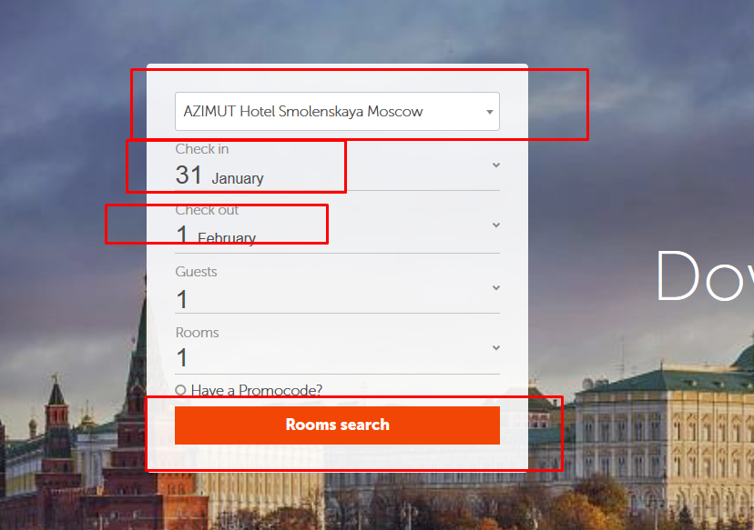

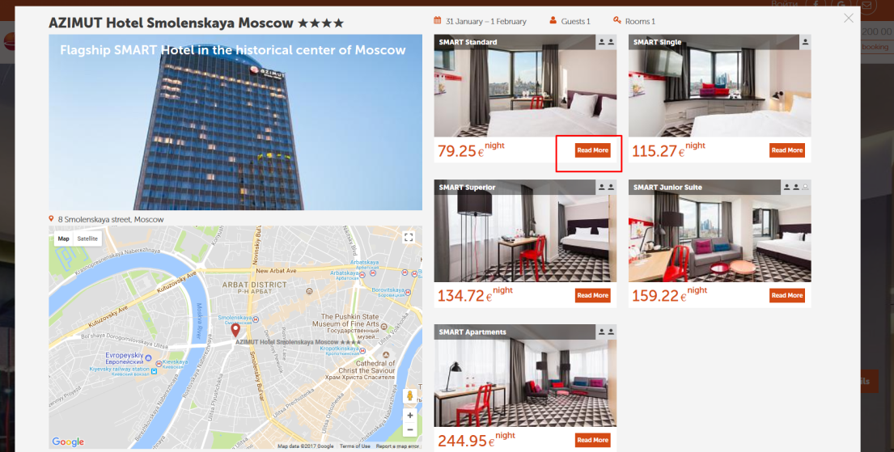

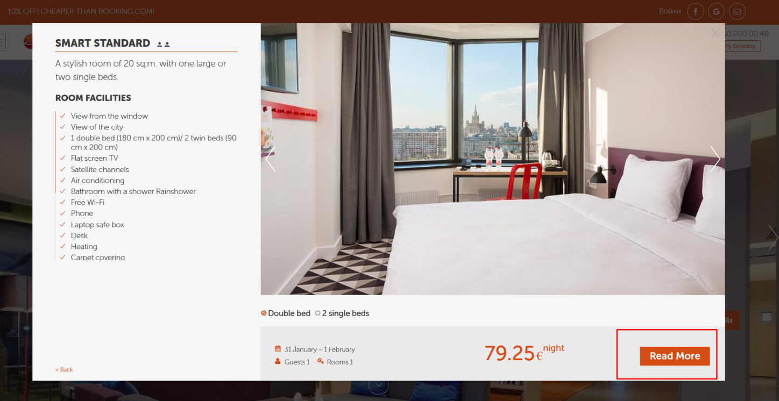

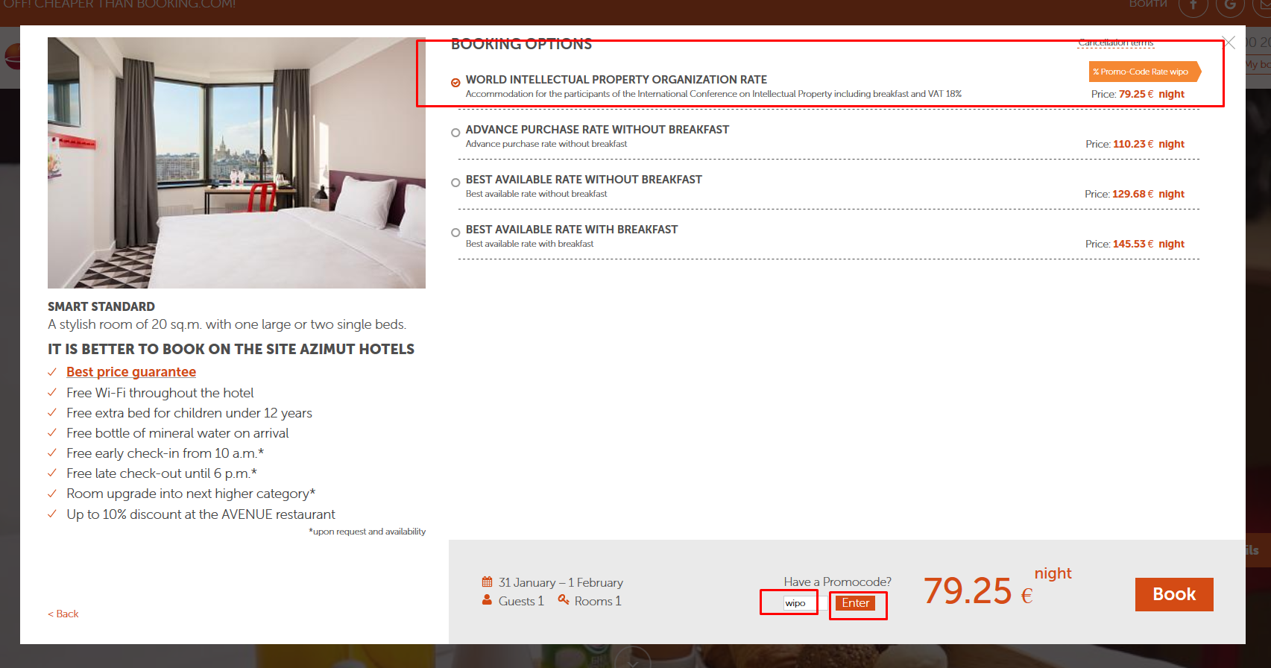

[End of document]