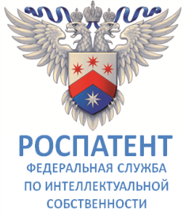 | 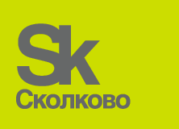
 | Skolkovo Foundation
International Conference

Intellectual Property in the New Technological Order

Moscow, Skolkovo Innovation Center, February 1 and 2, 2018

The World Intellectual Property Organization (WIPO) in cooperation with the Russian Federal Service for Intellectual Property (Rospatent) and the Skolkovo Foundation is organizing an International Conference on Intellectual Property in the New Technological Order.

The World Intellectual Property Organization being a key global player in development of a balanced and effective international intellectual property (IP) system promotes innovation and creativity for the economic, social and cultural development for the benefit of all countries.

The global process of digitalization of the economy, law and public life entails a change in the role of intellectual assets. The technological advent dictates new requirements to the society and legally regulated relations in the emerging reality. Technology is not just becoming a subject of a study by law, but law itself also is influenced and studied by technology. The Institute of Intellectual Property should be prepared for innovative advancements in order to adequately meet technological challenges of the existing system of international treaties in the field of IP.

An exponential growth of technologies can be expected, which leads to the leveling of existing forms of protection of intangible assets. The scale of the changes will be the result of openness, the extraordinary coherence of technology and the desire in minimizing the gap between newly created innovation and its implementation. And instead of entry barriers to the market, there will be a limit to openness. The latter is already apparent now: in a "major" technological industry, such as space, even small players successfully participate.

The Conference aims to conduct a discussion on the challenges facing the Institute of Intellectual Property in the context of rapid technological development and the actual innovation agenda. Renowned scientists and experts, officials and representatives from various international organizations, as well as lawyers and entrepreneurs are invited to participate as speakers. More than 500 Russian and foreign visitors are expected to participate at the conference in Skolkovo - the largest Technopark in Eastern Europe.

