 |  | E
wipo/ip/dev/GE/11/Inf 2
ORIGINAL: E
DATE: 06.09.2011

Evaluation Seminar Series

Learning from Existing Evaluation Practices on the Impacts and Effects of Intellectual Property on Development

Geneva, 6 and 7 October, 2011

Facts on Geneva

prepared by the Secretariat

Checklist for Participants of the seminar

Registration | √
Online registration form Learning from Existing Evaluation Practices on the Impacts and Effects of Intellectual Property on Development
Travel/ Accomodation
Book Flight
Book Hotel
VISA
Change Money
In Geneva
Coffee and Lunch Voucher prepared WIPO

The seminar

The seminar will take place in Room 0.107 in the New Construction (NC) Building of WIPO located between the main WIPO building and Hotel Intercontinental. The seminar is free of charge. Participants are expected to cover their own cost for accommodation and travel. Meal and Coffee vouchers will be given to registered participants.

Social Event

An aperitif will be offered to all participants in the late afternoon of Thursday 6th October 2011 .

Basic facts About Geneva
Geneva is the second largest city in Switzerland behind Zurich and the most international city in Europe with over 40% of its population coming from outside Switzerland. The main industries are banking, inter- and non-governmental administration, technology, and tourism. Geneva prides itself as being one of the most beautiful and cultured cities in the world, combining the splendors of nature with a rich palette of historic and architectural offerings. As well, the city is a major gateway to the Alps for outdoor enthusiasts year round.
History of Geneva
Geneva has a rich history that dates back more than 4000 years and continues to influence the development of the city today. Evidence of Geneva’s past is preserved throughout the city in its many museums, monuments and architectural treasures.
Hotels and hostels
Geneva has over 130 hotels ranging from luxury five star resorts to dorm style hostels. Most hotels are in easy walking distance of major attractions, shopping and of course food.
Geography
Geneva is the capital of the Swiss Canton of Geneva located in the westernmost corner of Switzerland. The city is situated along the banks of Europe’s largest lake, Lake Geneva, at the mouth of the Rhone River and is bordered by the Jura Mountains to the west and the French Alps in the east. The city is easily reached within 2 hours by plane from most major cities in Europe and is a hub of Europe’s highway network. High speed train connections to Paris and Milan as well as fast trains to Spain and Germany provide additional access.
Language
Switzerland has three official languages: French, German and Italian. French is the predominant language spoken in Geneva, but most citizens speak at least one other language. English is spoken by about a quarter of the local population and by the majority of foreigners. Of course you can hear just about every other language in Geneva if you listen hard enough, from Albanian to Zimbabwean. When dealing with locals it is recommended that you start off in French, even if it is only a greeting, before transitioning to English.
Currency
The currency in Switzerland is the Swiss Franc (CHF, SFr.). The Euro is also accepted at most businesses but expect to pay a premium rate. Check www.xe.com/ for the most up-to-date exchange rates. Most transactions in the city are conducted in cash and a surprising number of businesses and restaurants do not accept credit cards so be prepared. ATMs are widely available throughout the city, dispensing notes up to 1000 CHF.
Climate
Due to the tempering effects of the lake and surrounding mountains, Geneva is pleasant almost year round. September and October are the rainiest months. January and February are the coldest but rarely drop below freezing. Summers are long with relatively low humidity and cool breezes from the lake. The Mont Blanc is visible from Geneva about half of the days out of the year. For more information, go to: www.free-weather.com/Geneva-Switzerland.php
Electricity
Electricity in Switzerland is 220 volts, 50 cycle AC. Most U.S. appliances require a converter and an adapter to operate, although some dual-voltage items such as laptops may only require an adapter. Some European appliances may also require an adaptor as Switzerland uses a 3-prong outlet system that is smaller than most Continental plugs. For more information see www.travelproducts.com/store/electricity_guide.htm
Health and Safety
Geneva is a safe city with 1.99 violent crimes per 100,000 in 2003. Petty crimes such as pick-pocketing are common around the central train station, but common sense usually prevails. Top quality hospitals and clinics are available 24 hours throughout the city (see Print and Take).
Time Zone: GMT/UTC +1
Telephone area code: 041
Population: 176,000 (2004)
Some More Facts and Figures
- 40 % of residents in Geneva come from outside Switzerland
- Switzerland is a federal state founded in 1291. From 4 independent “Cantons” (=states) initially it has currently 26 Cantons, each with their own administration and specific laws.
- Geneva has the shortest commuting time of any major city in the word
- Dog droppings is annually listed as the top complaint of citizens in Geneva
- The World Wide Web was invented and developed in Geneva at CERN laboratories.
- Geneva has been the host of the League of Nations before it became the UN’s second largest “hub”, hosting parts of the Secretariat as well as of Programs and Funds as well as numerous Specialized Organizations.

http://www.geneva.info/

How to get to WIPO?

By Taxi:

It will cost you around 30-40 CHF from the airport to the center of the city.

By Public Transport:

- Please note that you will get a Geneva Transport card when you’re checking in a hotel, which is free and allows you to travel free during your stay in Geneva!
- Please note that when you arrive by plane, you will obtain a free one way bus- ticket from the airport to your place in Geneva. This ticket is available at the vending- machine of the TPG in the Hall where you pick up your luggage, at Geneva airport.

From the airport to WIPO:

Bus stop Aéroport: Take Bus 5 (direction Hôpital) and get out at Bus Stop Nations.

(It takes ca. 18 min.)

From the Train- station to WIPO (most run every 7-10 minutes, except Bus F):

Tram/ Bus Stop Gare Cornavin: Take Tram 15 (direction Nations) and get out at Tram/ Busstop Nations (It takes ca. 7 min.)

Tram/ Bus Stop Gare Cornavin: Take Tram 13 (direction Nations) and get out at Tram/ Bus stop Nations (It takes ca. 7 min.)

Tram/ Bus Stop Gare Cornavin: Take Bus 5 (direction Aéroport) and get out at Tram/ Busstop Nations (It takes ca. 8 min.)

Tram/ Bus Stop Gare Cornavin: Take Bus 8 (direction Appia) and get out at
Tram/ Busstop Nations (It takes ca. 7 min.)

Tram/ Bus stop Gare Cornavin: Take Bus F (direction Ferney-Voltaire-Mairie) and get out at Tram/ Busstop Nations (It takes ca. 5 min.)!!! Runs only every 20 minutes on average.

By Car:

Please not, that WIPO doesn’t have any free parking facilities! Parking des Nations is the closest public parking (http://www.geneve.ch/parkings/parkings/nations.html).

Maps see following pages

From outside Geneva to WIPO:

To see the map online click here ☺

From the airport to WIPO:
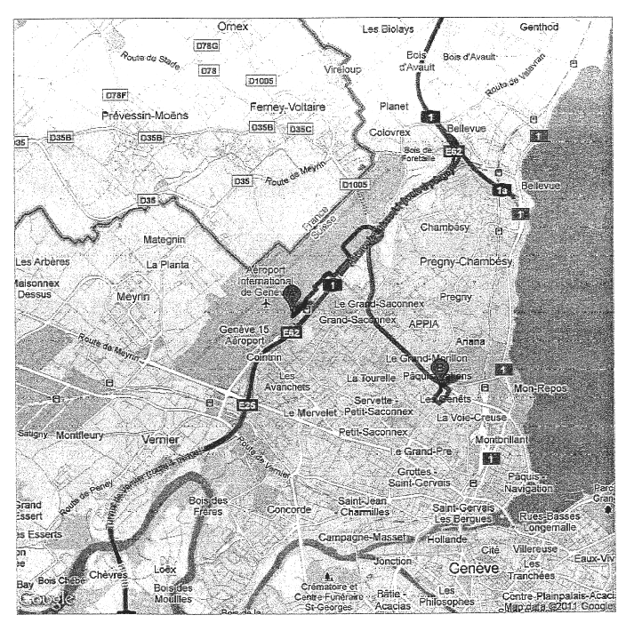

To see the map online click here ☺

From the Train- Station to WIPO:

To see the map online, please click here ☺

Contact Information

For enquiries about Geneva or opportunities to support the seminar please contact:

Susann Winter
Internal Audit and Oversight Division (IAOD)
World Intellectual Property Organization (WIPO)
34, Chemin des Colombettes
1211 Geneva - Switzerland
Tel.: +4122 338 7011
Fax: +4122 338 8770

E-mail: evaluation@wipo.int
http://www.wipo.int/about-wipo/en/oversight/evaluation/

