E
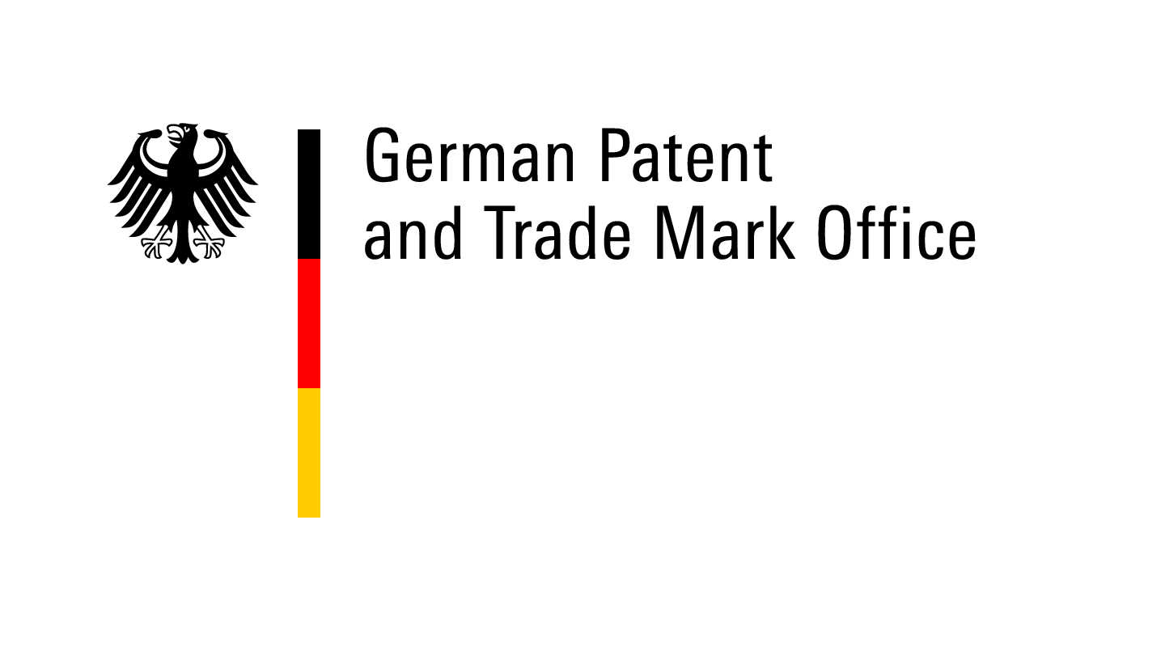
national seminar
WIPO/IP/DE/14/inf/1.prov
ORIGINAL: english
DATE: june 2014

WIPO Services and Initiatives

organized by
the World Intellectual Property Organization (WIPO)

in cooperation with
the German Patent and Trade Mark Office (DPMA)

Munich, Germany, July 1, 2014

Provisional Program

prepared by the Secretariat of WIPO and the DPMA

Kindly supported by:

Tuesday, July 1, 2014

09.30 a.m. – 10.00 a.m. REGISTRATION

10.00 a.m. – 10.20 a.m. Opening Session

Welcome addresses by:

- Ms. Cornelia Rudloff-Schäffer, President German Patent and Trade Mark Office (DPMA), Munich
- Mr. Christian Wichard, Deputy Director General, Global Challenges Sector, World Intellectual Property Organization (WIPO), Geneva

SESSION I

10.20 a.m. – 10.50 a.m. Topic 1: Introduction to WIPO
Development of the International Legal Framework
Major Intellectual Property Economic Studies

Speaker: Mr. Christian Wichard, Deputy Director General, Global Challenges Sector, WIPO

10.50 a.m. – 11.20 a.m. Topic 2: The Patent Cooperation Treaty (PCT)
Introduction and Future Developments

Speaker: Mr. Matthias Reischle, Deputy Director, PCT Legal Division, Innovation and Technology Sector (ITS), WIPO

11.20 a.m. – 11.50 p.m. Topic 3: Global IP Systems
The Madrid System for the International Registration of
Marks
The Hague System for the International Registration of
Industrial Designs
The Lisbon System for the International Registration of
Appellations of Origin

Speaker: Ms. Debbie Roenning, Director, Legal Division, Madrid Registry, Brands and Designs Sector, WIPO

11.50 a.m. – 12.10 p.m. Topic 4: The DPMA as WIPO’s cooperation partner and service provider for the users of the IP system

Speaker: Mr. Hubert Rothe, Head of Division Information Services for the Public, DPMA

12.10 p.m. – 12.40 p.m. Topic 5: WIPO Services: Perspectives from German Users

Speaker: Dr. Christof Keussen, Patent attorney, Vice President, German Chamber of Patent Attorneys, Hamburg

12.40 p.m. – 1.40 p.m. Lunch Break

SESSION II

1.40 p.m. – 2.10 p.m. Topic 6: WIPO Arbitration and Mediation
Alternative Dispute Resolution

Speaker: Mr. Christian Wichard, Deputy Director General, Global Challenges Sector, WIPO

2.10 p.m. – 2.40 p.m. Topic 7: Global Databases for IP
Platforms and Tools for the Connected Knowledge Economy

Speaker: Mr. Christophe Mazenc, Head, Global Databases Service, Global Infrastructure Sector, WIPO

2.40 p.m. – 3.10 p.m. Coffee break

3.10 p.m. – 3.40 p.m. Topic 8: Patent-based analysis for competitive intelligence
Free of charge opportunities with PATENTSCOPE (WIPO)

Speaker: Mr. Bruno Götz, Head of Division Patents and Standards, TÜV Rheinland Consulting GmbH, Patent Centre Nuremberg

3.40 p.m. – 4.45 p.m. PLENARY DISCUSSION

[End of document]

