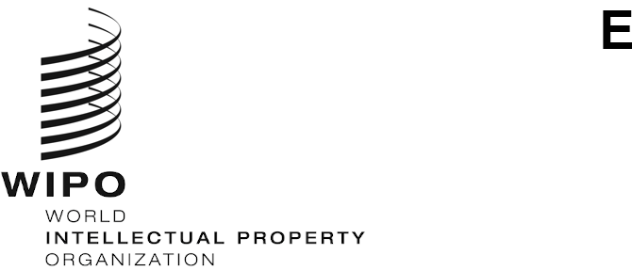
WIPO/IP/AI/3/GE/20/INF/1/PROV.2
ORIGINAL: ENGLISH
DATE: October 13, 2020

WIPO CONVERSATION ON INTELLECTUAL PROPERTY (IP)
AND ARTIFICIAL INTELLIGENCE (AI)

Third Session
Geneva, November 4, 2020

PROVISIONAL AGENDA
prepared by the WIPO Secretariat

Wednesday, November 4, 2020
10.00 – 10.15 Opening
Mr. Daren Tang, Director General, World Intellectual Property Organization (WIPO)
10.15 – 10.30 Introductory remarks
H.E. Mr. François Rivasseau, Ambassador, Permanent Representative, Permanent Mission of France to the United Nations and other International Organizations in Geneva
10.30 – 10.45 Keynote
The Honorable Ms. Amanda Solloway MP, Parliamentary Under Secretary of State, Minister for Science, Research and Innovation, Government of the United Kingdom, London

Session 1
Issue 1: Definitions
10.45 – 11.00 Introduction to Session 1
Mr. Jean-Marc Deltorn, Senior Researcher at Center for International Intellectual Property Studies, University of Strasbourg, Strasbourg
11.00 – 12.05 Session 1 Interventions

Session 2
Issue 13: Trademarks
12.05 – 12.20 Introduction to Session 2
Ms. Tiki Dare, President-Elect International Trademark Association (INTA), and Assistant General Counsel, Oracle, Burlington, United States of America
12.20 – 13.00 Session 2 Interventions
13.00 – 14.00 Lunch Break

Session 3
Issue 15: Capacity Building
Issue 16: Accountability for Decisions in Intellectual Property (IP) Administration
14.00 – 14.15 Introduction to Session 3
Ms. Nta Ekpiken, Partner and Head of IP, The New Practice (TNP), Lagos
Mr. Yuri Zubov, Deputy Head, Federal Service for Intellectual Property (Rospatent), Moscow
14.15 – 15.45 Session 3 Interventions
15.45 – 16.00 Closing
H.E. Mr. François Rivasseau
Mr. Daren Tang
[End of document]

