E
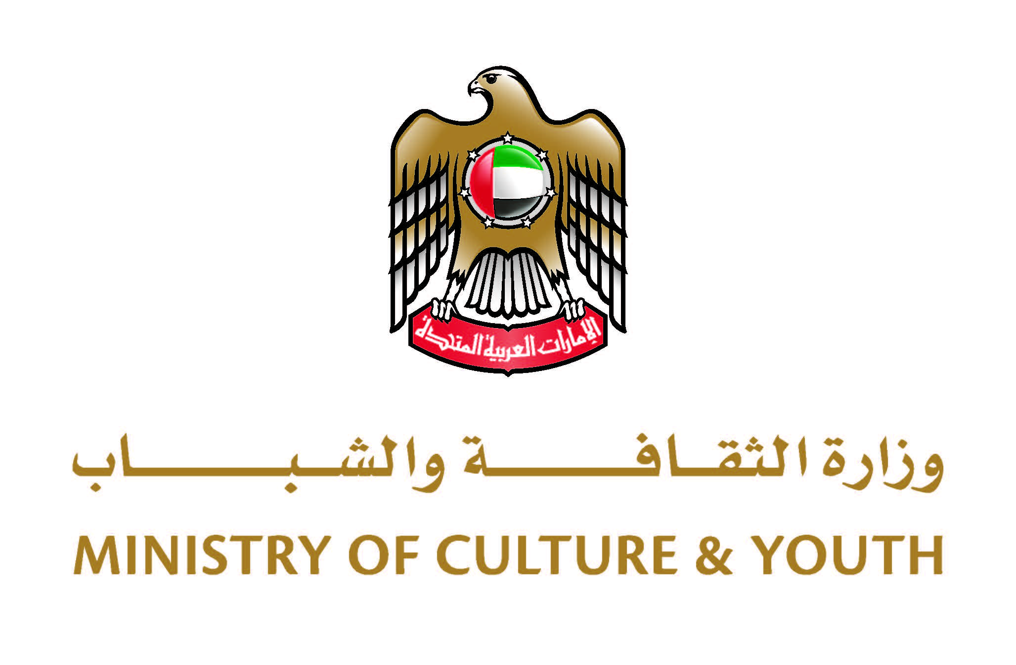
NATIONAL WORKSHOP
wipo/cr/abu/22/INF/1
ORIGINAL: english
DATE: June 27, 2022

Training session on data collection and analysis of the creative industries in the United Arab Emirates

organized by
the World Intellectual Property Organization (WIPO)

in cooperation with
the Ministry of Culture and Youth of the United Arab Emirates

Dubai, United Arab Emirates, June 27 to 30, 2022

Program

prepared by the International Bureau of WIPO

Tuesday, June 28, 2022 (all times are Gulf Standard Time (GST))

9.00 – 9.15 | Opening
 | Welcome remarks by: | Ms. Waheeda Al Hadrami, Acting Director of the National Cultural and Creative Industries Promotion Department, Ministry of Culture and Youth, Abu Dhabi, United Arab Emirates
Mr. Dimiter Gantchev, Deputy Director and Senior Manager, Information and Digital Outreach Division, Copyright and Creative Industries Sector, World Intellectual Property Organization (WIPO), Geneva

Mr. Rimantas Vaicenavičius, Expert on Statistical Methods and their Quality, Vilnius, Lithuania

9.15 – 9.30 | Overview of the program  Presenter: Mr. Dimiter Gantchev
9.30 – 10.30 | Module 1: | The Creative Industries concept and framework
  - Intellectual property as an underpinning principle.
  - Economic fundamentals of copyright, creative markets.
  - Major stakeholders in the creative economy.
  - Overview of international initiatives.
  - WIPO’s approach - main principles for defining the copyright/creative industries.
  - Uses of WIPO studies in policy planning.
 | Presenter: | Mr. Dimiter Gantchev
10.30 – 10.40 |  | Discussion
10.40 – 11.10 |  | Coffee Break
11.10 – 12.40 | Module 2: | In-detail review of the WIPO methodology for assessing the economic contribution of the creative sector
  - General framework of the study.
  - Statistical measurement as a central study method.
  - Statistical classification systems.
  - Main indicators – measuring Value Added, Employment and International Trade: methodological commonalities and specifics – recommended approaches.
 | Presenter: | Mr. Rimantas Vaicenavičius
12.40 – 13.40 |  | Lunch Break
13.40 – 14.00 |  | Discussion  Individual discussions and consultations upon the participant requests

Wednesday, June 29, 2022 (all times are Gulf Standard Time (GST))

9.00 – 10.30 | Module 3: | Official statistics as the central data source
  - Statistical Business Registries: their importance use and quality implications.
  - National accounting framework and data use for creative studies.
- Major defining terminology.
- Using statistical tools: activity
classification and product classification,
conversion issues.
- Supply and use tables.
- Input-output tables.

  - Structural Business Statistics (SBS).
Useful statistical imputation and estimation techniques.
  - Official statistics management framework as a useful tool for more granular planning of economic contribution studies (GSBPM).
  - Multi-annual planning in official statistics and the ways to integrate the studies or their parts into multi-annual and annual official statistics programs.
  - Statistical IT tooling.

 | Presenter: | Mr. Rimantas Vaicenavičius
10.30 – 11.00 |  | Coffee Break
11.00 – 12.30 | Satellite accounts in the national accounting: domains and granularity. Creating satellite accounts for creative industries.  Additional indicators - estimating correlations and measuring productivity.
 | Presenter: | Prof. Vanus James, Port of Spain, Trinidad and Tobago (online)
12.30 – 13.30 |  | Lunch Break
13.30 – 14.30 | Module 4: | Useful private and non-official statistics data sources
  - Company level financial reporting data.
  - Data of business associations and data vendors.
  - Government owned data, which does not qualify as official statistics.

 | Presenter: | Mr. Rimantas Vaicenavičius
14.30 – 14.40 |  | Discussion  Individual discussions and consultations upon request

Thursday, June 30, 2022 (all times are Gulf Standard Time (GST))

9.00 – 11.00 | Module 5: | Overview of the selected case studies made previously with an emphasis on emerging new methods.
 | Presenters: | Mr. Dimiter Gantchev
 |  | Mr. Rimantas Vaicenavičius
 |  | Prof. Vanus James
11.00 – 13.00 | Module 6: | Discussion on the lessons learned in the UAE country study  - Project and team management.  - Data needs and enhancement of statistical surveys.  - IT tools handling.  - Talent and qualifications needed and related demands for educational programs.  - What could be enhanced in the next study?
 | Presenters: | Mr. Dimiter Gantchev
Mr. Rimantas Vaicenavičius

Ms. Oumou El Kheirat El Abed, Senior Expert, Federal Competitiveness and Statistics Centre, Dubai, United Arab Emirates

13.00 – 14.00 |  | Lunch Break

14.00 – 15.00 |  | Next staps: to build a sustainable governance mechanism at a local and federal level

 | Presenters: | Ms. Oumou El Kheirat El Abed

Closing

[End of document]

